NEW JERSEY
FLOODPLAIN ADMINISTRATOR’S GUIDEBOOK
Version 2.0
August 17th, 2023

Prepared by the New Jersey Department of Environmental Protection (NJDEP), Division of Dam Safety & Flood Engineering, NFIP State Coordinator’s Office
In cooperation with the Federal Emergency Management Agency (FEMA) Region II



“Resilience starts with the floodplain administrator.”

“Pre-event resilience allows for post-event recovery.”

Table of Contents
Table of Contents 3
Introduction: 6
How to Use this Guide: 6
Acronyms: 6
CHAPTER 1: THE ROLE OF THE FLOODPLAIN ADMINISTRATOR 7
THE FLOODPLAIN ADMINISTRATOR 7
THE FPA’S RESPONSIBILITIES 7
THE FPA, FLOODPLAIN MANAGEMENT, FLOOD INSURANCE, AND DISASTER RELIEF 9
THE FPA AND THE FLOOD DAMAGE PREVENTION ORDINANCE 11
THE FPA AND THE MAP PROCESS 11
THE COMMUNITY RATING SYSTEM 12
ADMINISTERING THE FEDERAL FLOOD RISK MANAGEMENT STANDARD 12
Chapter 2: NFIP Floodplain Management Requirements 14
NFIP Regulations 14
NFIP Regulated Activities 15
NFIP Construction 15
NFIP Construction Certifications, Plans, and Elevation Certificates 17
NFIP Flood Damage Prevention Ordinance & Map Adoption Process 17
NFIP Floodplain Development Permit 19
Making Floodplain Development Permit Determinations 20
Floodplain Development Permit Pitfalls 20
Inspections 21
Enforcement and Violations 21
Floodplain Administrator Coordination with NJDEP Bureau of Coastal and Land Use Enforcement 22
Variances 23
Historic & Cultural Resources 24
Elevation Certificates 25
Letters of Map Change 26
Conditional Letters of Map Revision including Proposals for the Placement of Fill Prior to Development 28
Endangered Species Act 29
Substantial Improvement/Substantial Damage 29
Chapter 3: Incorporating Local and State Floodplain Management Regulations 31
The Precedence Rule and Regulating to Higher Standards 31
State Regulations –Flood Hazard Area Control Act Overview 31
New Jersey State Regulations – Flood Hazard Area Control Act Regulated Areas Not Mapped by FEMA or DEP 32
NJ State Regulations –Flood Hazard Area Control Act Riparian Zones 32
NJ State Regulations –Flood Hazard Area Control Act – Methodology for Determining the Flood Hazard Design Flood Elevation 33
NJ State Regulations –Flood Hazard Area Control Act and coordination with the Uniform Construction Code to Set Lowest Floor Elevations (Freeboard) 35
Municipal (Local) Regulations 36
Determining the Local Design Flood Elevation (LDFE) - What should the FPA regulate to? 37
An Important Notice about determining the Best Available 500 Year Stillwater Elevation with Wave Height for Critical Facility Design Flood Elevations 40
Other Land Use Laws and Permits that also apply within regulated floodplains 41
Permits-by-Rule, Permits-by-Certification, and General Permits 44
FHACA vs NFIP: Differences 45
Where can I find more information? 48
Chapter 4: NJ Construction Codes (UCC) 48
Understanding Construction Codes for Floodplain Management 48
Coordination of the UCC Building Permit and the Flood Damage Prevention Permit 50
ASCE 24-14 Building Classes and the FHACA Flood Hazard Design Flood Elevation 50
Winter 2019 UCC Construction Code Communicator 52
Building Additions & Clarifying the Summer 2016 UCC Construction Code Communicator 53
Chapter 5: Resources for Implementing the NFIP and Floodplain Management 55
Permit and Inspection Workflow 55
Fill 56
Inspections 57
1 Foot Freeboard Requirement 57
Coastal A Zones in NJ 57
Mitigation and AW-501s 58
Environmental Review 58
Bureau of Flood Engineering Resources 58
Trainings 59
Certifications 59
Publications, Bulletins, and Fact Sheets 59
Assistance 60
Chapter 6: Post-Disaster Best Practices 63
Action 1: Plan Ahead 63
Action 2: Assess Post-Disaster Needs and Request Assistance 67
Action 3: Document High Water Marks 67
Action 4: Make Substantial Damage Determinations 68
Action 5: Understand NFIP Claims and ICC 72
Action 6: Identify Sources of Mitigation Funding Assistance and Understand NJ Blue Acres 73
Chapter 7: Conclusion 74
Appendices 63
APPENDIX A: WORKSHEET 1 - Local Design Flood Elevation Worksheet 63
APPENDIX B: WORKSHEET 2 –Model Floodplain Development Permit 73
APPENDIX C: Development Plan Requirements 87
APPENDIX D: Other Applicable Permits 88
APPENDIX E: Flood Information – Site Specifics 97
APPENDIX F: Example Certificates and Forms 104
APPENDIX G:Permits-by-Rule Under the Flood Hazard Area Control Act and Coastal Zone Management Rules.. 117
APPENDIX H: Determining the Riperizan Zone Width 122
APPENDIX I: Identifying Threatened and Endangered Species 124
APPENDIX J: EXAMPLES FOR DETERMINING THE LOCAL DESIGN FLOOD ELEVATION (LDFE) AND FEDERAL FLOOD RISK MANAGEMENT STANDARD (FFRMS) USING WORKSHEETS 1, 2, & 3 126

Introduction:
Floodplain management is an important and required responsibility of local municipalities in New Jersey. Floodplain regulations are set at all levels of government including the Federal (Federal Emergency Management Agency (FEMA) and the National Flood Insurance Program (NFIP)), the State (Flood Hazard Area Control Act (FHACA), Uniform Construction Code (UCC), and Land Use (LU) legislation), and the Local Level (Municipal Ordinance). Responsibility for knowing and ensuring these regulations are followed falls on local officials, specifically the designated municipal Floodplain Administrator. Each municipality in New Jersey that is participating in the NFIP has a local Flood Damage Preventive Ordinance in effect. This Ordinance specifies the office/position designated as the Floodplain Administrator (FPA). This guide is intended to assist the FPA in understanding the rules and regulations related to floodplain management and what their responsibilities are.

How to Use this Guide:
This guide is focused on promoting awareness of floodplain administrator responsibilities and best practices to fulfill them. It is not intended to list and explain all floodplain mapping, construction, and insurance rules and regulations that are already documented elsewhere. As such, for the technical information, broad overviews are given with links to the full reference documents.
This guide is intended to work with the New Jersey Model Code Coordinated Ordinance and New Jersey Model Permit which navigate both the New Jersey Flood Hazard Area Control Act and the New Jersey Uniform Construction Code so that New Jersey’s Floodplain Administrators can ensure NFIP-compliant floodplain management practices in their community to retain participation in the NFIP.

Acronyms:
BFE – Base Flood Elevation
CLUE – Bureau of Coastal and Land Use Compliance & Enforcement
DFE – Design Flood Elevation
FEMA – Federal Emergency Management Agency
FHA – Flood Hazard Area
FHACA – Flood Hazard Area Control Act
FHDFE – Flood Hazard Design Flood Elevation
FIRM – Flood Insurance Rate Map
FIS – Flood Insurance Study
FPA – Floodplain Administrator
ICC – Increased Cost of Compliance
LDFE – Local Design Flood Elevation
NFIP – National Flood Insurance Program
NJDEP – New Jersey Department of Environmental Protection
RL – Repetitive Loss
SD/SI – Substantial Damage / Substantial Improvement
SFHA – Special Flood Hazard Area
SRL – Severe Repetitive Loss

CHAPTER 1: THE ROLE OF THE FLOODPLAIN ADMINISTRATOR

THE FLOODPLAIN ADMINISTRATOR
The Floodplain Administrator (FPA) is a community’s champion for sound floodplain management. The FPA is responsible for ensuring that floodplain development activities comply with floodplain management regulations and other applicable codes and ordinances. The FPA holistically works with land use, zoning, planning, construction, land preservation, enforcement, and local, State, and Federal stakeholders in the pursuit of this duty. The FPA also promotes resilience through higher floodplain standards in ordinances, best practices that reduce insurance premiums, and assists with mitigation strategies before and after disaster events.
The FPA is a mandated position for communities that have joined and participate in FEMA’s National Flood Insurance Program (NFIP). The NFIP is, by definition, a voluntary program, between local communities and the Federal government. Local communities agree to enforce floodplain development regulations and in exchange, property owners can purchase federal flood insurance, and communities are eligible for federal grants and disaster assistance. The NFIP provides benefits communities cannot find elsewhere and when administered properly, makes them more resilient to flooding events. Since it is a voluntary program for communities, the requirements agreed to upon program entry do not constitute an unfunded mandate.
FPAs have an important job under the NFIP. They must implement the community’s local Flood Damage Prevention Ordinance, ensure minimum NFIP floodplain management standards are met, and ensure higher standards mandated by local or State law are met.
The FPA may also be someone serving the community in multiple roles (e.g., construction/building official, zoning official, engineer, Emergency Management coordinator, Police Chief, etc.) The FPA’s position or office will be designated in the community’s Flood Damage Prevention Flood Damage Prevention Ordinance. If a community has used NJDEP’s new model ordinance, this information is specified in Section 103: Duties and Powers of the Floodplain Administrator.
New Jersey Model Code Coordinated Ordinances: https://www.nj.gov/dep/floodcontrol/modelord.htm

THE FPA’S RESPONSIBILITIES
The FPA is responsible for the following:
- Require, review, and evaluate floodplain development permit applications for all development located in or near a Special Flood Hazard Area (SFHA). This responsibility also includes regulating all development including minor development (e.g., fences, sheds, grading, paving) and activities (e.g., drilling, storing materials) that may not require local or State building permits or land use permits. The NFIP defines development as “any man-made change to improved or unimproved real estate, including but not limited to buildings or other structures, mining, dredging, filling, grading, paving, excavation or drilling operation or storage of equipment or materials”. The SFHA is defined by FEMA and the State’s Flood Hazard Area Control Act as the greater of the following:
(1) Land in the floodplain within a community subject to a 1% annual or greater chance of flooding in any given year, shown on the FIRM as Zone V, VE, V1-30, A, AO, A1-30, AE, A99, or AH;
(2) Land and the space above that land, which lies below the peak water surface elevation of the Flood Hazard Area Design Flood for a particular water as determined using the methods set forth in the New Jersey Flood Hazard Area Control Act in N.J.A.C. 7:13; and
(3) Riparian Buffers as determined in the New Jersey Flood Hazard Area Control Act in N.J.A.C. 7:13.
- Advise applicants of other federal, state, and local permits and approvals that may also be necessary within the SFHA and regulated floodplain. Require their documentation and approval prior to any floodplain development approval.
- Review development applications, plans, engineering analyses, and other documentation for compliance with the local floodplain ordinance, prior to approval.
- Require new and substantially improved residential structures to be elevated above the Local Design Flood Elevation (LDFE).
- Require new and substantially improved non-residential structures to be elevated above the LDFE or dry floodproofed.
- Review all proposed development to determine whether the project would be Substantial Improvement as defined in the local floodplain ordinance. If so, notify the applicant, in writing, that approval of the project is subject to required elevation or floodproofing in order to comply with the local flood ordinance and regulations.
- Assess damaged structures in the SFHA following flood, fire, wind, or other disaster events to determine whether there is Substantial Damage as defined in the local flood ordinance. If so, notify the applicant, in writing, that approval of repairs is subject to required elevation or floodproofing in order to comply with the local floodplain ordinance and regulations.
- Discourage development in the regulated floodplain when alternatives are possible.
- Restrict development in the floodway to comply with NJ State Law.
- Inspect permitted floodplain development to verify concurrence with the approved permit and compliance with the floodplain ordinance and regulations.
- Assure that development in the SFHA and additional regulated floodplain is reasonably safe from flooding, including properties constructed on fill.
- Review Elevation Certificates for completeness and accuracy. Identify deficiencies and have them corrected before accepting.
- Notify FEMA and adjacent communities of watercourse changes and physical changes that can affect flood hazards in the community, within six months of the change. Initiate a Letter of Map Revision (LOMR) with concurrence from FEMA.
- Investigate violations of the floodplain ordinance and initiate corrective action.
- Understand and enforce the floodplain and building code regulations set forth by FEMA, State, and Local laws.
- Educate community members and local officials about the requirements and benefits of floodplain management.
- Ensure building officials are fully aware of building code requirements related to floodplain development and that coordination occurs.
- Understand FEMA and State flood maps and the correct design flood elevation (the Local Design flood Elevation - LDFE) to use.
- Provide information to property owners and the public about flood boundaries, Base Flood Elevations (BFEs), Design Flood Elevations (FHDFE, DFE, and LDFE), and flood risk.
- Maintain records indefinitely of all floodplain activities, permits, approvals and denials, Elevation Certificates, engineering reports, etc.
- Enforce any additional duties assigned in the local floodplain ordinance.
- Ensure floodplain ordinance is updated each time new FEMA maps are released.
- Permit any Ordinary Maintenance and Minor Repairs as described in the March 5, 2018 New Jersey Register to ensure that all substantial improvements and substantial damage repairs are tracked and evaluated as per the requirements of 44 CFR 59.1.

Figure 1. The FPA is responsible for permitting floodplain development that meets or exceeds regulations and ensures public safety.

THE FPA, FLOODPLAIN MANAGEMENT, FLOOD INSURANCE, AND DISASTER RELIEF
The FPA’s actions directly impact flood insurance premiums in the community. The FPA must not overlook NFIP development standards, must not issue variances that do not carefully consider FEMA’s variance definition, and must not ignore substantial improvement and damage determinations. Conditions allowing variances to the NFIP are rare. If an inappropriate variance is given, property owners may be faced with higher than necessary premiums and increased vulnerability to flood damages. Failing to adhere to minimum standards and issuing variances may also jeopardize a community’s participation in the NFIP – suspension and removal can result. Property owners in communities suspended or removed from the NFIP cannot purchase or renew federal flood insurance policies and those communities will not receive federal aid after a disaster event.
FPA enforcement of proper building elevations, substantial improvement and damage determinations, and advocation of higher community standards rewards property owners with lower premiums, lower flood vulnerability, and faster recovery times when a flood event does occur. Figure 2, below, illustrates the financial benefits of building higher and safer and should be shared with anyone in the community who doubts the benefits.
Floodplain management and flood insurance are complicated. FPAs need to understand that the rules that govern these are not perfectly aligned. FEMA mandates that insurance be purchased in Special Flood Hazard Area corresponding with the 1% annual chance flood event. However, FEMA requires that floodplain management be regulated to higher state and local standards, resulting in an expanded Special Flood Hazard Area that corresponds with the State Flood Hazard Area Control Act. This concept is described in the NFIP’s “Precedence Rule” which is discussed in more detail in Chapter 3. Flood insurance rates, however, are priced based on minimum NFIP standards, with lower rates offered for building to higher standards. Through adherence to the State higher floodplain standards, it is anticipated that New Jersey’s structures will be more resilient and cost less to insure.
It should be noted that beginning in October 2021, FEMA will be implementing Risk Rating 2.0, which will move the rating structure towards actuarial rates. More information on this is available at Risk Rating 2.0: Equity in Action | FEMA.gov. While Figure 2, below, provides example rates based upon the prior insurance rating system, preferred lowest floor and foundation structure building practices will also be rewarded with similar relative premiums by this rating structure.
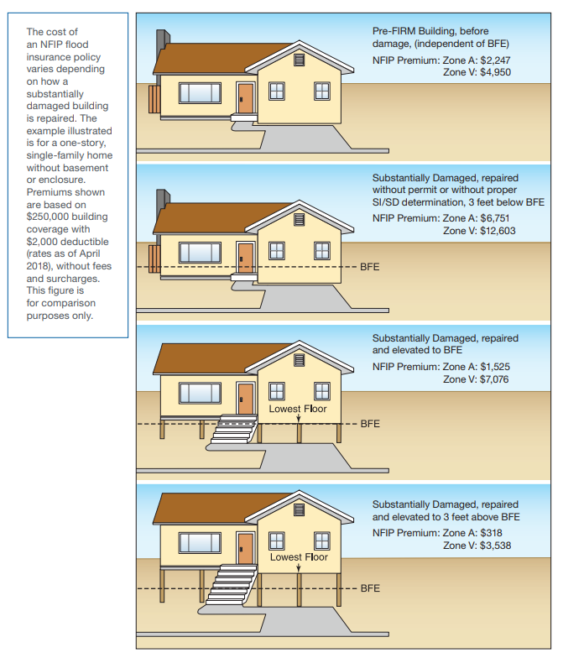
Figure 2. Reduce your Risk, Reduce your Premium. Build higher to reduce future flood damage and save money on flood insurance premiums. (Answers to Questions About Substantially Improved/Substantially Damaged Buildings, FEMA 2018, page 8).

THE FPA AND THE FLOOD DAMAGE PREVENTION ORDINANCE
The community’s Flood Damage Prevention Ordinance codifies the “contract” between a community and FEMA as part of the NFIP. Participating communities adopt FEMA’s flood maps and list floodplain management regulations in their ordinance. As stated previously, the benefit for NFIP participating communities is that property owners can purchase federal flood insurance (a requirement for federally backed mortgages and loans) and communities are eligible for federal financial assistance following a major disaster event.
In late 2020, New Jersey, with FEMA oversight, adopted the New Jersey Model Code Coordinated Ordinance (MCC0). The MCCO marries the higher Flood Hazard Area Control Act Standards with the Uniform Construction Code’s ASCE 24-14 standards to more clearly define floodplain and permit application standards in the State. Because past Model Ordinance versions did not completely address all NFIP requirements, all 553 participating communities will be required to transition to this new ordinance starting in January 2021. Adoption of these ordinances must be coordinated with NJDEP and FEMA prior to adoption.
Failure to comply and properly enforce a community’s Flood Damage Prevention Ordinance can be met with probation, suspension, and/or removal from the NFIP by FEMA. FEMA will perform Community Assistance Visits (CAVs) to ensure regulations are being properly enforced. If violations are found, FEMA can penalize the community. Probation implements a $50 surcharge on every flood insurance policy. Suspension and/or removal freezes flood insurance policy purchases and renewals and makes a community’s property owners ineligible for federally back mortgages and loans. The FPA must properly and effectively enforce the ordinance to ensure a community’s “good standing” with the NFIP is maintained. “Good standing” is also necessary to qualify for mitigation grant funding and post-event disaster assistance.

THE FPA AND THE MAP PROCESS
FPAs must take an active role in FEMA’s mapping process. FEMA produces maps, called Flood Insurance Rate Maps (FIRMs), for communities to use in enforcing floodplain management regulations. FEMA performs outreach throughout the map development life cycle and offers ample opportunity for community officials and residents to provide feedback. The FPA must be involved at each step to ensure the maps reflect accurate flooding conditions in the community. The FPA must notify FEMA of inaccuracies with proposed maps and any physical changes in the community that may affect flood hazards – within 6 months of the physical change occurring.
FPAs should include the Municipal Engineer in the mapping process too. They will provide technical expertise for the FPA.
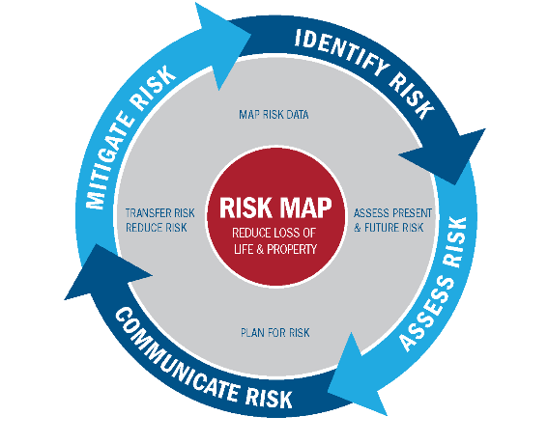
Figure 3. Risk Mapping, Assessment and Planning, or Risk MAP, is a FEMA program through which the Flood Insurance Rate Maps (FIRMs) are created and maintained. FPAs must be involved at all steps.

THE COMMUNITY RATING SYSTEM
The best FPAs have not only effectively implemented and enforced their floodplain ordinance but have successfully championed and implemented higher standards that have allowed their community to be accepted into FEMA’s Community Rating System (CRS) program. Only communities in “good standing” with the NFIP are allowed to join this optional program that provides insurance discounts for all policyholders in a community based upon a community’s adopted higher standards, mitigation activities, and resilience efforts. For more information visit https://crsresources.org/.

Figure 4. Adopting and enforcing higher standards such as freeboard or regulating the 0.2% floodplain will give a community credit towards flood insurance discounts under the Community Rating System.

ADMINISTERING THE FEDERAL FLOOD RISK MANAGEMENT STANDARD
Floodplain Administrators are responsible for permitting floodplain development and establishing the Local Design Flood Elevation (LDFE) as a prior approval to and concurrent with a local Construction Permit. This requires that Floodplain Administrators coordinate compliance with all Federal and State Laws and with a community’s local ordinance and when the Federal Flood Risk Management Standard (FFRMS) applies to new construction, substantially damaged, and substantially improved structures and “critical” and “non-critical” actions.
The FFRMS standard was established by the following Presidential Executive Orders and Policy:

- EO 11988, Floodplain Management (May 24, 1977), as amended by E.O. 12148 (July 20, 1979) and E.O. 13690 (January 30, 2015)
- EO13690 Establishing a Federal Flood Risk Management Standard and a Process for Further Soliciting and Considering Stakeholder Input (January 30, 2015), reinstated by E.O. 14030 (May 20, 2021)
- FEMA Policy #104-008-2 FEMA Policy: Guidance on the Use of Available Flood Hazard Information
- FEMA Policy 104-22-0003 FEMA Policy - Partial Implementation of the Federal Flood Risk Management Standard for Public Assistance Programs (Interim) dated June 3, 2022
- FEMA Policy 206-21-003-0001 FEMA Policy - Partial Implementation of the Federal Flood Risk Management Standard for Hazard Assistance Programs (Interim) dated December 7, 2022
- Memorandum of Understanding Establishing the Unified Federal Environmental and Historic Preservation Review Process for Disaster Recovery Projects (July 2014 – Signed by the Departments of Interior, Agriculture, Commerce, Urban Development, Transportation, Energy, Homeland Security, EPA, USACE, and the Advisory Councils on Environmental Quality and Historic Preservation)

In New Jersey’s State and Local regulatory environment, a careful review of the best available data (including State Studied waters), the definitions of critical actions, buildings, and facilities, the requirement to consider wave heights at the 500-year flood, and the required freeboards at the State and local level is required to ensure compliance with FFRMS, State law, and local ordinances. For example, if Federal funds were proposed for a home elevation permitted in a tidal community with a one foot freeboard requirement that used an effective Base Flood Elevation lower than the 2014, preliminary mapping, the home’s foundation would not be built high enough to receive Federal reimbursement. In addition, not understanding the State’s minimum Flood Hazard Area Design Flood Elevation requirements may result in the construction of a project which is non-compliant with State law.
Because there are many considerations necessary for implementing this standard, it is recommended that Floodplain Administrators review the Draft New Jersey Guidebook for Implementing the Federal Flood Risk Management Standard (FFRMS) dated December 15, 2022 to ensure that all projects built in their communities will be eligible to receive the full amount of Federal funds at project reimbursement. It is also recommended that the Floodplain Administrator document their decision-making using Worksheets 1, 2, and 3 provided in the FFRMS guidance document and included in this document as Appendix A, B, and C.

Chapter 2: NFIP Floodplain Management Requirements

NFIP Regulations
FPAs must know, regulate, and enforce the NFIP development rules and regulations as part of their duties. NFIP Regulations are captured in the Code of Federal Regulations, Title 44, Parts 59, 60, 65, & 70. The rules have been translated into a more user-friendly format in the following guide: FEMA 480: NFIP Floodplain Management Requirements: A Study Guide and Desk Reference for Local Officials (February 2005) (https://www.fema.gov/sites/default/files/documents/fema-480_floodplain-management-study-guide_local-officials.pdf).
NFIP regulations apply to any development activity in the Special Flood Hazard Area (SFHA), which are floodplains that have a 1-percent chance of occurring in any given year. SFHAs are mapped and labeled Zone A, AE, A1-A30, AH, AO, AR, A99, V, and VE on FEMA’s flood maps. The flood maps are called Flood Insurance Rate Maps (FIRM’s) because they are used to determine flood insurance rates or premiums.
FEMA designates flood zones on FIRM’s as follows:
A ZONES – Areas of ‘Special Flood Hazard in which the elevation of the surface water resulting from a flood that has a 1% annual chance of equaling or exceeding the Base Flood Elevation (BFE) in any given year shown on the FIRM zones A, AE, AH, A1–A30, AR, AR/A, AR/AE, AR/A1– A30, AR/AH, and AR/AO. When used in reference to the development of a structure in this ordinance, A Zones are not inclusive of Coastal A Zones because of the higher building code requirements for Coastal A Zones.
AH ZONES– Areas subject to inundation by 1-percent-annual-chance shallow flooding (usually areas of ponding) where average depths are between one and three feet. Base Flood Elevations (BFEs) derived from detailed hydraulic analyses are shown in this zone.
AO ZONES – Areas subject to inundation by 1-percent-annual-chance shallow flooding (usually sheet flow on sloping terrain) where average depths are between one and three feet.
LIMIT OF MODERATE WAVE ACTION (LiMWA) – Inland limit of the area affected by waves greater than 1.5 feet during the Base Flood. Base Flood conditions between the VE Zone and the LiMWA will be similar to, but less severe than those in the VE Zone. These areas are commonly called “Coastal A Zones”.
V ZONES – Areas of Special Flood Hazard in which the elevation of the surface water resulting from a flood that has a 1% annual chance of equaling or exceeding the Base Flood Elevation in any given year shown on the FIRM zones V1-V30 and VE and is referred to as the Coastal High Hazard Area. This area is affected by waves greater than 3 feet during the Base Flood.
SHADED X ZONES - Moderate risk areas within the 0.2-percent-annual-chance floodplain, areas of 1-percent-annual-chance flooding where average depths are less than 1 foot, areas of 1-percent-annual-chance flooding where the contributing drainage area is less than 1 square mile, and areas protected from the 1-percent-annual-chance flood by a levee. No BFEs or base flood depths are shown within these zones. (Zone X (shaded) is used on new and revised maps in place of Zone B.)
UNSHADED X Zones - Minimal risk areas outside the 1-percent and 0.2-percent-annual-chance floodplains. No BFEs or base flood depths are shown within these zones. (Zone X (unshaded) is used on new and revised maps in place of Zone C.)
FPAs are strongly encouraged to read FEMA 480 as well as reference other FEMA publications listed in the NFIP Construction subsection, below.

Figure 5. The NFIP has 3 branches: mapping, regulations, and insurance. Regulations dictate how development must be permitted in mapped areas. Maps inform how much insurance premiums will cost.

NFIP Regulated Activities
FPAs must review and approve any development activity in the SFHA as well as consider the State’s higher standards discussed in “NJ State Floodplain and Riparian Zones” in Chapter 3 and any local ordinance higher standards. Regulated activities include any man-made change to improved or unimproved real estate in the SFHA or regulated floodplain. This includes but is not limited to building construction, modifications, repairs, or improvements; excavation, mining, drilling, adding fill, grading, paving, dredging, driving piles, temporary stream crossing, and storage of materials or equipment.

NFIP Construction
Important Note: This section discusses minimum National Flood Insurance Standards. New Jersey Land Use and Building Code regulations require higher design flood elevations. The section below provides prospective floodplain managers with an overview of the NFIP requirements, which is the standard that the Certified Floodplain Manager’s Exam uses. Regulating to the Base Flood Elevation shown on New Jersey FIRM maps is non-compliant with State law as well as the NFIP because of the Precedence Rule discussed in Chapter 3.
NFIP construction requirements use the Base Flood Elevation (BFE) shown on the FIRM or listed in the Flood Insurance Study (FIS) that FEMA produces. The BFE is the elevation of surface water resulting from a 1% annual chance flood event. Construction requirements state that residential structures must be elevated at or above the BFE. In Zone “A the lowest floor must be at or above the BFE. In Zone V, the bottom of the lowest horizontal structural member must be at or above the BFE.
Non-residential structures must be elevated at or above the BFE, or floodproofed to the BFE if elevating is not feasible. Residential structures may not be floodproofed. Specific details regarding building type, lowest floor requirements, and flood zones are listed in FEMA 480, Unit 5.

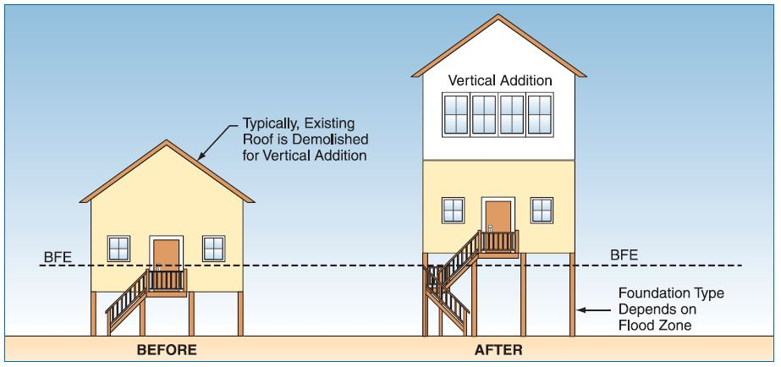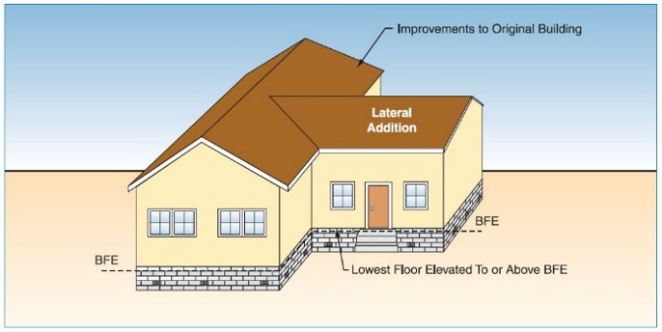
Figure 6. Residential structures must have their lowest floor at or above the BFE per NFIP regulations in Zones that are assigned as “A” (Left Picture). In zones that are assigned as “V” or “VE” residential structures must have the bottom of the lowest horizontal structural member at or above the BFE (Right Picture). (FEMA Substantial Improvement/Substantial Damage Desk Reference FEMA P-758).
Note: NJ requires that residential structures within the Limit of Moderate Wave Action (LiMWA) area in Zone AE on FEMA FIRMs be constructed as if they were located in V or VE zones. See link for FEMA LiMWA Fact Sheet: https://www.fema.gov/sites/default/files/documents/fema_using-limit-oderate-wave-action_fact-sheet_5-24-2021.pdf
Important Note: Under no circumstance shall new or substantially improved structures have basements, subgrade crawlspaces, and mechanical pits be allowed in a regulated floodplain – they are prohibited by the New Jersey Flood Hazard Area Control Act.
Flood resistant materials must be used at or below the BFE when constructing. Foundations, beams, joists, doors, windows, etc. are all included in this requirement. Flood-resistant materials are defined as any building product capable of withstanding direct and prolonged contact (at least 72 hours) with floodwaters without any more than cosmetic repairs. Flood resistant materials are highly encouraged above the BFE as well. Reference FEMA Technical Bulletin 2: Flood Damage Resistant Materials Requirements for more information.
The following FEMA Reference Publications (https://www.fema.gov/multimedia-library) provide guidance for specific construction types the FPA may need to regulate. They include, but are not limited to:
- FEMA P-55: Coastal Construction Manual for Residential Buildings
- FEMA P-85: Protecting Manufactured Homes from Floods and Other Hazards
- FEMA P-259: Engineering Principles and Practices for Retrofitting Flood-Prone Residential Structures
- FEMA P-312: Homeowner’s Guide to Retrofitting
- FEMA P-348: Protecting Building Utility Systems from Flood Damage
- FEMA P-499: Home Builder’s Guide to Coastal Construction
- FEMA P-550: Recommended Residential Construction for Coastal Areas
- FEMA P-762: Local Official’s Guide for Coastal Construction
- FEMA P-936: Floodproofing Non-Residential Buildings
- FEMA P-1037: Reducing Flood Risk to Residential Buildings that Cannot Be Elevated

The following FEMA Technical Bulletins (https://www.fema.gov/nfip-technical-bulletins)
provide guidance for specific construction techniques the FPA may need to regulate. They include, but are not limited to:
- 1 – Openings in Foundation Walls and Walls of Enclosures
- 2 – Flood Damage Resistant Materials Requirements
- 3 – Non-Residential Floodproofing – Requirements and Certification
- 4 – Elevator Installation
- 5 – Free-of-Obstruction Requirements
- 6 – Below-Grade Parking Requirements
- 7 – Wet Floodproofing Requirements
- 8 – Corrosion Protection of Metal Connectors in Coastal Areas
- 9 – Design and Construction Guidance for Breakaway Walls Below Elevated Coastal Buildings
- 10 – Ensuring that Structures Built on Fill in or Near SFHAs are Reasonably Safe from Flooding
- 11 – Crawlspace Construction for Buildings Located in SFHAs
- Policy #104-008-03 (Feb 2020) Agricultural Structures and Accessory Structures https://www.fema.gov/sites/default/files/2020-09/fema_agricultural-structures_policy-guidance_08-20-20.pdf

NFIP Construction Certifications, Plans, and Elevation Certificates
NFIP regulations require professional engineers, architects, or surveyors to certify certain design aspects for buildings constructed in the SFHA. These forms include Floodproofing Certifications, V Zone Certifications, and No-Rise Certifications. These forms should be completed based upon the design of the structure and submitted along with the floodplain development permit application.
Multi-use, multi-occupant residential and commercial structures, and underground parking garages should also have Emergency Management and Operation and Maintenance Plans for floodproofed areas. These too, should be submitted with the floodplain development permit application.
Important Note: Although submission of Elevation Certificates is not required by the NFIP, they are a submission requirement of the New Jersey Uniform Construction Code at foundation completion prior to vertical construction and prior to issuance of a Certificate of Occupancy. It is important to note that they are the only way to prove to FEMA’s Insurance Branch that a structure was built in compliance with floodplain regulations, so adherence to the UCC for new and substantially improved construction is advantageous to property owners.

NFIP Flood Damage Prevention Ordinance & Map Adoption Process
All communities currently participating in the NFIP have an in-effect Flood Damage Prevention Ordinance that was adopted when they joined the program. Ordinances must be updated each time FEMA issues updated community FIRM maps. The FPA is responsible for working with FEMA on map updates by verifying their accuracy and obtaining community concurrence. FPAs must also ensure their ordinance is updated appropriately prior to final issuance of updated maps. The ordinance update timeframe starts when FEMA sends a Letter of Final Determination (LFD) to the community. The LFD will always be sent 6 months prior to the updated maps’ effective date. The FPA must work with the community’s legislative body to update their ordinance within this 6-month timeframe. Additional regulations may be needed to address new flood zones and the updated maps must be referenced that will be used to regulate the community’s floodplains.
Ordinance regulations are determined by the type of FEMA floodplains identified in a community. Table 1, below, identifies the traditional methodology used by FEMA to designate an ordinance. By transitioning to the new Model Code Coordinated Ordinance, only two versions of the ordinance (Riverine and Coastal) were necessary to comply with both the NFIP and the State’s higher standards because both the Flood Hazard Area Control Act and the Uniform Construction Code are applicable to all projects regardless of floodplain characteristics. The nine possible ordinances discussed in Table 1, below, show the differences between NFIP ordinance types, which is helpful to understand when taking the Certified Floodplain Administrator exam.
Table 1. Ordinance model type shown with each type of flood hazard data it includes regulations for.
Ordinance  Model Type | Floodplain Area | LiMWA Identified | 1% Annual Chance Flooding Identified | BFEs  Identified | Floodways Identified | V Zones Identified
A | Riverine | No | No | No | No | No
B | Riverine | No | Yes | No | No | No
C | Riverine | No | Yes | Yes | No | No
D | Riverine | No | Yes | Yes | Yes | No
 | Coastal | Yes | Yes | Yes | Yes | No
E | Riverine | No | Yes | Yes | No | Yes
 | Coastal | Yes | Yes | Yes | No | Yes
D & E | Riverine | No | Yes | Yes | Yes | Yes
 | Coastal | Yes | Yes | Yes | Yes | Yes

When a community is adopting higher standards, bringing an ordinance into compliance with NFIP regulations, or adopting new FIRM’s and FIS’s pursuant to a Letter for Final Determination, both FEMA and the NJDEP must review the proposed ordinance prior to adoption.
Figure 7, below, is a timeline for the flood study, map adoption and ordinance update process required after a community is notified by a Letter of Final Determination that they must adopt a new FIRM panel and FIS study. If a community does not update their ordinance on time, the community will be suspended from the NFIP thereby freezing all flood insurance policy renewals and purchases.
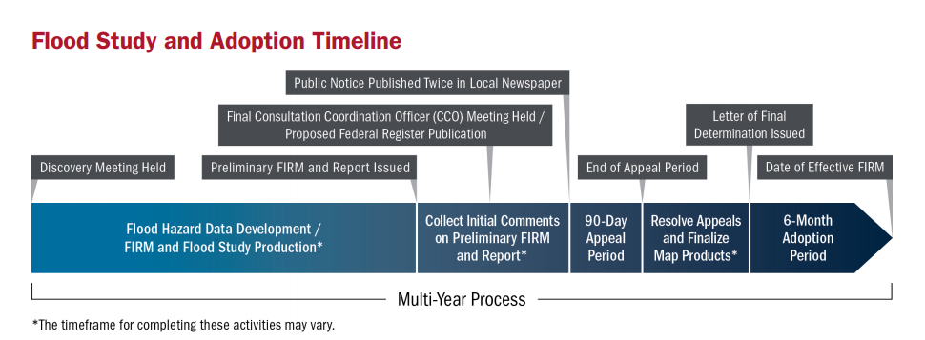
Figure 7. The full flood study and map adoption life cycle as described in FEMA-495: Adoption of Flood Insurance Rate Maps by Participating Communities, January 2019. https://www.fema.gov/sites/default/files/2020-07/fema_adoption-flood-insurance-rate-maps-participating-communities_bulletin.pdf.
Table 2 outlines the “6-Month Adoption Period” shown in Figure 7 above. This is the period during which the local Flood Damage Prevention Ordinance must be updated.
Table 2. The 6-month adoption period schedule until the FEMA FIRM(s) become effective.
The Months Before the FIRMs Become Effective
6 Months | 5 Months | 4 Months | 3 Months | 2 ½ Months | 1 Month | 0 Months
FEMA  6-month LFD Letter | NJDEP Assistance Letter | Draft Ordinance to NJDEP | FEMA 90-day Reminder Letter | Final Ordinance to NJDEP | FEMA 30-day Reminder Letter | FEMA FIRM is Effective
Note that ordinances can also be updated outside of the typical FEMA cycle if a community decides to enact higher regulations, or the ordinance is deemed non-compliant by FEMA.
More information on what should be included in a Flood Damage Prevention Ordinance can be found in FEMA 480, Unit 7.
See link for the New Jersey Model Code Coordinated Ordinances found on the NJDEP website: https://www.nj.gov/dep/floodcontrol/modelord.htm.

NFIP Floodplain Development Permit
The NFIP requires permits for all development and regulated activities in the SFHA. As such, each community must create and maintain a local Floodplain Development Permit that is separate from all other state and local permits. This permit should specifically review development in the floodplain and whether it meets the floodplain ordinance regulations or not. Note that this permit would also apply to additional regulated floodplain areas noted by state or local law.

The floodplain development permit should be the last permit submitted and reviewed for a development project. This is so the FPA can ensure all other applicable federal, state, and local permits have been obtained and approved. A common practice is to review the floodplain development permit concurrently with the construction permit.

Figure 8. The proper workflow for permitting development in the regulated floodplain.
If needed, communities may institute a modest fee to cover the costs of permit processing, review, inspections, and document storage, not unlike many other permit fees at the municipal level. The length of time a permit is valid for should be determined by the community and likely be commensurate with other local permits, such as the construction permit.
FEMA defines “start of construction” as the permit issuance date as long as actual construction begins within 180 days. If after 180 days, construction has not yet begun AND newer map data has been released, the permit should be re-reviewed with consideration of the newer map data.
See Appendix B: Model Floodplain Development Permit for a template permit.

Making Floodplain Development Permit Determinations
The FPA is responsible for making floodplain development permit determinations using the information submitted with the permit application to determine what type of regulated activity is proposed, any impacts to the floodplain, the Local Design Flood Elevation, and how the proposed activity will be constructed. The FPA may include other local subject matter experts, such as the building code official and engineer and/or delegate tasks, as needed. However, the FPA is responsible for approving, denying, or requesting more information. As required, the FPA must keep a record of the permit decision, inspect the project during construction, and take any enforcement actions necessary to ensure compliance with the NFIP.

Floodplain Development Permit Pitfalls
The permitting process can be complicated. FPAs should be aware of, plan for, and avoid common permitting pitfalls:
- Pitfalls to Avoid: The FPA gives an extension to the applicant for the start of construction without considering the current regulatory environment.
- Complications:
  - Other obtained permits may expire during an extension.
  - New flood maps may be issued by FEMA that change the flood zone and DFE that the construction was permitted for.
  - New construction standards may be issued that change how construction should occur.
  - Lack of awareness of higher State regulatory standards or floodplain areas regulated by State law.
- Pitfalls to Avoid: The FPA does not review activities governed by State Permit-by-Rules.
- Complications:
  - The project may be in violation of permit-by-rules.
  - The project meets the definition of a major development under the NJDEP Stormwater Management Rules (more than 1 acres of ground disturbance and 0.25 acres of net new impervious surface) and is not eligible for a permit-by-rule. Additionally, the new development could exacerbate flooding by increasing stormwater.
  - Development under a permit-by-rule may have occurred previously. Once the thresholds for permit-by-rule are exceeded cumulatively on a property regardless of ownership or subdivision, formal NJDEP review and approval is required.
- Pitfalls to Avoid: The FPA does not review unexpired, general permits issued by the State
- Complications: The unexpired, general permits may have been issued under old flood maps and floodplain regulations and if used as is, the project may violate current regulations.
- Pitfalls to Avoid: The FPA does not review the State FHDFE in relation to the Local freeboard requirements.
- Complications: Local freeboard and therefore the LDFE may be higher than the State FHDFE and therefore, may result in a local violation.
- Pitfalls to Avoid: The FPA does not review activities in the State regulated riparian zone.
- Complications: Removal of vegetation within the riparian zone is regulated by the NJDEP. Some vegetation removal is allowed. Limits are set within each permit. Exceeding threshold may require an individual permit from the NJDEP and mitigation.
More information on NJ State Permit-by-Rules, General Permits, and the riparian zone can be found in Chapter 3.

Inspections
The FPA should perform inspections of each approved development project according to the following guidance in Table 3, below.
Table 3. Suggested inspection guidance for approved development projects.
Start of Construction | The day a permit is issued  (provided construction begins within 180 days)
1st Inspection | Following groundbreaking
2nd Inspection | Just before lowest floor is poured or laid
Elevation Check | Just after lowest floor is poured or laid
3rd Inspection | Project is or nearly completed
Certificate of Occupancy | If all inspections and a final Elevation Certificate meets the plans and the project passes final inspection, issue the CO
Later Inspections | Conduct periodic inspections to ensure the building remains in compliance especially if there are subgrade enclosures

Enforcement and Violations
The FPA is responsible for ensuring regulations from the federal, state, and local level are followed that collectively address floodplain development. Typically, voluntary compliance comes easiest when stakeholders are educated on the reasons why regulations exist. FPAs should institute an outreach plan explaining where and what the flood hazards are in their community, the dangers and risks of flooding for property and people, and the benefits of constructing properly in flood prone areas – reduced flood risk at present and in the future, as well as lower flood insurance rates and better resale value.
The FPA and community should prevent non-compliance and violations, rather than addressing them after they occur. If compliance is not achieved willingly, the tools and references in the New Jersey Code Coordinated Ordinance, N.J.S.A. 40:49-5, Penalties for Violations of Municipal Ordinances and N.J.S.A. 5:23-4, the Uniform Construction Code (UCC), can be used to enforce land development and building codes related to flood damage prevention. While the Flood Damage Prevention Ordinance may be enforced using N.J.S.A. 40:49-5, the use of the UCC to enforce building-related violations will require coordination with the community’s Construction Official. The New Jersey Model Code Coordinated Ordinance defines the respective enforcement responsibilities between these two and references these Statutory Authorities in the ordinance.
Actions that the community can take to gain compliance include:
  - Issuing violation notices/letters
  - Issuing stop-work orders
  - Withholding Certificates of Occupancy
  - Suspension or revocation of a floodplain development permit for incomplete or inaccurate information
  - Issuing fines of $1250 or up to $2000 if specified in the Flood Damage Prevention Ordinance
  - Seeking a remedy from the court system which can include imprisonment of up to 90 days or a period of community service of up to 90 days or increased penalties for repeat offenders.
  - Pursuing penalties of $2000 and up to $10,000 for solid waste disposal in floodways and floodplains.
  - Pursuing enforcement through State floodplain management or other applicable development rules cited in the Flood Damage Prevention Ordinance.
  - Pursuing, if all efforts for achieving compliance are exhausted, denial of insurance from FEMA under Section 1316 of the National Flood Insurance Act of 1968.
Because N.J.S.A. 40:49-5 allows for a 30-day period for the homeowner to achieve compliance, it is important the Floodplain Administrator track the start and end of grace periods and all court dates and violation outcomes.
When higher property values create pressure for maximizing livable space, FPAs must ensure that enclosures below an elevated floor are not converted to apartments or space used for anything other than parking, access, or storage. Additionally, since the State Flood Hazard Area Control Act requires that enclosures greater than 6 feet in height have deed restrictions on uses other than parking, storage, and access, these deed restrictions should be in place before a flood damage prevention permit is issued for these types of enclosures. (Note: The minimum ceiling height for habitable space is 7 feet under the UCC.) If included in the Flood Damage Prevention Ordinance, the FPA may also make property owners sign and agree to Non-Conversion Agreements with a right of inspection so that the FPA or other local officials can periodically inspect the property year after year to ensure compliance.
See Appendix F: Example Certificates and Forms for a Non-Conversion Agreement template to use.
When violations or non-compliance do exist, in addition to the local tools noted above, FPAs should notify FEMA and the State – NJDEP Coastal and Land Use Enforcement (NJDEP CLUE) (https://www.nj.gov/dep/enforcement/clue.html). The NJDEP has jurisdiction over all regulated activities within flood hazard areas and riparian zones. NJDEP CLUE may exercise enforcement powers for violations, such as unauthorized regulated activities or noncompliance with NJDEP Flood Hazard Area Control Act (FHACA) permits that occur within flood hazard areas. In enforcing the local ordinance, the FPA should seek compliance with all aspects of local construction approvals that overlap with their NFIP responsibilities.

Floodplain Administrator Coordination with NJDEP Bureau of Coastal and Land Use Enforcement
Floodplain Administrators have significant expertise that is essential in the enforcement of floodplain development standards. The DEP’s Coastal and Land Use Compliance and Enforcement (CLUE) program frequently relies on that local expertise to assist in the investigator of suspected non-compliance.
CLUE case managers are assigned regionally to respond to complaints. CLUE is broken down into three regional offices located in Trenton, Toms River, and Chester. In general, the Trenton office covers the central Turnpike Corridor of the state, the Toms River office covers the coastal areas, and the Chester office covers the Highlands region. For each office’s contact information, visit https://www.nj.gov/dep/enforcement/clue.html.
Should a compliance issue arise that you need to communicate to CLUE, the first step is to log an incident with the DEP Communications Center by calling 1-877-927-6337. All incidents must be logged with the DEP Communications Center in order to be investigated by DEP Enforcement Staff. The incident will then be assigned to a CLUE case manager to begin an investigation.
Floodplain Administrators should share with the case manager any relevant information including any of the following:
  - Property owner’s name and contact information
  - Copies of any municipal construction permit applications or issued permits
  - Copies of any site plans
  - Copies of any DEP documents the municipality was provided with as part of an application for a local permit
  - Any photographs documenting the suspected non-compliance
All of this information becomes crucial for CLUE staff to conduct an investigation. Every CLUE investigation starts with an off-site desktop analysis, using all available documentation and available GIS data to review the site and determine the likelihood of there being regulated areas on site. CLUE contacts the property owner to obtain consent to conduct an inspection.
All CLUE inspections of residential properties must be done with the property owner’s consent or with the authorization of an administrative search warrant. Once the CLUE case manager is able to obtain the property owner’s permission to conduct an inspection, they may wish to schedule a site meeting with the Floodplain Administrator and the property owner to conduct the inspection and discuss any readily apparent issues. While having all interested parties involved during a site inspection is useful, the CLUE case manager cannot use their inspection authority to bring Floodplain Administrators onto the property. They may ask the property owner to consent to a Floodplain Administrator being present, but absent that you must follow the limits of your own authority to conduct inspections.
Following the site inspection, the case manager may need to review additional information or conduct additional analysis to determine whether a violation of the Flood Hazard Area Control Act or other land use statutes exists. A determination as to whether a violation of the State’s land use statutes exists shall be made solely by CLUE. It could also be possible that there may be a violation of your local Flood Damage Prevention Ordinance that is not a violation of the Flood Hazard Area Control Act.

Variances
Requests for variances to floodplain development permit decisions may occur in the community. When a community adopts the New Jersey Model Code Coordinated Ordinance, a municipal body is established to hear variance requests. Generally, these bodies are either Zoning or Planning Boards. This body must base its determinations on the technical justifications submitted by permit applicants and the comments and recommendations of the Floodplain Administrator and, as applicable, the Construction Official. This body has the right to condition variances as it deems necessary to further the purposes and objectives of the community’s Floodplain Damage Prevention Ordinance. The following considerations and conditions shall be considered by this body.
Considerations in Reviewing a Variance.
In reviewing requests for variances, all technical evaluations, all relevant factors, all other portions of these regulations, and the following shall be considered:
- The danger that materials and debris may be swept onto other lands resulting in further injury or damage.
- The danger to life and property due to flooding or erosion damage.
- The susceptibility of the proposed development, including contents, to flood damage and the effect of such damage on current and future owners.
- The importance of the services provided by the proposed development to the community.
- The availability of alternate locations for the proposed development that are not subject to flooding or erosion and the necessity of a waterfront location, where applicable.
- The compatibility of the proposed development with existing and anticipated development.
- The relationship of the proposed development to the comprehensive plan and floodplain management program for that area.
- The safety of access to the property in times of flood for ordinary and emergency vehicles.
- The expected heights, velocity, duration, rate of rise and debris and sediment transport of the floodwater and the effects of wave action, where applicable, expected at the site.
- The costs of providing governmental services during and after flood conditions including maintenance and repair of public utilities and facilities such as sewer, gas, electrical and water systems, streets, and bridges.
Conditions for issuance of a Variance
Variances shall only be issued upon:
- Submission by the applicant of a showing of good and sufficient cause that the unique characteristics of the size, configuration, or topography of the site limit compliance with any provision of these regulations or renders the elevation standards of the building code inappropriate.
- A determination that failure to grant the variance would result in exceptional hardship due to the physical characteristics of the land that render the lot undevelopable.
- A determination that the granting of a variance will not result in increased flood heights, additional threats to public safety, extraordinary public expense, nor create nuisances, cause fraud on or victimization of the public or conflict with existing local laws or ordinances.
- A determination that the variance is the minimum necessary, considering the flood hazard, to afford relief.
- Notification to the applicant in writing over the signature of the Floodplain Administrator that the issuance of a variance to construct a structure below the base flood level will result in increased premium rates for flood insurance up to amounts as high as $25 for $100 of insurance coverage, and that such construction below the base flood level increases risks to life and property.
Do not wait until an appeal is filed to educate the appeal body members on the variance process. Talk with those designated to serve on the appeal board about the National Flood Insurance Program requirements and FEMA’s expectations for community participation in the program. Reach out to neighboring floodplain administrators to discuss their process and experiences. Develop and document the details, including forms for appellants to fill out and a timeline for hearings and resolution.
Certain variances are available for wet floodproofing agricultural structures provided that that ability exists within the municipality’s ordinance. All ordinances adopting the Model Code Coordinated Ordinance after January 2021 allow municipalities to consider the variances described in FEMA’s Floodplain Management for Agricultural Structures and Accessory Structures, Floodplain Management Bulletin P-2140, July, 2020.

Historic & Cultural Resources
Historical structures may receive a local floodplain variance under NFIP regulations in certain circumstances. “Historic structures,” as defined in Floodplain Management Bulletin Variances and FEMA P-993 (https://www.fema.gov/sites/default/files/2020-08/FEMA_P-993_FPM-Bulletin_Variance.pdf), are those listed in the Department of the Interior (DOI) National Register of Historic Places, a DOI-certified State Inventory of Historic Places, or a certified local inventory, and structures listed as a contributing building in a listed historic district. Issuing a variance means that if they are conducting substantial improvements or suffer substantial damages from a flood, the resource may remain at its current elevation, at the discretion of the FPA. However, the FPA should highly encourage floodproofing, elevating utilities, filling in basements, and other mitigation measures. The variance from floodplain regulations may only be granted to designated historic structures if they will continue to maintain their historic status after repairs or improvements are completed, and the variance is the minimum necessary to preserve the historic character and design of the structure. The FPA should also warn historic property owners that variances do not apply to flood insurance rates. Insurance premium rates are required by statute to be based on actuarial risk and will not be modified by the granting of a variance.
FPAs looking for more information on Historic and Cultural Resources in floodplains, including sensitively elevating historic structures using the guidance referenced below, should contact the NJDEP Historic Preservation Office (https://www.state.nj.us/dep/hpo/1identify/nrsr_lists.htm).
Other references for mitigating flood risk without elevating the structure include the following:
- Protecting Building Utility Systems from Flood Damage (FEMA P-348)
https://www.fema.gov/sites/default/files/2020-07/fema_p-348_protecting_building_utility_systems_from_flood_damage_2017.pdf
- Reducing Flood Risk to Residential Buildings That Cannot Be Elevated (FEMA P-1037) https://www.fema.gov/sites/default/files/2020-07/fema_P1037_reducing_flood_risk_residential_buildings_cannot_be_elevated_2015.pdf
- Integrating Historic Property and Cultural Resource Considerations into Hazard Mitigation Planning (FEMA 386-6)
https://www.fema.gov/pdf/fima/386-6_Book.pdf
New Jersey Historic Preservation Office (NJHPO) Guidance for Elevating Historic Structures
- NJHPO Flood Mitigation Guide for Historic Properties
https://www.nj.gov/dep/hpo/images/_MULT_DG_32_v1_ID14076r.pdf
- NJHPO Elevation Design Guidelines for Historic Properties
https://www.nj.gov/dep/hpo/images/_MULT_DG_32_v2_ID14078r.pdf

Elevation Certificates
Elevation Certificates are a critical component in administering the NFIP. They capture elevations of buildings and surrounding grades, pictures, and details about a specific property. They also support flood insurance ratings for new and substantially improved or damaged buildings as well as LOMC requests. FPAs should require developers and homeowners to provide an Elevation Certificate for new or substantially improved properties in the floodplain prior to receiving a final Certificate of Occupancy. This will make reviewing permits and inspecting development easier and provide proof to FEMA that structures were built in compliance with the NFIP.
For more information on elevation certificates visit https://www.fema.gov/sites/default/files/2020-07/fema_nfip_elevation-certificate-form_feb-2020.pdf.
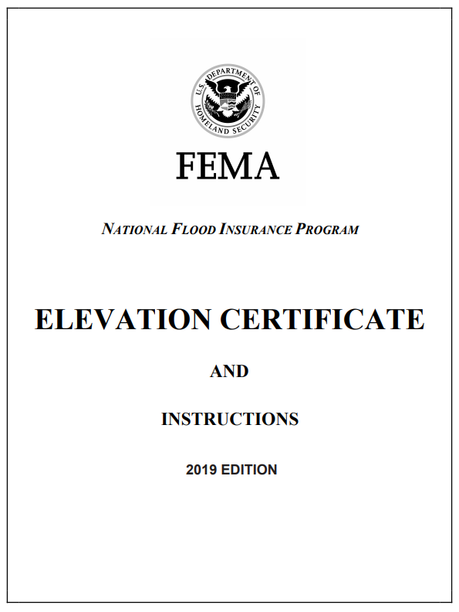
Elevation Certificates, once completed, do not expire for a structure unless the structure’s lowest floor or foundation are altered due to substantial improvement, damage, and/or if enclosures are illegally converted. New FEMA FIRMs and FISs may be issued over time that change the flood zone and BFE a structure is in - the elevation certificate does not need to be updated for this change. However, the FPA should be aware of this and know where to find the latest flood hazard information to inform any requirements triggered by substantial damage or improvement.
Do not assume Elevation Certificates are completed correctly. FPAs must review elevation certificates for accuracy. Common errors that can cost property owners money include:
- Wrong Building Diagram Number
- Wrong Flood Map
- Wrong flood zone and BFE
- Bad photos that do not show vents
- Showing a BFE for X Zones where there are no BFE’s
- Datum Conversion Errors
- Failure to indicated Datum-indicated Building Elevations.
- Incorrect flood vent calculations
If errors are found, Elevation Certificates should be returned to the property owner or surveyor for correction. Besides being good practice to have correct legal documents to ensure that property owners receive fair insurance rates, FEMA requires 90% of the elevation certificates in communities to be correct to enter and maintain participation in the Community Rating System.

Letters of Map Change
FEMA has processes in place to review and approve small to large changes to its FIRMs, understanding that better data or physical changes over time can impact flood hazard areas and flood insurance for property owners. Collectively, these processes result in Letters of Map Change (LOMC), which are amendments or revisions to effective FIRMs. Explaining each LOMC and the processes are beyond the scope of this guide, however, there are certain LOMCs that FPAs must be involved with for processing to move forward by FEMA. Letters of Map Change due to Fill (LOMR-F) and Letter of Map Revision (LOMR) are described below, while Conditional Letters of Map Revision (CLOMR) including those where fill is proposed (CLOMR-F), are described in the next section.
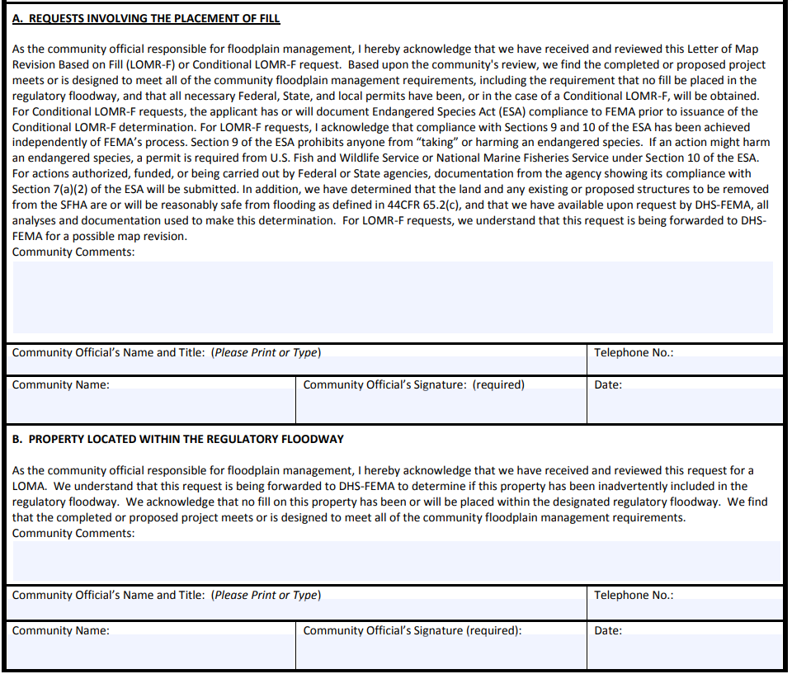
- LOMR-F: Any fill placed in the community’s floodplains must be reviewed through the floodplain development permit process. Resulting buildings constructed on fill may submit a LOMR-F to FEMA seeking removal from the SFHA. FEMA requires that the community FPA sign a Community Acknowledgement Form ensuring that fill was placed properly, was placed in compliance with the Endangered Species Act, and that existing and proposed structures will be reasonably safe from flooding, among other requirements. If the community FPA does not concur with the statements on the Community Acknowledgement Form, do not sign it! FEMA will not process a LOMR-F without a signed Community Acknowledgement Form.
- LOMR: Letters of Map Revision will revise portions of an effective FIRM, or FIS report and will be considered in setting insurance rates for property owners and will be considered by FEMA during Flood Insurance Studies. Due to the implications of these determinations such as maps that do not reflect watercourse changes, inaccurate ground surface elevation data, etc. on future floodplain management, FEMA requires that the FPA be aware of any LOMR requests and sign a Concurrence Form, acknowledging and understanding the changes, with each submittal.
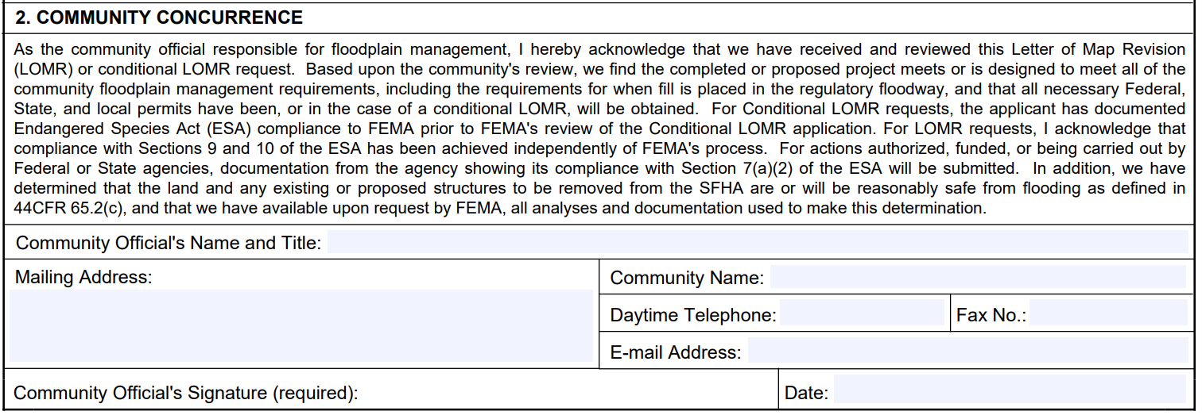

Conditional Letters of Map Revision including Proposals for the Placement of Fill Prior to Development
A Conditional Letter of Map Revision (CLOMR) is a letter from FEMA commenting on whether a proposed project would justify a revision to flood hazard areas, floodways, and BFEs, if constructed as proposed in the submittal. CLOMR letters are not regulatory, nor are they a building permit. They are simply a comment letter and are an important tool the FPA can use, to ensure proposed projects will not cause adverse impacts before they are built.
Factors that would encourage (but not require) a CLOMR submittal include:
- Proposed developments that will change flood hazards
- Proposed developments greater than 50 lots or 5 acres (or smaller thresholds if included in the Flood Damage Prevention Ordinance)
- Alteration or relocation of a stream (includes culverts and bridges)
- Proposed development that involves the placement of fill material to elevate the ground surface which would result in FEMA approving the issuance of a CLOMR-F.
Factors that would require a CLOMR submittal, per NFIP regulations, include the following:
- Development occurring in Zone AE (and Zones A1-A30) without a designated floodway, with proposed BFE increases of more than 1.0 foot
- Floodway encroachment that will increase the BFE (FEMA does not allow any BFE increase due to floodway development without a CLOMR review)
(Note: NJ does not allow building development in floodways, only transportation and water control structures.)

CLOMR submittals must provide documentation that the proposed project will comply with the Endangered Species Act (ESA). FEMA has created a fact sheet on CLOMR and the ESAs that FPAs should be familiar with: https://www.fema.gov/sites/default/files/2020-07/fema_risk-map_endangered-species-act_fact-sheet.pdf
If an FPA receives plans for a project that they or the engineering staff are not comfortable reviewing, request that the developer submit a CLOMR to FEMA prior to any permitting decisions.
For more information on CLOMRs visit https://www.fema.gov/conditional-letter-map-revision.
Following development, a Letter of Map Revision or Letter of Map Revision-Fill must be applied for to document as-built conditions and ensure that future mapping considers the changes that were made during property development.

Endangered Species Act
The Endangered Species Act (ESA) is an important piece of federal legislation that FPAs must understand. This 1973 act protects threatened and endangered species by preserving the habitats and ecosystems where they live. No federal, state, or private citizen may “take” or “harm” these species through projects that may adversely impact their habitats. The United States Fish and Wildlife Service (USFWS) and National Marine Fisheries Service (NMFS) share responsibility for implementing the ESA. While USFWS generally manages land and freshwater species, NMFS manages marine and anadromous (freshwater spawning-saltwater) species. The USFWS Information for Planning and Consultation (IPaC) tool identifies potential rare species at a site (https://ecos.fws.gov/ipac/). NMFS provides interactive ESA maps for the Greater Atlantic Region (https://www.fisheries.noaa.gov/new-england-mid-atlantic/consultations/section-7-species-critical-habitat-information-maps-greater). Please refer to Appendix I: Identifying Threatened and Endangered Species for guidance.
FEMA and the NFIP require that projects involving fill and projects that alter the physical landscape and thus alter flood hazards, comply with the requirements set forth in the ESA. FPAs should be aware that ESA compliance is required for LOMR-F, LOMR, and CLOMR submittals. Documentation does not need to be provided with LOMR-F or LOMR submittals but needs to be available should FEMA request it. Documentation is required as part of CLOMR submittals.
For more information on LOMR and ESA compliance visit https://www.fema.gov/flood-maps/change-your-flood-zone/esa

Substantial Improvement/Substantial Damage
Substantial Damage and Substantial Improvement (SD/SI) are processes of the NFIP that require structures comply with current floodplain regulations if improvements or damage repairs to the structure equal or exceed fifty percent (50%) of the market value of the structure (the value of the land is not included in the calculation). Fifty percent (50%) is the minimum NFIP standard, but local communities may implement a lower threshold such as 40% (which would constitute a higher standard) through their Flood Damage Prevention Ordinance. Communities can also regulate cumulative substantial improvement over a period of years (i.e., 50% of market value as of a certain date or over the past 10 years) or can regulate repetitive losses (i.e., 2 losses of greater than 25% of market value over a 10-year period).
To assist communities in meeting the NFIP requirements for substantial damages and improvements, a New Jersey Substantial Damage Management Plan Template was designed. The template can be used for CRS and Non-CRS Communities to assist in the process. See link for the New Jersey Substantial Damage Management Plan Template: https://www.nj.gov/dep/floodcontrol/docs/njsdmp-tempate.docx.
The NFIP also allows communities to use Repetitive Loss determinations to trigger Substantial Damage, however this specific provision must be adopted by the community in their Flood Damage Prevention Ordinance.
FPAs must know the SD/SI rules and have a process to issue and enforce determinations. Ignoring SD/SI responsibilities is a violation of the NFIP and a safety risk to the most vulnerable properties and residents. Unmitigated properties damaged during a flood event can also damage other neighboring mitigated properties or public infrastructure through impacts from debris strikes.
FPAs are expected to monitor construction progress for all SD/SI determined structures. Structures not brought into compliance will be assessed higher insurance rates. If an owner refuses to bring the structure into compliance within a reasonable period of time, the FPA is expected to cite it as a violation, take enforcement action, and notify FEMA if local and State court processes do not result in mitigation. FEMA can then deny flood insurance coverage for the structure and any others on the property in accordance with Section 1316 of the National Flood Insurance Act of 1968. Owners who refuse to resolve violations should be informed of the consequences of flood insurance denial: the property may be difficult to sell; the owner may have problems with mortgage lenders if flood insurance cannot be maintained; and future Federal disaster assistance may be denied.
SD/SI processes can be challenging to implement. Improvements to structures may not always require permits from the community, and officials may have a difficult time determining damage costs in the aftermath of an event due to sheer volume of damages and/or lack of resources. Given that, the following are some best practices to implementing an effective SD/SI process:
- Find a neighboring FPA or local official who has a process in place and experience implementing an SD/SI process. Ask to learn about their process.
- Establish a SD/SI process prior to a disaster. Conduct a community-wide appraisal of structures, including multiple photographs of all sides of the property. Understanding what the property looked like before a disaster is key.
- Include cumulative improvements and damages in the local Flood Damage Prevention Ordinance, over a period of at least 10 years. Setup a system/database to track the cumulative numbers. Educate homeowners in the floodplain about these requirements when they are submitting permits.
- Adopt and implement a Substantial Damage Plan using the most recent template provided on the Bureau of Flood Engineering website. This plan template is also included as Appendix F: Example Certificates and Forms.
For how to implement SD/SI and best practices, FPAs should reference FEMA 480, Unit 8, or FEMA’s SD/SI Desk Reference Guide (FEMA P-758) (https://www.fema.gov/sites/default/files/2020-08/fema_p_758_complete_r3_0.pdf).
For more suggestions on how to implement a Post-Disaster Recovery and Substantial Damage Process, see Chapter 6.
Note that SD/SI determination information is included in Appendix B: Model Floodplain Development Permit. Appendix F: Example Certificates and Forms also includes sample determination worksheets as well as Substantial Improvement and Substantial Damage Letter templates for communities.

Chapter 3: Incorporating Local and State Floodplain Management Regulations

The Precedence Rule and Regulating to Higher Standards
FPAs must regulate to higher standards that are adopted by State and local communities per NFIP regulations. The legal directive for this comes from the “Precedence Rule” set forth in the NFIP Regulations. Listed in Chapter 44 of the Code of Federal Regulations (44 CFR) Part 60, Section 1, part (d), the “Precedence Rule” states:
“The criteria set forth in this subpart are minimum standards for the adoption of floodplain management regulations by flood-prone, mudslide (i.e., mudflow)-prone and flood-related erosion-prone communities. Any community may exceed the minimum criteria under this part by adopting more comprehensive floodplain management regulations utilizing the standards such as contained in subpart C of this part. In some instances, community officials may have access to information or knowledge of conditions that require, particularly for human safety, higher standards than the minimum criteria set forth in subpart A of this part. Therefore, any floodplain management regulations adopted by a State or a community which are more restrictive than the criteria set forth in this part are encouraged and shall take precedence.” (44 CFR 60.1(d); FEMA 480, pg. 6-4)
The new Model Code Coordinated Ordinance required to be adopted by all 553 participating New Jersey communities after January 2021 was developed to ensure the alignment necessary to comply with the “Precedence Rule”. This new ordinance integrates the higher State standards with the NFIP and establishes roles at the local level to ensure coordination and cohesive enforcement. The following sections describe aspects of the Flood Hazard Area Control Act (https://www.nj.gov/dep/rules/rules/njac7_13.pdf) and that the municipality must incorporate into their ordinances and the FPA must incorporate into their decision-making and processes.
Reasons for participating communities to comply with the “Precedence Rule” and the State’s higher floodplain standards include:
- Maintain “good-standing” with the NFIP
- Community compliance with NJ state law.
- Reduction in flood insurance premiums in communities.
- Credits earned in the Community Rating System program.
- Reduction in flood risk in communities.

State Regulations –Flood Hazard Area Control Act Overview
NJ has more restrictive definitions than the NFIP for floodways, floodplains, and the design flood elevation (DFE). FPAs in New Jersey must be aware of and familiarize themselves with these rules to properly regulate them.
A broad overview of FHACA Rules is as follows:
- NJ does not allow new building construction in floodways, regardless of whether the construction might meet NFIP no-rise requirements. Water control structures are allowed, however. (For a complete list of allowable floodway activities see N.J.A.C. 7:13-11.3.) Riverine floodways are more restrictive and therefore wider than the NFIP standard. When FEMA maps new floodways for any NJ community, they use New Jersey standards on FIRMS.
- Regulated riverine floodplain elevations are higher than the NFIP standard. By rule, 25% more flood flow than FEMA’s 1% flood flow must be regulated. For example, a FEMA flow of 10,000 cubic feet per second (cfs) would be 12,500 cfs under New Jersey rules. New Jersey flood elevations would then be calculated from the resulting increase in flow. New Jersey has mapped many streams using this method from the late 1960’s through the mid 2000’s on “State Study Maps”. Appendix 2 of the FHACA Rules identifies these state-studied waters. Since 2009, however, all new studies are being mapped on FEMA’s FIRMs as the NJ Flood Hazard Area Design Flood (NJFHADF) line. Coverage is still limited though, so users looking for state studies should visit Flood Plan Locator for New Jersey – Overview (arcgis.com) to view these maps and Flood Profiles for New Jersey – Overview (arcgis.com) to view these flood profiles on line.
- Coastal / tidal floodplains and their flood elevations are equal to the NFIP standard and what is shown on FEMA’s FIRMs.
- Development and encroachments cannot increase the water surface elevations more than 0.2 feet.

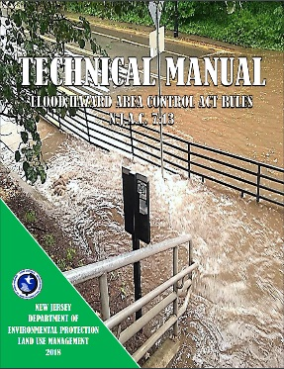
New Jersey State Regulations – Flood Hazard Area Control Act Regulated Areas Not Mapped by FEMA or DEP
Areas that are not mapped by FEMA or DEP may still have a NJFHADF Area per the following definition in the FHACA Rules:
“Any stream, ditch, pond, lake, river, or other surface water, that collects runoff from at least 50 acres of land has a flood hazard area.”
Methods to determine the flood hazard area in these instances are described in the FHACA Rules as well as in the technical manual (https://www.nj.gov/dep/landuse/download/fh_044.pdf).

Note: In areas where FEMA has mapped flood zones but has not provided Base Flood Elevations (Approximate A zones) or in watersheds 50 acres or greater where there are no mapped base flood elevations, applicants for State permits, including permits-by rules, can obtain a Flood Hazard Verification Letter with a Flood Hazard Design Flood Elevation from the DEP Division of Land Resource Protection. Local Floodplain Administrators should ensure that these verifications are not expired and should verify whether FEMA has released a more recent flood study that would be considered the best available flood hazard data.

NJ State Regulations –Flood Hazard Area Control Act Riparian Zones
The FHACA also establishes jurisdiction over riparian zones. A riparian zone is the land and vegetation within and adjacent to a regulated water. Riparian zones exist along both sides of every regulated water and include the regulated water itself. The extent of the riparian zone is determined by the attributes of the water. The portion of the riparian zone located outside of a regulated water is measured landward from the top of bank.
Note: Permit applicants with potential riparian zone construction can apply to the Division of Land Resource Protection for a Riparian Zone Verification Letter. Local Floodplain Administrators should ensure that verifications that accompany permit applications are not expired.
The width of the riparian zone is as follows:
- The width of the riparian zone along any regulated water designated as a Category One water, and all upstream tributaries situation within the same HUC-14 watershed, is 300 feet;
- Except for the regulated waters listed at (c)1 above, the width of the riparian zone along the following regulated waters is 150 feet:
- Any trout production waters and all upstream waters (including tributaries);
- Any trout maintenance water and all upstream waters (including tributaries) located within one mile of a trout maintenance water (measured along the length of the regulated water); and
- Any segment of a water flowing through an area that contains a threatened or endangered species, and/or present or documented habitat for those species, which is critically dependent on the water for survival, and all upstream waters (including tributaries) located within one mile of such habitat (measured along the length of the regulated water).
- For all other regulated waters not identified above, the width of the riparian zone is 50 feet.
Please refer to Appendix H: Determining the Riparian Zone Width to find information on where data is available to establish the width of the riparian zone. Appendix F: Identifying Threatened and Endangered Species can also help with this determination.
The clearing, cutting, and/or removal of vegetation in a riparian zone is a regulated activity under the FHACA Rules and requires authorization under the Rules. Each Permit-by-Rule, General Permit by Certification, General Permit, and Individual Permit sets allowable limits for vegetation removal in the riparian zone. FPA’s should be familiar with the requirements of these general permits, encourage property owners to abide by these requirements, and notify NJDEP Coastal and Land Use Enforcement of any violations.

NJ State Regulations –Flood Hazard Area Control Act – Methodology for Determining the Flood Hazard Design Flood Elevation
Understanding how Flood Hazard Design Flood Elevations are developed is important for Floodplain Administrators to ensure that Local Design Flood Elevations are compliant with State law. The Flood Hazard Area Control Act Rules specify six methods for calculating Flood Hazard Area Design Flood Elevations and considering the best available flood hazard data in State flood hazard permits.
Table 4, below, distinguishes between these methodologies. As required by the Flood Hazard Area Control Act Rules, the most restrictive elevation should be chosen when there is available mapping or calculated using Methods 5 or 6 where mapping is not available. If a State regulated activity has not received a Flood Hazard Design Flood Elevation Verification Letter, a local Floodplain Administrator may require that the applicant apply for one as part of the prior-approval process.
Table 4. Determining the NJ Flood Hazard Design Flood Elevation and Lowest Floor Requirements
Method Number | Rule Citation | Mapping Source | Appropriate Use  to determine the  Flood Hazard  Design Flood Elevation (FHDFE) | Determining Lowest Floor Requirements for a habitable building  (Freeboard and final lowest floor elevation must be no lower than required by Uniform Construction Code Rules) ²
1 | N.J.A.C. 7:13-3.3 & Appendix 2 | State (Department) Studied Watercourses determined based upon 125% of the 100-year flow rate | Mapped riverine areas specified in Appendix 2 of N.J.A.C. 7:13 | The greater of one foot or the freeboard dependent upon the Uniform Construction Code building class
2 | N.J.A.C. 7:13-3.4 | FEMA Mapping¹ in Tidal areas | A flood profile must exist with a 100-year elevation | The greater of one foot or the freeboard required dependent upon the Uniform Construction Code building class and if the structure is located in a Coastal A or V Zone
3 | N.J.A.C. 7:13-3.4 | FEMA Mapping¹ in Fluvial Areas | A flood profile must exist with a 100-year elevation. One foot of elevation is added to define the Flood Hazard Design Flood Elevation when using this method | The greater of one foot or the freeboard dependent upon the Uniform Construction Code building class
4 | N.J.A.C. 7:13-3.4 | FEMA Hydraulic Method (for determining a floodway when FEMA has not mapped one)¹ | A 100-year flow rate is provided for the regulated water AND hydraulic analysis such as a standard step backwater analysis comparing pre- and post-construction water elevations is performed using either 125% in a fluvial area or 100% in a tidal area of the 100-year flow rate | The greater of one foot or the freeboard dependent upon the Uniform Construction Code building class and if the structure is located in a Coastal A or V Zone.
5 | N.J.A.C. 7:13-3.5 and Appendix 1 | Area determined by Approximation | Calculation is dependent upon Watershed Management Area and Drainage Basin size according to the map and table provided in Appendix 1 of N.J.A.C. 7:13 | The greater of one foot or the freeboard dependent upon the Uniform Construction Code building class
6 | N.J.A.C. 7:13-3.6 | Area determined by Calculation | Base flood flow used in calculations is 125% of the 100-year flow rate the applicant calculates | The greater of one foot or the freeboard dependent upon the Uniform Construction Code building class
¹ FEMA flood mapping is defined in N.J.A.C. 7:13-1.2 and includes the information adopted as part of the most recent effective flood insurance study , dated on or after January 31, 1980, or any more recent advisory or proposed (preliminary) mapping, if the more recent advisory or proposed (preliminary) mapping results in higher elevations, wider floodway limits, or greater flow rates than depicted in the most recent effective FEMA flood insurance study or indicates a change from an A zone to a V zone or Coastal A zone.
² For the purposes of this column, one foot of freeboard is considered. If the permitted use is a Class III or Class IV use, additional freeboard will be added when the Flood Hazard Area Control Act permit is issued. Prior to issuance of a local Flood Damage Prevention permit, the Floodplain Administrator must review all Flood Hazard Area Control Act permits for changes in use (i.e., from a Class II apartment complex to a Class III assisted living facility). If this has occurred, the Floodplain Administrator must add additional freeboard to comply with the Uniform Construction Code. Class III and Class IV structures will require an additional freeboard of 1 foot and 2 feet, respectively, be added to any Flood Hazard Design Flood Elevation where the structure use has changed since permit issuance. This elevation must then be compared with the 500-year flood elevation to determine the most restrictive elevation.
Note: Local Design Flood Elevations shall be no lower than the Flood Hazard Design Flood Elevation

NJ State Regulations –Flood Hazard Area Control Act and coordination with the Uniform Construction Code to Set Lowest Floor Elevations (Freeboard)
The Flood Hazard Area Control Act coordinates with the Uniform Construction Code to set a uniform Statewide standard for freeboard as is noted by right-most column of Table 4 to determine the lowest floor elevation for any structure or electro-mechanical control. (Chapter 4 discusses the New Jersey Uniform Construction Code in more detail.) This Statewide standard for freeboard should not be confused with any additional factor of safety added by the six methodologies used to calculate the FHDFE which is described in the column marked “Appropriate Use to Determine the Flood Hazard Design Flood Elevation”.

For example, Method 3 adds one foot of freeboard to the FEMA BFE in fluvial (riverine) areas and also adds an additional one foot of freeboard to the FHDFE or any additional freeboard required by the Uniform Construction code. This means that the State standard for development in these areas would have a FHDFE equivalent to the FEMA FIRM BFE plus one foot but the State standard for the lowest floor of any structure would be the FHDFE plus one foot (the FEMA FIRM plus two feet) or higher if required by the UCC.
Because the UCC requires higher freeboard for ASCE 24-14 Building Classes III and IV (see Table 6), the freeboard for lowest floor requirements is higher for critical infrastructure and buildings. For example, a Class III stormwater pump station would require that two feet of freeboard be added to the FHDFE to determine the lowest floor and minimum elevation for electronic controls and generators. A Class IV hospital would require that a designer consider the highest lowest floor elevation of either the FHDFE plus three feet of freeboard or the 500-year flood elevation, whichever is more restrictive.

Table 5. The ASCE 24-14 Flood Resistant Design and Construction flood design class of buildings and structures. Highlights of ASCE 24-14 from FEMA can be found in the link: https://www.fema.gov/sites/default/files/2020-07/asce24-14_highlights_jan2015.pdf.
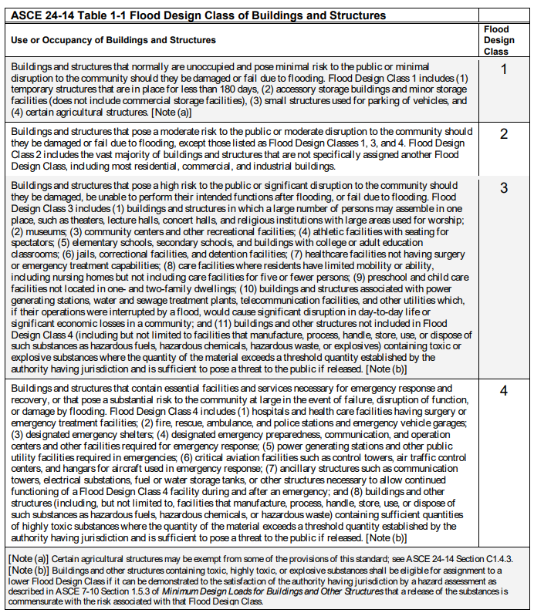

Municipal (Local) Regulations
Municipalities may or may not have municipal-specific higher regulations that exceed the freeboards required by both FHACA and the UCC. If they do, they will be listed in each communities’ Flood Damage Prevention Ordinance. Examples could include additional freeboard beyond what NJ requires or more restrictive building codes. FPAs must know what regulations their local ordinance contains and be able to decipher which of the state and local regulations is more restrictive to determine the Local Design Flood Elevation (LDFE). Because of the complexities of determining the best available flood hazard data to determine the FHDFE and the lowest floor elevations required by State law and local ordinances, it is recommended that the FPA utilize the Local Design Flood Elevation (LDFE) Worksheet in Appendix A. This worksheet walks the FPA and permit applicants through the process to determine the LDFE to ensure that all applicable regulatory requirements are considered. Examples are also found on the DEP website under Local Floodplain Management Resources on the following website: https://www.nj.gov/dep/floodcontrol/links.htm. The next section describes how the LDFE is determined.

Determining the Local Design Flood Elevation (LDFE) - What should the FPA regulate to?
The FPA must regulate to the most restrictive standards for their community. In NJ this means considering NFIP regulations, NJ State regulations, and local regulations and regulating to the highest of those. The widest flood hazard area and highest DFE, including freeboard requirements, must be regulated in communities.
The new Model Code Coordinated Ordinance refers to the Local Design Flood Elevation. This terminology is not present in the National Flood Insurance Program regulations, Flood Hazard Area Control Act, or the Uniform Construction Code. Some readers may ask why new terminology is necessary. The answer is that each of these regulations refers to slightly different terminology (see definitions in Table 6 below) for specifying the lowest floor (or lowest horizontal structural member) but it falls to the local Floodplain Administrator to navigate these regulations to ensure that all minimum regulatory requirements are observed when constructing buildings and structures and observing requirements for residential and critical buildings. The NFIP regulations are considered “minimum requirements”, however, in 44 CFR 60.1(d), it states that “any flood plain management regulations adopted by a State or a community which are more restrictive than the criteria … shall take precedence.” This means that in New Jersey, the use of best available data to determine the FHDFE and the addition of one foot of freeboard to determine design flood elevation for the lowest floor is a minimum requirement that often exceeds the NFIP minimum Base Flood Elevations for structures.
Table 6. Distinguishing Between Flood Elevation Terminology in New Jersey
Regulation/  Terminology | How is it Determined? | Freeboard
National Flood Insurance Program (NFIP)  Base Flood Elevation  (BFE) | BFE’s are specified in FEMA mapping products. Often “BFE” is preceded by “preliminary”, “advisory”, or “effective” to denote which BFE is referred to when there is more than one map issued for an area and the elevations are not equivalent.  Note: When preliminary maps are issued by FEMA, the Floodplain Administrator must choose the more restrictive Base Flood Elevation and more restrictive flood zone when comparing effective and preliminary mapping. This avoids increased insurance premium costs and possible flood damage for property owners when preliminary mapping becomes the effective map. | No freeboard is required under the NFIP regulations.  However, in riverine areas, regulating to the BFE without adding freeboard to designate a structure’s lowest floor (or lowest horizontal structural member in a V or Coastal A zone) results in a lower elevation than is required by the State’s Flood Hazard Area Control Act and the State’s Uniform Construction Code Design Flood Elevation (DFE).  In tidal areas, the BFE is equivalent to the Flood Hazard Area Control Act Design Flood Elevation (FHDFE) but regulating to this elevation would not meet the State’s Flood Hazard Area Control Act or the State Uniform Construction Code freeboard requirements for structures.
NJDEP Flood Hazard Area Control Act  Flood Hazard Design Flood Elevation (FHDFE) | The FHDFE is determined using the best available flood hazard data plus an additional factor of safety depending upon the calculation methodology found in N.J.A.C. 7:13-3. A more specific discussion of these determinations is given in Table 4.  Floodplain Administrators must consider the most recent best available data in developing the FHDFE. This may include:  - The FEMA Effective Map Base Flood Elevation  - Any FEMA Preliminary Map Base Flood Elevation  - Any work maps, Advisory Base Flood Elevations, Flood Insurance Study data  - Any State-studied Stream Elevations  Then, the Floodplain Administrator must choose the most restrictive flood zone and elevation.  If there is no base flood elevation because a watercourse hasn’t been studied in a watershed which is 50 acres or greater, Flood Hazard Area Control Act Rules provide guidance for calculation in N.J.A.C. 7:13-3.5 and 3.6. | Freeboard for the lowest floor (or lowest horizontal structural member) elevation is addressed in N.J.A.C. 7:13-12.5 and is added for habitable structures regulated through individual permits, general permits, permits-by-rule, and general permits-by-certification.  In riverine areas, the lowest floor elevation is the greater of one foot or the freeboard dependent upon the structure’s ASCE 24 building class.  In tidal areas, the lowest floor elevation (or lowest horizontal structural member elevation in a V or Coastal A zone) is the greater of one foot or the freeboard required dependent upon the structure’s ASCE 24 building class and whether it is located in a Coastal A or V Zone.  Freeboard requirements for lowest floor elevations are identical to those required by the Uniform Construction Code.
Uniform Construction Code (UCC)  Design Flood Elevation  (DFE) | The UCC DFE is equivalent to the higher of the FHDFE or the Local Design Flood Elevation (exclusive of any freeboard added by local ordinance) because elevation decisions made in permits pursuant to the Flood Hazard Area Control Act or local ordinances are considered “prior approvals” by the UCC.  In riverine areas, FEMA BFE’s are not equivalent to the FHDFE so they are also not equivalent to the DFE in these areas. Refer to Method 3 in Table 4 for more information.  In tidal areas, the best available most recent flood hazard data FEMA has provided is evaluated as part of the calculation of the FHDFE. Because of the appealed 2014 Preliminary Coastal mapping which will be in effect until it is replaced in 2024, this review must include a review of FEMA preliminary mapping and any adopted advisory base flood map products which differ from FEMA’s effective BFEs. Floodplain Administrators and Construction Officials should not assume that FEMA’s effective BFE is equivalent to the State’s minimum elevation in tidal areas without doing a comparison of the mapping. Because this evaluation of best available data has to occur every time a flood elevation is calculated, tidal base flood elevations are considered design flood elevations instead of base flood elevations to avoid confusion with any FEMA BFE that is lower than the FHDFE required by the Flood Hazard Area Control Act. | Freeboard is discussed in ASCE 24-14 Chapters 2 (Basic Requirements for Flood Hazard Areas that are not identified as Coastal High Hazard Areas and Coastal A Zones) and 4 (Coastal High Hazards and Coastal A Zones).  In areas which are not in V Zones or Coastal A Zones:  - Flood Design Class I, II, and III structures must be elevated 1 foot above the DFE.  - Flood Design Class IV structures must have the lowest floor elevated either 2 feet above the DFE or elevated to the 500-year flood elevation, whichever is higher.  In areas which are in V Zones and Coastal A Zones:  - Flood Design Class I and II structures must be elevated 1 foot above the DFE.  - Flood Design Class III structures must be elevated either 2 feet above the DFE or elevated to the 500-year flood elevation, whichever is higher.  - Flood Design Class IV structures must be elevated either 3 feet above the DFE or elevated to the 500-year flood elevation, whichever is higher.
Local  Model Code Coordinated Ordinance  Local  Design Flood Elevation (LDFE) | Because of the NFIP precedence rule (44 CFR 60.1(d)) requiring that higher State standards be encouraged and take precedence, LDFEs must, at a minimum, be equivalent to the FHDFE.  NFIP participating communities may also adopt more restrictive flood mapping pursuant to ASCE24-14 -1.3 for regulatory purposes as described in C1.3 provided that any LDFEs specified by these maps meets or exceeds the FHDFE and are adopted and referenced in the community’s Flood Damage Prevention Ordinance.  Some communities also regulate to the 2013 FEMA Advisory Base Flood Elevations, which have been superseded by more recent flood insurance data (the 2014 Preliminary FEMA Coastal mapping). In communities where these were adopted by local ordinance, advisory base flood elevations and flood zones must also be compared to the FHDFE, with the most restrictive elevation and zone selected as the LDFE. | The LDFE ensures that the most restrictive freeboard specified by the Flood Hazard Area Control Act and the Uniform Construction Code regulations are followed and adds any additional local freeboard specified by the Flood Damage Prevention Ordinance.  Some communities in New Jersey, especially some receiving Nation Flood Insurance Program Community Rating System insurance discounts, have ordinances adding up to 3-feet of freeboard

When reviewing Floodplain Development Permits, FPAs must evaluate all other federal, state, and local permits and ensure the highest standards are enforced for the development – even if those higher standards conflict with a local ordinance that is non-compliant with the NFIP and/or the new model code coordinated ordinance has not yet been adopted by the municipality. Note that receiving other approved permits DOES NOT mean the developer has received “prior-approval” for all floodplain regulations. Other permits may not include as complete a review as is required under the NFIP.
(Note: Although the local ordinance likely does not include specific language about the FHACA Rules, January 24, 2013 emergency rules adopted by NJDEP under the FHACA, as well as FEMA’s Precedence Rule discussed earlier, mandate that communities use the most restrictive floodplain boundaries, elevations, and freeboard when managing development.)

Figure 9. Choose the most restrictive mapping, flood and construction elevations, and rules, or combination thereof to regulate floodplain development to.
Navigating all these rules is not easy, however, understanding the minimum NFIP regulations makes learning the NJ higher regulations easier. Studying for and passing the NFIP-based Certified Floodplain Manager (CFM) exam is a recommended and foundational first step towards becoming an FPA. See Chapter 5 for more information on trainings and certifications. More information on the Certified Floodplain Manager Certification Program can be found here: https://www.floods.org/certification-program-cfm/what-is-the-cfm-certification-program/

An Important Notice about determining the Best Available 500 Year Stillwater Elevation with Wave Height for Critical Facility Design Flood Elevations
Because preliminary and effective 500-year Stillwater elevations given in Flood Insurance Studies do not currently include wave heights, wave height calculations must be added to the Stillwater elevation to determine the best available 500-year data. This means that effective and preliminary 500-year elevations must be compared. An empirical method for determining the 500 years with wave height is performed by determining the wave height of the 500-year water column above the ground surface at the proposed site of the critical facility, multiplying it by 0.55, and then adding to the 500-year elevation listed in the FIS. This equation is as follows:

500-Year Elevation with Wave Height | = | 500-Year FIS Study Elevation +  [.55 * (500-Year FIS Study Elevation - Ground Surface Elevation)]

Example:
The following provides an example of the comparison of 500-year effective and preliminary map elevations to determine the best available 500-year Elevation for a Critical Facility.
Effective Map 500-Year Elevation without wave height = 11.8 feet NAVD88
Preliminary Map 500-Year Elevation without wave height = 12.5 feet NAVD88
Ground Surface Elevation = 6 feet NAVD88
500-year Effective Elevation with wave height = (11.8) +(.55*(11.8 - 6)) = 15.0 feet NAVD88
500-year Preliminary Elevation with wave height = (12.5) +(.55*(12.5 - 6)) = 16.1 feet NAVD88
In the example case, the resulting Best Available 500-Year Elevation for use in determining the Local Design Flood Elevation would be the wave height associated with the Preliminary FIS.
In areas where there are bulkheads, other houses, and structures between the water body and the proposed critical facility that can reduce wave height, there are more specific methodologies that could be used to analyze overland waves to determine the 500-year elevation with wave height with more accuracy. The resources listed in Table 7 can be consulted to utilize these methodologies.
Table 7. Resources for determining the 500-year elevation with wave height.
FEMA  Guidance Document | Link
Determination of Wave Characteristics | https://www.fema.gov/sites/default/files/2020-02/Determination_Of_Wave_Characteristics_Guidance_Feb_2019.pdf
Coastal Wave Runup and Overtopping | https://www.fema.gov/sites/default/files/2020-02/Wave_Runup_and_Overtopping_Guidance_Feb_2018.pdf
Coastal Wave Setup | https://www.fema.gov/sites/default/files/2020-02/Coastal_Wave_Setup_Guidance_Nov_2015.pdf
Overland Wave Propagation | https://www.fema.gov/sites/default/files/2020-02/Coastal_Overland_Wave_Propagation_Guidance_Nov_2015.pdf

Other Land Use Laws and Permits that also apply within regulated floodplains
New Jersey has extensive land use laws and rules that overlap with the FHACA Rules and general floodplain management. FPAs should be aware when these state rules apply in their communities and request copies of issued permits when they are reviewing the Floodplain Development Permit. Table 8 lists the rules, regulations, and permits that often overlap with floodplain areas.
Table 8. Rules, regulations, and permits associated with floodplains.
Agency | Permit/  Authorization | Regulatory Authority | Description | Links
Delaware and Raritan Canal Commission | Delaware and Raritan Canal Commission Approval | Regulations for the Review Zone of the Delaware and Raritan Canal State Park  (N.J.A.C. 7:45) | Review any action in the Canal Park and Review Zones A and B (X) depending on the activity. In general, all projects located within Zone A are reviewed. Projects in Zone B (X) that do not meet the Commission's definition are a major project are exempt from review. | https://www.nj.gov/dep/drcc/pdf/drcc_regs.pdf
NJDEP  Division of Land Resource Protection (DLRP) | Freshwater Wetlands Protection Act Permit | Freshwater Wetlands Protection Act (N.J.S.A. 13:9B) and Rules (N.J.A.C. 7:7A) | Regulates activities within jurisdictional wetlands, their transition areas, and State open waters | https://www.nj.gov/dep/landuse/fww/fww_main.html  https://www.nj.gov/dep/landuse/download/13_9b.pdf  https://www.nj.gov/dep/rules/rules/njac7_7a.pdf
 | Flood Hazard Area Protection Act Permit | Flood Hazard Area Control Act (N.J.S.A. 58:16A) and Rules (N.J.A.C. 7:13) | Regulates activities within regulated waters, flood hazard areas, and riparian zones. | https://www.nj.gov/dep/landuse/fha_main.html  https://www.nj.gov/dep/landuse/download/58_16a_50.pdf  https://www.nj.gov/dep/rules/rules/njac7_13.pdf
 | Coastal Area Facilities Review Act (CAFRA) Permit | CAFRA (N.J.S.A. 13:19)  Coastal Zone Management Rules (N.J.A.C. 7:7) | Regulates activities within the CAFRA zone. Project must demonstrate compliance with the Coastal Zone Management Rules which defines Special Areas of environmental interest and compliance criteria. | https://www.nj.gov/dep/landuse/coastal/cp_main.html  https://www.nj.gov/dep/landuse/download/13_19.pdf  https://www.nj.gov/dep/rules/rules/njac7_7.pdf
 | Waterfront Development Act Permit | Waterfront Development Act (N.J.S.A. 12:5-3)  Coastal Zone Management Rules (N.J.A.C. 7:7) | Regulates activities in the Waterfront area. The Waterfront area is divided into three sections. Details of each section can be found in the Coastal Permit Program Rules at N.J.A.C. 7:7-2.3. As well as all tidal waterways, the waterfront area includes all man-made waterways and lagoons subject to tidal influence found within any three of the geographical areas. | https://www.nj.gov/dep/landuse/coastal/cp_main.html  https://www.nj.gov/dep/landuse/download/12_5_3.pdf  https://www.nj.gov/dep/rules/rules/njac7_7.pdf
NJDEP  Division of Land Resource Protection (DLRP) | Coastal Wetlands Act Permit | Wetlands Act of 1970 (N.J.S.A. 13:9A)  Coastal Zone Management Rules (N.J.A.C. 7:7) | Regulated activities in delineated and mapped coastal wetlands pursuant to the Wetlands Act of 1970. | https://www.nj.gov/dep/landuse/coastal/cp_main.html  https://www.nj.gov/dep/rules/rules/njac7_7.pdf  https://www.nj.gov/dep/landuse/download/13_9a.pdf
 | Highlands Preservation Area Approval | Highlands Water Protection and Planning Act (N.J.A.C. 13:20) and Rules  (N.J.A.C. 7:38) | Regulates all "major Highlands Developments" as defined by the Highlands Act, in the Preservation Area unless otherwise exempt by the Act. The Highlands Area is located in the northwestern portion of the state. | https://www.nj.gov/dep/landuse/highlands.html  https://www.nj.gov/dep/landuse/download/13_20.pdf  https://www.nj.gov/dep/rules/rules/njac7_38.pdf
 | Water Quality Certification | Section 401 of the Federal Clean Water Act  Freshwater Wetlands Protection Act (N.J.S.A. 13:9B) and Rules (N.J.A.C. 7:7A)  Coastal Zone Management Rules (N.J.A.C. 7:7) NJ Water Pollution Control Act  (N.J.S.A. 58:10A) | All projects requiring a Federal permit for the discharge of dredged or fill material into State waters and/or their adjacent wetlands also require the State Water Quality Certification which ensures consistency with State water quality standards. This also applies to Waters of the U.S. | None
 | Tidelands Instruments | Tidelands Act  (N.J.S.A. 12:3) | Tidelands are those lands now or formerly flowed by the mean high tide of a natural waterway. These lands are Stated owned or claimed to be owned. Activates on State owned tidelands requires a tidelands grant, lease, or license. | https://www.nj.gov/dep/landuse/tl_main.html  https://www.nj.gov/dep/landuse/download/12_3.pdf
NJDEP  Division of Water Quality Bureau of Stormwater Permitting | New Jersey Pollution Discharge Elimination System Construction Activity Stormwater GP | Federal Clean Water Act  NJ Pollution Discharge Elimination System Rules (7:14A) | This general permit authorizes point source discharges from certain construction activities resulting in 1 acre or more of ground disturbance. Regulated entities are required to develop a soil erosion and sediment control plan aimed at eliminating the flow of contaminated rainwater into streams and rivers. Soil Erosion and Sediment Control Certification is required to complete the application. Additional "good-housekeeping" requirements are included in the permit. Please note that this permit is in addition to compliance with the Stormwater Management Rules (N.J.A.C. 7:8) discussed above. | https://www.nj.gov/dep/dwq/5g3.htm
NJ Sports and Exposition Authority (NJSEA) | NJSEA Approval | Hackensack Meadowlands District Regulations  (N.J.A.C. 19:3) | If a project disturbance results in the need for a USACOE permit, then a NJSEA approval will also be needed. There may be other circumstances that would require a NJSEA approval. This may need to be evaluated on a case-by-case basis. | https://njmc.s3.us-east-2.amazonaws.com/pdfs/general/NJSEA-regs-web-courtesy-copy-08-19-2019.pdf
NJ Pinelands Commission | NJ Pinelands Approval | Pinelands Protection Act (N.J.S.A. 13:18A)  Pinelands Comprehensive Management Plan (N.J.A.C. 7:50) | Establishes regulations and standards designed to promote orderly development in the Pinelands. Proposed activities within the Pinelands requires review and approval.  The Pinelands Capability Map establishes 9 land use management areas with goals, objectives, development intensities, and permitted uses for each. | https://nj.gov/pinelands/
Soil Conservation District | Soil Erosion and Sediment Control Certification | Soil Erosion and Sediment Control Act (Chapter 251, P.L. 1975) | Projects resulting in 5,000 sq ft of ground disturbance or greater must submit a soil erosion and sediment control plan to the appropriate soil conservation district for certification. | https://www.nj.gov/agriculture/divisions/anr/nrc/njerosion.html
United States  Army Corps of Engineers  (USACE) | USACE Permit | Section 404 of the Federal Clean Water Act | Regulates the discharge of dredged or fill material into waters of the United States, including jurisdictional wetlands. | https://www.nap.usace.army.mil/Missions/Regulatory.aspx  https://www.nan.usace.army.mil/Missions/Regulatory/
 |  | Section 10 of the Rivers and Harbors Act of 1899 | Prohibits creation of obstructions to navigable capacity of any of the waters of the United States without prior authorization of the USACE.

Permits-by-Rule, Permits-by-Certification, and General Permits
Activities regulated under the FHACA Rules fall into two categories – those that are preapproved under the rules and those that must be reviewed and approved by NJDEP staff. Certain common activities that have a minimal impact on flooding and the environment, such as regular lawn maintenance and constructing a fence, may be “preapproved” under the rules, provided that strict requirements are met. The FHACA Rules include permits-by-rule, general permits-by-certification, and general permits for these activities. This does not mean that preapproved activities can be performed without notifying the NJDEP. While no written documentation is required to perform an activity that qualifies for a permit-by-rule, applicants must receive an authorization from the NJDEP before beginning activities approved under general permits-by-certifications and general permits. This means that the FPA should have awareness of these regulations because they are essentially best practices that have been codified into State laws for these types of development. Examples of development that qualifies for permit-by-rule include construction of an addition to a lawfully constructed existing habitable building, residential swimming pool construction, and fence construction. N.J.A.C. 7:13 6, 7, and 8 provide more guidance while also referring to important underlying sections in other subchapters. Other permit requirements for permits-by-rule, general permits-by-certification, and general permits in the Coastal Area Facilities Review Act (CAFRA) and the Waterfront Development Act may also apply. Appendix D: Permits-by-Rule Under the Flood Hazard Area Control Act also lists permit-by-rules, general permits-by-certification and general permits and lists restrictions for each under the FHACA and provides a list of these types of permits under CAFRA and Waterfront Development.
Anyone who is uncertain whether a proposed activity would qualify for a permit-by-rule, permit-by-certification, or general permit should contact the NJDEP Division of Land Resource Protection at 609-777-0454 for guidance. The criteria of permits-by-rule, permits-by-certification, and general permits should be reviewed upon each adoption of the FHACA Rules.
FPAs should also be aware that any person may undertake a regulated activity more than once on a single site. The activity may be authorized each time under a single permit-by-rule, permit-by-certification, or general permit, provided the individual limits and conditions of the permit are not exceeded, either individually or cumulatively.
Example 1:
If a particular activity may be conducted under a permit-by-rule with a disturbance limit of 750 square feet and the same activity may be authorized under a general permit with a disturbance limit of 1,500 square feet, a person who has disturbed 750 square feet of riparian zone vegetation under a permit-by-rule may apply for a general permit to increase the area of disturbance but would only be allowed a maximum of an additional 750 square feet as to not exceed the 1,500 square feet total disturbance limitation applicable to the general permit.
Example 2:
Permit-by-rule 12 (construction of an addition(s) to a lawfully existing building) allows for the construction of an addition to a lawfully existing habitable building provided it does not increase the footprint of the existing habitable building located outside a floodway at the time of construction. The criterion limits the size of the addition to 400 square feet cumulatively. An applicant may construct a 200 square feet addition and then several years later construct another 200 square feet addition. Once the 400 square feet threshold is exceeded, the permit-by-rule is no longer applicable and review from the NJDEP is needed.
A person may undertake more than one regulated activity on a single site. The activities may be authorized under one or more permit-by-rule, permit-by-certification, and/or general permit, provided the individual limits and conditions of each permit are not exceeded. Once the limits and conditions have been reached on a single site, no further activities under that permit can be authorized without receiving an individual permit regardless of how much time passes or whether the site is subsequently subdivided or transferred to a new owner.
More complex activities that do not meet the strict requirements of a permit-by-rule, permit-by-certification, or general permit must be approved by NJDEP staff under an individual permit.

FHACA vs NFIP: Differences
Both the FHACA rules and the NFIP rules have been implemented to mitigate adverse impacts to flooding and the environment that can be caused by development in the floodplain. However, FPA’s should be aware of the key differences between the two programs.
- Variances: The FHACA allows for the applicant to apply for a Hardship Exception as outlined in Section 15 of the rules if the requirements of an Individual Permit cannot be met. Hardship Exceptions are granted when:
- there is no feasible and prudent alternative to the activity;
- granting the exception would not compromise the reasonable requirements of public health, safety, welfare, and the environment;
- the cost of compliance with the requirement is unreasonably high in relation to the environmental benefits that would be achieved by compliance; or
- the NJDEP and applicant agree to one or more alternative requirements that provide equal or better protection to public health, safety, welfare, and the environment.
NFIP variances are typically more stringent. Although a property owner may have received a Hardship Exception from the NJDEP, if the activity can be performed or constructed differently but still comply with the NFIP without needing a variance as described by NFIP regulations, it will be considered an NFIP violation and result in higher flood insurance rates, increased flood risk, and possible community probation or suspension from the NFIP. Refer to FEMA Variances and the National Flood Insurance Program (P-993) for more information: https://www.fema.gov/sites/default/files/2020-08/FEMA_P-993_FPM-Bulletin_Variance.pdf
- Flood Hazard Design Flood Elevation and Verification: Method 6 (new hydraulic and hydrologic analyses of the floodplain and floodway) of the NJDEP FHACA allows submission of calculations to determine the FHDFE and assess the project’s compliance with the rules. However, Method 6 cannot be used in lieu of FEMA Effective or Preliminary maps at the local level where Model 6 flood hazard areas and elevations are smaller or lower than FEMA’s – this would result in non-NFIP compliant structures or development. To use Method 6 calculations in lieu of FEMA mapping, they should be submitted to FEMA as a revision to the effective FIRM through the Letter of Map Revision process.
FPA’s should keep in mind that only FEMA can change or revise preliminary or effective FIRM maps and that the participating community is responsible for ensuring that all development meets FEMA regulations, including those that require compliance with effective mapping and decision-making that specifies compliance with the highest BFE’s while preliminary mapping is proposed. Additionally, it should be noted that while FEMA has a Letter of Map Change process for effective mapping, it does not have one for preliminary mapping.
- The FHACA rules do not incorporate every FEMA Technical Bulletin and do not require Certification forms for V zones or floodproofing or Emergency Operations and Inspection and Maintenance plans as part of issuing a permit.
- Terminology between the two programs differs. The FHACA categorizes buildings as habitable and non-habitable whereas the NFIP categorizes them as residential and non-residential.
NJDEP’s habitable building means a building that is intended for regular human occupation and/or residence. Examples of habitat buildings include a single-family home, duplex, multi-residence building, or critical building; a commercial building such as a retail store, restaurant, office building, or gymnasium; an accessory structure that is regularly occupied, such as a garage, barn, or workshop; mobile and manufactured homes, and trailers intended for human residence, which are set on a foundation and/or connected to utilities, such as in a mobile home park (not including campers and recreational vehicles); and any other building that is regularly occupied, such as a house of worship, community center, or meeting hall, or animal shelter that includes regular human access and occupation. Examples of non-habitable buildings include a bus stop shelter, utility building, storage shed, self-storage unit, construction trailer, or an individual shelter for animals such as a doghouse or outdoor kennel.
Requirements for building construction and other regulated activities in a flood hazard area are described in detail in Subchapters 11 and 12 of the FHACA Rules (N.J.A.C. 7:13).
The NJDEP may allow the construction of a non-habitable enclosure below the flood hazard area. For those enclosures greater than six (6) feet in height, a deed for the lot on which the enclosure is constructed must be modified to:
- Explain that the enclosure is likely to be inundated by floodwaters, which may result in damage and/or inconvenience;
- Disclose the depth of flooding that the enclosure would experience during the FEMA 1% annual-chance-flood, if available, and the flood hazard area design flood;
- Prohibit habitation of the enclosure; and
- Explain that converting the enclosure into a habitable area may subject the property owner to enforcement under the FHACA Rules.
Source: (N.J.A.C. 7:13-12.5(p)6)
For NFIP purposes, a structure is a walled and roofed building that is principally above ground, as well as a manufactured home. Residential and non-residential structures are treated differently. A residential building built in a floodplain must be elevated above the BFE. Non-residential buildings may be elevated or floodproofed. Enclosures are allowed beneath elevated buildings under the condition they only be used for building access, parking, and storage; and that they are properly vented to allow floodwaters to enter and exit. These standards are discussed in more detail in FEMA 480, Unit 5.
- Deed Modifications. FHACA requires deed notices for enclosures greater than 6 feet in height pursuant to N.J.A.C. 12.5(p) that prohibit habitation of the structure as well as provide additional flood notices including that the property owner may be subject to enforcement action. The NFIP limits the use of enclosures to parking, storage, and access but does not require a deed notice. Because FHACA compliance is a “prior approval”, the deed notice must be filed before local floodplain permit can be approved by the FPA.
- Valid timeline for permits. DEP Land Resource Protection and FHACA permits are valid for 5 years from the date of issuance. Local Flood Damage Prevention permits are considered the “last permit” This requires them to be issued within 180 days of construction and have an expiration of 180 days to minimize the potential for non-compliant structures to be built during the six-month map adoption period. Considering this and recognizing that many map changes may occur within a 5-year period, FPAs must therefore still perform a full Floodplain Development Permit review, even if, for example, a 4-year old NJDEP Land Resource Protection permit is included with the application.

Where can I find more information?
- New Jersey Model Code Coordinated Ordinances
https://www.nj.gov/dep/floodcontrol/modelord.htm
- NJDEP Bureau of Flood Engineering Floodplain Communicator
https://www.nj.gov/dep/floodcontrol/newsletters.htm
- The NJDEP Division of Land and Resource Protection lists each act or regulation that it enforces
https://www.nj.gov/dep/landuse/index.html
- The NJDEP provides a useful Web Mapping Tool called NJ-GeoWeb which can be used to identify areas where each permit may apply
https://www.nj.gov/dep/gis/geowebsplash.htm
- The Delaware and Raritan Canal Commission regulations and review zone maps
https://www.nj.gov/dep/drcc/regulatory.html
- The New Jersey Pinelands Commission Comprehensive Management Plan and maps
https://nj.gov/pinelands/index.shtml
- The New Jersey Highlands Council Regional Master Plan and maps:
https://www.nj.gov/njhighlands/
- New Jersey Sports and Exposition Authority (NJSEA) Floodplain Management and Land Use Management
https://www.njsea.com/floodplain-management/
- Information from the United States Army Corps of Engineers – Philadelphia District
https://www.nap.usace.army.mil/Missions/Regulatory.aspx
- Information from the United States Army Corps of Engineers – New York District
https://www.nan.usace.army.mil/Missions/Regulatory/

Chapter 4: NJ Construction Codes (UCC)

Understanding Construction Codes for Floodplain Management
The NJ Department of Community Affairs (DCA), Division of Codes and Standards regulates building codes in NJ. These are captured in the NJ Uniform Construction Code (N.J.A.C. 5:23). As related to floodplain construction, the NJ UCC contains the following code sets:
- The International Building Code (IBC)
  - Coordinates with ASCE 24-14: The American Society of Civil Engineer’s “Flood Resistant Design and Construction” publication
  - IBC / ASCE 24-14 meet or exceed minimum NFIP standards
- International Residential Code (IRC)
Because New Jersey has extensive Statewide environmental regulations regarding the administration of development in the floodplain, the Chapter 1 General Administration regulations in the I codes are not adopted into the UCC regulations. Instead, the UCC defers to the FHACA as a “prior approval” for determining the Design Flood Elevation for projects in the floodplain. Both sets of regulations coordinate their freeboard requirements for lowest floors. FHACA does this by deferring to the UCC regulations with language that says “at least one foot above the flood hazard design flood elevation (FHDFE) and no lower than the elevation required under the Uniform Construction Code N.J.A.C. 5:23” which ensures that the higher freeboards for Class III and Class IV structures (see Table 6 in Chapter 3) are considered prior to issuing a permit. Even though actual paper permits are not issued for permits by rule and permits by certification, these requirements for determining the FHDFE and associated freeboard as a prior building code approval still apply and FPA’s and Construction Code Officials must be aware of the complexities in meeting State floodplain regulations for determining the FHDFE and associated freeboard before finalizing the LDFE.
In addition, I Code Appendix G, Flood Resistant Design is not adopted by the UCC. Instead, the UCC defers to the American Society of Civil Engineers (ASCE) 24-14 Flood Resistant Design and Construction for specifying building code standards. ASCE 24-14 provides guidance in nine chapters and provides a helpful commentary section (Chapters C1-C9) for better understanding design requirements, most of which are more specific and higher than the NFIP regulations. In fact, FEMA’s Building Science section regularly coordinates with both the International Code Council and ASCE by providing after-event analysis that informs and improves standards for buildings in floodplains. The nine ASCE-24-14 chapters are as follows:
Chapter 1: | General
Chapter 2: | Basic Requirements for Flood Hazard Areas That are Not Identified as Coastal High Hazard Areas and Coastal A Zones
Chapter 3: | High Risk Flood Hazard Areas
Chapter 4: | Coastal High Hazard and Coastal A Zones
Chapter 5: | Materials
Chapter 6: | Dry Floodproofing and Wet Floodproofing
Chapter 7: | Attendant Utilities and Equipment
Chapter 8: | Building Access
Chapter 9: | Miscellaneous Construction
Commentary Sections in ASCE 24-14 correspond to these Chapters and are noted as C1 through C9. These sections provide helpful insights into decision-making and implementation of these standards.
The NJ UCC can be found here: https://www.state.nj.us/dca/divisions/codes/codreg/ucc.html
Purchasing a copy of ASCE 24-14 is highly recommended for all FPA’s and Construction Code Offices. It is available for purchase at https://ascelibrary.org/doi/book/10.1061/9780784413791
For more information on ASCE 24-14 and how it compares with the NFIP, FEMA has put together a helpful highlights document available at https://www.fema.gov/sites/default/files/2020-07/asce24-14_highlights_jan2015.pdf.
This document is also a helpful resource for individuals who do not have a subscription to ASCE 24-14 or have not purchased a copy of the Standard.

Coordination of the UCC Building Permit and the Flood Damage Prevention Permit
Both the UCC and the NFIP regulations specify that their respective permits are the “last permit”. Because the UCC regulations consider the Flood Damage Prevention Permit to be a “prior approval”, both “last permit” requirements would be difficult to implement if the FPA and Construction Official work concurrently to satisfy their respective rule requirements. The new Model Code Coordinated Ordinance specifies both roles and indicates areas where coordination is necessary and encouraged.
In practice, the FPA has responsibility for non-structural (i.e., mining, filling, grading, bulkheads, etc.) development permitting, structural (building) development permitting, and determining the LDFE and any building requirements necessary for complying with the NFIP. There is overlap between both sets of regulations on permitting structural development, however, FEMA expects that the FPA will implement a permit management system that tracks distinct flood damage prevention permits for both structural and non-structural development and specify the LDFE and how it was calculated for structural development. When there is a permitting conflict on structural development between the NFIP and UCC permitting, the most stringent set of regulations apply, which is why the Model Code Coordinated Ordinance specifies compliance with the American Society of Civil Engineers (ASCE) 24-14 Flood Resistant Design and Construction for specifying building code standards as discussed below.
The UCC also references a Design Flood Elevation (DFE) refers to the LDFE specified by the FPA as a “prior approval”. The LDFE must be no lower than the FHDFE and accounts for more specific mapping requirements specified by the Flood Damage Prevention Ordinance and the higher freeboard requirements in UCC or the local Flood Damage Prevention Ordinance, whichever is higher.
FPAs must also coordinate with the construction official when new maps are issued (FEMA Effective, Preliminary, LOMRs, CLOMRs, FHACA, etc.). FPAs, in coordination with FEMA, should generally be aware of when these new map releases are occurring. In-progress permit reviews, expired permits, and approved permits where construction has not yet begun, but are over 180 days old, should be re-evaluated by both the Construction Official and the FPA and take into consideration the latest map information before floodplain permits and construction permits are issued or extended.

ASCE 24-14 Building Classes and the FHACA Flood Hazard Design Flood Elevation
ASCE 24-14 requirements for construction according to Flood Design Class for buildings and structures.
Table 5 in Chapter 3 describes the flood design class of buildings and structures. Generally, the classes are grouped as follows:
- Class I: Temporary and uninhabited accessory structures
- Class II: Residential and Commercial
- Class III: Community Gathering Places such as schools, stadiums, jails
- Class IV: Critical Facilities such as hospitals, fire, police, and utilities
FPAs must be aware of these class types and the ASCE requirements when assessing FHDFE determinations. For example, Class IV facilities must elevate or floodproof to the 0.2% annual chance floodplain or 500-year flood event if it is the highest elevation when compared to 1% annual chance elevations with freeboard. Table 9, below, provides a summary of elevation requirements for structures in both A Zones and Coastal High Hazard Zones (V and Coastal A Zones), attendant utilities, dry and wet floodproofing, and materials. Table 9 refers to the DFE, which is equivalent to the FHDFE in New Jersey or the LDFE specified by municipal ordinance, whichever is higher. Refer to Table 5 in Chapter for difference between DFE, LDFE, and FHDFE.

Table 9. The ASCE 24-14 Flood Resistant Design and Construction minimum elevation requirements based on the flood design class of buildings and structures. Highlights of ASCE 24-14 from FEMA can be found in the link: https://www.fema.gov/sites/default/files/2020-07/asce24-14_highlights_jan2015.pdf.
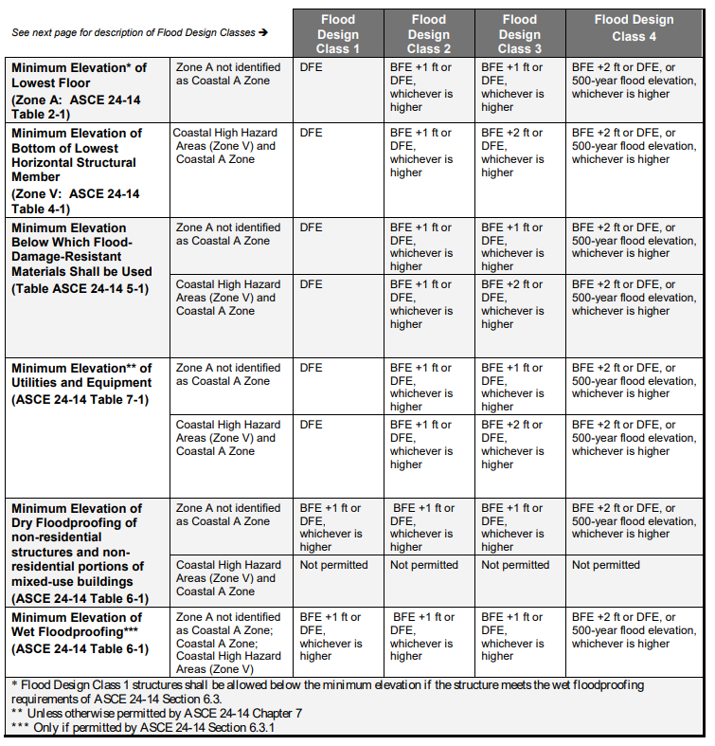
Reminder: The higher of the Flood Hazard Design Flood Elevation (FHDFE) or the ordinance Local Design Flood Elevation (LDFE) must be used.

Winter 2019 UCC Construction Code Communicator
The Winter 2019 UCC Communicator reminds code officials of the NJDEP FHACA rules, mandatory +1-foot freeboard requirements, and requirements that Coastal A Zone structures (within FEMA’s Limit of Moderate Wave Action (LiMWA) area where waves can measure 1.5 feet but are lower than the 3-foot wave height threshold for a designated V zone) are to be built using V Zone rules as is required in ASCE 24-14. FPAs should coordinate with code officials on these rules to ensure consistent understanding and enforcement.
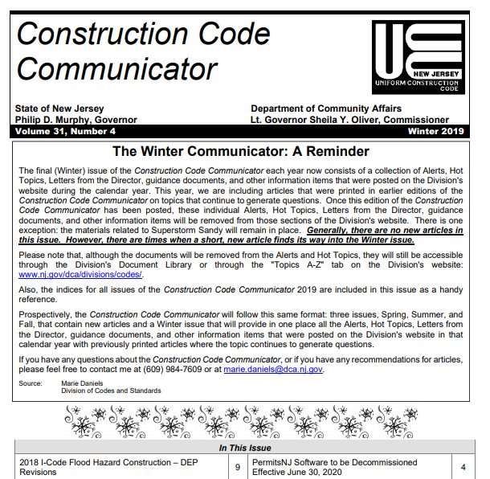
Source: https://www.nj.gov/dca/divisions/codes/publications/pdf_ccc/CCC_Winter_2019.pdf

Building Additions & Clarifying the Summer 2016 UCC Construction Code Communicator
The Summer 2016 UCC Communicator included information about Building Additions in a Flood Zone as shown below. It concluded that additions not considered substantial improvement would not have to be elevated – THIS STATEMENT IS NOT TRUE. Both the FHACA and NFIP require additions to be elevated as described below.
The FHACA, N.J.A.C. 7:13-7.12(a)3, states that for any addition, the lowest floor must be constructed at least one foot above the FHDFE elevation, and no lower than the elevation required under the UCC, N.J.A.C. 5:23.

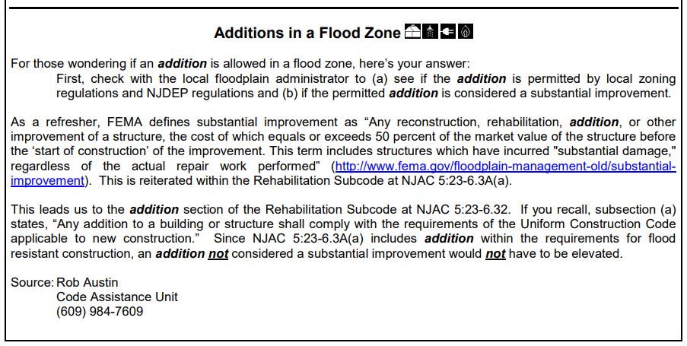
Source: https://www.nj.gov/dca/divisions/codes/publications/pdf_ccc/CCC_Smr_2016.pdf
Note: This article is incurred

The NFIP regulations for residential additions are based upon pre-FIRM vs. post-FIRM status. Pre-FIRM means a structure was built before the first community FIRM was released (typically in the 1970’s) and Post-FIRM means a structure was built after. This information can be found in the Community Map History table in the FIS. Figure 10 is an example of a Community Map History table for Mercer County, New Jersey.

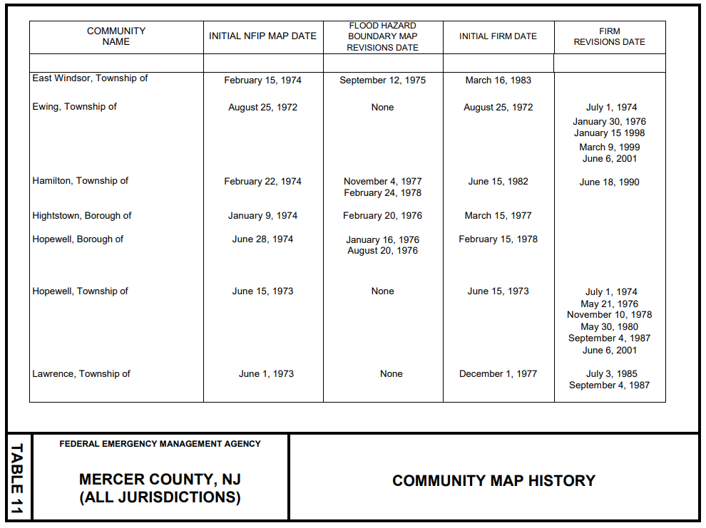
Figure 10. Community Map History table from the July 20, 2016, Mercer County, NJ Effective FIS.
NFIP regulations state that ANY addition to a post-FIRM residential structure must be elevated, regardless of size, structural connectedness to the main structure, or substantial improvement determination. The exact DFE is dependent on certain factors which are discussed in FEMA’s SD/SI Desk Reference P-758, Section 6.4, May 2010 (https://www.fema.gov/sites/default/files/2020-08/fema_p_758_complete_r3_0.pdf).
NFIP regulations state that non-substantial improvement additions to a pre-FIRM structure are not required to be elevated. But if it is substantial improvement and pre-FIRM, then the addition must be elevated.
For each of the above scenarios, the main building may need to be elevated as well, depending on certain factors.
Non-residential structures’ additions are not required to be elevated, provided they are floodproofed appropriately.
Information describing each of these situations can be found in FEMA’s SD/SI Desk Reference, May 2010 (see link above).
Regardless of the NFIP rules, for additions, the FHACA rules are more restrictive and therefore must be followed.

Chapter 5: Resources for Implementing the NFIP and Floodplain Management
This chapter features guidance, trainings, best practices, and rules for how best to achieve successful implementation and execution of the many FPA responsibilities.

Permit and Inspection Workflow
FPAs must be familiar with federal, state, and local regulations that trigger non-floodplain development permits. They should check for inclusion of these applicable permits when reviewing the floodplain development permit. Relevant certifications for the project should also be included. Approval of the local floodplain development permit cannot be conditioned upon receipt of an approved NJ State permit – a full local review must be done. Figure 11, below, outlines the typical permitting workflow.
Applicant obtains relevant
Federal and State Permits and Certifications
(such as Endangered Species or Floodproofing)
Applicant Prepares or Revises
Local Floodplain Development Permit Application
FPA Records Permit
and Collects Fees
FPA Reviews Application
for Completeness
Incomplete Application Returned
Distribute Copies of Application to other Local Officials for Review (Code Official, Engineer, Zoning, etc.)
Review Application for Compliance
Noncompliant Application
Denied and Returned
Applicant Resubmits Noncompliant Application
with Required Modifications
Application Approved and Permit Issued
Track Construction Start Dates à if start is after
180 days of permit issuance AND newer map data is released, permit needs to be re-reviewed
Conduct Inspections
Construction Violations Identified, Recorded, and Notifications Made
Violations Corrected
Project Complete and Certificate of Compliance is Issued

Figure 11. Example Permit Process Workflow (adapted from FEMA 480, Unit 7)

Fill
Fill is a regulated activity in the regulated floodplain and must always be reviewed through the permitting process prior to placement. Proposed fill for a new structure should be reviewed and permitted independent of and prior to the building permit review, NOT together.
FPAs must recognize and communicate to stakeholders that structures built on fill are inherently more susceptible to flood damages due to seepage, erosion, and bank failure, when compared to structures built on natural high ground. In addition, the placement of fill can result in an increase in flood elevations by reducing conveyance and storage of floodwaters, thereby increasing flood risk to upstream and downstream properties. These risks should be communicated to property owners BEFORE fill is placed and FPAs should highly encourage continuation of flood insurance coverage in areas where fill has been placed.
Basements and subgrade crawlspaces are not allowed in fill unless they are above the Local DFE, and generally should be discouraged altogether.
FPAs should read and refer to FEMA’s Technical Bulletin 10-01: Ensuring that Structures Built on Fill In or Near Special Flood Hazard Areas are Reasonably Safe From Flooding (https://www.fema.gov/sites/default/files/2020-07/fema_tb10_ensuring_structures.pdf).
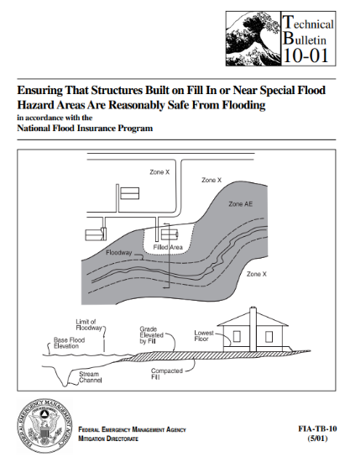

FPAs should reference the LOMR-F subsection in Chapter 2 of this guide for when they may be required to sign the Community Acknowledgement Form regarding fill.

Inspections
In N.J.A.C. 5:23-2.18(b)1ii(2), the UCC specifies inspection requirements for foundation construction in a flood hazard area which require the submission of elevation certificates to the construction official and floodplain administrator prior to further vertical construction.

1 Foot Freeboard Requirement
FPAs working in NJ must be aware of the freeboard requirement in the FHACA Rules. The NFIP does not require freeboard for structures. Required freeboard varies by building type and may be significantly higher for Class III and IV structures. In New Jersey, freeboard is in addition to any factor of safety required in riverine areas under the Flood Hazard Area Control Act.
This 1-foot freeboard rule also applies to attached garages with a slab floor built at FEMA’s BFE or at the NJ DFE without freeboard. Although garages are not considered living space, vents would have to be installed in the garage walls to be compliant with New Jersey law event if the top of slab meets the NFIP BFE.
Additional information on how freeboard is calculated is discussed in Table 4 in Chapter 3. NFPAs should refer to APPENDIX J: EXAMPLES FOR DETERMINING THE LOCAL DESIGN FLOOD ELEVATION (LDFE) AND FEDERAL FLOOD RISK MANAGEMENT STANDARD (FFRMS) USING WORKSHEETS 1, 2, & 3 to help them calculate the correct flood elevation to build to.

Coastal A Zones in NJ
When constructing any addition to a residential structure in a Coastal A Zone (area of moderate wave action within an AE Zone where waves exceed 1.5 feet but are lower than the 3-foot threshold for a designated V zone) in NJ, V Zone rules apply, and the entire structure must be elevated to the proper Local DFE. When elevating, however, these structures are allowed to be constructed on back-filled stem walls, as an alternative to pilings, posts, or columns per ASCE 24-14.

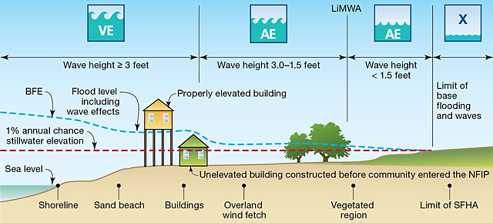
Figure 12. Coastal flood hazard mapping boundaries

Mitigation and AW-501s
The FPA should work closely with the local and county OEM Coordinators on mitigating flood risk and known losses in communities. Continual involvement with mitigation planning and grant acquisition should occur. Keep track of Repetitive Loss and Severe Repetitive Loss properties, encourage their mitigation, and when mitigated fill out AW-501 forms. The forms should be kept on file and if participating in CRS, sent to the ISO Specialist for the community. See link for the FEMA AW-501 form and instructions: https://www.fema.gov/pdf/plan/floodplain/fema497_AppxG.pdf.

Environmental Review
FPAs should coordinate with their planning boards and environmental commissions to review environmentally sensitive resources that could be affected by the development. These may include floodplains, wetlands, streams, threatened or endangered species habitat, involvement with hazardous/regulated material, cultural resources, parks, etc. Refer to Chapter 3 of this Guide for a list of other land use laws and permits that may apply. In addition, Appendix F: Identifying Threatened and Endangered Species provides useful online resources for Threatened and Endangered Species research.

Bureau of Flood Engineering Resources
The DEP Bureau of Flood Engineering maintains a website (https://www.nj.gov/dep/floodcontrol/) that includes the following information:
  - DEP’s Floodplain Communicator Newsletter, including how to subscribe and helpful back issues
  - New Jersey Model Code Coordinated Ordinances for Riverine and Coastal areas
  - Model Flood Damage Prevention Permit Example
  - LDFE Worksheets and Examples
  - Mapping Resources
  - New Jersey State-studied stream list and mapping resources
  - FEMA Area-Specific Memorandums

Trainings
DEP offers training from the Bureau of Flood Engineering, which is announced through the Floodplain Communicator newsletter and through the newsletter’s delivery service. Visit https://www.nj.gov/dep/floodcontrol/newsletters.htm to subscribe.

FEMA offers in-person training on the NFIP at their Emergency Management Institute in Emmitsburg, MD. Course E0273 Managing Floodplain Development through the NFIP is a 4-day course that covers all aspects of the NFIP. For more information on FEMA training courses visit https://training.fema.gov/emicourses/emicatalog.aspx.
FEMA also offers online tutorials on how to use FIRMs and FISs, Letter of Map Changes, etc. For more information visit https://www.fema.gov/flood-maps/tutorials.
Local NFIP trainings may also be held throughout NJ by the New Jersey Association for Floodplain Management (NJAFM) (http://www.njafm.org/) or by county Offices of Emergency Management
NJDEP and the Rutgers Office of Continuing Professional Education offer a 3-course Flood Hazard Area Certificate Program each year. The program focuses on the NJ FHACA Rules. For more information visit http://www.cpe.rutgers.edu/certificate/flood-hazard-area.html.

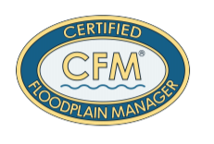
Certifications
The Association of State Floodplain Managers (ASFPM) offers a national Certified Floodplain Manager (CFM) Certification that is based upon the NFIP standards. For more information visit https://www.floods.org/ and look for Certification Program (CFM) on the main page.

The New Jersey Society of Professional Land Surveyors (NJSPLS) offers a NJ-specific Certified Floodplain Surveyor (CFS) training and certification. A 20-hour course is followed by the exam. This program and certification are new as of March 2020. For more information visit https://www.njspls.org/.

Publications, Bulletins, and Fact Sheets
FEMA provides many publications to help FPAs understand the rules and effectively enforce the NFIP. FEMA 480: NFIP Floodplain Management Requirements: A Study Guide and Desk Reference for Local Officials (February 2005) is a holistic guide that every FPA should read.
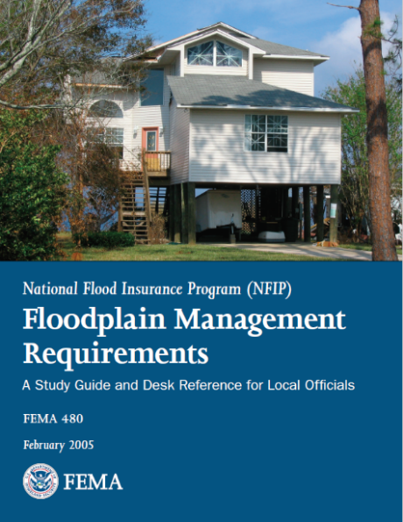
Figure 13. FEMA 480: Floodplain Management Requirements: A Study Guide and Desk Reference for Local Officials (2005)
Construction specific publications and technical bulletins are listed in Chapter 2 of this Guide under the NFIP Construction subsection.
Substantial Improvement and Damage best practices are detailed in FEMA P-758: Substantial Improvement/Substantial Damage Desk Reference (2010).
Topic-specific publications can be easily found by searching for the term or topic on https://www.fema.gov/ in the “Search” bar.
The New Jersey Association for Floodplain Management (NJAFM) has produced a Quick Guide (2015) for Floodplain Administrators which can be accessed with an NJAFM membership: https://njafm.wildapricot.org/resources/Documents/KeyDocs/NJQuickGuide_web.pdf.
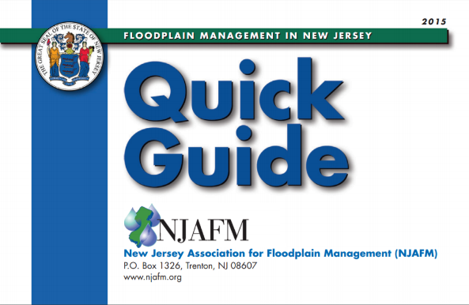
Figure 14. The New Jersey Quick Guide for Floodplain Management (2015)
For more information on ASCE 24-14 and how it compares with the NFIP, FEMA has put together a helpful highlights document available at https://www.fema.gov/sites/default/files/2020-07/asce24-14_highlights_jan2015.pdf.

Assistance
FPAs can request subject matter and technical assistance from a variety of sources.
- General Floodplain Administrator and Flood Hazard Mapping Questions:
NJDEP, Division of Dam Safety & Flood Engineering, Bureau of Flood Engineering
NJ State NFIP Coordinator's Office
44 S. Clinton Ave, Mail Code 44-03A, PO Box 420
Trenton, NJ 08625-0420,
Phone: (609) 292-2296, Fax: (609) 984-1908
https://www.nj.gov/dep/floodcontrol/
- Flood Hazard Area Control Act and Land Use Permitting Questions:
NJDEP, Division of Land Resource Protection
501 East State Street, Mail Code 501-02A, P. O. Box 420, Trenton, NJ 08625-0420
Phone: (609) 777-0454
https://www.nj.gov/dep/landuse/
- Construction Code Questions:
NJDCA, Division of Codes and Standards
101 South Broad Street, P. O. Box 802, Trenton, NJ 08625
Phone: (609) 292-7899, Fax: (609) 633-6729
https://www.nj.gov/dca/divisions/codes/

- National Flood Insurance Program:
FEMA Mapping Information eXchange (FMIX)
Phone: 1-877-336-2627
Email: FEMAMapSpecialist@riskmapcds.com
https://www.floodmaps.fema.gov/fhm/fmx_main.html
https://www.floodsmart.gov/
- Community Rating System:
https://www.fema.gov/flood-insurance/rules-legislation/community-rating-system
https://crsresources.org/
- National and State Professional Association (includes state, local, private, and academic representatives):
New Jersey Association for Floodplain Management (NJAFM)
Email: administrator@njafm.org
https://www.njafm.org/
Association of State Floodplain Managers
https://www.floods.org/

Chapter 6: Post-Disaster Best Practices
In a post-disaster situation, FPAs play a critical role. The FPA is responsible for assessing damages in the aftermath of a storm event and requiring substantially damaged or substantially improved structures be made compliant with current floodplain regulations. This chapter will discuss six (6) actions that FPAs can implement in their communities now, in preparation for the next storm.
More detailed steps and guidance post disaster is included in the New Jersey Substantial Damage Management Plan Template. This plan was developed to provide guidance to communities on how to prepare before and after a disaster. It provides letter and notice templates, suggestions for tracking substantial damage and improvement determinations, and other recommended best practices for all communities. This template should be used in conjunction with the contents of this guidebook. See link for the New Jersey Substantial Damage Management Plan Template: https://www.nj.gov/dep/floodcontrol/docs/njsdmp-tempate.docx.
(Note: Many of the post-disaster recommendations below have been adapted from the Florida State Emergency Response Team Florida Post-Disaster Toolkit for Floodplain Administrators found here: https://portal.floridadisaster.org/mitigation/SFMP/External/Community%20Resources/Community%20Guidance%20and%20Quick%20Guide%20for%20FPM/Florida%E2%80%99s%20Post-Disaster%20Toolkit%20for%20Floodplain%20Administrators.pdf)

Figure 15. Six (6) actions FPAs should take before, during, and after the next disaster

Action 1: Plan Ahead
Communicating with elected officials, community officials, stakeholders, and residents prior to a storm event is important for successful execution of post-storm activities. While many post-storm activities can be planned, every flood is unique and may have unpredictable impacts. Establishing strong communication pathways prior to the storm can help FPAs more effectively address a variety of storm impacts.
Key messages about the role of FPAs in the post-disaster environment should be shared with community leaders and policy makers before the storm. These may include:
1. Reminding elected officials, community managers, and property owners that FPAs need to access and inspect buildings after the storm to make damage determinations.
2. Advising property owners that permits are required to make repairs.
3. Explaining the concept of damage determinations to all relevant parties including how substantially damaged buildings may be brought into compliance with local codes and standards.

Additionally, FPAs should work to make property owners aware of their own responsibilities after a disaster. Property owners’ responsibilities may include:

Property Owner Responsibilities After a Disaster
1 | Obtaining a safety inspection from local officials before entering a building that appears to be damaged.
2 | Taking pictures of damaged buildings and their contents.
3 | Contacting insurance companies if buildings are covered by NFIP policies.
4 | Seeking emergency assistance by visiting a Disaster Recovery Centers or registering on FEMA’s website (www.DisasterAssistance.gov).
5 | Working with local officials to determine requirements for bringing substantially damaged buildings into compliance before starting repairs.
6 | Applying for a permit.
7 | Documenting damage and cost estimates for repairs.

Fliers, brochures, social media posts, billboards, and other outreach materials can support this action. These materials should be targeted towards property owners, contractors, and elected officials. Examples are shown below.

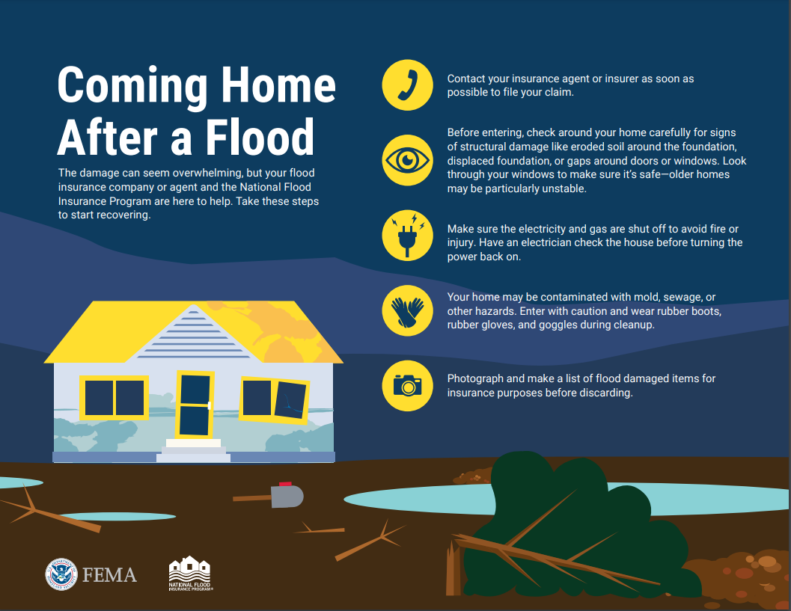
Source: https://www.fema.gov/sites/default/files/2020-07/fema_nfip_Coming-Home-Infographic.pdf

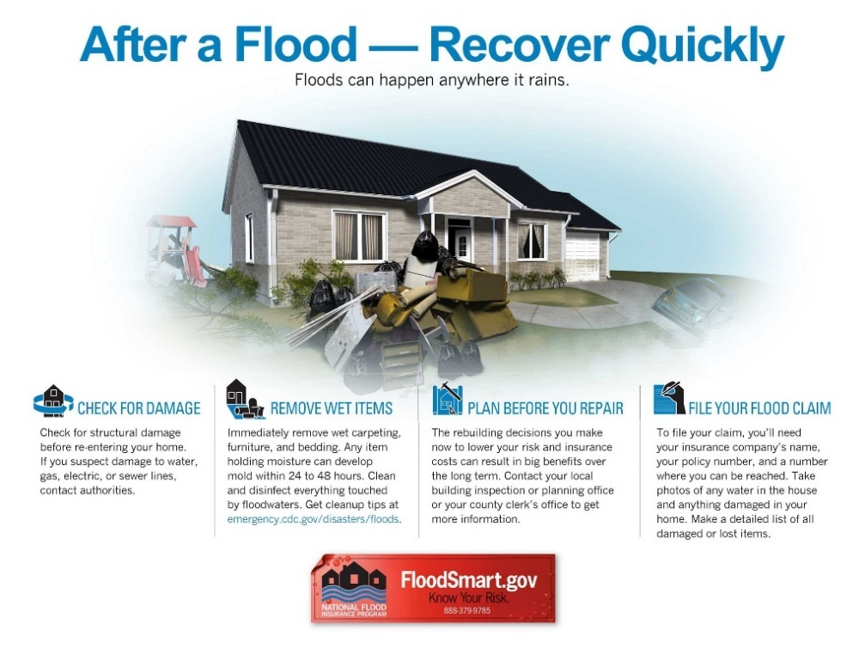
Source: http://www.multivu.com/players/English/7920751-fema-iii-floodsmart-flood-risk/image/after-a-flood-infographic-7-HR.jpg

In addition, a sample letter to notify property owners about required damage inspections is included below.
SAMPLE OUTREACH LETTER FOR POST-EVENT DAMAGE INSPECTIONS
[Community Letterhead]

Dear Property Owner or Persons Residing at this Address,

The [city/town] is requesting your cooperation to assist us with expediting recovery of our community from the impacts of [insert name of event]. As you should be aware, properties in flood zones designated on our flood maps that were damaged by wind, water, fallen trees or other factors must be inspected before we can issue building permits for repair, reconstruction, or other improvements. Repairs cannot begin until the property is inspected, and permits issued. In accordance with the NJ Uniform Construction Code and our flood damage prevention regulations, we must determine whether the damage meets the definition of “substantial damage.”

The process we’ve developed to achieve efficient, orderly, and responsive permit review, begins with damage inspections. Therefore, we ask that you allow our staff, or staff of other agencies such as State, FEMA, or private contractors working on our behalf, to access and inspect your damaged building. These authorized staff carry a “right of entry” document and their agency identification and must show them to you before you let them access your property.

The preliminary damage inspections are limited to evaluating the extent of damage to foundations, roofs, windows and doors, siding, installed appliances, electrical and plumbing, heating and air conditioning, and walls and floors. Inspections are required to assess the condition of the building and determine the work required to repair the building to its pre-damage condition. The period of inspections is limited to daylight hours only between [insert anticipated period of inspections]. Once we have inspected your property and the results recorded in our database, we will send you a letter with the results and explain any requirements that may apply.

We greatly appreciate your willingness to allow our community inspectors to assess the condition of your property which will help you and the community move forward as quickly as possible with the permitting and repair of your building.

If you have any questions about this process or the inspectors, please contact us immediately by calling [insert local contact].

Thank you for your cooperation and support to help our community to recover from [insert name of event].

Sincerely,

City Manager/County Administrator

Action 2: Assess Post-Disaster Needs and Request Assistance
FPAs must be prepared to handle the increased workload and urgency following an event. Before an event, FPAs should think through issues such as:

FPA Pre-Flood Event Questions to Answer
1 | How many buildings in the community are vulnerable to flooding?
2 | Do the appropriate departments have the capacity to identify damaged buildings and conduct safety inspections within a few weeks of the disaster?
3 | Do the appropriate departments have the capacity to conduct detailed inspections and notify property owners of preliminary damage estimates within a few weeks or months of the disaster?
4 | Are there enough staff available to field questions from property owners and others about repairing and rebuilding damaged structures to local codes and standards?

Recognizing the size of their community, what is at-risk, the magnitude of past flooding events, and what local and external support is available is key. With this information, an FPA can begin to plan before the disaster for additional resources that may be needed to address post-disaster needs.
Mutual aid and shared service agreements with county, state, and federal partners can help meet outstanding needs after a major disaster. These agreements should be established before the storm. Understanding and instituting a span of control and organizational hierarchy for requesting assistance is important as well. These agreements and action plans can likely be coordinated through the County Office of Emergency Management.

Action 3: Document High Water Marks
FPAs should capture and catalogue high water marks after a flood event. Documenting high water marks has many benefits. This information can be used to map the extent and depth of the floodwaters, assess building damages, plan for rebuilding higher and safer, and inform mitigation actions and funding opportunities. In approximate Zone A areas where base flood elevations are not known, high water mark data can be an especially useful indicator of risk.
High water marks should be collected shortly after floodwaters recede to ensure that subsequent rainfall or cleanup efforts don’t erase indicators of high-water levels. Because other agencies may also be collecting high water marks, FPAs should coordinate with these agencies to prevent duplication of efforts and develop the most complete understanding of flooding in the area. Coordinate with County and State OEM, as well as the State NFIP Office within NJDEP to determine who will capture high water marks.
If FPAs are unable to collect high water marks, the United States Geological Survey (USGS) maintains an online, map-based Flood Event Viewer that displays gauge and sensor data https://stn.wim.usgs.gov/FEV/ that can be referenced for post-event assessments. Be aware, however, that geographic coverage of these gauges and sensors may be limited in certain communities.
To reliably collect high water mark data, a collection methodology should be established. See below for procedures to include.

How to Collect High Water Marks
1   | Target and visit locations of reported and observed flooding, looking for stains or mud lines on buildings, vegetation damage, objects caught in trees, and debris lines.
2   | Record locations using building addresses and/or GPS coordinates. Use a mobile device with a GIS app, or write them down in an organized notebook.
3   | Measure and record the height of the water mark and take site-specific notes. Place a permanent marker or nail in the building, sign, pole, or tree, if possible.
4   | Take several pictures to document flood impacts in the immediate and surrounding areas. This includes an overview of the building or area with building number, mailbox, or street sign included; a close-up of the water mark and adjacent grade with a person and measuring stick included for visual reference and to indicate depth of water; and other pictures that capture the resulting damage.
5   | Record data on a mobile device, laptop, or notebook such as location, date collected, measurements, pictures, collection team names and site notes. Organize the data concisely.
6   | Share the data with OEM, NJDEP, and FEMA.

Anticipated high water mark collection staff should be familiarized with the established procedure and trained on how to use related hardware and software during non-disaster periods.
Once some time has passed and post-flood recovery is underway, FEMA encourages communities to erect high water mark signs in highly visible locations to increase community awareness of flood risk and encourage mitigation actions. For more information on FEMA’s High Water Mark Initiative program, visit https://www.fema.gov/high-water-mark-initiative.

Action 4: Make Substantial Damage Determinations
Substantial Improvement and Substantial Damage (SD/SI) are processes of the NFIP that require structures be brought into compliance with current floodplain regulations if cost of proposed improvements or cost of damage repairs equal or exceed 50% of the market value of the structure (not the land) before improvements or damages occurred. Damages can be caused by any source (flood, fire, wind, etc.). FPAs are required to regulate and enforce SD/SI rules as part of NFIP participation.
After an event, substantial damage determinations are made by assessing damaged properties. Usually, a preliminary evaluation is completed soon after the event to determine if structures are damaged between 0 and 40 percent, 40 and 60 percent, or 60 and 100 percent. Once this determination has been made, communities can focus on inspecting structures estimated to be 40 to 60 percent damaged. For these properties especially, it is important to have a standard assessment procedure in place because determinations can become controversial and must be defensible. Substantial damage determinations are required by the NFIP – they cannot be ignored after an event.
Any repair, reconstruction, rehabilitation, alteration, addition, or other improvement of a structure equal to or exceeding 50% of the market value of the building is considered a substantial improvement. If a structure has been substantially damaged, all repairs are considered substantial improvement regardless of the repair work done. Substantial improvements do not include improvements required to correct existing health, sanitary or safety code violations that are the minimum necessary to assure safe conditions or any alterations to a historic structure as long as those alterations do not preclude the structure’s historic designation.
The NFIP also allows communities to use Repetitive Loss determinations to trigger SD, however this specific provision must be adopted by the community in their Flood Damage Prevention Ordinance. Contact NJDEP, Division of Dam Safety & Flood Engineering, Bureau of Flood Engineering to discuss this option further.
To determine whether a repair or improvement is SI or SD, the FPA should work in close coordination with building or construction officials.
Steps to Determine SI or SD
1 | Estimate the market value of the building. This is the market value of the building before any damage occurred or repairs were made. For larger disasters, prepare preliminary SD/SI determinations by using tax assessment value as the Market value and estimating repair costs by using valuation tables.
2 | Compare the cost to make an improvement, cost to repair the building to its pre-damaged condition, or the combined cost of improvements and repairs to the market value of the building determined in Step 1.
3 | Determine and document whether the proposed improvements and/or repairs are considered SD/SI (i.e., equal to or greater than 50% as calculated in Step 2).
4 | Follow up with the property owner if a SD/SI determination is made and notify them of the requirements to bring the structure into compliance with current floodplain regulations.
Follow the steps in the process diagram in Figure 16, below.

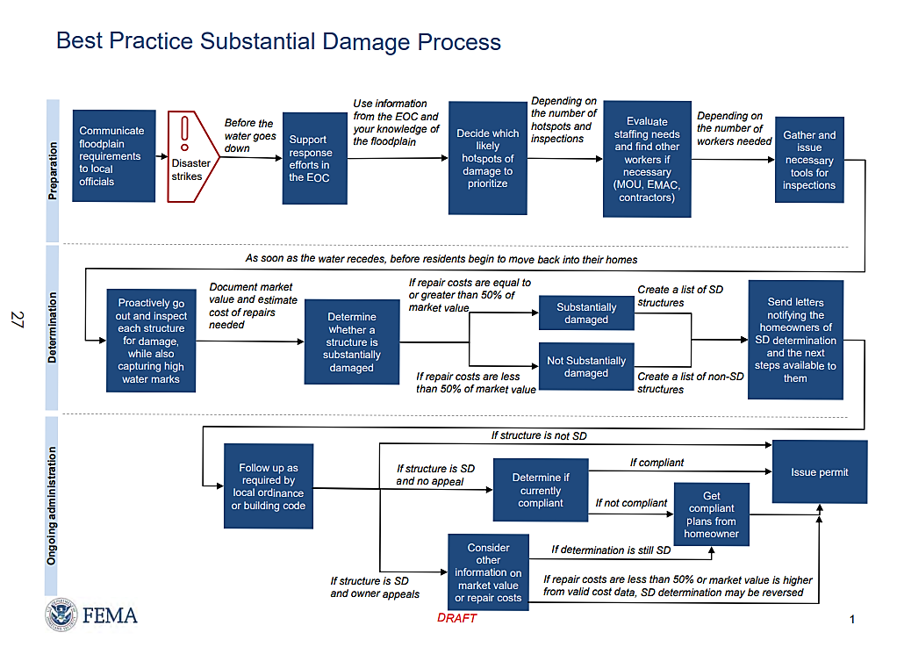
Figure 16. Best Practices for the Substantial Damage Process
FEMA has several resources to help FPAs in implementing the SD/SI requirements. FEMA P-758: Substantial Improvement/Substantial Damage Desk Reference (2010) is a must-read guide for all aspects of SD/SI. FEMA’s Substantial Damage Estimator (FEMA P-784 CD) is a software program developed to help officials determine potential damage for residential and non-residential structures. It can serve as a basis and objective process for providing quick and consistent substantial damage determinations. The Substantial Damage Estimator User manual and Workbook includes several worksheets to guide inspection of different structure types.
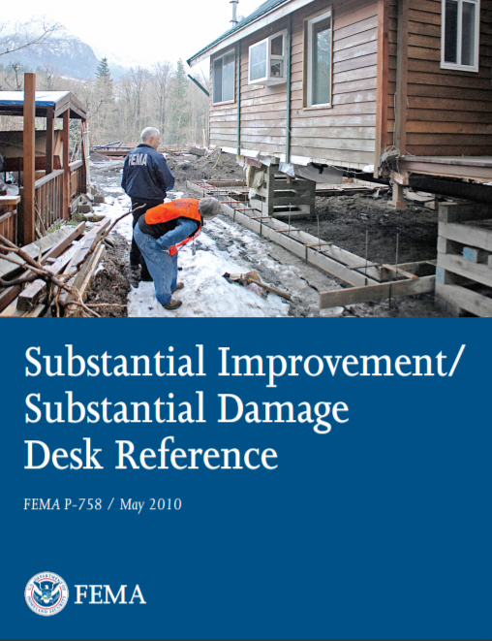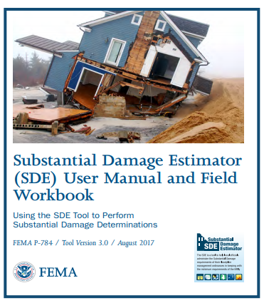
Figure 17. FEMA's SD/SI Desk Reference (2010) and Substantial Damage Estimator (SDE) User Manual and Field Workbook (2017)
When a repair or improvement is determined to be SI or SD, buildings must be brought into compliance with the floodplain management requirements for new construction. This includes all elements of compliance such as DFE, foundation type, utilities and equipment and usage of flood damage-resistant materials.
A substantial improvement/damage worksheet (see Figure 18, below) is encouraged for consistency and documentation. Additionally, FPAs should train and practice the SD/SI process with their staff before an event to test execution and become more familiar with the process.
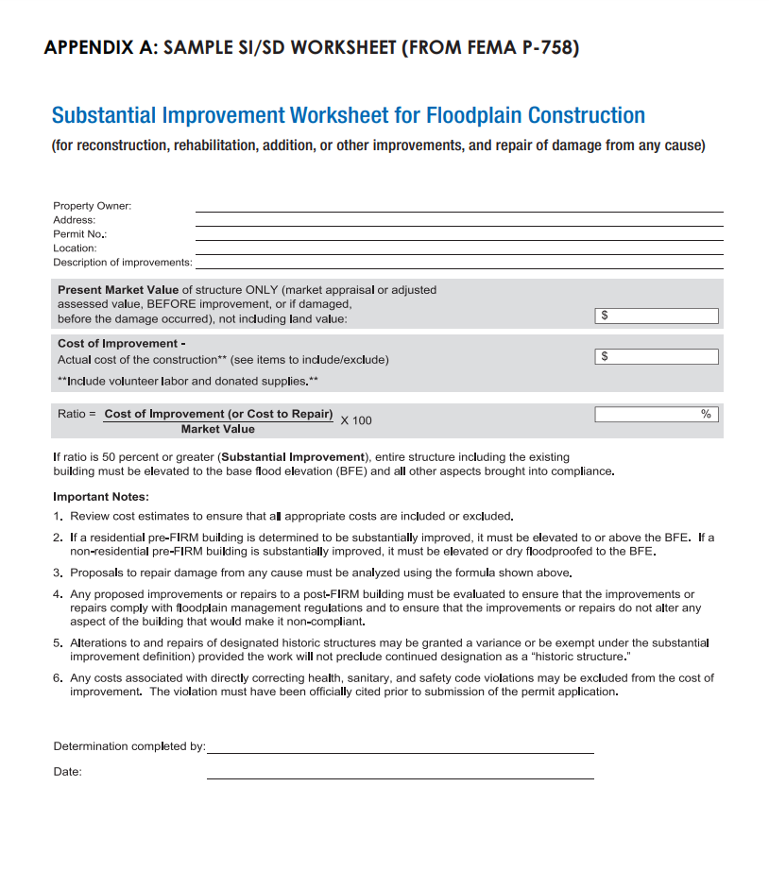
Figure 18. Substantial Improvement Worksheet for Floodplain Construction from FEMA P-758, Substantial Improvement/ Substantial Damage Desk Reference, Appendix D (2010)
When notifying property owners of a SD/SI determination, an official letter must be sent. Copies of these letters must be sent to the NJDEP, Division of Dam Safety and Flood Engineering, Bureau of Flood Engineering, 44 S. Clinton, Mail Code 44-03A, PO Box 420, Trenton, NJ 08625-0420, Attn: Substantial Damage. Depending on the outcome of the determination, different letters with different requirements are needed.
- A letter stating that proposed improvements are substantial improvements.
- A letter stating that a structure has sustained substantial damage.
- A letter stating that damage is not substantial.
See Appendix F: Example Certificates and Forms for Substantial Improvement and Substantial Damage Letter templates to use.
If a damaged property is in the SFHA, the letter must state that damage was caused by flooding for the property owner to be eligible for Increased Cost of Compliance (ICC) claims. ICC claims may provide up to $30,000 towards the cost of bring the building into compliance.

Action 5: Understand NFIP Claims and ICC
FPAs need to understand what an NFIP policy holder will go through when submitting a claim after a flood. It will be a stressful time for property owners, and they will be coordinating with many parties at the same time – local officials including the FPA, insurance agents, FEMA, the Red Cross, family members, etc. Property owners with NFIP insurance policies will receive information from FEMA on the claims process including the NFIP Insurance Claims Handbook. FPAs will be involved in identifying damaged buildings, making SD determinations, advising property owners on permitting requirements, and working with them to ensure they’re complying with SD/SI requirements.
The NFIP starts paying claims relatively soon after a disaster, sometimes before a community can do post-disaster inspections. Property owners may think they can begin repairs once claims are paid without a post-disaster inspection or permits, however this is false. FPAs must educate their community on the rules prior to and directly after a storm, as needed.
FPAs should have an agreement with FEMA to receive flood insurance claims data. If claims are paid quickly, FPAs should use this data to focus inspections on and prevent non-permitted repair work. Contractors licensed in NJ should know about the permitting requirements and should obtain permits before working.
Visit these resources to learn more about the NFIP claims process:
- The National Flood Insurance Program Flood Claims Process (Fact Sheet)
https://www.fema.gov/sites/default/files/2020-07/fema_nfip_Starting-Your-Recovery_2020.pdf
- NFIP Flood Insurance Claims Handbook (FEMA F-687)
https://www.fema.gov/sites/default/files/2020-05/FINAL_ClaimsHandbook_10252017.pdf
NFIP flood insurance policies include Increased Cost of Compliance (ICC) coverage for buildings in the SFHA that receive a substantially damaged determination from the community that is caused by flooding only. This coverage provides up to $30,000 to help cover elevation, relocation, demolition, or floodproofing (non-residential only) costs to bring a building into compliance with current floodplain management regulations. FPAs should be aware of the benefits of ICC and communicate with homeowners about this both pre- and post-event. Property owners cannot receive the ICC benefit unless the FPA declares them substantially damaged.

Figure 19. FPAs and NFIP policyholders should understand how ICC funds become available and what the funds can be used for
Visit these resources to learn more about ICC:
- Increased Cost of Compliance Coverage (policy holder resources and checklist): https://www.fema.gov/increased-cost-compliance-coverage
- Increased Cost of Compliance (ICC) Fact Sheet:
https://www.fema.gov/sites/default/files/2020-08/fema_increased-cost-of-compliance_fact-sheet.pdf
- Increased Cost of Compliance Coverage Guidance for State and Local Officials (FEMA 301): Provides detailed guidance on how the ICC coverage relates to community administration of Flood Damage Prevention Ordinances:
https://www.fema.gov/pdf/plan/floodplain/fema301.pdf

Action 6: Identify Sources of Mitigation Funding Assistance and Understand NJ Blue Acres
FPAs should have a basic understanding of the pre- and post-disaster funding assistance programs. It is likely that at some point they will be involved in coordination among property owners, local, state, and federal officials regarding these programs. FPAs should talk with County and State OEM officials to learn more about these funding sources BEFORE the next disaster. With this information, FPAs and other local officials can help property owners make decisions about mitigation that bolster community resilience.

FEMA’s Four (4) Major Grant Programs
DRRA | The Disaster Recovery Reform Act (DRRA) of 2018 provides assistance to  state and local governments for building code and floodplain administration and enforcement, including inspections for substantial damage compliance, in addition to base and overtime wages for extra hires to facilitate the implementation and enforcement of adopted building codes for a period of not more than 180 days after the major disaster is declared.  https://www.fema.gov/disaster/disaster-recovery-reform-act-2018
FMA | The Flood Mitigation Assistance (FMA) program provides grants to states, communities, private non-profits, and federally recognized tribes to mitigation or eliminate flood risk to NFIP-insured properties.  https://www.fema.gov/flood-mitigation-assistance-grant-program
HMGP | The Hazard Mitigation Grant Program (HMGP) provides grants to states, communities, private non-profits, and federally recognized tribes to implement long-term hazard mitigation actions. The funding for this program is available after a major disaster is declared by the President.  https://www.fema.gov/grants/mitigation
PA | The Public Assistance Program (PA) provides grants so that communities can quickly respond to and recover from declared disasters. This funding is available to states, tribal governments, local governments, and certain types of non-profit organizations. It can be used for debris removal, life-saving emergency protective measures, and repair/replacement/restoration of certain public or non-profit facilities.  https://www.fema.gov/public-assistance-local-state-tribal-and-non-profit
BRIC | The Building Resilient Infrastructure and Communities (BRIC) program provides grants to states, communities, private non-profits, and federally recognized tribes to implement sustained pre-disaster hazard mitigation projects with the goal of reducing overall risk from future hazard events.  https://www.fema.gov/grants/mitigation/building-resilient-infrastructure-communities

Communities do not apply directly to FEMA for funding. Instead, they must apply to the NJ State OEM, who then collectively applies to FEMA on behalf of communities throughout NJ.
For the HMGP, FMA, and PDM programs, the community must be listed in the FEMA-approved County Hazard Mitigation Plan (HMP) to receive funding for mitigation actions.
Additional funding may be available through FEMA’s Individual Assistance (IA) Program https://www.fema.gov/individual-disaster-assistance, the Small Business Administration https://www.sba.gov/, the U.S. Department of Housing and Urban Development’s Community Development Block Grant (CDBG) Program https://www.hud.gov/program_offices/comm_planning/communitydevelopment, state agencies, and more.
The NJDEP administers the Blue Acres Program under the umbrella of the larger Green Acres Program. Blue Acres leverages state and federal funding for buyouts (demolitions) of residential properties only. The land is then permanently preserved as open space. FPAs should understand the rules and qualifications of the program and discuss it with homeowners. For more information on the Blue Acres Program contact the NJDEP or visit https://www.nj.gov/dep/greenacres/blue_flood_ac.html.

Chapter 7: Conclusion
Floodplain management is an important responsibility every community has under the NFIP and New Jersey State law. Floodplain administrators are the people responsible for implementing a sound, safe, and robust floodplain management program. Filling the floodplain administrator position and providing municipal support and resources are critical to building resilient communities.

Regulations
Mapping
In Good Standing with NFIP
Flood Insurance Available
Resilient
Community
Floodplain Management

Figure 20. Floodplain management is about understanding the NFIP, regulations, mapping, and insurance and how the combination of these creates resilient communities

Appendices

APPENDIX A: WORKSHEET 1 - Local Design Flood Elevation Worksheet
The New Jersey Local Design Flood Elevation Worksheet was developed to ensure that local floodplain administrators, consulting engineers, property owners, and construction officials have an easy template to use that incorporates the State-level floodplain and construction code requirements and any higher standards implemented by a participating community. Building to the effective FEMA Base Flood Elevation in New Jersey is non-compliant with State law. Using this template effectively organizes and consider all applicable regulatory requirements to avoid costly corrective actions, potential fines, and increased insurance costs. Considerations in determining the Local Flood Hazard Design Elevation include:
- The use of best available flood hazard data in determining flood hazard design flood elevations;
- The requirement of the Uniform Construction Code to add additional freeboard based upon building class (as described in ASCE 24-14);
- The additional freeboard specified by a community’s flood damage prevention ordinance;
- Any specific requirements in community’s flood damage prevention ordinance that affect the area extent or elevations in the community’s Special Flood Hazard Area that are more restrictive than what is required by State law.
Using the worksheet is highly recommended because it will ensure that proposed new projects and substantial improvements are built compliantly throughout the State.
The use of this worksheet for project documentation purposes and in grant applications is highly recommended when Federal funds, such as grants and loans are used for housing and infrastructure projects – especially since the worksheet documents the dates of maps used in making these determinations at project application and design. Please note that anything built in a State or Federally regulated floodplain with Federal funds requires, as a condition of funding, that the project comply with all applicable Federal, State, and Local regulations at the time of construction. Non-compliance could result in the repayment of federal funding or costly compliance fixes necessary to bring structures into compliance. Worksheets 2 (APPENDIX B) and 3 (APPENDIX C) attached to this guidebook address the issues associated with Wave Height (See Ch. 3 An important notice about determining Best Available Stillwater Elevations for Critical Facilities Design Flood Elevations) and the Federal Flood Risk Management Standard (see Chapter 1 Administering the Federal Flood Risk Management Standard). All Worksheets are designed to work with each other to ensure Local Design Flood Elevaiton compliance.
Three examples of a completed worksheet are included in this appendix. Note that the Gas Station/Convenience Store and Raritan EMS Examples do not reflect compliant local ordinances because they do not require one foot of freeboard; therefore, these examples are for illustrative purposes only to show that the higher State floodplain standards have precedence over non-compliant local ordinances that do not consider best available data, include the mandatory 1 foot of freeboard, or require additional freeboard for ASCE 24-14 Class III and IV structures.

Worksheet # 1 - Determining the Local Design Flood Elevation – Part I (Riverine)
Site Name: |  |  | Date:
Address:
Latitude (y): |  | Longitude (x):

 | State Flood Study¹ |  | FEMA Effective FIRM² |  | FEMA Best Available³ Preliminary, Draft, or Advisory Flood Hazard Data  (Circle Source)
Data Available (Yes/No)
Panel Number & Date
Flood Zone Designation | N/A
Floodway (Yes/No)
Design¹ or Base Flood Elevation^{2, 3}
Vertical Datum^ |  |  | NAVD 88
^⁴Resulting Elevations below must be in same datum, if conversion factor needed, note here: NAVD88 = NGVD29 - ______ ft.
Riverine Req. | +2 |  | +3 |  | +3
Resulting Elevation | Box A  NGVD29 NAVD88 |  | Box B  NGVD29 NAVD88 |  | Box C  NAVD88D
If none of the above data is available and/or the project is in a watershed 50 acres or greater in size, licensed NJ Professional Engineers may use NJFHACA Method 5 or 6 to approximate the DFE for design purposes, however, an unexpired Flood Hazard Verification Letter dated July 17th, 2023 and later, which includes a Flood Hazard Design Elevation is necessary to ensure compliance with State standards. Enter elevation in Box D.
Date of Letter Verifying the NJ Flood Hazard Design Flood Elevation (FHDFE): |  | Box D
Select highest elevation from Box A, B, C, and D to determine the
New Jersey Flood Hazard Design Flood Elevation (FHDFE) and input into Box E
¹Use Appendix 2 of the FHACA Rules (N.J.A.C. 7:13) to identify state-studied waters; or visit https://www.nj.gov/dep/floodcontrol/studied_streams.htm
²https://msc.fema.gov/portal/home
³ The most recent available preliminary flood risk guidance FEMA has provided. The Best Available Flood Hazard Data may be depicted on but not limited to Advisory Flood Hazard Area Maps, Work Maps or Preliminary FIS and FIRM.
⁴Vertical datum conversion factor sources: FIS report or https://vdatum.noaa.gov/runapp_agreement.php

This worksheet is designed to result in accurate determinations of the Federal Flood Risk Management Standard (FFRMS). Please consult the New Jersey Guidebook for Implementing the Federal Flood Risk Management Standard for additional information to ensure that all applicable federal projects receive full reimbursement.

Comments:

Worksheet # 1 - Determining the Local Design Flood Elevation – Part II (Riverine)
Site Name:
Freeboard Requirements |  |  |  | Highest Elevation |  | Highest Elevation with Freeboard Comparison
State Freeboard Requirements - The NJ Flood Hazard Area Control Act (NJFHACA) requires that a minimum of 1 foot of freeboard be added to the Flood Hazard Design Flood Elevation (FHDFE) and no lower than that required by the UCC pursuant to the calculation below for Class I through IV facilities. |  | 1 Foot | + | Box E  ____ Ft | = | State  Box 1  _____ Ft
Local Community Freeboard Requirements – More restrictive freeboard must be added if a higher freeboard is adopted in the Community’s Flood Damage Prevention Ordinance. |  | ___ Ft*** | + | Box E  ____ Ft* | = | Local  Box 2  _______ Ft
ASCE Class IV: 500-year Elevation  Or  FFRMS Critical Action: 500-year Elevation |  |  |  |  |  | Box 3
FFRMS Critical Action or ASCE 24** Type of Facility (circle one):  Class I Class II Class III Class IV |  | If Class IV or FFRMS Critical Action, chose the Highest Elevation from Box 1, Box 2 and Box 3 à |  |  |  | FFRMS Critical Action or ASCE 24 Critical Facility  Box 4  _______ Ft
Select highest DFE from State (Box 1), Local (Box 2),  and ASCE (Box 4):  (This is your Local DFE****) à |  |  |  |  |  | Box 5  _______ Ft
Note Vertical Datum à
Note Flood Zone à
*Review community ordinance to determine if the freeboard should be added to the BFE or NJ State Flood Hazard Area DFE.
Notes: Use the space below to document comments, assumptions, and sources. For example, source of the datum conversion factor or source of the ordinance BFE in Box E.
**ASCE Classes and Elevation Requirements are Defined in ASCE 24-14: https://www.fema.gov/sites/default/files/2020-07/asce24-14_highlights_jan2015.pdf
*** The local Flood Damage Prevention ordinance may require that additional freeboard for a critical facility be added to the Local Minimum Freeboard calculated in Box 2 which may be higher than the State minimum freeboard calculated in Box 1. The local ordinance should be consulted to confirm the calculations in this worksheet. In no circumstance should a critical facility be constructed lower than required by both the Flood Hazard Area Control Act and the Uniform Construction Code.
****Local Design Flood Elevation (DFE) Definition - the Local DFE is the elevation reflective of the most recent available preliminary flood elevation guidance FEMA has provided as depicted on but not limited to Advisory Flood Hazard Area Maps, Work Maps, or Preliminary FIS and FIRM which is also inclusive of freeboard specified by the New Jersey Flood Hazard Area Control Act and Uniform Construction Codes and any additional freeboard specified in a community’s ordinance. In no circumstances shall a project’s LDFE be lower than a permit-specified Flood Hazard Area Design Flood Elevation or a valid NJDEP Flood Hazard Area Verification Letter plus the freeboard as required in ASCE 24 and the effective FEMA Base Flood Elevation.
COMMENTS: Use the box on the first page to document the use of additional worksheets, comments, assumptions, and sources. For example, source of the datum conversion factor or effective date of the local ordinance requirements in Box 2.
ATTACH WORKSHEETS 2C (Federal Flood Risk Management Standard Documentation) to this worksheet if applicable.

Worksheet # 2A - Determining the Local Design Flood Elevation – Part I (Coastal)
Site Name: |  |  | Date:
Address:
Latitude (y): |  | Longitude (x):

 | FEMA Effective FIRM² |  | FEMA Best Available³ Preliminary, Draft, or Advisory Flood Hazard Data  (Circle Source)
Data Available (Yes/No)
Panel Number & Date
Flood Zone Designation
LiMWA Area (Yes/No)
Base Flood Elevation^{2, 3}
Vertical Datum^
^⁴Resulting Elevations below must be in same datum, if conversion factor needed, note here: Box A NAVD88 = NGVD29 - ______ ft.
Resulting Elevation | Box B  NGVD29 NAVD88 |  | Box C  NAVD88
If none of the above data is available a licensed NJ Professional Engineer may use NJFHACA Method 6 to approximate the DFE for design purposes, however, an unexpired Flood Hazard Verification Letter dated July 17th, 2023 and later, which includes a Flood Hazard Design Elevation is necessary to ensure compliance with State standards. Enter elevation in Box D.
Date of Letter Verifying the NJ Flood Hazard Design Flood Elevation (FHDFE): |  | Box D
Select highest elevation from Box B, C, and D to determine the
New Jersey Flood Hazard Design Flood Elevation (FHDFE) and input into Box E
²https://msc.fema.gov/portal/home
³ The most recent available preliminary flood risk guidance FEMA has provided. The Best Available Flood Hazard Data may be depicted on but not limited to Advisory Flood Hazard Area Maps, Work Maps or Preliminary FIS and FIRM.
⁴Vertical datum conversion factor sources: FIS report or https://vdatum.noaa.gov/runapp_agreement.php

This worksheet is designed to result in accurate determinations of the Federal Flood Risk Management Standard (FFRMS). For Coastal/tidal critical and non-critical actions, Box 3A must be completed to ensure an accurate comparison of local and State freeboard requirements. Please consult the New Jersey Guidebook for Implementing the Federal Flood Risk Management Standard for additional information to ensure that all applicable federal projects receive full reimbursement.

Comments:

Worksheet # 2A - Determining the Local Design Flood Elevation – Part II (Coastal)
Site Name:
Freeboard Requirements |  |  |  | Highest Elevation |  | Highest Elevation with Freeboard Comparison
State Freeboard Requirements - The NJ Flood Hazard Area Control Act (NJFHACA) requires that a minimum of 1 foot of freeboard be added to the Flood Hazard Design Flood Elevation FHDFE and no lower than that required by the UCC pursuant to the calculation below for Class I through IV facilities. |  | 1 Foot | + | Box E  ____ Ft | = | State  Box 1  _____ Ft
Local Community Freeboard Requirements – More restrictive freeboard must be added if a higher freeboard is adopted in the Community’s Flood Damage Prevention Ordinance. |  | ___ Ft | + | Box E  ____ Ft* | = | Local  Box 2  _______ Ft

Coastal Area Federal Flood Risk Management Standard for Non-Critical Actions – complete only if applicable (See WORKSHEET 2C guidance) |  | 2 Feet | + | Box E  _____ Ft |  | Coastal FFRMS Non-Critical Action  Box 3A  ______ Ft
Coastal Area Federal Flood Risk Management Standard for Critical Actions – complete only if applicable (See WORKSHEET 2C guidance) |  | 3 Feet | + | Box E  _____ Ft |  | Coastal FFRMS Critical Action  Box 3A  ______ Ft
Coastal Area Federal Flood Risk Management Standard for Non-Critical Actions:  Please Select the Lower of Elevation values when compared between Box 3A and Box G. |  |  |  |  |  | Box 3B  ______ Ft
Coastal Area Federal Flood Risk Management Standard for Critical Actions:  Please Select the Higher of Elevation values when compared between Box 3A and Box G. |  |  |  |  |  | Box 3B  ______ Ft
ASCE 24** Type of Facility (circle one):  Class I Class II Class III Class IV  If Class I or II no further entry is required  If Class III or IV, enter elevations below |  | If Class III or Class IV, chose Highest Elevation from below and enter here à |  |  |  | ASCE 24 Critical Facility  Box 4  _______ Ft
Class III choose either:
Box 1 Elevation + 1’
Box 2 Elevation + 1’***
Class IV choose either:  Box 1 Elevation + 1’  Box 2 Elevation + 1’*** | Box F
Class IV and Coastal Area Federal Flood Risk Management Standard for Critical and Non-Critical Actions:  500-year Wave Adjusted Elevation Must be Determined Using Worksheet 2B | Box G
Select highest DFE from State (Box 1), Local (Box 2), Coastal Area FFRMS (Box 3B – if applicable) and ASCE (Box 4 – if applicable):  (This is your Local DFE****) à |  |  |  |  |  | Box 5  _______ Ft
Note Vertical Datum à
Note Flood Zone and if LiMWA Area à
*Review community ordinance to determine if the freeboard should be added to the BFE or NJ State Flood Hazard Area DFE.
**ASCE Classes and Elevation Requirements are Defined in ASCE 24-14: https://www.fema.gov/sites/default/files/2020-07/asce24-14_highlights_jan2015.pdf
*** The local Flood Damage Prevention ordinance may require that additional freeboard for a critical facility be added to the Local Minimum Freeboard calculated in Box 2 which may be higher than the State minimum freeboard calculated in Box 1. The local ordinance should be consulted to confirm the calculations in this worksheet. In no circumstance should a critical facility be constructed lower than required by both the Flood Hazard Area Control Act and the Uniform Construction Code.
****Local Design Flood Elevation Definition - the Local DFE is the elevation reflective of the most recent available preliminary flood elevation guidance FEMA has provided as depicted on but not limited to Advisory Flood Hazard Area Maps, Work Maps, or Preliminary FIS and FIRM which is also inclusive of freeboard specified by the New Jersey Flood Hazard Area Control Act and Uniform Construction Codes and any additional freeboard specified in a community’s ordinance. In no circumstances shall a project’s LDFE be lower than a permit-specified Flood Hazard Area Design Flood Elevation or a valid NJDEP Flood Hazard Area Verification Letter plus the freeboard as required in ASCE 24 and the effective FEMA Base Flood Elevation.
COMMENTS: Use the box on the first page to document the use of additional worksheets, comments, assumptions, and sources. For example, source of the datum conversion factor or effective date of the local ordinance requirements in Box 2.
ATTACH WORKSHEETS 2B (Wave Height Adjustment including any attachments signed and sealed by a Licensed NJ Professional Engineer) and 2C (Federal Flood Risk Management Standard Documentation) to this worksheet if applicable.

Worksheet # 2B – Determining the Wave Height Adjusted 500 Year Preliminary and Effective Map Elevation for ASCE24-14 Critical Facilities and Critical Actions under 44 CFR Part 9

The effective FIRMs and FIS reports for a community typically have information regarding the 500-year floodplain. In New Jersey’s coastal areas, neither the effective nor the preliminary 500-year floodplain map elevations include wave height in the specified elevation. These must be included using either the empirical methodology included in Part I of this worksheet or be calculated using the process and resources discussed in Part II.

Part I – Worksheet for Determining the Best Available 500-year Elevation including a Wave Height Adjustment Using Empirical Methodology
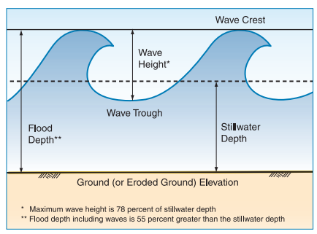
Empirical Formula:
500 Year Elevation With Wave Height =

500 Year FIS Study Elevation +

[.55 * (500 Year FIS Study Elevation - Ground Surface Elevation)]

Wave Height Calculation Table for Critical Facilities in Coastal Zones
Effective FIRM |  |  | Preliminary FIRM
500 Year Elevation | ^{Box 1A}  ^{NGVD29 NAVD88} | FT | 500 Year Elevation | ^{Box 2A}  ^{NAVD88} | FT
Ground Elevation | ^{Box 1B}  ^{NGVD29 NAVD88} | FT | Ground Elevation | ^{Box 2B}  ^{NAVD88} | FT
Wave Height  (.55*(Box 1A-Box 1B) | ^{Box 1C} | FT | Wave Height  (.55*(Box 2A-Box 2B) | ^{Box 2C} | FT
500 Year Elevation w/ Wave Height  (Box 1A + Box 1C) | ^{Box 1D}  ^{NGVD29 NAVD88} | FT | 500 Year Elevation w/ Wave Height  (Box 2A + Box 2C) | ^{Box 2D}  ^{NAVD88} | FT
Vertical Datum - Resulting Elevations below must be in same datum, if conversion factor needed, note here:  NAVD88 = NGVD29 - _____ft. | ^{Box 1E}  ^{NAVD88} | FT |  |  | Ft
Select highest Elevation from Effective (Box 1D or 1E)  and Preliminary (Box 2D)  Alll Elevations must be in NAVD88  This is your Class IV 500-Year Elevation à  ENTER RESULT IN WORKSHEET 2A, BOX G |  |  |  | ^{Box 3A} | FT  NAVD88

Part II. Determining Wave Height Adjustment Using Detailed Analyses
The empirical formula given in Part I, above, is a conservative estimate of the wave height adjustment to the preliminary and effective 500 year elevations in New Jersey’s coastal areas. If there are structures or protective works between a project and shoreline where waves break, additional analyses may be performed to further refine the wave runup using the following guidance documents: In areas where there are bulkheads, other houses, and structures between the water body and the proposed critical facility that can reduce wave height, there are more specific methodologies that could be used to analyze overland waves to determine the 500-year elevation including the wave height adjustment with more accuracy.
Determination of Wave Characteristics https://www.fema.gov/sites/default/files/documents/fema_determination-wave-characteristics-guidance_112021.pdf
Coastal Wave Runup and Overtopping https://www.fema.gov/sites/default/files/documents/fema_coastal-wave-runup-overtopping_112021.pdf
Coastal Wave Setup https://www.fema.gov/sites/default/files/2020-03/frm_p1wave1.pdfOverland
Wave Propagation https://www.fema.gov/sites/default/files/documents/fema-coastal-overland-wave-propagation_112021.pdf
These analyses should be performed by a licensed NJ Professional Engineer familiar with coastal erosion processes and the impact of wave loads on structures. It is recommended that the project designers contact the funding agency, the NFIP Coordinator’s Office, and the local Floodplain Administrator if these methodologies for determining wave height adjustments are pursued.
Wave Height Calculation Table for Critical Facilities in Coastal Zones
Effective FIRM |  |  | Preliminary FIRM
500 Year Elevation w/ Wave Height | ^{Box 4A} | FT | 500 Year Elevation w/ Wave Height | ^{Box 5A} | FT
Vertical Datum - Resulting Elevations below must be in same datum, if conversion factor needed, note here:  NAVD88 = NGVD29 - _____ft. | ^{Box 4B} | FT
Select highest Elevation from Effective (Box 4A or 4B)  and Preliminary (Box 5A) - ALL ELEVATIONS MUST BE IN NAVD88  This is your 500-Year Elevation à  ENTER RESULT IN WORKSHEET 2A: LOCAL DESIGN FLOOD ELEVATION, BOX G |  |  |  | ^{Box 6A} | FT  NAVD88
ATTACH DOCUMENTATION OF ALL ANALYSES INCLUDING THE SIGNATURE AND SEAL OF A LICENSED NJ PROFESSIONAL ENGINEER TO THIS WORKSHEET

Worksheet # 2C - Federal Flood Risk Management Standard Documentation Worksheet

Note: This worksheet is intended to be used with the following resources:
- New Jersey Guidebook for Implementing the Federal Flood Risk Management Standard
- WORKSHEET 1 and 2A: Local Design Flood Elevation (LDFE) Worksheet which determines the most restrictive Best Available Flood Hazard Data for either Coastal or Riverine.
- WORKSHEET 2B: Determining the Wave Height Adjusted 500 Year Preliminary and Effective Map Elevation for ASCE 24-14 Critical Facilities and Critical Actions under 44 CFR Part 9 (For Coastal)
- 44 CFR 9.4 FEMA Critical Action Definition and 44 CFR 9.11 Mitigation for guidance on critical action elevation standards
- June 3, 2022 FEMA Policy 104-22-0003 Partial Implementation of the Federal Flood Risk Management Standard for Hazard Mitigation Assistance Programs (Interim) https://www.fema.gov/sites/default/files/documents/fema_fp-104-22-0003-partial-implemetnation-ffrms-pa-interim.pdf
American Society for Civil Engineers (ASCE) Standard: ASCE 24-14 Flood Resistant Design and Construction
- The Flood Hazard Area Control Act and local Flood Damage Prevention Ordinance Regulations

FFRMS Worksheet Summary
Type of Action | Y/N | Federal Flood Risk Standard (FFRMS)
Non-critical Action¹ |  | Project Design Flood Elevation (from Applicable FFRMS Worksheet and Worksheet 1/2A, Box 5) | ___________ FT
Critical Action² |  | Vertical Datum Confirmation:  (Circle one) | NGVD or NAVD88
Floodplain Type:  (Check one) |  | Flood Zone  Designation | ___________
Riverine |  | LiMWA (Coastal A) or V Zone Construction (Check one) |  | Yes | No
Coastal
¹If yes, Use the FFRMS Non-Critical Action Worksheet
²If yes, Use the FFRMS Critical Action Worksheet

Project Name:
FFRMS Critical Action Worksheet
Complete only the Riverine or the Coastal Box on this Worksheet.

Building Class | RIVERINE | COASTAL
 | FFRMS Standard with State and Local Compliance
Class I  Class II  Class III  Class IV | - Complete Worksheet 1  - Enter the Elevation from Box 5, below  __________ FT NAVD88 | - Complete Worksheet 2B.  - Complete Worksheet 2A including Boxes 4, F, and G.  - Enter the Elevation from Box 5, below  __________ FT NAVD88
WORKSHEET 1 & 2A: Local Design Flood Elevation (LDFE) Worksheet which determines the most restrictive Best Available Flood Hazard Data – Box 5 must include vertical datum conversions to NAVD88 if necessary
WORKSHEET 2B: Determining the Wave Height Adjusted 500-Year Preliminary and Effective
FFRMS Non-Critical Action Worksheet
Complete only one of the six boxes on this Worksheet.

Building Class | RIVERINE | COASTAL
 | FFRMS Standard with State and Local Floodplain Compliance
Class  1 & 2 | - Complete Worksheet 1 including Box 3B  - Enter the Elevation from Box 5, below | - Complete Worksheet 2A including Boxes 3A and 3B  - Enter the Elevation from Box 5, below  _________ FT NAVD88
Class 3 | - Complete Worksheet 1 including Boxes 3, 4, and E.  - Enter the Elevation from Box 5, below | - Complete Worksheet 2B.  - Complete Worksheet 2A including Boxes 3A, 3B, 4, F, and G.  - Enter the Elevation from Box 5, below  _________ FT NAVD88
Class 4 | - Complete Worksheet 1 including Boxes F and G  - Enter the Elevation from Box 5, below  ______FT NAVD88 | - Complete Worksheet 2B.  - Complete Worksheet 2A including Boxes 3A, 3B, 4, F, and G.  - Enter the Elevation from Box 5, below  __________ FT NAVD88

WORKSHEET 1 and 2A: Local Design Flood Elevation (LDFE) Worksheet which determines the most restrictive Best Available Flood Hazard Data – Box 5 must include vertical datum conversions in necessary.
WORKSHEET 2B: Determining the Wave Height Adjusted 500 Year Preliminary and Effective

APPENDIX B: Model Floodplain Development Permit
FEMA has required participating communities to implement a floodplain management program, including permitting, since the 1968 National Flood Insurance Act. The National Flood Insurance Program requires a compliant floodplain management program as a condition of continued participation. In exchange for implementing an NFIP-compliant floodplain management program, property owners in the community to receive federally-subsidized insurance, federally-backed mortgages, and Small Business Administration loans. Participating communities are also eligible for public assistance to repair or mitigate publicly owned property after flooding.
The Model Permit was developed to assist floodplain managers and can be adapted to a community's floodplain characteristics. It can also reflect the zoned development/land uses in a participating community. This product provides checklists that coordinate with FEMA Technical Bulletins and ASCE 24. There are also appendices that include the State Land Resource Protection permit by Rule and General Permits that must be incorporated into local decision-making as required by FEMA's "Precedence Rule" (44 CFR 60.1(d)). Other State requirements such as deed restrictions for enclosures greater than 6 feet in height, riparian buffers and other best practices are also incorporated into the checklists.
The Model Permits are designed to be partially completed by applicants and provide a format for Floodplain Administrators to track compliance, violations, and variances. It also includes the new Local Design Flood Elevation Worksheet to ensure that best available data and local freeboard is determined consistently and tracked. Examples of this worksheet filled out for different scenarios can be found in Appendix A.

The Floodplain Development Permit application assists communities in evaluating impacts of activities proposed within New Jersey regulated floodplains or FEMA’s Special Flood Hazard Areas (SFHAs). All activities must be in compliance with the regulations and standards set forth by local, state, and federal entities. For residents and property owners to be eligible for national flood insurance rates under the National Flood Insurance Program (NFIP), For communities to receive certain kinds of federal monies, the community must agree to meet certain floodplain development standards. The Floodplain Development Permit application packet is a tool to ensure these standards are met. It should be noted that depending on the type of development, you may be required to hire a surveyor or engineer to help complete the required forms.
New Jersey NFIP Model Floodplain Development Permit
Prior to applying for a Floodplain Development Permit, the Applicant MUST obtain other required federal, state, and local permits, including the required New Jersey Land Resource Protection Permits set forth by the New Jersey Department of Environmental Protection (NJDEP). Refer to Appendix B of this application for a list of potential permit-by-rules, general permits-by certification, and general permits, or see your local Floodplain Administrator. All permits obtained for the project MUST be attached to this application.
If approved, a community official, or the Floodplain Administrator (FPA), will perform inspections throughout the project, as well as when the project is completed to ensure that the development is compliant with the requirements of the Local Flood Damage Prevention Ordinance, thus helping you get a better premium rate on flood insurance.
PART I
The Applicant (i.e. Owner/Builder/Engineer) completes the General Provisions.
PART II
Complete the Owner/Builder/Engineer Information and Project Overview.
Project Overview
Provide a description of the project location and attach a recent survey. Check all the applicable box(es) under project type that are being proposed.
PART IV
The FPA will determine the position of the proposed development relative to community floodplains and floodways. Flooding data and site specifications determined through FEMA and NJDEP will be included when applicable.
PART V
The FPA will indicate if the proposed development is conformant with the requirements of the local Flood Damage Prevention Ordinance, and if the requested permit is issued. If the decision is to NOT issue the permit, the FPA will provide an explanation of the perceived deficiencies to the Applicant.

APPLICATION INSTRUCTIONS
PART III
Complete and attach required information for the Flood Hazard Area Checklist Information and other permits.

Flood Hazard Area Checklist Information
Check all the applicable box(es) under “Flood Hazard Area Information Required for Review” and provide input when directed. Provide required documentation if applicable.

Other Permits
The Applicant must obtain other required federal, state, and local permits, including NJDEP Land Use Permits PRIOR to applying for a Floodplain Development Permit. Refer to Appendix B for a list of potential permits.

PART VI
The FPA will track inspection results and deficiencies. The elevation certificate representing final construction will also be reviewed for accuracy.

If you are proposing development of any kind (constructing a new building, adding on to an existing building, clearing land, placing fill, mining, drilling, etc.) in a floodplain as defined by NJDEP or FEMA, you MUST submit this application to your local FPA. Depending upon the type of development you are proposing, additional forms and/or permits may be required.
Per NFIP participation rules, if the property you propose to develop is located within a Special Flood Hazard Area on a FEMA FIRM, you MUST obtain a Floodplain Development Permit prior to beginning the project in accordance with the requirements of the local Flood Damage Prevention Ordinance of your community. Failure to do so may incur penalties, including high insurance rates.
For the purposes of this application, the “Applicant” is considered either the property owner, builder, or engineer. The “Applicant” cannot be the FPA. Typically, the Applicant completes Part I, II, & III of this application and submits the information to the local FPA. If any information is missing by the Applicant, the FPA will assist in filling in the missing information. The FPA reviews the submission, forms a determination, then notifies the Applicant of whether or not additional information is needed. Once all required materials have been submitted, the FPA will make a permitting decision and either issue a permit, which may include conditions of approval, or deny the requested permit.
[Add any community-specific text here.]

DEFINITIONS
ASCE 24: The standard for Flood Resistant Design and Construction referenced by the building code, and developed, and published by the American Society of Civil Engineers, Reston, VA. References to ASCE 24 shall mean ASCE 24-14 or the most recent version of ASCE 24 adopted in the UCC Code [N.J.A.C. 5:23].
Base Flood: A flood having a 1% chance (100-year) of being equaled or exceeded in any given year.
Base Flood Elevation (BFE): The water surface elevation resulting from a flood that has a 1% or greater chance of being equaled or exceeded in any given year, as shown in a published Flood Insurance Study (FIS), Flood Insurance Rate Map (FIRM) or preliminary flood elevation guidance from FEMA. May also be referred to as the “100-year flood elevation.”
Best Available Flood Hazard Data: The most recent available preliminary flood risk guidance FEMA has provided. The Best Available Flood Hazard Data may be depicted on but not limited to Advisory Flood Hazard Area Maps, Work Maps, or Preliminary FIS and FIRM.
Conditional Letter of Map Revision (CLOMR): A Conditional Letter of Map Revision (CLOMR) is FEMA's comment on a proposed project that would, upon construction, affect the hydrologic or hydraulic characteristics of a flooding source and thus result in the modification of the existing regulatory floodway or Special Flood Hazard Area (SFHA). The letter does not revise an effective FIRM map, it indicates whether the project, if built as proposed, would be recognized by FEMA. FEMA charges a fee for processing a CLOMR to recover the costs associated with the review as described in the Letter of Map Change (LOMC) process. Building permits cannot be issued based on a CLOMR, because a CLOMR does not change the FIRM map.
Critical Facility: Structures with American Society of Civil Engineers (ASCE) Class III and IV flood design classifications (as described in ASCE 24-14 Table 1.1) that provide services and functions essential to a community, especially during and after a disaster, and require additional freeboard for protection. Critical facilities with Class IV designations must be elevated or protected to 2 feet above DFE or to the 500-year (0.2% chance) flood elevation, whichever is higher.
Development: Any man-made change to improved or unimproved real estate, including but not limited to buildings or other structures, mining, dredging, filling, grading, paving, excavation or drilling operations or storage of equipment or materials.
Elevation Certificate: An administrative tool of the National Flood Insurance Program (NFIP) that can be used to provide elevation information, to determine the proper insurance premium rate, and to provide the support required for a Letter of Map Amendment (LOMA) or Letter of Map Revision based on Fill (LOMR-F).
Federal Emergency Management Agency (FEMA): The Federal agency under which the NFIP is administered.
FEMA Publications: Any publication authored or referenced by FEMA related to building science, building safety, or floodplain management related to the National Flood Insurance Program. Publications include but are not limited to technical bulletins, desk references, and ASCE 24.
Flood Hazard Area Design Flood Elevation (FHDFE): Per the New Jersey Flood Hazard Area Control Act, the peak water surface elevation that will occur in a water during the flood hazard area design flood. This elevation is determined via available flood mapping adopted by the State, flood mapping published by FEMA (including effective flood mapping dated on or after January 31, 1980, or any more recent advisory, preliminary, or pending flood mapping; whichever results in higher flood elevations, wider floodway limits, greater flow rates, or indicates a change from an A Zone to a V Zone or Coastal A Zone), approximation, or calculation pursuant to the Flood Hazard Area Control Act Rules at N.J.A.C. 7:13-3.1 – 3.6 and is typically higher than FEMA’s Base Flood Elevation (BFE). A water that has a drainage area measuring less than 50 acres does not possess, and is not assigned, a flood hazard area design flood elevation.
Flood Insurance Rate Map (FIRM): The official map on which FEMA has delineated both the areas of special flood hazards and the risk premium zones applicable to the community.
Flood Insurance Study (FIS): The official report of a community in which the FEMA has provided flood profiles, as well as Flood Insurance Rate Map(s) and the risk premium zones applicable to the community.
Floodplain or Flood Prone Area: Any land area susceptible to being inundated by floodwaters from any source.
Floodproofing: Any combination of structural and nonstructural additions, changes or adjustments to structures, which reduce or eliminate risk of flood damage to real estate or improved real property, water and sanitation facilities or structures with their contents.
Floodway: The channel of a river or other watercourse and the adjacent land areas that must be reserved in order to discharge the base flood without cumulatively increasing the water surface elevation more than 0.2 foot.
Freeboard: A factor of safety usually expressed in feet above a flood level for purposes of floodplain management. “Freeboard” tends to compensate for the many unknown factors that could contribute to flood heights greater than the height calculated for a selected size flood and floodway conditions, such as wave action, bridge openings, and the hydrological effect of urbanization of the watershed.
Letter of Determination Review (LODR): FEMA's ruling on the determination made by a lender or third party that a borrower's building is in a Special Flood Hazard Area (SFHA). A LODR deals only with the location of a building relative to the SFHA boundary shown on the Flood Insurance Rate Map (FIRM).
Letter of Map Amendment (LOMA): A Letter of Map Amendment (LOMA) is an official amendment, by letter, to an effective Flood Insurance Rate Map (FIRM) map that is requested through the Letter of Map Change (LOMC) process. A LOMA establishes a property's location in relation to the Special Flood Hazard Area (SFHA). LOMAs are usually issued because a property has been inadvertently mapped as being in the floodplain but is actually on natural high ground above the base flood elevation.
Letter of Map Revision (LOMR): A Letter of Map Revision (LOMR) is FEMA's modification to an effective Flood Insurance Rate Map (FIRM). LOMRs are generally based on the implementation of physical measures that affect the hydrologic or hydraulic characteristics of a flooding source and thus result in the modification of the existing regulatory floodway, the effective Base Flood Elevations (BFEs), or the Special Flood Hazard Area (SFHA). The LOMR officially revises the Flood Insurance Rate Map (FIRM) and sometimes the Flood Insurance Study (FIS) report, and when appropriate, includes a description of the modifications. A LOMR is issued only by FEMA.
Letter of Map Revision Based on Fill (LOMR-F): A Letter of Map Revision Based on Fill (LOMR-F) is FEMA's modification of the Special Flood Hazard Area (SFHA) shown on the Flood Insurance Rate Map (FIRM) based on the placement of fill outside the existing regulatory floodway. A LOMR-F may be initiated through the Letter of Map Change (LOMC) Process. A LOMR-F is issued only by FEMA.
Limit of Moderate Wave Action (LiMWA): Inland limit of the SFHA (AE Zone) affected by waves between 1.5 and 3 feet. Base Flood conditions between the V Zone and the LiMWA will be similar to, but less severe than, those in the V Zone. Also known as “Coastal A Zone” areas.
Local Design Flood Elevation (LDFE): The elevation reflective of the most recent available preliminary flood elevation guidance FEMA has provided as depicted on but not limited to Advisory Flood Hazard Area Maps, Work Maps, or Preliminary FIS and FIRM which is also inclusive of freeboard specified by the New Jersey Flood Hazard Area Control Act and Uniform Construction Codes and any additional freeboard specified in a community’s ordinance. In no circumstances shall a project’s LDFE be ​lower than a permit-specified Flood Hazard Area Design Flood Elevation or a valid NJDEP Flood Hazard Area Verification Letter plus the freeboard as required in ASCE 24 and the effective FEMA Base Flood Elevation.
Lowest Floor: In A Zones, the lowest floor is the top surface of the lowest floor of the lowest enclosed area (including basement). In V Zones and Coastal A Zones, the bottom of the lowest horizontal structural member of a building is the lowest floor. An unfinished or flood resistant enclosure, usable solely for the parking of vehicles, building access or storage in an area other than a basement is not considered a building's lowest floor provided that such enclosure is not built so as to render the structure in violation of other applicable non-elevation design requirements of these regulations.
Lowest Horizontal Structural Member: In an elevated building in a Coastal A Zone or Coastal High Hazard Area (VE Zone), the lowest beam, joist, or other horizontal member that supports the building is the lowest horizontal structural member. Grade beams installed to support vertical foundation members where they enter the ground are not considered lowest horizontal members.
National Flood Insurance Program (NFIP): The program of flood insurance coverage and floodplain management administered under the Act and applicable federal regulations promulgated in Title 44 of the Code of Federal Regulations, Subchapter B. This community has voluntarily chosen to receive the benefits of participation in this program by adopting a Floodplain Development Permit.
Preliminary FIRM & FIS: Preliminary flood hazard data and map products provide the public with an early look at their home or community‘s projected risk to flood hazards. Preliminary data may include new or revised Flood Insurance Rate Maps (FIRM), Flood Insurance Study (FIS) reports, and FIRM Databases.
Special Flood Hazard Area (SFHA): The greater of the following: (1) Land in the floodplain within a community subject to a 1% or greater chance of flooding in any given year, shown on the FIRM as Zone V, VE, V1-3-, A, AO, A1-30, AE, A99, or AH; (2) Land and the space above that land, which lies below the peak water surface elevation of the flood hazard area design flood for a particular water, as determined using the methods set forth in the New Jersey Flood Hazard Area Control Act in N.J.A.C. 7:13; (3) Riparian Buffers as determined in the New Jersey Flood Hazard Area Control Act in N.J.A.C. 7:13. Also referred to as the AREA OF SPECIAL FLOOD HAZARD.
Structure: A walled and roofed building, a manufactured home, or a gas or liquid storage tank that is principally above ground
[Add any community-specific definitions here.]

For Office Use Only:
Received Date: ______________
Permit File Number: _______________

Permit Application to be Filled out in Duplicate

PART I – GENERAL PROVISIONS - To Be Completed by the Applicant

GENERAL INFORMATION – To be read and signed by the Applicant
- No work of any kind may start in the NJ Flood Hazard Area or FEMA SFHA until all permits, including, but not limited to a floodplain development permit, are issued.
- This permit may be revoked if any false statements are made herein.
- If revoked, all work must cease until a permit is re-issued.
- Development shall not be used or occupied until a Certificate of Occupancy is issued.
- Work must commence within six (6) months of issuance or this permit will expire.
- The Applicant is hereby informed that other permits may be required to fulfill federal, state, or local regulatory requirements.
- The Applicant hereby gives consent to the Administrator or his/her representative to make reasonable inspections that are required to verify compliance.
- The Applicant certifies that “All statements herein and in attachments to the application are true and accurate to the best of my knowledge.”
_________________________ | ____________________________ | _____________
Name of Applicant | Signature of Applicant | Date

PART II – PROJECT INFORMATION - To Be Completed by the Applicant

PROPERTY OWNER INFORMATION
Name: |  |  | Phone Number:
Address: |  | Email:
City: | State: |  |  | Zip Code:

BUILDER INFORMATION
Name: |  |  | Phone Number:
Address: |  | Email:
City: | State: |  |  | Zip Code:

ENGINEER INFORMATION
Name: |  |  | Phone Number:
Address: |  | Email:
City: | State: |  |  | Zip Code:

PROJECT OVERVIEW (Attach survey and construction plan/documents if available)
Project Address:
Project Description:
Block: |  | Lot:
PROJECT TYPE (Check all that apply):
Type of Structure: | Type of Structural Activity: |  | Other Development Activities:
☐ Residential 1 – 4 Family | ☐ New Structure |  | ☐ Excavation
☐ Residential 5+ Family | Relocation |  | ☐ Placement of Fill Material
☐ Non-Residential | Replacement |  | ☐ Clearing
☐ Manufactured Home | Addition |  | ☐ Mining
☐ Accessory Structure | Alteration |  | ☐ Dredging
☐ Recreational Vehicle | ☐ Substantial Improvement |  | ☐ Drilling
☐ Detached Garage | ☐ Substantial Damage |  | ☐ Grading
☐ Subdivision  (New or Expansion) | ☐ Swimming Pool/  Spa Installation |  | ☐ Fill
☐ Agricultural Structure | ☐ Tanks |  | ☐ Watercourse Alterations  (incl. dredging/channel modifications)
☐ Utility or Miscellaneous  Group U Structure | ☐ Sanitary Sewerage Facilities including Septic Systems |  | ☐ Drainage Improvements (incl. culverts)
☐ Historic Structure on Federal or State Historic Preservation Registry (must provide documentation) | ☐ Water Facilities |  | ☐ Individual Water or Sewer System
 | ☐ Fence Installation |  | ☐ Road, Street, or Bridge Construction
 | ☐ Elevation Changes |  | ☐ Erosion-Control/Infrastructure Project
 | ☐ Retaining Wall |  | ☐ Bulkhead, Sea Wall, Revetment
 |  |  | ☐ Dune Construction/Repair
 |  |  | ☐ Other (incl. FEMA LOMA, LOMR, CLOMR, LOMR-F forms) (Please specify):
 |  |  | ___________________________________
PART III – REQUIRED DOCUMENTATION - To Be Completed by the Applicant

FLOOD HAZARD AREA CHECKLIST INFORMATION (See Appendix A)
Flood Hazard Area Information Required for Review | Included?
Provide an estimate of the current market value of the property:
Land $____________ Structure $____________
Provide an estimate of the total cost of building improvements using qualified labor and materials obtained at market prices. (Note: Unpaid or discounted labor and materials must be counted at their true market cost per the NFIP.) $____________
Estimates should either be signed and sealed by the Applicant’s architect or engineer, an estimating firm’s or contractor’s estimate signed and sealed by an engineer, or a bona fide contractor’s bid.
Plans – all submitted development plans must include sufficient detail to complete the permit review. See Appendix A for additional information.
All elevations on the submitted plans shall be in NAVD88.
Plans showing the location, layout, and elevation of existing and proposed development including parking areas, driveways, drainage, sewer, and water facilities (including connections), plantings, seedlings, fences, signs, and any other information necessary for managing the floodplain.
A Zone Construction – The dimensions, location, and elevation of the lowest floor (including basements) of existing and proposed structures. The elevations shall be in relation to NAVD88.
V Zone and Coastal A Zone Construction seaward of the Limit of Moderate Wave Action (LiMWA) – Plans must show the lowest horizontal member of the structure (including any venting, insulation, etc.) and the dimensions, location, and elevation of the lowest floor (including storage areas and garages) of existing and proposed structures. The elevations shall be in relation to NAVD88. Basements, mechanical pits, underground parking garages, etc. are prohibited in these zones. Construction must have open foundations. Back-filled stem walls are permissible in Coastal A Zones only. Completed V Zone Certifications and Breakaway Wall Certifications shall be included in the permit application.
Watercourses – The description of the extent of any watercourse, if any, which will be altered and/or relocated as the result of the proposed development must show exact location of the floodway and flood hazard area limits.
Wet and Dry Floodproofing Certification (non-residential or approved historic structures only) – Certification by a Professional Engineer or Architect that the floodproofing methods meet the floodproofing criteria in ASCE 24 for nonresidential structures. The plans must also show the elevation in relation to NAVD88 that a floodproofed structure is protected to. A partially completed Floodproofing Certification (completed by the Architect certifying the construction design) shall be included in the permit application and a fully completed Floodproofing Certification must be provided prior to occupancy.
For structures in more than one flood zone – If the structure is in more than one flood zone, the location and identification of all flood zones must be indicated on the survey and the most restrictive design flood elevation shall be used in all development plans.
For Elevators – plans shall comply with FEMA Technical Bulletin 4 and ASCE 24. All required flood-resistant construction information shall be noted on the plans.
For Below-Grade Parking Garages (not permitted for residential buildings and in Coastal A and V Zones) – plans shall comply with FEMA Technical Bulletins 3 and 6, note all required information on the plans, and include a partially completed Floodproofing Certification (completed by the Architect certifying the construction design), an Emergency Operations Plan, and an Inspection and Maintenance Plan in this application. A fully completed Floodproofing Certification must be provided prior to occupancy.
For Historic Structures – Documentation confirming that the property is listed on an approved State or Federal Historic Register inventory.
For Enclosures – Evidence of a Deed Restriction for the structure must be included in the permit application if enclosed space is greater than 6 feet in height as per N.J.A.C. 7:13-12.5(p)6. Local ordinances may also require a Non-Conversion Agreement.
FEMA LOMA, CLOMR, LOMR, LOMR-F forms shall be fully completed with documentation of a recent Endangered Species Program Review if a Community Acknowledgement is requested prior to submission to FEMA.
Elevation Certificates – Partially completed Elevation Certificates are required to be submitted at foundation completion and prior to inspection to ensure that the lowest floor or lowest horizontal structural member is properly elevated, and all required openings are properly constructed. A fully completed elevation certificate must be submitted prior to occupancy.
Additional Required Information:

OTHER PERMITS (See Appendix B)
The applicant must obtain the required Federal, State, and Local permits prior to applying for a Floodplain Development Permit (See Appendix B for a detailed list of agencies and permits).
The proposed development MUST be in compliance with other Federal, State, and Local laws.
List Other Permits obtained for the project:
(Attach obtained permits)
Permit by Type  (Federal, State, Local)  *Attach additional sheet if necessary | Permit # | Date of Issuance | Expiration  Date | Description

PART IV – FLOOD INFORMATION - To Be Completed by the Floodplain Administrator

FLOOD HAZARD DATA & LOCAL DESIGN FLOOD ELEVATION
Complete the Local Design Flood Elevation (LDFE) Worksheet in Appendix C and attach it to this permit. This will calculate the proper DFE and flood zone for the proposed development.

Worksheet completed: Y / N

For more information on the methods to determine the flood hazard area and DFE see
Technical Manual: Flood Hazard Area Control Act Rules, 2018 (https://www.nj.gov/dep/landuse/download/fh_044.pdf)

FLOOD HAZARD VERIFICATION
Unexpired NJDEP Land Resource Protection Flood Hazard Verification Letter with a Flood Hazard Area Design Flood Elevation Submitted?
Y / N Date:

Unexpired NJDEP Verification Letter with a Verification of Riparian Zone limits submitted?
Y / N Date:

Recent Permit Applicability Determination from the NJDEP Division of Land Resource Protection?
Y / N

Comments:

RIPARIAN ZONE¹
Stream Classification:
Category One within HUC-14: Yes / No |  | If Yes, Upstream | Or Downstream
Trout Status: | Trout Maintenance | Trout Production | NA
Threatened & Endangered Species Within 1 Mile Downstream: |  | Yes | No
Riparian Zone Width: | 50’ | 150’ | 300’
Riparian Zone Clearing: Yes / No |  | If Yes, how much? square feet
¹ Riparian zones exist along both sides of every regulated water, regardless of the water’s drainage area, and include the regulated water itself.

SITE SPECIFICATIONS (See Appendix D for additional sections to print and add to this section)
For any Community Acknowledgement requested,

- Has the applicant provided sufficient Endangered Species Assessment documentation? Y / N
Explain:

- Has the applicant documented the site is reasonably safe from flooding (see FEMA Technical Bulletin 10*)?
Y / N
Explain:

Note: Applications for Letters of Map Change with lowest floors including basements, parking garages, machine pits, etc. below the FEMA Base Flood Elevation will be returned to the municipality for enforcement action as a potential violation by FEMA. Further review of the request will be halted until the violation is addressed.
Substantial Damage / Substantial Improvement:
Substantial Improvement (SI) Estimate | $__________
Substantial Damage (SD) Estimate | $__________
Market Value of Property (Structure Only) | $__________ | Data Source: | ____________
Assessed Value of Property (Structure Only) | $__________
Substantial Improvement / Substantial Damage Percentage | _______ %
Cumulative SI/SD Amount (Optional) | $__________ | Since? | _________
Sufficient Corrosion Protection (FEMA Technical Bulletin 8*)? | Y / N
Is this a non-residential building? Y / N If yes, fill out section D-1 in Appendix D.
Is this building in a non-coastal A-Zone^? Y / N If yes, fill out section D-2 in Appendix D.
Is this building in a V Zone or Coastal A Zone^? Y / N If yes, fill out section D-3 in Appendix D.
Is this a multi-family or mixed-use building? Y / N If yes, fill out section D-4 in Appendix D.
Is this an agricultural structure? Y / N If yes, fill out section D-5 in Appendix D.
Is this an accessory structure? Y / N If yes, fill out section D-6 in Appendix D.
Is there an elevator proposed? Y / N If yes, fill out section D-7 in Appendix D.
Is there below-grade parking proposed? Y / N If yes, fill out section D-8 in Appendix D.
Wet Floodproofing (FEMA Technical Bulletin 7*):
Note: Floodproofing is allowed in non-residential buildings only. Prohibited in residential.
Corrosion-Protection? | Y / N
*https://www.fema.gov/nfip-technical-bulletins
^Non-coastal A Zone is defined as riverine areas or tidal areas landward of the Limit of Moderate Wave Action (LiMWA). Coastal A Zone is defined as tidal areas seaward of the Limit of Moderate Wave Action (LiMWA).

PART V – FLOODPLAIN DETERMINATION – To Be Completed by the Floodplain Administrator

PERMIT FINDINGS
Zoning Board (In conformance?)
Planning Board (In conformance?)
Require a NJDEP Land Use Permit?
(If so, the permit is required BEFORE completion of this application.)
(See Appendix B for NJDEP Permits)
Other Permits Required (Federal, State, or Local)
Permit Deficiencies (explain):

ACTIONS TAKEN TO CORRECT PERMIT DEFICIENCIES
Action: Date:

Action: Date:

Action: Date:

Action: Date:

PERMIT DETERMINATION
 | Permit Approved: The information submitted for the proposed project was reviewed and is in compliance with the flood damage prevention ordinance and New Jersey Flood Hazard Area Control Act rules.
Permit Approved with Conditions: The information submitted was reviewed and the project is conditionally approved assuming certain conditions are met. See attached.

Note: No permit shall be approved upon condition upon receiving a State Land Use permit or any other State, Federal, or Local Permit. UCC Building Permits must be received concurrently.
 | Permit Approved with Variance Granted: A variance was granted for the proposed project. This does not reduce flood risk and does not reduce flood insurance premiums. See attached.
 | Permit Denied: The proposed project does not comply with the flood damage prevention ordinance and/or New Jersey Flood Hazard Area Control Act rules. See attached.

PERMIT DATES (IF APPROVED)
Permit Number: | Issue Date: | Expiration Date:

Signature of Floodplain Administrator
I certify that the information herein and in attachments to the application are true and accurate to the best of my knowledge.
_________________________ | ____________________________ | _____________
Name of Floodplain Manager | Signature of Floodplain Manager | Date

PART VI – INSPECTION RESULTS – To Be Completed by the Floodplain Administrator

INSPECTIONS
Inspection 1: Site Survey | Date:
General Findings:

Construction Materials Used (water resistant?):

Elevations:

Violations:

Resolutions:
Inspection 2: Pre-Foundation | Date:
General Findings:

Construction Materials Used (water resistant?):

Elevations:

Violations:

Resolutions:
Inspection 3: Post-Foundation | Date:
General Findings:

Construction Materials Used (water resistant?):

Elevations:

Violations:

Resolutions:

VIOLATION TRACKING
Is this a Repeat Violation? Y / N
Permit Number:
Date of Final Decision:

Notice of Violation Date:
Start of 30-Day Period:
End of 30-Day Period:
Court Date:
Dates of Extensions:
Final Decision:

Referral Date for State Enforcement:

FEMA Section 1316 Request Date:
CERTIFICATION OF COMPLIANCE
Is the completed development in compliance with the Floodplain Development Permit?
(Circle one, sign, and provide a copy to the property owner and construction official.)
Yes / No Name: ________________________ Signature: ______________________ Date: ___________

Explain:
ELEVATION CERTIFICATE
Final Elevation Certificate Received Date:
Is the Elevation Certificate correct and in concurrence with the Floodplain Development Permit? (Circle one)

Yes / No

Explain:

END

APPENDIX C
Development Plan Requirements

- Two (2) sets of plans showing the existing and proposed work (all rooms in structures must be identified).
- Elevation view of any structure.
- Specify materials, if any, used for fire rating (must be flood-proof)
- Structural details including foundation, floor, wall, ceiling, and roof assemblies.
- Anchoring details of foundation, floor, walls, and roof assembly. Building must be designed to resist all loads, including flood, wind, and uplift, during flooding.
- Location of all mechanical systems (boilers, furnaces, air-conditioning, water heaters, pumps, duct work, etc.); all must be above the Design Flood Elevation (DFE). Sunken tubs are prohibited below the DFE.
- All outdoor air-conditioning units, oil, or propane tanks, unless subsurface, must be elevated and anchored above the DFE.
- The enclosed area below the DFE may only be used for storage, parking, access to the home, or non-livable space.
- The finished ground level of an under-floor space such as a crawl space must be equal to or higher than the outside finished ground level.
- All building material used below the DFE must be of flood resistant material.
- Indicate the type of material used for foundation, floor framing, insulation, walls, and floor finishes.
- Structures in VE Zone and Coastal A Zone must be designed and certified by a licensed Professional Engineer or Architect including breakaway walls.
- Decks in a VE Zone and Coastal A Zone may not be lower than the lowest horizontal member of the main structure (if attached to the structure)
- Flood vents shall be provided for enclosed areas below the DFE including for breakaway walls. Flood vents shall have an opening of 1 square inch per every 1 square feet of enclosed area. Each enclosed area shall have a minimum of 2 flood vents. Flood vents must be installed no more than 12 inches above grade.
- Electrical meter: provide a landing with stairs where required by the utility company for reading the meter.
- All proposed development must comply with the applicable FEMA publications and ASCE 24.

APPENDIX D
Other Applicable Permits

All applicable federal, state, and local permits listed below shall be obtained and plans shall reflect compliance with state requirements.

Agency | Permit/Authorization | Regulatory Authority | Description | Links
Delaware and Raritan Canal Commission | Delaware and Raritan Canal Commission Approval | Regulations for the Review Zone of the Delaware and Raritan Canal State Park (N.J.A.C. 7:45) | Review any action in the Canal Park and Review Zones A and B depending on the activity. In general, all projects located within Zone A are reviewed. Projects in Zone B that do not meet the Commission's definition are a major project are exempt from review. | https://www.nj.gov/dep/drcc/regulatory.html
NJDEP – Division of Land Use Regulation (DLUR) | Freshwater Wetlands Protection Act Permit | Freshwater Wetlands Protection Act (N.J.S.A. 13:9B) and Rules (N.J.A.C. 7:7A) | Regulates activities within jurisdictional wetlands, their transition areas, and State open waters | https://www.nj.gov/dep/landuse/fww/fww_main.html  https://www.nj.gov/dep/landuse/download/13_9b.pdf  https://www.nj.gov/dep/rules/rules/njac7_7a.pdf
 | *Flood Hazard Area Protection Act Permit | Flood Hazard Area Control Act (N.J.S.A. 58:16A) and Rules (N.J.A.C. 7:13) | Regulates activities within regulated waters, flood hazard areas, and riparian zones. | https://www.nj.gov/dep/landuse/fha_main.html  https://www.nj.gov/dep/landuse/download/58_16a_50.pdf  https://www.nj.gov/dep/rules/rules/njac7_13.pdf
 | **Coastal Area Facilities Review Act (CAFRA) Permit | CAFRA (N.J.S.A. 13:19)  Coastal Zone Management Rules (N.J.A.C. 7:7) | Regulates activities within the CAFRA zone. Project must demonstrate compliance with the Coastal Zone Management Rules which defines Special Areas of environmental interest and compliance criteria. | https://www.nj.gov/dep/landuse/coastal/cp_main.html  https://www.nj.gov/dep/landuse/download/13_19.pdf  https://www.nj.gov/dep/rules/rules/njac7_7.pdf
 | **Waterfront Development Act Permit | Waterfront Development Act (N.J.S.A. 12:5-3)  Coastal Zone Management Rules (N.J.A.C. 7:7) | Regulates activities in the Waterfront area. The Waterfront area is divided into three sections. Details of each section can be found in the Coastal Permit Program Rules at N.J.A.C. 7:7-2.3. As well as all tidal waterways, the waterfront area includes all man-made waterways and lagoons subject to tidal influence found within any three of the geographical areas. | https://www.nj.gov/dep/landuse/coastal/cp_main.html  https://www.nj.gov/dep/landuse/download/12_5_3.pdf  https://www.nj.gov/dep/rules/rules/njac7_7.pdf
 | **Coastal Wetlands Act Permit | Wetlands Act of 1970 (N.J.S.A. 13:9A)  Coastal Zone Management Rules (N.J.A.C. 7:7) | Regulated activities in delineated and mapped coastal wetlands pursuant to the Wetlands Act of 1970. | https://www.nj.gov/dep/landuse/coastal/cp_main.html  https://www.nj.gov/dep/rules/rules/njac7_7.pdf  https://www.nj.gov/dep/landuse/download/13_9a.pdf
 | Highlands Preservation Area Approval | Highlands Water Protection and Planning Act (N.J.A.C. 13:20) and Rules (N.J.A.C. 7:38) | Regulates all "major Highlands Developments" as defined by the Highlands Act, in the Preservation Area unless otherwise exempt by the Act. The Highlands Area is located in the northwestern portion of the state. | https://www.nj.gov/dep/landuse/highlands.html  https://www.nj.gov/dep/landuse/download/13_20.pdf  https://www.nj.gov/dep/rules/rules/njac7_38.pdf
 | Water Quality Certification | Section 401 of the Federal Clean Water Act  Freshwater Wetlands Protection Act (N.J.S.A. 13:9B) and Rules (N.J.A.C. 7:7A)  Coastal Zone Management Rules (N.J.A.C. 7:7) NJ Water Pollution Control Act (N.J.S.A. 58:10A) | All projects requiring a Federal permit for the discharge of dredged or fill material into State waters and/or their adjacent wetlands also require the State Water Quality Certification which ensures consistency with State water quality standards. This also applies to Waters of the U.S. | None
 | Tidelands Instruments | Tidelands Act (N.J.S.A. 12:3) | Tidelands are those lands now or formerly flowed by the mean high tide of a natural waterway. These lands are Stated owned or claimed to be owned. Activates on State owned tidelands requires a tidelands grant, lease or license. | https://www.nj.gov/dep/landuse/tl_main.html  https://www.nj.gov/dep/landuse/download/12_3.pdf
Agency | Permit/Authorization | Regulatory Authority | Description | Links
NJDEP – Division of Water Quality Bureau of Nonpoint Pollution Control | New Jersey Pollution Discharge Elimination System Construction Activity Stormwater GP | Federal Clean Water Act  NJ Pollution Discharge Elimination System Rules (7:14A) | This general permit authorizes point source discharges from certain construction activities resulting in 1 acre or more of ground disturbance. Regulated entities are required to develop a soil erosion and sediment control plan aimed at eliminating the flow of contaminated rainwater into streams and rivers. Soil Erosion and Sediment Control Certification is required to complete the application. Additional "good-housekeeping" requirements are included in the permit. Please note that this permit is in addition to compliance with the Stormwater Management Rules (N.J.A.C. 7:8) discussed above. | https://www.nj.gov/dep/dwq/5g3.htm
NJ Sports and Exposition Authority (NJSEA) | NJSEA Approval | Hackensack Meadowlands District Regulations (N.J.A.C. 19:3) | If a project disturbance results in the need for a USACOE permit, then a NJSEA approval will also be needed. There may be other circumstances that would require a NJSEA approval. This may need to be evaluated on a case by case basis. | None
NJ Pinelands Commission | NJ Pinelands Approval | Pinelands Protection Act (N.J.S.A. 13:18A)  Pinelands Comprehensive Management Plan (N.J.A.C. 7:50) | Establishes regulations and standards designed to promote orderly development in the Pinelands. Proposed activities within the Pinelands requires review and approval.  The Pinelands Capability Map establishes 9 land use management areas with goals, objectives, development intensities, and permitted uses for each. | https://nj.gov/pinelands/
Soil Conservation District | Soil Erosion and Sediment Control Certification | Soil Erosion and Sediment Control Act (Chapter 251, P.L. 1975) | Projects resulting in 5,000 sq ft of ground disturbance or greater must submit a soil erosion and sediment control plan to the appropriate soil conservation district for certification. | https://www.nj.gov/agriculture/divisions/anr/nrc/njerosion.html
United States Army Corps of Engineers (USACE) | Army Permit | Section 404 of the Federal Clean Water Act | Regulates the discharge of dredged or fill material into waters of the United States, including jurisdictional wetlands. | https://www.nap.usace.army.mil/Missions/Regulatory.aspx  https://www.nan.usace.army.mil/Missions/Regulatory/
 |  | Section 10 of the Rivers and Harbors Act of 1899 | Prohibits creation of obstructions to navigable capacity of any of the waters of the United States without prior authorization of the USACE.

*See FHACA Permits-by-Rule, General Permits-by-Certification, General Permits-by-Category below
**See CZM Permits-by-Rule, General Permits-by-Certification, General Permits-by-Category below

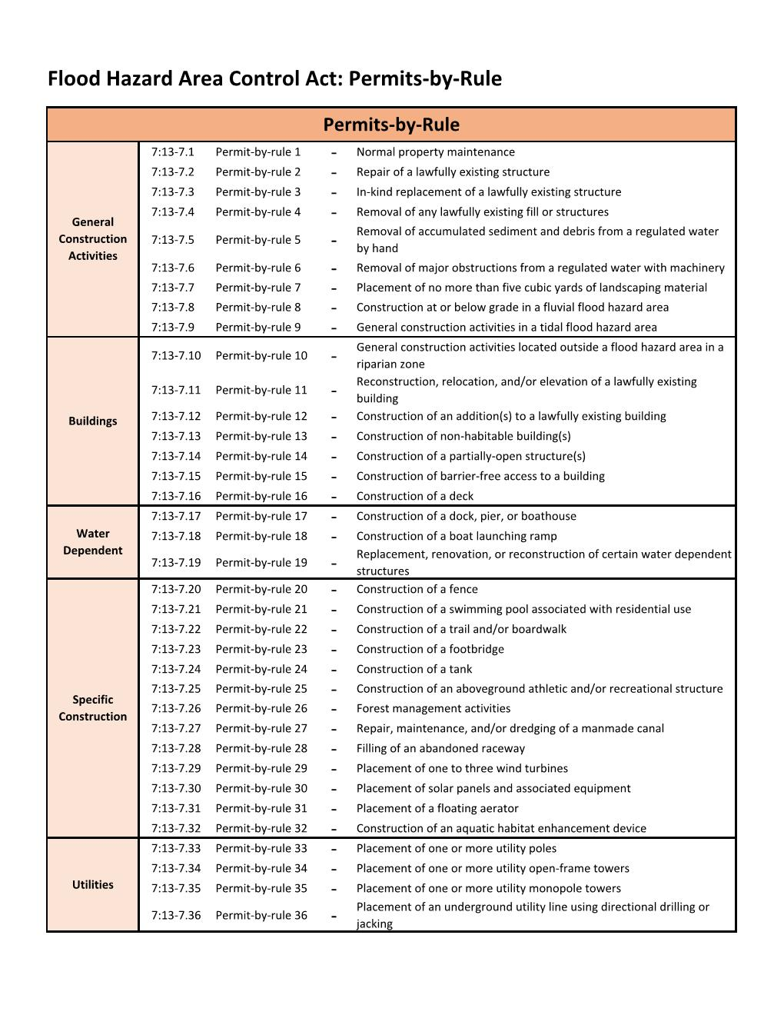

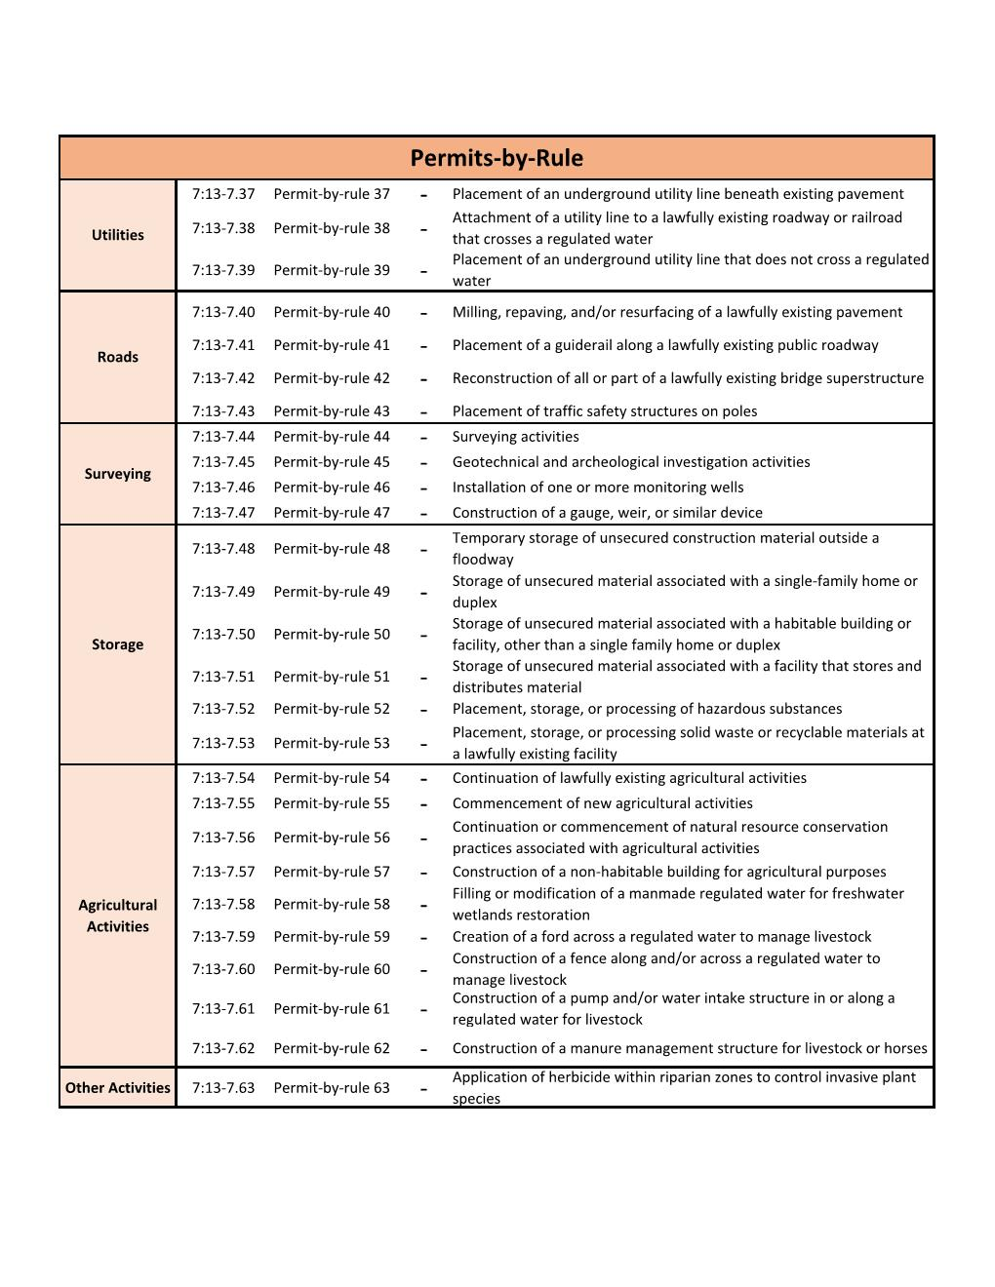
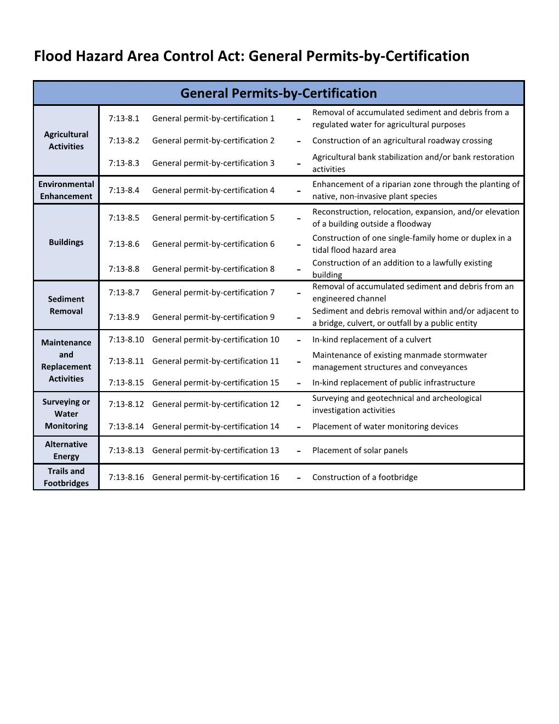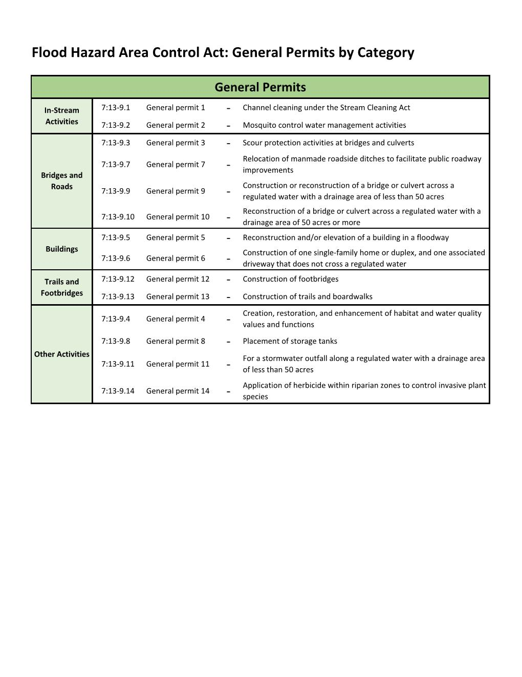

Note: Development under the jurisdiction of the Coastal Zone Management (CZM) Rules do not require a separate NJDEP Flood Hazard Area Control Act (FHACA) Permit. However, per Section 7:7-9.25 of the CZM Rules, the development must still meet the NJDEP FHACA Rules. Furthermore, any development listed under a CZM Permit-by-Rule, General Permit-by-Certification, or General Permit that is regulated under the NFIP, must still be reviewed by the FPA and issued a Floodplain Development Permit. Examples include but are not limited to single-family home construction or expansion, as well as filling tidelands.

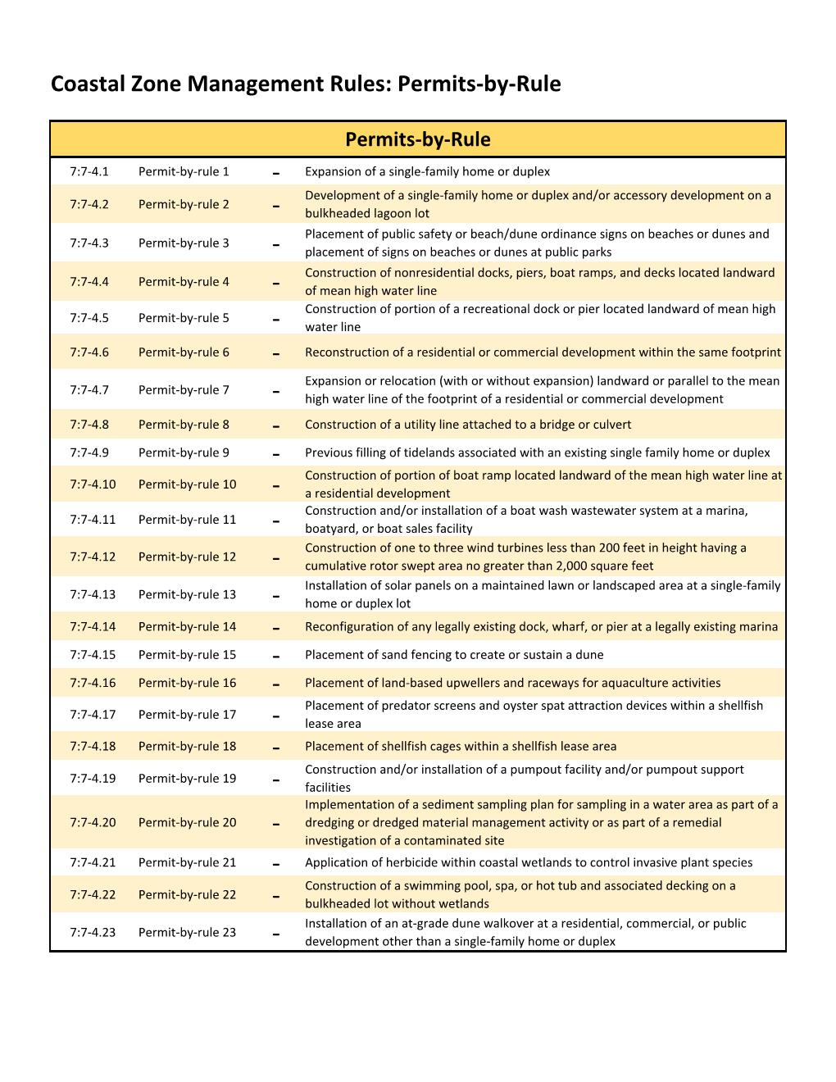
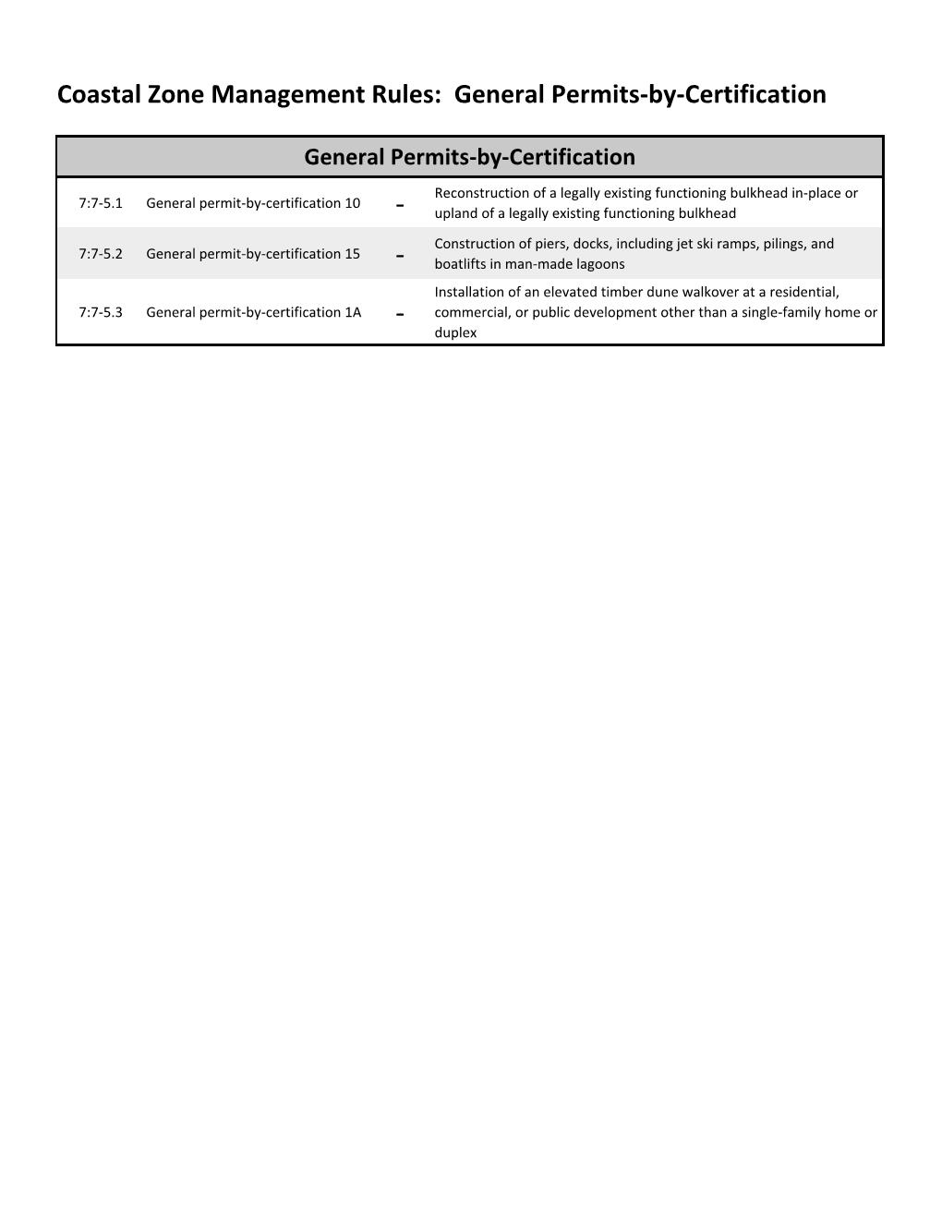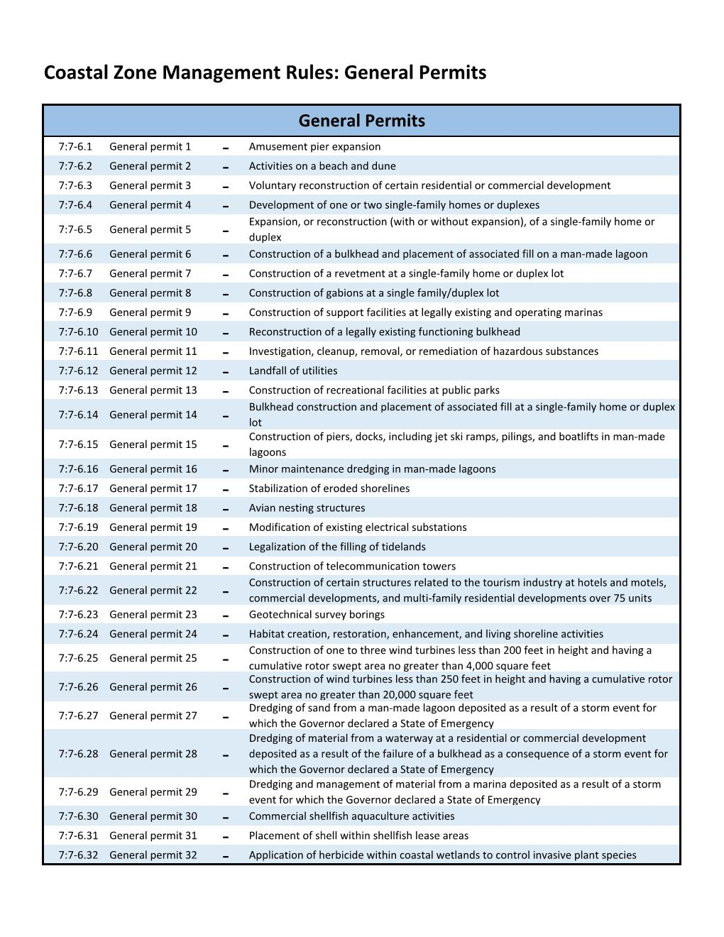

APPENDIX E
PART IV – FLOOD INFORMATION – Site Specifications

PART IV – FLOOD INFORMATION - To Be Completed by the Floodplain Administrator

Non-residential building: Section D-1
Building in a non-coastal A-Zone^: Section D-2
Building in a V Zone or Coastal A Zone^: Section D-3
Multi-family or mixed-use building: Section D-4
Agricultural structure: Section D-5
Accessory structure: Section D-6
Elevator proposed: Section D-7
Below-grade parking proposed: Section D-8

^Non-coastal A Zone is defined as riverine areas or tidal areas landward of the Limit of Moderate Wave Action (LiMWA). Coastal A Zone is defined as tidal areas seaward of the Limit of Moderate Wave Action (LiMWA).

D-1
SITE SPECIFICATIONS – NON-RESIDENTIAL BUILDINGS ONLY
Lowest Electrical/Mechanical Equipment | Description: | ____________________________
Dry Floodproofing Certificate for areas below the Base Flood Elevation plus a minimum of 1-foot Freeboard | Y / N
Flood Resistant Materials | Y / N

D-2
SITE SPECIFICATIONS – A ZONE BUILDINGS^
Note: Incl. accessory structures, detached garages, and storage sheds.
Subgrade crawlspaces and basements are prohibited.
Top of Lowest Floor Elevation | __________
Openings in Walls and Foundations (see FEMA Technical Bulletin 1*):
- Number of openings in walls and foundations | __________
- Square inches of all openings | __________
- Engineered openings | Y / N
- Engineered opening manufacturer and model | __________
- Architect/Engineer Certification of Non-Engineered opening | Y / N
Anchoring (manufactured homes, accessory buildings, storage sheds, recreational vehicles on-site greater than 180 days) | Y / N
Architect/Engineered Certification for Back-filled Stem Walls | Y / N
*https://www.fema.gov/nfip-technical-bulletins
^Non-coastal A Zone is defined as riverine areas or tidal areas landward of the Limit of Moderate Wave Action (LiMWA). Coastal A Zone is defined as tidal areas seaward of the Limit of Moderate Wave Action (LiMWA).
D-3
SITE SPECIFICATIONS – V ZONE AND COASTAL A ZONE^ BUILDINGS
Lowest Horizontal Member Elevation | ________
Size of Enclosure (must be less than 300 square feet external dimension for lower insurance rates) | ________
Use of Enclosure | _______________
Number of openings in breakaway walls | ________
Coastal A Zone Breakaway Wall Certification | Y / N
Non-Conversion Agreement Attached | Y / N
- Deed Restricted | Y / N
Free of Obstruction (see FEMA Technical Bulletin 5*):  - Access Ramps/Stairs/Decks are open to water flow | Y / N
- Access Ramps / Stairs / Decks are structurally supported and independent of the Structure | Y / N
- Engineer’s Certificate for Breakaway Walls, Engineered Walls, Slabs, or Other Potential Obstructions where Piles and Columns are not feasible | Y / N
*https://www.fema.gov/nfip-technical-bulletins
^Non-coastal A Zone is defined as riverine areas or tidal areas landward of the Limit of Moderate Wave Action (LiMWA). Coastal A Zone is defined as tidal areas seaward of the Limit of Moderate Wave Action (LiMWA).

D-4
SITE SPECIFICATIONS – MULTI-FAMILY AND MIXED-USE BUILDINGS
See: FEMA Flood Mitigation Measures for Multi-Family Buildings^ & NFIP Technical Bulletin 3 - Requirements for the Design and Certification of Dry Floodproofed Non-Residential and Mixed-Use Buildings*

Notes: Basements and below grade parking area prohibited below residential portions of multi-family structures including those for hotels and motels. Dry floodproofing is prohibited in non-residential portions of mixed-use structures in Coastal A and V Zones. Dry floodproofing is prohibited for all areas servicing residential areas and ancillary portions of residential structures which service residential areas. At least one access to residential areas must be available for use and cannot be dry floodproofed. Building systems servicing residential portions of structures cannot be located in dry-floodproofed areas and must be elevated above the LDFE.

ASCE 24-14 limits dry floodproofing:
- To areas where the base flood velocities do not exceed 5 feet/second; and
2) Any proposed human intervention is in conformance with ASCE 24-14 6.2.3
Below grade basements and parking do not service any residential portions of the structure? | Y / N
Below grade basements and parking are not located in a Coastal A Zone or V Zone based upon an evaluation of the most recent best available flood hazard data? | Y / N
No residential areas including at least one building egress are dry floodproofed and all residential areas including those meeting the definition of ancillary space are above the BFE? | Y / N
All residential areas including those meeting the definition of ancillary space are above the BFE? | Y / N
Mechanical, Electrical, and Plumbing Systems are located at or above the LDFE or if below the LDFE are designed to resist flood loads and prevent water from entering or accumulating within the components and service only non-residential portions of the structure and meets the requirements of chapter 7, ASCE 24-14? | Y / N
Substantial Improvement and Substantial Damage measures meet standards and practices discussed in the FEMA Mitigation Measures for Multi-Family Buildings^? | Y / N
A Floodproofing Certificate for non-residential portions of the structure has been submitted at permit application? | Y / N
An Emergency Operations Plan for floodproofing in non-residential portions of the structure has been submitted at permit application and meets ASCE 24-14 6.2.3?  Note: This shall include meeting the 12-hour flood warning time unless the community operates a flood warning system. If so, the designer will have to determine the available time necessary to implement dry floodproofing measures. | Y / N
All proposed floodproofing products used in non-residential areas meet American National Standard for Flood Mitigation Equipment (ANSI/FM)? | Y / N
Inspection and Maintenance Plan proposed at permit application?  Note: Inspections are recommended at least once a year and could be coordinated with regular drills. | Y / N
The architect/engineer has provided evidence that the structure can withstand a combination of flood loads (hydrostatic, hydrodynamic, wave, and impact) according to ASCE 7? | Y / N
The Floodproofing Certificate has been fully completed at project completion? | Y / N
^https://content.govdelivery.com/attachments/USDHSFEMA/2020/06/24/file_attachments/1481529/16-J-0218_Multi-FamilyGuidance_06222020.pdf
*https://www.fema.gov/nfip-technical-bulletins

D-5
SITE SPECIFICATIONS – AGRICULTURAL STRUCTURES
FEMA Floodplain Management Bulletin P-2140 Floodplain Management Requirements for Agricultural Structures and Accessory Structures*

Note: Variances can only be granted in municipalities that have adopted the New Jersey Model Code Coordinated Ordinance after January 2021.
Meets the FEMA or Model Code Coordinated Ordinance definition of Agricultural Structure and is used exclusively for that use? | Y / N
If Substantial Improvement / Substantial Damage is determined, is elevation required? | Y / N
If Substantial Improvement / Substantial Damage is determined and the structure type requires dry-floodproofing, is the floodproofing proposed to the LDFE?  Note: Structure cannot be located in a V Zone or Coastal A Zone. | Y / N
Variance requested to repair/restore to pre-flood condition and wet floodproof? | Y / N
If a variance is requested, is justification provided with an explanation of the hardship? | Y / N
Is a variance granted that restricts use? | Y / N
Is the structure anchored? Is mechanical equipment raised? Are flood resistant materials used? Does the foundation have adequate openings? | Y / N
*https://www.fema.gov/nfip-technical-bulletins

D-6
SITE SPECIFICATIONS – ACCESSORY STRUCTURES
FEMA Floodplain Management Bulletin P-2140 Floodplain Management Requirements for Agricultural Structures and Accessory Structures*

Note: Variances can only be granted in municipalities that have adopted the New Jersey Model Code Coordinated Ordinance after January 2021.
Meets the FEMA or Model Code Coordinated Ordinance definition of an Accessory Structure and is used exclusively for that use? | Y / N
New Construction or Substantial Improvements – Elevation Required? | Y / N
New Construction or Substantial Improvements – Dry-floodproofed at least to the LDFE? | Y / N
Variance Requested to Wet floodproof and the New Jersey Model Code Coordinated Ordinance is adopted? | Y / N
If a variance is requested, is justification provided with an explanation of the hardship? | Y / N
A Zone – Structure is the size of a one-story two-car garage or smaller and not in a floodway?  Note: FEMA guidance notes that the typical footprint is less than 600 square feet (See page 19 of the Technical Bulletin). | Y / N
V Zone – Structure is less than 100 square feet? | Y / N
Variance granted that restricts use? | Y / N
Is the structure anchored? Is mechanical equipment raised? Are flood resistant materials used? Does the foundation have adequate openings? | Y / N
*https://www.fema.gov/nfip-technical-bulletins

D-7
SITE SPECIFICATIONS – ELEVATORS
Proposed Elevator meets FEMA Technical Bulletin 4*
Note: Please coordinate with your code official when reviewing elevator compliance in the SFHA.
Elevation of lowest Electronic Controls/Junction Box/Switch | __________
Lowest elevation of electronic controls is above the LDFE | Y / N
Components below the required elevations are composed of flood damage-resistant materials and capable of resisting physical damage due to flooding | Y / N
Float Switch Detection System to prevent the elevator cab or lift from descending into flood waters | Y / N
Backflow Prevention for elevator shafts | Y / N
Architect’s/Engineer’s Certification stating that the enclosure design can resist hydrodynamic and hydrostatic flood forces  Note: Elevator shafts must resist flood loads. In Zone A, shafts are not required to have flood openings; in Zone V and Coastal A Zones, shafts are not required to have breakaway walls. | Y / N
Confirm that any hydraulic elevators below the required elevation have elevated electrical control panels, hydraulic pumps, and tanks; drainage provided for the elevator pit; hydraulic lines, hydraulic cylinders, and buffer springs located to prevent physical damage due to flooding or painted or coated with galvanic or rust-preventive paint | Y / N
Confirm that any traction elevator systems have elevated machine rooms, and components in hoist ways below the required elevation must be protected from physical damage due to flooding | Y / N
Chairlifts, pneumatic elevators, and platform lifts are reasonably safe from flooding (See ASCE24-14 7.5 and related commentary) | Y / N
*https://www.fema.gov/nfip-technical-bulletins

D-8
SITE SPECIFICATIONS – BELOW-GRADE PARKING REQUIREMENTS
See: FEMA Technical Bulletin 6*, FEMA Flood Mitigation Measures for Multi-Family Buildings^, and NFIP Technical Bulletin 3* (if applicable, also use Checklist D-4)

Notes: Below-Grade Parking is prohibited in Coastal A Zones and V Zones. Below-Grade Parking is prohibited in Residential Buildings and is allowed only for non-residential portions of Mixed-Use Buildings.
An exit is available above the LDFE | Y / N
The Below-Grade Parking Garage is not located in a Coastal A Zone or V Zone based upon the most recent best available flood hazard data | Y / N
A Floodproofing Certificate for the structure has been submitted at permit application (See FEMA Technical Bulletin 3*) | Y / N
There are no residential uses proposed for the building | Y / N
Emergency Operations Plan for floodproofing in non-residential portions of the structure has been submitted at permit application that meets ASCE 24-14 6.2.3  Note: This shall include meeting the 12-hour flood warning time unless the community operates a flood warning system. If so, the designer will have to determine the available time necessary to implement dry floodproofing measures. (See FEMA Technical Bulletin 3*) | Y / N
All proposed floodproofing products used in non-residential areas meet American National Standard for Flood Mitigation Equipment (ANSI/FM) | Y / N
Inspection and Maintenance Plan proposed at permit application  Note: Inspections are recommended at least once a year and could be coordinated with regular drills. (See FEMA Technical Bulletin 3*) | Y / N
The architect/engineer has provided evidence that the structure can withstand a combination of flood loads (hydrostatic, hydrodynamic, wave, and impact) according to ASCE 7 | Y / N
The Floodproofing Certificate has been fully completed at project completion | Y / N
*https://www.fema.gov/nfip-technical-bulletins
^https://content.govdelivery.com/attachments/USDHSFEMA/2020/06/24/file_attachments/1481529/16-J-0218_Multi-FamilyGuidance_06222020.pdf

APPENDIX F: Example Certificates & Forms
(Elevation Certificate, Floodproofing Certificate, Non-Conversion Agreement, No-Rise Certificate, V Zone Design Certificate, SD/SI Determination & Letters)

Note: Communities must maintain on file the applicable forms below, as received through the Floodplain Development Permit Process.
- Elevation Certificate: The Elevation Certificate (EC) is an NFIP form used to record elevation information necessary to ensure compliance with community Flood Damage Prevention Ordinances; to determine the proper NFIP flood insurance premium rate; and/or support a request for a Letter of Map Amendment (LOMA) to remove a building from the SFHA. For communities in the CRS program, ECs are required to be maintained on file for new and substantially improved/damaged structures in the SFHA.
- The latest EC can be found on FEMA’s website:
https://www.fema.gov/sites/default/files/2020-07/fema_nfip_elevation-certificate-form-instructions_feb-2020.pdf
- Floodproofing Certificate: The Floodproofing Certificate is an NFIP form used to document certification by a registered professional engineer or architect that the design and construction methods of a floodproofed non-residential building follow accepted practices and meet the requirements outlined in the community Flood Damage Prevention Ordinance. This documentation is required for both floodplain management requirements and insurance rating purposes.
For NFIP flood insurance rating purposes, a building’s floodproofed design elevation must be at least one foot above the Base Flood Elevation (BFE) to receive full rating credit for the floodproofing. If the building is floodproofed only to the BFE, the flood insurance rates will be considerably higher.
For NJ FHACA compliance purposes, like the NFIP, residential buildings may not be floodproofed, however, non-residential building that are floodproofed must be floodproofed to 1 foot above the Local Design Flood Elevation. (N.J.A.C 7:13-12.5(r-u))
- The latest Floodproofing Certificate can be found on FEMA’s website: https://www.fema.gov/sites/default/files/2020-05/FF-086034_Nonres_Floodproofing_RE_11Feb2020.pdf
(Note: The PDF may not display properly in a browser – be sure to download the PDF and then open in Adobe.)
- Non-Conversion Agreement: Non-Conversion Agreements are a critical tool in ensuring enclosures below the Local Design Flood Elevation remain in compliance with the NFIP and community Flood Damage Prevention Ordinance. Namely that they are only used for parking, access, or storage and are not converted to habitable, living spaces. Communities are highly encouraged to create their own Non-Conversion Agreements that include the following:
  - Allow periodic inspections by local officials after the Certificate of Occupancy is issued (to deter illegal conversions)
  - Require deed restriction of the Non-Conversion Agreement
  - Upon resale, withhold the Certificate of Occupancy from the new buyers if an illegal conversion was performed
- Non-Conversion Agreement Examples can be found on FEMA’s website: https://www.fema.gov/media-library/assets/documents/84059
- No-Rise Certificate: NFIP regulations state any project in a floodway must be reviewed to determine if the project will increase flood heights. To determine this, an engineering analysis must be conducted, the results documented, and a No-Rise Certification signed by a registered professional engineer. Although the NJ FHACA prohibits new building construction in the floodway, channel improvements such as culvert or bridge replacement still require a No-Rise Certification.
Example “No-Rise Certificate”
This is to certify that I am a duly qualified registered professional engineer licensed to practice in the State of New Jersey.
It is further to certify that the attached technical data supports the fact that proposed ______________________ [Name of Development Project] will not impact the 1-percent-annual-chance flood, floodway elevations, or floodway widths on _______________ [Name of Stream] at published cross sections in the Flood Insurance Study for _______________ [Name of Community] dated ______________ [Study Date] and will not impact unpublished cross sections in the vicinity of the proposed development and also will not impact the NJ Flood Hazard Area Design Flood for this stream.
Attached are the following documents that support my findings:

Date: | Seal:
Signature:
Title:

- V Zone Design Certificate: NFIP regulations state that buildings built in “V” Zones must be built to withstand wind and water forces acting simultaneously. A registered professional engineer or architect must certify that the design and construction methods meet NFIP and community Flood Damage Prevention Ordinance requirements.
If breakaway walls are used to enclose areas below the building that exceed a design safe loading resistance of 20 pounds per square feet, those walls must also be certified by the registered professional engineer or architect.
Example “V Zone Design Certificate”

Name ______________________________ Policy Number (Insurance Co. Use) _______________
Building Address or Other Description ________________________________________________
Permit No. ________________ City _____________________ State _______ Zip Code _________

SECTION I: Flood Insurance Rate Map (FIRM) Information

Community No. __________ Panel No. ________________ Suffix _____
FIRM Date __________ FIRM Zone(s) ______________

SECTION II: Elevation Information Used for Design

[NOTE: This section documents the elevations/depths used or specified in the design – it does not document surveyed elevations and is not equivalent to the as-built elevations required to be submitted during or after construction.]

1. FIRM Base Flood Elevation (BFE)................................................................................._____ feet*
2. Community’s Design Flood Elevation (DFE) ................................................................_____ feet*
3. Elevation of the Bottom of Lowest Horizontal Structural Member ............................_____ feet* 4. Elevation of Lowest Adjacent Grade..........................................................................._____ feet*
5. Depth of Anticipated Scour/Erosion used for Foundation Design.............................._____ feet*
6. Embedment Depth of Pilings or Foundation Below Lowest Adjacent Grade.............._____ feet*
* Indicate elevation datum used in 1-4: ❑ NGVD29 ❑ NAVD88 ❑ Other ______________

SECTION III: V Zone Design Certification Statement

I certify that: (1) I have developed or reviewed the structural design, plans, and specifications for construction of the above referenced building and (2) that the design and methods of construction specified to be used are in accordance with accepted standards of practice** for meeting the following provisions:

- The bottom of the lowest horizontal structural member of the lowest floor (excluding piles and columns) is elevated to or above the BFE.
- The pile and column foundation and structure attached thereto is anchored to resist flotation, collapse, and lateral movement due to the effects of the wind and water loads acting simultaneously on all building components. Water loading values used are those associated with the base flood***. Wind loading values used are those required by the applicable State or local building code. The potential for scour and erosion at the foundation has been anticipated for conditions associated with the base flood, including wave action.

SECTION IV: Breakaway Wall Design Certification Statement

[NOTE. This section must be certified by a registered engineer or architect when breakaway walls are designed to have a resistance of more than 20 psf (0.96 kN/m2) determined using allowable stress design.]

I certify that: (1) I have developed or reviewed the structural design, plans, and specifications for construction of breakaway walls to be constructed under the above-referenced building and (2) that the design and methods of construction specified to be used are in accordance with accepted standards of practice** for meeting the following provisions:

- Breakaway wall collapse shall result from a water load less than that which would occur during the base flood***.
- The elevated portion of the building and supporting foundation system shall not be subject to collapse, displacement, or other structural damage due to the effects of wind and water loads acting simultaneously on all building components (see Section III).

SECTION V: Certification and Seal

This certification is to be signed and sealed by a registered professional engineer or architect authorized by law to certify structural designs. I certify the V Zone Design Certification Statement (Section III) and _____ the Breakaway Wall Design Certification Statement (Section IV, check if applicable).

Certifier’s Name_________________________ License Number ____________________
Title __________________________________ Company Name ____________________
Address _________________________________________________________________
City __________________________________ State _____Zip Code ________________
Signature ________________________ Date ___________ Telephone _______________

Seal:

- SD/SI Determination & Letters: NFIP regulations require that structures be brought up to current floodplain regulations if improvements or damage repairs equal or exceed 50% of the market value of the structure only (not the land). The following links provide standard FEMA documents that satisfy NFIP standards but should be modified as needed to document NJ regulations and any higher local regulations.
- Sample Notices to Property Owners about the Requirements of SD/SI, Affidavits, and Determination Worksheets can be found in Appendix D of FEMA P-758: Substantial Improvement/Substantial Damage Desk Reference (2010) (https://www.fema.gov/sites/default/files/2020-08/fema_p_758_complete_r3_0.pdf).

- Sample Letters to Property Owners of a Substantial Improvement or Damage Determination can be found in Appendix E of FEMA P-758: Substantial Improvement/Substantial Damage Desk Reference (2010) (https://www.fema.gov/sites/default/files/2020-08/fema_p_758_complete_r3_0.pdf).
The following templates include NJ-specific language for notifying property owners of SD/SI and damage estimate results. Please note that the removal of a building permit for “ordinary maintenance and minor repairs” in the March 5, 2018 New Jersey Register necessitates the regulation of these items by either the Flood Damage Prevention Ordinance or the Zoning ordinance so that the community complies with the NFIP substantial improvement regulations. (Items included in this list such as roofing, siding, kitchen cabinet replacement, plumbing fixture replacement, and window and door replacement must be considered in substantial damage and improvement determinations and tracked with floodplain permits.) These substantial damage and improvement templates should be modified as needed to account for any higher local regulations.

SAMPLE LETTER TO PROPERTY OWNER OF A DETERMINATION THAT
WORK CONSTITUTES SUBSTANTIAL IMPROVEMENT
[Community Letterhead]
To: Property Owner Name
Property Owner Address
From: Local Official
Local Official Address
Subject: Substantial Improvement Determination
Dear ______________ (Mr. Mrs. Name)
We have reviewed your recent application for a permit to [describe proposed improvement/addition] your existing home that is located in a mapped Special Flood Hazard Area. As required by our floodplain management regulations and/or building code, we have determined that the proposed work constitutes substantial improvement of the building. This determination is based on a comparison of the cost estimate of the proposed work to the market value of the building (excluding land value). When the costs equal or exceed 50 percent or lower percent of the market value of the building, the work is substantial improvement. Additionally, since [Community Name] tracks substantial damages and improvements cumulatively, this value is added to any previous cost of improvement or damage that the building may have when calculating this percentage.
As a result of this determination, you are required to bring the building into compliance with the flood damage-resistant provisions of [Community Name]’s Flood Damage Prevention Ordinance.
We are available to meet with you and your designated representative (architect/builder) at a time convenient to you to discuss how to bring your home into compliance. There are several aspects that must be addressed to achieve compliance. The most significant requirement is that the lowest floor must be elevated to the Local Design Flood Elevation (LDFE) which is calculated using the methodology described in the Flood Damage Prevention Ordinance. Please note that any enclosure greater than 6 feet in height can only be used for parking, storage, and access and must be deed restricted to these uses. You may wish to contact your insurance agent to understand how raising the lowest floor higher than the minimum required elevation can reduce NFIP flood insurance premiums.
Please resubmit your permit application along with plans and specifications that incorporate compliance measures. Construction activities that are undertaken without a proper permit are violations and may result in stop work orders, fines, or other legal action.
Sincerely,
Building Official/Floodplain Administrator
Contact Information
Copy: Municipal Attorney
Enclosure: SD/SI Notice to Property Owners
SAMPLE LETTER TO PROPERTY OWNER OF A DETERMINATION THAT
WORK CONSTITUTES REPAIR OF SUBSTANTIAL DAMAGE
[Community Letterhead]
To: Property Owner Name
Property Owner Address
From: Local Official
Local Official Address
Subject: Substantial Damage Determination

Dear ______________ (Mr. Mrs. Name)
We have reviewed your recent application for a permit to repair your existing home that was damaged by [insert cause of damage]. The building is located in a mapped Special Flood Hazard Area. As required by our floodplain management regulations and/or building code, we have determined that the building has been substantially damaged. This determination is based on a comparison of the cost estimate of the work required to restore the building to its pre-damage condition to the market value of the building (excluding land value). When the cost to repair equals or exceeds 50 percent or lower percentage of the market value of the building, the work is repair of substantial damage. Additionally, since [Community Name] tracks substantial damages and improvements cumulatively, this value is added to any previous cost of improvement or damage that the building may have when calculating this percentage.
As a result of this determination, you are required to bring the building into compliance with the flood damage-resistant provisions of [Community Name]’s Flood Damage Prevention Ordinance.
We are available to meet with you and your designated representative (architect/builder) at a time convenient to you to discuss how to bring your home into compliance. There are several aspects that must be addressed to achieve compliance. The most significant requirement is that the lowest floor must be elevated to the Local Design Flood Elevation (LDFE) which is calculated using the methodology described in the Flood Damage Prevention Ordinance. Please note that any enclosure greater than 6 feet in height can only be used for parking, storage, and access and must be deed restricted to these uses. You may wish to contact your insurance agent to understand how raising the lowest floor higher than the minimum required elevation can reduce NFIP flood insurance premiums.
If the damage was caused by flooding and if you have a flood insurance policy from the National Flood Insurance Program, you should contact your adjuster to discuss the Increased Cost of Compliance (ICC) coverage. This coverage may provide a claim payment to help pay for work required to bring your home into compliance. Your adjuster can explain that the ICC claim may also be used to pay certain costs associated with demolishing and rebuilding your home or moving your home to a site outside of the floodplain.
Please resubmit your permit application along with plans and specifications that incorporate compliance measures. Construction activities that are undertaken without a proper permit are violations and may result in stop works, fines, or other legal action.
Sincerely,
Building Official/Floodplain Administrator
Contact Information
Copy: Municipal Attorney
Enclosure: SD/SI Notice to Property Owners
SAMPLE LETTER TO PROPERTY OWNER OF A DETERMINATION THAT
WORK DOES NOT CONSTITUTES REPAIR OF SUBSTANTIAL DAMAGE
[Community Letterhead]
To: Property Owner Name
Property Owner Address
From: Local Official
Local Official Address
Subject: Substantial Damage Determination

Dear ______________ (Mr. Mrs. Name)
We have reviewed your recent application for a permit to repair your existing building that was damaged by [insert cause of damage]. The building is located in a mapped Special Flood Hazard Area. As required by our floodplain management regulations and/or building code, we have determined that the work proposed to repair the damage does not constitute repair of substantial damage. This determination is based on a comparison of the cost estimate of the work required to restore the building to its pre-damage condition to the market value of the building.
Please be advised that we will make another determination if you elect to perform work other than what is necessary to repair the damage, such as additional renovations or upgrades or building an addition. Construction activities that are undertaken without a proper permit are violations and may result in stop work orders, fines, or other legal action.
Sincerely,
Building Official/Floodplain Administrator
Contact Information
Copy: Municipal Attorney
Enclosure: SD/SI Notice to Property Owners

INSTRUCTIONS: IF COMPUTED PERCENTAGE IS LESS THAN 50% SKIP TO THE LAST PARAGRAPH. IF THE PERCENTAGE IS EQUAL TO OR GREATER THAN 50% (OR A LOWER NUMBER AS SET IN YOUR FLOOD DAMAGE PREVENTION ORDINANCE), INCLUDE THE APPROPRIATE PARAGRAPH AS FOLLOWS. ATTACH WORKSHEET SHOWING HOW THE PRELIMINARY SUBSTANTIAL DAMAGE DETERMINATION WAS MADE. ESPECIALLY IF THE OWNER HAS NFIP FLOOD INSURANCE, THIS DOCUMENTATION IS NECESSARY FOR THE OWNER TO CLAIM INCREASED COST OF COMPLIANCE (UP TO $30,000 TO HELP PAY FOR COMPLIANCE).
SAMPLE LETTER TO PROPERTY OWNER OF DAMAGE INSPECTION ESTIMATE RESULTS
(TEMPLATE CAN BE USED FOR SUBSTANTIAL DAMAGE AND NON-SUBSTANTIAL DAMAGE)
[Community Letterhead]
To: Property Owner Name
Property Owner Address
From: Local Official
Local Official Address
Subject: Building Damage Estimate

Dear ______________ (Mr. Mrs. Name)
On [date] your [home/business/structure] located at [address/legal description] was damaged by [flood/fire/tornado/other]. Your property is located in flood zone [A, AE, A1-30, AH, AO, VE, V1-30]. When a property in a FEMA Special Flood Hazard Area (SFHA) is damaged by any cause, we must determine whether the damages meet the definition of “substantial damage.” The damage estimate for your property has been determined to be [number] percent. This number is determined by comparing the estimated cost to repair the building to its pre-damage condition to the estimated market value of the building before the damage occurred.
Prior to beginning repairs, please contact the Building Department for a building permit and the Floodplain Administrator for a Flood Damage Prevention permit for items considered “ordinary maintenance and minor repairs” as described in the March 5, 2018 New Jersey Register. A permit is required. Failure to obtain a required permit is a violation. We regret your loss and the damage you have experienced. We will try to make the permitting process as easy as possible
INSTRUCTION: MODIFY THIS LETTER IF YOUR COMMUNITY ENFORCES CUMULATIVE SUBSTANTIAL IMPROVEMENT OR REPETITIVE FLOOD DAMAGE LOSSES.
[Use this paragraph if the building was determined to be substantially damaged by flooding.]
Because the cost to repair your flood-damaged building to its pre-damage condition may equal or exceed 50% of its market value, we have determined that your building was substantially damaged by flooding. Substantially damaged buildings are required to be brought into full compliance with floodplain regulations set forth by the National Flood Insurance Program (NFIP), NJ Flood Hazard Area Control Act, and NJ Uniform Construction Code. In addition, residential buildings must be elevated at least one foot [or more if local freeboard is higher] above the NJ Design Flood Elevation (DFE). Non-residential structures must be elevated or dry-floodproofed to at least one foot [or more if local freeboard is higher] above the NJ Design Flood Elevation (DFE). Call this office at [phone number] by [deadline date] to schedule a consultation to discuss your options for bringing the building into compliance. If you have an NFIP flood insurance policy, you may be eligible to file a claim for “Increased Cost of Compliance” which is part of that policy. Provide a copy of this determination letter to your insurance adjuster.

[Use this paragraph if the building was determined to be substantially damaged by other than flooding or a combination of flood and other cause such as wind.]
Because the cost to repair your flood-damaged building to its pre-damage condition may equal or exceed 50% of its market value, we have determined that your building was substantially damaged. Substantially damaged buildings are required to be brought into full compliance with floodplain regulations set forth by the National Flood Insurance Program (NFIP), NJ Flood Hazard Area Control Act, and NJ Uniform Construction Code. In addition, residential buildings must be elevated at least one foot [or more if local freeboard is higher] above the NJ Design Flood Elevation (DFE). Non-residential structures must be elevated or dry-floodproofed to at least one foot [or more if local freeboard is higher] above the NJ Design Flood Elevation (DFE). Call this office at [phone number] by [deadline date] to schedule a consultation to discuss your options for bringing the building into compliance.
[Use this paragraph with a substantial damage determination]
If you disagree with the damage estimate, you may file an appeal. An appeal will require additional information such as a contractor’s detailed estimate of the cost of repairs or a professional property appraisal prepared by a licensed appraiser. The appeal process and how the damage estimation was prepared can be discussed in more detail by calling this office. We are sure you want to repair your property as soon as possible.
[Include this paragraph with all letters]
The [community name] participates in the National Flood Insurance Program (NFIP). Failing to enforce floodplain damage requirements can jeopardize our participation which could results in losing eligibility for flood insurance, disaster assistance and federally backed loans and grants for our residents. Thank you in advance for your cooperation and assistance at a difficult time.
Sincerely,
Building Official/Floodplain Administrator
Contact Information
Copy: Municipal Attorney
Enclosure: SD/SI Notice to Property Owners

The following SD/SI Notice to Property Owners can be included with SD/SI letters to educate property owners on the rules and regulations.
SUBSTANTIAL IMPROVEMENT/SUBSTANTIAL DAMAGE NOTICE TO PROPERTY OWNERS
Repairing your building after a storm? Additions, renovations, or remodeling your building?
Here’s what YOU need to know about the “50% Rule.”
If the lowest floor of your home or business is below the base flood (1% annual chance flood) elevation (BFE) or the required local design flood elevation established by your community, there are floodplain management requirements in the New Jersey Flood Hazard Area Control Act (FHACA) and New Jersey Uniform Construction Code (UCC) that may affect how you repair, renovate, or remodel the structure. These requirements also allow nonresidential structures to be dry floodproofed rather than elevated. These requirements are consistent with the requirements of the National Flood Insurance Program (NFIP), which protects public safety and investments from flood damage.
Save yourself time, aggravation, and money. Please read the following information.
SUBSTANTIAL DAMAGE means damage of any origin sustained by a structure whereby the cost of restoring the structure to its before damage condition would equal or exceed 50 percent of the market value of the structure before the damage occurred. (Note: The cost of the repairs must include all costs necessary to fully repair the structure to it’s before damage condition.)
SUBSTANTIAL IMPROVEMENT means any alteration, rehabilitation, addition or other improvement of a structure, the cost of which equals or exceeds 50 percent of the market value of the structure before the “start of construction” of the improvement.
If a building is “substantially damaged” or “substantially improved,” it must be brought into compliance with the floodplain management requirements mentioned above, including elevating the building to or above the elevation required by the community. Following NFIP requirements, communities have the responsibility to determine “substantial damage” and “substantial improvement,” described here:
1. Your community will estimate Market Value by using the tax assessment value of your structure (excluding the land) [or insert method used by the community]. If you disagree with this estimate, you may hire a State licensed appraiser and submit a market value appraisal.
2. You must obtain and submit to your Building Official and Floodplain Administrator a detailed and complete cost estimate for the addition, remodeling, reconstruction or for the repair of all damage incurred by your building, prepared and signed by a licensed general contractor. Your contractor must also include items in the estimate that are considered “ordinary maintenance and minor repairs” under the Uniform Construction Code. Your community may require the contractor to sign an affidavit indicating that the cost estimated submitted includes repairs of all damage or all improvements to your building, not just structural work. See below for a list of items that must be included.
3. Your community will evaluate the cost of improvements or cost of repairs and determine if they are fair and reasonable. For repair of storm or flood damage, pre-storm prices and rates will be used. The cost of improvements or repairs does not include items not considered a permanent part of the structure (i.e., plans, surveys, sidewalks, pools, sheds, fences, etc.)
4. If your building is determined to have incurred “substantial damage” or is proposed to be “substantially improved,” then an Elevation Certificate must be submitted to your community to determine the elevations of the existing buildings.

5. If the existing lowest floor is below the BFE or required local design flood elevation, the building must be elevated to or above that, plus any required freeboard. Likewise, all electrical and mechanical equipment (heating, cooling, etc.) must be elevated to or above that level. Only parking, building access, and limited storage is allowed below the BFE or required local design flood elevation and must be constructed with flood-resistant materials in accordance with the NJ FHACA and NJ UCC. If engineering analyses indicate dry floodproofing is feasible, nonresidential buildings may be dry floodproofed instead of being elevated.
6. If the building conforms to all NJ FHACA and NJ UCC requirements for the flood zone in which it is located, repairs and improvements may be performed provided they maintain conformance with these requirements. No additional flood-related requirements are imposed.
7. Building plans must be prepared to show how the building is to be elevated and brought into compliance with all flood-related requirements. If located in Zone VE (Coastal High Hazard Area) or Coastal AE LiMWA, or if the building is to be dry floodproofed, the plans must be prepared and certified by a registered professional engineer or architect. Certificates for this purpose are available from the Building Official or Floodplain Administrator.
ITEMS TO BE INCLUDED FOR DETERMINATION OF SUBSTANTIAL DAMAGE/IMPROVEMENT
All structural elements, including:
-Foundations (e.g., spread or continuous foundation footings, perimeter walls, pilings, columns, posts, etc.)
-Monolithic or other types of concrete slabs
-Bearing walls, tie beams, trusses
-Joists, beams, subflooring, framing, ceilings
-Interior non-bearing walls
-Exterior finishes (e.g., brick, stucco, siding, painting, and trim)
-Windows and exterior doors
-Roofing, gutters, and downspouts
-Hardware
-Attached decks and porches
All interior finish elements, including:
-Tiling, linoleum, stone, or carpet over subflooring
-Bathroom tiling and fixtures
-Wall finishes (drywall, painting, stucco, plaster, paneling, marble)
-Kitchen, utility, and bathroom cabinets
-Built in bookcases, cabinets, and furniture
-Hardware
All utility and service equipment, including:
-HVAC
-Plumbing and electrical
-Light fixtures and ceiling fans
-Security systems
-Built in appliances
-Water filtration, conditioning, or recirculation
Also:
-All ordinary maintenance and minor repairs as described in the March 5, 2018 New Jersey Register such as roofing, siding, kitchen cabinets, plumbing fixtures, etc.
-Labor and other costs associated with demolishing, removing, or altering building components
-Overhead and profit

APPENDIX F: Permits-by-Rule Under the Flood Hazard Area Control Act and Coastal Zone Management Rules
Floodplain Administrators should be aware of that the New Jersey Department of Environmental Protection has set forth the standards and conditions for use of permits-by-rule. Because local Flood Damage Prevention Permits are issued after and must consider prior Federal and State permitting. Floodplain Administrators must be familiar with State permits-by-rule and the best practices that have been incorporated into State rulemaking. Due to the nature of these permits, which are not issued traditional paper permits, Floodplain Administrators must take care to consider and incorporate these best practices into their decision-making in situations requiring compliance with a permit-by-rule.
In order for a regulated activity to take place under a permit-by-rule under N.J.A.C. 7:13, the following conditions must be applicable:
- A person conducting regulated activities pursuant to a permit-by-rule, or pursuant to an authorization under a general permit-by-certification or general permit shall comply with:
  - The specific conditions set forth in the permit-by-rule, general permit-by-certification, or general permit itself, including the conditions incorporated by reference into each of those permits set forth at (b) below; and
  - The conditions that apply to conducting regulated activities under any authorization or permit, set forth at N.J.A.C. 7:13-22.2.
- The following conditions are incorporated by reference in each permit-by-rule, general permit-by-certification, or general permit:
  - Any new, reconstructed, enlarged, or elevated structure within a flood hazard area shall be secured to resist flotation, collapse, and displacement due to hydrostatic and hydrodynamic forces from floodwaters;
  - The regulated activity shall not adversely affect low-flow aquatic passage in any regulated water;
  - The regulated activity shall not expose unset or raw cement to flowing water within any channel or regulated water during construction;
  - The regulated activity shall not destroy, jeopardize, or adversely modify a present or documented habitat for threatened or endangered species, and shall not jeopardize the continued existence of any local population of a threatened or endangered species;
  - Except for normal property maintenance conducted in accordance with permit-by-rule 1 at N.J.A.C. 7:13-7.1 and forest management activities under permit-by-rule 26 at N.J.A.C. 7:13-7.26, all riparian zone vegetation that is cleared, cut, and/or removed to conduct a regulated activity, access an area where regulated activities will be conducted, or otherwise accommodate a regulated activity shall be replanted immediately after completion of the regulated activity, unless prevented by seasonal weather, in which case the vegetation shall be replanted as soon as conditions permit. Portions of the riparian zone occupied by an authorized structure need not be replanted.
    - Except as provided in (b)5ii below, the vegetation replanted shall:
      - Consist of vegetation of equal or greater ecological function and value as the vegetation that was cleared, cut, or removed. For example, herbaceous vegetation may be replaced with the same type of vegetation or with trees, but the trees in forested areas must be replaced with trees of equal or greater density and ecological function and value; and
      - Consist of native, non-invasive vegetation, except in an actively disturbed area. In an actively disturbed area, the vegetation may be replaced with the same type of vegetation that was cleared, cut, or removed, or with another kind of vegetation typical of an actively disturbed area. For example, lawn grass may be replaced with garden plants or agricultural crops.
    - In cases where replanting in accordance with (b)5i above would interfere with continued access to or maintenance of a structure that is required by Federal, State, or local law, the vegetation replanted shall meet the requirements of (b)5i above to the extent feasible.
- Except for normal property maintenance under permit-by-rule 1 at N.J.A.C. 7:13-7.1 and forest management activities under permit-by-rule 26 at N.J.A.C. 7:13-7.26, regulated activities authorized under a permit-by-rule, a general permit-by-certification, or a general permit, in combination with all proposed activities, shall not constitute a major development, as defined in the Stormwater Management rules at N.J.A.C. 7:8-1.2.
- The person undertaking a regulated activity under a permit-by-rule or seeking authorization under a general permit-by-certification, is responsible for ensuring that each condition of the permit-by-rule or general permit-by-certification applicable under (a) above is met. The Department will not entertain a request to review engineering calculations, in the context of an applicability determination or otherwise, for the purpose of determining that a proposed activity will meet any condition of a permit-by-rule or general permit-by-certification.
- In addition to the conditions that apply to every authorization pursuant to a general permit under (a) above, the Department shall establish conditions in a specific authorization pursuant to a general permit, on a case-by-case basis, as required to ensure the authorized regulated activity meets all applicable requirements of this chapter and its enabling statutes.
For an applicant to use more than one permit on a single site, the following conditions must be met in accordance with N.J.A.C. 7:13-6.4:
A person may undertake a regulated activity more than once on a single site. The activity may be authorized each time under a single permit-by-rule, general permit-by-certification, or general permit, provided the individual limits and conditions of the permit are not exceeded, either individually or cumulatively.
Example 1:
If a particular activity may be conducted under a permit-by-rule with a disturbance limit of 750 square feet and the same activity may be authorized under a general permit with a disturbance limit of 1,500 square feet, a person who has disturbed 750 square feet of riparian zone vegetation under a permit-by-rule may apply for a general permit to increase the area of disturbance but would only be allowed a maximum of an additional 750 square feet so as not to exceed the 1,500 square feet total disturbance limitation applicable to the general permit.
Example 2:
Permit-by-rule 12 allows for the construction of an addition to a lawfully existing habitable building provided it does not increase the footprint of the existing habitable building located outside a floodway at the time of construction. The criterion limits the size of the addition to 400 square feet cumulatively. An applicant may construct a 200 square feet addition and then several years later construct another 200 square feet addition. Once the 400 square feet threshold is exceeded, the permit-by-rule is no longer applicable and review from the NJDEP is needed.

Flood Hazard Area Control Act: Permits-by-Rule

Flood Hazard Area Control Act: Permits-by-Rule

Coastal Zone Management Rules: Permits-by-Rule

APPENDIX I: Determining the Riparian Zone Width
Note: Permit applicants with potential riparian zone construction can apply to the Division of Land Resource Protection for a Riparian Zone Verification Letter. Local Floodplain Administrators should ensure that verifications that accompany permit applications are not expired.
Riparian zones are considered regulated areas under N.J.A.C. 7:13. Determining the width of the riparian zone buffer is necessary to determine the appropriate permits and/or regulations for a project. For more details on riparian zones, see N.J.A.C. 7:13 Flood Hazard Area Control Act Rules or the Technical Manual: Flood Hazard Area Control Act Rules N.J.A.C. 7:13.
The NJDEP has developed interactive mapping showing streams, HUC-14 watershed boundaries, and threatened or endangered species habitat, which is available on the NJ-GeoWeb online application found at https://www.nj.gov/dep/gis/geowebsplash.htm. It is highly recommended that the planning department map and regularly update the riparian zones in the community.

The following are instructions on completing the riparian zone table in Part IV - Flood Information in the Model Floodplain Development Permit.
Stream Classification
The NJDEP Surface Water Quality Standards GIS data, lists the stream classifications for all identified streams in New Jersey. The following are applicable Stream Classifications:
- FW1 | - FW2-NT/SE3 | - FW2-TP | - SE1C1
- FW1-TM | - FW2-NTC1 | - FW2-TPC1 | - SE2
- FW1-TP | - FW2-NTC1/SE1 | - PL | - SE3
- FW2-NT | - FW2-NTC1/SE2 | - PL-TM
- FW2-NT/SE1 | - FW2-TM | - SCC1
- FW2-NT/SE2 | - FW2-TMC1 | - SE1

Category One Waters within the HUC-14 Watershed
A waterway is designated as a Category One water if the stream classification includes “C1” in the classification. If the project waterway is a Category One water, the riparian zone width is 300 feet wide. If the waterway is not a Category One water, determine if the waterway is located upstream of a Category One waterway. If a Category One water exists in the same HUC-14 watershed and if the project waterway is upstream of the Category One waterway, a 300-foot riparian zone exists.
Trout Status
The Trout Status can be found in the stream classification. The trout status can be one of the following:
NT = Non-Trout | TP = Trout Production | TM = Trout Maintenance

Threatened and Endangered Species Habitat Within 1 Mile Downstream
Threatened and endangered species habitat has been determined with the NJDEP Landscape Project data. Using the List of threatened and endangered species that are critically dependent on regulated waters for survival and the NJ-GeoWeb application, determine if any critically dependent species exist at the waterway or within one-mile upstream of the project area.
Riparian Zone Width
A regulated water can have a riparian zone width that extends 50 feet, 150 feet, or 300 feet from the top of bank along both sides of the regulated water. If a regulated water is applicable for multiple riparian zone widths (i.e., 150 foot and 300 foot), the larger width must be used. Using the data collected in the riparian zone table in Part IV - Flood Information in the Model Floodplain Development Permit, the riparian zone width can be determined:
300-foot Riparian Zone
The width of the riparian zone along any regulated water is 300 feet if:
- The waterway is designated as a Category One waterway; and
- All upstream tributaries of a Category One waterway that is situated within the same HUC-14 watershed
150-foot Riparian Zone
The width of the riparian zone along any regulated water is 150 feet if:
- Any trout production water and all upstream waters (including tributaries);
- Any trout maintenance water and all upstream waters (including tributaries) located within one mile of a trout maintenance water (measured along the length of the regulated water); and
- Any segment of a water flowing through an area that contains a threatened or endangered species, and/or present or documented habitat for those species, which is critically dependent on the regulated water for survival, and all upstream waters (including tributaries) located within one mile of such habitat (measured along the length of the regulated water)
  - The List of threatened and endangered species that are critically dependent on regulated waters for survival can be found on the Department website set forth at N.J.A.C. 7:13-1.3
50-foot Riparian Zone
The width of the riparian zone along any regulated water is 50 feet if:
- A 300 foot or 150-foot riparian zone is not applicable

APPENDIX J: Identifying Threatened and Endangered Species
The New Jersey Department of Environmental Protection defines threatened or endangered species as a species identified pursuant to the Endangered and Nongame Species Conservation Act, N.J.S.A. 23:2A-1 et seq., the Endangered Species Act of 1973, 16 U.S.C. § § 1531 et seq. or the Endangered Plant Species List, N.J.A.C. 7:5C-5.1, and any subsequent amendments thereto. Determining the presence of threatened and endangered species, as well as documented habitat for threatened and endangered species, is required to ensure said species and habitat will not be adversely affected as per N.J.A.C. 7:13-6.7(b)4.

State and National resources are available for determining the habitat and presence of threatened and endangered species of an area. Please consult any state-specific resources for more information.

New Jersey
- New Jersey Landscape Project: https://www.state.nj.us/dep/fgw/ensp/landscape/
  - The Landscape Project data is a free GIS dataset that identifies the State of New Jersey’s critical wildlife habitat and threatened and endangered species
  - GIS data lists critical habitat and potential species according to ‘Rank,’ as defined by the NJDEP Division of Fish and Wildlife
    - Species ranked 3, 4, or 5 are considered threatened and endangered
  - A tutorial of the ArcGIS Online Landscape Project Viewer can be found on the NJDEP website
  - The Landscape Project data can be accessed from the below sources:
    - NJ-GeoWeb https://www.nj.gov/dep/gis/geowebsplash.htm
    - NJDEP Open Data https://gisdata-njdep.opendata.arcgis.com/
    - NJ Geographic Information Network (NJGIN) https://www.nj.gov/dep/parksandforests/natural/heritage/

- Natural Heritage Program: https://www.nj.gov/dep/parksandforests/natural/heritage/
  - The New Jersey Natural Heritage Program identifies the state's most significant natural areas through a comprehensive inventory of rare plant and animal species and representative ecological communities
  - As per N.J.A.C. 7:13-11.6(c), for endangered or threatened plant species and for those wildlife species for which a landscape model in the Landscape Project has not been developed, the Department shall rely on the New Jersey Natural Heritage Database for site-specific information
  - A data request must be made to the NJDEP by completing the Natural Heritage Data Request Form with attachments

National
- Information for Planning and Consultation (IPaC): https://ecos.fws.gov/ipac/
- An IPaC report is a free online tool used to identify migratory birds, species proposed or listed under the Endangered Species Act, inter-jurisdiction fishes, specific marine mammals, wetlands, and Service National Wildlife Refuge lands
- The IPaC report will identify both state and federally listed species
- The project area can be drawn in the online application or uploaded through a GIS shapefile
- The user can ‘Request Species List’ and receive a PDF of the IPaC report within a few minutes

- USFWS Threatened and Endangered Species Active Critical Habitat Report: https://ecos.fws.gov/ecp/report/table/critical-habitat.html
- The spatial data contains active and proposed critical habitat for USFWS and Joint FWS/NMFS threatened and endangered species
- The data can be accessed via a GIS database or the Critical Habitat for Threatened & Endangered Species online mapping application

- NOAA Essential Fish Habitat (EFH) Mapper: https://www.fisheries.noaa.gov/resource/map/essential-fish-habitat-mapper
- The EFH Mapper is an online mapping application used for viewing the spatial representations of essential fish habitat, habitat areas of particular concern (HAPCs), and EFH areas protected from fishing
- Note that the marine species identified using the online mapper are species of concern under the Magnuson-Stevens Fishery Conservation and Management Act and therefore may not be considered state or federally threatened or endangered

APPENDIX K: EXAMPLES FOR DETERMINING THE LOCAL DESIGN FLOOD ELEVATION (LDFE) AND FEDERAL FLOOD RISK MANAGEMENT STANDARD (FFRMS) USING WORKSHEETS 1, 2, & 3

Local Design Flood Elevation (LDFE) Worksheet – Non-Critical Coastal Tidal Example with Datum Change
PART I
Site Name: | Ocean Drive Parking Improvement |  | Date: | 12/23/2022
Address: | Ocean Drive, Lower Township, NJ
Latitude (y): | 38.955438 | Longitude (x): |  |  | -74.871645

 | State Flood Study¹ |  | FEMA Effective FIRM² |  | FEMA Best Available³ Preliminary, Draft, or Advisory Flood Hazard Data  (Circle Source)
Data Available (Yes/No) | No |  | Yes |  | Yes
Panel Number & Date |  |  | 3401530008B, 2/2/1983 |  | 3401530008B, 2/2/1983
Flood Zone Designation | N/A |  | A7 |  | AE
Floodway (Yes/No) |  |  | No |  | No
LiMWA Area (Yes/No) |  |  | No |  | No
Design¹ or Base Flood Elevation^{2, 3} |  |  | 10ft |  | 9ft
Vertical Datum^ |  |  | NGVD29 |  | NAVD88
^⁴Resulting Elevations below must be in same datum, if conversion factor needed, note here: NAVD88 = NGVD29 - __1.275____ ft.
Tidal or Riverine FEMA Mapping⁵ |  |  | Tidal |  | Tidal
If Riverine, add 1 foot |  |  | +1 |  | +1
Resulting Elevation | Box A  NGVD29 NAVD88 |  | Box B  8.725 Ft  NGVD29 NAVD88 |  | Box C  9 Ft  NAVD88
If none of the above data is available and/or the project is in a watershed 50 acres or greater in size, licensed NJ Professional Engineers may use NJFHACA Method 5 or 6 to approximate the DFE for design purposes, however, an unexpired Flood Hazard Verification Letter which includes a Flood Hazard Design Elevation is necessary to ensure compliance with State standards. Enter elevation in Box D.
Date of Letter Verifying the NJ Flood Hazard Design Flood Elevation (FHDFE): |  | Box D
Select highest elevation from Box A, B, C, and D to determine the
New Jersey Flood Hazard Design Flood Elevation (FHDFE) and input into Box E
¹Use Appendix 2 of the FHACA Rules (N.J.A.C. 7:13) to identify state-studied waters; or visit https://www.nj.gov/dep/floodcontrol/studied_streams.htm
²https://msc.fema.gov/portal/home
³ The most recent available preliminary flood risk guidance FEMA has provided. The Best Available Flood Hazard Data may be depicted on but not limited to Advisory Flood Hazard Area Maps, Work Maps or Preliminary FIS and FIRM.
⁴Vertical datum conversion factor sources: FIS report or https://vdatum.noaa.gov/runapp_agreement.php
⁵ Tidal flooding refers to modeled and mapped floodplains where the primary flood hazard is controlled by coastal or tidal forces. Note that many mouths and lower reaches of rivers are considered tidal. The riverine/fluvial adjustment that adds one foot to FEMA Base Flood Elevations is discussed in N.J.A.C. 7:13-3.4.

This worksheet is designed to result in accurate determinations of the Federal Flood Risk Management Standard (FFRMS). For Coastal/tidal non-critical actions, Box 3 must be completed to ensure an accurate comparison of local and State freeboard requirements. Please consult the New Jersey Guidebook for Implementing the Federal Flood Risk Management Standard for additional information to ensure that all applicable federal projects receive full reimbursement.

Comments:
* This project is a non-critical action under the Federal Flood Risk Management Standard (see E.O.13690 and associated FEMA policies). According to this policy and any rulemaking by Federal agencies, freeboard added to the BFE in coastal areas is dependent upon the source of funding. If Federal funds are utilized for new construction or substantial improvements, the final LDFE for this project would be 11 feet. If no Federal funds are utilized, the final LDFE is 10 feet.

PART II
Site Name: | Ocean Drive Parking Improvement
Freeboard Requirements |  |  |  |  | Highest Elevation |  | Highest Elevation with Freeboard Comparison
State Freeboard Requirements - The NJ Flood Hazard Area Control Act (NJFHACA) requires that a minimum of 1 foot of freeboard be added to the Flood Hazard Design Flood Elevation FHDFE and no lower than that required by the UCC pursuant to the calculation below for Class I through IV facilities. |  |  | 1 Foot | + | Box E  9  _____ Ft | = | State  Box 1  10  _______ Ft
Local Community Freeboard Requirements – More restrictive freeboard must be added if a higher freeboard is adopted in the Community’s Flood Damage Prevention Ordinance. |  |  | 1  ___ Ft | + | Box E  9 Ft* | = | Local  Box 2  10  _______ Ft
Coastal Area Federal Flood Risk Management Standard for Non-Critical Actions – complete only if applicable (See WORKSHEET 3 guidance) |  |  | 2 Feet | + | Box E  9__ Ft |  | Coastal FFRMS Non-Critical Action  Box 3  ___11*____ Ft
ASCE 24** Type of Facility (circle one):  Class I Class II Class III Class IV  If Class I or II no further entry is required  If Class III or IV, enter elevations below |  |  | If Class III (in V Zone only) or Class IV, chose Highest Elevation from below and enter here à |  |  |  | ASCE 24 Critical Facility  Box 4  _______ Ft
Class III (in V Zone only) choose either:
Box 1 Elevation + 1’
Box 2 Elevation + 1’***
Class IV choose either:  Box 1 Elevation + 2’  Box 2 Elevation + 2’*** |  | Box F
Class IV: 500-year Elevation |  | Box G
Coastal Area Class IV: 500-year Wave Adjusted Elevation Must be Determined Using WORKSHEET 2 |  | Box H
Select highest DFE from State (Box 1), Local (Box 2), FFRMS Tidal Non-Critical Actions (Box 3 – if applicable) and ASCE (Box 4):  (This is your Local DFE****) à |  |  |  |  |  |  | Box 5  ___10____ Ft
Note Vertical Datum from Part I à |  |  |  |  |  |  | NAVD 88
Note Flood Zone and if LiMWA Area à |  |  |  |  |  |  | AE
*Review community ordinance to determine if the freeboard should be added to the BFE or NJ State Flood Hazard Area DFE.
**ASCE Classes and Elevation Requirements are Defined in ASCE 24-14: https://www.fema.gov/sites/default/files/2020-07/asce24-14_highlights_jan2015.pdf
*** The local Flood Damage Prevention ordinance may require that additional freeboard for a critical facility be added to the Local Minimum Freeboard calculated in Box 2 which may be higher than the State minimum freeboard calculated in Box 1. The local ordinance should be consulted to confirm the calculations in this worksheet. In no circumstance should a critical facility be constructed lower than required by both the Flood Hazard Area Control Act and the Uniform Construction Code.
****Local Design Flood Elevation Definition - the Local DFE is the elevation reflective of the most recent available preliminary flood elevation guidance FEMA has provided as depicted on but not limited to Advisory Flood Hazard Area Maps, Work Maps, or Preliminary FIS and FIRM which is also inclusive of freeboard specified by the New Jersey Flood Hazard Area Control Act and Uniform Construction Codes and any additional freeboard specified in a community’s ordinance. In no circumstances shall a project’s LDFE be lower than a permit-specified Flood Hazard Area Design Flood Elevation or a valid NJDEP Flood Hazard Area Verification Letter plus the freeboard as required in ASCE 24 and the effective FEMA Base Flood Elevation.
COMMENTS: Use the box on the first page to document the use of additional worksheets, comments, assumptions, and sources. For example, source of the datum conversion factor or effective date of the local ordinance BFE in Box 2.
ATTACH WORKSHEETS 2 (Wave Height Adjustment including any attachments signed and sealed by a Licensed NJ Professional Engineer) and 3 (Federal Flood Risk Management Standard Documentation) to this worksheet if applicable.

FEMA Effective FIRM
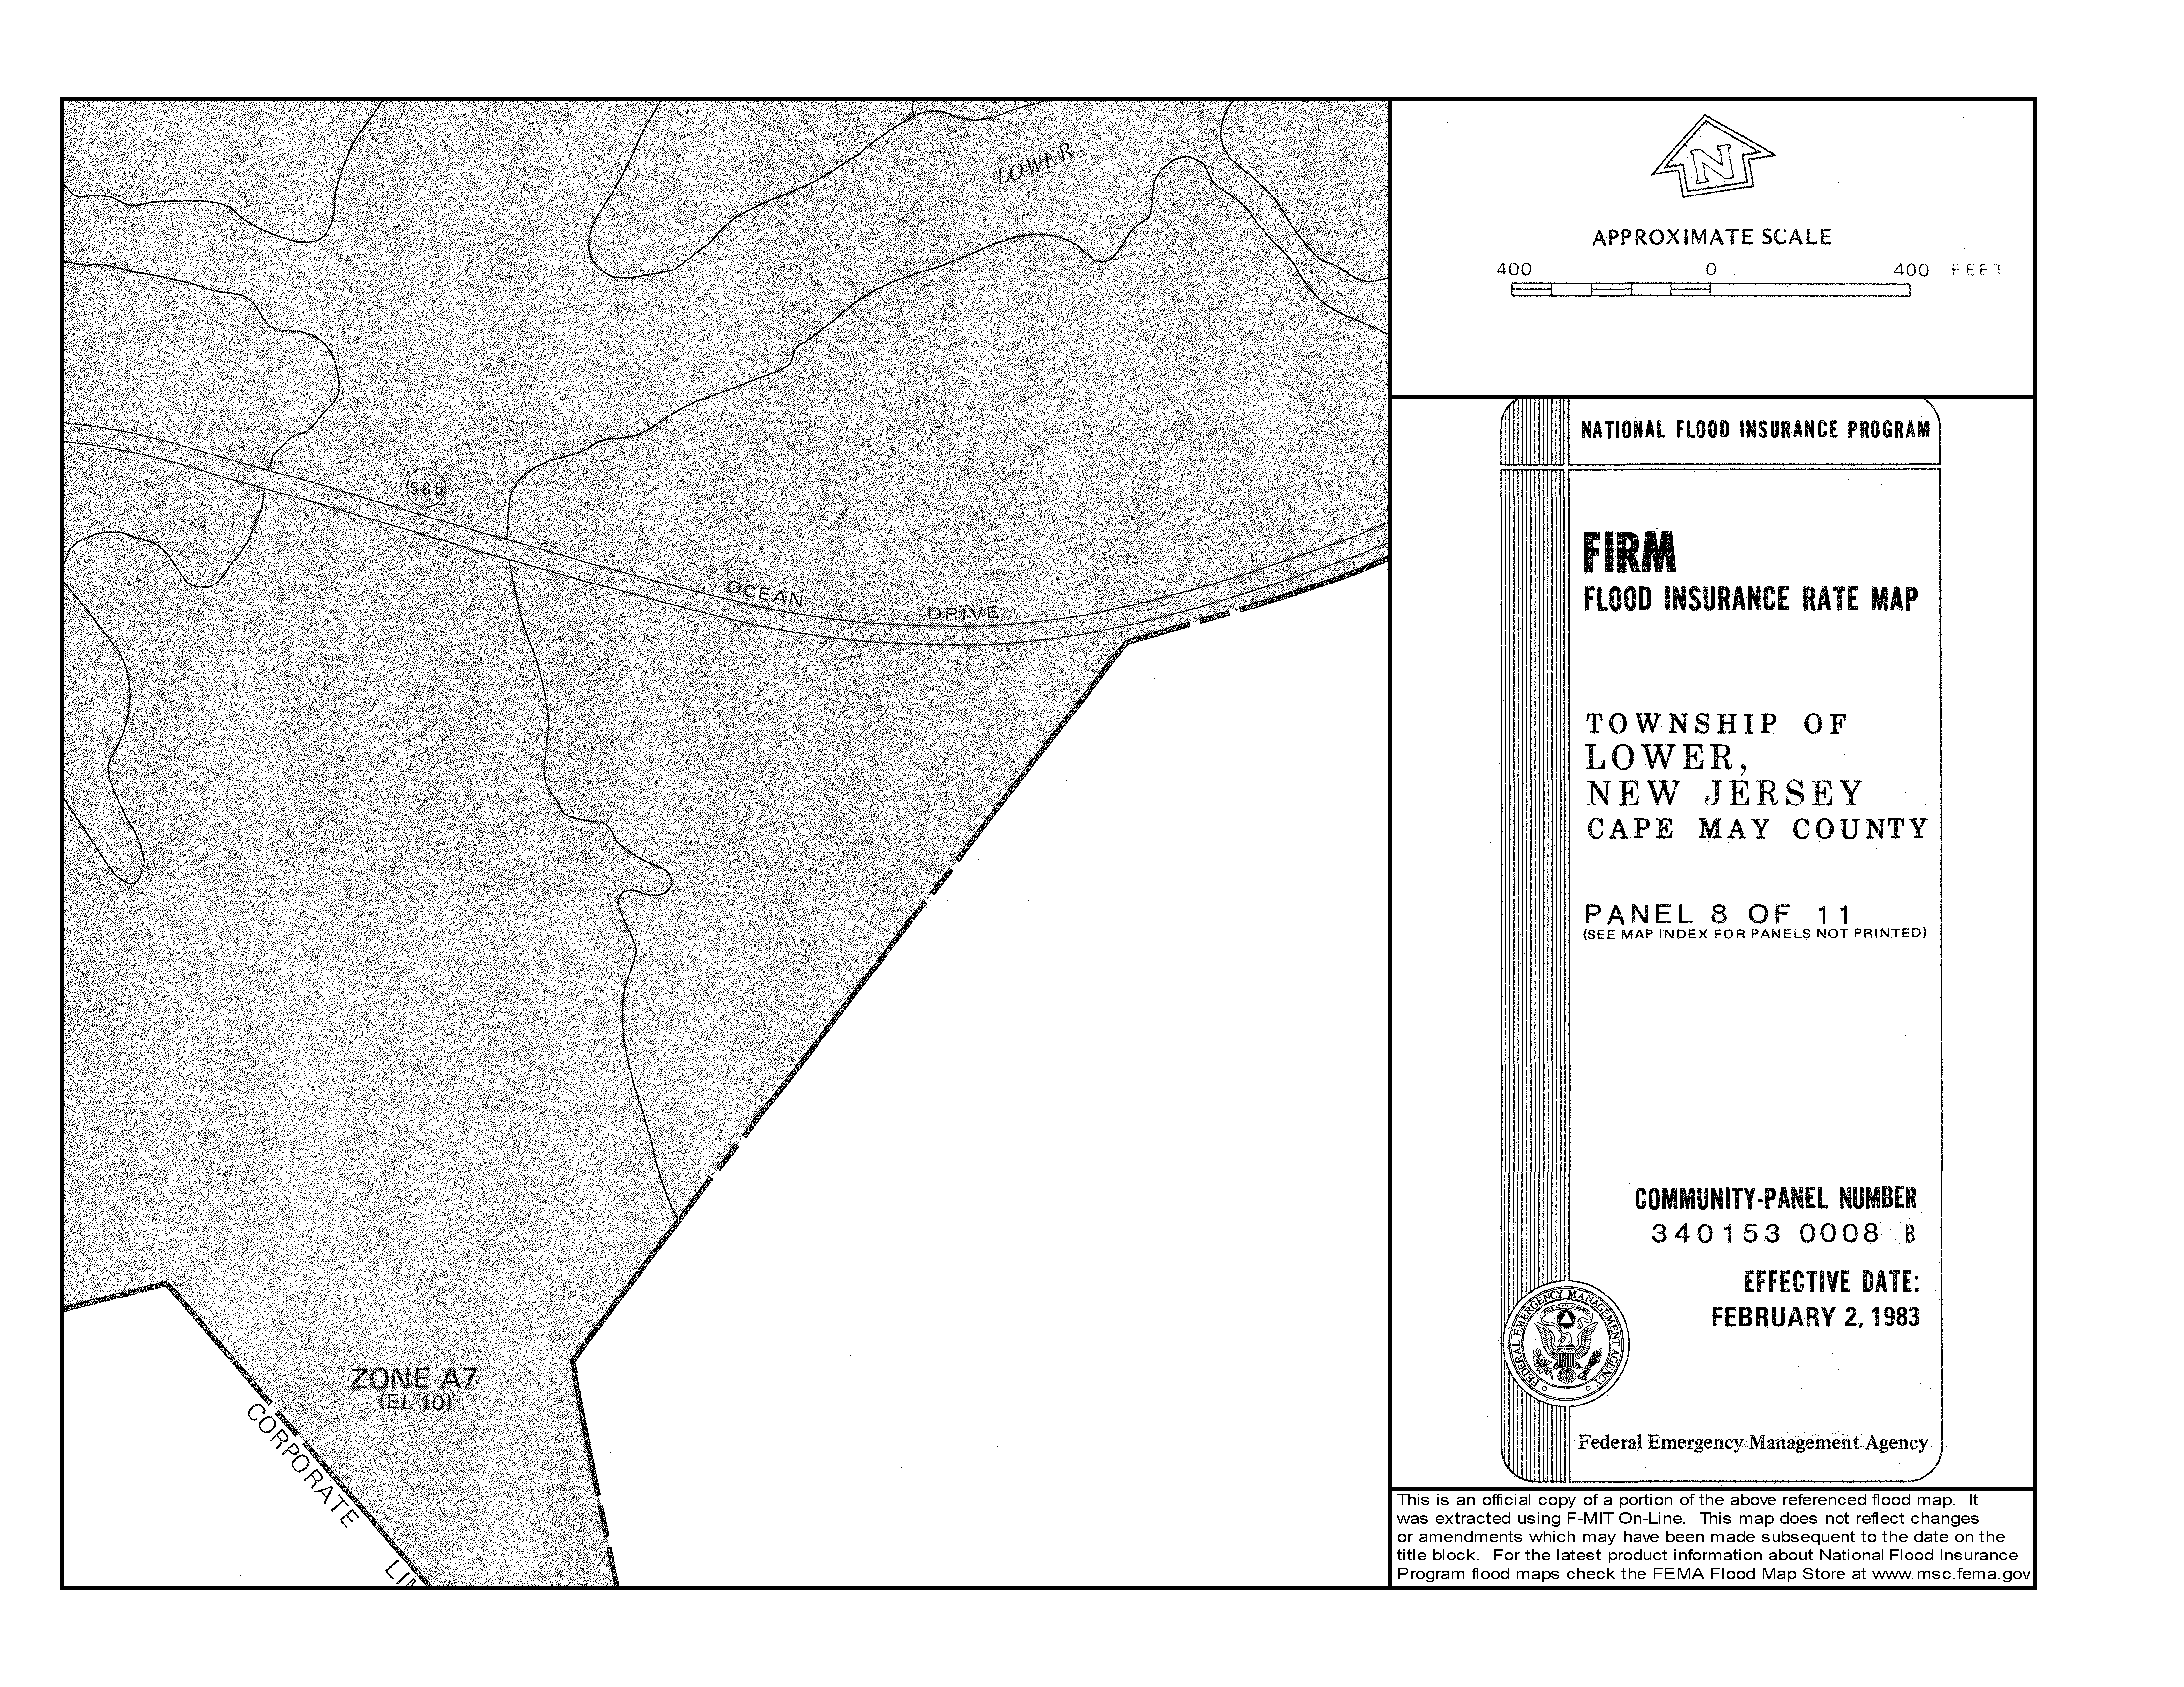

FEMA Preliminary FIRM & FIS Vertical Datum Conversion Factor
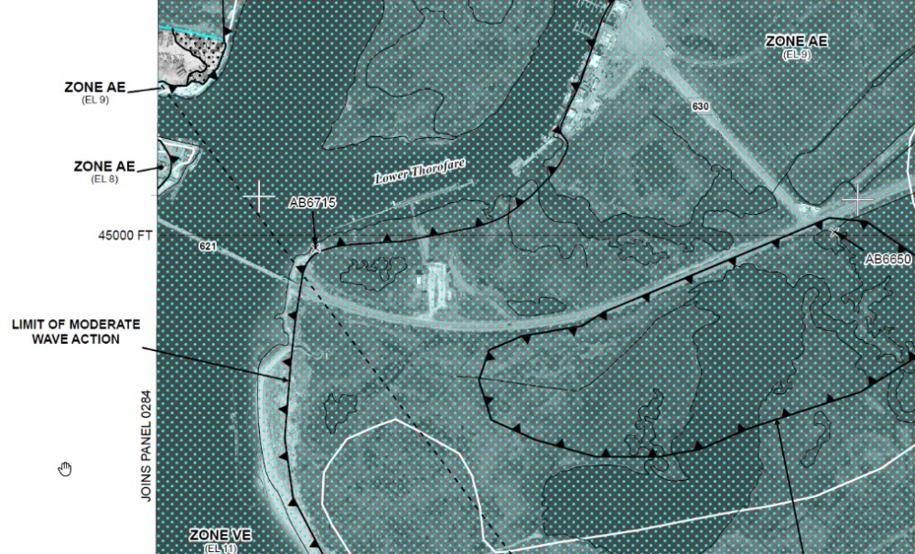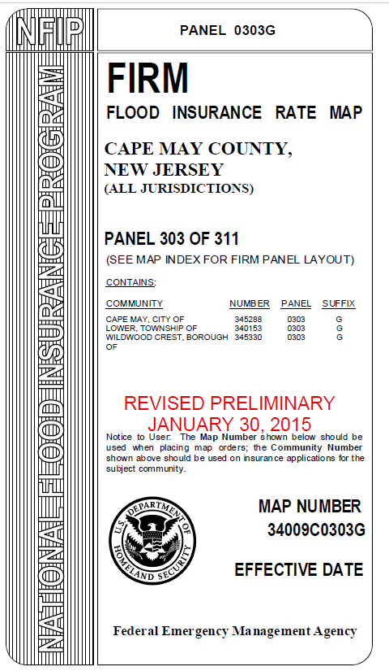

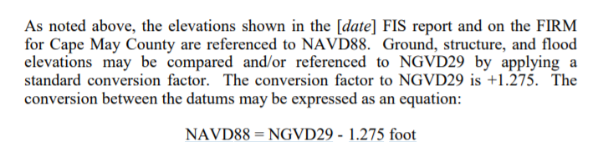

Local Design Flood Elevation (LDFE) Worksheet – CRITICAL ACTION Coastal Tidal Example with Datum Change
NOTE: This example relies on the same supporting floodplain information at the Non-Critical Coastal Tidal Example with Datum Change (see above for more detail on base flood elevations and datum changes)
PART I
Site Name: | Ocean Drive Parking Improvement and Marine Police Station |  | Date: | 12/20/2022
Address: | Ocean Drive, Lower Township, NJ
Latitude (y): | 38.955438 | Longitude (x): |  |  | -74.871645

 | State Flood Study¹ |  | FEMA Effective FIRM² |  | FEMA Best Available³ Preliminary, Draft, or Advisory Flood Hazard Data  (Circle Source)
Data Available (Yes/No) | No |  | Yes |  | Yes
Panel Number & Date |  |  | 3401530008B, 2/2/1983 |  | 3401530008B, 2/2/1983
Flood Zone Designation | N/A |  | A7 |  | AE
Floodway (Yes/No) |  |  | No |  | No
LiMWA Area (Yes/No) |  |  | No |  | No
Design¹ or Base Flood Elevation^{2, 3} |  |  | 10ft |  | 9ft
Vertical Datum^ |  |  | NGVD29 |  | NAVD88
^⁴Resulting Elevations below must be in same datum, if conversion factor needed, note here: NAVD88 = NGVD29 - __1.275____ ft.
Tidal or Riverine FEMA Mapping⁵ |  |  | Tidal |  | Tidal
If Riverine, add 1 foot |  |  | +1 |  | +1
Resulting Elevation | Box A  NGVD29 NAVD88 |  | Box B  8.725 Ft  NGVD29 NAVD88 |  | Box C  9 Ft NAVD88  NAVD88
If none of the above data is available and/or the project is in a watershed 50 acres or greater in size, licensed NJ Professional Engineers may use NJFHACA Method 5 or 6 to approximate the DFE for design purposes, however, an unexpired Flood Hazard Verification Letter which includes a Flood Hazard Design Elevation is necessary to ensure compliance with State standards. Enter elevation in Box D.
Date of Letter Verifying the NJ Flood Hazard Design Flood Elevation (FHDFE): |  | Box D
Select highest elevation from Box A, B, C, and D to determine the
New Jersey Flood Hazard Design Flood Elevation (FHDFE) and input into Box E
¹Use Appendix 2 of the FHACA Rules (N.J.A.C. 7:13) to identify state-studied waters; or visit https://www.nj.gov/dep/floodcontrol/studied_streams.htm
²https://msc.fema.gov/portal/home
³ The most recent available preliminary flood risk guidance FEMA has provided. The Best Available Flood Hazard Data may be depicted on but not limited to Advisory Flood Hazard Area Maps, Work Maps or Preliminary FIS and FIRM.
⁴Vertical datum conversion factor sources: FIS report or https://vdatum.noaa.gov/runapp_agreement.php
⁵ Tidal flooding refers to modeled and mapped floodplains where the primary flood hazard is controlled by coastal or tidal forces. Note that many mouths and lower reaches of rivers are considered tidal. The riverine/fluvial adjustment that adds one foot to FEMA Base Flood Elevations is discussed in N.J.A.C. 7:13-3.4.

This worksheet is designed to result in accurate determinations of the Federal Flood Risk Management Standard (FFRMS). For Coastal/tidal non-critical actions, Box 3 must be completed to ensure an accurate comparison of local and State freeboard requirements. Please consult the New Jersey Guidebook for Implementing the Federal Flood Risk Management Standard for additional information to ensure that all applicable federal projects receive full reimbursement.

Comments:
* Worksheet 2 is included to adjust the 500-year flood elevation for wave heights, which is required by ASCE24. This project is also a Critical Action under the Federal Flood Risk Management Standard (FFRMS - see E.O.13690 and associated FEMA policies). Worksheet 3 is attached to document compliance with any Federal Funding received for this project. Elevation of the lowest floor is 17 NAVD88 for the Marine Police Station. Parking, storage, and facility access is the only allowable activity below 17Ft NAVD88.

PART II
Site Name: | Ocean Drive Parking Improvement and Marine Police Station
Freeboard Requirements |  |  |  |  | Highest Elevation |  | Highest Elevation with Freeboard Comparison
State Freeboard Requirements - The NJ Flood Hazard Area Control Act (NJFHACA) requires that a minimum of 1 foot of freeboard be added to the Flood Hazard Design Flood Elevation FHDFE and no lower than that required by the UCC pursuant to the calculation below for Class I through IV facilities. |  |  | 1 Foot | + | Box E  9  _____ Ft | = | State  Box 1  10  _______ Ft
Local Community Freeboard Requirements – More restrictive freeboard must be added if a higher freeboard is adopted in the Community’s Flood Damage Prevention Ordinance. |  |  | 1  ___ Ft | + | Box E  9 Ft* | = | Local  Box 2  10  _______ Ft
Coastal Area Federal Flood Risk Management Standard for Non-Critical Actions – complete only if applicable (See WORKSHEET 3 guidance) |  |  | 2 Feet | + | Box E  ____ Ft |  | Coastal FFRMS Non-Critical Action  Box 3  ______ Ft
ASCE 24** Type of Facility (circle one):  Class I Class II Class III Class IV  If Class I or II no further entry is required  If Class III or IV, enter elevations below |  |  | If Class III (in V Zone only) or Class IV, chose Highest Elevation from below and enter here à |  |  |  | ASCE 24 Critical Facility  Box 4  17  _______ Ft
Class III (in V Zone only) choose either:
Box 1 Elevation + 1’
Box 2 Elevation + 1’***
Class IV choose either:  Box 1 Elevation + 2’  Box 2 Elevation + 2’*** |  | Box F  11 Ft
Class IV: 500-year Elevation |  | Box G
Coastal Area Class IV: 500-year Wave Adjusted Elevation Must be Determined Using WORKSHEET 2 |  | Box H  17 Ft
Select highest DFE from State (Box 1), Local (Box 2), FFRMS Tidal Non-Critical Actions (Box 3 – if applicable) and ASCE (Box 4):  (This is your Local DFE****) à |  |  |  |  |  |  | Box 5  ___17____ Ft
Note Vertical Datum à |  |  |  |  |  |  | NAVD 88
Note Flood Zone and if LiMWA Area à |  |  |  |  |  |  | AE
*Review community ordinance to determine if the freeboard should be added to the BFE or NJ State Flood Hazard Area DFE.
**ASCE Classes and Elevation Requirements are Defined in ASCE 24-14: https://www.fema.gov/sites/default/files/2020-07/asce24-14_highlights_jan2015.pdf
*** The local Flood Damage Prevention ordinance may require that additional freeboard for a critical facility be added to the Local Minimum Freeboard calculated in Box 2 which may be higher than the State minimum freeboard calculated in Box 1. The local ordinance should be consulted to confirm the calculations in this worksheet. In no circumstance should a critical facility be constructed lower than required by both the Flood Hazard Area Control Act and the Uniform Construction Code.
****Local Design Flood Elevation Definition - the Local DFE is the elevation reflective of the most recent available preliminary flood elevation guidance FEMA has provided as depicted on but not limited to Advisory Flood Hazard Area Maps, Work Maps, or Preliminary FIS and FIRM which is also inclusive of freeboard specified by the New Jersey Flood Hazard Area Control Act and Uniform Construction Codes and any additional freeboard specified in a community’s ordinance. In no circumstances shall a project’s LDFE be lower than a permit-specified Flood Hazard Area Design Flood Elevation or a valid NJDEP Flood Hazard Area Verification Letter plus the freeboard as required in ASCE 24 and the effective FEMA Base Flood Elevation.
COMMENTS: Use the box on the first page to document the use of additional worksheets, comments, assumptions, and sources. For example, source of the datum conversion factor or effective date of the local ordinance BFE in Box 2.
ATTACH WORKSHEETS 2 (Wave Height Adjustment including any attachments signed and sealed by a Licensed NJ Professional Engineer) and 3 (Federal Flood Risk Management Standard Documentation) to this worksheet if applicable.

Worksheet 2 – Determining the Wave Height Adjusted 500 Year Preliminary and Effective Map Elevation for ASCE 24-14 Critical Facilities and Critical Actions under 44 CFR Part 9

Part I – Worksheet for Determining the Best Available 500 year Elevation including a Wave Height Adjustment Using Empirical Methodology

Empirical Formula:

500 Year Elevation With Wave Height =
500 Year FIS Study Elevation + [.55 * (500 Year FIS Study Elevation - Ground Surface Elevation)]

Wave Height Calculation Table for Critical Facilities in Coastal Zones
Effective FIRM |  |  | Preliminary FIRM
500 Year Elevation  (circle datum) | ^{Box 1A}  ^{13.1}  NGVD 29 NAVD88 | FT | 500 Year Elevation | ^{Box 2A}  ^{11.3}  NAVD88 | FT
Ground Elevation | ^{Box 1B}  ³ | FT | Ground Elevation | ^{Box 2B}  ³ | FT
Wave Height  (.55*(Box 1A-Box 1B)  .55(13.1 – 3) | ^{Box 1C}  ^{5.55} | FT | Wave Height  (.55*(Box 2A-Box 2B)  .55(11.3 – 3) | ^{Box 2C}  ^{4.56} | FT
500 Year Elevation w/ Wave Height  (Box 1A + Box 1C)  (13.1 + 5.55) | ^{Box 1D}  ^{18.56} | FT | 500 Year Elevation w/ Wave Height  (Box 2A + Box 2C)  (11.3 + 4.56) | ^{Box 2D}  ^{15.86 (rounded up to 16 ft)}  NAVD88 | FT
Vertical Datum - Resulting Elevations below must be in same datum, if conversion factor needed, note here:  NAVD88 =  NGVD29 - _1.275____ft. | ^{Box 2E}  17.31 (rounded down to 17)  NAVD88 | FT |  |  | Ft
Select highest Elevation from Effective (Box 1D or 1E)  and Preliminary (Box 2D)  Alll Elevations must be in NAVD88  This is your Class IV 500-Year Elevation à  ENTER RESULT IN WORKSHEET 1, BOX H |  |  |  | ^{Box 3A}  ¹⁷ | FT  NAVD88

Effective Flood Insurance Study – 500 year Elevation
Does not include Wave Height

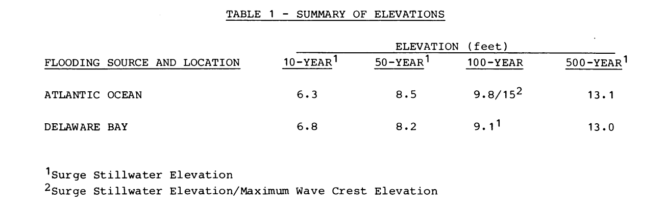
Transects do not include Wave Height for the 500-Year but 15 Ft is higher than 13.1 Ft so minimum 500 year in this area would be 15ft – BUT this number must compared to the calculated value in
Worksheet #2
Effective Flood Insurance Study – Transect Information
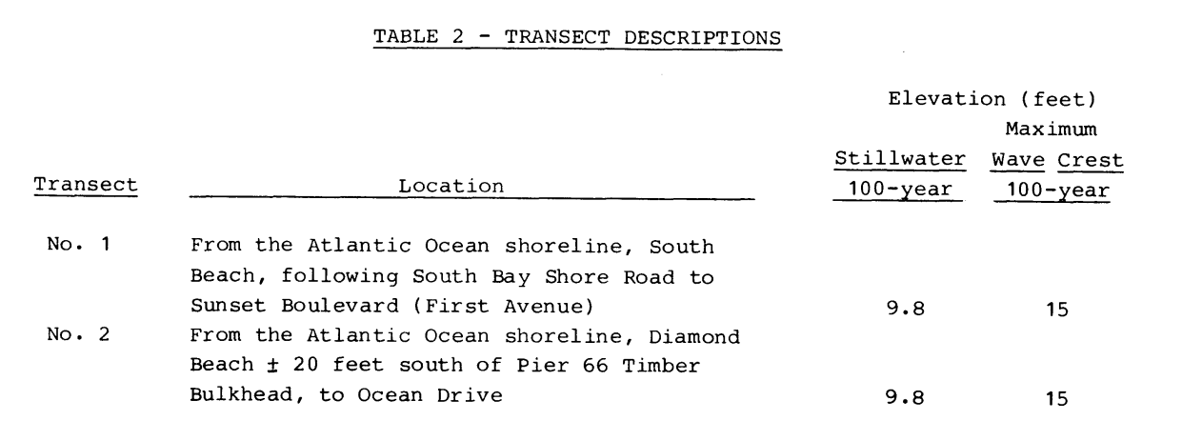

Preliminary Flood Insurance Study – Transect Map
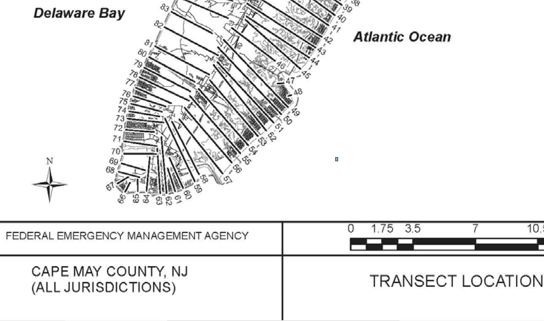
Transect 58

Preliminary Flood Insurance Study – Preliminary Transect Data
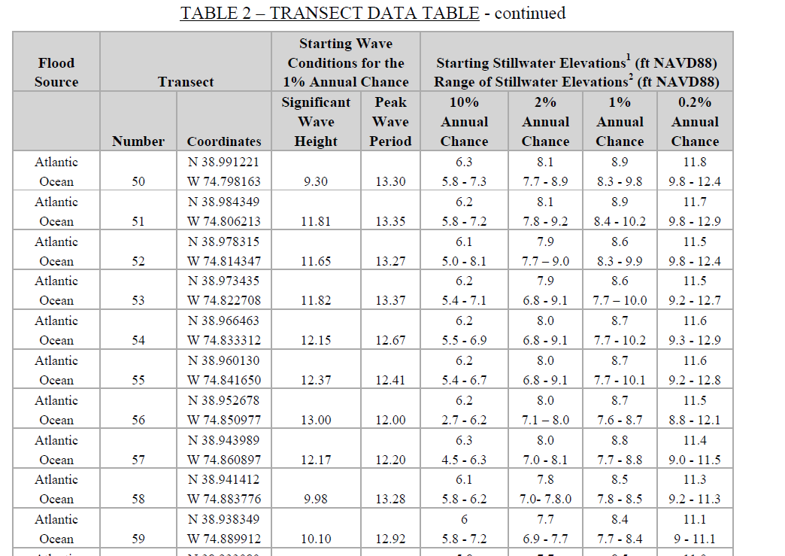
11.3Ft
No Wave Height – Stillwater Elevations Only

Documenting the Federal Flood Risk Management Standard – Worksheet #3
WORKSHEET #3 – CRITICAL ACTION
Building Class | RIVERINE |  | COASTAL
 | FFRMS Standard with State and Local Compliance
Class I  Class II  Class III  Class IV | - Complete Worksheet 1 including Boxes F and G  - Enter the Elevation from Box 5, below |  | - Complete Worksheet 2.  - Complete Worksheet 1 including Boxes 4, F, and H.  - Enter the Elevation from Box 5, below  ______17____ FT NAVD88
 | ___________ | FT NAVD88
WORKSHEET 1: Local Design Flood Elevation (LDFE) Worksheet which determines the most restrictive Best Available Flood Hazard Data – Box 5 must include vertical datum conversions to NAVD88 if necessary
WORKSHEET 2: Determining the Wave Height Adjusted 500 Year Preliminary and Effective
FFRMS Worksheet Summary
Project Name: Ocean Drive Parking Improvement and Marine Police Station
Type of Action | Y/N | Federal Flood Risk Standard (FFRMS)
Non-critical Action¹ |  | Project Design Flood Elevation (from Applicable FFRMS Worksheet and Worksheet 1, Box 5) | _____17______ FT
Critical Action² | YES | Vertical Datum Confirmation:  (Circle one) | NGVD or NAVD88
Floodplain Type:  (Check one) |  | Flood Zone  Designation | ____AE_______
Riverine |  | LiMWA (Coastal A) or V Zone Construction (Check one) |  | Yes | No
Coastal | YES |  |  |  | X
¹If yes, Use the FFRMS Non-Critical Action Worksheet
²If yes, Use the FFRMS Critical Action Worksheet

Local Design Flood Elevation (LDFE) Worksheet – Riverine Class IV Example

PART I
Site Name: | Raritan EMS Addition |  | Date: |  | 12/23/2022
Address: | 33 Risler Street, Stockton, NJ
Latitude (y): | 40⁰24’33.52”N | Longitude (x): |  | 74⁰59’09.74”W

 | State Flood Study¹ |  | FEMA Effective FIRM² |  | FEMA Best Available³ Preliminary, Draft, or Advisory Flood Hazard Data  (Circle Source)
Data Available (Yes/No) | Yes |  | Yes |  | No
Panel Number & Date | 34019C0336G, 5/2/2012 |  | 34019C0336G, 5/2/2012
Flood Zone Designation | N/A |  | AE
Floodway (Yes/No) | No |  | No
LiMWA Area (Yes/No) | No |  | No
Design¹ or Base Flood Elevation^{2, 3} | 87.6 Ft |  | 83.7 Ft
Vertical Datum^ | NAVD88 |  | NAVD88
^⁴Resulting Elevations below must be in same datum, if conversion factor needed, note here: NAVD88 = NGVD29 - ______ ft.
Tidal or Riverine FEMA Mapping⁵ | Riverine |  | Riverine
If Riverine, add 1 foot |  |  | +1 | 84.7 Ft | +1
Resulting Elevation | Box A  87.6 Ft  NGVD29 NAVD88 |  | Box B  84.7 FT  NGVD29 NAVD88 |  | Box C  NAVD88
If none of the above data is available and/or the project is in a watershed 50 acres or greater in size, licensed NJ Professional Engineers may use NJFHACA Method 5 or 6 to approximate the DFE for design purposes, however, an unexpired Flood Hazard Verification Letter which includes a Flood Hazard Design Elevation is necessary to ensure compliance with State standards. Enter elevation in Box D.
Date of Letter Verifying the NJ Flood Hazard Design Flood Elevation (FHDFE): |  | Box D
Select highest elevation from Box A, B, C, and D to determine the
New Jersey Flood Hazard Design Flood Elevation (FHDFE) and input into Box E
¹Use Appendix 2 of the FHACA Rules (N.J.A.C. 7:13) to identify state-studied waters; or visit https://www.nj.gov/dep/floodcontrol/studied_streams.htm
²https://msc.fema.gov/portal/home
³ The most recent available preliminary flood risk guidance FEMA has provided. The Best Available Flood Hazard Data may be depicted on but not limited to Advisory Flood Hazard Area Maps, Work Maps or Preliminary FIS and FIRM.
⁴Vertical datum conversion factor sources: FIS report or https://vdatum.noaa.gov/runapp_agreement.php
⁵ Tidal flooding refers to modeled and mapped floodplains where the primary flood hazard is controlled by coastal or tidal forces. Note that many mouths and lower reaches of rivers are considered tidal. The riverine/fluvial adjustment that adds one foot to FEMA Base Flood Elevations is discussed in N.J.A.C. 7:13-3.4.

This worksheet is designed to result in accurate determinations of the Federal Flood Risk Management Standard (FFRMS). For Coastal/tidal non-critical actions, Box 3 must be completed to ensure an accurate comparison of local and State freeboard requirements. Please consult the New Jersey Guidebook for Implementing the Federal Flood Risk Management Standard for additional information to ensure that all applicable federal projects receive full reimbursement.

Comments: This is a critical facility. Worksheet 3 is attached to this worksheet to document compliance with the Federal Flood Risk Management Standard if federal funds utilized require documentation of the design flood elevation for the addition.

PART II
Site Name: | Raritan EMS Addition (Critical Facility)
Freeboard Requirements |  |  |  |  | Highest Elevation |  | Highest Elevation with Freeboard Comparison
State Freeboard Requirements - The NJ Flood Hazard Area Control Act (NJFHACA) requires that a minimum of 1 foot of freeboard be added to the Flood Hazard Design Flood Elevation FHDFE and no lower than that required by the UCC pursuant to the calculation below for Class I through IV facilities. |  |  | 1 Foot | + | Box E  87.6  _____ Ft | = | State  Box 1  88.6  _______ Ft
Local Community Freeboard Requirements – More restrictive freeboard must be added if a higher freeboard is adopted in the Community’s Flood Damage Prevention Ordinance. |  |  | 0  ___ Ft | + | Box E  83.7  ____ Ft* | = | Local  Box 2  83.7  ______ Ft
Coastal Area Federal Flood Risk Management Standard for Non-Critical Actions – complete only if applicable (See WORKSHEET 3 guidance) |  |  | 2 Feet | + | Box E  _____ Ft |  | Coastal FFRMS Non-Critical Action  Box 3  _______ Ft
ASCE 24** Type of Facility (circle one):  Class I Class II Class III Class IV  If Class I or II no further entry is required  If Class III or IV, enter elevations below |  |  | If Class III (in V Zone only) or Class IV, chose Highest Elevation from below and enter here à |  |  |  | ASCE 24 Critical Facility  Box 4  90.6  _______ Ft
Class III (in V Zone only) choose either:
Box 1 Elevation + 1’
Box 2 Elevation + 1’***
Class IV choose either:  Box 1 Elevation + 2’  Box 2 Elevation + 2’*** |  | Box F  90.6
Class IV: 500-year Elevation |  | Box G  88.8
Coastal Area Class IV: 500-year Wave Adjusted Elevation Must be Determined Using WORKSHEET 2 |  | Box H
Select highest DFE from State (Box 1), Local (Box 2), FFRMS Tidal Non-Critical Actions (Box 3 – if applicable) and ASCE (Box 4):  (This is your Local DFE****) à |  |  |  |  |  |  | Box 5  ____90.6___ Ft
Note Vertical Datum à |  |  |  |  |  |  | NAVD88
Note Flood Zone and if LiMWA Area à |  |  |  |  |  |  | AE
*Review community ordinance to determine if the freeboard should be added to the BFE or NJ State Flood Hazard Area DFE.
**ASCE Classes and Elevation Requirements are Defined in ASCE 24-14: https://www.fema.gov/sites/default/files/2020-07/asce24-14_highlights_jan2015.pdf
*** The local Flood Damage Prevention ordinance may require that additional freeboard for a critical facility be added to the Local Minimum Freeboard calculated in Box 2 which may be higher than the State minimum freeboard calculated in Box 1. The local ordinance should be consulted to confirm the calculations in this worksheet. In no circumstance should a critical facility be constructed lower than required by both the Flood Hazard Area Control Act and the Uniform Construction Code.
****Local Design Flood Elevation Definition - the Local DFE is the elevation reflective of the most recent available preliminary flood elevation guidance FEMA has provided as depicted on but not limited to Advisory Flood Hazard Area Maps, Work Maps, or Preliminary FIS and FIRM which is also inclusive of freeboard specified by the New Jersey Flood Hazard Area Control Act and Uniform Construction Codes and any additional freeboard specified in a community’s ordinance. In no circumstances shall a project’s LDFE be lower than a permit-specified Flood Hazard Area Design Flood Elevation or a valid NJDEP Flood Hazard Area Verification Letter plus the freeboard as required in ASCE 24 and the effective FEMA Base Flood Elevation.

FEMA Effective FIRM
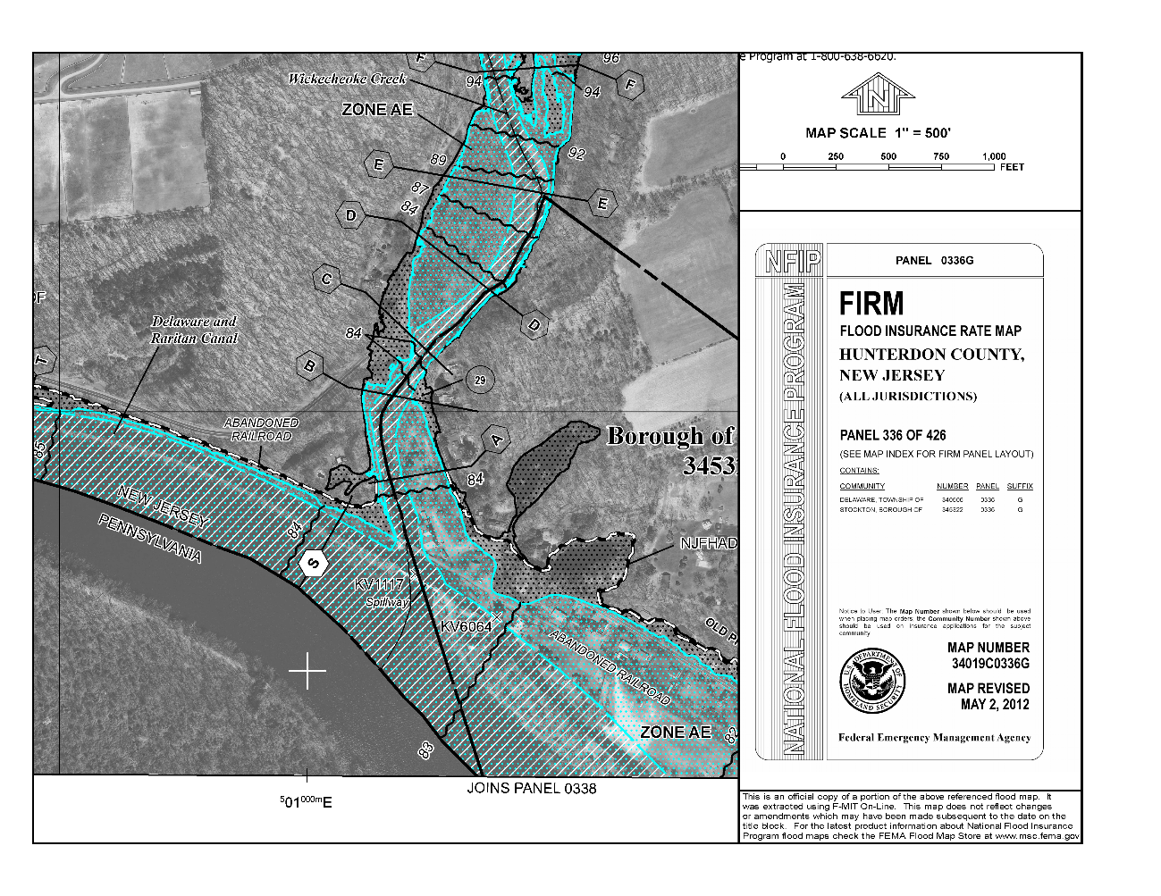
FEMA Effective FIS Profile – for 1% Elevation & 0.2% ASCE Class IV Elevation
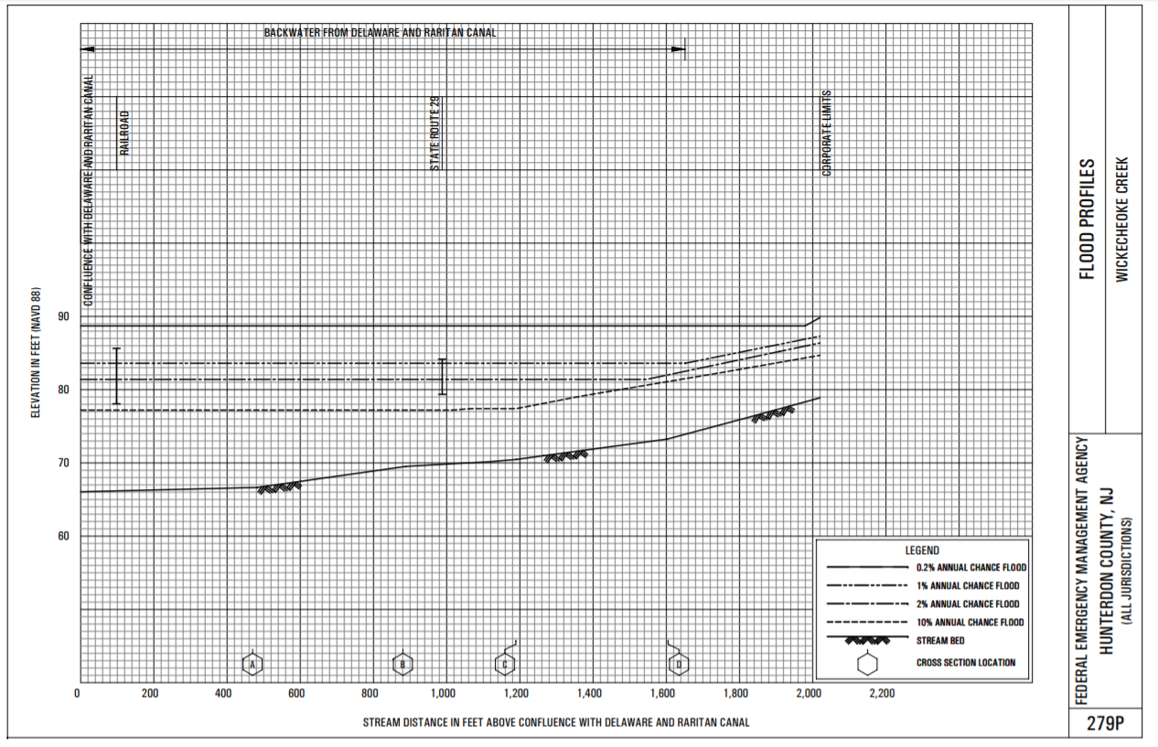

FEMA Effective FIS Profile – for NJFHADF (State Study) Elevation
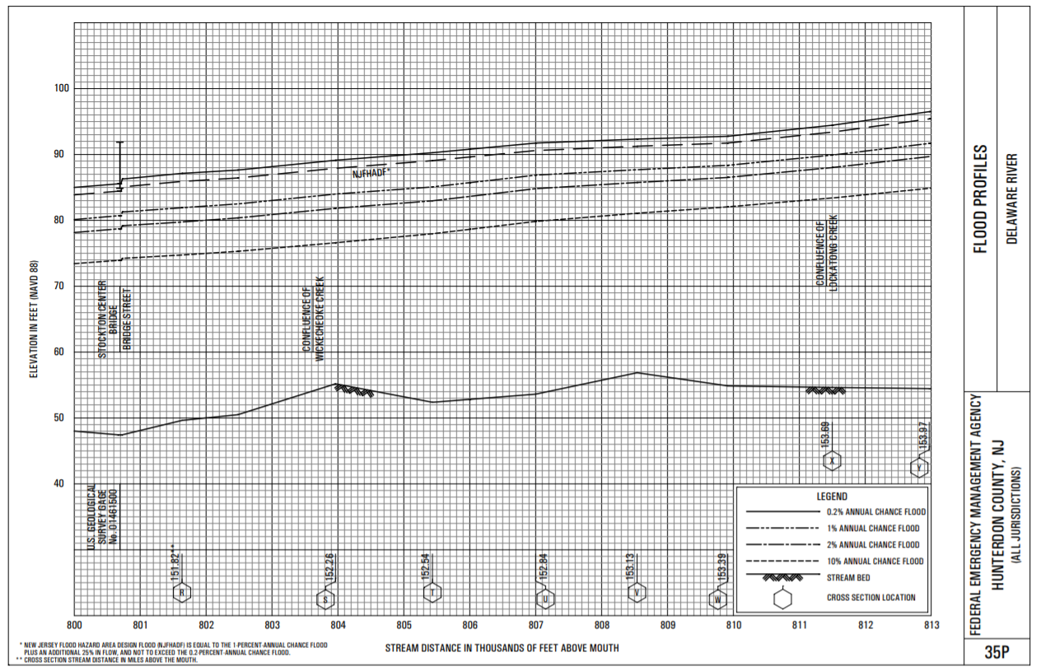

FFRMS Critical Action Worksheet
Complete only the Riverine or the Coastal Box on this Worksheet.

Building Class | RIVERINE |  | COASTAL
 | FFRMS Standard with State and Local Compliance
Class I  Class II  Class III  Class IV | - Complete Worksheet 1 including Boxes F and G  - Enter the Elevation from Box 5, below |  | - Complete Worksheet 2.  - Complete Worksheet 1 including Boxes 4, F, and H.  - Enter the Elevation from Box 5, below  __________ FT NAVD88
 | ____90.6_______ | FT NAVD88
WORKSHEET 1: Local Design Flood Elevation (LDFE) Worksheet which determines the most restrictive Best Available Flood Hazard Data – Box 5 must include vertical datum conversions to NAVD88 if necessary
WORKSHEET 2: Determining the Wave Height Adjusted 500 Year Preliminary and Effective
FFRMS Non-Critical Action Worksheet
Complete only one of the six boxes on this Worksheet.

Building Class | RIVERINE |  | COASTAL
 | FFRMS Standard with State and Local Floodplain Compliance
Class  1 & 2 | - Complete Worksheet 1 including Box 3  - Enter the Elevation from Box 5, below |  | - Complete Worksheet 1 including Boxes 2 and 3  - Enter the Elevation from Box 5, below
 | _________ | FT NAVD88 |  | _________ FT NAVD88
Class 3 | - Complete Worksheet 1 including Boxes 3, 4, and E.  - Enter the Elevation from Box 5, below |  | - Complete Worksheet 2.  - Complete Worksheet 1 including Boxes 3, 4, F, and H.  - Enter the Elevation from Box 5, below
 | _________ | FT NAVD88 |  | ___________ FT NAVD88
Class 4 | - Complete Worksheet 1 including Boxes F and G  - Enter the Elevation from Box 5, below  __________ FT NAVD88 |  | - Complete Worksheet 2.  - Complete Worksheet 1 including Boxes 4, F, and H.  - Enter the Elevation from Box 5, below  __________ FT NAVD88
WORKSHEET 1 : Local Design Flood Elevation (LDFE) Worksheet which determines the most restrictive Best Available Flood Hazard Data – Box 5 must include vertical datum conversions in necessary
WORKSHEET 2: Determining the Wave Height Adjusted 500 Year Preliminary and Effective

FFRMS Worksheet Summary
Project Name: Raritan EMS Addition (Critical Facility
Type of Action | Y/N | Federal Flood Risk Standard (FFRMS)
Non-critical Action¹ |  | Project Design Flood Elevation (from Applicable FFRMS Worksheet and Worksheet 1, Box 5) | _______90.6____ FT
Critical Action² | YES | Vertical Datum Confirmation:  (Circle one) | NGVD or NAVD88
Floodplain Type:  (Check one) |  | Flood Zone  Designation | _____ AE______
Riverine | X | LiMWA (Coastal A) or V Zone Construction (Check one) |  | Yes | No
Coastal |  |  |  |  | X
¹If yes, Use the FFRMS Non-Critical Action Worksheet
²If yes, Use the FFRMS Critical Action Worksheet

Local Design Flood Elevation (LDFE) Worksheet – Approximate A Zone Example
Part I
Site Name: | Gas Station & Convenience Store |  | Date: |  | 12/28/22
Address: | US 130 North, Cranbury, NJ
Latitude (y): | 40.295749 | Longitude (x): |  | -74.516647

 | State Flood Study¹ |  | FEMA Effective FIRM² |  | FEMA Best Available³ Preliminary, Draft, or Advisory Flood Hazard Data  (Circle Source)
Data Available (Yes/No) | No |  | Yes |  | No
Panel Number & Date |  |  | 34023C0242F, 7/6/2010
Flood Zone Designation | N/A |  | A
Floodway (Yes/No) |  |  | No
LiMWA Area (Yes/No) |  |  | No
Design¹ or Base Flood Elevation^{2, 3} |  |  | N/A
Vertical Datum^ |  |  | N/A
^⁴Resulting Elevations below must be in same datum, if conversion factor needed, note here: NAVD88 = NGVD29 - ______ ft.
Tidal or Riverine FEMA Mapping⁵ |  |  | Riverine
If Riverine, add 1 foot |  |  | +1 | N/A | +1
Resulting Elevation | Box A  NGVD29 NAVD88 |  | Box B  N/A  NGVD29 NAVD88 |  | Box C  NAVD88C
If none of the above data is available and/or the project is in a watershed 50 acres or greater in size, licensed NJ Professional Engineers may use NJFHACA Method 5 or 6 to approximate the DFE for design purposes, however, an unexpired Flood Hazard Verification Letter which includes a Flood Hazard Design Elevation is necessary to ensure compliance with State standards. Enter elevation in Box D.
Date of Letter Verifying the NJ Flood Hazard Design Flood Elevation (FHDFE):  (Example Only) 00/00/0000 |  | Box D  93 ft. NAVD88
Select highest elevation from Box A, B, C, and D to determine the
New Jersey Flood Hazard Design Flood Elevation (FHDFE) and input into Box E
¹Use Appendix 2 of the FHACA Rules (N.J.A.C. 7:13) to identify state-studied waters; or visit https://www.nj.gov/dep/floodcontrol/studied_streams.htm
²https://msc.fema.gov/portal/home
³ The most recent available preliminary flood risk guidance FEMA has provided. The Best Available Flood Hazard Data may be depicted on but not limited to Advisory Flood Hazard Area Maps, Work Maps or Preliminary FIS and FIRM.
⁴Vertical datum conversion factor sources: FIS report or https://vdatum.noaa.gov/runapp_agreement.php
⁵ Tidal flooding refers to modeled and mapped floodplains where the primary flood hazard is controlled by coastal or tidal forces. Note that many mouths and lower reaches of rivers are considered tidal. The riverine/fluvial adjustment that adds one foot to FEMA Base Flood Elevations is discussed in N.J.A.C. 7:13-3.4.

This worksheet is designed to result in accurate determinations of the Federal Flood Risk Management Standard (FFRMS). For Coastal/tidal non-critical actions, Box 3 must be completed to ensure an accurate comparison of local and State freeboard requirements. Please consult the New Jersey Guidebook for Implementing the Federal Flood Risk Management Standard for additional information to ensure that all applicable federal projects receive full reimbursement.

Comments:

PART II
Site Name: | Gas Station & Convenience Store
Freeboard Requirements |  |  |  |  | Highest Elevation |  | Highest Elevation with Freeboard Comparison
State Freeboard Requirements - The NJ Flood Hazard Area Control Act (NJFHACA) requires that a minimum of 1 foot of freeboard be added to the Flood Hazard Design Flood Elevation FHDFE and no lower than that required by the UCC pursuant to the calculation below for Class I through IV facilities. |  |  | 1 Foot | + | Box E  93  _____ Ft | = | State  Box 1  94  _______ Ft
Local Community Freeboard Requirements – More restrictive freeboard must be added if a higher freeboard is adopted in the Community’s Flood Damage Prevention Ordinance. |  |  | 0  ___ Ft | + | Box E  N/A  ____ Ft* | = | Local  Box 2  N/A  _______ Ft
Coastal Area Federal Flood Risk Management Standard for Non-Critical Actions – complete only if applicable (See WORKSHEET 3 guidance) |  |  | 2 Feet | + | Box E  _____ Ft |  | Coastal FFRMS Non-Critical Action  Box 3  _______ Ft
ASCE 24** Type of Facility (circle one):  Class I Class II Class III Class IV  If Class I or II no further entry is required  If Class III or IV, enter elevations below |  |  | If Class III (in V Zone only) or Class IV, chose Highest Elevation from below and enter here à |  |  |  | ASCE 24 Critical Facility  Box 4  _______ Ft
Class III (in V Zone only) choose either:
Box 1 Elevation + 1’
Box 2 Elevation + 1’***
Class IV choose either:  Box 1 Elevation + 2’  Box 2 Elevation + 2’*** |  | Box F
Class IV: 500-year Elevation |  | Box G
Coastal Area Class IV: 500-year Wave Adjusted Elevation Must be Determined Using WORKSHEET 2 |  | Box H
Select highest DFE from State (Box 1), Local (Box 2), FFRMS Tidal Non-Critical Actions (Box 3 – if applicable) and ASCE (Box 4):  (This is your Local DFE****) à |  |  |  |  |  |  | Box 5  94  _______ Ft
Note Vertical Datum à |  |  |  |  |  |  | NAVD88
Note Flood Zone and if LiMWA Area à |  |  |  |  |  |  | A
*Review community ordinance to determine if the freeboard should be added to the BFE or NJ State Flood Hazard Area DFE.
**ASCE Classes and Elevation Requirements are Defined in ASCE 24-14: https://www.fema.gov/sites/default/files/2020-07/asce24-14_highlights_jan2015.pdf
*** The local Flood Damage Prevention ordinance may require that additional freeboard for a critical facility be added to the Local Minimum Freeboard calculated in Box 2 which may be higher than the State minimum freeboard calculated in Box 1. The local ordinance should be consulted to confirm the calculations in this worksheet. In no circumstance should a critical facility be constructed lower than required by both the Flood Hazard Area Control Act and the Uniform Construction Code.
****Local Design Flood Elevation Definition - the Local DFE is the elevation reflective of the most recent available preliminary flood elevation guidance FEMA has provided as depicted on but not limited to Advisory Flood Hazard Area Maps, Work Maps, or Preliminary FIS and FIRM which is also inclusive of freeboard specified by the New Jersey Flood Hazard Area Control Act and Uniform Construction Codes and any additional freeboard specified in a community’s ordinance. In no circumstances shall a project’s LDFE be lower than a permit-specified Flood Hazard Area Design Flood Elevation or a valid NJDEP Flood Hazard Area Verification Letter plus the freeboard as required in ASCE 24 and the effective FEMA Base Flood Elevation.

Method 5: Approximate Method Example
Appendix 1 of the Flood Hazard Area Control Act Rules provides detailed instructions on how to use the Approximate Method (Method 5).
The rules can be found here: https://www.nj.gov/dep/rules/rules/njac7_13.pdf
To use the Approximate Method, the following information is needed:
- The Watershed Management Area the project is located.
- The Contributary Drainage Area of the water. USGS provides topographical mapping that can be used to make this determination. The NJDEP can also be contacted to make this determination.
- Determine the approximate depth of flooding from Table 1 of Appendix 1.
- Find the low point elevation of each roadway crossing or other water control structure within 1 mile downstream of the site and review Table 2.
- The approximate flood hazard area design flood elevation will be the higher of either the depth from Table 1 measured above the average streambed elevation or the depth from Table 2, measured above the highest roadway low point.
Example
A gas station and convenience store development is proposed adjacent to an unnamed tributary to the Millstone River. The FEMA FIRM depicts a Zone A with no detailed study.
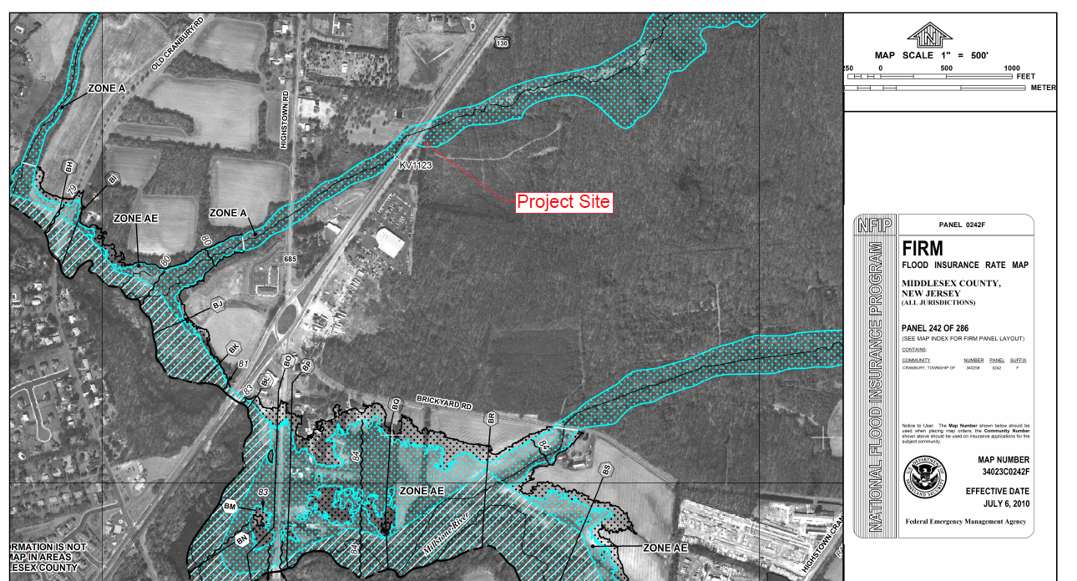

Step 1
The project site is in WMA 10. This can be determined using the NJDEP GIS Data Viewer https://nj.gov/dep/gis/apps.html or the map below.
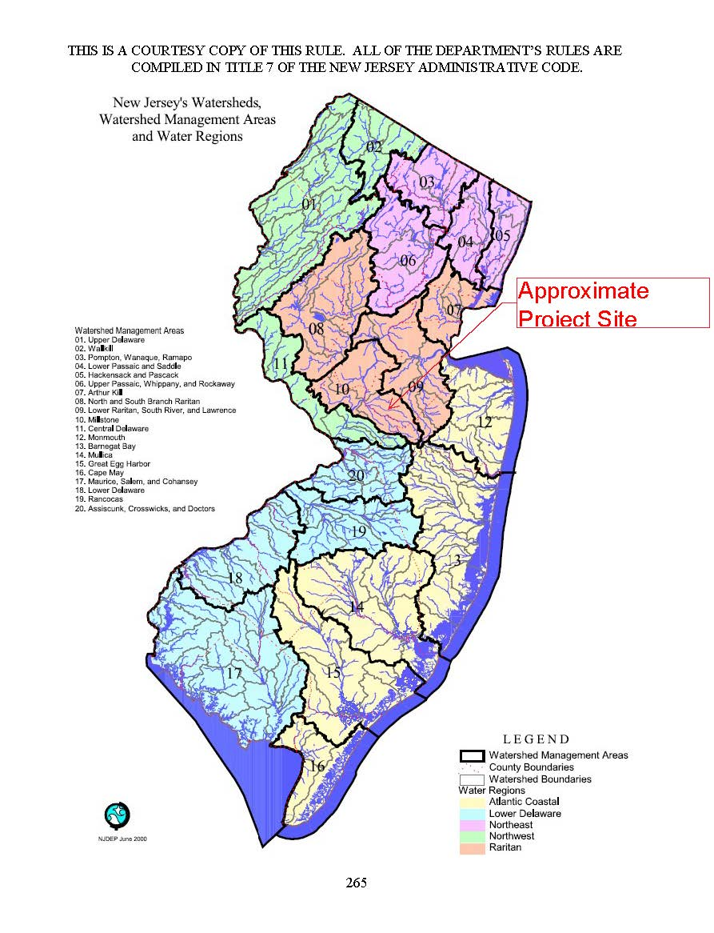

Step 2
The contributory drainage area to this location was determined using the USGS StreamStats program https://streamstats.usgs.gov/ss/ and is 0.76 square miles (486 acres).
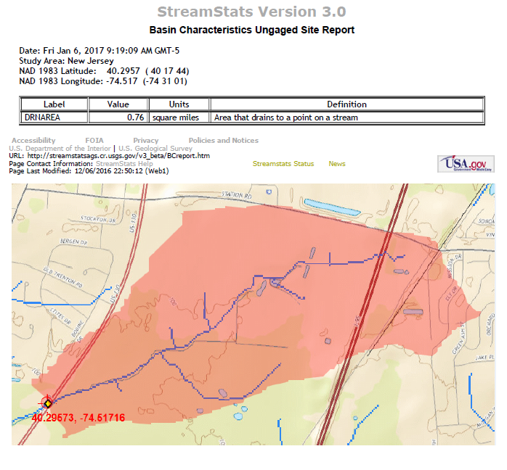

Step 3
Using Table 1, for a contributary drainage area, the flood hazard area is 10 feet above the stream bed. The average streambed elevation is 83 ft NAVD88, so the approximate flood elevation is 93 ft NAVD88.
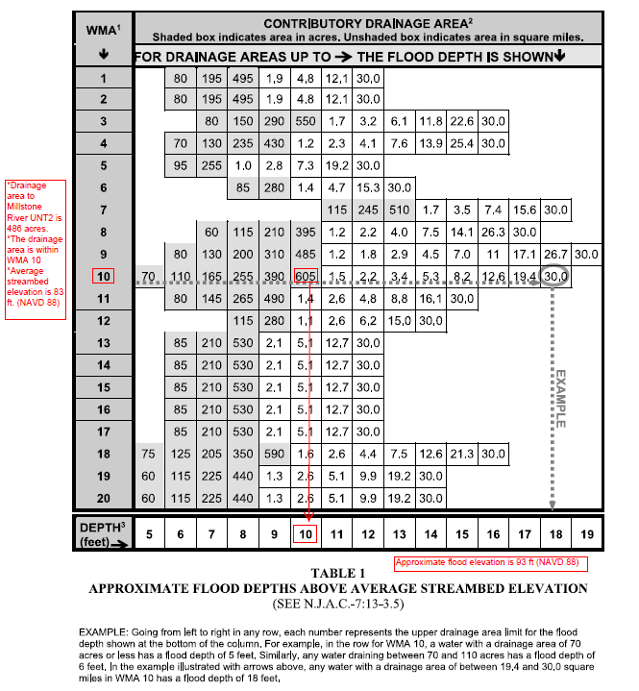

Step 4
The approximate roadway elevation at the Route 130 crossing is 90 ft (NAVD 88). You can find this through survey plans or digital elevation data. Since the contributary drainage area is less than 1 square mile and more than 200 acres, using Table 2, the flood hazard area is 1.5 feet above the roadway elevation for an approximate flood elevation of 91.5 ft (NAVD 88).
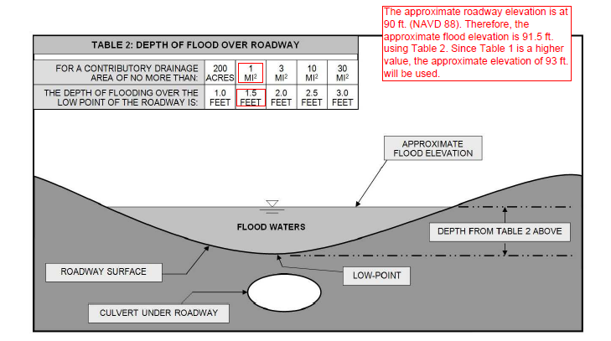

Step 5
Using Table 1, the flood hazard area elevation is 93 ft (NAVD 88). Using Table 2, the flood hazard area elevation is 91.5 ft (NAVD 88). Since the Table 1 elevation is higher, use 93 ft (NAVD88) for the Approximate Method (Method 5) flood elevation.

