The Floodplain Development Permit application assists communities in evaluating impacts of activities proposed within New Jersey regulated floodplains or FEMA’s Special Flood Hazard Areas (SFHAs). All activities must be in compliance with the regulations and standards set forth by local, state, and federal entities. For residents and property owners to be eligible for national flood insurance rates under the National Flood Insurance Program (NFIP), For communities to receive certain kinds of federal monies, the community must agree to meet certain floodplain development standards. The Floodplain Development Permit application packet is a tool to ensure these standards are met. It should be noted that depending on the type of development, *you may be required to hire a surveyor or engineer to help complete the required forms*.

**New Jersey NFIP Model Floodplain Development Permit**

Prior to applying for a Floodplain Development Permit, the Applicant **MUST** obtain other required federal, state, and local permits, including the required New Jersey Land Resource Protection Permits set forth by the New Jersey Department of Environmental Protection (NJDEP). Refer to *Appendix B* of this application for a list of potential permit-by-rules, general permits-by certification, and general permits, or see your local Floodplain Administrator. All permits obtained for the project **MUST** be attached to this application.

If approved, a community official, or the Floodplain Administrator (FPA), will perform inspections throughout the project, as well as when the project is completed to ensure that the development is compliant with the requirements of the Local Flood Damage Prevention Ordinance, *thus helping you get a better premium rate on flood insurance.*

**PART I**

The Applicant (i.e. Owner/Builder/Engineer) completes the General Provisions.

**PART II**

Complete the Owner/Builder/Engineer Information and Project Overview.

***Project Overview***

Provide a description of the project location and attach a recent survey. Check all the applicable box(es) under project type that are being proposed.

**PART IV**

The FPA will determine the position of the proposed development relative to community floodplains and floodways. Flooding data and site specifications determined through FEMA and NJDEP will be included when applicable.

**PART V**

The FPA will indicate if the proposed development is conformant with the requirements of the local Flood Damage Prevention Ordinance, and if the requested permit is issued. If the decision is to **NOT** issue the permit, the FPA will provide an explanation of the perceived deficiencies to the Applicant.

APPLICATION INSTRUCTIONS

**PART III**

Complete and attach required information for theFlood Hazard Area Checklist Information and other permits.

***Flood Hazard Area Checklist Information***

Check all the applicable box(es) under “Flood Hazard Area Information Required for Review” and provide input when directed. Provide required documentation if applicable.

***Other Permits***

The Applicant must obtain other required federal, state, and local permits, including NJDEP Land Use Permits **PRIOR** to applying for a Floodplain Development Permit. Refer to *Appendix B* for a list of potential permits.

**PART VI**

The FPA will track inspection results and deficiencies. The elevation certificate representing final construction will also be reviewed for accuracy.

If you are proposing development of any kind (constructing a new building, adding on to an existing building, clearing land, placing fill, mining, drilling, etc.) in a floodplain as defined by NJDEP or FEMA, you **MUST** submit this application to your local FPA. Depending upon the type of development you are proposing, additional forms and/or permits may be required.

Per NFIP participation rules, if the property you propose to develop is located within a Special Flood Hazard Area on a FEMA FIRM, you **MUST** obtain a Floodplain Development Permit prior to beginning the project in accordance with the requirements of the local Flood Damage Prevention Ordinance of your community. Failure to do so may incur penalties, including high insurance rates.

For the purposes of this application, the “Applicant” is considered either the property owner, builder, or engineer. The “Applicant” cannot be the FPA. Typically, the Applicant completes Part I, II, & III of this application and submits the information to the local FPA. If any information is missing by the Applicant, the FPA will assist in filling in the missing information. The FPA reviews the submission, forms a determination, then notifies the Applicant of whether or not additional information is needed. Once all required materials have been submitted, the FPA will make a permitting decision and either issue a permit, which may include conditions of approval, or deny the requested permit.

***[Add any community-specific text here.]***

DEFINITIONS

**ASCE 24:** The standard for Flood Resistant Design and Construction referenced by the building code, and developed, and published by the American Society of Civil Engineers, Reston, VA. References to ASCE 24 shall mean ASCE 24-14 or the most recent version of ASCE 24 adopted in the UCC Code [N.J.A.C. 5:23].

**Base Flood:** A flood having a 1% chance (100-year) of being equaled or exceeded in any given year.

**Base Flood Elevation (BFE):** The water surface elevation resulting from a flood that has a 1% or greater chance of being equaled or exceeded in any given year, as shown in a published Flood Insurance Study (FIS), Flood Insurance Rate Map (FIRM) or preliminary flood elevation guidance from FEMA. May also be referred to as the “100-year flood elevation.”

**Best Available Flood Hazard Data:** The most recent available preliminary flood risk guidance FEMA has provided. The Best Available Flood Hazard Data may be depicted on but not limited to Advisory Flood Hazard Area Maps, Work Maps, or Preliminary FIS and FIRM.

**Conditional Letter of Map Revision (CLOMR):** A Conditional Letter of Map Revision (CLOMR) is FEMA's comment on a proposed project that would, upon construction, affect the hydrologic or hydraulic characteristics of a flooding source and thus result in the modification of the existing regulatory floodway or Special Flood Hazard Area (SFHA). The letter does not revise an effective FIRM map, it indicates whether the project, if built as proposed, would be recognized by FEMA. FEMA charges a fee for processing a CLOMR to recover the costs associated with the review as described in the Letter of Map Change (LOMC) process. Building permits cannot be issued based on a CLOMR, because a CLOMR does not change the FIRM map.

**Critical Facility:** Structures with American Society of Civil Engineers (ASCE) Class III and IV flood design classifications (as described in ASCE 24-14 Table 1.1) that provide services and functions essential to a community, especially during and after a disaster, and require additional freeboard for protection. Critical facilities with Class IV designations must be elevated or protected to 2 feet above DFE or to the 500-year (0.2% chance) flood elevation, whichever is higher.

**Development:** Any man-made change to improved or unimproved real estate, including but not limited to buildings or other structures, mining, dredging, filling, grading, paving, excavation or drilling operations or storage of equipment or materials.

**Elevation Certificate:** An administrative tool of the National Flood Insurance Program (NFIP) that can be used to provide elevation information, to determine the proper insurance premium rate, and to provide the support required for a Letter of Map Amendment (LOMA) or Letter of Map Revision based on Fill (LOMR-F).

**Federal Emergency Management Agency (FEMA):** The Federal agency under which the NFIP is administered.

**FEMA Publications**: Any publication authored or referenced by FEMA related to building science, building safety, or floodplain management related to the National Flood Insurance Program. Publications include but are not limited to technical bulletins, desk references, and ASCE 24.

**Flood Hazard Area Design Flood Elevation (FHDFE)**: Per the New Jersey Flood Hazard Area Control Act, the peak water surface elevation that will occur in a water during the flood hazard area design flood. This elevation is determined via available flood mapping adopted by the State, flood mapping published by FEMA (including effective flood mapping dated on or after January 31, 1980, or any more recent advisory, preliminary, or pending flood mapping; whichever results in higher flood elevations, wider floodway limits, greater flow rates, or indicates a change from an A Zone to a V Zone or Coastal A Zone), approximation, or calculation pursuant to the Flood Hazard Area Control Act Rules at N.J.A.C. 7:13-3.1 – 3.6 and is typically higher than FEMA’s Base Flood Elevation (BFE). A water that has a drainage area measuring less than 50 acres does not possess, and is not assigned, a flood hazard area design flood elevation.

**Flood Insurance Rate Map (FIRM):** The official map on which FEMA has delineated both the areas of special flood hazards and the risk premium zones applicable to the community.

**Flood Insurance Study (FIS):** The official report of a community in which the FEMA has provided flood profiles, as well as Flood Insurance Rate Map(s) and the risk premium zones applicable to the community.

**Floodplain or Flood Prone Area:** Any land area susceptible to being inundated by floodwaters from any source.

**Floodproofing:** Any combination of structural and nonstructural additions, changes or adjustments to structures, which reduce or eliminate risk of flood damage to real estate or improved real property, water and sanitation facilities or structures with their contents.

**Floodway:** The channel of a river or other watercourse and the adjacent land areas that must be reserved in order to discharge the base flood without cumulatively increasing the water surface elevation more than 0.2 foot.

**Freeboard:** A factor of safety usually expressed in feet above a flood level for purposes of floodplain management. “Freeboard” tends to compensate for the many unknown factors that could contribute to flood heights greater than the height calculated for a selected size flood and floodway conditions, such as wave action, bridge openings, and the hydrological effect of urbanization of the watershed.

**Letter of Determination Review (LODR):** FEMA's ruling on the determination made by a lender or third party that a borrower's building is in a Special Flood Hazard Area (SFHA). A LODR deals only with the location of a building relative to the SFHA boundary shown on the Flood Insurance Rate Map (FIRM).

**Letter of Map Amendment (LOMA):** A Letter of Map Amendment (LOMA) is an official amendment, by letter, to an effective Flood Insurance Rate Map (FIRM) map that is requested through the Letter of Map Change (LOMC) process. A LOMA establishes a property's location in relation to the Special Flood Hazard Area (SFHA). LOMAs are usually issued because a property has been inadvertently mapped as being in the floodplain but is actually on natural high ground above the base flood elevation.

**Letter of Map Revision (LOMR):** A Letter of Map Revision (LOMR) is FEMA's modification to an effective Flood Insurance Rate Map (FIRM). LOMRs are generally based on the implementation of physical measures that affect the hydrologic or hydraulic characteristics of a flooding source and thus result in the modification of the existing regulatory floodway, the effective Base Flood Elevations (BFEs), or the Special Flood Hazard Area (SFHA). The LOMR officially revises the Flood Insurance Rate Map (FIRM) and sometimes the Flood Insurance Study (FIS) report, and when appropriate, includes a description of the modifications. A LOMR is issued only by FEMA.

**Letter of Map Revision Based on Fill (LOMR-F):** A Letter of Map Revision Based on Fill (LOMR-F) is FEMA's modification of the Special Flood Hazard Area (SFHA) shown on the Flood Insurance Rate Map (FIRM) based on the placement of fill outside the existing regulatory floodway. A LOMR-F may be initiated through the Letter of Map Change (LOMC) Process. A LOMR-F is issued only by FEMA.

**Limit of Moderate Wave Action (LiMWA):** Inland limit of the SFHA (AE Zone) affected by waves between 1.5 and 3 feet. Base Flood conditions between the V Zone and the LiMWA will be similar to, but less severe than, those in the V Zone. Also known as “Coastal A Zone” areas.

**Local Design Flood Elevation (LDFE)**: The elevation reflective of the most recent available preliminary flood elevation guidance FEMA has provided as depicted on but not limited to Advisory Flood Hazard Area Maps, Work Maps, or Preliminary FIS and FIRM which is also inclusive of freeboard specified by the New Jersey Flood Hazard Area Control Act and Uniform Construction Codes and any additional freeboard specified in a community’s ordinance. In no circumstances shall a project’s LDFE be ​lower than a permit-specified Flood Hazard Area Design Flood Elevation or a valid NJDEP Flood Hazard Area Verification Letter plus the freeboard as required in ASCE 24 and the effective FEMA Base Flood Elevation.

**Lowest Floor:** In A Zones, the lowest floor is the top surface of the lowest floor of the lowest enclosed area (including basement). In V Zones and Coastal A Zones, the bottom of the lowest horizontal structural member of a building is the lowest floor. An unfinished or flood resistant enclosure, usable solely for the parking of vehicles, building access or storage in an area other than a basement is not considered a building's lowest floor provided that such enclosure is not built so as to render the structure in violation of other applicable non-elevation design requirements of these regulations.

**Lowest Horizontal Structural Member:** In an elevated building in a Coastal A Zone or Coastal High Hazard Area (VE Zone), the lowest beam, joist, or other horizontal member that supports the building is the lowest horizontal structural member. Grade beams installed to support vertical foundation members where they enter the ground are not considered lowest horizontal members.

**National Flood Insurance Program (NFIP):** The program of flood insurance coverage and floodplain management administered under the Act and applicable federal regulations promulgated in Title 44 of the Code of Federal Regulations, Subchapter B. This community has voluntarily chosen to receive the benefits of participation in this program by adopting a Floodplain Development Permit.

**Preliminary FIRM & FIS:** Preliminary flood hazard data and map products provide the public with an early look at their home or community‘s projected risk to flood hazards. Preliminary data may include new or revised Flood Insurance Rate Maps (FIRM), Flood Insurance Study (FIS) reports, and FIRM Databases.

**Special Flood Hazard Area (SFHA):** The greater of the following: (1) Land in the floodplain within a community subject to a 1% or greater chance of flooding in any given year, shown on the FIRM as Zone V, VE, V1-3-, A, AO, A1-30, AE, A99, or AH; (2) Land and the space above that land, which lies below the peak water surface elevation of the flood hazard area design flood for a particular water, as determined using the methods set forth in the New Jersey Flood Hazard Area Control Act in N.J.A.C. 7:13; (3) Riparian Buffers as determined in the New Jersey Flood Hazard Area Control Act in N.J.A.C. 7:13. Also referred to as the AREA OF SPECIAL FLOOD HAZARD.

**Structure:** A walled and roofed building, a manufactured home, or a gas or liquid storage tank that is principally above ground

***[Add any community-specific definitions here.]***

***For Office Use Only:***

***Received Date: ______________***

***Permit File Number: _______________***

***Permit Application to be Filled out in Duplicate***

|  |
| --- |
| **PART I – GENERAL PROVISIONS - To Be Completed by the Applicant** |

|  |  |  |
| --- | --- | --- |
| *GENERAL INFORMATION – To be read and signed by the Applicant* | | |
| 1. No work of any kind may start in the NJ Flood Hazard Area or FEMA SFHA until all permits, including, but not limited to a floodplain development permit, are issued. 2. This permit may be revoked if any false statements are made herein. 3. If revoked, all work must cease until a permit is re-issued. 4. Development shall not be used or occupied until a Certificate of Occupancy is issued. 5. Work must commence within six (6) months of issuance or this permit will expire. 6. The Applicant is hereby informed that other permits may be required to fulfill federal, state, or local regulatory requirements. 7. The Applicant hereby gives consent to the Administrator or his/her representative to make reasonable inspections that are required to verify compliance. 8. The Applicant certifies that **“All statements herein and in attachments to the application are true and accurate to the best of my knowledge.”** | | |
| _________________________ | ____________________________ | _____________ |
| Name of Applicant | Signature of Applicant | Date |

|  |
| --- |
| **PART II – PROJECT INFORMATION - To Be Completed by the Applicant** |

|  |  |  |  |  |
| --- | --- | --- | --- | --- |
| *PROPERTY OWNER INFORMATION* | | | | |
| Name: | | | Phone Number: | |
| Address: | | Email: | | |
| City: | State: | | | Zip Code: |

|  |  |  |  |  |
| --- | --- | --- | --- | --- |
| *BUILDER INFORMATION* | | | | |
| Name: | | | Phone Number: | |
| Address: | | Email: | | |
| City: | State: | | | Zip Code: |

|  |  |  |  |  |
| --- | --- | --- | --- | --- |
| *ENGINEER INFORMATION* | | | | |
| Name: | | | Phone Number: | |
| Address: | | Email: | | |
| City: | State: | | | Zip Code: |

|  |  |  |  |
| --- | --- | --- | --- |
| *PROJECT OVERVIEW (Attach survey and construction plan/documents if available)* | | | |
| Project Address: | | | |
|  | | | |
| Project Description: | | | |
|  | | | |
| Block: | | Lot: | |
|  | |  | |
| **PROJECT TYPE (Check all that apply):** | | | |
| *Type of Structure:* | *Type of Structural Activity:* | | *Other Development Activities:* |
| Residential 1 – 4 Family | New Structure | | Excavation |
| Residential 5+ Family | ⭘ Relocation | | Placement of Fill Material |
| Non-Residential | ⭘ Replacement | | Clearing |
| Manufactured Home | ⭘ Addition | | Mining |
| Accessory Structure | ⭘ Alteration | | Dredging |
| Recreational Vehicle | Substantial Improvement | | Drilling |
| Detached Garage | Substantial Damage | | Grading |
| Subdivision  (New or Expansion) | Swimming Pool/  Spa Installation | | Fill |
| Agricultural Structure | Tanks | | Watercourse Alterations  (incl. dredging/channel modifications) |
| Utility or Miscellaneous  Group U Structure | Sanitary Sewerage Facilities including Septic Systems | | Drainage Improvements (incl. culverts) |
| Historic Structure on Federal or State Historic Preservation Registry (must provide documentation) | Water Facilities | | Individual Water or Sewer System |
|  | Fence Installation | | Road, Street, or Bridge Construction |
|  | Elevation Changes | | Erosion-Control/Infrastructure Project |
|  | Retaining Wall | | Bulkhead, Sea Wall, Revetment |
|  |  | | Dune Construction/Repair |
|  |  | | Other (incl. FEMA LOMA, LOMR, CLOMR, LOMR-F forms) (Please specify): |
|  |  | | ___________________________________ |
| **PART III – REQUIRED DOCUMENTATION - To Be Completed by the Applicant** | | | |

|  |  |
| --- | --- |
| *FLOOD HAZARD AREA CHECKLIST INFORMATION (See Appendix A)* | |
| **Flood Hazard Area Information Required for Review** | **Included?** |
| Provide an estimate of the current market value of the property:  Land $____________ Structure $____________  Provide an estimate of the total cost of building improvements using qualified labor and materials obtained at market prices. *(Note: Unpaid or discounted labor and materials must be counted at their true market cost per the NFIP.)* $____________  Estimates should either be signed and sealed by the Applicant’s architect or engineer, an estimating firm’s or contractor’s estimate signed and sealed by an engineer, or a bona fide contractor’s bid. |  |
| Plans **–** all submitted development plans must include sufficient detail to complete the permit review. *See* ***Appendix A*** *for additional information.* |  |
| All elevations on the submitted plans shall be in NAVD88. |  |
| Plans showing the location, layout, and elevation of existing and proposed development including parking areas, driveways, drainage, sewer, and water facilities (including connections), plantings, seedlings, fences, signs, and any other information necessary for managing the floodplain. |  |
| **A Zone Construction –** The dimensions, location, and elevation of the lowest floor (including basements) of existing and proposed structures. The elevations shall be in relation to NAVD88. |  |
| **V Zone and Coastal A Zone Construction seaward of the Limit of Moderate Wave Action (LiMWA) –** Plans must show the lowest horizontal member of the structure (including any venting, insulation, etc.) and the dimensions, location, and elevation of the lowest floor (including storage areas and garages) of existing and proposed structures. The elevations shall be in relation to NAVD88. Basements, mechanical pits, underground parking garages, etc. are prohibited in these zones. Construction must have open foundations. Back-filled stem walls are permissible in Coastal A Zones only. Completed *V Zone Certifications and Breakaway Wall Certifications* shall be included in the permit application. |  |
| **Watercourses –** The description of the extent of any watercourse, if any, which will be altered and/or relocated as the result of the proposed development must show exact location of the floodway and flood hazard area limits. |  |
| **Wet and Dry Floodproofing Certification (non-residential or approved historic structures only) –** Certification by a Professional Engineer or Architect that the floodproofing methods meet the floodproofing criteria in ASCE 24 for nonresidential structures. The plans must also show the elevation in relation to NAVD88 that a floodproofed structure is protected to. A partially completed *Floodproofing Certification* (completed by the Architect certifying the construction design) shall be included in the permit application and a fully completed *Floodproofing Certification* must be provided prior to occupancy. |  |
| **For structures in more than one flood zone –** If the structure is in more than one flood zone, the location and identification of all flood zones must be indicated on the survey and the most restrictive design flood elevation shall be used in all development plans. |  |
| **For Elevators –** plans shall comply with FEMA Technical Bulletin 4 and ASCE 24. All required flood-resistant construction information shall be noted on the plans. |  |
| **For Below-Grade Parking Garages** **(not permitted for residential buildings and in Coastal A and V Zones) –** plans shall comply with FEMA Technical Bulletins 3 and 6, note all required information on the plans, and include a partially completed *Floodproofing Certification* (completed by the Architect certifying the construction design), an *Emergency Operations*  *Plan*, and an *Inspection and Maintenance Plan* in this application. A fully completed *Floodproofing Certification* must be provided prior to occupancy. |  |
| **For Historic Structures –** Documentation confirming that the property is listed on an approved State or Federal Historic Register inventory. |  |
| **For Enclosures –** Evidence of a *Deed Restriction* for the structure must be included in the permit application if enclosed space is greater than 6 feet in height as per N.J.A.C. 7:13-12.5(p)6. Local ordinances may also require a Non-Conversion Agreement. |  |
| **FEMA LOMA, CLOMR, LOMR, LOMR-F forms** shall be fully completed with documentation of a recent Endangered Species Program Review if a Community Acknowledgement is requested prior to submission to FEMA. |  |
| **Elevation Certificates –** Partially completed Elevation Certificates are required to be submitted at foundation completion and prior to inspection to ensure that the lowest floor or lowest horizontal structural member is properly elevated, and all required openings are properly constructed. A fully completed elevation certificate must be submitted prior to occupancy. |  |
| **Additional Required Information:** |  |

|  |  |  |  |  |
| --- | --- | --- | --- | --- |
| *OTHER PERMITS (See Appendix B)* | | | | |
| The applicant must obtain the required Federal, State, and Local permits prior to applying for a Floodplain Development Permit (See **Appendix B** for a detailed list of agencies and permits).  ***The proposed development MUST be in compliance with other Federal, State, and Local laws.*** | | | | |
| **List Other Permits obtained for the project:**  **(Attach obtained permits)** | | | | |
| **Permit by Type**  **(Federal, State, Local)**  **\*Attach additional sheet if necessary** | **Permit #** | **Date of Issuance** | **Expiration**  **Date** | **Description** |
|  |  |  |  |  |
|  |  |  |  |  |
|  |  |  |  |  |
|  |  |  |  |  |
|  |  |  |  |  |

|  |
| --- |
| **PART IV – FLOOD INFORMATION - To Be Completed by the Floodplain Administrator** |

|  |
| --- |
| *FLOOD HAZARD DATA & LOCAL DESIGN FLOOD ELEVATION* |
| Complete the Local Design Flood Elevation (LDFE) Worksheet in **Appendix C** and attach it to this permit. This will calculate the proper DFE and flood zone for the proposed development.  ***Worksheet completed: Y / N*** |
| For more information on the methods to determine the flood hazard area and DFE see  *Technical Manual: Flood Hazard Area Control Act Rules, 2018 (*<https://www.nj.gov/dep/landuse/download/fh_044.pdf>) |

|  |  |  |  |
| --- | --- | --- | --- |
| *FLOOD HAZARD VERIFICATION* | | | |
| ***Unexpired NJDEP Land Resource Protection Flood Hazard Verification Letter with a Flood Hazard Area Design Flood Elevation Submitted?   Y / N Date:***  ***Unexpired NJDEP Verification Letter with a Verification of Riparian Zone limits submitted?  Y / N Date:***  ***Recent Permit Applicability Determination from the NJDEP Division of Land Resource Protection?***  ***Y / N*** | | | |
| ***Comments:*** | | | |
|  |  |  |  |

|  |  |  |  |
| --- | --- | --- | --- |
| *RIPARIAN ZONE1* | | | |
| Stream Classification: | |  | |
| Category One within HUC-14: Yes / No | | If Yes, Upstream | Or Downstream |
| Trout Status: | Trout Maintenance | Trout Production | NA |
| Threatened & Endangered Species Within 1 Mile Downstream: | | Yes | No |
| Riparian Zone Width: | 50’ | 150’ | 300’ |
| Riparian Zone Clearing: Yes / No | | If Yes, how much? square feet | |

1 Riparian zones exist along both sides of every regulated water, regardless of the water’s drainage area, and include the regulated water itself.

|  |  |  |  |
| --- | --- | --- | --- |
| *SITE SPECIFICATIONS (See Appendix D for additional sections to print and add to this section)* | | | |
| For any Community Acknowledgement requested,   1. Has the applicant provided sufficient Endangered Species Assessment documentation? Y / N   Explain:   1. Has the applicant documented the site is reasonably safe from flooding (see ***FEMA Technical Bulletin 10*\***)?  Y / N   Explain: | | | |
| *Note: Applications for Letters of Map Change with lowest floors including basements, parking garages, machine pits, etc. below the FEMA Base Flood Elevation will be returned to the municipality for enforcement action as a potential violation by FEMA. Further review of the request will be halted until the violation is addressed.* | | | |
| **Substantial Damage / Substantial Improvement:** | | | |
| Substantial Improvement (SI) Estimate | $__________ | | |
| Substantial Damage (SD) Estimate | $__________ | | |
| Market Value of Property (Structure Only) | $__________ | Data Source: | ____________ |
| Assessed Value of Property (Structure Only) | $__________ | | |
| Substantial Improvement / Substantial Damage Percentage | _______ % | | |
| Cumulative SI/SD Amount *(Optional)* | $__________ | Since? | _________ |
| Sufficient Corrosion Protection (***FEMA Technical Bulletin 8\****)? | Y / N | | |
| **Is this a non-residential building? Y / N If yes, fill out section D-1 in Appendix D.** | | | |
| **Is this building in a non-coastal A-Zone^? Y / N If yes, fill out section D-2 in Appendix D.** | | | |
| **Is this building in a V Zone or Coastal A Zone^? Y / N If yes, fill out section D-3 in Appendix D.** | | | |
| **Is this a multi-family or mixed-use building? Y / N If yes, fill out section D-4 in Appendix D.** | | | |
| **Is this an agricultural structure? Y / N If yes, fill out section D-5 in Appendix D.** | | | |
| **Is this an accessory structure? Y / N If yes, fill out section D-6 in Appendix D.** | | | |
| **Is there an elevator proposed? Y / N If yes, fill out section D-7 in Appendix D.** | | | |
| **Is there below-grade parking proposed? Y / N If yes, fill out section D-8 in Appendix D.** | | | |
| **Wet Floodproofing (*FEMA Technical Bulletin 7\**):**  ***Note: Floodproofing is allowed in non-residential buildings only. Prohibited in residential.*** | | | |
| Corrosion-Protection? | Y / N | | |

*<https://www.fema.gov/nfip-technical-bulletins>

^Non-coastal A Zone is defined as riverine areas or tidal areas landward of the Limit of Moderate Wave Action (LiMWA). Coastal A Zone is defined as tidal areas seaward of the Limit of Moderate Wave Action (LiMWA).

|  |
| --- |
| **PART V – FLOODPLAIN DETERMINATION – To Be Completed by the Floodplain Administrator** |

|  |  |
| --- | --- |
| *PERMIT FINDINGS* | |
| Zoning Board (In conformance?) |  |
| Planning Board (In conformance?) |  |
| Require a NJDEP Land Use Permit?  *(If so, the permit is required* ***BEFORE*** *completion of this application.)*  *(See* ***Appendix B*** *for NJDEP Permits)* |  |
| Other Permits Required (Federal, State, or Local) |  |
| **Permit Deficiencies (explain):** | |

|  |
| --- |
| *ACTIONS TAKEN TO CORRECT PERMIT DEFICIENCIES* |
| **Action: Date:** |
| **Action: Date:** |
| **Action: Date:** |
| **Action: Date:** |

|  |  |
| --- | --- |
| *PERMIT DETERMINATION* | |
|  | **Permit Approved:** The information submitted for the proposed project was reviewed and is in compliance with the flood damage prevention ordinance and New Jersey Flood Hazard Area Control Act rules. |
|  | **Permit Approved with Conditions:** The information submitted was reviewed and the project is conditionally approved assuming certain conditions are met. **See attached.**  ***Note: No permit shall be approved upon condition upon receiving a State Land Use permit or any other State, Federal, or Local Permit. UCC Building Permits must be received concurrently.*** |
|  | **Permit Approved with Variance Granted:** A variance was granted for the proposed project. This does not reduce flood risk and does not reduce flood insurance premiums. **See attached.** |
|  | **Permit Denied:** The proposed project does not comply with the flood damage prevention ordinance and/or New Jersey Flood Hazard Area Control Act rules. **See attached.** |

|  |  |  |
| --- | --- | --- |
| *PERMIT DATES (IF APPROVED)* | | |
| Permit Number: | Issue Date: | Expiration Date: |

|  |  |  |
| --- | --- | --- |
| *Signature of Floodplain Administrator* | | |
| *I certify that the information herein and in attachments to the application are true and accurate to the best of my knowledge.* | | |
| _________________________ | ____________________________ | _____________ |
| Name of Floodplain Manager | Signature of Floodplain Manager | Date |

|  |
| --- |
| **PART VI – INSPECTION RESULTS – To Be Completed by the Floodplain Administrator** |

|  |  |
| --- | --- |
| *INSPECTIONS* | |
| **Inspection 1: Site Survey** | **Date:** |
| General Findings:  Construction Materials Used (water resistant?):  Elevations:  Violations:  Resolutions: |  |
|  |  |
|  |  |
| **Inspection 2: Pre-Foundation** | **Date:** |
| General Findings:  Construction Materials Used (water resistant?):  Elevations:  Violations:  Resolutions: |  |
|  |  |
|  |  |
| **Inspection 3: Post-Foundation** | **Date:** |
| General Findings:  Construction Materials Used (water resistant?):  Elevations:  Violations:  Resolutions: |  |
|  |  |
|  |  |

|  |  |
| --- | --- |
| *VIOLATION TRACKING* | |
| **Is this a Repeat Violation?** Y / N  Permit Number:  Date of Final Decision:  Notice of Violation Date:  Start of 30-Day Period:  End of 30-Day Period:  Court Date:  Dates of Extensions: | |
| Final Decision:  Referral Date for State Enforcement:  FEMA Section 1316 Request Date: | |
| *CERTIFICATION OF COMPLIANCE* | |
| **Is the completed development in compliance with the Floodplain Development Permit?**  *(Circle one, sign, and provide a copy to the property owner and construction official.)* | |
| ***Yes / No*** Name: ________________________ Signature: ______________________ Date: ___________  Explain: | |
|  | |
| *ELEVATION CERTIFICATE* | |
| Final Elevation Certificate Received Date: |  |
| Is the Elevation Certificate correct and in concurrence with the Floodplain Development Permit? *(Circle one)*  ***Yes / No***  Explain: | |
|  |  |

**END**

APPENDIX A

**Development Plan Requirements**

* Two (2) sets of plans showing the existing and proposed work (all rooms in structures must be identified).
* Elevation view of any structure.
* Specify materials, if any, used for fire rating (must be flood-proof)
* Structural details including foundation, floor, wall, ceiling, and roof assemblies.
* Anchoring details of foundation, floor, walls, and roof assembly. Building must be designed to resist all loads, including flood, wind, and uplift, during flooding.
* Location of all mechanical systems (boilers, furnaces, air-conditioning, water heaters, pumps, duct work, etc.); all must be above the Design Flood Elevation (DFE). Sunken tubs are prohibited below the DFE.
* All outdoor air-conditioning units, oil, or propane tanks, unless subsurface, must be elevated and anchored above the DFE.
* The enclosed area below the DFE may only be used for storage, parking, access to the home, or non-livable space.
* The finished ground level of an under-floor space such as a crawl space must be equal to or higher than the outside finished ground level.
* All building material used below the DFE must be of flood resistant material.
* Indicate the type of material used for foundation, floor framing, insulation, walls, and floor finishes.
* Structures in VE Zone and Coastal A Zone must be designed and certified by a licensed Professional Engineer or Architect including breakaway walls.
* Decks in a VE Zone and Coastal A Zone may not be lower than the lowest horizontal member of the main structure (if attached to the structure)
* Flood vents shall be provided for enclosed areas below the DFE including for breakaway walls. Flood vents shall have an opening of 1 square inch per every 1 square feet of enclosed area. Each enclosed area shall have a minimum of 2 flood vents. Flood vents must be installed no more than 12 inches above grade.
* Electrical meter: provide a landing with stairs where required by the utility company for reading the meter.
* All proposed development must comply with the applicable FEMA publications and ASCE 24.

APPENDIX B

**Other Applicable Permits**

All applicable federal, state, and local permits listed below shall be obtained and plans shall reflect compliance with state requirements.

|  |  |  |  |  |
| --- | --- | --- | --- | --- |
| Agency | Permit/Authorization | Regulatory Authority | Description | Links |
| Delaware and Raritan Canal Commission | Delaware and Raritan Canal Commission Approval | Regulations for the Review Zone of the Delaware and Raritan Canal State Park (N.J.A.C. 7:45) | Review any action in the Canal Park and Review Zones A and B depending on the activity. In general, all projects located within Zone A are reviewed. Projects in Zone B that do not meet the Commission's definition are a major project are exempt from review. | https://www.nj.gov/dep/drcc/regulatory.html |
| NJDEP – Division of Land Use Regulation (DLUR) | Freshwater Wetlands Protection Act Permit | Freshwater Wetlands Protection Act (N.J.S.A. 13:9B) and Rules (N.J.A.C. 7:7A) | Regulates activities within jurisdictional wetlands, their transition areas, and State open waters | https://www.nj.gov/dep/landuse/fww/fww_main.html  https://www.nj.gov/dep/landuse/download/13_9b.pdf  https://www.nj.gov/dep/rules/rules/njac7_7a.pdf |
| *Flood Hazard Area Protection Act Permit | Flood Hazard Area Control Act (N.J.S.A. 58:16A) and Rules (N.J.A.C. 7:13) | Regulates activities within regulated waters, flood hazard areas, and riparian zones. | https://www.nj.gov/dep/landuse/fha_main.html  https://www.nj.gov/dep/landuse/download/58_16a_50.pdf  https://www.nj.gov/dep/rules/rules/njac7_13.pdf |
| **Coastal Area Facilities Review Act (CAFRA) Permit | CAFRA (N.J.S.A. 13:19) Coastal Zone Management Rules (N.J.A.C. 7:7) | Regulates activities within the CAFRA zone. Project must demonstrate compliance with the Coastal Zone Management Rules which defines Special Areas of environmental interest and compliance criteria. | https://www.nj.gov/dep/landuse/coastal/cp_main.html  https://www.nj.gov/dep/landuse/download/13_19.pdf  https://www.nj.gov/dep/rules/rules/njac7_7.pdf |
| **Waterfront Development Act Permit | Waterfront Development Act (N.J.S.A. 12:5-3) Coastal Zone Management Rules (N.J.A.C. 7:7) | Regulates activities in the Waterfront area. The Waterfront area is divided into three sections. Details of each section can be found in the Coastal Permit Program Rules at N.J.A.C. 7:7-2.3. As well as all tidal waterways, the waterfront area includes all man-made waterways and lagoons subject to tidal influence found within any three of the geographical areas. | https://www.nj.gov/dep/landuse/coastal/cp_main.html  https://www.nj.gov/dep/landuse/download/12_5_3.pdf  https://www.nj.gov/dep/rules/rules/njac7_7.pdf |
| **Coastal Wetlands Act Permit | Wetlands Act of 1970 (N.J.S.A. 13:9A) Coastal Zone Management Rules (N.J.A.C. 7:7) | Regulated activities in delineated and mapped coastal wetlands pursuant to the Wetlands Act of 1970. | https://www.nj.gov/dep/landuse/coastal/cp_main.html  https://www.nj.gov/dep/rules/rules/njac7_7.pdf  https://www.nj.gov/dep/landuse/download/13_9a.pdf |
| Highlands Preservation Area Approval | Highlands Water Protection and Planning Act (N.J.A.C. 13:20) and Rules (N.J.A.C. 7:38) | Regulates all "major Highlands Developments" as defined by the Highlands Act, in the Preservation Area unless otherwise exempt by the Act. The Highlands Area is located in the northwestern portion of the state. | https://www.nj.gov/dep/landuse/highlands.html  https://www.nj.gov/dep/landuse/download/13_20.pdf  https://www.nj.gov/dep/rules/rules/njac7_38.pdf |
| Water Quality Certification | Section 401 of the Federal Clean Water Act Freshwater Wetlands Protection Act (N.J.S.A. 13:9B) and Rules (N.J.A.C. 7:7A) Coastal Zone Management Rules (N.J.A.C. 7:7) NJ Water Pollution Control Act (N.J.S.A. 58:10A) | All projects requiring a Federal permit for the discharge of dredged or fill material into State waters and/or their adjacent wetlands also require the State Water Quality Certification which ensures consistency with State water quality standards. This also applies to Waters of the U.S. | None |
| Tidelands Instruments | Tidelands Act (N.J.S.A. 12:3) | Tidelands are those lands now or formerly flowed by the mean high tide of a natural waterway. These lands are Stated owned or claimed to be owned. Activates on State owned tidelands requires a tidelands grant, lease or license. | https://www.nj.gov/dep/landuse/tl_main.html  https://www.nj.gov/dep/landuse/download/12_3.pdf |
| Agency | **Permit/Authorization** | **Regulatory Authority** | **Description** | **Links** |
| NJDEP – Division of Water Quality Bureau of Nonpoint Pollution Control | New Jersey Pollution Discharge Elimination System Construction Activity Stormwater GP | Federal Clean Water Act NJ Pollution Discharge Elimination System Rules (7:14A) | This general permit authorizes point source discharges from certain construction activities resulting in 1 acre or more of ground disturbance. Regulated entities are required to develop a soil erosion and sediment control plan aimed at eliminating the flow of contaminated rainwater into streams and rivers. Soil Erosion and Sediment Control Certification is required to complete the application. Additional "good-housekeeping" requirements are included in the permit. Please note that this permit is in addition to compliance with the Stormwater Management Rules (N.J.A.C. 7:8) discussed above. | https://www.nj.gov/dep/dwq/5g3.htm |
| NJ Sports and Exposition Authority (NJSEA) | NJSEA Approval | Hackensack Meadowlands District Regulations (N.J.A.C. 19:3) | If a project disturbance results in the need for a USACOE permit, then a NJSEA approval will also be needed.  There may be other circumstances that would require a NJSEA approval.  This may need to be evaluated on a case by case basis. | None |
| NJ Pinelands Commission | NJ Pinelands Approval | Pinelands Protection Act (N.J.S.A. 13:18A) Pinelands Comprehensive Management Plan (N.J.A.C. 7:50) | Establishes regulations and standards designed to promote orderly development in the Pinelands. Proposed activities within the Pinelands requires review and approval.  The Pinelands Capability Map establishes 9 land use management areas with goals, objectives, development intensities, and permitted uses for each. | https://nj.gov/pinelands/ |
| Soil Conservation District | Soil Erosion and Sediment Control Certification | Soil Erosion and Sediment Control Act (Chapter 251, P.L. 1975) | Projects resulting in 5,000 sq ft of ground disturbance or greater must submit a soil erosion and sediment control plan to the appropriate soil conservation district for certification. | https://www.nj.gov/agriculture/divisions/anr/nrc/njerosion.html |
| United States Army Corps of Engineers (USACE) | Army Permit | Section 404 of the Federal Clean Water Act | Regulates the discharge of dredged or fill material into waters of the United States, including jurisdictional wetlands. | https://www.nap.usace.army.mil/Missions/Regulatory.aspx  https://www.nan.usace.army.mil/Missions/Regulatory/ |
| Section 10 of the Rivers and Harbors Act of 1899 | Prohibits creation of obstructions to navigable capacity of any of the waters of the United States without prior authorization of the USACE. |

*See FHACA Permits-by-Rule, General Permits-by-Certification, General Permits-by-Category below

**See CZM Permits-by-Rule, General Permits-by-Certification, General Permits-by-Category below

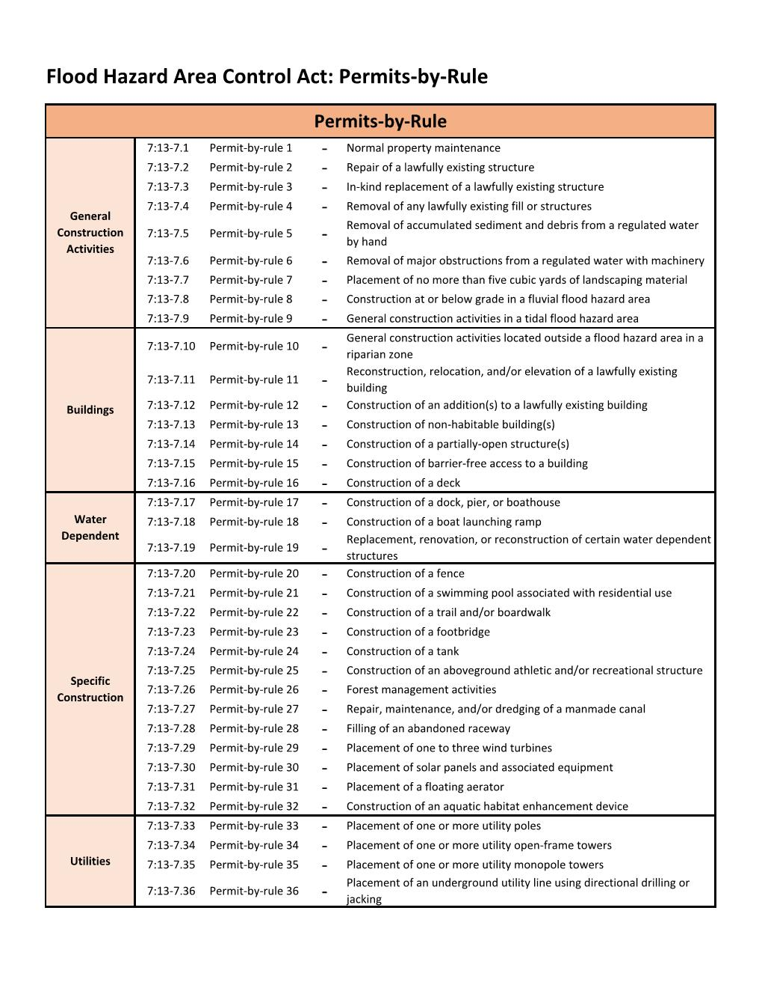

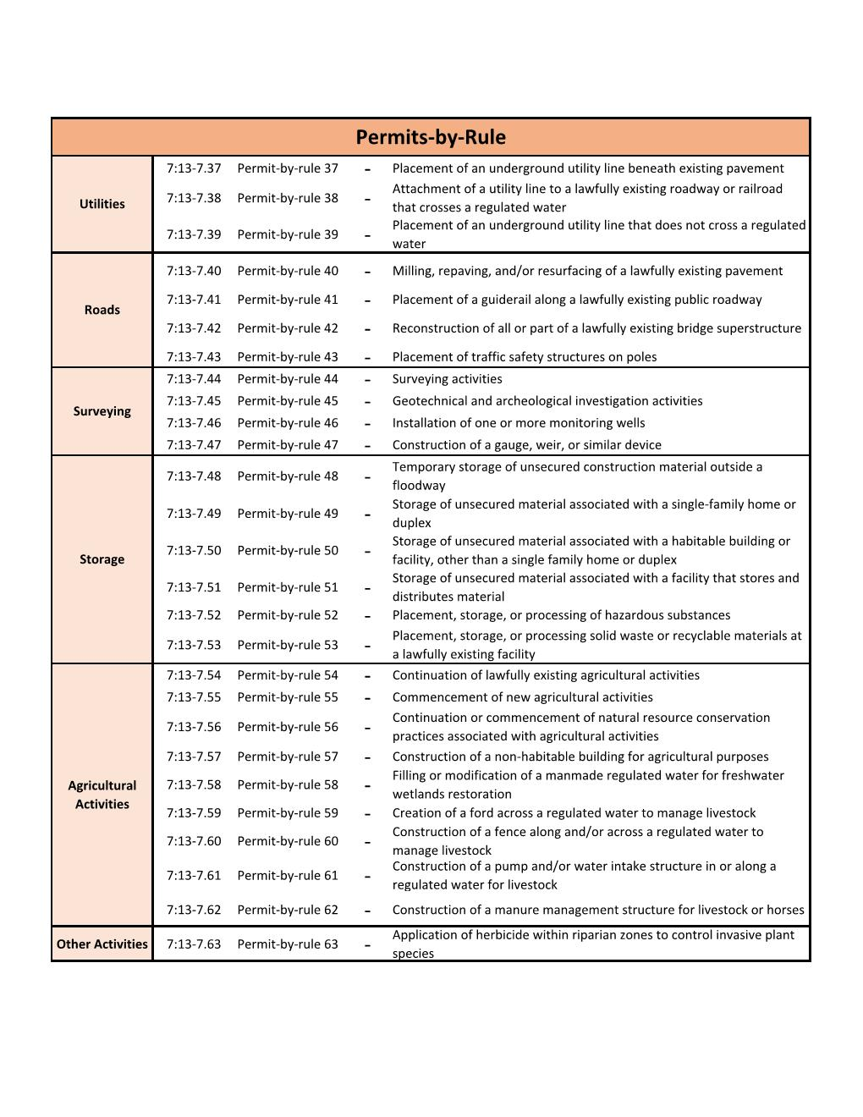

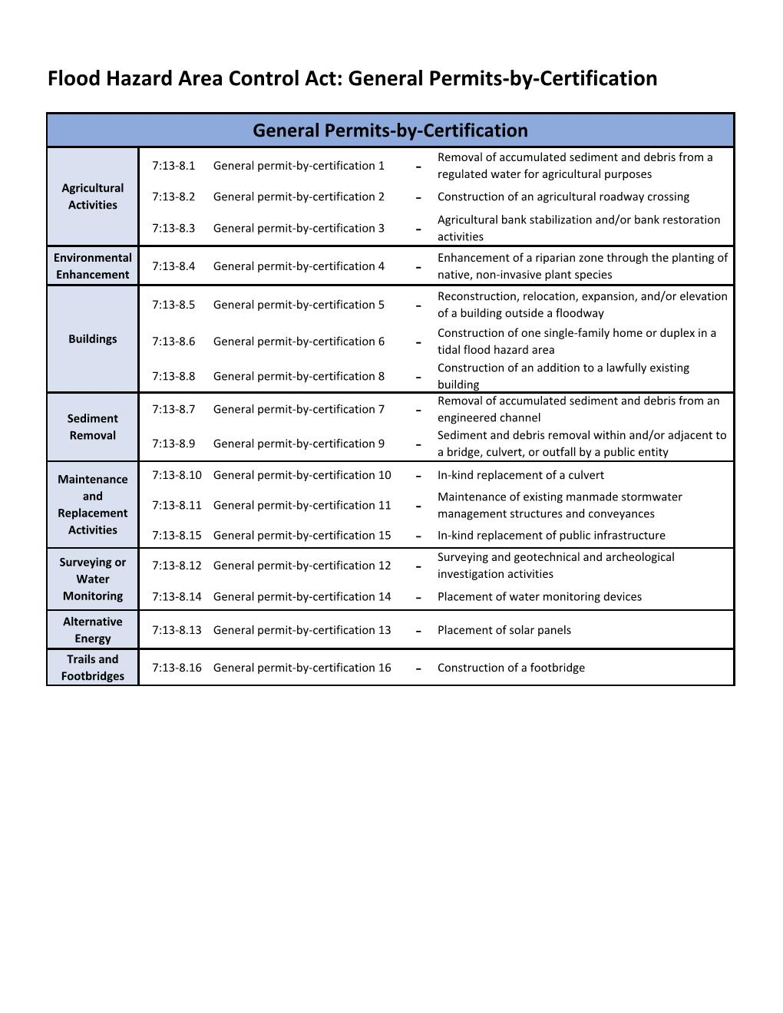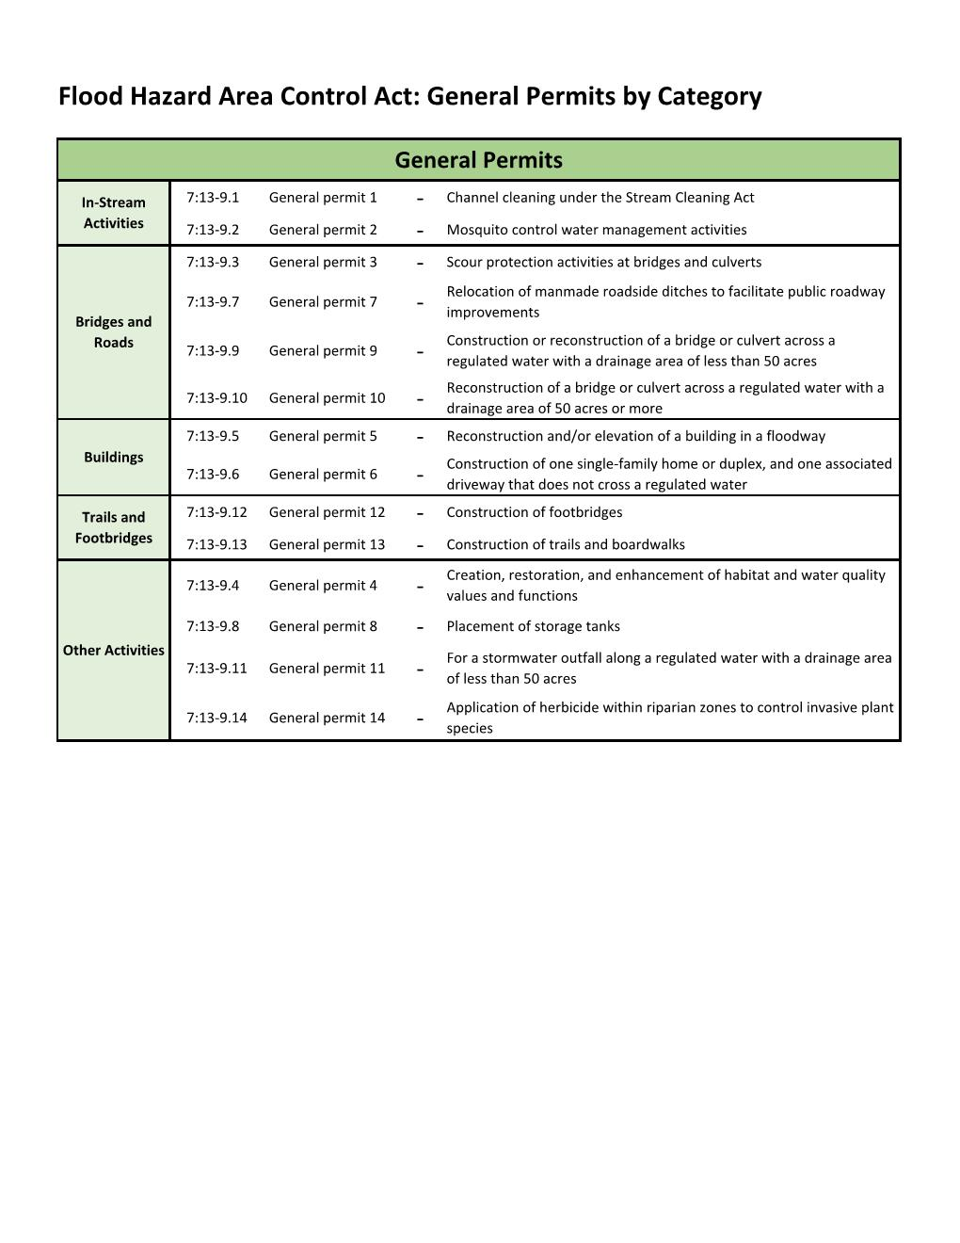

Note: Development under the jurisdiction of the Coastal Zone Management (CZM) Rules do not require a separate NJDEP Flood Hazard Area Control Act (FHACA) Permit. However, per Section 7:7-9.25 of the CZM Rules, the development must still meet the NJDEP FHACA Rules. Furthermore, any development listed under a CZM Permit-by-Rule, General Permit-by-Certification, or General Permit that is regulated under the NFIP, must still be reviewed by the FPA and issued a Floodplain Development Permit. Examples include but are not limited to single-family home construction or expansion, as well as filling tidelands.

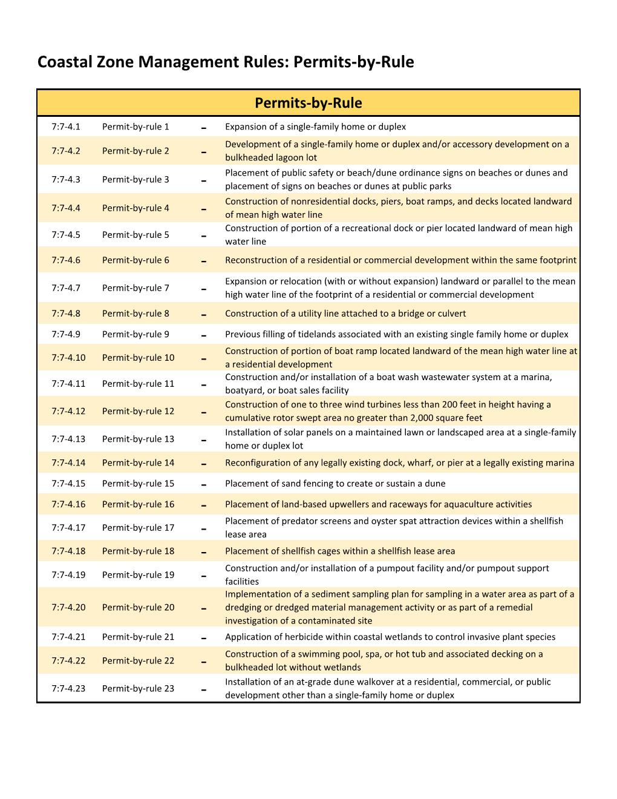

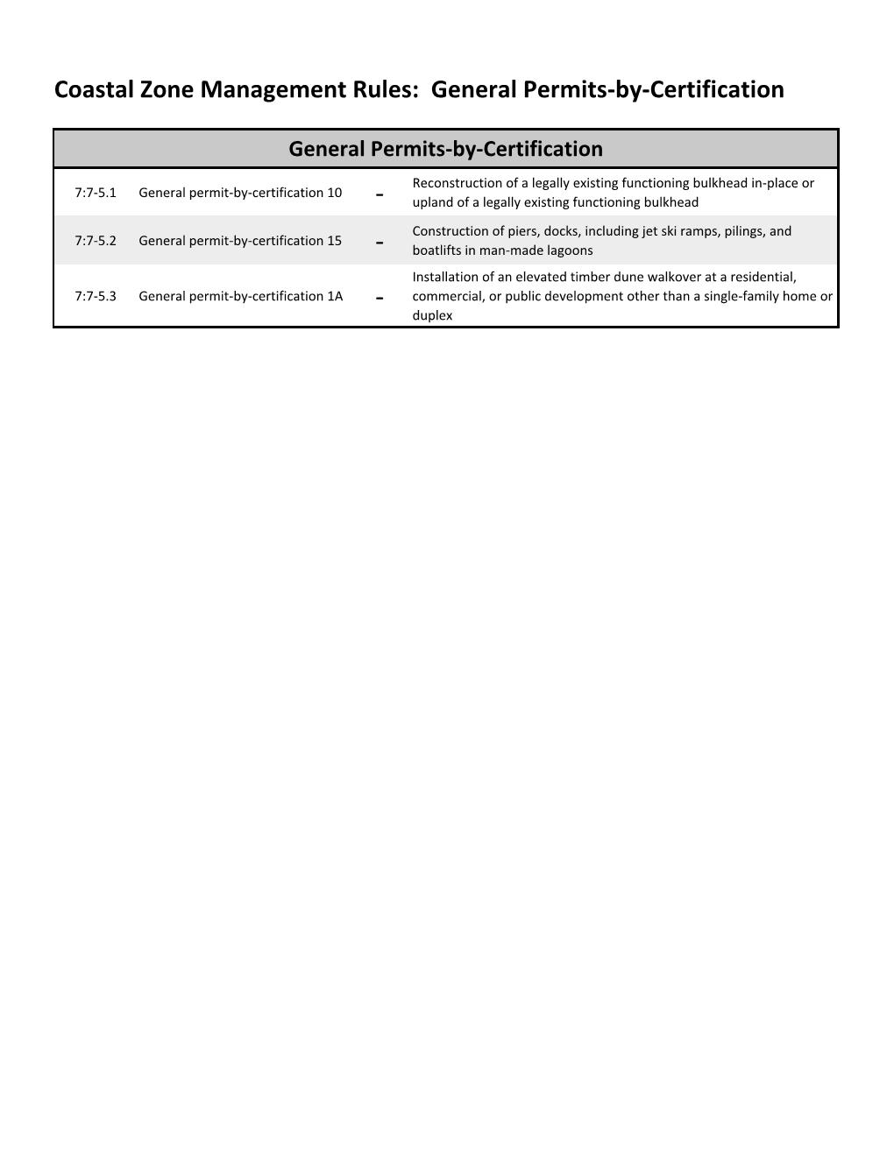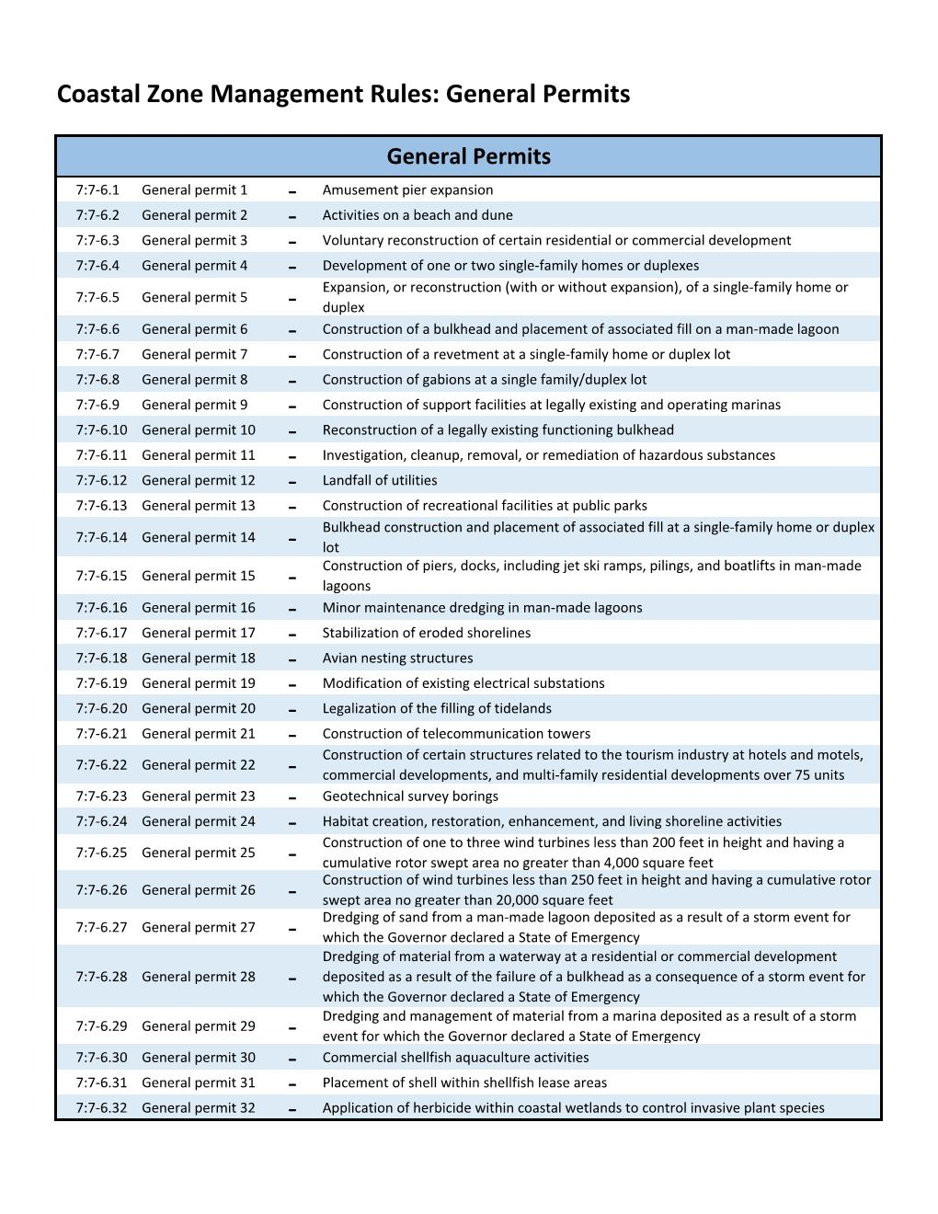

APPENDIX C

**Worksheets for Determining the Local Design Flood Elevation (LDFE)**

**Worksheet #1 – Determining the Local Design Flood Elevation for Riverine**

The use of Worksheet #1 ensures compliance with the use of best available data in accordance with the Flood Hazard Area Control Act (FHACA) and the Federal Flood Risk Management Standard (FFRMS). It also includes the addition of a factor of safety in riverine floodplains in accordance with FHACA and regulatory freeboards required pursuant to FHACA, FFRMS, and local ordinances.

**Worksheet #2A – Determining the Local Design Flood Elevation for Coastal**

The use of Worksheet #2 ensures compliance with the use of best available data in accordance with the Flood Hazard Area Control Act (FHACA) and the Federal Flood Risk Management Standard (FFRMS). It also includes regulatory freeboards required pursuant to FHACA, FFRMS, and local ordinances.

**Worksheet #2B - Determining the Wave Height Adjusted 500 Year Preliminary and Effective Map Elevation for ASCE24-14 Critical Facilities and Critical Actions under 44 CFR Part 9**

Current FEMA Effective and Preliminary 500-year floodplain mapping do not adjust for wave height which must be considered in design flood elevations for critical facilities and actions in coastal areas. This worksheet should be followed to determine whether and how much of an elevation adjustment is necessary.

## **Worksheet # 2C- Federal Flood Risk Management Standard Documentation Worksheet**

This worksheet documents the design flood elevation for federally funded projects under FFRMS, which may require specifying design flood elevations higher than State and Local law to ensure that the project can receive full reimbursement of funds while also complying with the State’s FHACA regulations.

**Worksheet # 1 - Determining the Local Design Flood Elevation – Part I (Riverine)**

|  |  |  |  |  |  |
| --- | --- | --- | --- | --- | --- |
| **Site Name:** |  | | **Date:** | |  |
| **Address:** |  | | | | |
| **Latitude (y):** |  | **Longitude (x):** | |  | |

|  |  |  |  |  |  |  |
| --- | --- | --- | --- | --- | --- | --- |
|  | State Flood Study1 | | FEMA Effective FIRM2 | | FEMA Best Available3 Preliminary, Draft, or Advisory Flood Hazard Data  **(Circle Source)** | |
| Data Available (Yes/No) |  | |  | |  | |
| Panel Number & Date |  | |  | |  | |
| Flood Zone Designation | N/A | |  | |  | |
| Floodway (Yes/No) |  | |  | |  | |
| Design1 or Base Flood Elevation2, 3 |  | |  | |  | |
| Vertical Datum^ |  | | NAVD 88 | |  | |
| ^4Resulting Elevations below must be in same datum, if conversion factor needed, note here: NAVD88 = NGVD29 - ______ ft. | | | | |  | |
| **Riverine Req.** | +2 | | +3 |  | +3 |  |
| Resulting Elevation | Box A  NGVD29 NAVD88 | | Box B  NGVD29 NAVD88 | | Box C  NAVD88D | |
| If none of the above data is available and/or the project is in a watershed 50 acres or greater in size, licensed NJ Professional Engineers may use NJFHACA Method 5 or 6 to approximate the DFE for design purposes, however, an unexpired Flood Hazard Verification Letter dated July 17th, 2023 and later, which includes a Flood Hazard Design Elevation is necessary to ensure compliance with State standards. Enter elevation in Box D. | | | | | | |
| Date of Letter Verifying the NJ Flood Hazard Design Flood Elevation (FHDFE): | | Box D | | | | |
| ***Select highest elevation from Box A, B, C, and D to determine the***  ***New Jersey Flood Hazard Design Flood Elevation (FHDFE) and input into Box E*** | | | | | | |

1Use Appendix 2 of the FHACA Rules (N.J.A.C. 7:13) to identify state-studied waters; or visit https://www.nj.gov/dep/floodcontrol/studied_streams.htm

2<https://msc.fema.gov/portal/home>

3 The most recent available preliminary flood risk guidance FEMA has provided.  The Best Available Flood Hazard Data may be depicted on but not limited to Advisory Flood Hazard Area Maps, Work Maps or Preliminary FIS and FIRM.

4Vertical datum conversion factor sources: FIS report or [https://vdatum.noaa.gov/runapp_agreement.php](https://nam11.safelinks.protection.outlook.com/?url=https%3A%2F%2Fvdatum.noaa.gov%2Frunapp_agreement.php&data=02%7C01%7Cagetz%40mbakerintl.com%7C9da4370732444a13c06c08d7c458740c%7C4e1ee3db4df64142b7b9bec15f171ca4%7C0%7C0%7C637193756500551738&sdata=3pGAVARwzUgDAjulwkS0TYEmEm0DlVBp6sYJ3iRSJHg%3D&reserved=0)

**This worksheet is designed to result in accurate determinations of the Federal Flood Risk Management Standard (FFRMS). Please consult *the New Jersey Guidebook for Implementing the Federal Flood Risk Management Standard* for additional information to ensure that all applicable federal projects receive full reimbursement.**

|  |
| --- |
| Comments: |

**Worksheet # 1 - Determining the Local Design Flood Elevation – Part II (Riverine)**

|  |  |  |  |  |  |  |
| --- | --- | --- | --- | --- | --- | --- |
| **Site Name:** |  | | | | | |
| **Freeboard Requirements** | | |  | **Highest Elevation** |  | **Highest Elevation with Freeboard Comparison** |
| **State Freeboard Requirements -** The NJ Flood Hazard Area Control Act (NJFHACA) requires that a minimum of 1 foot of freeboard be added to the Flood Hazard Design Flood Elevation (FHDFE) and no lower than that required by the UCC pursuant to the calculation below for Class I through IV facilities. | | 1 Foot | + | **Box E**  ____ Ft | = | **State**  **Box 1**  _____ Ft |
| **Local Community Freeboard Requirements** – More restrictive freeboard must be added if a higher freeboard is adopted in the Community’s Flood Damage Prevention Ordinance. | | ___ Ft*** | + | **Box E**  ____ Ft* | = | **Local**  **Box 2**  _______ Ft |
| **ASCE Class IV**: 500-year Elevation  **Or**  **FFRMS Critical Action:** 500-year Elevation | |  | | | | Box 3 |
| **FFRMS Critical Action** or **ASCE 24** Type of Facility (circle one):**  Class I Class II Class III Class IV | | If Class IV **or** FFRMS Critical Action, chose the Highest Elevation from Box 1, Box 2 and Box 3 à | | | | **FFRMS Critical Action or ASCE 24 Critical Facility**  **Box 4**  _______ Ft |
| ***Select highest DFE from State (Box 1), Local (Box 2),***  ***and ASCE (Box 4):***  ***(This is your Local DFE****) à*** | | | | | | **Box 5**  _______ Ft |
| ***Note Vertical Datum à*** | | | | | |  |
| ***Note Flood Zone à*** | | | | | |  |

*Review community ordinance to determine if the freeboard should be added to the BFE or NJ State Flood Hazard Area DFE.

**ASCE Classes and Elevation Requirements are Defined in ASCE 24-14: <https://www.fema.gov/sites/default/files/2020-07/asce24-14_highlights_jan2015.pdf>

*** The local Flood Damage Prevention ordinance may require that additional freeboard for a critical facility be added to the Local Minimum Freeboard calculated in Box 2 which may be higher than the State minimum freeboard calculated in Box 1. The local ordinance should be consulted to confirm the calculations in this worksheet. In no circumstance should a critical facility be constructed lower than required by both the Flood Hazard Area Control Act and the Uniform Construction Code.

****Local Design Flood Elevation (DFE) Definition - the Local DFE is the elevation reflective of the most recent available preliminary flood elevation guidance FEMA has provided as depicted on but not limited to Advisory Flood Hazard Area Maps, Work Maps, or Preliminary FIS and FIRM which is also inclusive of freeboard specified by the New Jersey Flood Hazard Area Control Act and Uniform Construction Codes and any additional freeboard specified in a community’s ordinance. In no circumstances shall a project’s LDFE be lower than a permit-specified Flood Hazard Area Design Flood Elevation or a valid NJDEP Flood Hazard Area Verification Letter plus the freeboard as required in ASCE 24 and the effective FEMA Base Flood Elevation.

|  |
| --- |
| **COMMENTS:** Use the box on the first page to document the use of additional worksheets, comments, assumptions, and sources. For example, source of the datum conversion factor or effective date of the local ordinance requirements in Box 2.  **ATTACH WORKSHEETS 2C (Federal Flood Risk Management Standard Documentation) to this worksheet if applicable.** |

**Worksheet # 2A - Determining the Local Design Flood Elevation – Part I (Coastal)**

|  |  |  |  |  |  |
| --- | --- | --- | --- | --- | --- |
| **Site Name:** |  | | **Date:** | |  |
| **Address:** |  | | | | |
| **Latitude (y):** |  | **Longitude (x):** | |  | |

|  |  |  |  |  |
| --- | --- | --- | --- | --- |
|  | FEMA Effective FIRM2 | | FEMA Best Available3 Preliminary, Draft, or Advisory Flood Hazard Data  **(Circle Source)** | |
| Data Available (Yes/No) |  | |  | |
| Panel Number & Date |  | |  | |
| Flood Zone Designation |  | |  | |
| LiMWA Area (Yes/No) |  | |  | |
| Base Flood Elevation2, 3 |  | |  | |
| Vertical Datum^ |  | |  | |
| ^4Resulting Elevations below must be in same datum, if conversion factor needed, note here: Box A NAVD88 = NGVD29 - ______ ft. | | | |  |
| Resulting Elevation | Box B  NGVD29 NAVD88 | | Box C  NAVD88 | |
| If none of the above data is available a licensed NJ Professional Engineer may use NJFHACA Method 6 to approximate the DFE for design purposes, however, an unexpired Flood Hazard Verification Letter dated July 17th, 2023 and later, which includes a Flood Hazard Design Elevation is necessary to ensure compliance with State standards. Enter elevation in Box D. | | | | |
| Date of Letter Verifying the NJ Flood Hazard Design Flood Elevation (FHDFE): | | Box D | | |
| ***Select highest elevation from Box B, C, and D to determine the***  ***New Jersey Flood Hazard Design Flood Elevation (FHDFE) and input into Box E*** | | | | |

2<https://msc.fema.gov/portal/home>

3 The most recent available preliminary flood risk guidance FEMA has provided.  The Best Available Flood Hazard Data may be depicted on but not limited to Advisory Flood Hazard Area Maps, Work Maps or Preliminary FIS and FIRM.

4Vertical datum conversion factor sources: FIS report or [https://vdatum.noaa.gov/runapp_agreement.php](https://nam11.safelinks.protection.outlook.com/?url=https%3A%2F%2Fvdatum.noaa.gov%2Frunapp_agreement.php&data=02%7C01%7Cagetz%40mbakerintl.com%7C9da4370732444a13c06c08d7c458740c%7C4e1ee3db4df64142b7b9bec15f171ca4%7C0%7C0%7C637193756500551738&sdata=3pGAVARwzUgDAjulwkS0TYEmEm0DlVBp6sYJ3iRSJHg%3D&reserved=0)

**This worksheet is designed to result in accurate determinations of the Federal Flood Risk Management Standard (FFRMS). For Coastal/tidal critical and non-critical actions, Box 3A must be completed to ensure an accurate comparison of local and State freeboard requirements. Please consult *the New Jersey Guidebook for Implementing the Federal Flood Risk Management Standard* for additional information to ensure that all applicable federal projects receive full reimbursement.**

|  |
| --- |
| Comments: |

**Worksheet # 2A - Determining the Local Design Flood Elevation – Part II (Coastal)**

|  |  |  |  |  |  |  |
| --- | --- | --- | --- | --- | --- | --- |
| **Site Name:** |  | | | | | |
| **Freeboard Requirements** | | |  | **Highest Elevation** |  | **Highest Elevation with Freeboard Comparison** |
| **State Freeboard Requirements -** The NJ Flood Hazard Area Control Act (NJFHACA) requires that a minimum of 1 foot of freeboard be added to the Flood Hazard Design Flood Elevation FHDFE and no lower than that required by the UCC pursuant to the calculation below for Class I through IV facilities. | | 1 Foot | + | **Box E**  ____ Ft | = | **State**  **Box 1**  _____ Ft |
| **Local Community Freeboard Requirements** – More restrictive freeboard must be added if a higher freeboard is adopted in the Community’s Flood Damage Prevention Ordinance. | | ___ Ft | + | **Box E**  ____ Ft* | = | **Local**  **Box 2**  _______ Ft |

|  |  |  |  |  |  |  |
| --- | --- | --- | --- | --- | --- | --- |
| **Coastal Area Federal Flood Risk Management Standard for Non-Critical Actions** – complete only if applicable (See WORKSHEET 2C guidance) | | 2 Feet | + | **Box E**  _____ Ft |  | **Coastal FFRMS Non-Critical Action**  **Box 3A**  ______ Ft |
| **Coastal Area Federal Flood Risk Management Standard for Critical Actions** – complete only if applicable (See WORKSHEET 2C guidance) | | 3 Feet | + | **Box E**  _____ Ft |  | **Coastal FFRMS Critical Action**  **Box 3A**  ______ Ft |
| **Coastal Area Federal Flood Risk Management Standard for Non-Critical Actions:**  Please Select the **Lower** of Elevation values when compared between Box 3A and Box G. | |  | | | | **Box 3B**  ______ Ft |
| **Coastal Area Federal Flood Risk Management Standard for Critical Actions:**  Please Select the **Higher** of Elevation values when compared between Box 3A and Box G. | |  | | | | **Box 3B**  ______ Ft |
| **ASCE 24** Type of Facility (circle one):**  Class I Class II Class III Class IV  *If Class I or II no further entry is required*  *If Class III or IV, enter elevations below* | | If Class III or Class IV, chose Highest Elevation from below and enter here à | | | | **ASCE 24 Critical Facility**  **Box 4**  _______ Ft |
| Class III choose either:  Box 1 Elevation + 1’  Box 2 Elevation + 1’*** |  |  | | | | |
| Class IV choose either:  Box 1 Elevation + 1’  Box 2 Elevation + 1’*** | Box F |  | | | | |
| Class IV and Coastal Area Federal Flood Risk Management Standard for Critical and Non-Critical Actions: 500-year Wave Adjusted Elevation Must be Determined Using Worksheet 2B | Box G |  | | | | |
| ***Select highest DFE from State (Box 1), Local (Box 2), Coastal Area FFRMS (Box 3B – if applicable) and ASCE (Box 4 – if applicable):***  ***(This is your Local DFE****) à*** | | | | | | **Box 5**  _______ Ft |
| ***Note Vertical Datum à*** | | | | | |  |
| ***Note Flood Zone and if LiMWA Area à*** | | | | | |  |

*Review community ordinance to determine if the freeboard should be added to the BFE or NJ State Flood Hazard Area DFE.

**ASCE Classes and Elevation Requirements are Defined in ASCE 24-14: <https://www.fema.gov/sites/default/files/2020-07/asce24-14_highlights_jan2015.pdf>

*** The local Flood Damage Prevention ordinance may require that additional freeboard for a critical facility be added to the Local Minimum Freeboard calculated in Box 2 which may be higher than the State minimum freeboard calculated in Box 1. The local ordinance should be consulted to confirm the calculations in this worksheet. In no circumstance should a critical facility be constructed lower than required by both the Flood Hazard Area Control Act and the Uniform Construction Code.

****Local Design Flood Elevation Definition - the Local DFE is the elevation reflective of the most recent available preliminary flood elevation guidance FEMA has provided as depicted on but not limited to Advisory Flood Hazard Area Maps, Work Maps, or Preliminary FIS and FIRM which is also inclusive of freeboard specified by the New Jersey Flood Hazard Area Control Act and Uniform Construction Codes and any additional freeboard specified in a community’s ordinance. In no circumstances shall a project’s LDFE be lower than a permit-specified Flood Hazard Area Design Flood Elevation or a valid NJDEP Flood Hazard Area Verification Letter plus the freeboard as required in ASCE 24 and the effective FEMA Base Flood Elevation.

|  |
| --- |
| **COMMENTS:** Use the box on the first page to document the use of additional worksheets, comments, assumptions, and sources. For example, source of the datum conversion factor or effective date of the local ordinance requirements in Box 2.  **ATTACH WORKSHEETS 2B (Wave Height Adjustment including any attachments signed and sealed by a Licensed NJ Professional Engineer) and 2C (Federal Flood Risk Management Standard Documentation) to this worksheet if applicable.** |

## Worksheet # 2B – Determining the Wave Height Adjusted 500 Year Preliminary and Effective Map Elevation for ASCE24-14 Critical Facilities and Critical Actions under 44 CFR Part 9

The effective FIRMs and FIS reports for a community typically have information regarding the 500-year floodplain. In New Jersey’s coastal areas, neither the effective nor the preliminary 500-year floodplain map elevations include wave height in the specified elevation. These must be included using either the empirical methodology included in Part I of this worksheet or be calculated using the process and resources discussed in Part II.

**Part I – Worksheet for Determining the Best Available 500-year Elevation including a Wave Height Adjustment Using Empirical Methodology**

Empirical Formula:

500 Year Elevation With Wave Height =

500 Year FIS Study Elevation +

[.55 * (500 Year FIS Study Elevation - Ground Surface Elevation)]

|  |  |  |  |  |  |
| --- | --- | --- | --- | --- | --- |
| **Wave Height Calculation Table for Critical Facilities in Coastal Zones** | | | | | |
| Effective FIRM | | | Preliminary FIRM | | |
| 500 Year Elevation | Box 1A  NGVD29 NAVD88 | FT | 500 Year Elevation | Box 2A  NAVD88 | FT |
| Ground Elevation | Box 1B  NGVD29 NAVD88 | FT | Ground Elevation | Box 2B  NAVD88 | FT |
| Wave Height  (.55*(Box 1A-Box 1B) | Box 1C | FT | Wave Height  (.55*(Box 2A-Box 2B) | Box 2C | FT |
| 500 Year Elevation w/ Wave Height  (Box 1A + Box 1C) | Box 1D  NGVD29 NAVD88 | FT | 500 Year Elevation w/ Wave Height  (Box 2A + Box 2C) | Box 2D  NAVD88 | FT |
| Vertical Datum - Resulting Elevations below must be in same datum, if conversion factor needed, note here:  NAVD88 = NGVD29 - _____ft. | Box 1E  NAVD88 | FT |  |  | Ft |
| ***Select highest Elevation from Effective (Box 1D or 1E)***  ***and Preliminary (Box 2D)***  ***Alll Elevations must be in NAVD88***  ***This is your Class IV 500-Year Elevation à***  ***ENTER RESULT IN WORKSHEET 2A, BOX G*** | | | | Box 3A | FT  NAVD88 |

**Part II. Determining Wave Height Adjustment Using Detailed Analyses**

The empirical formula given in Part I, above, is a conservative estimate of the wave height adjustment to the preliminary and effective 500 year elevations in New Jersey’s coastal areas. If there are structures or protective works between a project and shoreline where waves break, additional analyses may be performed to further refine the wave runup using the following guidance documents: In areas where there are bulkheads, other houses, and structures between the water body and the proposed critical facility that can reduce wave height, there are more specific methodologies that could be used to analyze overland waves to determine the 500-year elevation including the wave height adjustment with more accuracy.

Determination of Wave Characteristics <https://www.fema.gov/sites/default/files/documents/fema_determination-wave-characteristics-guidance_112021.pdf>

Coastal Wave Runup and Overtopping <https://www.fema.gov/sites/default/files/documents/fema_coastal-wave-runup-overtopping_112021.pdf>

Coastal Wave Setup <https://www.fema.gov/sites/default/files/2020-03/frm_p1wave1.pdf>Overland

Wave Propagation <https://www.fema.gov/sites/default/files/documents/fema-coastal-overland-wave-propagation_112021.pdf>

These analyses should be performed by a licensed NJ Professional Engineer familiar with coastal erosion processes and the impact of wave loads on structures. It is recommended that the project designers contact the funding agency, the NFIP Coordinator’s Office, and the local Floodplain Administrator if these methodologies for determining wave height adjustments are pursued.

|  |  |  |  |  |  |
| --- | --- | --- | --- | --- | --- |
| **Wave Height Calculation Table for Critical Facilities in Coastal Zones** | | | | | |
| Effective FIRM | | | Preliminary FIRM | | |
| 500 Year Elevation w/ Wave Height | Box 4A | FT | 500 Year Elevation w/ Wave Height | Box 5A | FT |
| Vertical Datum - Resulting Elevations below must be in same datum, if conversion factor needed, note here:  NAVD88 = NGVD29 - _____ft. | Box 4B | FT |  |  |  |
| ***Select highest Elevation from Effective (Box 4A or 4B)***  ***and Preliminary (Box 5A) - ALL ELEVATIONS MUST BE IN NAVD88***  ***This is your 500-Year Elevation à***  ***ENTER RESULT IN WORKSHEET 2A: LOCAL DESIGN FLOOD ELEVATION, BOX G*** | | | | Box 6A | FT  NAVD88 |
| ***ATTACH DOCUMENTATION OF ALL ANALYSES INCLUDING THE SIGNATURE AND SEAL OF A LICENSED NJ PROFESSIONAL ENGINEER TO THIS WORKSHEET*** | | | | | |

## Worksheet # 2C - Federal Flood Risk Management Standard Documentation Worksheet

## Note: This worksheet is intended to be used with the following resources:

* New Jersey Guidebook for Implementing the Federal Flood Risk Management Standard
* WORKSHEET 1 and 2A: Local Design Flood Elevation (LDFE) Worksheet which determines the most restrictive Best Available Flood Hazard Data for either Coastal or Riverine.
* WORKSHEET 2B: Determining the Wave Height Adjusted 500 Year Preliminary and Effective Map Elevation for ASCE 24-14 Critical Facilities and Critical Actions under 44 CFR Part 9 (For Coastal)
* 44 CFR 9.4 FEMA Critical Action Definition and 44 CFR 9.11 Mitigation for guidance on critical action elevation standards
* June 3, 2022 FEMA Policy 104-22-0003 Partial Implementation of the Federal Flood Risk Management Standard for Hazard Mitigation Assistance Programs (Interim) <https://www.fema.gov/sites/default/files/documents/fema_fp-104-22-0003-partial-implemetnation-ffrms-pa-interim.pdf>  
  American Society for Civil Engineers (ASCE) Standard: ASCE 24-14 Flood Resistant Design and Construction
* The Flood Hazard Area Control Act and local Flood Damage Prevention Ordinance Regulations

|  |  |  |  |  |  |
| --- | --- | --- | --- | --- | --- |
| **FFRMS Worksheet Summary** | | | | | |
| Type of Action | Y/N | Federal Flood Risk Standard (FFRMS) | | | |
| **Non-critical Action1** |  | **Project Design Flood Elevation (from Applicable FFRMS Worksheet and Worksheet 1/2A, Box 5)** | ___________ FT | | |
| **Critical Action2** |  | **Vertical Datum Confirmation:**  **(Circle one)** | NGVD or NAVD88 | | |
| **Floodplain Type:**  **(Check one)** | | **Flood Zone**  **Designation** | ___________ | | |
| Riverine |  | **LiMWA (Coastal A) or V Zone Construction (Check one)** | | Yes | No |
| Coastal |  |  |  |
| 1If yes, Use the FFRMS Non-Critical Action Worksheet  2If yes, Use the FFRMS Critical Action Worksheet | | | | | |

|  |  |  |
| --- | --- | --- |
| **Project Name:** | | |
| **FFRMS Critical Action Worksheet**  **Complete only the Riverine or the Coastal Box on this Worksheet.** | | |
| **Building Class** | **RIVERINE** | **COASTAL** |
| **FFRMS Standard with State and Local Compliance** | |
| Class I  Class II  Class III  Class IV | 1. Complete Worksheet 1 2. Enter the Elevation from Box 5, below   __________ FT NAVD88 | 1. Complete Worksheet 2B. 2. Complete Worksheet 2A including Boxes 4, F, and G. 3. Enter the Elevation from Box 5, below   __________ FT NAVD88 |
| WORKSHEET 1 & 2A: Local Design Flood Elevation (LDFE) Worksheet which determines the most restrictive Best Available Flood Hazard Data – Box 5 must include vertical datum conversions to NAVD88 if necessary  WORKSHEET 2B: Determining the Wave Height Adjusted 500-Year Preliminary and Effective | | |
|  | | |

|  |  |  |
| --- | --- | --- |
| **FFRMS Non-Critical Action Worksheet**  **Complete only one of the six boxes on this Worksheet.** | | |
| **Building Class** | **RIVERINE** | **COASTAL** |
| **FFRMS Standard with State and Local Floodplain Compliance** | |
| Class  1 & 2 | 1. Complete Worksheet 1 including Box 3B 2. Enter the Elevation from Box 5, below | 1. Complete Worksheet 2A including Boxes 3A and 3B 2. Enter the Elevation from Box 5, below   _________ FT NAVD88 |
| Class 3 | 1. Complete Worksheet 1 including Boxes 3, 4, and E. 2. Enter the Elevation from Box 5, below | 1. Complete Worksheet 2B. 2. Complete Worksheet 2A including Boxes 3A, 3B, 4, F, and G. 3. Enter the Elevation from Box 5, below   _________ FT NAVD88 |
| Class 4 | 1. Complete Worksheet 1 including Boxes F and G 2. Enter the Elevation from Box 5, below   ______FT NAVD88 | 1. Complete Worksheet 2B. 2. Complete Worksheet 2A including Boxes 3A, 3B, 4, F, and G. 3. Enter the Elevation from Box 5, below   __________ FT NAVD88 |
| WORKSHEET 1 and 2A: Local Design Flood Elevation (LDFE) Worksheet which determines the most restrictive Best Available Flood Hazard Data – Box 5 must include vertical datum conversions in necessary.  WORKSHEET 2B: Determining the Wave Height Adjusted 500 Year Preliminary and Effective | | |

APPENDIX D

**PART IV – FLOOD INFORMATION – Site Specifications**

|  |
| --- |
| **PART IV – FLOOD INFORMATION - To Be Completed by the Floodplain Administrator** |

Non-residential building: Section D-1

Building in a non-coastal A-Zone^: Section D-2

Building in a V Zone or Coastal A Zone^: Section D-3

Multi-family or mixed-use building: Section D-4

Agricultural structure: Section D-5

Accessory structure: Section D-6

Elevator proposed: Section D-7

Below-grade parking proposed: Section D-8

^Non-coastal A Zone is defined as riverine areas or tidal areas landward of the Limit of Moderate Wave Action (LiMWA). Coastal A Zone is defined as tidal areas seaward of the Limit of Moderate Wave Action (LiMWA).

**D-1**

|  |  |  |
| --- | --- | --- |
| *SITE SPECIFICATIONS – NON-RESIDENTIAL BUILDINGS ONLY* | | |
| Lowest Electrical/Mechanical Equipment | Description: | ____________________________ |
| Dry Floodproofing Certificate for areas below the Base Flood Elevation plus a minimum of 1-foot Freeboard | Y / N | |
| Flood Resistant Materials | Y / N | |

**D-2**

|  |  |
| --- | --- |
| *SITE SPECIFICATIONS – A ZONE BUILDINGS^* | |
| ***Note: Incl. accessory structures, detached garages, and storage sheds.  Subgrade crawlspaces and basements are prohibited.*** | |
| Top of Lowest Floor Elevation | __________ |
| *Openings in Walls and Foundations (see* ***FEMA Technical Bulletin 1****\*):* | |
| * Number of openings in walls and foundations | __________ |
| * Square inches of all openings | __________ |
| * Engineered openings | Y / N |
| * Engineered opening manufacturer and model | __________ |
| * Architect/Engineer Certification of Non-Engineered opening | Y / N |
| Anchoring (manufactured homes, accessory buildings, storage sheds, recreational vehicles on-site greater than 180 days) | Y / N |
| Architect/Engineered Certification for Back-filled Stem Walls | Y / N |

*<https://www.fema.gov/nfip-technical-bulletins>

^Non-coastal A Zone is defined as riverine areas or tidal areas landward of the Limit of Moderate Wave Action (LiMWA). Coastal A Zone is defined as tidal areas seaward of the Limit of Moderate Wave Action (LiMWA).

**D-3**

|  |  |
| --- | --- |
| *SITE SPECIFICATIONS**–**V ZONE AND COASTAL A ZONE^ BUILDINGS* | |
| Lowest Horizontal Member Elevation | ________ |
| Size of Enclosure (must be less than 300 square feet external dimension for lower insurance rates) | ________ |
| Use of Enclosure | _______________ |
| Number of openings in breakaway walls | ________ |
| Coastal A Zone Breakaway Wall Certification | Y / N |
| Non-Conversion Agreement Attached | Y / N |
| * Deed Restricted | Y / N |
| *Free of Obstruction (see* ***FEMA Technical Bulletin 5\*****):*   * Access Ramps/Stairs/Decks are open to water flow | Y / N |
| * Access Ramps / Stairs / Decks are structurally supported and independent of the Structure | Y / N |
| * Engineer’s Certificate for Breakaway Walls, Engineered Walls, Slabs, or Other Potential Obstructions where Piles and Columns are not feasible | Y / N |

*<https://www.fema.gov/nfip-technical-bulletins>

^Non-coastal A Zone is defined as riverine areas or tidal areas landward of the Limit of Moderate Wave Action (LiMWA). Coastal A Zone is defined as tidal areas seaward of the Limit of Moderate Wave Action (LiMWA).

**D-4**

|  |  |
| --- | --- |
| *SITE SPECIFICATIONS – MULTI-FAMILY AND MIXED-USE BUILDINGS* | |
| **See: *FEMA Flood Mitigation Measures for Multi-Family Buildings^ & NFIP Technical Bulletin 3 - Requirements for the Design and Certification of Dry Floodproofed Non-Residential and Mixed-Use Buildings\****  ***Notes: Basements and below grade parking area prohibited below residential portions of multi-family structures including those for hotels and motels. Dry floodproofing is prohibited in non-residential portions of mixed-use structures in Coastal A and V Zones. Dry floodproofing is prohibited for all areas servicing residential areas and ancillary portions of residential structures which service residential areas. At least one access to residential areas must be available for use and cannot be dry floodproofed. Building systems servicing residential portions of structures cannot be located in dry-floodproofed areas and must be elevated above the LDFE.***    ***ASCE 24-14 limits dry floodproofing:***   1. ***To areas where the base flood velocities do not exceed 5 feet/second; and***   ***2) Any proposed human intervention is in conformance with ASCE 24-14 6.2.3*** |  |
| Below grade basements and parking do not service any residential portions of the structure? | Y / N |
| Below grade basements and parking are not located in a Coastal A Zone or V Zone based upon an evaluation of the most recent best available flood hazard data? | Y / N |
| No residential areas including at least one building egress are dry floodproofed and all residential areas including those meeting the definition of ancillary space are above the BFE? | Y / N |
| All residential areas including those meeting the definition of ancillary space are above the BFE? | Y / N |
| Mechanical, Electrical, and Plumbing Systems are located at or above the LDFE or if below the LDFE are designed to resist flood loads and prevent water from entering or accumulating within the components and service only non-residential portions of the structure and meets the requirements of chapter 7, ASCE 24-14? | Y / N |
| Substantial Improvement and Substantial Damage measures meet standards and practices discussed in the *FEMA Mitigation Measures for Multi-Family Buildings*^? | Y / N |
| A *Floodproofing Certificate* for non-residential portions of the structure has been submitted at permit application? | Y / N |
| An *Emergency Operations Plan* for floodproofing in non-residential portions of the structure has been submitted at permit application and meets ASCE 24-14 6.2.3?  ***Note: This shall include meeting the 12-hour flood warning time unless the community operates a flood warning system. If so, the designer will have to determine the available time necessary to implement dry floodproofing measures.*** | Y / N |
| All proposed floodproofing products used in non-residential areas meet *American National Standard for Flood Mitigation Equipment* (ANSI/FM)? | Y / N |
| *Inspection and Maintenance Plan* proposed at permit application?  ***Note: Inspections are recommended at least once a year and could be coordinated with regular drills.*** | Y / N |
| The architect/engineer has provided evidence that the structure can withstand a combination of flood loads (hydrostatic, hydrodynamic, wave, and impact) according to ASCE 7? | Y / N |
| The *Floodproofing Certificate* has been fully completed at project completion? | Y / N |

^<https://content.govdelivery.com/attachments/USDHSFEMA/2020/06/24/file_attachments/1481529/16-J-0218_Multi-FamilyGuidance_06222020.pdf>

*<https://www.fema.gov/nfip-technical-bulletins>

**D-5**

|  |  |
| --- | --- |
| *SITE SPECIFICATIONS – AGRICULTURAL STRUCTURES* | |
| ***FEMA Floodplain Management Bulletin P-2140 Floodplain Management Requirements for Agricultural Structures and Accessory Structures*\***  ***Note: Variances can only be granted in municipalities that have adopted the New Jersey Model Code Coordinated Ordinance after January 2021.*** |  |
| Meets the FEMA or Model Code Coordinated Ordinance definition of Agricultural Structure and is used exclusively for that use? | Y / N |
| If Substantial Improvement / Substantial Damage is determined, is elevation required? | Y / N |
| If Substantial Improvement / Substantial Damage is determined and the structure type requires dry-floodproofing, is the floodproofing proposed to the LDFE?  ***Note: Structure cannot be located in a V Zone or Coastal A Zone.*** | Y / N |
| Variance requested to repair/restore to pre-flood condition and wet floodproof? | Y / N |
| If a variance is requested, is justification provided with an explanation of the hardship? | Y / N |
| Is a variance granted that restricts use? | Y / N |
| Is the structure anchored? Is mechanical equipment raised? Are flood resistant materials used? Does the foundation have adequate openings? | Y / N |

*<https://www.fema.gov/nfip-technical-bulletins>

**D-6**

|  |  |
| --- | --- |
| *SITE SPECIFICATIONS – ACCESSORY STRUCTURES* | |
| ***FEMA Floodplain Management Bulletin P-2140 Floodplain Management Requirements for Agricultural Structures and Accessory Structures*\***  ***Note: Variances can only be granted in municipalities that have adopted the New Jersey Model Code Coordinated Ordinance after January 2021.*** |  |
| Meets the FEMA or Model Code Coordinated Ordinance definition of an Accessory Structure and is used exclusively for that use? | Y / N |
| New Construction or Substantial Improvements – Elevation Required? | Y / N |
| New Construction or Substantial Improvements – Dry-floodproofed at least to the LDFE? | Y / N |
| Variance Requested to Wet floodproof and the *New Jersey Model Code Coordinated Ordinance* is adopted? | Y / N |
| If a variance is requested, is justification provided with an explanation of the hardship? | Y / N |
| A Zone – Structure is the size of a one-story two-car garage or smaller and not in a floodway?  ***Note: FEMA guidance notes that the typical footprint is less than 600 square feet (****See* ***page 19 of the Technical Bulletin).*** | Y / N |
| V Zone – Structure is less than 100 square feet? | Y / N |
| Variance granted that restricts use? | Y / N |
| Is the structure anchored? Is mechanical equipment raised? Are flood resistant materials used? Does the foundation have adequate openings? | Y / N |

*<https://www.fema.gov/nfip-technical-bulletins>

**D-7**

|  |  |
| --- | --- |
| *SITE SPECIFICATIONS – ELEVATORS* | |
| **Proposed Elevator meets *FEMA Technical Bulletin 4*\***  ***Note: Please coordinate with your code official when reviewing elevator compliance in the SFHA.*** | |
| Elevation of lowest Electronic Controls/Junction Box/Switch | __________ |
| Lowest elevation of electronic controls is above the LDFE | Y / N |
| Components below the required elevations are composed of flood damage-resistant materials and capable of resisting physical damage due to flooding | Y / N |
| Float Switch Detection System to prevent the elevator cab or lift from descending into flood waters | Y / N |
| Backflow Prevention for elevator shafts | Y / N |
| Architect’s/Engineer’s Certification stating that the enclosure design can resist hydrodynamic and hydrostatic flood forces  ***Note: Elevator shafts must resist flood loads. In Zone A, shafts are not required to have flood openings; in Zone V and Coastal A Zones, shafts are not required to have breakaway walls.*** | Y / N |
| Confirm that any hydraulic elevators below the required elevation have elevated electrical control panels, hydraulic pumps, and tanks; drainage provided for the elevator pit; hydraulic lines, hydraulic cylinders, and buffer springs located to prevent physical damage due to flooding or painted or coated with galvanic or rust-preventive paint | Y / N |
| Confirm that any traction elevator systems have elevated machine rooms, and components in hoist ways below the required elevation must be protected from physical damage due to flooding | Y / N |
| Chairlifts, pneumatic elevators, and platform lifts are reasonably safe from flooding (See ***ASCE24-14 7.5 and related commentary***) | Y / N |

*<https://www.fema.gov/nfip-technical-bulletins>

**D-8**

|  |  |
| --- | --- |
| *SITE SPECIFICATIONS – BELOW-GRADE PARKING REQUIREMENTS* | |
| **See: *FEMA Technical Bulletin 6*, FEMA Flood Mitigation Measures for Multi-Family Buildings^,* and *NFIP Technical Bulletin 3\** (if applicable, also use Checklist D-4)**  ***Notes: Below-Grade Parking is prohibited in Coastal A Zones and V Zones. Below-Grade Parking is prohibited in Residential Buildings and is allowed only for non-residential portions of Mixed-Use Buildings.*** | |
| An exit is available above the LDFE | Y / N |
| The Below-Grade Parking Garage is not located in a Coastal A Zone or V Zone based upon the most recent best available flood hazard data | Y / N |
| A *Floodproofing Certificate* for the structure has been submitted at permit application (See **FEMA Technical Bulletin 3\***) | Y / N |
| There are no residential uses proposed for the building | Y / N |
| *Emergency Operations Plan* for floodproofing in non-residential portions of the structure has been submitted at permit application that meets ASCE 24-14 6.2.3  ***Note: This shall include meeting the 12-hour flood warning time unless the community operates a flood warning system. If so, the designer will have to determine the available time necessary to implement dry floodproofing measures.*** (See **FEMA Technical Bulletin 3\***) | Y / N |
| All proposed floodproofing products used in non-residential areas meet American National Standard for Flood Mitigation Equipment (ANSI/FM) | Y / N |
| *Inspection and Maintenance Plan* proposed at permit application  ***Note: Inspections are recommended at least once a year and could be coordinated with regular drills.*** (See **FEMA Technical Bulletin 3\***) | Y / N |
| The architect/engineer has provided evidence that the structure can withstand a combination of flood loads (hydrostatic, hydrodynamic, wave, and impact) according to ASCE 7 | Y / N |
| The *Floodproofing Certificate* has been fully completed at project completion | Y / N |

*<https://www.fema.gov/nfip-technical-bulletins>

^<https://content.govdelivery.com/attachments/USDHSFEMA/2020/06/24/file_attachments/1481529/16-J-0218_Multi-FamilyGuidance_06222020.pdf>