Community Substantial Damage Management Plan
Date, Version 1.0

Community specific information in [brackets] and highlighted yellow
Higher Standards highlighted in blue
CRS-Specific language options highlighted in green
Cross References are in magenta
Instructions for community in italics and bold (remove from finalized version)

0. Introduction
In the following section you will find two sections: one for communities that participate in CRS and one for those that do not. Use whichever introduction is fitting for your community.
(1) Non-CRS Community Introduction

0. Introduction
The following plan was implemented by [Community Name] to assist with meeting requirements of the Federal Emergency Management Agency (FEMA) National Flood Insurance Program regarding substantial damages and improvements. This plan outlines [Community Name]’s definition of substantial damage (SD) and substantial improvement (SI) requirements, outlines vulnerable areas, tracks SI and SD determinations, and outlines steps to take before and after a disaster.
The following six steps were used in the development of this plan:
- Assess community’s vulnerability to substantial damage
- Identify community’s team for management of substantial damage properties
- Identify post-event efforts related to substantial damage
- Build a property database for substantial damage estimates
- Identify actions community can take to address potential substantial damage
- Determine implementation steps and procedures for updating the plan
The correct use of this plan is intended to help [Community Name] be better prepared with resources and materials prior to a disaster and to have clear steps to follow post-disaster to allow for quick and successful recovery.
(2) CRS Community Introduction
CRS Communities should use this check list to ensure all requirements are met to earn these credits:
Substantial Damage Plan (SDP) Review Checklist
https://crsresources.org/500-2/

0.1 CRS and Substantial Damage
The community rating system (CRS) is a program that was developed by the Federal Emergency Management Agency (FEMA) that provides discounts on flood insurance for communities that go beyond the basic requirements of the National Flood Insurance Program (NFIP). Communities can receive discounts in flood insurance premiums for its residents and business owners by meeting criteria outlined in the CRS Coordinator’s Manual and earning credits. The number of credits earned correlates with different class levels which each provide a different level of discounts, up to 45%.
In 2021, FEMA released an addendum to the CRS Coordinator’s Manual that provides a new credit opportunity (Activity 512.d SDP) for developing a Substantial Damage Management Plan (SDP). This new credit allows for up to 140 points and the requirements are outlined in the following Section 0.2. This document was created to also meet the requirements of this credit.

0.2 Steps to Develop Substantial Damage Management Plans that meet CRS Requirements
There are three opportunities for credits for the Activity 512.d SDP credit and they are:
- SDP1 – 40 points for the development of an SDP
- SDP2 – 50 points if FEMA’s Substantial Damage Estimator (SDE) is prepopulated or other equivalent program
- SDP3 – 50 points if pre-event mitigation alternatives are considered
This totals to 140 points available for this credit. The CRS Coordinator’s manual outlines the requirements of this credit, including the following seven criteria:
- Must be developed using a definition of substantial damage that meets or exceeds the NFIP definition of substantial damage
- If a community is receiving credit for cumulative substantial improvement (element CSI) under Activity 430 (Higher Regulatory Standards), then the substantial damage management plan must reference the community’s cumulative substantial damage definition credited under CSI and describe the community’s process for tracking cumulative substantial improvements. If a community is receiving credit for having a lower threshold for substantial improvement (element LSI), then the definition of lower substantial improvement must be referenced.
- The plan must be the outcome of the six-step planning process, which is outlined following this list.
- The community must prepare an annual evaluation report for its substantial damage management plan.
- The substantial damage management plan and the annual evaluation report must be submitted to the community’s governing body. If private or sensitive information (such as names or street addresses) is included in the report, then a summary report(s) must be prepared for the governing body, committees, media, and the public.
- The community must provide its latest update or revision to its substantial damage management plan in time for each CRS cycle verification visit. The update or revision must include a review of each of the six planning steps.
- The substantial damage management plan must be made available to the State NFIP Coordinator and the FEMA Regional Office, if requested.
One of these seven criteria above requires the following six steps be followed when developing the SDP:
- Assess community’s vulnerability to substantial Damage
- Identify community’s team for management of substantial damage properties
- Identify post-event efforts related to substantial damage
- Build a property database for substantial damage estimates
- Identify actions community can take to address potential substantial damage
- Determine implementation steps and procedures for updating the plan
[Community Name] has followed these steps in the development of this plan, as outlined in the following sections. The following table is an outline of the requirements of each step and where they can be found within the plan.
Please update this table if your community altered the sections and numbering. Steps 2 through 5 can be done in any order. Steps 1 and 6 need to be the first and last steps of this process.
Table 1 CRS requirements for SDP and Location in this document
Requirement | Section Number
Assess community’s vulnerability to substantial Damage | 1
Define SD, SI, CSI, and Lower SI/SD Threshold | 1.1
Describe previous SI and SD | 1.2, Appendix 2
List and map of SFHA properties | 1.4, Appendix 3 and 4
Description of other building or flood factors | 1.6
General description of buildings on the potential SD list | 1.5
Identify community’s team for management of substantial damage properties | 2
Includes department responsible for issuing permits and office that tracks CSI | 2.1
Includes sufficient additional personnel for the SD effort after a major flood or event | 2.1
Considers personnel resources such as the State NFIP Coordinator and/or FEMA | 2.2
Identify post-event efforts related to substantial damage | 3
Post-event coordination and communication efforts | 3
Damage estimate and substantial damage determination procedures | 3
Post-substantial damage determination procedures for compliance | 3
Build a property database for substantial damage estimates | 4
Basic substantial damage property database | 4
SDP2 – Pre-populate FEMA SDE or other equivalent program | 4
Identify actions community can take to address potential substantial damage | 5
Include one action the community will take to educate community about SD/SI | 5.1
SDP3 - Consider mitigation alternatives for areas of community with high SD potential | 5.1
Determine implementation steps and procedures for updating the plan | 6
Provide annual evaluation report | 6
Share with elected officials | 6
Propose an update process for SD management plan and/or schedule | 6
Steps that must be taken to adhere to the Privacy Act or state or community privacy requirement | 6

1. Assessment of Vulnerability to Substantial Damage
Implementing this plan requires identifying vulnerable areas so that substantially damaged properties can be safely identified and evaluated, and homeowners and business owners can rebuild and reoccupy their structures. Identifying areas that are more vulnerable can help focus efforts to those areas that may need the most attention post disaster. Assessing vulnerability requires tracking previous substantial damages (SD) and substantial improvements (SI), identifying vulnerable buildings within the special flood hazard areas, describing other flood factors considered, and providing a general overview of structures in the special flood hazard area.

1.1 Substantial Damage, Substantial Improvement, Cumulative Substantial Improvement and Lower Substantial Improvement Threshold
Current Ordinance Definitions:
The following definitions are from [Community Name]’s current Flood Damage Prevention Ordinance.
These definitions are from the most recent Model Code Coordinated Ordinance. Please ensure that they match up with what is in your current flood damage prevention ordinance (FDPO) definitions. If your community considers Cumulative Substantial Improvement or a Lower Substantial Improvement Threshold, please be sure this is reflected in these definitions. If your communities FDPO has been updated, ensure that you alter this language to match your new ordinance during your annual review of this document.
If your community has not adopted the Model Code Coordinated Ordinance, you will need to. In the interim, ensure that these definitions include any other regulations that my apply to your community such as building codes, zoning, etc.
SUBSTANTIAL DAMAGE – Damage of any origin sustained by a structure whereby the cost of restoring the structure to its before damaged condition would equal or exceed 50 [or optional lower number] percent of the market value of the structure before the damage occurred.
SUBSTANTIAL IMPROVEMENT – Any combination of reconstruction, rehabilitation, addition, or other improvement including those considered ordinary maintenance and minor work of a structure taking place over a number of [years] year period, the cumulative cost of which equals or exceeds fifty (50) [or optional lower number] percent of the market value of the structure before the "start of construction" of the improvement. The period of accumulation includes the first improvement or repair of each structure is permanent subsequent to [date]. This term includes structures which have incurred "substantial damage," regardless of the actual repair work performed. The term does not, however, include either:
- Any project for improvement of a structure to correct existing violations of State or local health, sanitary or safety code specifications which have been identified by the local code enforcement officer and which are the minimum necessary to assure safe living conditions; or
- Any alteration of a "historic structure", provided that the alteration will not preclude the structure's continued designation as a "historic structure."
Cumulative Substantial Improvement — Any reconstruction, rehabilitation, addition, or other improvement of a structure that equals or exceeds 50 percent [lower threshold – e.g.: replace 50 percent with 40 percent] of the market value of the structure at the time of the improvement or repair when counted cumulatively for 10 years.
Previous Ordinance Definitions:
[Community Name]’s definition for Substantial Damage and Substantial Improvement has altered slightly throughout the years. The following is how SD and SI were defined in [Community Name]’s previous ordinance, adopted on [date].
Below are sample definitions from previous Model Flood Damage Prevention Ordinances. These definitions may vary depending on when you adopted your ordinance. Please indicate which ordinance and what timeframe the definitions you historically used were effective. This step is not required for the CRS SDP credit, but is recommended for best practices.
Substantial Damage — Damage of any origin sustained by a structure whereby the cost of restoring the structure to its before damaged condition would equal or exceed fifty (50) percent of the market value of the structure before the damage occurred. Substantial Damage also means flood-related damages sustained by a structure on two or more separate occasions during a 10-year period for which the cost of repairs at the time of each such flood event, on the average, equals or exceeds 25 percent of the market value of the structure before the damages occurred.
Substantial Damage — Damage of any origin sustained by a structure whereby the cost of restoring the structure to its condition before damage would equal or exceed fifty (50) percent [optional – higher standard – lower threshold – e.g.: replace 50 percent with 40 percent] of the market value of the structure before the damage occurred.
Substantial Improvement — Any reconstruction, rehabilitation, addition, or other improvement of a structure during a 10-year period the cost of which equals or exceeds fifty (50) percent of the market value of the structure before the "start of construction" of the improvement. Substantial improvement also means “cumulative substantial improvement.” This term includes structures which have incurred "substantial damage", regardless of the actual repair work performed or “repetitive loss”. The term does not, however, include either:
- Any project for improvement of a structure to correct existing violations of State or local health, sanitary or safety code specifications which have been identified by the local code enforcement officer and which are the minimum necessary to assure safe living conditions; or
- Any alteration of a "historic structure", provided that the alteration will not preclude the structure's continued designation as a "historic structure".
Substantial Improvement — Any reconstruction, rehabilitation, addition, or other improvement of a structure, the cost of which equals or exceeds fifty (50) percent [optional – higher standard – lower threshold – e.g.: replace 50 percent with 40 percent] of the market value of the structure before the "start of construction" of the improvement. This term includes structures which have incurred "substantial damage", regardless of the actual repair work performed. The term does not, however, include either:
- Any project for improvement of a structure to correct existing violations of State or local health, sanitary or safety code specifications which have been identified by the local code enforcement officer and which are the minimum necessary to assure safe living conditions; or
- Any alteration of a "historic structure", provided that the alteration will not preclude the structure's continued designation as a "historic structure".

1.2 Description of Previous Substantial Damage and Substantial Improvement Determinations
Some communities track cumulative SD/SD using a table. A sample table can be found in Appendix 2. This sample table is not required but is recommended as a simple way of documenting this information. Your community can choose to export this information from wherever it is tracked, or you may provide a short and simple explanation of previous substantial damage and substantial damage determinations. If structural information is being shared with local officials or the public, please make sure that it does not contain Personally Identifiable Information (PII).
In addition to being a requirement of the NFIP, keeping track of previous substantial damages and improvements can make these calculations quicker for structures where these calculations have already been made. A list of all previous substantial damage determinations can be found in Appendix 2. In order to ensure its accuracy and that compliance is met in the allotted time, this list is updated and considered annually on the [first of every year, or each year from the date of the implementation of this plan, at the same time as County Hazard Mitigation Plan Update or other annual date selected by community. This could be done at the same time as the SDP annual evaluation and update].

1.3 Procedure for Tracking Cumulative Damage or Improvement
[Community name] keeps track of cumulative damage and improvement using [tracking system used whether it is just an excel sheet, the SDE tool, or other tracking tools]. Whenever any floodplain development permit is received by [community name] the cost of the improvement is recorded in [database]. The [database] additionally includes information on the market value of the property, and other pertinent information for determining if cumulative substantial improvement was triggered. [Community Name] considers the sum of improvements to a structure over a [number of years. 5, 10, lifetime of structure] year period when calculating cumulative substantial improvement.
For cumulative damage, whenever a substantial damage determination is made, the damage cost is recorded in [database] regardless of substantial damage being triggered or not. If there are future damages considered they would be added to the previous damage calculated, and then the sum would be compared to the market value to see if substantial damage has been triggered. [community name] considers the sum of damages to a structure over a [number of years. 5, 10, lifetime of structure] year period when calculating cumulative substantial damage.
Post disaster, rather than wait for a floodplain development permit, the Floodplain Administrator assembles a team to assess structures in the Special Flood Hazard Area and make substantial damage determinations. More details on the substantial damage team can be found in Section 2 of this document. Additionally, more information on the procedures post disaster can be found in Section 3 of this document.

1.4 List and Map of SFHA Properties (buildings that have SD potential)
Appendix 3 contains [Community Name]’s list of [1) all buildings in the SFHA, 2) properties suspected to be below BFE, 3) RL structures, 4) Properties with prior SD determinations, or 5) building which could meets cumulative SD] including pertinent information about the structures. Tracking these structures and additional information ahead of time will focus efforts where they are most needed post-disaster and will speed up the substantial damage determination process.
In addition to this table, [Community Name] also has maps of structures in this list. The full map is available upon request from [FPA, Office, etc] as it is a [File type, like ArcGIS] file. Copies are maintained by the Floodplain Administrator and the Town Planner as a [Arc GIS, file type, etc.].
In Appendix 4 [Community Name] has included exported maps depicting structures of the Special Flood Hazard Area. After a disaster, copies are made of these maps and are handed out to those going out into the field and making substantial damage determinations.

1.5 General Description of Building so the Potential Substantial Damage List
The majority of structures in [Community Name] that are in the special flood hazard area are [residential, non-residential, etc.]. The proportion of the residential to non-residential structures is [X:X]. The types of structures that are present in [Community Name] include: [list types of structures, commercial, residential, critical facilities, etc.].

1.6 Description of Other Building or Flood Factors
The following studies, maps and data are not required to be included for the SDP credit. This information is beneficial to have at hand for your community and it is recommended by the state to include these sections.
The following are the maps, data, studies, and other determined flood zones that [Community Name] uses to evaluate flood risks. These will all be used to after a disaster to determine which areas are vulnerable and need to be focused on.
Effective Flood Insurance Study
Special flood hazard areas are determined by FEMA in scientific and engineering reports called Flood Insurance Studies and are accompanied by Flood Insurance Rate Maps. The below table indicates the effective studies and maps used by [Community Name].
Please fill in the table below. All of this information should be available to you in your community’s local flood damage prevention ordinance.
Table 4. Effective Flood Insurance Study
Map Panel # | Effective Date | Revision Letter | Map Panel # | Effective Date | Revision Letter

Federal Best Available Information
[Community name] additionally considers Federal flood information as listed in the table below that provides more detailed hazard information, higher flood elevations, larger flood hazard areas, and results in more restrictive regulations. This information may include but is not limited to preliminary flood elevation guidance from FEMA (such as Advisory Flood Hazard Area Maps, Work Maps or Preliminary FIS and FIRM). These studies are listed on FEMA’s Map Service Center. This information shall be used for floodplain regulation purposes only.
Please fill in the table below. All of this information should be available to you in your community’s local flood damage prevention ordinance.
Table 5. Federal Best Available Information
Map Panel # | Preliminary Date | Map Panel # | Preliminary Date

State Regulated Flood Hazard Areas
In addition to studies done by FEMA, there are State Studies that need to be considered in [community name]. For State regulated waters, the NJ Department of Environmental Protection (NJDEP) identifies the flood hazard area as the land, and the space above that land, which lies below the “Flood Hazard Area Control Act Design Flood Elevation”. A FHACA flood hazard area exists along every regulated water that has a drainage area of 50 acres or greater. Such area may extend beyond the boundaries of the Special Flood Hazard Areas (SFHAs) as identified by FEMA. The following is a list of New Jersey State studied waters in this community under the FHACA, and their respective map identification numbers.
Please fill in the table below. All of this information should be available to you in your community’s local flood damage prevention ordinance.
Table 6. State Regulated Flood Hazard Areas
Name of Studied Water | Section Studied | Project | File Name | Map Number

Community-determined flood zone not depicted on Flood Insurance Rate Maps (High water marks, flood hazard protection areas, gage data from NOAA, etc.)
In addition to the Federal and State Studies described above, [community name] shall utilize high water elevations from flood events, groundwater flooding areas, studies by federal or state agencies, or other information deemed appropriate. This other “best available information” is never used in a way that results in less restrictive flood elevations, design standards, or smaller flood hazard areas than the sources described above. This information shall be used for floodplain regulation purposes only. Below is a list of all additional information utilized by [community name].
Please list any information your community additionally considers including high water marks, flood hazard protection areas, gage data from NOAA, etc.)
Historic Maps
As new effective and preliminary maps are released, include historical maps here with the dates they were effective. This information is useful to look back on to see what maps were effective during the construction of structures.
The following is a list of previously effective maps and the time period that they were effective for [Community Name].
Map Panel # | Time Period Effective | Revision Letter | Map Panel # | Time Period Effective | Revision Letter

2. Team for Management of Substantial Damage Properties
When gathering information for this document, it was indicated that many communities already have a team in place that meets regularly to discuss their flood program and said team would be their team for Management of Substantial Damage Properties. If this is the case, make sure that the team meets one time per year to review and discuss roles and responsibilities related to substantial damage.

2.1 [Community Name] Substantial Damage Management Team
After a disaster, there are many different offices and local officials that need to be involved in the recovery process. Identifying these individuals and offices ahead of time and ensuring they are trained in their roles and responsibilities prior to an event is necessary for a swift and quick rebuild. The following is a list of the members that make up this team and their responsibilities post-disaster for [Community Name]:
These roles and individuals on the team may be different for your community. Remove or add members of team as applicable and move responsibilities necessary.
- Floodplain Administrator (responsibilities below can be delegated)
  - Letters Prior to an Event
  - Notification on permitting procedures for rebuilding
  - Request additional help through mutual aid agreement (see Section 5 for more information on mutual aid agreements)
  - Provide training and outreach to the staff and contractors
  - Identify available resources
  - Notify elected officials and community departments including fire, police, and emergency services, planning, and building code of the upcoming fieldwork
  - Plan the SI/SD field inspections including initial field surveys, establishing damage trends, preparing cost information, and collecting data
  - Hire, train, supervise, certify and license staff for field operations
  - Ensure follow-up coordination with structure owners is completed
  - Coordinate final storage of SI/SD files
  - Organize press release and provide information on flood hazards, floodplain map data, advisory flood data and compliance to residents and property owners
  - Review elevation certificates
  - Process, maintain, and track temporary occupancy permits and inspect temporary occupancy buildings
  - Take corrective action necessary to ensure compliance
  - Determine if damaged structures have been designated as historic or that may be eligible for such designation
- Construction Official
  - Conduct and process condemnation determinations
  - Assist in substantial damage inspections and determinations
  - If DCA allows for Temporary Certificates of Occupancy, implement a procedure for properties with these certificates to be mitigated as soon as possible, keeping in mind the 6-year limit of the ICC eligibility period.
  - Regularly document and require repairs of existing violations of state or local health, sanitary, or safety code specifications which have been identified by the Construction Code Official and are the minimum necessary to ensure safe living conditions. If appropriate, this pre-event documentation may be used by a qualified professional to adjust the market value of distressed properties after an event.
- Office that does permitting
  - Review and process permit applications
  - Determine if interim permitting procedure is necessary
  - Track cumulative substantial improvement
  - Process and track requests for building code variances and record outcomes
  - Collect fees
  - Monitor impacted areas for unpermitted construction activities
  - Inspect structures under construction for compliance
- Municipal Engineer
  - Assist in substantial damage inspections and determinations
- Tax Assessor
  - Assist in establishing market value for structures
- OEM Coordinator
  - Assist in communicating to public before and after disaster
  - Draw on their Community Emergency Response Team (CERT) team (if applicable) to assist during and after emergencies and conduct preliminary damage assessments
- CRS Coordinator
- Grants coordinator/planner
- Municipal administrator

2.2 Other Personnel Resources including the State National Flood Insurance Program Coordinator’s Office and The Federal Emergency Management Agency Region II
[Community Name] will consider other personnel resources when necessary post disaster. This includes the State NFIP Coordinator’s office and the Federal Emergency Management Agency Region II resources. More detail on this is provided in Section 3 steps 5 and 8, as well as Section 5.2.
2.3 Evaluate Potential Options for Utilizing DRRA 1206 Public Assistance Funding
The Disaster Recovery Reform Act of 2018 (DRRA), amended Sections 402 and 406 of the Robert T. Stafford Disaster Relief and Emergency Assistance Act (Stafford Act), and authorized FEMA to “provide assistance to state and local governments for building code and floodplain administration and enforcement, including inspections for substantial damage compliance” and “base and overtime wages for extra hires to facilitate the implementation and enforcement of adopted building codes for a period of not more than 180 days after the major disaster is declared.” This policy enacted through FEMA’s Public Assistance (PA) Program implements section 1206 of DRRA by leveraging the amendments to Section 402 and Section 406. Utilization of these funds requires a non-federal match. More information is available in Section 3.9.
Sources of assistance include:
- Force Account Labor (i.e. hourly or full time employees working on disaster recovery or other municipal/county employees available through a shared service agreement)
- Contracted Assistance procured through a procurement process compliant with federal, state, and local laws.
- Use of a Disaster Assistance Response Team (DART) available through the Association of State Floodplain Managers (ASFPM), which is also subject to Force Account and Contracted Assistance Procurement concerns if reimbursement is sought for expenses and labor.

3. Post-Event Actions Related to Substantial Damage
The following are steps that your community may take post disaster. These steps are recommended by the state, but there is a chance that some steps are not feasible or need to be done out of order. It is ultimately up to your community to add or remove steps that you plan to take. Keep in mind, different levels of disasters may not warrant all of these steps.
The following is a list of steps for [Community Name] to follow after a disaster.
- Warning Prior to an Event

If there is ever an instance where [Community Name] is aware of an impending disaster, [letters, social media posts, or emails] notifying the residents will be sent out. This notice contains information to inform residents of the upcoming event, include information on permitting and requirements for substantial damage. Language for this notice has been prepared ahead of time and can be found in Appendix 5 of this document.

- Debris Management

Information on staging areas are available in your County’s Hazard Mitigation Plan. If this is not available in your County’s plan, work with the your Local and County Offices of Emergency Management to develop a Disaster Debris Management Plan (DDMP).
Clearing debris is an important first step to take after a disaster so that emergency vehicles are able to navigate the community. This effort will be led by [department leading effort, department of public works]. The [County Name]’s Hazard Mitigation Plan indicates the following staging areas in [Community Name] that the debris can be transported to, including [list of locations of staging areas, provide map of locations if available].

Note: FEMA provides supplemental Federal disaster grant assistance for debris removal through the Public Assistance (PA) Program. Consider this resource if additional assistance is needed. More information on this program can be found in below in #8 of this list ‘Post Disaster and Mitigation Funding Assistance’.

- Communication with Elected Officials and Property Owners

Notify Property Owners
After a disaster, notifications will be sent out to property owners via [letters, email, social media] informing them of permitting procedures, substantial damage requirements, and of upcoming inspections of structures. During this time, property owners will be eager to rebuild, so it is important to inform them of these requirements as quickly as possible and ensure that work performed on their property is properly permitted. Appendix 5 contains example language to be shared property owners.

Press Release
After a disaster, it is important to get the word out to citizens about rebuilding plans and resources they may need. Appendix 6 contains example text for press releases that can be altered to fit the disaster situation. [Community Name] will work with their Public Information Officer to develop an appropriate and informative press release. Here are a few items that are important to be included and considered:
- Permit requirements
- Substantial damage requirements including information on elevation and freeboard ordinance requirements
- Safety hazards
- Update on public utilities (i.e. what is working and what is not, a timeline of when things will be restored, etc.)
- Locations for resources, shelters and food
- State and Federal Assistance
- How to file flood insurance claims and how to appeal claims payments
- NFIP Increased Cost of Compliance Procedure
- Phone number or email address where questions can be directed to

- Meet with Substantial Damage Team, Train Members, and Assign Areas of Responsibility
The roles and responsibilities of the substantial damage manager were designated to the Floodplain Administrator in Section 2 of this document (unless your community has changed them). If so, change who is designated as the Substantial Damage Manager in this section.

The substantial damage team members and their areas of responsibility are defined in Section 2 of this document. After a disaster, [Community Name] will schedule a meeting with the team as soon as possible to review roles and responsibilities and ensure all members are trained and have all necessary tools to carry out their work. This substantial damage team will be broken up into smaller groups to assess the floodplain and structure damages or will acquire additional help and delegate these assessments. The floodplain administrator will be designated as the Substantial Damage Manager. These roles and responsibilities are as follows:
- Identify available resources.
- Notify elected officials and community departments including fire, police, and emergency services, planning, and building code of the upcoming fieldwork.
- Plan the SI/SD field inspections.
- Organize and train the inspectors, and construction code/floodplain administration support staff.
- Supervise field operations.
- Ensure follow-up coordination with structure owners is completed.
- Coordinate final storage of SI/SD files

- Notify the New Jersey Office of Emergency Management of the intent to utilize DRRA 1206 funds

- Establish the need and eligibility for funding (See Section 2.3, above)
- Notify the New Jersey Office of Emergency Management Public Assistance Section within 90 days of the Recovery Scoping Meeting of the intent to utilize DRRA 1206 funds.
- Establish a plan for ensuring full reimbursement that is compliant with the Public Assistance Program and Policy Guide.
- Obtain the CFO’s or Purchasing Agent’s approval of any procurement methodology and contracting below the Federal, State, and Local minimum purchase requirements provided in Appendix 13.

- Assess Post-Disaster Needs and Request Assistance

Initial Screening of Damages
In the case of a flood, the initial damage assessments, led by the Substantial Damage Team, includes a tour of the flooded portions of the Special Flood Hazard Area (SFHA) to identify every affected structure and those with obvious structural damage. It is key to identify affected properties in the first days after an event. This initial damage assessment will be done by walking the SFHA and viewing structures from the street. At that time, damage will be estimated depending on the level of the high-water mark (in the case of flooding) or on other characteristics, such as roof damage after a high-wind event. Additionally, photos will be taken of these structures and a photo log will be kept. High water marks will also be documented and tracked. A printout of a map will be used to identify locations of damaged buildings and photographs will be taken for future reference. When marking this map, buildings should be marked with green, yellow and red colors to indicate levels of damages.

Designation | Description
Green | - Structures with low water levels (in the case of a flood) and damages  - Not likely to be substantially damaged  - Approximately 0-40% damaged
Yellow | - Structures that are not clearly substantially damaged or not  - May need more extensive evaluation to determine if substantial damage is triggered  - Approximately 40-60% damaged
Red | - Structures that experienced high levels of water (in the case of a flood) and damages  - Clearly substantially damaged  - Approximately 60-100% damaged

Some rules of thumb that the Substantial Damage Team will use during this initial screening include the following:
  - If a structure has been moved off of its foundation or if there is major foundation damage, it is nearly certain that it has been substantially damaged
  - If flood depths exceed two feet above the first (primary) floor on a traditionally constructed (frame) building, the structure may be approaching substantial damage thresholds.
  - If flood depths exceed one foot on a mobile or manufactured home, the structure may be approaching substantial damage thresholds.

During this time, notices will be posted on structures notifying the owners that damage has occurred and that there is a need for inspection before the house is occupied again or repair work is done. The notice that will be used is provided in Appendix 7. Additionally, if the disaster is flood related, door hangers informing property owners of substantial damage requirements and flood recovery will be hung up. The door hanger that will be used is also in Appendix 7.

Information collected during this initial damage assessment will identify the approximate location of the affected structures. This information will be used to define the scope of the field inspection, and to calculate the number of days and staffing needs to complete the SI/SD determinations. Areas that have a lot of structures with the “yellow” marking should have teams with more experience assigned to them. It is important to note, that even structures that are clearly damaged still need evaluation and documentation of the substantial damage determination.

Establishing Timeframes

Establishing timeframes is not a requirement for the CRS credit for developing an SDP. It is recommended by the state to consider this section to have a better understanding of timing and staffing needs to recover. Keep in mind that DRRA Section 1206, discussed in Section 8, provides funds (matched at 25% by municipalities) for this work in a 180-day period after a Federally declared disaster that can be used to supplement existing staff with force account or contracted staff.

It is recommended by FEMA that local officials begin damage assessments as soon as possible after a disaster, whenever determined to be safe. After the initial screening of damages, the Substantial Damage Team will have a better understanding the extent of the damages. Using this information, the following equation will be used by the team to determine the amount of time necessary to assess all structures in the Special Flood Hazard Area. Using this calculation will help in determining whether additional assistance is necessary to perform all of these inspections in a timely manner.

FEMA has estimated that a two-person team can assess approximately 20 to 35 homes in one day when they can walk between structures. Or approximately 2 to 4 homes per hour. Keep this in mind when doing these calculations.

Mutual Aid Agreements
Section 5.2 of this document provides information on what mutual aid agreements [Community Name] has in place. After the initial screening and assessing timeframes and post-disaster needs, the Substantial Damage Team will consider areas and work that they need assistance with and will seek help through their established agreements.

Interim Permit Procedures

Waving permit fees and inspection fees is a common practice post disaster. This does not waive the requirements of permitting. It is up to your community to determine if that is an action you would like to take post disaster.

After a disaster, the [office that handles permits] will be flooded with permit applications as property owners are eager to rebuild. This may require interim permitting procedures in order to process the large number of applications in a timely manner. This does not waive the requirement to obtain a permit. [Insert community interim permit procedures here].

- Damage Determinations

Conduct Inspections, Make Damage Estimates, and Occupancy Determinations
When breaking up teams to conduct inspections and assigning areas of work, the Substantial Damage Team will send more experienced teams to areas indicated as the “yellow” color during the initial screening. All groups will walk the floodplain and conduct inspections in their assigned areas. Appendix 8 has worksheets that were created by FEMA that will aid in this inspection process, along with guidance on estimating damages and percentages. Using this data, the team or floodplain administrator will be able to make estimates of the damage costs. It is important to remember, the damage estimate needs to include all costs to return the structure to its pre-damaged condition regardless of if the owner plans to have all of the work done or not.

Additionally, if the owner plans perform labor themselves or uses donated materials, the cost of these still need to be added to the to the damage estimate. Appendix 5 includes two lists of what should be considered in the damage estimate and what should be excluded. All calculations for damage are tracked by [Community Name] in [whatever tracking system is used, SDE tool, spreadsheet, or other database].

During this time, teams will also make occupancy determinations for the structures. If a structure is unsafe, the building will be marked with notices stapled directly onto the properties. An example of this notice can be found in Appendix 7. Homeowners will also be notified in by [letter, email, etc.] in case they are not in the area.

Establishing Market Value
It is important that this is done in a uniform way by your community. There are several ways to do this, but here are recommendations from the state. Adjust as necessary for your community. Method (1) is recommended for consistency and because the homeowner is already paying taxes on this value. If the cost is contested, then use the other methods.

When calculating substantial damage, the market value used is of the structure alone, and does not consider land or exterior improvements. Section 4.5 of the FEMA Desk Reference P-758 “Substantial Improvement/Substantial Damage Desk Reference” provides extensive background information that can but used to determine market value. While establishing market value [Community name]…
Pick one of the following methods
(1) recommended for consistency. If contested, then use the alternative methods.
…consults with the tax assessor to get the market value of the structure who can also provide advice on adjusting a structure’s tax assessed market value to reflect the market at the time of the event.
(2) - Some communities, with the advice of their tax appraiser, allocate percentage of a distressed property’s purchase price to the structure and the remaining percentage to the land for properties that were distressed prior to a disaster or have been sold post-disaster as a previously-designated substantially damaged structure that is proposed for renovation.
… finds the price that the structure was purchased for and estimates the percentage of that price for the structure based upon structure condition at the time of sale in consultation with the tax assessor.
(3)
…uses independent appraisals performed by New Jersey professional appraisers to determine market value.
(4)
… uses detailed estimates of the structure’s Actual Cash Value (replacement cost minus deprecation)
(5)
… uses qualified estimates based on sound professional judgment made by staff of the local building department.

All determinations of market value are tracked by [Community Name] in [whatever tracking system is used, SDE tool, spreadsheet, or other database].

Substantial Damage Determinations
After the damage estimate and market value have been determined and recorded, [Community Name] will calculate if the cost of work is equivalent to greater than 50% [or other lower threshold for substantial damage] of the market value. If that is the case, then the structure is substantially damaged. Since [Community Name] tracks substantial damages and improvements cumulatively, this value is added to any previous cost of improvement or damage that the building may have when calculating this percentage.
Cost of Improvement or cost to Repair to Pre-Damage Condition
------------------------------------------------------------------------------------ ≥ 50% (or lower %)
Market Value of Building

Notify Property Owners
Once all of the determinations have been made, property owners need to be notified of the outcomes. Appendix 5 contains two letters that should be sent to property owners if their structures are determined to be substantially damaged or not substantially damaged. Additionally, these letters will be posted directly on the structure. If a structure has been determined substantially damaged homeowners will also be informed to contact their insurance provider, where resources for NFIP insurance including Increased Cost of Compliance coverage can be found. Some homeowners may have private sector flood coverage where coverage options and resources can vary. More information on these is provided in step 7 of this section, with links and resources that can be shared with owners of substantially damaged structures.

Double check your municipality’s ordinance to see if the following is a requirement.

The New Jersey NFIP Coordinator’s office should be copied on all substantial damage letters issued. Contact information can be found in step 10 below.

Variances
Language for variances or appeals can be found in the new model code coordinated ordinance. Older ordinances refer to appeals. Check your ordinance to make sure the language here matches what you find there. If your ordinance is updated, remember to update this section during your annual review.

Not every property owner is going to be satisfied with their substantial damage determination. An owner may apply for a variance to the local official’s finding or determination that the proposed work constitutes substantial damage. The owner may apply for a variance to an SI/SD determination on the basis of insufficient information, errors, repair/improvement costs that should be included/excluded, inappropriate valuations of costs for the proposed work, or an inappropriate method to determine the market value of the building. Pre-event outreach regarding SI/SD can help reduce the number of variances. Community officials should inform residents whose homes are within the SFHA that SI/SD determinations will apply to them. FEMA Publication 213 “Answers to Questions about Substantially Damaged Buildings” can be a helpful resource that can be shared with property owners.

Language from [Community Name]’s Local Flood Damage Prevention Ordinance regarding the process to apply for variances can be found in Appendix 11.

- Flood Insurance claims and Increased Cost of Compliance

National Flood Insurance Program Flood Insurance Claims
Property owners who have NFIP flood insurance policies receive information from FEMA on the claims process, including the NFIP Insurance Claims Handbook. The following steps need to be taken to file a claim and the process:
- Owners report losses to their insurance agents or companies.
- Adjusters are assigned to estimate damage (“a detailed room-by-room unit-cost estimate of damage”) and advise owners about preparing the “Proof of Loss” documentation. Adjusters may authorize advance partial payments to help owners start making repairs.
- After the adjuster and owner agree on the damage estimate, the adjuster sends documentation to the owner’s insurance company and the claim is settled (paid), unless the claim is denied by FEMA.
Often times, NFIP claims can be paid quickly and ahead of a community’s effort to determine building permit requirements. Therefore, it is important that the Substantial Damage Team makes sure property owners understand the need for permits, and that working without them may violate the building code. If residents ask about filing a claim, they will be directed to the resources below. If they do not have NFIP insurance, they will be informed that they need to work with their insurance provider.
Additional resources for policy holders:
National Flood Insurance Program Claims Handbook:
https://www.fema.gov/sites/default/files/2020-05/FINAL_ClaimsHandbook_10252017.pdf
FEMA Web Page, How do I start my flood claim?
https://www.fema.gov/flood-insurance/resources-practitioners/file-your-claim

Increased Cost of Compliance (ICC)
Substantially damaged properties that are in the SFHA and insured through the NFIP may be eligible for Increased Cost of Compliance (ICC) coverage. (Private insurance may or may not have a rider that provides these funds.) As of 2021, ICC coverage provides up to $30,000 toward the costs to mitigate a property that has been determined to be substantially damaged. A substantial damage determination triggers the requirement that owners bring structures into compliance with NFIP requirements for new buildings and the community’s ordinance in effect at the time of the flood event, which may mean elevating or relocating the structure, adding flood vents, or making other changes based on the flood zone. Below are the steps property owners need to take to file an ICC claim:
- Contact insurance company and document the loss, including photos.
- If home determined to be substantially damaged, discuss with community what mitigation activity is required to bring their buildings into compliance and if any mitigation grants are available.
- Submit to adjuster the community’s substantial damage or repetitive loss letter, a signed repair contract, and building permit that documents rebuilding requirements in the floodplain.
- Insurance providers will also verify that a building’s flood damages equate to 50% or greater of the before damage market value.

Owners can also assign ICC payments to communities seeking FEMA grant funds for mitigation; the assigned ICC claim funds are used as part of the non-federal share required by FEMA mitigation grant programs and can cover structure demolition costs. Some communities have found that grouping applicants allow for better mitigation value. ICC funds can be used for relocating, elevating, and demolishing buildings, and for dry floodproofing non-residential buildings.

The following paragraph only applies if your community has adopted a repetitive loss provision (or cumulative substantial damage or improvement language) in your flood damage prevention ordinance. This provision needs to be in the ordinance before the time of a disaster and cannot be applied retroactively. Please remove if this section does not apply to your community...
Additionally, ICC funds can be used for repetitive loss structures. In order for a structure to be considered a repetitive loss structure, it needs to have been damaged two times over a 10-year period, and the cost of repairs was on average 25% or higher than the market value of the building before the damage occurred each time. Additionally, a flood insurance claim needs to have been paid out after each instance of damage.

…End

Additional resources on Increased Cost of Compliance can be found here below. If the Substantial Damage Team is asked about ICC, they should point residents to these resources.

FEMA ICC Website:
https://www.fema.gov/floodplain-management/financial-help/increased-cost-compliance

Increased Cost of Compliance Factsheet
https://www.fema.gov/sites/default/files/2020-08/fema_increased-cost-of-compliance_fact-sheet.pdf

FEMA P-1080 – Answers to Frequently Asked Questions About Increased Cost of Compliance
https://www.fema.gov/sites/default/files/2020-11/fema_p1080_icc_faq_20170817.pdf

FEMA 301 ICC guidance was not included at this time because neither the 2003 or 2008 versions are
FEMA National Flood Insurance Program Claims Manual
https://www.fema.gov/sites/default/files/2020-05/NFIPClaimsManual_withcover_v6_Guidehouse_092718.pdf

- Post Disaster and Mitigation Funding Assistance

Most FEMA post-disaster funding assistance requires a matching 25% cost share of local funds at the disaster level (can be made in-kind or met through a global match at the disaster level or through homeowner contributions). Reducing and eliminating risk in the floodplain over time through the enforcement of building practices and substantial damage and improvement determinations is a fairer and more equitable way to address buildings built in the SFHA because it doesn’t impact property owners who have little to no risk but must pay increased taxes to fund grant cost shares. Gradually, improved floodplain management and enforcement should reduce municipal floodplain risk and increase building resiliency after floods. However, when circumstances dictate that a community’s viability is dependent upon housing stock rehabilitation and/or the elimination of structures in the floodplain, there may be disaster recovery and competitive grant funding available.

The following programs are subject to specific eligibility, funding, and application requirements that may change from year to year. FEMA mitigation funding is distributed through the New Jersey Office of Emergency Management. Check their website for the latest New Jersey Hazard Mitigation Plan and for more information on prioritization of projects: http://ready.nj.gov/mitigation/hazard-mitigation-plans.shtml. Blue Acres funding is distributed through the Blue Acres Program at the NJDEP. This section is intended as an overview.

Disaster Recovery & Reform Act (DRRA)

The Disaster Recovery Reform Act of 2018 (DRRA) amended sections of the Robert T. Stafford Disaster Relief and Emergency Assistance Act (Stafford Act) to authorize FEMA to assist state and local governments for building code and floodplain administration enforcement. This policy is intended to provide communities with the necessary resources to administer and enforce state and locally adopted building codes and floodplain management ordinances for a period no longer than 180 days after a declared disaster. In doing so, this policy aims to increase the overall speed of recovery and enhance compliance. This is a FEMA Public Assistance program that is administered by the New Jersey Office of Emergency Management (NJOEM).
FEMA Policy FP 2-4-079-01 Building Code and Floodplain Management Administration and Enforcement defines the framework and requirements for consistent and appropriate implementation with the objective of increasing the overall speed of recovery by providing additional assistance for major disasters declared after November 20, 2020 in NFIP-participating communities. The following funding conditions should be considered when evaluating this source of funding:

1. All building code and floodplain management ordinance administration and enforcement activities must be performed, in a designated area of the major disaster declaration and relate to the repair, replacement, or retrofit of disaster-damaged structures in the jurisdiction of the Applicant. This may include public, private, and residential structures.

2. FEMA will determine the eligibility of actions based on whether the work falls within the general parameters described below in Section 3, below, and is consistent with the work that is normally done to administer and enforce building codes.

3. Eligible Work. The following list provides examples of eligible activities under this policy. Activities not on this list will be evaluated on a case-by-case basis by FEMA and/or the New Jersey Office of Emergency Management Public Assistance Section.

a) Building Code Administration:

i. Review and process applications for building permits; certificates of occupancy; certificates of compliance; and the associated plans, specifications, and construction documents for compliance with federal, state, and municipal building, housing, and life-safety codes and standards applicable to disaster-related repair, replacement, or retrofit.

ii. Process requests for building code variances.

iii. Collect fees.

iv. Hire, train, supervise, certify, and license staff, as required to conduct eligible activities.

v. Contract for services (e.g., contract planning, initiation, solicitation, evaluation, and award).

vi. Provide training and information to staff, contractors, and the public on unique considerations for repair of disaster-damaged historic buildings.

vii. Provide training and outreach to the public on building code and building permit requirements applicable to the repair, replacement, or retrofit of disaster-damaged buildings.

viii. Establish construction plan review and inspection processes, procedures, and instructions for permit holders.

ix. Monitor impacted areas for unpermitted construction activities.

x. Coordinate building code administration and enforcement with floodplain management ordinance administration and enforcement, as appropriate.

FEMA provides PA funding for contract costs based on the terms of the contract if the Applicant meets Federal procurement and contracting requirements under 2 C.F.R. Part 200. To ensure that contracting and procurement methodologies meet all Federal, State, and Local regulations, it is recommended that the CFO provide additional guidance on any contracting that is below minimum purchase thresholds. These thresholds are included in Appendix 13 For more guidance on the public assistance requirements, eligibility, contracting and procurement consult the following documents below. Additionally, work with your Office of Emergency Management Coordinator to get more information on Public Assistance funding.

Public Assistance Program and Policy Guide FP 104-009-2
https://www.fema.gov/sites/default/files/2020-06/fema_public-assistance-program-and-policy-guide_v4_6-1-2020.pdf

Procurement Guidance for Recipients and Subrecipients Under 2 C.F.R PART 200 (Uniform Rules)
https://www.fema.gov/sites/default/files/2020-07/fema_procurement-under-grants-field-manual-supplement_1.pdf

Hazard Mitigation Grant Programs

Note: this information changes annually. Be sure to check with your Office of Emergency Management Coordinator for the latest Notice of Funding Opportunity for the latest information for the current fiscal year.

The Hazard Mitigation Grant Program (HMGP) provides grants to state and local governments, Indian tribes or other tribal organizations, and certain private non-profit to implement long-term hazard mitigation measures after a major disaster declaration. The purpose of the program is to reduce the loss of life and property due to natural disasters and to enable mitigation measures to be implemented during the immediate recovery from a disaster. Hazard Mitigation Grant Program funding is only available in states following a Presidential disaster declaration.

Individual homeowners and businesses may not apply directly to the program; however, a community or other qualified sub-grantee may apply on their behalf. Projects must provide a long-term solution to a problem, for example, elevation of a home to reduce the risk of flood damages as opposed to buying sandbags and pumps to fight the flood. In addition, a project's potential savings must be more than the cost of implementing the project. Funds may be used to protect either public or private property or to purchase property that has been subjected to, or is in danger of, repetitive damage.

Additional information on HMGP can be found here:
https://www.fema.gov/grants/mitigation/hazard-mitigation

Hazard Mitigation Assistance Guidance:
https://www.fema.gov/sites/default/files/2020-07/fy15_HMA_Guidance.pdf

Flood Mitigation Assistance

Note: this information changes annually. Be sure to check with your Office of Emergency Management Coordinator for the latest Notice of Funding Opportunity for the latest information for the current fiscal year.

The Flood Mitigation Assistance (FMA) Program is a competitive grant program that is offered on an annual basis and provides funding to states, local communities, federally recognized tribes and territories to be used for projects that reduce or eliminate the risk of flood damage to buildings insured by the NFIP. Grants are designed to help communities apply a sustained flood reduction program that focuses on reducing or eliminating claims under the NFIP. The goal is to reduce overall risk to population and structures from future flood hazard events while reducing reliance on federal disaster funding.

FEMA requires local governments to develop and adopt hazard mitigation plans as a condition for receiving funding for FMA projects. FEMA chooses recipients based on the applicant’s ranking of the project and the eligibility and cost-effectiveness of the project. FEMA establishes ranking criteria with each grant cycle. Project eligibility requirements include a positive benefit cost analysis, good standing in the NFIP and the project must be identified in the Hazard Mitigation Plan. Consult the Hazard Mitigation Assistance guidance below for more information.

Local governments may apply for FMA grants through the state. Individuals must seek assistance and apply through their local governing authority.

FMA Project Grants are available to help States and NFIP participating communities implement measures to reduce flood losses. Communities receiving FMA Project Grants must be participating in the NFIP. Examples of eligible FMA projects include: flood reduction projects, elevation, acquisition, or relocation of NFIP-insured structures.

Additional information on FMA grants can be found here:
https://www.fema.gov/grants/mitigation/floods

Hazard Mitigation Assistance Guidance:
https://www.fema.gov/sites/default/files/2020-07/fy15_HMA_Guidance.pdf

Link to DCA Division of Disaster Recovery and Mitigation
https://www.nj.gov/dca/ddrm/pdf_docs/2.10.102%20MAP_Policy_Final.pdf

Building Resilient Infrastructure and Communities (BRIC)

Note: this information changes annually. Be sure to check with your Office of Emergency Management Coordinator for the latest Notice of Funding Opportunity for the latest information for the current fiscal year.

FEMA’s Building Resilient Infrastructure and Communities (BRIC) program is also a competitive grant program that is offered on an annual basis for infrastructure projects. It supports communities that undertake hazard mitigation projects to reduce the risks they face from disasters and natural hazards. BRIC is a new pre-disaster hazard mitigation program that replaces FEMA’s Pre-Disaster Mitigation (PDM) program.

The BRIC program's guiding principles are supporting communities through capability- and capacity-building; encouraging and enabling innovation; promoting partnerships; enabling large projects; maintaining flexibility; and providing consistency.

The BRIC program aims to categorically shift the federal focus away from reactive disaster spending and toward research-supported, proactive investment in community resilience. BRIC projects demonstrate innovative approaches to partnerships, such as shared funding mechanisms, and/or project design. Through BRIC, FEMA will continue to invest in a variety of mitigation activities, with an added focus on infrastructure projects and Community Lifelines.

More information on the BRIC program can be found here: https://www.fema.gov/grants/mitigation/building-resilient-infrastructure-communities

Hazard Mitigation Assistance Guidance:
https://www.fema.gov/sites/default/files/2020-07/fy15_HMA_Guidance.pdf

Pre-Disaster Mitigation (PDM) Grant
The Pre-Disaster Mitigation Grant funding is currently unavailable. Check with your Office of Emergency Management Coordinator for current Notice of Funding Opportunity.

Community Development Block Grant-Disaster Recovery (CDBG-DR)
Following major disasters declared by the President, the U.S. Congress may appropriate additional funds for Disaster Recovery Grants to help rebuild affected areas. This funding can cover a broad range of recovery activities and enables HUD to help communities that may not otherwise be able to recover due to limited resources.

Individuals nor communities can apply for funds. HUD will notify eligible States, cities and counties if they are eligible to receive CDBG-DR grants. HUD allocates funds based on unmet recovery needs. Each CDBG-DR award/allocation method is published in a Federal Register Notice, which also contains information on:
- Eligible Recovery Activities.
- Program Requirements, including distribution of funds to be spent in low- and moderate-income communities.
- Appropriation Specific Waivers and Alternative Requirements
For more information, visit the Community Development Block Grant Disaster Recovery Program Website:
https://www.hudexchange.info/programs/cdbg-dr/

CBDG-DR Fact Sheet
https://files.hudexchange.info/resources/documents/CDBG-DR-Fact-Sheet.pdf

Blue Acres Program
The Green Acres, Farmland, Blue Acres, and Historic Preservation Bond Act of 2007 authorized $12 million for acquisition of lands in the floodways of the Delaware River, Passaic River or Raritan River, and their respective tributaries, for recreation and conservation purposes. An additional $24 million was approved by the voters in the Green Acres, Water Supply and Floodplain Protection, and Farmland and Historic Preservation Bond Act of 2009. In 2014, under the Preserve New Jersey Act, voters approved permanently dedicating a portion of the Corporate Business Tax for open space and historic preservation efforts and that legislation earmarks 4% of each preservation allocation to the State’s acquisition of flood prone properties.

Residential properties (including structures) that have been damaged by, or may be prone to incurring damage caused by, storms or storm-related flooding, or that may buffer or protect other lands from such damage, are eligible for acquisition. All Blue Acres acquisitions must be from willing sellers, and the program looks to buy clusters of homes or whole neighborhoods in flood vulnerable areas. In many cases, the program will buyout your home at its pre damaged cost and is intended to give homeowners the ability to choose the best option for their individual situation. After the homes are acquired and demolished, the land will be permanently preserved as open space, accessible to the public, for recreation or conservation. The preserved land will serve as natural buffers against future storms and floods. The goal of the Blue Acres Program is to dramatically reduce the risk of future catastrophic flood damage, and to help families to move out of harm’s way.

For more information, visit their website:
https://www.nj.gov/dep/greenacres/blue_flood_ac.html

Funding Resource Summary Table

Grant | Who is Eligible? | When? | Other Requirements | What's covered? | Cost Share | More info:
Increased Cost of Compliance (ICC) | NFIP policy holders in the special flood hazard area with substantially damaged or severe repetitive loss structures | After a substantial damage determination has been received | Funds need to be used to bring structure into compliance with community's flood damage prevention ordinance | Any one or combination of the following: relocation, elevation, and demolition of buildings, and for dry floodproofing non-residential buildings | $30,000 provided at no cost share | https://www.fema.gov/floodplain-management/financial-help/increased-cost-compliance
Disaster Recovery and Reform Act (DRRA) | State and local governments, Indian tribes or other tribal organizations | Within 180 days after a declared disaster | Community in good standing with NFIP, meet federal procurement rules in 2 CFR Part 200. Must notify of intent to leverage funding within 90 days of the post-disaster Recovery Scoping Meeting. Must consult with CFO on any procurement below minimum thresholds. | Building code and floodplain administration enforcement post-disaster |  | https://www.fema.gov/sites/default/files/2020-10/fema_building-dode-floodplain-management-ddministration-enforcement-policy_drra-1206_signed_10-15-2020.pdf
Hazard Mitigation Grant Program (HMGP) | State, local governments, Indian tribes or other tribal organizations, certain private non-profit organization (Local community must apply on property owners behalf) | After state received a presidential major disaster declaration | Approved hazard mitigation plan (HMP), project needs to be in the HMP, and be a member in good standing with NFIP | Long-term efforts to reduce risk and the potential impact of future disasters. | Up to 75% FEMA, 25% Applicant | https://www.fema.gov/grants/mitigation/hazard-mitigation  See the latest Notice of Funding Opportunity and HMA Guidance for more information.  https://www.fema.gov/sites/default/files/2020-07/fy15_HMA_Guidance.pdf
Flood Mitigation Assistance (FMA) | States, local communities, federally recognized tribes and territories | Offered annually, FEMA announces Notice of Funding Opportunity | Approved hazard mitigation plan (HMP), project has to be in the HMP, be a member in good standing with NFIP, property has to be NFIP insured. | Two types of Grants: Planning grant to develop or update Flood Mitigation Plans or Projects grants to reduce or eliminate the risk of repetitive flood damage to buildings insured by the NFIP | 75% FEMA, 25% Applicant (Repetitive loss or Severe Repetitive loss may be eligible for higher cost share up to 90% or 100% respectively) | https://www.fema.gov/grants/mitigation/floods  See the latest Notice of Funding Opportunity and HMA Guidance for more information.  https://www.fema.gov/sites/default/files/2020-07/fy15_HMA_Guidance.pdf
Building Resilient Infrastructure and Communities (BRIC) | States, local communities, federally recognized tribes and territories | Offered annually, FEMA announces Notice of Funding Opportunity | Approved hazard mitigation plan (HMP), and project has to be part of the HMP.  Infrastructure projects. | Research-supported, proactive investment in community resilience. Priority given to: public infrastructure, mitigate risk to one or more lifelines, incorporating nature based solutions, enforcing modern building codes | 75% FEMA, 25% Applicant | https://www.fema.gov/grants/mitigation/building-resilient-infrastructure-communities  See the latest Notice of Funding Opportunity and HMA Guidance for more information.  https://www.fema.gov/sites/default/files/2020-07/fy15_HMA_Guidance.pdf
Community Development Block Grant Disaster Recovery Program  (CDBG-DR) | State and Local Governments. Individuals nor communities can apply for funds. | After a declared disaster, Congress may appropriate funds to HUD when significant needs are unmet for recovery | HUD will notify eligible States, cities and counties if they are eligible to receive CDBG-DR grants | Disaster Relief, Long Term-Recovery, Restoration of Infrastructure, Housing, Economic Revitalization |  | https://www.hudexchange.info/programs/cdbg-dr/  Check Federal Registrar Notice after a disaster for more information on award/allocation, eligible recovery activities, program requirements, appropriation specific waivers and alternative requirements.
New Jersey Blue Acres Program | Property owners willing to sell properties and structures that have incurred damage caused by storms or storm related flooding or that may buffer or protect other lands from such damage | Any time, complete Blue Acres offer application which is available on their website | Seeks to buyout clusters of flood vulnerable residential properties from willing sellers | Acquisition of properties throughout the State including those in the floodway and floodplain or properties that serve a recreation and conservation purpose | Buyouts are State and Federally funded. There are no upfront costs to property owners to consider a buyout. Closing costs and legal fees may apply. | https://www.nj.gov/dep/greenacres/blue_flood_ac.html

- Enforcing Permitting for Repairs and Mitigation Compliance

Affidavit to ensure no additional work is being done – Owner and Contractor
For structures which were not substantially damaged, [Community Name] will review permit applications to ensure that substantial improvement [or cumulative substantial improvement] will not be triggered, thus requiring the structure to be brought into compliance with NFIP requirements. In some cases, property owners will try to avoid triggering this requirement by only applying for part of the work at one time. In Appendix 5 you will find sample affidavits for homeowners and contractors to sign. These should be sent out with SD and SI Determination Letters.

Intent to Raise, Demolish or Floodproof Form
After a structure is determined to be substantially damaged, it is the [Community Name]’s responsibility to ensure that it is mitigated as soon as possible, and to keep in mind the six-year eligibility limit on ICC funds. One way [Community Name] ensures compliance and confirms the awareness of property owners of these requirements is to have them sign an intent to raise or demolish form. The form that [Community Name] uses can be found in Appendix 10.

AW-501 Forms
Tracking and mitigating severe repetitive loss (SRL) and repetitive loss (RL) properties is important for making communities more resilient. It also helps in updating National Flood Insurance Program (NFIP) data, which in turn, helps owners of mitigated properties reduce their premium costs.
FEMA designates SRL as any NFIP-insured single family or multi-family residential building:
- That has incurred flood-related damage for which four or more separate claims payments have been made, with the amount of each claim (including building and contents payments) exceeding $5,000, and with the cumulative amount of such claims payments exceeding $20,000; or
- For which at least two separate claims payments (building payments only) have been made under such coverage, with the cumulative amount of such claims exceeding the market value of the building. In both instances, at least two of the claims must be within 10 years of each other, and claims made within 10 days of each other will be counted as one claim.

A RL structure is a structure where two claims over a 10-year period have totaled 25% of the value of the structure or a structure where two or more claims of $1000 have been paid over a 10-year period since 1978.

Addressing SRL and RL properties is an important part of floodplain management and is required for Community Rating System participation. In addition, NJOEM Hazard Mitigation Grant Program, County Hazard Mitigation Plans and NJDEP's Blue Acres Buyout program use SRL and RL information to assess and prioritize flood mitigation activities and measure success.

Tracking and completing paperwork to update the status of these RL and SRL properties to “mitigated” on the NFIP records when structures are relocated, retrofitted, elevated, and bought out and demolished is an important responsibility of the [Community Name]’s Floodplain Administrator and will save time and confusion if these are done on a structure-by-structure basis as they occur.

When permitting a structure elevation or floodproofing project for an RL or SRL structure in advance of removing it from RL/SRL lists, [Community Name]’s Floodplain Administrators will ensure that the newly elevated/floodproofed structures are compliant with NFIP standards. Only when these structures are deemed compliant by FEMA can the structure be successfully updated on the RL/SRL lists.

AW-501 Forms to update the status of these properties on [Community Name]’s RL/SRL lists can be obtained here. Once forms have been completed, they will be submitted to the National Flood Insurance Program (NFIP) via the NFIP Underwriting Mailbox.
All submissions will be sent individually (one per each property location). The submission file needs to include;
- The AW-501 form and signed transmittal
- The post-mitigation Elevation Certificate for the structure
- Photographs of the mitigated structure
- Building permits
- A statement regarding the mitigation effort that was used, (elevated, demolished, relocated, retrofitted).
- A community letter, detailing methods used if the structure has been mitigated due to a project by the public works department

When [Community Name]’s Local Officials or Floodplain Administrator needs to obtain a copy of the list of RL and SRL properties, an Information Sharing Access Agreement will need to be made with FEMA to protect Personally Identifiable Information associated with this list. They will need to contact FEMA Region II or the state NFIP coordinator’s office for guidance on this request.

Guidance for Historic Structures
While ensuring buildings are brought into compliance, [Community Name] will consider the different requirements when it comes to historic structures. When historic structures in special flood hazard areas are substantially damaged by flood, fire, or other hazard, they must be mitigated by elevating, retrofitting, buyouts, or relocations just like other structures in a floodplain. When severe damage or future risk make elevation or retrofitting structurally impossible, historic structures should be saved for future generations by pursuing a combination of a buyout and relocations to higher ground. Demolition of historic structures should be reserved only for those structures too damaged to be saved or relocated.

When full mitigation is not an option, only structures that are listed on Federal and State registries can be given a variance according to NFIP and UCC rules. Unfortunately, partial mitigation activities will not significantly lower insurance premiums for any structure that receives a variance because the flood risk has not been fully mitigated.

For more guidance, [Community Name] will develop an adaptation plan for their historic structures to avoid future flood damage and to reduce insurance premiums. Guidance from the HPO office along with FEMA guidance can be found below.

NJ Historic Preservation Office - Flood Mitigation Guide for Historic Properties
https://www.nj.gov/dep/hpo/images/_MULT_DG_32_v1_ID14076r.pdf

NJ Historic Preservation Office - Elevation Design Guidelines for Historic Properties
https://www.nj.gov/dep/hpo/images/_MULT_DG_32_v2_ID14078r.pdf

FEMA P-467-2 – Floodplain Management Bulletin – Historic Structures
https://www.nj.gov/dep/hpo/Index_HomePage_images_links/FEMA/FEMA%20historic_structures.pdf

Temporary Certificates of Occupancy
It is up to your community to determine procedures and policies for issuing temporary certificates of occupancy. It is important to note, an end date and plan should be included, and any work done to make the structure habitable (electrical, mechanical, plumbing, structural, etc.) still needs to be included in the substantial damage determination.
In some cases, like large scale disasters, there may be several homes determined to be substantially damaged and a limited amount of alternative housing for displaced residents. If necessary, [community name] will determine if the structure is safe to occupy and may issue Temporary Certificates of Occupancy for the time needed to bring the structure into compliance. Any permits for minimal repairs (i.e., electrical, mechanical, plumbing and structural) granted for temporary occupancy must be included in the calculation for the substantial damage determination. Only minimal repairs shall be made so the residence is safe to live in and no other improvements are made until the structure meets the SD requirements of the local ordinance. The permit application will document the purpose and need for temporary occupancy of the damaged structure along with appropriate time restrictions to ensure damaged homes are brought into compliance with local codes and ordinances within a reasonable time. Temporary occupancy will need to be reconsidered once the established time limit is over. A determination to extend the temporary occupancy will be based on need and documented in the permit file. [Insert any policies and procedures from your community here]. Additional guidance on Temporary certificates of occupancy can be found below.

FEMA Temporary Occupancy of Substantially Damaged Structures after a Disaster Fact Sheet -
http://www.kymitigation.org/wp-content/uploads/2010/09/FSTempOccupancySubstantiallyDamagedStructuresAfterDisaster508.pdf

- Updates to the State National Flood Insurance Program Coordinator’s office and FEMA Regional Office
The state NFIP Coordinator’s office is a great resource post disaster. If [Community Name] has questions, issues or needs assistance they will notify this office at the contact information below. Additionally, any substantial damage letters should be copied to the contact below.

New Jersey State NFIP Coordinator’s Office
Kenya Lovill
Kenya.lovill@dep.nj.gov
PO BOX 420
Mail Code 501-01A
Trenton, NJ 08625
609-292-2296

4. Build and Utilize a Property Database for Substantial Damage Estimates
There are a few different options for creating a property database. The following are four examples of property databases. Include whichever method your community uses and remove other sections.
This step requires you to build a ‘basic database’. This is defined as a database that contains the following:
- Property address or PIN,
- Building type (residential/non-residential),
- Foundation type, and the number of stories,
- Square footage,
- Fair market value of the building (if available)
- Lowest floor and/or first floor elevation (if available).
This database can be: A table in hard-copy or digital format (a handful of SD buildings), A larger stand-alone spreadsheet (more at-risk structures), or a GIS layer or database.
(1) Excel sheet
[Community Name] utilizes Excel to store data on structures in the special flood hazard area and to track their substantial damage and substantial improvement determinations. One spreadsheet keeps track of which structures are substantially damaged, improved or are close to triggering either of the two. It also helps keep track of which structures need to be brought into compliance and by when. The other contains data on [SAME AS AREA IN SECTION 1.4, 1) all buildings in the SFHA, 2) properties suspected to be below BFE, 3) RL structures, 4) Properties with prior SD determinations, or 5) building which could meets cumulative SD] that are in higher risk areas. The Tables in Appendix 2 and 3 of this document were taken from these spreadsheet.
(2) Database (like Access)
[Community Name] utilizes [database] to store data on structures in the special flood hazard area and to track their substantial damage and substantial improvement determinations. This database keeps track of which structures are substantially damaged, improved or are close to triggering either of the two. It also helps keep track of which structures need to be brought into compliance and by when. Additionally, it contains data on [SAME AS AREA IN SECTION 1.4, 1) all buildings in the SFHA, 2) properties suspected to be below BFE, 3) RL structures, 4) Properties with prior SD determinations, or 5) building which could meets cumulative SD] that are in higher risk areas. The Tables in Appendix 2 and 3 of this document were exported from the database.
(3) Other Application
[Community Name] utilizes [Application Name] to store data on structures in the special flood hazard area and to track their substantial damage and substantial improvement determinations. All information that is tracked in FEMA’s Substantial Damage Estimator is tracked with this application. This application keeps track of which structures are substantially damaged, improved or are close to triggering either of the two. It also helps keep track of which structures need to be brought into compliance and by when. The tables in Appendix 2 and 3 of this document were exported from the database.
(4) Substantial Damage Estimator
[Community Name] utilizes FEMA’s Substantial Damage Estimator (SDE) tool to store data on structures in the special flood hazard area and to track their substantial damage and substantial improvement determinations. The SDE tool was developed by FEMA to assist State and community officials in estimating Substantial Damage to residential and non-residential structures. It provides a formal and systematic approach for determining Substantial Damage while meeting NFIP requirements and is a single database for storage of data collected during substantial damage determinations. It also has the capability of exporting geospatial data so that one can see the location of the structures and identify vulnerable areas. The Table in Appendix 2 and 3 of this document is taken from the SDE tool.
For additional credit (SDP 2), your community can fully populate a structure database using all 28 data entry fields found in the substantial damage estimator tool. Once the substantial damage estimator tool (or equivalent program) is pre-populated with this data, another 50 points are available. This section is up to your community to decide to include or exclude this section.
Below, there are two options for language: if your community uses the SDE tool or if your community uses an equivalent program.
- Substantial Damage Estimator Tool
Substantial Damage Estimator (SDE) Tool
Here is the link to download and other guidance on the SDE tool: https://www.fema.gov/emergency-managers/risk-management/building-science/substantial-damage-estimator-tool
The Substantial Damage Estimator (SDE) tool was developed by FEMA to assist State and community officials in estimating Substantial Damage to residential and non-residential structures. It provides a formal and systematic approach for determining Substantial Damage while meeting NFIP requirements and is a single database for storage of data collected during substantial damage determinations.
If your community uses the SDE for tracking above, and prepopulates the SDE, move the following paragraph above and skip the other blue highlighted text.
This database has been downloaded by [Community Name] and has been pre-populated to include basic data on structures in the SFHA. Field worksheets and guidance are included in Appendix 8 of this document, which will be used post-disaster to complete substantial damage determinations post-disaster.
- Other equivalent program to the SDE
CRS will allow other methods or systems (tools) in place of the SDE provided that (1) the tool accurately determines substantial damage or substantial improvement (SD/SI) as required by the NFIP. (2) that it can be prepopulated with the building information for all buildings the community identifies for the SDP1 credit (those buildings that could be substantially damaged), and (3) the information gathered on the buildings, at a minimum, matches what the SDE requires.
To meet the additional CRS Credit SDP 2, [Community Name] has pre-populated [program name] with basic data on structures in the SFHA. [Program Name] was approved by FEMA as an equivalent that can be used to meet this credit in place of the Substantial Damage Estimator Tool.

5. Identify Pre-Event Actions Related to Substantial Damage
There are a number of activities that can be done ahead of time to prepare for a disaster and make the process easier and faster. The following sections go over procedures and preparation that [community name] has put into place.

5.1 Education and Outreach
This section only requires one action to be taken for education on SD/SI, NFIP or CRS. Remove any that your community does not wish to do and add any additional activities that apply.
Annual Training of Substantial Damage Team Members
When gathering information for this document, it was indicated that many communities already have a team in place that meets regularly to discuss their flood program and said team would be their team for Management of Substantial Damage Properties. If this is the case, make sure that the team meets one time per year to review and discuss roles and responsibilities related to substantial damage.
Once per year on [specify time of year, during plan update, during Hazard Mitigation Plan Update, first of every year, etc.], the Substantial Damage Team that was assembled in Section 2 will meet to go over each member’s responsibilities and assess any changes that need to be made. During this time, the process and requirements for substantial damage will be reviewed, materials to assist with the work will be considered and any necessary training will take place and will assess any new roles that need to be assigned or established roles that need to be reassigned.
Handouts and Letters for Property Owners
When gathering information for this document, it was indicated that many communities already reach out to property owners in repetitive loss areas once per year. If this is something your community does, these letters can be tailored to cover additional information on substantial damage and to go out to all properties in the special flood hazard area in addition to repetitive loss areas.
Example documents can be found in Appendix 9 and you community should include whichever documents you intend to use. These documents should be considered and updated if necessary during the annual review of this report.
It is also suggested to tie this into your community’s public outreach/municipal PPI plans.
[Once, quarterly, etc.] per year [Community Name] will send out [letters, handouts, fact sheets, flyers] to all owners of properties in the special flood hazard area. These documents give basic information on substantial damage, substantial improvements, NFIP requirements, or CRS. The documents that [Community Name] will send out can be found in Appendix 9.
Communication with Elected Officials on Substantial Damage and Substantial Improvement Responsibilities
This could be achieved with an annual evaluation report that is shared with elected officials. A meeting could also be held after they have time to review the report and answer any questions they may have.
When gathering information for this document, it was indicated that many communities already have a team in place that meets regularly to discuss their flood program and said team would be their team for Management of Substantial Damage Properties. These teams comprised of at least on individual from each department. These team meetings could be a good time to go over substantial damage and improvement responsibilities that the community has. This team could also provide an annual report to the body designated by the community’s ordinance to hear variances (or appeals if an older ordinance). This body (often the planning board) would generally include representation by one council member, who is an elected official so further clarification from ISO may be necessary if this option is selected.
Each year, after the annual review of this report is completed, the report and updated document is shared with the elected officials of [Community Name]. After the elected officials have had time to review this report, a meeting will be held to go over the review, updated report, and to answer any questions they may have.
[Once, quarterly, monthly, etc.] per year [community name]’s floodplain administrator holds a meeting with elected officials to discuss the community’s responsibilities for substantial damage and substantial improvement to meet the requirements of the NFIP. Prior to the meeting, the fact sheet found in Appendix 9 is shared with elected officials, which goes over NFIP requirements including SI and SD, as well as CRS requirements.
Consideration of Mitigation Alternatives for Neighborhoods with High Potential for Substantial Damage
This step is optional for the additional SDP 3 credit, which awards 50 points. If your community already performs a Repetitive Loss Area Analysis for Activity 512.b of the CRS Coordinator’s Manual, that analysis can be extended to the entirety of the SFHA to receive this credit. This step should also include your community’s plan to perform outreach to SD property owners identified.
This Retrofitting and Screening Matrix from FEMA may be helpful when considering mitigation alternatives: https://emilms.fema.gov/is_0280/media/336.pdf
The best time for properties with a high risk of flooding to take mitigation actions is before the next flood. [Community Name] has historically seen severe flooding in [description of area], as can be seen in the map below in [Figure(s) #]. Below (each of) the following image(s) you will see a list of the mitigation alternatives considered, and weather they are recommended or not.
Insert image of mapped area here. If there are a lot of images they can alternatively be included in the appendix of this document.
For this area in the image(s) above, [Community Name] has considered the following mitigation actions: acquisition, relocation, elevation and retrofitting. The table below is the summary of findings from these considerations. This process is very similar to the Repetitive Loss Area Analysis completed for Activity 512.b of the CRS Coordinator’s Manual but is applied to the entire [AREA DESIGNATED IN SECTION 1.4].
Complete the table below to summarize consideration of each method for the specified area. Your community should also look at the Funding Resource Summary Table in Section 3, Step 8 of this document. As stated above, if there are a lot of areas your town is analyzing you could include this table in the appendix of this document.
Method | Feasible? | Recommended? | Ranking | Comments
Relocation
Acquisition
Building Elevation
Retrofitting

5.2 Additional Actions Taken Prior to a Disaster
All of these additional actions within this section are not a requirement of the SDP credit. These are good practices and recommendations from the state for your community to consider.
Mutual Aid and Shared Services Agreements
Depending on the severity of the disaster, additional assistance may need to be requested. Mutual aid agreements have been set up by [Community Name] with neighboring municipalities to provide reciprocal emergency aid and assistance after a disaster. Types of assistance can range from staff support to equipment and materials, including additional staff for conducting substantial damage assessments. A summary of [Community Name]’s Mutual Aid and Shared Service Agreements, along with [where to find them and/or copies of them] can be found in Appendix 12.
Have copies of MAAs in appendix or provide links to where they are located.
Elevation Certificate Promotion and Assistance
Understanding their flood risk and insurance ratings by documenting their lowest floor is helpful to property owners and can help them troubleshoot areas of improvement such as increasing venting or filling basements that will save on insurance premiums and protect their investment. It is also beneficial for towns to have this information easily accessible after a disaster. [Community Name] will partner with surveyors perform outreach to homes on the need for Elevation Certificates and assist in completing them.
Another option is to require ECs for the resale of homes. Your community can choose if it wishes to do either of these things.
Another way that [Community Name] can increases the number of Elevation Certificates acquired is by requiring that a homeowner get an Elevation Certificate before they are able to sell their home.
Keep Copies of Documents Used Post Disaster
After a disaster there is always a chance of power outages. As mentioned in Section 5.6, [Community Name] has a shared service agreement with [Name of Community with Agreement] in the event that power is lost so that [Name of Community with Agreement’s] facilities can be used for activities related to substantial damage determinations. This agreement can be found [link, appendix section X, or both]. To save time and effort post disaster, copies of necessary paper documents are prepared and stored at [location where documents will be stored] in the case of emergency. The following list is what copies will be stored in this location:
- Flood Maps
- Maps of structures in the special flood hazard area
- Substantial damage worksheets
- Notices for unsafe structures
- Informational flyers on permitting and rebuilding procedures
- Substantial damage door hangers
- Floodplain Development Permits
- Maintain Public Assistance Documentation for any DRRA 1206 reimbursements for the duration of the mandatory recordkeeping period.

6. Plan Implementation and Updates
The only requirements for the report are that it is updated or evaluated annually, describe who prepared the evaluation, be shared with elected officials, and propose an update process or schedule. The below is a recommendation. It is up to your community to alter this to best fit your needs. If your community does an annual update for the Hazard Mitigation Report, we recommend doing this update/evaluation at that time and that the same team collaborates on this. Alternatively, the governing body could provide a resolution stating that they have reviewed the report, approved and indicate what changes have been made. Check the CRS Resources website for an Annual Evaluation Report Template for this credit: https://crsresources.org/500-2/
Once per year [Community Name] will update this Substantial Damage Management Plan on/during [Hazard Mitigation Report update, on the first of every year, or other time selected by community]. The report will be evaluated and reviewed by [the floodplain administrator, governing body, substantial damage team, or other individuals that your community selects]. During this review, the team will go over the following:
- Review of pre-event action items
- Describe what was implemented (or not implemented)
- Recommend changes to the action items
- Highlight flood damage that occurred and update Appendix 2 and 3 of this report
- Update the plan to reflect new ordinance language that affect substantial damage or substantial improvement (i.e. the Local Design Flood Elevation, implementation of cumulative substantial damage or improvements, changes to variance language, etc.)
The above is required for the SDP credit. Below are some additional reviews your community may want to consider.
- Review or roles and responsibilities of Substantial Damage Management team. This includes confirming roles, assigning new roles, redistributing roles, etc.
- Review of post event actions. If a disaster has recently occurred, [Community Name]’s review team will ask the following questions: What steps were followed? What steps were not necessary? Were there additional steps necessary? Are there additional materials or research that could have been done to make the process easier? Should the order of steps be altered?
- Inspect documents that are prepared and printed out in case of a disaster. Are they up to date with current requirements and regulations? Are they in usable condition? Are there any additional resources to include?
- Double check that links for references and guidance in the document are up to date, and include any additional guidance that may have been released in the past year.
After this review is completed, the [governing body/review team] provides a resolution stating that they have reviewed and approved the report, and indicates any changes that have been made. This updated plan and evaluation report is shared with [Community Name]’s elected officials. If there is any personally identifiable information in the data, a summary report will be prepared as aggregate data that will adhere to the Privacy Act. This summary report will then be shared with elected officials, committees, media, and the public.

APPENDIX 1 – RESOURCES AND REFERENCES

CRS Coordinator’s Manual - https://www.fema.gov/sites/default/files/documents/fema_community-rating-system_coordinators-manual_2017.pdf
CRS Coordinator’s Manual Addendum - https://www.fema.gov/sites/default/files/documents/fema_community-rating-system_coordinator-manual_addendum-2021.pdf
Delaware Substantial Improvement/Substantial Damage Guidance - http://www.dnrec.delaware.gov/swc/Shoreline/Documents/Delaware-SI-SD-Guidance.pdf
FEMA 480 – National Flood Insurance Program Floodplain Management Requirements - https://www.tn.gov/content/dam/tn/tema/documents/national-flood-insurance/FEMA_480_Complete_reduced_v7.pdf
FEMA F-687 National Flood Insurance Program Claims Handbook - https://www.fema.gov/sites/default/files/2020-05/FINAL_ClaimsHandbook_10252017.pdf
FEMA Increased Cost of Compliance Fact Sheet – https://www.fema.gov/sites/default/files/2020-08/fema_increased-cost-of-compliance_fact-sheet.pdf
FEMA Policy FP 204-079-01 Building Code and Floodplain Management Administration and Enforcement - https://www.fema.gov/sites/default/files/2020-10/fema_building-dode-floodplain-management-ddministration-enforcement-policy_drra-1206_signed_10-15-2020.pdf
FEMA Publication 213 - Answers to Questions about Substantially Damaged Buildings. https://www.fema.gov/sites/default/files/2020-07/fema_p213_08232018.pdf
FEMA Substantial Damage Estimator and Field Workbook - https://www.fema.gov/sites/default/files/2020-07/sde_3.0_user_manual_field_workbook_0.pdf
FEMA Substantial Improvement/Substantial Damage Desk Reference - https://www.fema.gov/sites/default/files/2020-07/fema_nfip_substantial-improvement-substantial-damage-desk-reference.pdf
Florida Post Disaster Tool Kit for Floodplain Administrator’s – https://portal.floridadisaster.org/mitigation/SFMP/External/Community%20Resources/Floodplain%20Administrators%20Post-Disaster%20Toolkit/Florida%20Post-Disaster%20Tool%20Kit%20for%20Floodplain%20Administrators.pdf
Hazard Mitigation Assistance Guidance - https://www.fema.gov/sites/default/files/2020-07/fy15_HMA_Guidance.pdf
Kansas Disaster Damage Assessment Packet - https://agriculture.ks.gov/docs/default-source/dwr-floodplains/2018-flood-damage-assessment-packet_sde.pdf?sfvrsn=583e8ac1_0
North Carolina Department of Public Safety NFIP Flood Damage Assessment Package - https://flood.nc.gov/NCFLOOD_BUCKET/NFIP/NC_Post_Flood.docx
Procurement Guidance for Recipients and Subrecipients Under 2 C.F.R PART 200 (Uniform Rules) - https://www.fema.gov/sites/default/files/2020-07/fema_procurement-under-grants-field-manual-supplement_1.pdf
Public Assistance Program and Policy Guide FP 104-009-2 - https://www.fema.gov/sites/default/files/2020-06/fema_public-assistance-program-and-policy-guide_v4_6-1-2020.pdf
State of Illinois Flood Damage Assessment Packet - https://www2.illinois.gov/dnr/WaterResources/Documents/IL_Damage_Assess_Packet_%20March_2020%20%281%29.pdf

APPENDIX 2 – SUBSTANTIAL DAMAGE AND IMPROVEMENT DETERMINATIONS
Below is an example table for describing previous substantial damage determinations. If your community uses a tracking system or database, please export the following information and include the table in this section. If this document is being shared with local officials or publicly, make sure that it does not contain Personally Identifiable Information (PII).
Substantial Damage Determinations
Address | Building Type | Flood Zone | SD or SI? | Date of Determination | Date to Comply? | Compliant? (Y/N)

APPENDIX 3 – LIST AND DATA OF PROPERTIES IN SFHA
Note: Include table here to list either: 1) all buildings in the special flood hazard area, 2) properties suspected to be below BFE, 3) RL structures, 4) Properties with prior SD determinations, or 5) building which could meets cumulative SD. If your community uses a tracking system or database, please export the following information and include the table in this section.
If this document is being shared with local officials or publicly, make sure that it does not contain Personally Identifiable Information (PII).
The only data required for this credit is as follows:
- Property address or PIN,
- Building type (residential/non-residential),
- Foundation type, and the number of stories,
- Square footage,
- Fair market value of the building (if available)
- Lowest floor and/or first floor elevation (if available).
This database can be: A table in hard-copy or digital format (a handful of SD buildings), A larger stand-alone spreadsheet (more at-risk structures), or a GIS layer or database.
Note: If your community is going for the SDP2 credit, this table should include all the fields from the Substantial Damage Estimator Tool, listed in this table taken from the Substantial Damage Estimator User Manual:

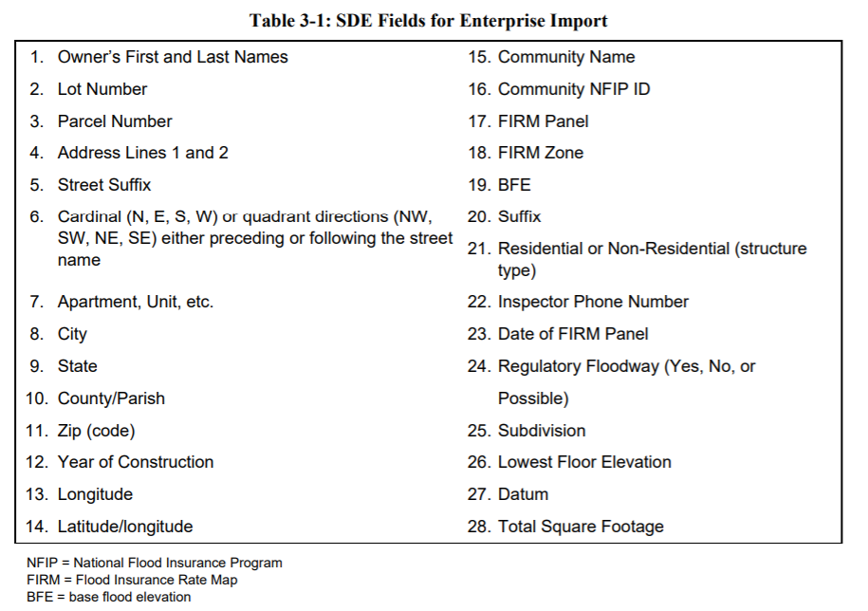
This is especially important if you will be using a different software to prepopulate the SDE for the SDP2 Credit. You will need to export and provide a table with all of this data, explain any data missing from fields, import it into the SDE tool, and make sure the properties match the list of properties made in step 1.

APPENDIX 4 – Exported Maps of Structures in the SFHA
Please include exported maps of structures in the SFHA.

APPENDIX 5 – Letters to Property Owners
Appendix 5 Contents:
- Letter Prior to a Disaster
- Sample Notice for Property Owners, Contractors, and Design Professionals
- Requirements for Applications for Permits for Substantial Improvements and Repair of Substantial Damage
- Costs for Substantial Improvements and Repair of Substantial Damage
- Owner’s Affidavit
- Contractor’s Affidavit
- Sample Letter to Notify Property Owners of a Determination That Work Constitutes Substantial Improvement
- Sample Letter to Notify Property Owners of a Determination That Work Constitutes Repair of Substantial Damage
- Sample Letter to Notify Property Owners of a Determination That Work Does NOT Constitute Repair of Substantial Damage

Letter Prior to a Disaster
Insert a letter using your community’s letterhead with signature blocks of Mayor, FPA, or whoever appropriate.
[Community Letterhead]
Date

TO: Property Owners, Contractors, and Design Professionals
Address
FROM: Local Official
Address
SUBJECT: Damages Expected from [upcoming disaster]

Dear [Name],

[Disaster type, name if known] is likely to result in significant damages to structures due to [descriptor of disaster, i.e. coastal and inland flooding, wind damage, etc.] in [Community Name]. Residents and business owners are understandably anxious to repair damaged building components after the storm. Municipalities are already burdened with the necessity to make sure that structures are safe.
Rebuilding requirements after a flood or any other disaster must also consider the flood protection requirements contained in [Community Name]’s Flood Damage Prevention Ordinance that was passed as a condition of participation in the National Flood Insurance Program. These requirements also coordinate with the New Jersey Flood Hazard Area Control Act, and the Uniform Construction Code.
A primary goal of the National Flood Insurance Program is to break the damage – rebuild – damage cycle by requiring all new, substantially improved, and substantially damaged structures within mapped flood hazard areas to be constructed in a manner that is reasonably safe from flooding. That requires proper building elevation and protection techniques. The definition of “substantial damage” is:
“Damage of any origin sustained by a structure whereby the cost of restoring the structure to its before damaged condition would equal or exceed 50 [or lower number if in your flood damage prevention ordinance] percent of the market value of the structure before the damage occurred.”
This definition applies whether or not actual repair work is performed. Additionally, since [Community Name] tracks substantial damages and improvements cumulatively, this value is added to any previous cost of improvement or damage that the building may have when calculating this percentage.
FEMA regulations (44 CFR 60.3) require new construction and substantially improved or damaged structures within mapped flood hazard areas to meet specific floodplain development standards.
The New Jersey Flood Hazard Area Control Act, Uniform Construction Code, and [Community Name]’s Flood Damage Prevention Ordinance all require substantially damaged buildings in flood hazard areas to meet all of the flood design requirements for new construction. The purpose of these requirements is to make sure that damage is minimized when the next flood occurs.
It is the responsibility of [Community Name] as participant in the National Flood Insurance Program, and as the enforcement agents for the Uniform Construction Code to determine if a damaged structure is in a FEMA mapped flood hazard area and, if so, to determine if the structure has been substantially damaged. If a structure has been substantially damaged, it must then be elevated to the Local Design Flood Elevation required by our Flood Damage Prevention Ordinance.
The [community name] is requesting your cooperation to assist us with expediting the recovery of our community from the impacts of [insert name of event]. As you should be aware, before we can issue building permits for repair, reconstruction, or other improvements, we must inspect properties in the high-risk flood zones shown on our flood maps that were damaged by wind, water, fallen trees, or other hazards must be inspected before we can issue building permits for repair, reconstruction, or other improvements.
In accordance with the [community name] building code and our flood damage prevention regulations, we must determine whether the damage meets the definition of “substantial damage.” The process we’ve developed to achieve an efficient, orderly, and responsive permit review begins with damage inspections. Therefore, please allow our staff, or staff from state, FEMA, or private contractors working on our behalf, to access and inspect your damaged building. These authorized staff carry a “right of entry” document and their agency identification. They must show you those documents before you let them access your property.
The preliminary damage inspections are limited to evaluating the extent of damage to foundations, roofs, windows and doors, siding, installed appliances, electrical and plumbing, heating and air conditioning, and walls and floors. These inspections are required to assess the condition of the building and determine the work required to repair the building to its pre-damaged condition. The period of inspections is limited to daylight hours only, between [insert anticipated period of inspections]. Once we have inspected your property and recorded the results in our database, we will send you a letter with the results and explain any requirements that may apply.
We greatly appreciate your willingness to allow our community’s inspectors to assess the condition of your property. This will help you and the community move forward as quickly as possible with the permitting and repair of your building.
For further assistance on floodplain development requirements during this difficult time, or at any time, please call your regional [Community Contact, FPA or other].

Sample Notice for Property Owners, Contractors, and Design Professionals
[Community Letterhead]
Date

TO: Property Owners, Contractors, and Design Professionals
Address
FROM: Local Official
Address
SUBJECT: Notice for Work on Existing Buildings in Special Flood Hazard Areas
Substantial Improvement / Substantial Damage Worksheets

The [community name] is requesting your cooperation to assist us with expediting the recovery of our community from the impacts of [name of event]. As you should be aware, before we can issue building permits for repair, reconstruction, or other improvements, we must inspect properties in the high-risk flood zones shown on our flood maps that were damaged by wind, water, fallen trees, or other hazards must be inspected before we can issue building permits for repair, reconstruction, or other improvements.
The [Community Name]’s floodplain management regulations and codes require the determination if structures damaged in the Special Flood Hazard Areas (SFHAs) (regulated floodplains) constitute “substantial damage”. If the structure is deemed substantially damaged, it may be required to have their lowest floors elevated to the Local Design Flood Elevation (LDFE) which is calculated using the methodology described in the Flood Damage Prevention Ordinance. It is important to note that all costs to repair a substantially damaged building to its pre-damage condition must be identified.
Prior to applying for permits or beginning any work, [Community Name] will be conducting preliminary damage inspections. Please allow our staff, or staff from state, FEMA, or private contractors working on our behalf, to access and inspect your damaged building. These authorized staff carry a “right of entry” document and their agency identification. They must show you those documents before you let them access your property.
The preliminary damage inspections are limited to evaluating the extent of damage to foundations, roofs, windows and doors, siding, installed appliances, electrical and plumbing, heating and air conditioning, and walls and floors. These inspections are required to assess the condition of the building and determine the work required to repair the building to its pre-damaged condition. The period of inspections is limited to daylight hours only, between [insert anticipated period of inspections]. Once we have inspected your property and recorded the results in our database, we will send you a letter with the results and explain any requirements that may apply
There are several aspects that must be addressed to achieve compliance with the floodplain management requirements. The requirements depend on several factors, including the flood zone at your property. The most significant compliance requirement is that the lowest floor, as defined in [Community Name]’s Flood Damage Prevention Ordinance must be elevated to the Local Design Flood Elevation specified in our Flood Damage Prevention Ordinance.
Our regulations define these terms:
Ensure that the definitions used match the definitions in your community’s flood damage prevention ordinance.
Substantial damage - Damage of any origin sustained by a structure whereby the cost of restoring the structure to its before damaged condition would equal or exceed 50 [or optional lower number] percent of the market value of the structure before the damage occurred.
Substantial improvement – Any combination of reconstruction, rehabilitation, addition, or other improvement including those considered ordinary maintenance and minor work of a structure taking place over a number of [years] year period, the cumulative cost of which equals or exceeds fifty (50) [or optional lower number] percent of the market value of the structure before the "start of construction" of the improvement. The period of accumulation includes the first improvement or repair of each structure is permanent subsequent to [date]. This term includes structures which have incurred "substantial damage," regardless of the actual repair work performed. The term does not, however, include either:
- Any project for improvement of a structure to correct existing violations of State or local health, sanitary or safety code specifications which have been identified by the local code enforcement officer and which are the minimum necessary to assure safe living conditions; or
- Any alteration of a "historic structure", provided that the alteration will not preclude the structure's continued designation as a "historic structure.
To make the substantial damage determination, we compare the cost of the repairs to the market value of the building (excluding land, accessory structures, and landscaping). If the resulting ratio equals or exceeds 50 percent [or lower threshold], the existing building must be brought into compliance with the floodplain management requirements for new construction. If additional work is being completed in addition to the repairs to bring the structure to its before damaged condition, this work is added to the cost of repairs and may trigger the substantial damage threshold. Additionally, since [Community Name] tracks substantial damages and improvements cumulatively, this value is added to any previous cost of improvement or damage that the building may have when calculating this percentage.
Cost of Improvement or cost to Repair to Pre-Damage Condition
------------------------------------------------------------------------------------ ≥ 50% (or lower %)
Market Value of Building

Please note:
- You must provide an estimate of the cost to perform the proposed improvements or repairs. If your building has been damaged, the cost estimate must include all work required to repair the building to its pre-damage condition. The cost estimate must include all labor and materials. If the work will be done by a contractor, the contractor’s overhead and profit must be included. If the work will be done by the owner or volunteers, market rates must be used to estimate the cost of materials and the value of labor. Attached to this notice is a list of costs that must be included and costs that are excluded. After we review the cost estimate, we may require that it be broken down to show all materials and labor estimates.
- We will use the tax assessment value of your building as the estimate of the market value of the building before the work is performed. If you feel that this is not an appropriate evaluation of your structure’s market value, you must provide a market value appraisal of the building that is prepared by a professional appraiser according to standard practices of the profession. We will review the appraisal to determine that it accurately describes your building and does not include the value of the land, accessory buildings, and landscaping.
If you have any questions regarding this information, please contact [Include FPA’s Contact information].
Attachments:
- Requirements for Applications for Permits for Substantial Improvements and Repair of Substantial Damage
- Costs for Substantial Improvements and Repair of Substantial Damage
- Owner’s Affidavit
- Contractor’s Affidavit

Requirements for Applications for Permits for Substantial Improvements and Repair of Substantial Damage
Please contact _____________ if you have questions about the substantial improvement and substantial damage requirements. Your building may have to be brought into compliance with the floodplain management requirements for new construction.
Applications for permits to work on existing buildings that are located in Special Flood Hazard Areas must include the following:
- Current photographs of the exterior (front, rear, sides)
- If your building has been damaged, include photographs of the interior and exterior; provide pre-damage photos of the exterior, if available
- Detailed description of the proposed improvement (rehabilitation, remodeling, addition, etc.) or repairs
- Cost estimate of the proposed improvement or the cost estimate to repair the damaged building to its before-damage condition
- Current elevation certificate or elevation survey
- A deed restriction for any proposed enclosure that is greater than 6 feet in height that
- A non-conversion agreement with inspection language if included in the ordinance or other zoning rules.
- A V zone Certificate signed and sealed by a New Jersey Licensed Architect or Engineer.
- A Breakaway Wall Certification signed and sealed by a New Jersey Licensed Architect or Engineer.
- (For non-residential structures proposed for floodproofing only) A Floodproofing Certification signed and sealed by a New Jersey Licensed Architect or Engineer.
- You may submit a market value appraisal prepared by a licensed professional appraiser If you disagree with the most recent tax assessment value of the building
- Owner’s affidavit (signed and dated)
- Contractor’s affidavit (signed and dated)

Costs for Substantial Improvements and Repair of Substantial Damage
Included Costs
Items that must be included in the costs of improvement or costs to repair are those that are directly associated with the building. The following list of costs that must be included is not intended to be exhaustive, but characterizes the types of costs that must be included:
- Materials and labor, including the estimated value of donated or discounted materials and owner or volunteered labor
- Site preparation related to the improvement or repair (foundation excavation, filling in basements)
- Demolition and construction debris disposal
- Labor and other costs associated with demolishing, moving, or altering building components to accommodate improvements, additions, and making repairs
- Costs associated with complying with any other regulation or code requirement that is triggered by the work, including costs to comply with the requirements of the Americans with Disabilities Act (ADA)
- Costs associated with elevating a structure to an elevation that is lower than the BFE
- Construction management and supervision
- Contractor’s overhead and profit
- Sales taxes on materials
- Structural elements and exterior finishes, including:
  - Foundations (e.g., spread or continuous foundation footings, perimeter walls, chainwalls, pilings, columns, posts, etc.)
  - Monolithic or other types of concrete slabs
  - Bearing walls, tie beams, trusses
  - Joists, beams, subflooring, framing, ceilings
  - Interior non-bearing walls
  - Exterior finishes (e.g., brick, stucco, siding, painting, and trim)
  - Windows and exterior doors
  - Roofing, gutters, and downspouts
  - Hardware
  - Attached decks and porches
- Interior finish elements, including:
  - Floor finishes (e.g., hardwood, ceramic, vinyl, linoleum, stone, and wall-to-wall carpet over subflooring)
  - Bathroom tiling and fixtures
  - Wall finishes (e.g., drywall, paint, stucco, plaster, paneling, and marble)
  - Built-in cabinets (e.g., kitchen, utility, entertainment, storage, and bathroom)
  - Interior doors
  - Interior finish carpentry
  - Built-in bookcases and furniture
  - Hardware
  - Insulation
- Utility and service equipment, including:
  - HVAC equipment
  - Plumbing fixtures and piping
  - Electrical wiring, outlets, and switches
  - Light fixtures and ceiling fans
  - Security systems
  - Built-in appliances
  - Central vacuum systems
  - Water filtration, conditioning, and recirculation systems
Excluded Costs
Items that can be excluded are those that are not directly associated with the building. The following list characterizes the types of costs that may be excluded:
- Clean-up and trash removal
- Costs to temporarily stabilize a building so that it is safe to enter to evaluate required repairs
- Costs to obtain or prepare plans and specifications
- Land survey costs
- Permit fees and inspection fees
- Carpeting and recarpeting installed over finished flooring such as wood or tiling
- Outside improvements, including landscaping, irrigation, sidewalks, driveways, fences, yard lights, swimming pools, pool enclosures, and detached accessory structures (e.g., garages, sheds, and gazebos)
- Costs required for the minimum necessary work to correct existing violations of health, safety, and sanitary codes
- Plug-in appliances such as washing machines, dryers, and stoves

Owner’s Affidavit: Substantial Improvement or Repair of Substantial Damage
Property Address:
Parcel ID Number:
Owner’s Name:
Owner’s Address/Phone:
Contractor:
Contractor’s License Number:
Date of Contractor’s Estimate:

I hereby attest that the description included in the permit application for the work on the existing building that is located at the property identified above is all of the work that will be done, including all improvements, rehabilitation, remodeling, repairs, additions, and any other form of improvement. I further attest that I requested the above-identified contractor to prepare a cost estimate for all of the work, including the contractor’s overhead and profit. I acknowledge that if, during the course of construction, I decide to add more work or to modify the work described, that the [insert community] will re-evaluate its comparison of the cost of work to the market value of the building to determine if the work is substantial improvement. Such re-evaluation may require revision of the permit and may subject the property to additional requirements.
I also understand that I am subject to enforcement action and/or fines if inspection of the property reveals that I have made or authorized repairs or improvements that were not included in the description of work and the cost estimate for that work that were the basis for issuance of a permit.

Owner’s Signature:
Date:
Notarized:

Contractor’s Affidavit: Substantial Improvement or Repair of Substantial Damage
Property Address:
Parcel ID Number:
Owner’s Name:
Owner’s Address/Phone:
Contractor:
Contractor’s License Number:
Date of Contractor’s Estimate:

I hereby attest that I have personally inspected the building located at the above-referenced address and discussed the nature and extent of the work requested by the owner, including all improvements, rehabilitation, remodeling, repairs, additions, and any other form of improvement.
At the request of the owner, I have prepared a cost estimate for all of the improvement work requested by the owner and the cost estimate includes, at a minimum, the cost elements identified by the [community] that are appropriate for the nature of the work. If the work is repair of damage, I have prepared a cost estimate to repair the building to its pre-damage condition. I acknowledge that if, during the course of construction, the owner requests more work or modification of the work described in the application, that a revised cost estimate must be provided to the [insert community], which will re-evaluate its comparison of the cost of work to the market value of the building to determine if the work is substantial improvement. Such re-evaluation may require revision of the permit and may subject the property to additional requirements.
I also understand that I am subject to enforcement action and/or fines if inspection of the property reveals that I have made or authorized repairs or improvements that were not included in the description of work and the cost estimate for that work that were the basis for issuance of a permit.

Owner’s Signature:
Date:
Notarized:

Sample Letter to Notify Property Owners of a Determination That Work Constitutes Substantial Improvement
[Community Letterhead]
Date

TO: Property Owners
Address
FROM: Local Official
Address
SUBJECT Substantial Improvement Determination
Dear Property Owner:
We have reviewed your recent application for a permit to [describe proposed improvement/addition] your existing home that is located in a mapped Special Flood Hazard Area. As required by our floodplain management regulations and/or building code, we have determined that the proposed work constitutes substantial improvement of the building. This determination is based on a comparison of the cost estimate of the proposed work to the market value of the building (excluding land value). When the costs equal or exceed 50 percent or lower percent of the market value of the building, the work is substantial improvement. Additionally, since [Community Name] tracks substantial damages and improvements cumulatively, this value is added to any previous cost of improvement or damage that the building may have when calculating this percentage.
As a result of this determination, you are required to bring the building into compliance with the flood damage-resistant provisions of [Community Name]’s Flood Damage Prevention Ordinance.
We are available to meet with you and your designated representative (architect/builder) at a time convenient to you to discuss how to bring your home into compliance. There are several aspects that must be addressed to achieve compliance. The most significant requirement is that the lowest floor must be elevated to the Local Design Flood Elevation (LDFE) which is calculated using the methodology described in the Flood Damage Prevention Ordinance. Please note that any enclosure greater than 6 feet in height can only be used for parking, storage, and access and must be deed restricted to these uses. You may wish to contact your insurance agent to understand how raising the lowest floor higher than the minimum required elevation can reduce NFIP flood insurance premiums.
Please resubmit your permit application along with plans and specifications that incorporate compliance measures. Construction activities that are undertaken without a proper permit are violations and may result in stop work orders, fines, or other legal action.

Sample Letter to Notify Property Owners of a Determination That Work Constitutes Repair of Substantial Damage
[Community Letterhead]
Date

TO: Property Owners
Address
FROM: Local Official
Address
SUBJECT Substantial Damage Determination

Dear Property Owner:
We have reviewed your recent application for a permit to repair your existing home that was damaged by [insert cause of damage]. The building is located in a mapped Special Flood Hazard Area. As required by our floodplain management regulations and/or building code, we have determined that the building has been substantially damaged. This determination is based on a comparison of the cost estimate of the work required to restore the building to its pre-damage condition to the market value of the building (excluding land value). When the cost to repair equals or exceeds 50 percent or lower percentage of the market value of the building, the work is repair of substantial damage. Additionally, since [Community Name] tracks substantial damages and improvements cumulatively, this value is added to any previous cost of improvement or damage that the building may have when calculating this percentage.
As a result of this determination, you are required to bring the building into compliance with the flood damage-resistant provisions of [Community Name]’s Flood Damage Prevention Ordinance.
We are available to meet with you and your designated representative (architect/builder) at a time convenient to you to discuss how to bring your home into compliance. There are several aspects that must be addressed to achieve compliance. The most significant requirement is that the lowest floor must be elevated to the Local Design Flood Elevation (LDFE) which is calculated using the methodology described in the Flood Damage Prevention Ordinance. Please note that any enclosure greater than 6 feet in height can only be used for parking, storage, and access and must be deed restricted to these uses. You may wish to contact your insurance agent to understand how raising the lowest floor higher than the minimum required elevation can reduce NFIP flood insurance premiums.
If the damage was caused by flooding and if you have a flood insurance policy from the National Flood Insurance Program, you should contact your adjuster to discuss the Increased Cost of Compliance (ICC) coverage. This coverage may provide a claim payment to help pay for work required to bring your home into compliance. Your adjuster can explain that the ICC claim may also be used to pay certain costs associated with demolishing and rebuilding your home, or moving your home to a site outside of the floodplain.
Please resubmit your permit application along with plans and specifications that incorporate compliance measures. Construction activities that are undertaken without a proper permit are violations and may result in stop works, fines, or other legal action.

Sample Letter to Notify Property Owners of a Determination That Work Does NOT Constitute Repair of Substantial Damage
[Community Letterhead]
Date

TO: Property Owners
Address
FROM: Local Official
Address
SUBJECT Substantial Damage Determination
Dear Property Owner:

We have reviewed your recent application for a permit to repair your existing building that was damaged by [insert cause of damage]. The building is located in a mapped Special Flood Hazard Area. As required by our floodplain management regulations and/or building code, we have determined that the work proposed to repair the damage does not constitute repair of substantial damage. This determination is based on a comparison of the cost estimate of the work required to restore the building to its pre-damage condition to the market value of the building.
Please be advised that we will make another determination if you elect to perform work other than what is necessary to repair the damage, such as additional renovations or upgrades or building an addition. Construction activities that are undertaken without a proper permit are violations and may result in stop work orders, fines, or other legal action.

APPENDIX 6 – Sample Press Release
RESIDENTS IN [Community Name] WITH DISASTER DAMAGE REMINDED OF PERMIT REQUIREMENTS
This will need to be adjusted depending on the situation after the disaster. Remove any language that is not applicable and add anything important that is missing. Work with the community public information officer to finalize language.
Residents of [Community Name], hopefully this message finds you and your family out of harms way. This press release is intended to provide information useful to all community members.
Firstly, community members should be aware of the following safety hazards [fill in safety hazards here].
Additionally, there is a [County Name] curfew in effect after [time].
The following resources are available to those in need as far as resources, shelters and food. [Location] has been set up as a temporary shelter. Food will be provide at [location] during the hours of [times].
The following are updates for utilities. Electricity is still out, and the [power company] is doing all they can to restore power. It can be expected to be restored [anticipated time if available, if not indicate it is still unknown]. The drinking water is currently [safe/unsafe] for consumption [if unsafe indicate when will be restored if known].
As property owners in [Community Name] contemplate clean up and repairs following recent [disaster], the [Floodplain Administrators and Construction Official’s Offices] is reminding residents to obtaining local permits before repairing or rebuilding flood-damaged structures.
The permits are required as part of local government participation in the National Flood Insurance Program, providing eligibility for flood insurance, flood disaster assistance, state and federal grants and loans, and buyout funds for flood-prone property.
Local floodplain management ordinances require that permits be obtained for any construction or development activity in a floodplain area, including the repair or reconstruction of structures damaged by a disaster.
Special conditions apply to substantially damaged buildings - those in which the total cost of repairs is [50 percent or more, update to reflect your community’s ordinance] of the structure’s pre-disaster market value. If a building is found to be substantially damaged, regulations require that repairs not begin until compliance with the local floodplain ordinance is demonstrated and will have the same building requirements as new construction. In some cases, that may require repairs that include elevating or flood-proofing the structure to reduce the potential for future flood damage.
The cost to repair must be calculated for full repair to "pre-damaged" condition, even if the owner elects to do fewer repairs. The total cost to repair includes structural and finish materials as well as labor. If labor and materials have been donated, they must still be assigned a value. If local building codes require the structure to be repaired according to certain standards, these additional costs must be included in the full repair cost for the structure.
If you are filing a flood insurance claim, you need to report your losses to your insurance agent or company. An adjuster will be assigned to estimate your damages and advise you how to prepare “Proof of Loss” documentation. Adjusters may authorize advance partial payments to help owners start making repairs. After the adjuster and owner agree on the damage estimate, the adjuster sends documentation to the owner’s insurance company and the claim is settled (paid), unless the claim is denied by FEMA. Often times NFIP claims can be paid quickly and ahead of a community’s effort to determine building permit requirements. Makes sure you acquire the necessary permits for any work performed to avoid violating the building code and Flood Damage Prevention Ordinance. The National Flood Insurance Program Claims Handbook can be found here: https://www.fema.gov/sites/default/files/2020-05/FINAL_ClaimsHandbook_10252017.pdf
Information on how to start your claim can be found here: https://www.fema.gov/flood-insurance/resources-practitioners/file-your-claim
If you disagree with your insurance clam, you can file an appeal with your insurance company. The policyholder must submit the appeal within 60 days after the date of the insurance company’s written denial letter. Information on this process can be found here: https://www.fema.gov/sites/default/files/2020-09/fema_appealing-flood-insurance-claim-en_fact-sheet_jun2020.pdf
State and federal assistance may be available to property owners to reduce the chances of future flood damage. Mitigation assistance may cover costs of relocation, or for elevating or purchasing flood-damaged structures. If damage is caused by a flood, flood insurance may also provide up to $30,000 to protect a structure from future flooding through a claims process known as ICC (Increased Cost of Compliance). The property owner must have had NFIP flood insurance prior to the flood event for ICC to become available.
Property owners and residents with [disaster name]-damaged buildings should contact [local building and zoning administrator] for more information on repair and reconstruction permits.
Any other questions or concerns can be directed to [contact information].

APPENDIX 7 – SAMPLE NOTICES
Appendix 7 Contents:
- Door Hanger Example
- Notice of Damage and Permits Required
- Notice of Occupancy

Door Hanger Example
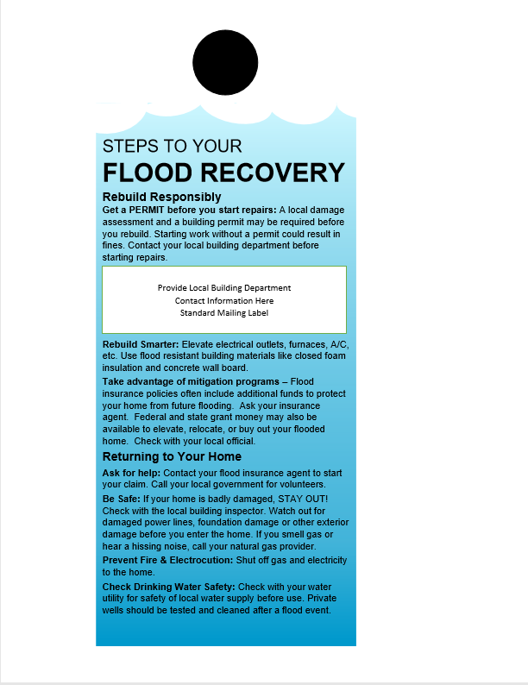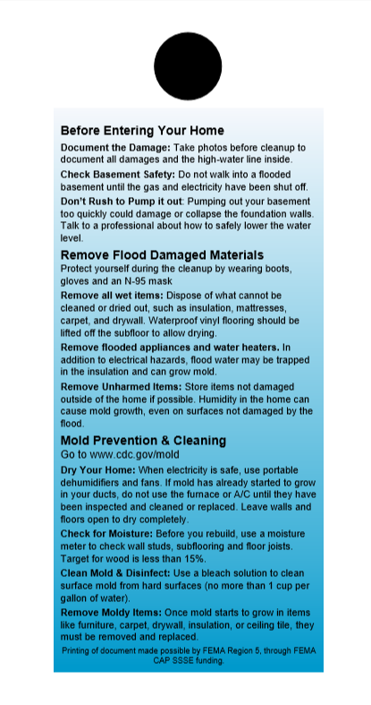

Notice of Damage and Permits Required
Add or adjust language to be fitting for your community. Add a community seal if desired.
NOTICE!
Your structure is located in a floodplain and was damaged by [Event name/type].
A damage assessment must be conducted by [Community Name].
Before occupying this building or beginning any repairs you must call the [contact, FPA, permitting office] to schedule an inspection.
They can be reached at the following contact information [contact].
Failure to obtain reconstruction approval may result in a Stop Work Order.

Notice of Occupancy
Add or adjust language to be fitting for your community. Add a community seal if desired.
UNSAFE STRUCTURE NOTICE!
This structure has been deemed unsafe for human occupancy.
No individual is to occupy this building until the structure is rendered safe and secure.
Before occupying this building or beginning any repairs you must call the [contact, FPA, permitting office].
They can be reached at the following contact information [contact].
Failure to obtain reconstruction approval may result in a Stop Work Order.

APPENDIX 8 – FIELD WORKSHEET FOR SUBSTANTIAL DAMAGE ESTIMATES AND GUIDANCE FOR ESTIMATING PERCENT DAMAGE FOR RESIDENTIAL AND NON-RESIDENTIAL STRUCTURES

Appendix 8 Contents:
- Blank SDE Damage Inspection Worksheets – Single, Town, or Row House or Manufactured House
- Blank SDE Damage Inspection Worksheets – Non-Residential Structures
- Checklist 1 – Post-Disaster Planning
- Checklist 2 – Field Preparations
- Photo Log
- Guidance for Estimating Percent Damage for Residential Structures
- Guidance for Estimating Percent Damage for Non-Residential Structure

Source: FEMA P-784 - Substantial Damage Estimator User Manual and Field Workbook
https://www.fema.gov/sites/default/files/2020-07/sde_3.0_user_manual_field_workbook_0.pdf

Blank SDE Damage Inspection Worksheets – Single, Town, or Row House or Manufactured House
Residential
SDE DAMAGE INSPECTION WORKSHEET
Single-Family, Town or Row House (Site Built Residences), or Manufactured House
Address:______________________________________________________________________________
SDE ADDRESS Tab
Subdivision / Community Information
Subdivision___________________________________________ Parcel Number: ___________________
Lot Number: _____________ Elevation of Lowest Floor: _________________ Datum: ________________

Community Information
NFIP Community ID: ___________________ NFIP Community Name: _____________________________
Latitude: __________________________________ Longitude: __________________________________

Building Address
Owner First Name: ___________________________ Owner Last Name: __________________________
Street Address: ________________________________________________________________________
City: _________________________________________________ State: __________________________
County/Parish: _________________________________________ Zip: ____________________________
Phone: ___________________________________ Cell Phone: __________________________________

Mailing Address Check here if same as building address: ________
Owner First Name: ___________________________ Owner Last Name: __________________________
Street Address: ________________________________________________________________________
City: _________________________________________________ State: __________________________
County/Parish: _________________________________________ Zip: ____________________________
Phone: ___________________________________ Cell Phone: __________________________________

SDE STRUCTURE / DAMAGE / NFIP INFO Tab
Structure Attributes / Information
Residence Type: _____Single Family _____Town or Row House _____Manufactured House
Foundation: _____Continuous Wall w/Slab (Standard) _____Basement _____Crawlspace
_____Piles _____Slab-on-Grade _____Piers and Posts
Superstructure: _____Stud-Framed (Standard) _____Common Brick _____ICF _____Masonry
Roof Covering: _____Shingles – Asphalt, Wood (Standard) _____Clay Tile
_____Standing Seam (Metal) _____Slate
Exterior Finish: _____Siding or Stucco (Standard) _____Brick Veneer _____EIFS
_____None – common brick, structural
HVAC System: _____Heating and/or Cooling _____None
Story: _____One Story (Standard) _____Two or More Stories
Structure Information
Year of Construction: _________________________
Quality of Initial Construction: _____Low _____Budget _____Average _____Good _____Excellent
Residence Information (if needed): ________________________________________________________
_____________________________________________________________________________________
_____________________________________________________________________________________

Inspector / Damage Information
Inspector’s Name: __________________________________ Inspector’s Phone: ____________________
Date of Inspection (mm/dd/yyyy): _________________________________________________________
Date Damage Occurred (mm/dd/yyyy): _____________________________________________________
Cause of Damage: _____Fire _____Flood _____Flood and Wind _____Seismic _____Wind
_____Other
Cause of Damage (if “Other” is selected):________________________________
_________________________________________________________________
_________________________________________________________________

SDE STRUCTURE / DAMAGE / NFIP INFO Tab
Damage Undetermined: ______ (check here and check the reason below):
_____ No Physical Damage Sustained _____ Vacant / Property _____ Resident Refused Inspection
_____ Address Does Not Exist _____ Other (Explain)
_____________________________________________________________________________________
_____________________________________________________________________________________
_____________________________________________________________________________________
Duration of Flood: ____________________ Hours ______________________Days
Depth of Flood Above Ground (estimated to nearest 0.5 foot):
Depth of Flood Above Lowest Floor (estimated to nearest 0.5 foot):

NFIP / Community Information
FIRM Panel Number: ___________ Suffix: ____________ Date of FIRM Panel (mm/dd/yyyy): __________
FIRM Zone: _____________________ Base Flood Elevation: ____________________________
Regulatory Floodway: _____Yes _____No _____Possible

Community Information (if needed): _______________________________________________________
_____________________________________________________________________________________
_____________________________________________________________________________________
_____________________________________________________________________________________
_____________________________________________________________________________________
_____________________________________________________________________________________

COST Tab
Select appropriate diagram of structure footprint and enter structure dimensions and the number of stories:

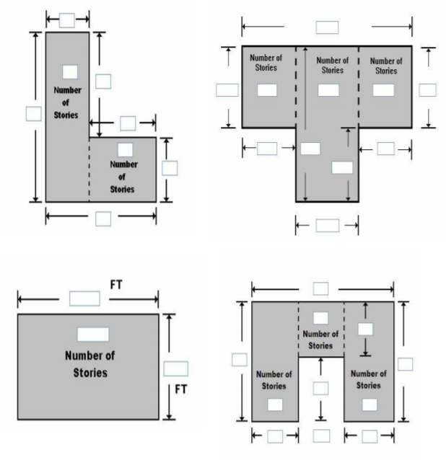

COST Tab
Square Footage
Base Cost per Sq Ft.: ________________________ Total Square Footage: _________________________
Geographic Adjustment: ________________________
Cost Adjustments
Single-Family House | Quantity | Units | Unit Cost | Item Cost
Roofing |  | Sq. Ft.
Heating/Cooling |  | Each
Appliances |  | Each
Fireplaces |  | Each
Porch/Breezeways |  | Sq. Ft.
Garage |  | Sq. Ft.
Manufactured House | Quantity | Units | Unit Cost | Item Cost
Expando |  | Sq. Ft.
Carport |  | Sq. Ft.
Open Porch |  | Sq. Ft.
Enclosed Porch |  | Sq. Ft.
Decks |  | Each
Skirting |  | Sq. Ft.
Fireplaces |  | Each

COST Tab
Additional Cost Adjustments
Adjustments | Quantity | Unit Cost | Item Cost

Cost Data Reference (source or name): _____________________________________________________
______________________________________________________________________________
______________________________________________________________________________
Cost Data Date: _________________________________________________________________
Note: The computed Actual Cash Value (ACV) for the structure will be calculated once the square footage, base cost, cost adjustments, costs add-ons, and depreciation percentage are entered into the SDE tool.
Depreciation Rating:
_____1. Very Poor Condition _____2. Requires Extensive Repairs _____3. Requires Some Repairs
_____4. Average Condition _____5. Above Average Condition _____6. Excellent Condition _____7. Other
Depreciation Percentage (if ‘Other’ selected for Depreciation Rating): _____________________________
Depreciation Explanation (if ‘Other’ selected for Depreciation Rating): ____________________________
_____________________________________________________________________________________
______________________________________________________________________________
______________________________________________________________________________
______________________________________________________________________________
______________________________________________________________________________

ELEMENT PERCENTAGE Tab
Note: The inspector needs only enter the % Damaged data here. The data in the Element %, Item Cost, and Damage Values columns will be populated based on the selected attributes once all the data are entered into the SDE tool.
Residence Type: _____Single-Family (SF) House _____Townhouse _____Manufactured House (MH)
Item | % Damaged | Element % | Item Cost | Damage Values
Foundation (Not required for MH)
Superstructure

Roof Covering

Exterior Finish

Interior Finish

Doors and Windows

Cabinets and Countertops
Flood Finish

Plumbing

Electrical

Appliances

HVAC

Skirting/Forms Piers (MH Only)

SDE OUTPUT SUMMARY Tab – Optional User Entered Data
Professional Market Appraisal: ____________________________________________________________
Tax Assessed Value: _______________________ Tax Factor Adjustment: __________________________
Adjusted Tax Assessed Value: _____________________________________________________________
Contractor’s Estimate of Damage: _________________________________________________________
Community’s Estimate of Damage: ________________________________________________________
Blank SDE Damage Inspection Worksheets – Non-Residential Structures
Non-Residential
SDE DAMAGE INSPECTION WORKSHEET
Address: _____________________________________________________________________________
SDE ADDRESS Tab
Subdivision / Community Information
Subdivision___________________________________________ Parcel Number: ___________________
Lot Number: _____________ Elevation of Lowest Floor: _________________ Datum: ________________

Community Information
NFIP Community ID: ___________________ NFIP Community Name: _____________________________
Latitude: __________________________________ Longitude: __________________________________

Building Address
Owner First Name: ___________________________ Owner Last Name: __________________________
Street Address: ________________________________________________________________________
City: _________________________________________________ State: __________________________
County/Parish: _________________________________________ Zip: ____________________________
Phone: ___________________________________ Cell Phone: __________________________________

Mailing Address Check here if same as building address: ________
Owner First Name: ___________________________ Owner Last Name: __________________________
Street Address: ________________________________________________________________________
City: _________________________________________________ State: __________________________
County/Parish: _________________________________________ Zip: ____________________________
Phone: ___________________________________ Cell Phone: __________________________________

SDE STRUCTURE / DAMAGE / NFIP INFO Tab
Structure Attributes / Information
Year of Construction: __________ Number of Stories: _____1 Story _____2 to 4 _____5 or more
Structure Use: _________________________________________________________________________
Sprinkler System: _____Yes _____No Conveyance: _____Yes _____No
Quality of Initial Construction: _____Low _____Budget _____Average _____Good _____Excellent
Structure Information (if needed): _________________________________________________________
_____________________________________________________________________________________
_____________________________________________________________________________________
_____________________________________________________________________________________

Inspector / Damage Information
Inspector’s Name: ______________________________________________________________________
Inspector’s Phone: _____________________________________________________________________
Date of Inspection (mm/dd/yyyy): _________________________________________________________
Date Damage Occurred (mm/dd/yyyy): _____________________________________________________
Cause of Damage: _____Fire _____Flood _____Flood and Wind _____Seismic _____Wind _____Other
Cause of Damage (if ‘Other’ is selected): ______________________________________________
______________________________________________________________________________
Damage Undetermined: ______ (check here and check the reason below):
_____ No Physical Damage Sustained _____ Vacant / Property
_____ Resident Refused Inspection _____ Address Does Not Exist _____ Other (Explain)
_____________________________________________________________________________________
_____________________________________________________________________________________
_____________________________________________________________________________________
Duration of Flood: _______________________Hours _______________________Days
Depth of Flood Above Ground (estimated to nearest 0.5 foot): ___________________________________
Depth of Flood Above Lowest Floor (estimated to nearest 0.5 foot): ______________________________

SDE STRUCTURE / DAMAGE / NFIP INFO Tab
NFIP / Community Information:
FIRM Panel Number: ___________ Suffix: ____________ Date of FIRM Panel (mm/dd/yyyy): __________
FIRM Zone: _____________________ Base Flood Elevation: ____________________________
Regulatory Floodway: _____Yes _____No _____Possible

Community Information (if needed): _______________________________________________________
_____________________________________________________________________________________
_____________________________________________________________________________________
_____________________________________________________________________________________
_____________________________________________________________________________________
_____________________________________________________________________________________

COST Tab
Select appropriate diagram of structure footprint and enter structure dimensions and the number of stories:

COST Tab
Square Footage
Base Cost per Sq Ft.: ________________________ Total Square Footage: ________________________
Geographic Adjustment: ________________________
Cost Adjustments
Adjustments | Quantity | Units | Unit Cost | Item Cost

Additional Cost Adjustments
Adjustments | Quantity | Unit Cost | Item Cost

Cost Data Reference (source or name): _____________________________________________________
_____________________________________________________________________________________
Cost Data Date: ________________________________________________________________________

Note: The computed Actual Cash Value (ACV) for the structure will be calculated once the square footage, base cost, cost adjustments, costs add-ons, and depreciation percentage are entered into the SDE tool.
Depreciation Rating:
_____1. Very Poor Condition _____2. Requires Extensive Repairs _____3. Requires Some Repairs
_____4. Average Condition _____5. Above Average Condition _____6. Excellent Condition _____7. Other
Depreciation Percentage (if ‘Other’ selected for Depreciation Rating): _____________________________
Depreciation Explanation (if ‘Other’ selected for Depreciation Rating): ____________________________
_____________________________________________________________________________________
_____________________________________________________________________________________

ELEMENT PERCENTAGES Tab
Note: The inspector needs only enter the % Damaged data here. The data in the Element %, Item Cost, and Damage Values columns will be populated based on the selected attributes once all the data are entered into the SDE tool.
Item | % Damaged | Element % | Item Cost | Damage Values
Foundation

Superstructure

Roof Covering

Plumbing

Electrical

Interiors

HVAC

SDE OUTPUT SUMMARY Tab – Optional User Entered Data
Professional Market Appraisal: ____________________________________________________________
Tax Assessed Value: _______________________ Tax Factor Adjustment: __________________________
Adjusted Tax Assessed Value: _____________________________________________________________
Contractor’s Estimate of Damage: _________________________________________________________
Community’s Estimate of Damage: ________________________________________________________
Checklist 1 – Post-Disaster Planning
# | Need | Completed | Item
1. |  |  | Brief all elected officials as soon as possible after the event regarding the NFIP requirements for Substantial Damage determinations.  Source:  - FEMA P-758, Substantial Improvement/Substantial Damage Desk Reference, Chapter 7 (May 2010)
2. |  |  | Select an SDE Manager.  Source:  - FEMA P-784, SDE User Manual and Workbook, Section 7.1 (August 2017)
3. |  |  | Review NFIP requirements for Substantial Damage and Substantial Improvement.  Sources:  - NFIP Regulations  - FEMA P-758, Substantial Improvement/Substantial Damage Desk Reference (May 2010)  - FEMA 213, Answers to Questions About Substantially Damaged Buildings (May 1991)
4. |  |  | Review SDE tool and User Manual to understand the SDE data requirements.  Sources:  - FEMA P-784, SDE User Manual and Workbook, Sections 3 and 4 (August 2017)  - FEMA SDE Best Practices (August 2017)  - FEMA Substantial Damage Estimator Tool Frequently Asked Questions
5. |  |  | Identify Flood Insurance Rate Maps (FIRMs) or other floodplain maps to review the boundaries of the SFHA.  Data may include FIRMs, FBFMs, FIS reports, community maps showing previously flooded areas, and flood studies by State or other Federal agencies.  Source:  - FEMA P-784, SDE User Manual and Workbook, Section 8.1 (August 2017)  - Community NFIP coordinator
6. |  |  | Identify type, location, and community contacts for tax or GIS data for structures within the SDE inventory area that are potentially Substantially Damaged.  Any or all of the following data will be useful: owner name, building address, type of house, non-residential building use, year of construction, square footage, number of stories, adjusted building values, number of years since last tax adjustment, and dates of additions or renovations.  Source:  - FEMA P-784, SDE User Manual and Workbook, Section 8.1 (August 2017)
7. |  |  | Identify community street, address, or tax maps for delineating the boundaries of the SFHA.  This will help delineate the maximum limits of the SDE inventory area while also showing addresses or lot locations.  Source:  - FEMA P-784, SDE User Manual and Workbook, Section 7 (August 2017)
8. |  |  | Transfer SFHA boundaries from floodplain map to a base map that includes streets, addresses, or a tax map.  Using the effective FIRM for the community, transfer the SFHA boundaries to a base map with named streets and either addresses or lot boundary lines. This will delineate the maximum limits of the SDE inventory to narrow the focus of the inspections while avoiding areas outside the SFHA.  Source:  - FEMA P-784, SDE User Manual and Workbook, Sections 8.1 and 9.3 (August 2017)
9. |  |  | Perform a curbside review of structures within the SDE inventory area.  This helps the SDE Manager understand the scope and extent of the inventory area as well as the initial construction quality, size, and type of structures that will require inspections.  Source:  - FEMA P-784, SDE User Manual and Workbook, Sections 7.3 and 9.5 (August 2017)
10. |  |  | Identify the property and structure access procedures for locked or unoccupied structures.  These procedures should be written and well defined; the elected officials and community legal counsel should then review and approve them to ensure that the procedures are legal and defensible. As a minimum, these procedures should include guidance on owner/resident interaction, and requirements for entering open property and structures when owners/residents are not present or when occupants are present but refuse entry to the structure or property. In addition, inspectors with permission to enter a structure need to verify that the structure is structurally stable and safe to enter.  Source:  - FEMA P-784, SDE User Manual and Workbook, Sections 8.2 and 9.1 (August 2017)
11. |  |  | Pre-load available property data into the SDE tool.  These data must be cross-referenced to a FIRM, address, or tax map so that the inspectors know which structure and property record are being inspected. Once the data are uploaded into the SDE tool, it will create property records. After the inspection is complete and the field data are entered, the records become SDE assessments.  Source:  - FEMA P-784, SDE User Manual and Workbook, Sections 3.7, 7.5, and 8.1 (August 2017)
12. |  |  | Identify the number and names of inspectors required for the inventory and form the inspection teams.  The number of inspectors and inspection teams will determine the potential daily rate of completed inspections and a target completion date.  Source:  - FEMA P-784, SDE User Manual and Workbook, Section 8.2 (August 2017)
13. |  |  | Identify inspection areas that may require permission or special access.  Industrial parks, factories, private or gated subdivisions, islands, airports, school campuses, and other areas may require permission or other advance coordination to gain access to the property and structures.
14. |  |  | Identify the proposed sequence of SDE inspections.  Decide which subdivisions, neighborhoods, or areas will be inspected first, then next, and so on. The sequence will depend on the number of inspectors, their availability during the inspection process, the number of structures to inspect, and the proposed completion date of the inspections. The sequence may be revised as issues arise due to other post-disaster activities that may restrict or limit the inspection teams.  Source:  - FEMA P-784, SDE User Manual and Workbook, Section 8.2 (August 2017)
15. |  |  | Prepare a list of local contacts for all project personnel and local agencies.  This list should include, as a minimum, the SDE Manager, a responsible community official, inspectors, office staff, and the police, fire, and emergency management contacts.  Source:  - FEMA P-784, SDE User Manual and Workbook, Section 8.1 (August 2017)
16. |  |  | Research, obtain, or develop base costs for determining reasonable structure values for residential and non-residential structures in the community.  Resources include industry-accepted cost-estimating guides, building permit data, discussions with local contractors or realtors, adjusted tax data, guidance from adjacent communities, or personal experience with residential and nonresidential cost estimating.  Sources:  - FEMA P-784, SDE User Manual and Workbook, Sections 3.11, 8.1, and 8.4 (August 2017)
17. |  |  | Prepare a Letter of Introduction on community letterhead.  The letter will be handed to occupants by the inspectors as they prepare to enter a new property. This should include, as a minimum, a brief discussion of the intent and scope of the SDE inspections, the normal work hours and days, the option of the structure owner or resident to refuse entry to the property or the structure, and the name, telephone number, and e-mail address of the SDE Manager or local official in charge of the SDE inventory.  Source:  - FEMA P-784, SDE User Manual and Workbook, Appendix C (August 2017)
18. |  |  | Make Substantial Damage determinations for structures located in the SFHA.  Sources:  - FEMA P-784, SDE User Manual and Workbook, Sections 3.11 and 9 (August 2017)
19. |  |  | After Substantial Damage determinations are complete, issue permits for repair and reconstruction.  Source:  - FEMA P-758, Substantial Improvement/Substantial Damage Desk Reference, Chapter 7 (May 2010)

Checklist 2 – Field Preparations
# | Need | Have | Item
1. |  |  | Flood maps such as FIRMs, FBFMs, FEMA Flood Recovery maps, or other floodplain or flood risk maps
2. |  |  | Tax or address map with 100-year flood boundaries
3. |  |  | Route or area map showing proposed areas and sequence for data collection
4. |  |  | Tax data, including structure owner name, address, and zip code, mailing address and zip code, number of stories, and dimensions or habitable square footage (if available)
5. |  |  | Copies of blank SDE Damage Inspection Worksheets
6. |  |  | Copies of blank photo logs (if needed)
7. |  |  | Photo ID badges for inspectors
8. |  |  | Letter of Introduction with community point of contact (name and telephone number)
9. |  |  | Clip boards, pens/pencils, steno pad or notebook, highlighter
10. |  |  | 100 ft tape measure (to obtain or verify structure dimensions)
11. |  |  | Address board and dry erase markers
12. |  |  | Hard hat, gloves, safety glasses and vest, steel-toe and steelshank shoes, safety vest, and flashlight
13. |  |  | Cell phones or walkie-talkies
14. |  |  | Digital camera, primary and alternate memory cards, and extra batteries
15. |  |  | Verification that police, fire, and emergency management agencies have been advised of SDE inspections
16. |  |  | Laptop computers or tablets with SDE tool installed and power cords with plug adaptors for use and re-charging in field vehicles
17. |  |  | Rain or cold-weather gear

Procedures to review with inspectors prior to the start of data collection
# | Need | Have | Item
1. |  |  | Field safety procedures for dealing with extreme temperatures, wild and domestic animals, driving, parking, and accidents
2. |  |  | SDE data collection and recording requirements
3. |  |  | Guidance for entering locked, occupied, or unoccupied structures
4. |  |  | Guidance on identifying initial construction quality for both residential and non-residential structures
5. |  |  | SDE inspection procedures for residential structures
6. |  |  | SDE inspection procedures for non-residential structures
7. |  |  | Guidance on selecting the depreciation rating
8. |  |  | Data collection routes and sequence
9. |  |  | Guidelines for interaction with structure owners and occupants

Photo Log

Team ID Name/Number: ________________________________ Date (mm/dd/yyyy): _______________
Memory Stick No. | Photo No. | Address/Description

Guidance for Estimating Percent Damage for Residential Structures
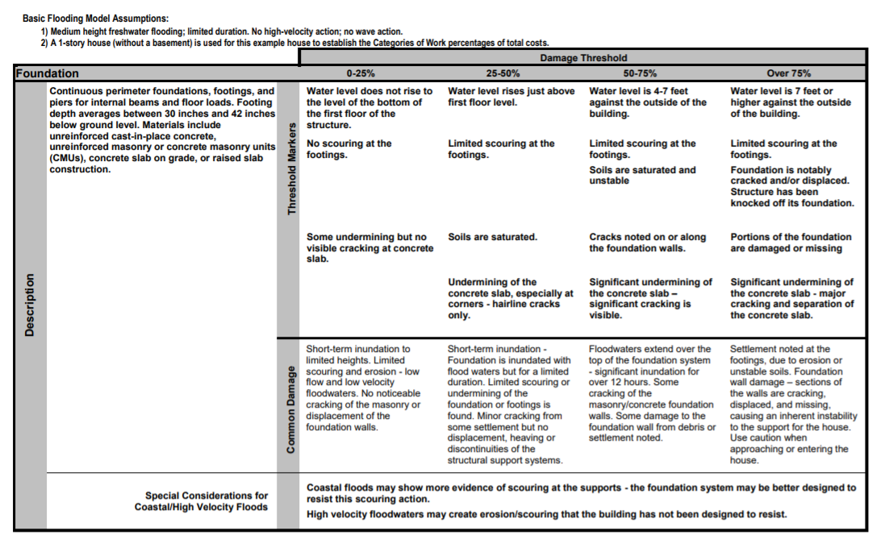
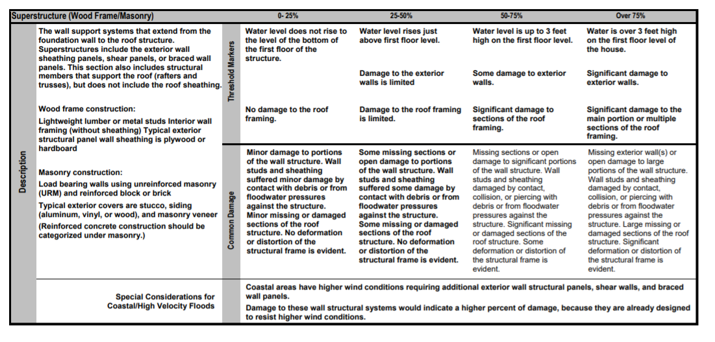
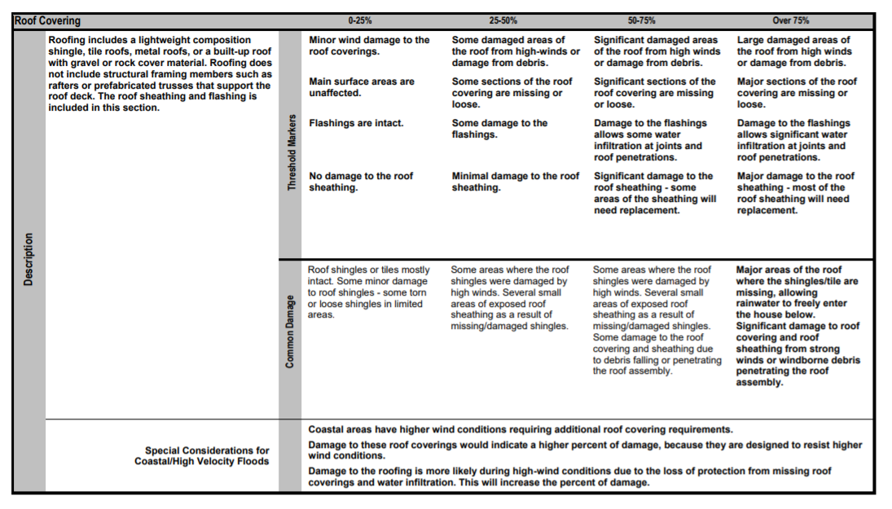
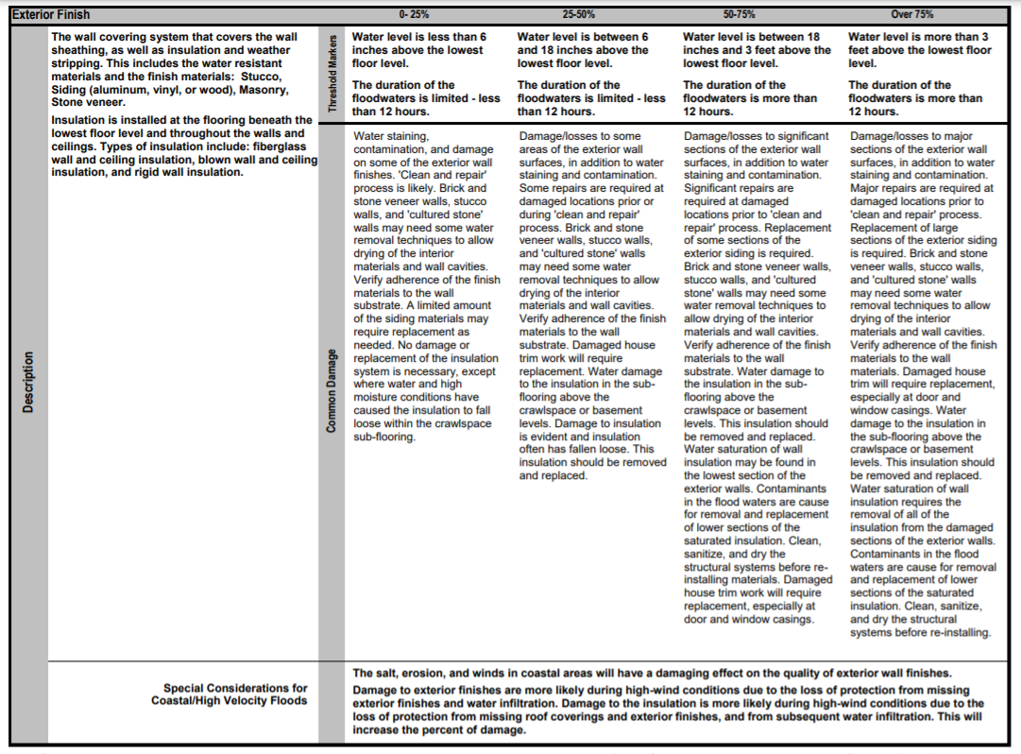
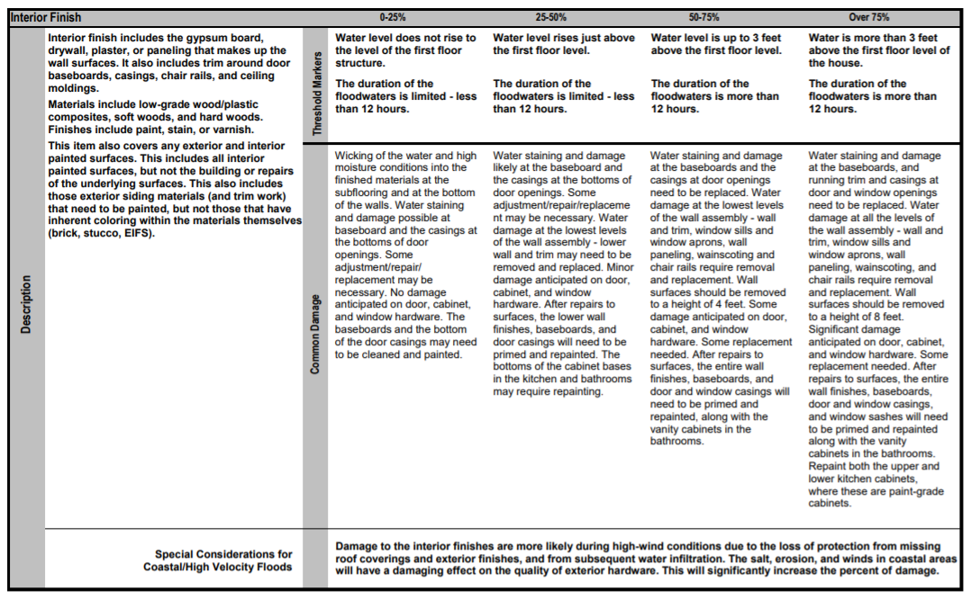
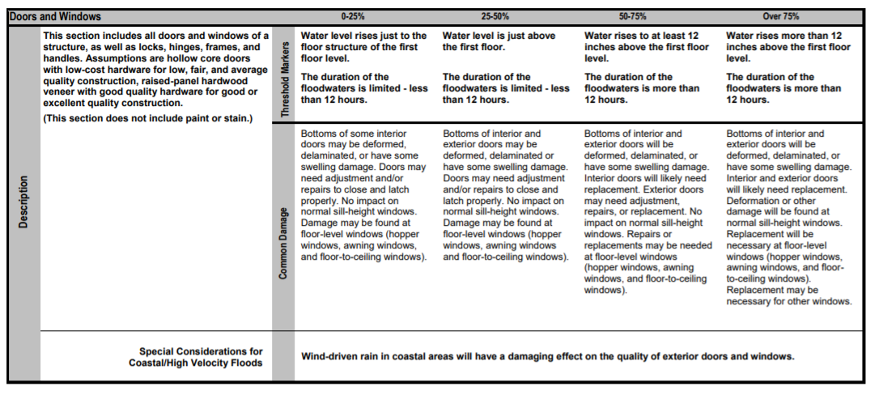
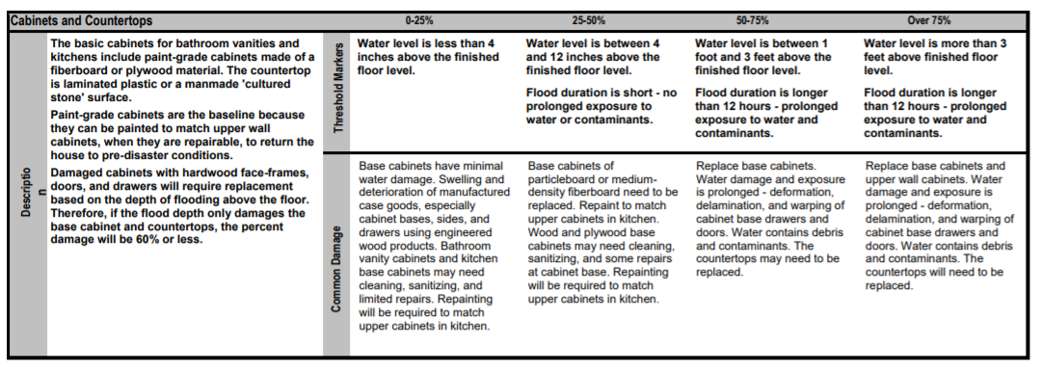
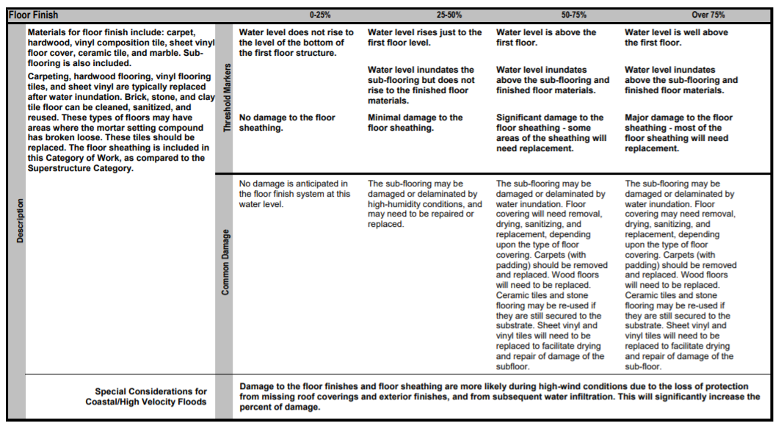
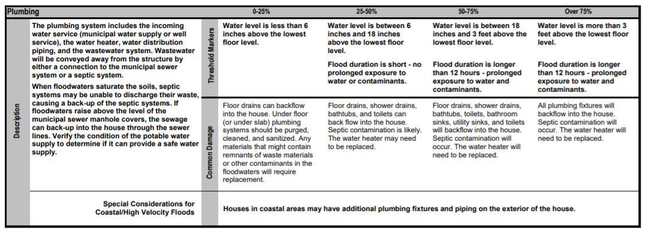
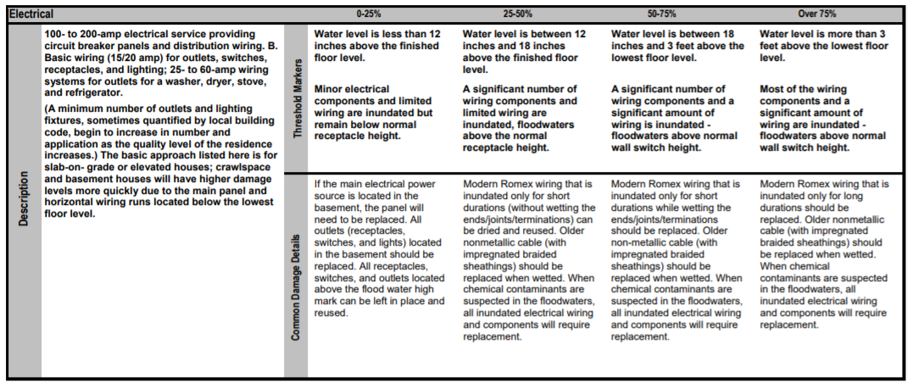
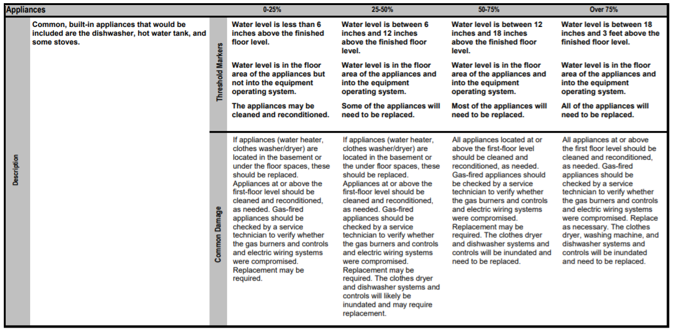
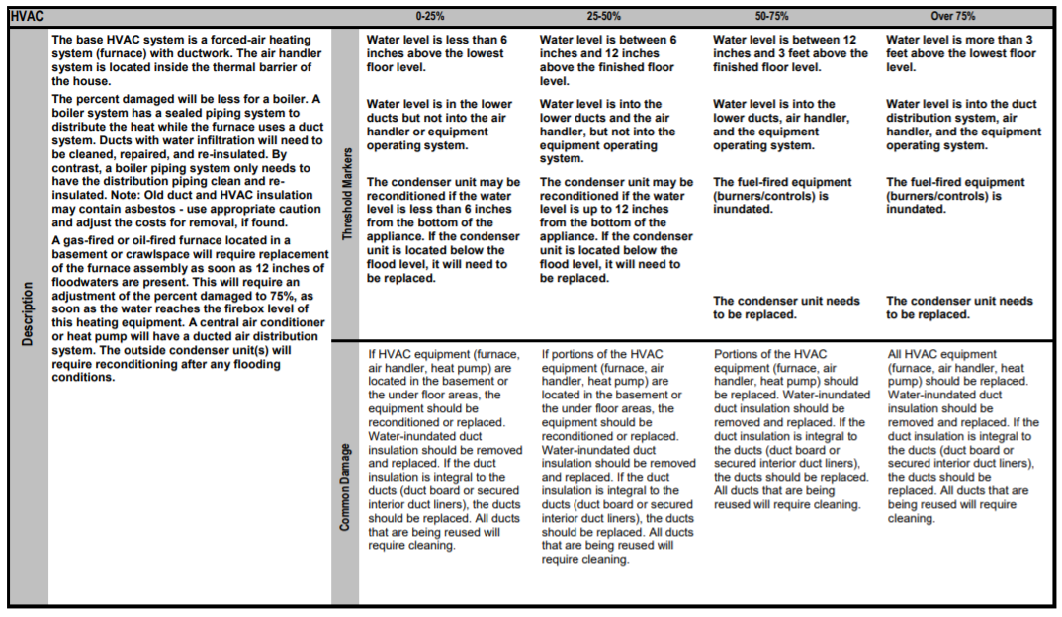
Guidance for Estimating Percent Damage for Non-Residential Structures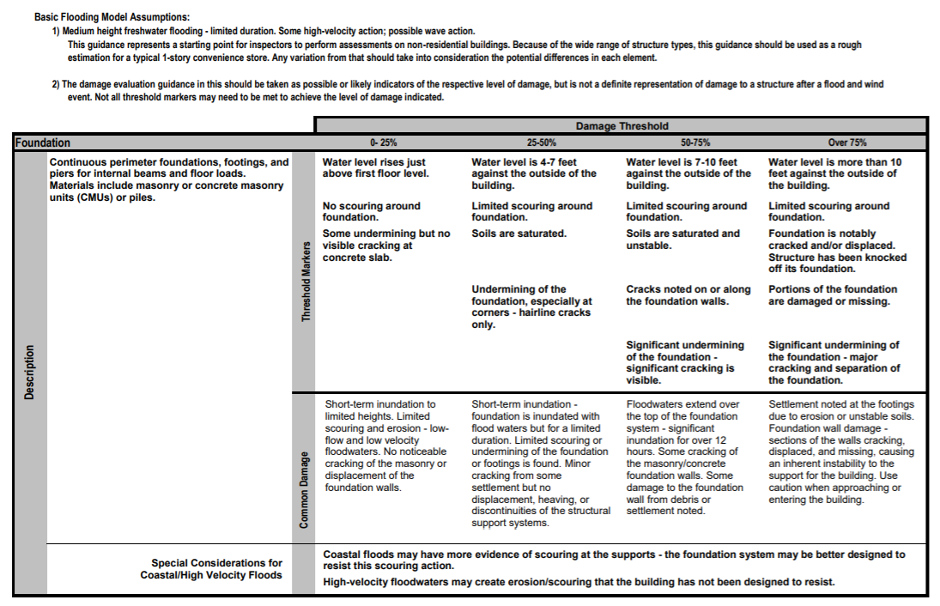
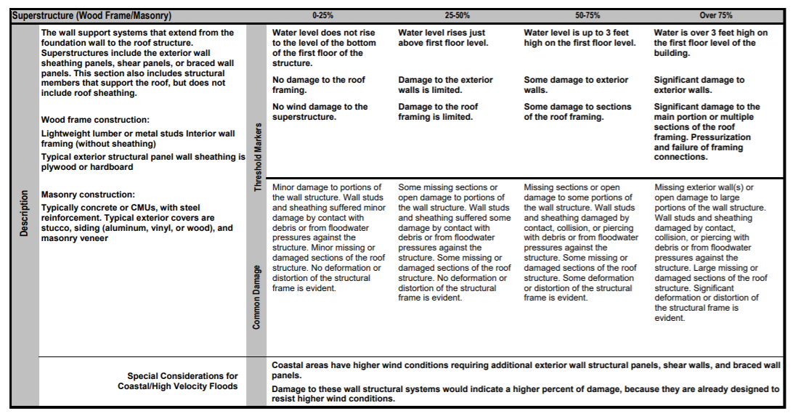
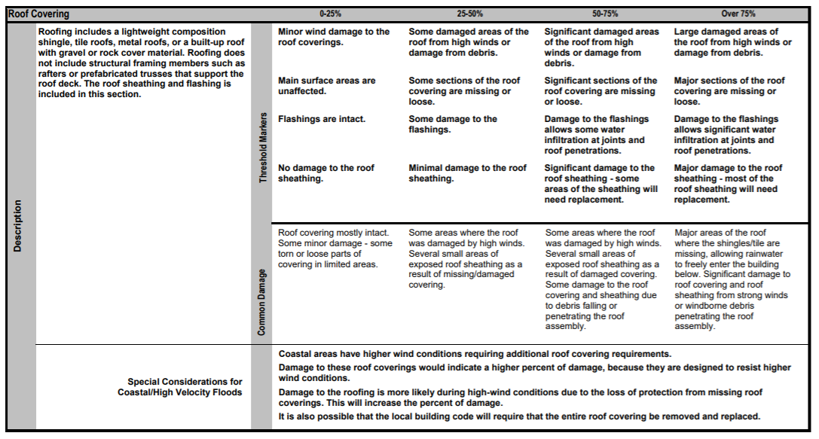
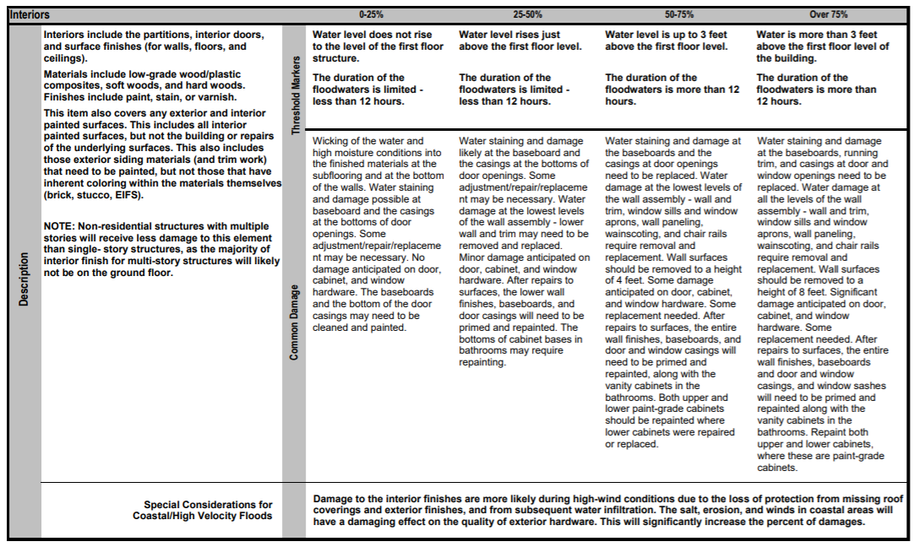
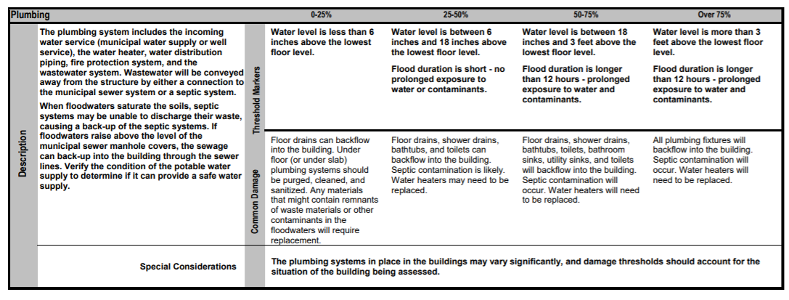
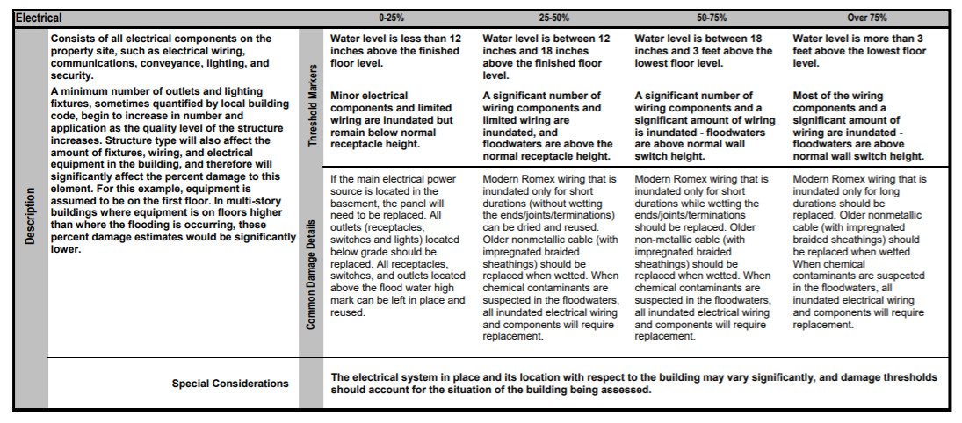
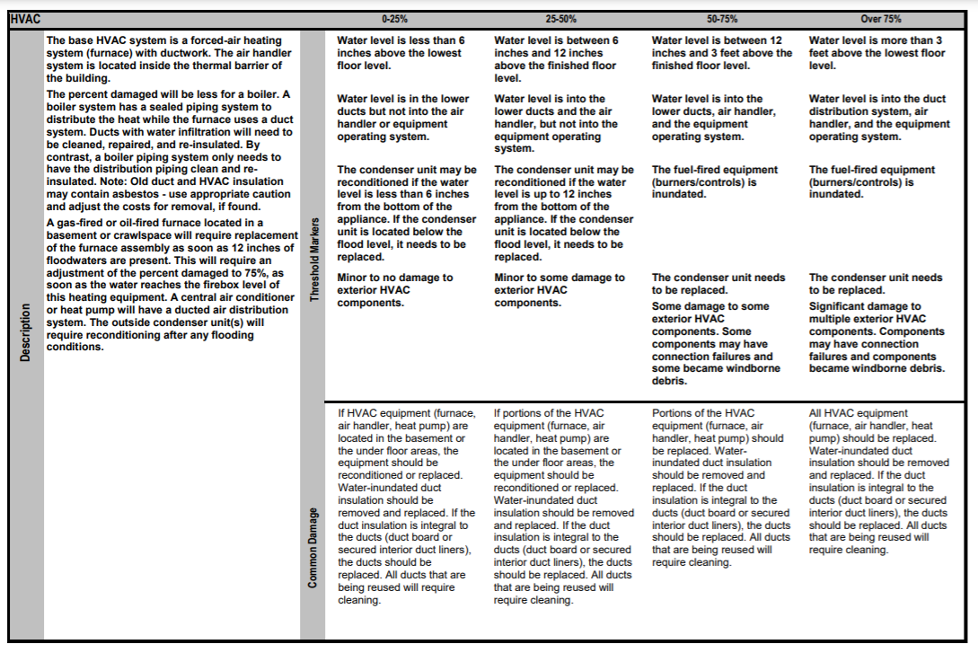

APPENDIX 9 –HANDOUTS FOR PROPERTY OWNERS AND LOCAL OFFICIALS

FEMA Help After a Disaster Brochure
https://www.fema.gov/sites/default/files/2020-08/fema_help-after-disaster_english_trifold.pdf
National Flood Insurance Program Factsheet
https://www.fema.gov/pdf/media/factsheets/2011/mit_natl_flood_ins.pdf
Increased Cost of Compliance Fact Sheet
https://www.fema.gov/sites/default/files/2020-08/fema_increased-cost-of-compliance_fact-sheet.pdf
Myths and Facts About Flood Insurance
https://www.fema.gov/es/blog/facts-and-myths-about-flood-insurance
Factsheet: Mold: Problems and Solutions
https://www.fema.gov/press-release/20201016/fact-sheet-mold-problems-and-solutions
After the Flood: Advice for Salvaging Damaged Family Treasures
https://www.fema.gov/sites/default/files/2020-06/Flood_FIMA_Fact_Sheet_advice_salvaging.pdf
The Benefits of Flood Insurance Versus Disaster Assistance
https://insurance.ky.gov/ppc/Documents/NFIP3.pdf
Flood Insurance 101 - Talking Points for Community Officials
https://www.santa-clarita.com/home/showdocument?id=11700
Examples from Past Disasters:
Fact Sheet – Rebuilding after Sandy
https://www.state.nj.us/dep/special/hurricane-sandy/docs/rebuilding-after-sandy-factsheet.pdf
Fact Sheet - NFIP “Substantial Damage” What does it mean?
https://www.fema.gov/news-release/20200220/fact-sheet-nfip-substantial-damage-what-does-it-mean-0
You got a Substantial Damage Determination Letter, Now what?
https://www.fema.gov/fact-sheet/you-got-substantial-damage-determination-letter-now-what
Cleaning Flooded Buildings – Hurricane Sandy Recovery Factsheet 1
https://www.fema.gov/sites/default/files/2020-08/sandy_factsheet1_cleaning_flooded_bldgs.pdf
Community Rating System
FEMA B573 – NFIP Community Rating System Brochure
https://www.fema.gov/sites/default/files/documents/fema_community-rating-system_local-guide-flood-insurance-2018.pdf
Examples from other States
Key West Substantial Improvement Brochure
https://www.cityofkeywest-fl.gov/DocumentCenter/View/2322/Substantial-Improvement-Brochure
Kansas Local Elected Officials Mitigation Factsheet
https://www.agriculture.arkansas.gov/wp-content/uploads/2020/05/Substantial_Damage_Fact_Sheets_Local_Elected_Officials.pdf
Montana DNRC Substantial Damage Fact Sheet
http://dnrc.mt.gov/divisions/water/operations/floodplain-management/training/flood-coordination/Substantial_Damage_BrochureFinal.pdf

APPENDIX 10 – INTENT TO RAISE, DEMOLISH OR FLOODPROOF FORM
[Community Letterhead]
LETTER OF INTENT TO RAISE or DEMOLISH
Property Address:

Block:

Lot:

Owner’s Name:

Date of Substantial Damage/ Substantial Improvement (Circle One) Determination:

According to FEMA all structures substantially damaged by [disaster name/type] shall be raised, demolished or floodproofed (floodproofing is only for non-residential structures) as soon as possible, keeping in mind the six year eligibility of ICC funds. I intend to bring the structure into compliance, at the above-referenced property, by [date] in order to comply with the [Community Name] Flood Damage Prevention Ordinance and FEMA requirements. I understand that no improvements can be made to the structure, that the structure can only be raised, floodproofed, or demolished and rebuilt and brought into compliance with the [Community Name] Flood Damage Prevention Ordinance. I understand that failure to comply with the required Floodplain regulations may result in penalties from [Community Name] and/or FEMA.

Signature:

Printed Name:

Notarized:

APPENDIX 11 – VARIANCE LANGUAGE FROM ORDINANCE

Double check the following language to make sure it is consistent with what is in your communities Flood Damage Prevention Ordinance
SECTION 107 VARIANCES
  - General. The {body to hear variances} shall hear and decide requests for variances. The {body to hear variances} shall base its determination on technical justifications submitted by applicants, the considerations for issuance in Section 107.5, the conditions of issuance set forth in Section 107.6, and the comments and recommendations of the Floodplain Administrator and, as applicable, the Construction Official. The {body to hear variances} has the right to attach such conditions to variances as it deems necessary to further the purposes and objectives of these regulations.

  - Historic structures. A variance is authorized to be issued for the repair or rehabilitation of a historic structure upon a determination that the proposed repair or rehabilitation will not preclude the structure's continued designation as a historic structure, the historic structure is eligible for the exception in the section in Chapter 12 of the Existing Building Code applicable to historic structures in flood hazard areas, and the variance is the minimum necessary to preserve the historic character and design of the structure.

  - Functionally dependent uses. A variance is authorized to be issued for the construction or substantial improvement necessary for the conduct of a functionally dependent use provided the variance is the minimum necessary to allow the construction or substantial improvement, and that all due consideration has been given to use of methods and materials that minimize flood damage during the base flood and create no additional threats to public safety.

  - Restrictions in floodways. A variance shall not be issued for any proposed development in a floodway when any increase in flood levels would result during the base flood discharge, as evidenced by the applicable analysis and certification required in Section 105.3(1) of these regulations.

  - Considerations. In reviewing requests for variances, all technical evaluations, all relevant factors, all other portions of these regulations, and the following shall be considered:
    - The danger that materials and debris may be swept onto other lands resulting in further injury or damage.
    - The danger to life and property due to flooding or erosion damage.
    - The susceptibility of the proposed development, including contents, to flood damage and the effect of such damage on current and future owners.
    - The importance of the services provided by the proposed development to the community.
    - The availability of alternate locations for the proposed development that are not subject to flooding or erosion and the necessity of a waterfront location, where applicable.
    - The compatibility of the proposed development with existing and anticipated development.
    - The relationship of the proposed development to the comprehensive plan and floodplain management program for that area.
    - The safety of access to the property in times of flood for ordinary and emergency vehicles.
    - The expected heights, velocity, duration, rate of rise and debris and sediment transport of the floodwater and the effects of wave action, where applicable, expected at the site.
    - The costs of providing governmental services during and after flood conditions including maintenance and repair of public utilities and facilities such as sewer, gas, electrical and water systems, streets, and bridges.

  - Conditions for issuance. Variances shall only be issued upon:
    - Submission by the applicant of a showing of good and sufficient cause that the unique characteristics of the size, configuration or topography of the site limit compliance with any provision of these regulations or renders the elevation standards of the building code inappropriate.
    - A determination that failure to grant the variance would result in exceptional hardship due to the physical characteristics of the land that render the lot undevelopable.
    - A determination that the granting of a variance will not result in increased flood heights, additional threats to public safety, extraordinary public expense, nor create nuisances, cause fraud on or victimization of the public or conflict with existing local laws or ordinances.
    - A determination that the variance is the minimum necessary, considering the flood hazard, to afford relief.
    - Notification to the applicant in writing over the signature of the Floodplain Administrator that the issuance of a variance to construct a structure below the base flood level will result in increased premium rates for flood insurance up to amounts as high as $25 for
$100 of insurance coverage, and that such construction below the base flood level increases risks to life and property.

APPENDIX 12 – [COMMUNITY NAME] MUTUAL AID/SHARED SERVICES AGREEMENTS
Include any mutual aid agreements that your community has here, or the location of where they can be easily found.

APPENDIX 13 – [COMMUNITY NAME] MINIMUM PROCUREMENT THRESHOLDS
Confirm and update this table if DRRA contractor procurement is anticipated below the minimum procurement thresholds.

THE NEW JERSEY DEPARTMENT OF ENVIRONMENTAL PROTECTION IS PROVIDING THIS SPREADSHEET FOR INFORMATIONAL PURPOSES ONLY
FEDERAL AND STATE REGULATIONS MAY CHANGE AND TREASURY CIRCULARS MAY BE AMENDED OR RETRACTED
ALL POLICIES AND REGULATIONS MUST BE CONFIRMED BY ANY CONTRACTING ENTITY BEFORE ENTERING INTO NEGOTIATIONS FOR ANY CONTRACT

Procurement Types | Description | Bid Threshold Amounts | Conditions | Guidance Documents / Regulations
Force Account Labor | Communities, including State entities, can submit for reimbursement of hourly employees and equipment costs. Reimbursement for full time employees may be possible provided that the work project is not considered to be a part of their regular work duties. | N/A | Force Account Labor includes any labor hired directly by the community. It is not subject to Davis Bacon and Related Acts regulations. Employees must be paid fairly under the Fair Labor Standards Act. | Public Assistance Program and Policy Guide Version 4 (fema.gov)  Pages 68-71.
State Bid Threshold – Local Governments with no Qualified Purchasing Agent | Contracts below this amount can be awarded by communities without advertising but through a competitive contracting process. Contracts above this amount must have an open and competitive process. | $17,500 | Threshold for communities without a Qualified Purchasing Agent  Note that 40:11-4 3k. may allow competitive contracting in lieu of public bidding for procurement of specialized goods and services that exceed the bid threshold for the following purposes:  k. The operation, management or administration of other services, with the approval of the Director of the Division of Local Government Service (NOTE: This would need a determination from DCA DLGS that this type of contracting is necessary to maximize FEMA funds during the emergency period) | N.J.S.A. 40A:11-3 and Local Finance Notice 2011-15 NJ Department of Community Affairs
State Bid Threshold – Local Governments with a Qualified Purchasing Agent | Contracts below this amount can be awarded by communities without advertising but through a competitive contracting process if they have a Qualified Purchasing Agent. Contracts above this amount must have an open and competitive process. | $44,000 | Threshold for communities with a Qualified Purchasing Agent  Note that 40:11-4 3k. may allow competitive contracting in lieu of public bidding for procurement of specialized goods and services that exceed the bid threshold for the following purposes:  k. The operation, management or administration of other services, with the approval of the Director of the Division of Local Government Service (NOTE: This would need a determination from DCA DLGS that this type of contracting is necessary to maximize FEMA funds during the emergency period) | N.J.S.A. 40A:11-3 NJ Division of Purchase and Property - Adjustment to Public Bidding Threshold (state.nj.us)
Bids by Local Governments above the State Bid Threshold | Contracts above the bid threshold (dependent upon whether a Qualified Purchasing Agent is employed by a community) | Above $17,500 (no QPA) or Above $44,000 (with QPA) | 40:11-4 Contracts required to be advertised...(when over the $17.5K/$44K bid threshold)  a. Every contract awarded by the contracting agent for the provision or performance of any goods or services, the cost of which in the aggregate exceeds the bid threshold, shall be awarded only by resolution of the governing body of the contracting unit to the lowest responsible bidder after public advertising for bids and bidding therefor, except as is provided otherwise in this act or specifically by any other law. The governing body of a contracting unit may, by resolution approved by a majority of the governing body and subject to subsections b. and c. of this section, disqualify a bidder who would otherwise be determined to be the lowest responsible bidder, if the governing body finds that it has had prior negative experience with the bidder. | N.J.S.A. 40:11-4 Local Public Contracts Law
State Agency and Authority Bid Thresholds and Policy | The State Treasurer specifies the Delegated Purchasing AuthorityDPA) Thresholds, which may vary by entity (see link).  Additionally, in a Governor-declared disaster, thresholds may be increased if certain conditions are met. However, if the entity is seeking reimbursement of Federal funds under the Stafford Act, compliance with Federal procurement regulations is necessary to ensure full reimbursement as this threshold is set at $250K and is below the maximum $1M threshold set by the State Treasurer. For example, while the State may waive bid advertisement, for a contract estimated to cost $300K, the Federal government requirement to advertise would apply because the Federal threshold for advertisement is set at $250K. | Bid Threshold Amount Varies by Agency (see link) | Effective January 18, 2022, the Delegated Purchasing Authority (DPA) threshold was increased from $44,000 to $150,000 for goods and services for most entities (see link in next column). In the event the Governor declares an emergency through Executive Order, the Department of Treasury’s Director of Division of Purchase and Property (DPP) may increase the DPA threshold to $1,000,000 for necessary supplies and services related to the declared emergency, and purchased during the declared emergency period. A DPA purchase is defined as a transaction that cannot be procured through one of the following four primary contracting methods:  1) a current State contract, including contracts acquired through Waivers of Advertising;  2) the State Distribution and Support Services Center (“DSS”);  3) the Bureau of State Use Industries (“DEPTCOR”); or  4) the Central Non-profit Agency CNA/ACCSES NJ (“CNA").  AND is within an agency’s current DPA threshold | State Bid Thresholds -  NJ Division of Purchase and Property - Adjustment to Public Bidding Threshold (state.nj.us)  Governor-Declared Emergency Bid Policy –  OMB Circular 22-09-DPP  CIRCULAR (nj.gov)
Federal Micro- purchase | Micro-purchases may be awarded without soliciting competitive price or rate quotations if the non-State entity considers the price to be reasonable based on research, experience, purchase history or other information and documents it files accordingly. All New Jersey Communities would be able to use the Federal Micro-Purchase regulations up to $10,000 provided they use competitive contracting in accordance with Local Public Contracts law and ensure that they follow any State and local thresholds. State entities must follow applicable State procurement thresholds and Office of Management and Budget (OMB) Circulars. | $10,000 | § 200.67 Micro-purchase.  Micro-purchase means a purchase of supplies or services using simplified acquisition procedures, the aggregate amount of which does not exceed the micro-purchase threshold. Micro-purchase procedures comprise a subset of a non-Federal entity's small purchase procedures. The non-Federal entity uses such procedures in order to expedite the completion of its lowest-dollar small purchase transactions and minimize the associated administrative burden and cost. The micro-purchase threshold is set by the Federal Acquisition Regulation at 48 CFR Subpart 2.1 (Definitions). It recently was raised to $10,000 to adjust for inflation. | 2 CFR 200.67  Purchasing Under a FEMA Award: OMB Revisions  2020-17468.pdf (govinfo.gov)
Local Government and State Agency Increases in the Micro-Purchase Threshold | Self-Certification must be done annually and documentation must be made available. A justification is necessary. This would increase the federal threshold from $10K to $17.5K for communities without a QPA and from $10K - $44K for local governments with a QPA. To increase the amount to the full $50K, DCA Division of Local Government Services (DLGS) approval would have to be obtained and the community would have to follow a competitive contracting form of procurement and document all decision-making. Non-state entities must also ensure that they follow any applicable State or local thresholds and keep documentation of any threshold increase by DLGS.  State entities must follow applicable State procurement thresholds and Office of Management and Budget (OMB) Circulars. | Up to $50,000 | 2 CFR 320(a)1iv Non-Federal entity increase to the micro-purchase threshold up to $50,000. Non-Federal entities may establish a threshold higher than the micro-purchase threshold identified in the FAR in accordance with the requirements of this section. The non-Federal entity may self-certify a threshold up to $50,000 on an annual basis and must maintain documentation to be made available to the Federal awarding agency and auditors in accordance with § 200.334. The self-certification must include a justification, clear identification of the threshold, and supporting documentation of any of the following:  (A) A qualification as a low-risk auditee, in accordance with the criteria in § 200.520 for the most recent audit;  (B) An annual internal institutional risk assessment to identify, mitigate, and manage financial risks; or,  (C) For public institutions, a higher threshold consistent with State law. | 2 CFR 200.320(a)1iv  Purchasing Under a FEMA Award: OMB Revisions  2020-17468.pdf (govinfo.gov)
Federal Simplified Acquisition Threshold | The simplified acquisition threshold has a higher limit than is allowed by the Municipal Public Contracts law. Contracts of this size must be competitively bid in New Jersey unless approval is given by DCA Division of Local Government Services.  Federal Small Purchase requirements apply for bids between $10,000 and $250,000 but contracts over a community’s approved Local Public Contracts Law bid threshold (either $17.5K or $44K) must be advertised and competitively bid. State entities must follow applicable State procurement thresholds and Office of Management and Budget (OMB) Circulars. | $250,000.00 | Federal Small Purchase Requirements - The procuring entity must get rate quotations from an “adequate” number of qualified sources (not defined, but generally more than one). No cost or price analysis is required (see 2 CFR § 200.323(a)), and public notice is not required. Price or rate quotations can be either verbal or written. The community must send a request for quotes to potential vendors with a detailed description of the services needed. Each quote should include pricing information that allows the community to compare costs across bidders and ensure cost reasonableness. Documentation of quotes should be maintained by the town. Contract award should be based on the lowest price from a responsible bidder who submits a responsive bid/quote. Communities must follow all other federal procurement requirements, including the competition requirements set forth at 2 CFR 200.319. The firm that prepares the description of services needed is not allowed to bid on the work. | 2 CFR 200.320(b)
Federal Procurement over $250,000 | All contracts above $250K must be advertised and competitively bid with a cost and price analysis. Sealed bids or Proposals with a fixed price (not to exceed) or cost-reimbursement type contract. Non-competitive bids can only be used in narrow circumstances. Contracts over a community’s approved Local Public Contracts Law bid threshold (either $17.5K or $44K) must be advertised and competitively bid. . State entities must follow applicable State procurement thresholds and Office of Management and Budget (OMB) Circulars. If State entities are seeking reimbursement under the Stafford Act, Federal requirements for contracts in excess of $250K take precedence even if the State OMB circular does not require State-level compliance with regulations such as bid advertisement and fair and open competition. | Contracts greater than $250,000 | 2 CFR 320(b) | 2 CFR 320(b)
Other Considerations:

Recordkeeping:
- Force Account Labor – recordkeeping, timekeeping, and equipment usage must be in accordance with NJOEM Public Assistance reimbursement requirements.
- All contractors must pass Federal Debarment/ Suspension checks (SAM.gov | Entity Information) and State Debarment/Suspension Checks (State of NJ - NJ Treasury - DORES) before the contract is awarded.
- Communities must document that professional services rates and hours allocated per task that are submitted for reimbursement are cost-reasonable.

