**APPENDIX D: Model Stormwater Control Ordinance for Municipalities**

**(Simplified Version)**

***Important Notes****: This sample ordinance is provided to assist municipalities in revising their municipal stormwater control ordinances to reflect amendments to the Stormwater Management rules at N.J.A.C. 7:8. It is provided for information purposes only. It is important that amended rules are carefully reviewed before any portion of this draft ordinance is adopted. This simplified version cites subchapter and section numbers the Stormwater Management rules, instead of the full text, to reduce or eliminate the need for the municipalities to revise their ordinance when the Stormwater Management rules are amended. A municipality has to comply with the applicable laws and procedures for the passage and adoption of ordinance pursuant to this simplified version.*

*This sample ordinance represents the minimum standards and expectations, except where noted otherwise. It is the goal of stormwater management to minimize pollution caused by stormwater in order to restore, enhance and maintain the integrity of waters of the State. Federal, as well as, State water pollution laws permit municipalities to undertake additional actions including ordinances with standards stronger than the statewide minimum requirements. Under New Jersey Municipal Separate Storm Sewer System General Permits (MS4), the stormwater program must incorporate Additional Measures when the Department of Environmental Protection (Department) provides a written notice of the adoption of any Additional Measure(s) to any affected municipalities. A municipality’s stormwater program may also include Optional Measures (OMs), that prevent or reduce the pollution of the waters of the State. A municipality may choose these stronger or additional measures in order to address local water quality and flooding conditions as well as other environmental and community needs. For example, municipalities may choose to define “major development” with a smaller area of disturbance and/or smaller area of regulated impervious cover or regulated motor vehicle surface; apply stormwater requirements to both major and minor development; and/or require groundwater recharge, when feasible, in urban redevelopment areas.*

*Although this model ordinance does include a section on penalties, it is entirely optional for a municipality to include this section and therefore, this section does not establish any monetary values. The Department expects that the review of development applications under this ordinance would be an integral part of the municipal review of developments. As a result, the costs to municipalities of reviewing development applications under this ordinance could be defrayed by fees charged for review under N.J.S.A. 40:55D-8.b.*

*Notes are provided in italics throughout this model stormwater control ordinance and are not intended to be adopted as part of the ordinance. Where non-italicized text is bounded in a rectangular border, the text inside that boundary is the sample ordinance language.*

*An editable Word version of this model ordinance is available online at:*

<https://dep.nj.gov/stormwater/bmp-manual/>.

**Sample Municipal Stormwater Control Ordinance**

**Ordinance #[***insert number***] – Stormwater Control**

**Section I. Scope and Purpose:**

1. Policy Statement

Flood control, groundwater recharge, and pollutant reduction shall be achieved through the use of stormwater management measures, including green infrastructure Best Management Practices (GI BMPs) and nonstructural stormwater management strategies. GI BMPs should be utilized to meet the goal of maintaining natural hydrology to reduce stormwater runoff volume, reduce erosion, encourage infiltration and groundwater recharge, and reduce pollution. GI BMPs should be developed based upon physical site conditions and the origin, nature and the anticipated quantity, or amount, of potential pollutants. Multiple stormwater management BMPs may be necessary to achieve the established performance standards for green infrastructure, water quality, quantity, and groundwater recharge.

1. Purpose

The purpose of this ordinance is to establish minimum stormwater management requirements and controls for “major development,” as defined below in Section II.

1. Applicability
2. This ordinance shall be applicable to the following major developments:
3. Non-residential major developments and redevelopment projects; and
4. Aspects of residential major developments and redevelopment projects that are not pre-empted by the Residential Site Improvement Standards at N.J.A.C. 5:21 et seq.
5. This ordinance shall also be applicable to all major developments undertaken by [*insert name of municipality*].
6. Applicability of this ordinance to major developments shall comply with last amended N.J.A.C. 7:8-1.6, incorporated herein by reference.
7. Compatibility with Other Permit and Ordinance Requirements

Development approvals issued pursuant to this ordinance are to be considered an integral part of development approvals and do not relieve the applicant of the responsibility to secure required permits or approvals for activities regulated by any other applicable code, rule, act, or ordinance. In their interpretation and application, the provisions of this ordinance shall be held to be the minimum requirements for the promotion of the public health, safety, and general welfare.

This ordinance is not intended to interfere with, abrogate, or annul any other ordinances, rule or regulation, statute, or other provision of law except that, where any provision of this ordinance imposes restrictions different from those imposed by any

other ordinance, rule or regulation, or other provision of law, the more restrictive provisions or higher standards shall control.

**Section II. Definitions:**

For the purpose of this ordinance, the following terms, phrases, words and their derivations shall have the meanings stated herein unless their use in the text of this ordinance clearly demonstrates a different meaning. When not inconsistent with the context, words used in the present tense include the future, words used in the plural number include the singular number, and words used in the singular number include the plural number. The word "shall" is always mandatory and not merely directory. The definitions used in this ordinance shall be the same as the last amended Stormwater Management Rules at N.J.A.C. 7:8-1.2, incorporated herein by reference.

**Section III. Design and Performance Standards for Stormwater Management**

**Measures:**

This section establishes design and performance standards for stormwater management measures for major development intended to minimize the adverse impact of stormwater runoff on water quality and water quantity and loss of groundwater recharge in receiving water bodies. Design and performance standards for stormwater management measures shall comply with last amended N.J.A.C. 7:8-5, incorporated herein by reference.

**Section IV. Solids and Floatable Materials Control Standards:**

1. Site design features identified under Section III above, or alternative designs in accordance with Section III above, to prevent discharge of trash and debris from drainage systems shall comply with the following standard to control passage of solid and floatable materials through storm drain inlets. For purposes of this paragraph, “solid and floatable materials” means sediment, debris, trash, and other floating, suspended, or settleable solids. For exemptions to this standard see Section IV.A.2 below.
2. Design engineers shall use one of the following grates whenever they use a grate in pavement or another ground surface to collect stormwater from that surface into a storm drain or surface water body under that grate:
3. The New Jersey Department of Transportation (NJDOT) bicycle safe grate, which is described in Chapter 2.4 of the NJDOT Bicycle Compatible Roadways and Bikeways Planning and Design Guidelines; or
4. A different grate, if each individual clear space in that grate has an area of no more than seven (7.0) square inches, or is no greater than 0.5 inches across the smallest dimension. Note that the Residential Site Improvement Standards at N.J.A.C. 5:21 include requirements for bicycle safe grates.

Examples of grates subject to this standard include grates in grate inlets, the grate portion (non-curb-opening portion) of combination inlets, grates on storm sewer manholes, ditch grates, trench grates, and grates of spacer bars in slotted drains. Examples of ground surfaces include surfaces of roads (including bridges), driveways, parking areas, bikeways, plazas, sidewalks, lawns, fields, open channels, and stormwater system floors used to collect stormwater from the surface into a storm drain or surface water body.

1. For curb-opening inlets, including curb-opening inlets in combination inlets, the clear space in that curb opening, or each individual clear space if the curb opening has two or more clear spaces, shall have an area of no more than seven (7.0) square inches, or be no greater than two (2.0) inches across the smallest dimension.
2. The standard in IV.A.1. above does not apply:
3. Where each individual clear space in the curb opening in existing curb-opening inlet does not have an area of more than nine (9.0) square inches;
4. Where the municipality agrees that the standards would cause inadequate hydraulic performance that could not practicably be overcome by using additional or larger storm drain inlets;
5. Where flows from the water quality design storm as specified in the last amended Stormwater Management rules at N.J.A.C. 7:8 et seq. are conveyed through any device (e.g., end of pipe netting facility, manufactured treatment device, or a catch basin hood) that is designed, at a minimum, to prevent delivery of all solid and floatable materials that could not pass through one of the following:
   1. A rectangular space four and five-eighths (4.625) inches long and one and one-half (1.5) inches wide (this option does not apply for outfall netting facilities); or
6. A bar screen having a bar spacing of 0.5 inches.

Note that these exemptions do not authorize any infringement of requirements in the Residential Site Improvement Standards for bicycle safe grates in new residential development (N.J.A.C. 5:21-4.18(b)2 and 7.4(b)1).

1. Where flows are conveyed through a trash rack that has parallel bars with one-inch (1 inch) spacing between the bars, to the elevation of the Water Quality Design Storm as specified in N.J.A.C. 7:8; or
2. Where the New Jersey Department of Environmental Protection determines, pursuant to the New Jersey Register of Historic Places Rules at N.J.A.C. 7:4-7.2(c), that action to meet this standard is an undertaking that constitutes an encroachment or will damage or destroy the New Jersey Register listed historic property.

**Section V. Safety Standards for Stormwater Management Basins:**

A. This section sets forth requirements to protect public safety through the proper design and operation of stormwater management basins. This section applies to any new stormwater management basin. Safety standards for stormwater management measures shall comply with last amended N.J.A.C. 7:8-6, incorporated herein by reference.

1. Safety Ledge Illustration

Elevation View –Basin Safety Ledge Configuration

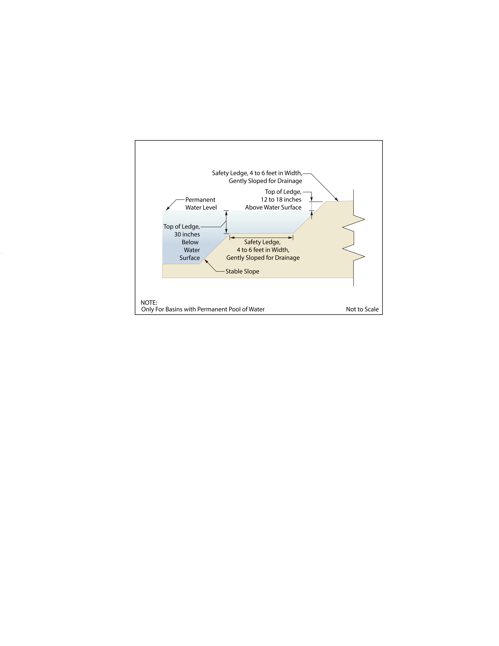

**Section VI. Requirements for a Site Development Stormwater Plan:**

1. Submission of Site Development Stormwater Plan
2. Whenever an applicant seeks municipal approval of a development subject to this ordinance, the applicant shall submit all of the required components of the Checklist for the Site Development Stormwater Plan at Section VI.C below as part of the submission of the application for approval.
3. The applicant shall demonstrate that the project meets the standards set forth in this ordinance.
4. The applicant shall submit [*specify number*] copies of the materials listed in the checklist for site development stormwater plans in accordance with Section VI.C of this ordinance.
5. Site Development Stormwater Plan Approval

The applicant's Site Development project shall be reviewed as a part of the review process by the municipal board or official from which municipal approval is sought. That municipal board or official shall consult the municipality’s review engineer to determine if all of the checklist requirements have been satisfied and to determine if the project meets the standards set forth in this ordinance.

1. Submission of Site Development Stormwater Plan

The following information shall be required:

1. Topographic Base Map

The reviewing engineer may require upstream tributary drainage system information as necessary. It is recommended that the topographic base map of the site be submitted which extends a minimum of 200 feet beyond the limits of the proposed development, at a scale of 1"=200' or greater, showing 2-foot contour intervals. The map as appropriate may indicate the following: existing surface water drainage, shorelines, steep slopes, soils, erodible soils, perennial or intermittent streams that drain into or upstream of the Category One waters, wetlands and flood plains along with their appropriate buffer strips, marshlands and other wetlands, pervious or vegetative surfaces, existing man-made structures, roads, bearing and distances of property lines, and significant natural and manmade features not otherwise shown.

1. Environmental Site Analysis

A written and graphic description of the natural and man-made features of the site and its surroundings should be submitted. This description should include a discussion of soil conditions, slopes, wetlands, waterways and vegetation on the site. Particular attention should be given to unique, unusual, or environmentally sensitive features and to those that provide particular opportunities or constraints for development.

1. Project Description and Site Plans

A map (or maps) at the scale of the topographical base map indicating the location of existing and proposed buildings roads, parking areas, utilities, structural facilities for stormwater management and sediment control, and other permanent structures. The map(s) shall also clearly show areas where alterations will occur in the natural terrain and cover, including lawns and other landscaping, and seasonal high groundwater elevations. A written description of the site plan and justification for proposed changes in natural conditions shall also be provided.

1. Land Use Planning and Source Control Plan

This plan shall provide a demonstration of how the goals and standards of Section III is being met. The focus of this plan shall be to describe how the site is being developed to meet the objective of controlling groundwater recharge, stormwater quality and stormwater quantity problems at the source by land management and source controls whenever possible.

1. Stormwater Management Facilities Map

The following information, illustrated on a map of the same scale as the topographic base map, shall be included:

1. Total area to be disturbed, paved or built upon, proposed surface contours, land area to be occupied by the stormwater management facilities and the type of vegetation thereon, and details of the proposed plan to control and dispose of stormwater.
2. Details of all stormwater management facility designs, during and after construction, including discharge provisions, discharge capacity for each outlet at different levels of detention and emergency spillway provisions with maximum discharge capacity of each spillway.
3. Calculations
4. Comprehensive hydrologic and hydraulic design calculations for the pre-development and post-development conditions for the design storms specified in Section III of this ordinance.
5. When the proposed stormwater management control measures depend on the hydrologic properties of soils or require certain separation from the seasonal high water table, then a soils report shall be submitted. The soils report shall be based on onsite boring logs or soil pit profiles. The number and location of required soil borings or soil pits shall be determined based on what is needed to determine the suitability and distribution of soils present at the location of the control measure.
6. Maintenance and Repair Plan

The design and planning of the stormwater management facility shall meet the maintenance requirements of Section VII.

1. Waiver from Submission Requirements

The municipal official or board reviewing an application under this ordinance may, in consultation with the municipality’s review engineer, waive submission of any of the requirements in Section VI.C.1 through VI.C.6 of this ordinance when it can be demonstrated that the information requested is impossible to obtain or it would create a hardship on the applicant to obtain and its absence will not materially affect the review process.

**Section VII. Maintenance and Repair:**

1. Applicability

Projects subject to review as in Section I.C of this ordinance shall comply with the

requirements of Section VII.B and VII.C.

1. General Maintenance
2. Maintenance for stormwater management measures shall comply with last amended N.J.A.C. 7:8-5.8, incorporated herein by reference.
3. The following requirements of N.J.A.C. 7:8-5.8 do not apply to stormwater management facilities that are dedicated to and accepted by the municipality or another governmental agency, subject to all applicable municipal stormwater general permit conditions, as issued by the Department:
   1. If the maintenance plan identifies a person other than the property owner (for example, a developer, a public agency or homeowners' association) as having the responsibility for maintenance, the plan shall include documentation of such person's or entity’s agreement to assume this responsibility, or of the owner's obligation to dedicate a stormwater management facility to such person under an applicable ordinance or regulation; and
   2. Responsibility for maintenance shall not be assigned or transferred to the owner or tenant of an individual property in a residential development or project, unless such owner or tenant owns or leases the entire residential development or project. The individual property owner may be assigned incidental tasks, such as weeding of a green infrastructure BMP, provided the individual agrees to assume these tasks; however, the individual cannot be legally responsible for all of the maintenance required.

*Note: It may be appropriate to delete requirements in the maintenance and repair plan that are not applicable if the ordinance requires the facility to be dedicated to the municipality. If the municipality does not want to take this responsibility, the ordinance should require the posting of a two year maintenance guarantee in accordance with N.J.S.A. 40:55D-53. Maintenance and inspection guidance can be found on the Department’s website at:*

<https://www.njstormwater.org/maintenance_guidance.htm>.

1. In the event that the stormwater management facility becomes a danger to public safety or public health, or if it is in need of maintenance or repair, the municipality shall so notify the responsible person in writing. Upon receipt of that notice, the responsible person shall have fourteen (14) days to effect maintenance and repair of the facility in a manner that is approved by the municipal engineer or his designee. The municipality, in its discretion, may extend the time allowed for effecting maintenance and repair for good cause. If the responsible person fails or refuses to perform such maintenance and repair, the municipality or County may immediately proceed to do so and shall bill the cost thereof to the responsible person. Nonpayment of such bill may result in a lien on the property.
2. Nothing in this subsection shall preclude the municipality in which the major development is located from requiring the posting of a performance or maintenance guarantee in accordance with N.J.S.A. 40:55D-53.

**Section VIII. Penalties:**

Any person(s) who erects, constructs, alters, repairs, converts, maintains, or uses any

building, structure or land in violation of this ordinance shall be subject to the following penalties:

{*Municipality to specify}*

**Section IX. Severability:**

Each section, subsection, sentence, clause and phrase of this Ordinance is declared to be an independent section, subsection, sentence, clause and phrase, and the finding or holding of any such portion of this Ordinance to be unconstitutional, void, or ineffective for any cause, or reason, shall not affect any other portion of this Ordinance.

**Section X. Effective Date:**

This Ordinance shall be in full force and effect from and after its adoption and any publication as required by law.

ALL OF WHICH IS ADOPTED THIS __________ day of __________, 20___, by the _________________________________________________________________________.