Surface Infiltration – Extended Detention Basin
Basin #___ on the Location Map

Development Name: ___________________________

Township, County: ___________________________

Location of Basin: X: ______; Y: ______ (or N: ______; E :_____)

Location Description: e.g., Northwest corner of the development, near County RT 531

Location Map
N
E

County Route 531

Discharge
Grass Swale #1

Basin #1
Drywell #1

Corporation Road
Building
Parking
Lot

Vegetative Filter strip #1

Drywell #2

Example Map: Use aerial photo, site plan, or other graphics showing the locations of BMPs.

Access
Grass Swale #2

NOTE

This Field Manual is intended to be editable and adjustable in accordance with the design of stormwater management measures, the site conditions, and the special needs of responsible party. The Engineer should supplement information and best management practice to assist the responsible party to perform maintenance.

Blue text indicates information may be deleted and or replaced as necessary.

Table of Contents

Infiltration Basin – Extended Detention Overview 4
Basic Design Information 5
Visual Aid for Dry Type Stormwater Basin Inspection 7
Reference Documents 12
Inspection Checklist / Maintenance Actions 14
Preventative Maintenance Record 21
Corrective Maintenance Record 22

Infiltration Basin – Extended Detention Overview

Functionality
An infiltration – extended detention basin is a stormwater management facility constructed of highly permeable soils that provides temporary storage of stormwater runoff from Water Quality Storm. It also functions to temporarily store and attenuate the stormwater runoff from large storms, such as 2, 10, and 100 year storms. The surface infiltration – detention basin has the infiltration function to remove pollutants and to infiltrate stormwater; in addition to groundwater recharge. Pollutants in runoff are treated through the processes of filtration through and biological and chemical activity within the soils. It also has the storage space to store the runoff volume from large storms. The total suspended solids (TSS) removal rate attributed to infiltration basins is 80%.

Proper care and attention in the long-term maintenance of the stormwater management measure is critically important to the safety and health of the public.

Type of BMP – Dry Basin / Infiltration and Extended Detention
An infiltration – extended detention basin is a type of dry basin. Dry basins must fully drain within 72 hours of the most recent rainfall. Standing water in excess of 72 hours is a sign of basin failure. It may also contribute to mosquito breeding and other health and safety issues. The design drain time shall be closely monitored to ensure that potential failure is recognized early.

For the field manual for a surface infiltration basin without extended detention, please see: Surface Infiltration Basin Field Manual. For the field manual for an extended detention basin without infiltration, please see: Extended Detention Basin Field Manual.

Basic Design Information
This Section Shall be filled out by the Designing Engineer.

Hydrology Design Targets
- This basin is designed with a subsoil permeability rate of _________ inches/hour (pre-construction) and __________ inches/hour (post-construction - tested on
(MM) / (DD) / (YYYY) ).
- The design detention time of this basin is __________ hours.
- The design drain time is __________ hours.

Note: The design detention time is not equivalent to the design drain time. A basin’s detention time is defined as the time from when the maximum storage volume is achieved until only 10 percent of that volume remains. The design drain time is the time to drain 100 percent of the storage volume, which may be significantly longer than the design detention time; however, an extended detention basin shall be completely drained within 72 hours or less after the most recent rain event.

- The elevation of the seasonal high water table of this basin was observed on
(MM) / (DD) / (YYYY) and it was _________ feet below the basin bottom surface, at EL._______ feet.
- The basin is designed to achieve a TSS removal rate of ________ %.
- This basin will be discharged to (municipal stormwater sewer system/ combined sewer system/ stream (stream name).)

Hydraulic Design Targets
- Design parameters
 | Water Quality Design Storm | 2-year  storm | 10-year  storm | 100-year  storm
Rainfall Depth (inches) | 1.25 inch  in 2 hours | ___ inches  in 24 hours | ___ inches  In 24 hours | ___ inches  In 24 hours
Runoff Volume (cubic feet)
Peak Flow Rate
(cfs)
Water Surface Elevation
(feet)
Note: The design engineer shall fill out the table in accordance with the design of the stormwater management measure. If the item is not applicable, enter N/A in the table.

- The emergency spillway is at EL. ___________ feet (if applicable).

Basin Configuration Targets
- Pretreatment is provided by a (forebay with a depth of _________ feet / BMP Type: __________, BMP No.). A perforated riser (is / is not) used.
- Outlet Information:
Outlet Description | Outlet Type | Orifice Size / Weir Length | Invert Elevation
Water Quality Orifice
Outlet #1
Outlet #2
(Other)

- Vegetation
  - The top of basin bed (or sand bed) is designed to (have / have no) vegetation (if the basin is vegetated, a Landscaping Plan should be included in the Reference Documents section.)

Critical Maintenance Features
- No heavy equipment on the basin surface or sand layer.
- Trash racks and discharge outlet shall be cleaned frequently.
- Grass clippings shall be collected from the basin and properly disposed.
- (Others to be added by the design engineer, if necessary)

Attach the following Disturbance Notices, if applicable to the site:

Wetland Disturbance Notice:
Maintenance of this BMP may disturb a wetland area. Contact NJDEP Division of Land Use Regulation for guidance and any required permit(s) before performing maintenance.

Wildlife Disturbance Notice:
Maintenance of this BMP may disturb or remove vegetation in an area designated to endangered and/or threatened species. Contact NJDEP Division of Fishing and Wildlife for guidance and any required permit(s) before performing maintenance.

Visual Aid for Dry Type Stormwater Basin Inspection
(Note: Basins shown here include various types of dry basins, not limited to the category of basin in this field manual.)
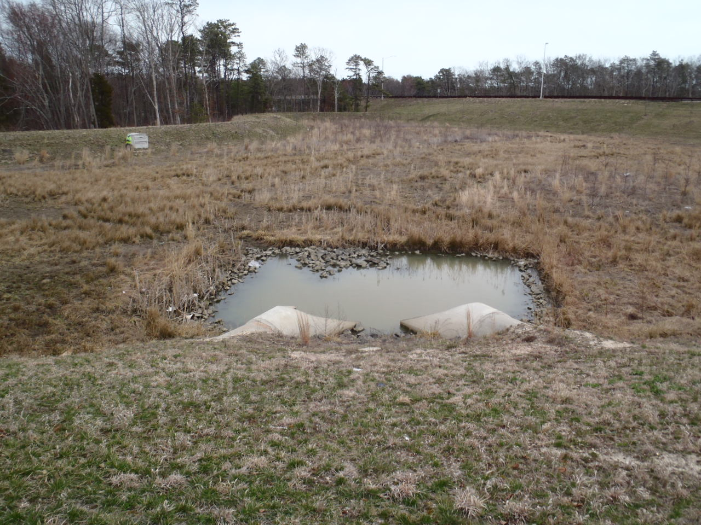
Courtesy of NJDOT

Issue:  Corrective Action:  Preventative Action: |  |  | The inlet is not properly drained, assuming it has not rained within 72 hours.  Clear and remove sediment. Check whether the water table is at or above the bottom of the forebay. Also check the permeability of the underlying soil, if necessary.  Routine inspections and removal of sediment from the forebay.
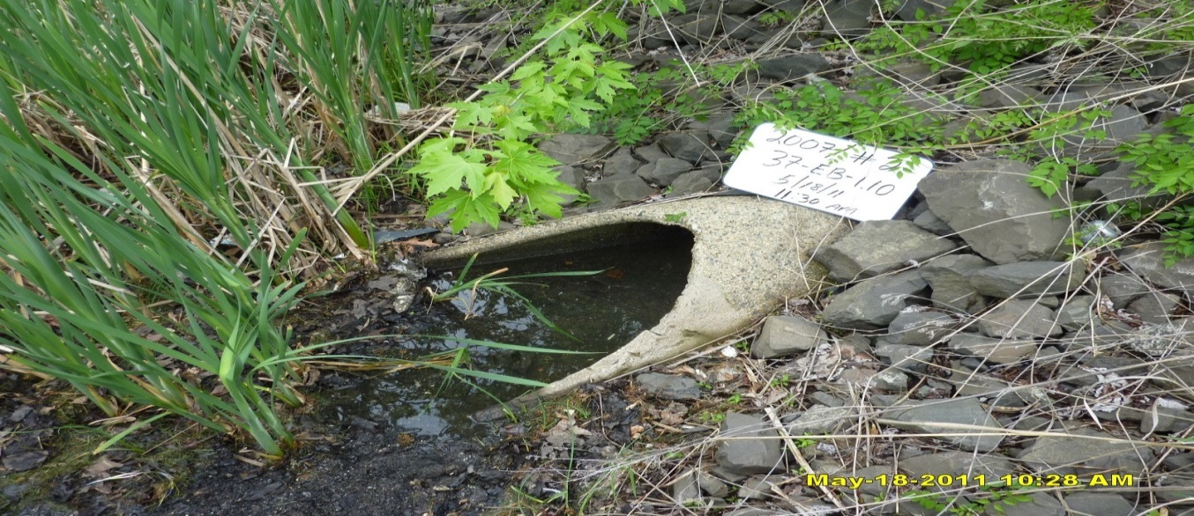
Courtesy of NJDOT
Issue:  Corrective Action:  Preventative Action: |  |  | The Inflow pipe is clogged by sediment and vegetation.  Clear and remove sediment and unwanted vegetation.  Routine inspection and removal of sediment and unwanted vegetation.
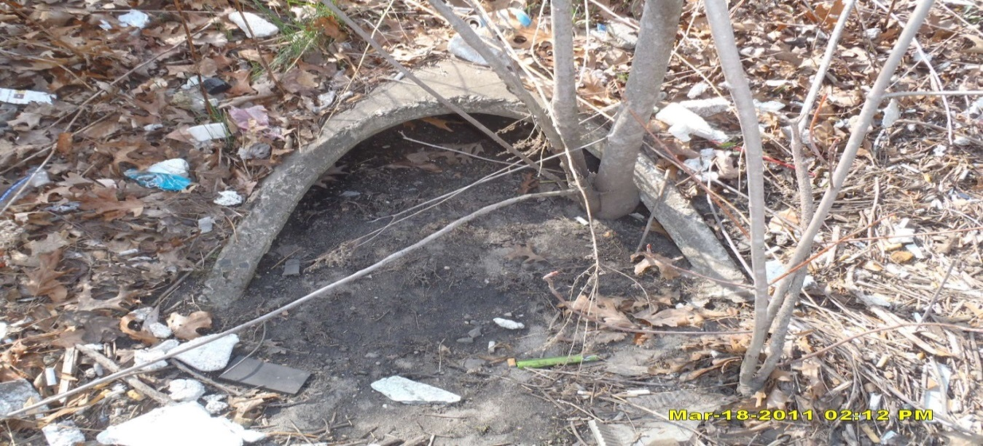
Courtesy of NJDOT

Issue:  Corrective Action:  Preventative Action: |  |  | The Inflow pipe is entirely clogged by sediment and trees.  Clear and remove sediment and trees.  Routine inspection & removal of sediment and unwanted vegetation.
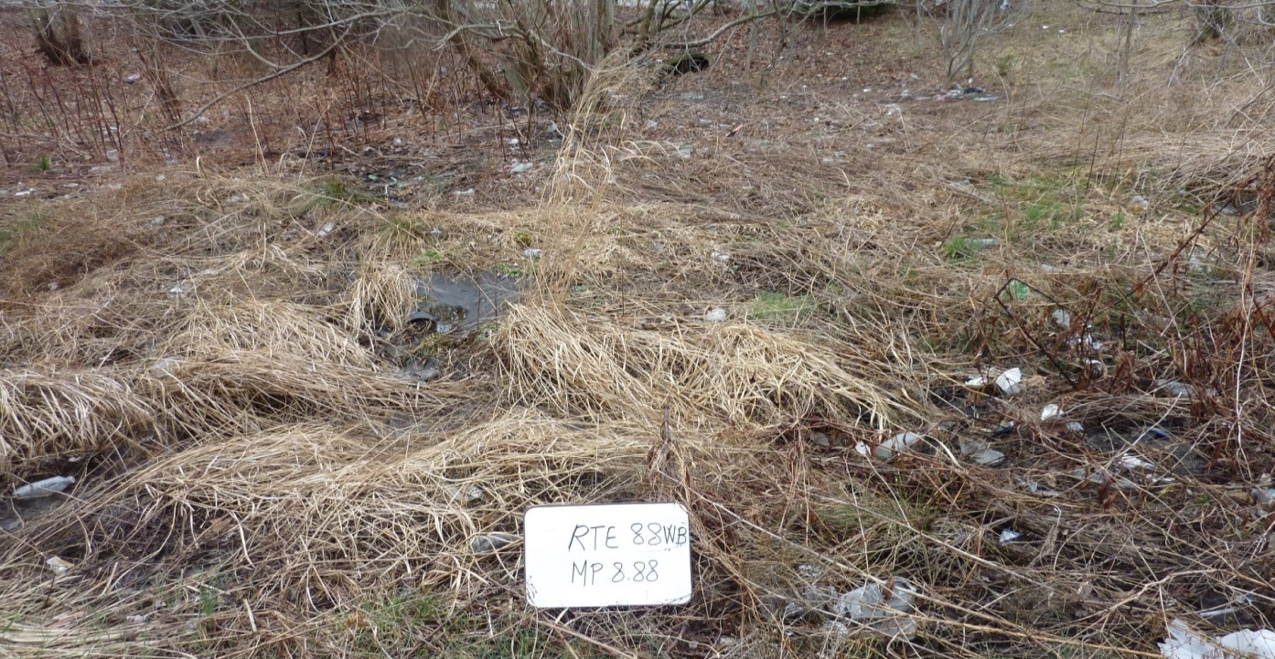
Courtesy of NJDOT

Issue:  Corrective Action:  Preventative Action: |  |  | The excessive sediment in inflow pipe (shown above) might be caused by a blockage of flow to the basin due to excessive vegetation and overgrown trees.  Clear and remove trees and vegetation. If necessary, re-grade the bottom slope to ensure the flow properly spreads over the basin bottom.  Routine inspection and removal of sediment and unwanted vegetation.
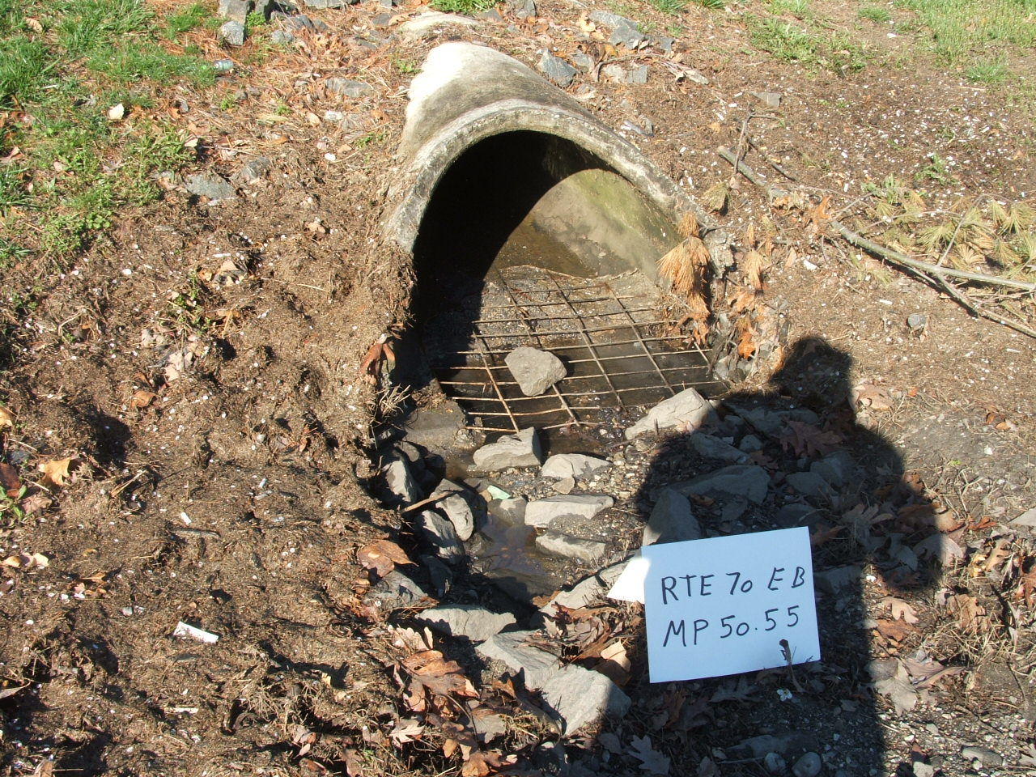
Courtesy of NJDOT
Issue:  Corrective Action:  Preventative Action: |  | Eroded inflow apron.  Repair apron.  Routine inspection and rehabilitation, if necessary.
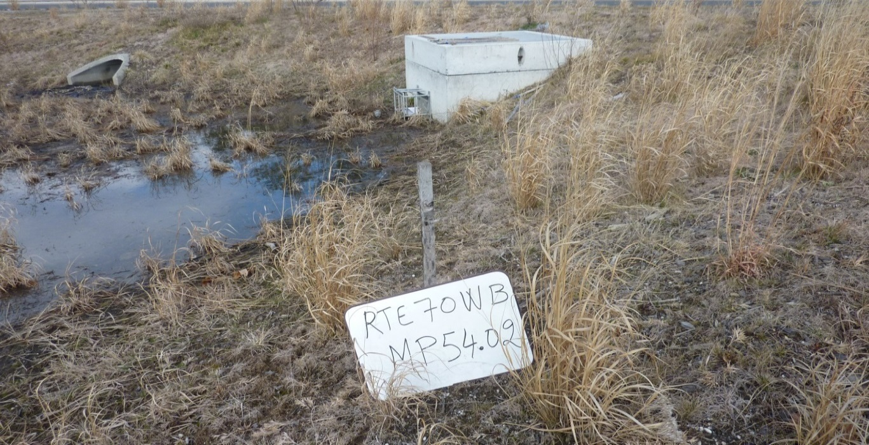
Courtesy of NJDOT

Issue:  Corrective Action:  Preventative Action: | The vegetation loss and the blackish soil may indicate frequent inundation.  Check the permeability rate of the soil and the water table elevation.  Replace the soil if necessary.  Routine inspection and tilling/aeration, if necessary.
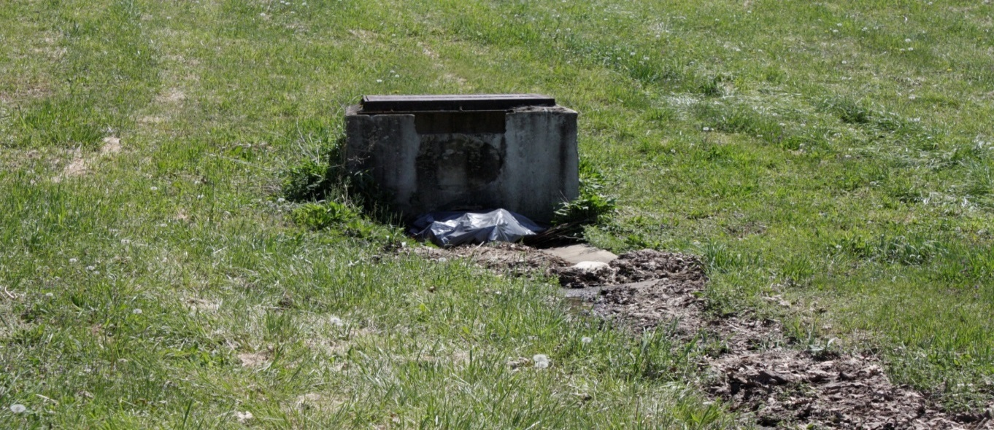
Issue:  Corrective Action:  Preventative Action: | The low flow channel has excessive accumulation of sediment and debris. The outflow orifice is clogged by a trash bag and debris. Note that there is no trash rack installed.  Check the permeability rate of the soil and the water table elevation.  Replace the soil if necessary.  Routine inspection and cleaning.
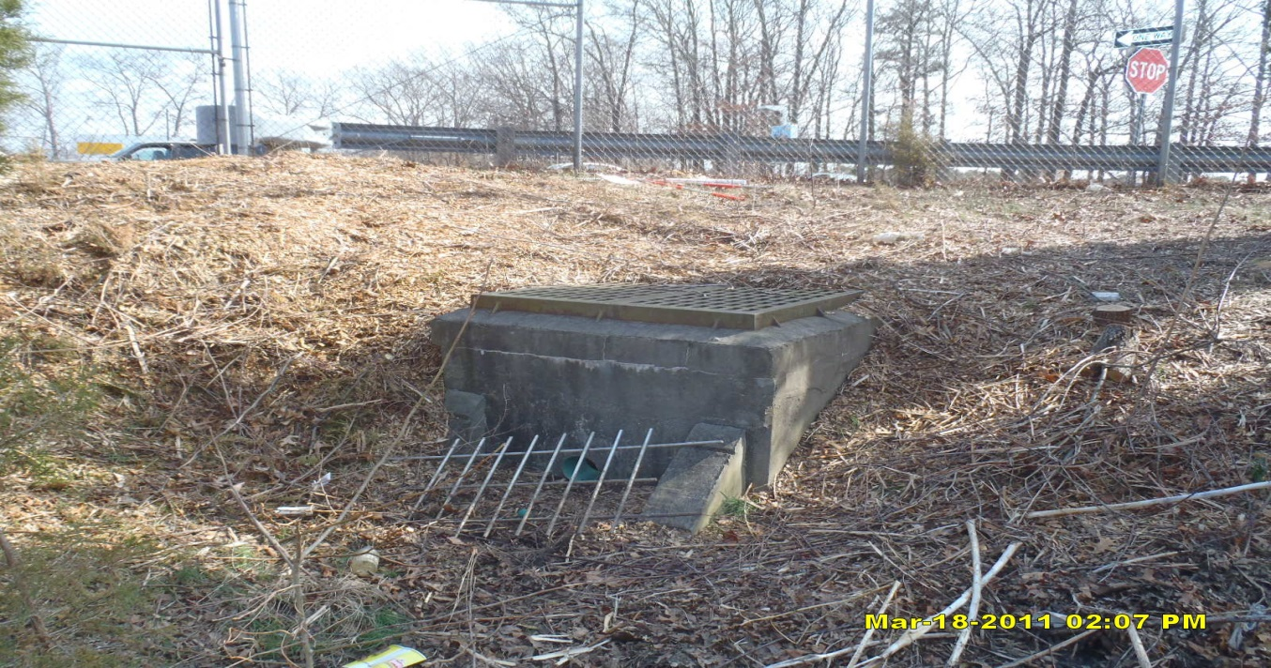
Courtesy of NJDOT

Issue:  Corrective Action:  Preventative Action: | Trash rack is damaged.  Repair the trash rack.  Routine inspection, especially after large storm events. Tighten any loose bolts and repair structural flaws.
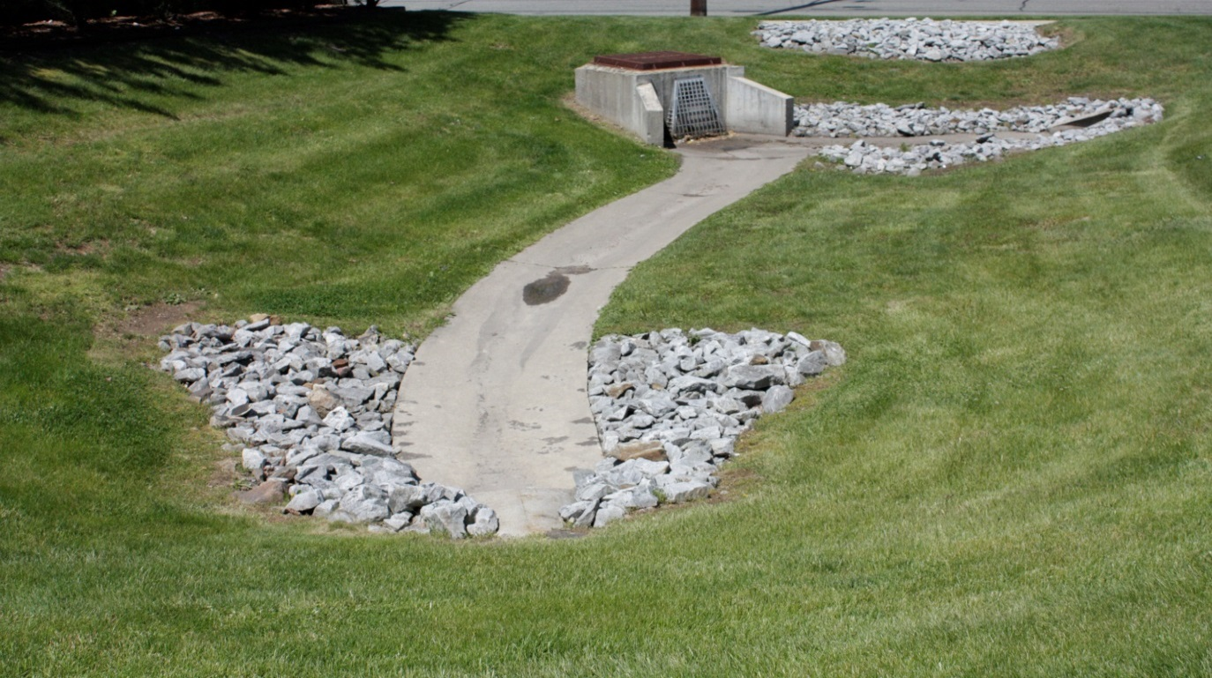
A well maintained detention basin

Reference Documents

Documents to be placed in this field manual should include the following:

- As-built Drawings with Drainage Plans
- Soil Boring Logs
- Permeability Test (Pre-construction)
- Permeability Test (Post-construction)
- Landscaping Plan
- Groundwater Mounding Analysis

Attach Reference Documents Here

Inspection Checklist / Maintenance Actions
Surface Infiltration – Extended Detention Basin

Checklist (circle one): Quarterly / Annual / Monthly / Special Event Inspection

Checklist No. ______________ Inspection Date: _______________

Date of most recent rain event: __________

Rain Condition (circle one):
Drizzle / Shower / Downpour / Other _____________

Ground Condition (circle one):
Dry / Moist / Ponding / Submerged / Snow accumulation

The following inspection items and preventative/corrective maintenance actions listed below represent general requirements. The design engineer and/or responsible party shall adjust the items and actions to better meet the conditions of the site, the specific design targets, and the requirements of regulatory authorities.
 | For Inspector |  |  | For Maintenance Crew
Component No. Component Name | Inspection Item and Inspection Item No. |  | Result | Preventative / Corrective Maintenance Actions
A1  Pretreatment  (Forebay) | 1 | Scouring or erosion is present at inlet structure and/or riprap apron | Y__  N__ | Check the flow diversion device before the inlet pipe and whether the bypass flow channel is clogged  Work Order # __________
 | 2 | Clogged pipes or excessive sediment in the forebay | Y__  N__ | Remove sediment or debris
 | 3 | Damaged outlet structure (e.g.,  cracking, subsidence, spalling, erosion, or deterioration) | Y__  N__ | Repair or replace the outlet structure  Work Order # __________
A2  Pretreatment  (MTD,  if installed) | 1 | MTD inspection | Y__  N__ | (If a MTD is used for pretreatment, see manufacturer’s maintenance manual)
A3  Pretreatment  (Structural BMP) | 1 | BMP inspection | Y__  N__ | (See BMP No. ________ Field Manual)
Note:
B  Infiltration Bed | 1 | Standing water is present after the design drain time  The observed drain time is approximately _________ hours | Y__  N__ | Recheck to determine if there is standing water after 72 hours. If standing water is present longer than 5 days, report to mosquito commission.  Remove any sediment buildup  Replace the sand layer (if sand layer is installed; volume of replacement sand is specified in the Basin Configuration Targets in the Basic Design Information Section of this Manual)  Work Order # ______________
 | 2 | Excessive sediment, silt, or trash accumulation on basin bed | Y__  N__ | Clean pretreatment system Remove silt, sediment, and trash  Work Order # __________
 | 3 | Erosion or channelization is present | Y__  N__ | Check whether the flow bypass or diversion device is clogged  Re-grade the infiltration bed  Work Order # ______________
 | 4 | Animal burrows/rodents are present | Y__  N__ | Pest control  Work Order # __________
 | 5 | Uneven bed | Y__  N__ | Use light equipment to resurface the bed  Work Order # _________
 | 6 | Evidence of sinkholes or subsidence | Y__  N__ | Monitor for sinkhole development
Note:
C  Vegetation | 1 | Large spot(s) showing bare soil | Y__  N__ | Vegetative cover must be maintained at 85%. Revegetate if 50% or more vegetation has been lost  Work Order # __________
 | 2 | Overgrown vegetation | Y__  N__ | Mow/trim the vegetation  Work Order # _______
 | 3 | Tree growth in the basin | Y__  N__ | Clear, trim, or prune the trees according to the original Landscaping Plan  Inspect to determine if the tree roots caused any structural damage  Work Order # __________
Note:
D Basin Embankment and Side Slopes | 1 | Signs of erosion, soil slide or bulges, seeps and wet spots, loss of vegetation, or erosion on the basin slope | Y__  N__ | Check for excessive overland runoff flow through the embankment.  Check for any sink hole development  Direct the overland runoff to the forebay or pretreatment area  Restabilize the bank  Work Order # __________
E  Outlet | 1 | Trash or debris accumulation more than 20% | Y__  N__ | Clean and remove  Determine source of trash and address to reduce future maintenance costs or basin failure
 | 2 | Trash rack is damaged or rusted greater than 50%  Trash rack is loose or missing parts | Y__  N__ | Repair or replace trash rack  Work Order #__________
 | 3 | Outlet components (e.g., orifice plates or weir plate) skewed, misaligned, or missing | Y__  N__ | Repair or replace component  Work Order #__________
 | 4 | Discharge pipe apron is eroded or scoured | Y__  N__ | Restabilize the discharge riprap apron  Work Order #__________
 | 5 | Standing water is present in the outlet structure longer than 72 hours | Y__  N__ | Pump out the standing water  Work Order # __________
Note:
F  Emergency  Spillway | 1 | Trees or excessive vegetation present | Y__  N__ | Remove trees and roots, and restore berms if necessary  Work Order #________
 | 2 | Damaged structure | Y__  N__ | Repair  Work Order #________
G  Miscellaneous | 1 | Fence: broken or eroded parts | Y__  N__ | Repair or replace  Work Order #__________
 | 2 | Gate: missing gate or lock | Y__  N__ | Repair or replace  Work Order #__________
 | 3 | Sign/plate: tiled, missing, or faded | Y__  N__ | Repair or replace  Work Order #__________
 | 4 | Excessive or overgrown vegetation blocking access to the basin | Y__  N__ | Clear, trim, or prune the vegetation to allow access for inspection and maintenance  Work Order #________
Note:

Follow Up Items (Component No. / Inspection Item No.):
(e.g., B/1, C/2)

Associated Work Orders: # ______, # ______, # ______, # ______, # _____

________________________ ______________________ ________________
Inspector Name Signature Date

Report issues to the local authority and mosquito commission as required by local ordinances and regulatory authorities.

File this checklist in the Maintenance Log after performing maintenance.

Preventative Maintenance Record

Corresponding Checklist No. ________
Component No._______, Inspection Item No.________

Work Logs
Activities | Components | Date Completed
Sediment/debris removal  Sediment removal should take place when the basin is thoroughly dry. | A1/A2/A3 – Pretreatment
 | B – Infiltration Bed
 | D – Basin Embankment and Side Slopes
 | E – Outlet
Vegetation removal | A1/A2/A3 – Pretreatment
 | B – Infiltration Bed
 | D – Basin Embankment and Side Slopes
 | E – Outlet
 | F – Emergency Spillway
(List additional tasks, if applicable)
Vegetation is removed by _____________ (type of equipment) with minimum disruption to the remaining vegetation.

All use of fertilizers, pesticides, mechanical treatments, and other means to ensure optimum vegetation health must not compromise the intended purpose of the stormwater management measure. The fertilizer applied is ____________ (type), and _________ (quantity per usage) is applied _____________ (frequency of use).

Debris, sediment, and trash are handled (onsite / by ____________ (contractor name) to disposal site _________________). (See Part I: Maintenance Plan – Disposal Plan Section)

If a sand layer is installed, replacement of the sand will occur according to the scheduled frequency (see Basin Configuration Targets above). The next scheduled replacement is _____________ (date).

Crew member:___________________/_________________ Date: _____________
(name/ signature)

Supervisor:_____________________/__________________ Date: _____________
(name/ signature)
File this Preventative Maintenance Record in the Maintenance Log after performing maintenance.

Corrective Maintenance Record

- Work Order # ______________________ Date Issued _____________

- Issue to be resolved:
(e.g., orifice plate is loose and bent)

- The issue was from Corresponding Checklist No. ________, Component No. (e.g., E – Outlet), Inspection Item No. (e.g., 2, 3) .

- Required Actions
Actions | Planned Date | Date Completed
New bolts to fix the orifice plate
Repair/replace the trash rack
Restabilize side slope (indicate location)
Repair riprap apron with 100 cubic yards of aggregate
Revegetate
(List additional tasks, if applicable)

- Responsible person(s):
_____________________________________________________________

- Special requirements
  - Time of the season or weather condition:_________________________
  - Tools/equipment:____________________________________________
  - Subcontractor (name or specific type):___________________________
Approved by ___________________/_______________ Date _____________
(name/signature)

Verification of completion by ____________/________ Date _____________
(name/signature)

File this Corrective Maintenance Record in the Maintenance Log after performing maintenance.

