Grass Swale
Measure #___ on the Location Map

Development Name: ___________________________

Township, County: ___________________________

Location of Grass Swale: X: ______; Y: ______ (or N: ______; E :_____)

Location Description: e.g., Northwest corner of the development, near County RT 531

Location Map
N
E

County Route 531

Grass Swale #1

Discharge

Basin #1
Drywell #1

Corporation Road
Building
Parking
Lot

Vegetative Filter strip #1

Drywell #2

Access
Grass Swale #2

Example Map: Use aerial photo, site plan, or other graphics showing the locations of BMPs

NOTE

This Field Manual is intended to be editable and adjustable in accordance with the design of stormwater management measures, the site conditions, and the special needs of responsible party. The Engineer should supplement information and best management practice to assist the responsible party to perform maintenance.

Blue text indicates information may be deleted and or replaced as necessary.

Table of Contents

Grass Swale Overview 4
Basic Design Information 5
Visual Aid for Vegetative Filter Strip/Grass Swale Maintenance 6
Reference Documents 10
Inspection Checklist / Maintenance Actions 12
Preventative Maintenance Record 16
Corrective Maintenance Record 17

Grass Swale Overview

Functionality
A grass swale is a stable, parabolic or trapezoidal channel that is lined with turf; it is used to improve water quality and convey stormwater runoff. Grass swales do not rely on the permeability of the underlying soil for pollutant removal; instead, pollutants are removed by settling and filtration through the grass. The maximum total suspended solids (TSS) removal rate is 50%.

Low velocities and shallow depths of runoff generated from the Water Quality Design Storm allow for particulate settling; while at the same time, the blades of grass in the swale filter the suspended solids. Because these pollutant removal mechanisms do not rely on infiltration into the subsoil, soil permeability is not a design consideration. For larger storm events, the swale can be designed to convey stormwater downstream.

Proper care and attention in the long-term maintenance of the stormwater management measure is critically important to the safety and health of the public.

Type of BMP – Dry Stormwater Management Measure
A grass swale is a type of dry stormwater management measure. Dry stormwater management measures must fully drain within 72 hours of the most recent rainfall. Standing water in excess of 72 hours is a sign of failure. It may also contribute to mosquito breeding and other health and safety issues. The design drain time shall be closely monitored to ensure that potential failure is recognized early. For the design drain time, please see Hydrology Design Targets in the Basic Design Information section.

Basic Design Information
This section shall be filled out by the design engineer.

Hydrology Design Targets
- The maximum design storm is (Water Quality Design Storm / 2 year storm / 10 year storm / 100 year storm), which corresponds to _______ inches of rain in _____ hours.
- The design drain time is __________ hours.
- The design total suspended solids removal rate is ________ %.
- The elevation of the seasonal high water table of this grass swale was observed on
(MM) / (DD) / (YYYY) and it was _________ feet below the swale bottom, at EL._______ feet.

Hydraulic Design Targets
- The maximum design velocity in the grass swale is ________ feet per second.
- The outlet structure is (orifice / pipe / grate / overland / other). The invert elevation of the outlet is __________ feet (if applicable).

Configuration Targets
- The longitude slope of the grass swale is _____________ %.
- The side slope is : .
- The length of the grass swale is ___________ feet.
- The swale shape is (trapezoidal / parabolic), with a bottom width of ____ feet.
- The grass height must be established and maintained between ____ and ____ inches.

Critical Maintenance Features
- Grass clippings shall be collected and properly disposed.
- Check any eroded or channelized area, repair it immediately. Find the cause of erosion or channelization and find solution to prevent it.
- Remove dead vegetation to keep grass swale aesthetic.
- (Others to be added by the design engineer, if necessary)

Attach the following Disturbance Notices, if applicable to the site:

Wetland Disturbance Notice: Maintenance of this BMP may disturb a wetland area. Contact NJDEP Division of Land Use Regulation for guidance and any required permit(s) before performing maintenance.

Wildlife Disturbance Notice:
Maintenance of this BMP may disturb or remove vegetation in an area designated to endangered and/or threatened species. Contact NJDEP Division of Fishing and Wildlife for guidance and any required permit(s) before performing maintenance.

Visual Aid for Vegetative Filter Strip/Grass Swale Maintenance
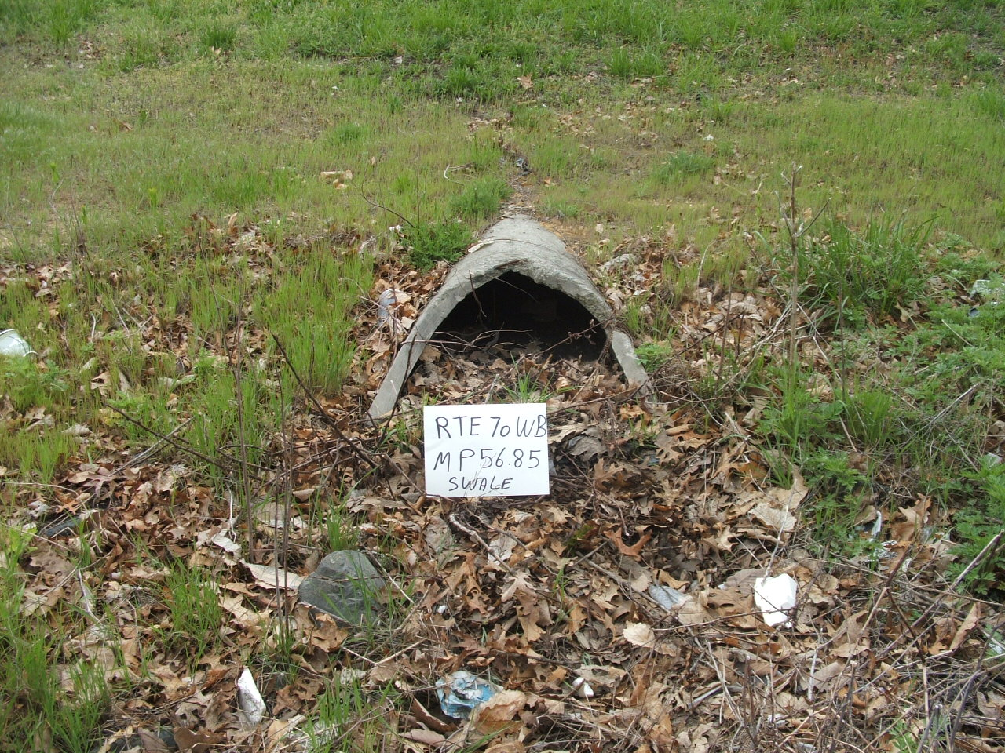
Courtesy of NJDOT
Issue:  Corrective Action:  Preventative Action: |  | The inlet to the swale is clogged by sediment and leaves.  Clear and remove sediment and leaves.  Preventative Action: Routine inspection and removal of sediment and debris.
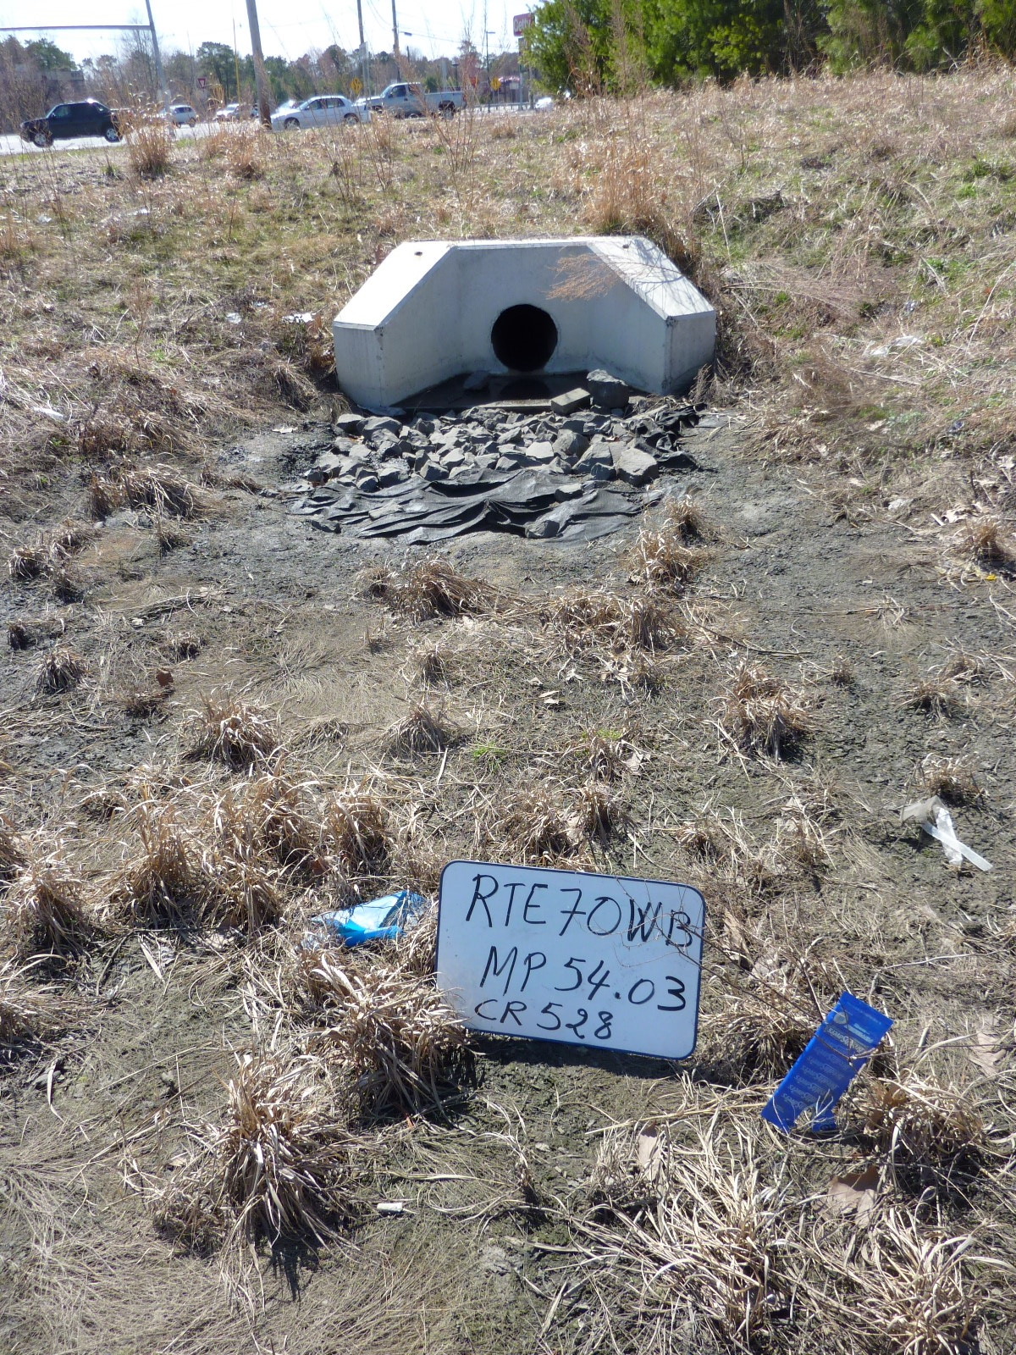
Courtesy of NJDOT

Issue:  Corrective Action:  Preventative Action: |  |  | The sediment and loss of vegetation indicates that the swale is not well drained.  Re-grade the swale to ensure proper drainage. A steeper slope may be required but must ensure that all criteria are met for the required TSS removal rate (see the Basic Design Information section). Revegetate the grass swale.  Routine inspection and monitoring of the drain time.
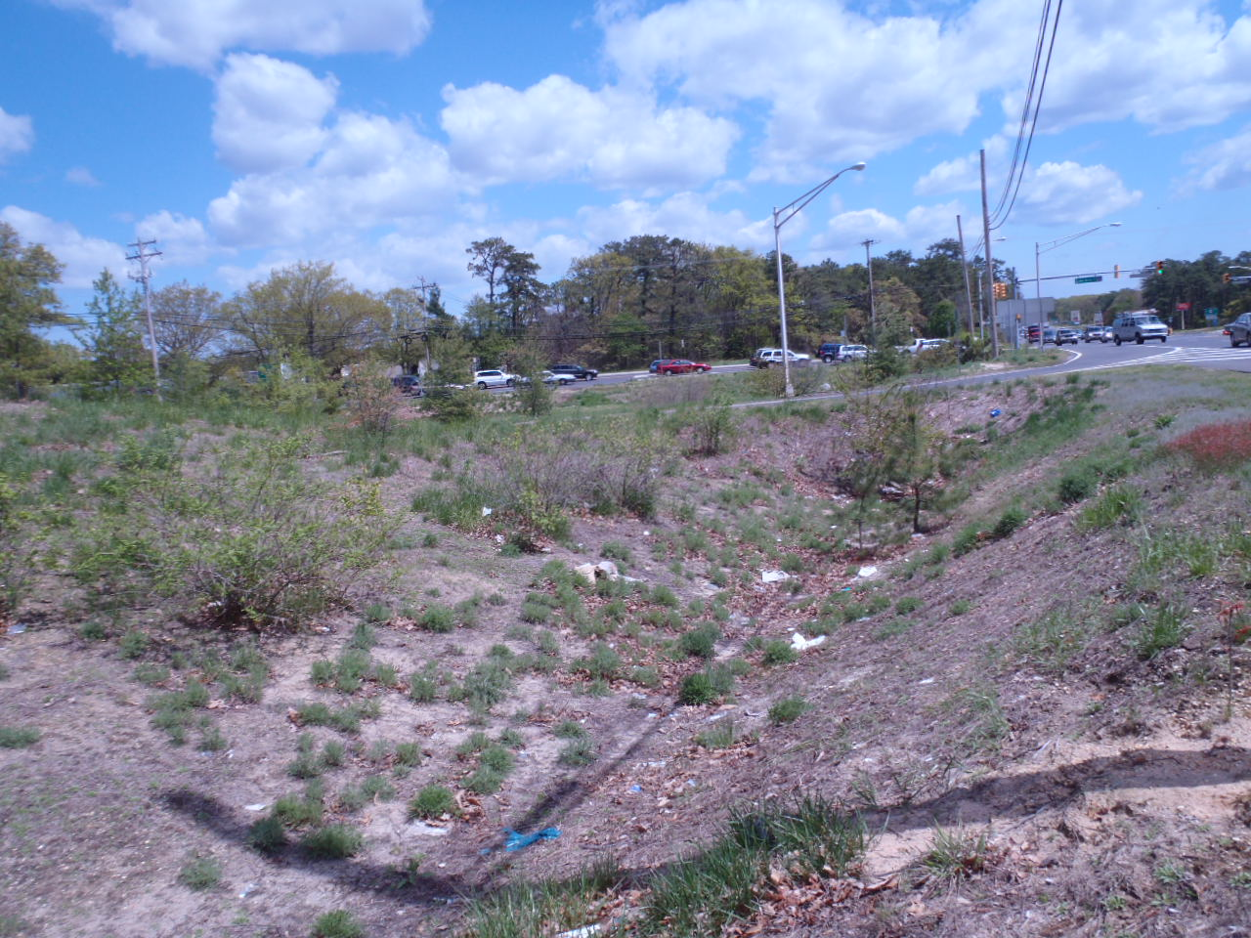
Courtesy of NJDOT
Issue:  Corrective Action:  Preventative Action: | The loss of vegetation on the side slope and bottom likely indicate an erosion problem.  Re-grade the side slope of the swale to prevent erosion and revegetate the swale.  Routine inspection and reseeding the soil before the erosion becomes severe.
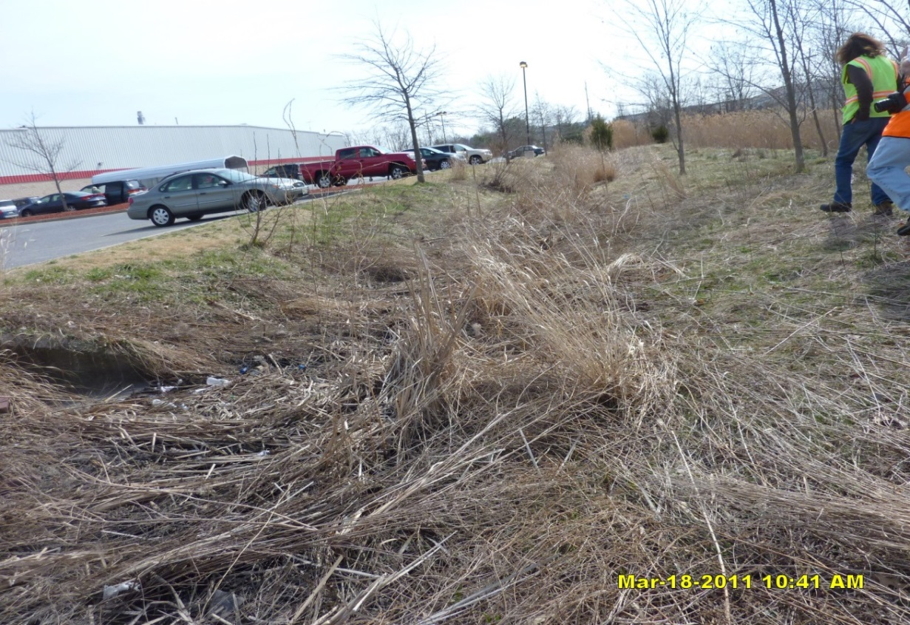
Courtesy of NJDOT
Issue:  Corrective Action:  Preventative Action: | Overgrown and dead vegetation in swale.  Remove dead and unwanted vegetation.  Routine inspection and mowing of the swale.
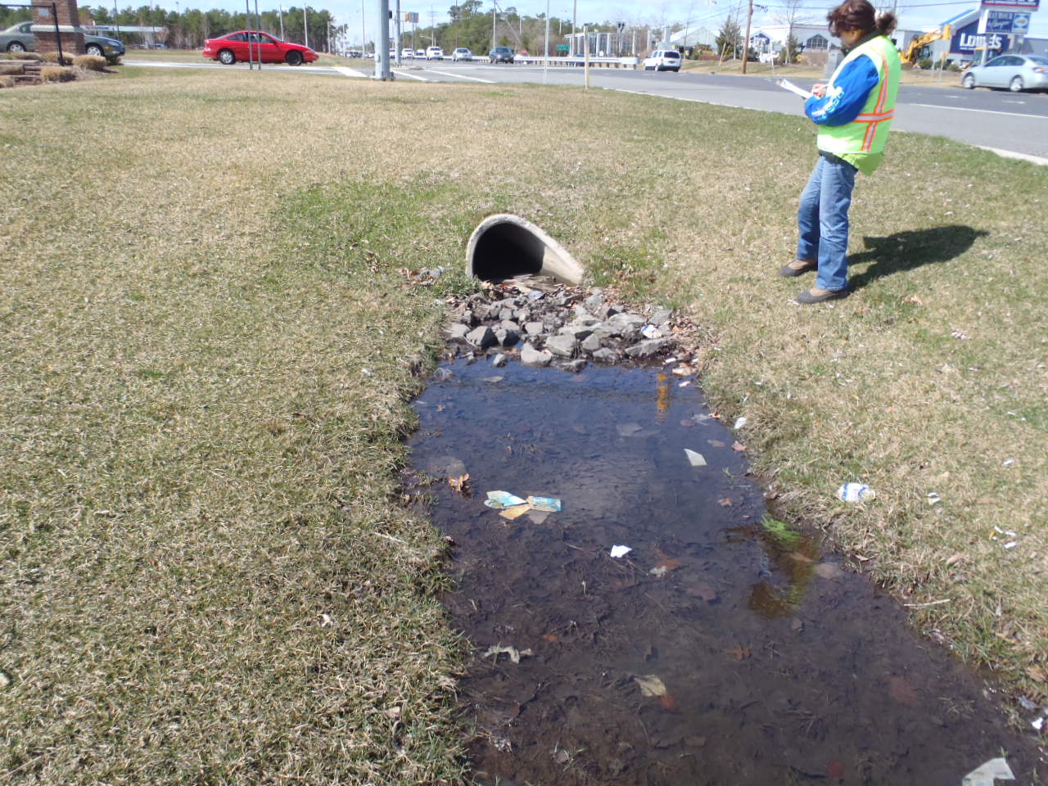
Courtesy of NJDOT
Issue:  Corrective Action:  Preventative Action: | Ponding in swale. Vegetation loss due to long term inundation.  Clear the outlet structure, clear the sediment in the outlet, and re-grade the swale to allow for better drainage.  Routine inspection and cleaning.
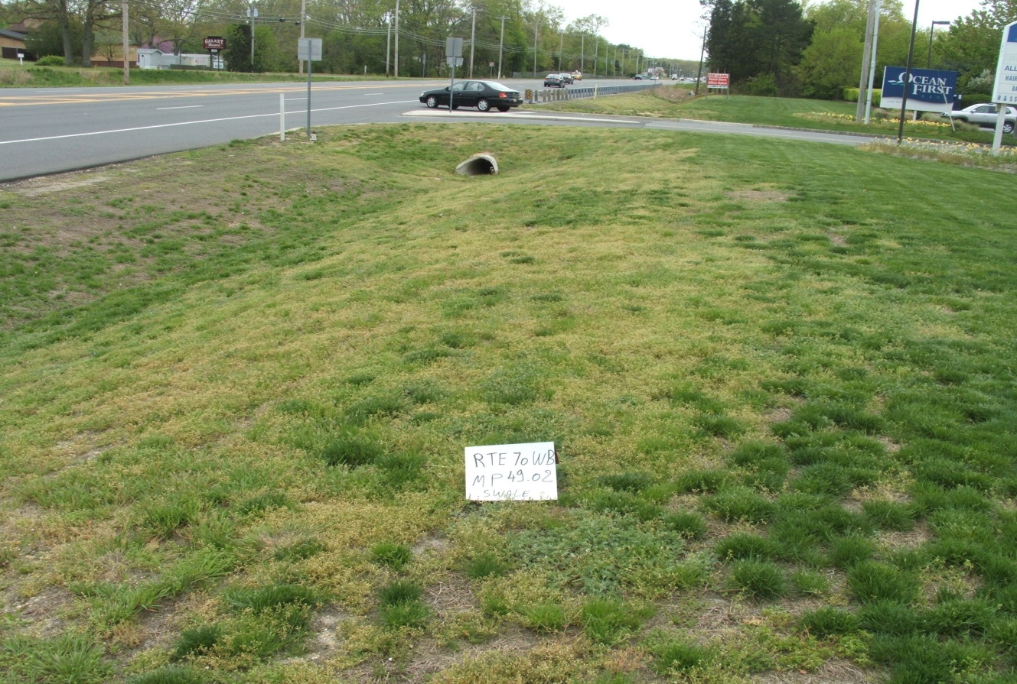
Courtesy of NJDOT
Issue:  Corrective Action:  Preventative Action: | The left slope of the swale is eroded by runoff from the roadside.  Re-grade the slope or provide energy dissipation to reduce the flow velocity and alleviate the erosion. Revegetate the slope.  Routine inspection and reseeding of bare soil.

Reference Documents

Documents to be placed in this field manual should include the following:

- As-built Drawings with Drainage Plans
- Soil Boring Logs
- Landscaping Plan

Attach Reference Documents Here

Inspection Checklist / Maintenance Actions
Grass Swale

Checklist (circle one): Quarterly / Annual / Monthly / Special Event Inspection

Checklist No. ______________ Inspection Date: _______________

Date of most recent rain event: __________

Rain Condition (circle one):
Drizzle / Shower / Downpour / Other _____________

Ground Condition (circle one):
Dry / Moist / Ponding / Submerged / Snow accumulation

The inspection items and preventative/corrective maintenance actions listed below represent general requirements. The design engineer and/or responsible party shall adjust the items and actions to better meet the conditions of the site, the specific design targets, and the requirements of regulatory authorities.
 | For Inspector |  |  | For Maintenance Crew
Component No. Component Name | Inspection Item and Inspection Item No. |  | Result | Preventative / Corrective Maintenance Actions
A  Grass Swale Area | 1 | Standing water is present after the design drain time  The observed drain time is approximately _________ hours. | Y__  N__ | Remove excessive sediment and debris  Check whether the outlet is clogged (if applicable)  Re-grade the slope to allow the swale to drain within the design drain time. Revegetate if necessary  If standing water is present longer than 5 days, report to mosquito commission.  Work Order #_______________
 | 2 | Excessive sediment, silt, or trash accumulation in swale | Y__  N__ | Remove sediment, silt, and trash
 | 3 | Erosion or channelization is present | Y__  N__ | Check whether the flow is concentrated. If so, re-grade the swale to ensure smoother flow.  Work Order #________
 | 4 | Animal burrows/rodents are present | Y__  N__ | Pest control  Work Order # __________
 | 5 | Sediment and/or debris on the edge between the contributing drainage area and the grass swale | Y__  N__ | Remove sediment and debris
Note:

B  Vegetation | 1 | Large spot(s) showing bare soil | Y__  N__ | Vegetative cover must be maintained at 85%. Revegetate the entire swale if 50% or more vegetation has been lost.  Check Landscaping plan for guidance (if available)  Work Order # __________
 | 2 | Excessive tree canopy shading the vegetated area inhibiting the growth of vegetation | Y__  N__ | Prune and trim the trees
 | 3 | Grass is overgrown and taller than the design height (________ inches) | Y__  N__ | Mow the grass to the design height
 | 4 | Grass clippings are not collected and removed | Y__  N__ | Remove the grass clippings
Note:
C  Outlet | 1 | Trash or debris accumulation more than 20% | Y__  N__ | Clean and remove  Determine source of trash and address to reduce future maintenance costs or BMP failure
 | 2 | Trash rack is damaged or rusted greater than 50%  Trash rack is bent, loose, or missing parts | Y__  N__ | Repair or replace trash rack  Work Order #__________
 | 3 | Outlet components (e.g., orifice plates or weir plate) skewed, misaligned, or missing | Y__  N__ | Repair or replace component  Work Order #__________
 | 4 | Discharge pipe apron is eroded or scoured | Y__  N__ | Restabilize the discharge riprap apron  Work Order #__________
 | 5 | Standing water is present in the outlet structure longer than 72 hours | Y__  N__ | Clean out the standing water  Work Order # __________
Note:
Follow Up Items: (Component No. / Checklist No.):
(e.g., B/1, C/2)

Associated Work Orders: # ______, # ______, # ______, # ______, # _____

________________________ ______________________ ________________
Inspector Name Signature Date

Report issues to the local authority and mosquito commission as required by local ordinances and regulatory authorities.

File this checklist in the Maintenance Log after performing maintenance.

Preventative Maintenance Record

Corresponding Checklist No. ________
Component No._______, Inspection Item No.________

Work Logs
Activities | Components | Date Completed
Sediment/debris removal  Sediment removal should take place when the ground is thoroughly dry. | A - Grass Swale Area
 | C – Outlet
Vegetation removal | B – Vegetation
(List additional tasks, if applicable)

Vegetation is removed by _____________ (type of equipment) with minimum disruption to the remaining vegetation.

All use of fertilizers, pesticides, mechanical treatments, and other means to ensure optimum vegetation health must not compromise the intended purpose of the stormwater management measure. The fertilizer applied is ____________ (type), and _________ (quantity per usage) is applied _____________ (frequency of use).

Debris, sediment, and trash are handled (onsite / by ____________ (contractor name) to disposal site _________________). (See Part I: Maintenance Plan – Disposal Plan Section)

Crew member:___________________/_________________ Date: _____________
(name/ signature)

Supervisor:_____________________/__________________ Date: _____________
(name/ signature)

File this Preventative Maintenance Record in the Maintenance Log after performing maintenance.

Corrective Maintenance Record

- Work Order # ______________________ Date Issued _____________

- Issue to be resolved:
(e.g., orifice plate is loose and bent)

- The issue was from Corresponding Checklist No. ________, Component No. (e.g., C – Outlet), Inspection Item No. (e.g., 2, 3) .

- Required Actions
Actions | Planned Date | Date Completed
Revegetation
Re-grading
(If there are additional tasks, list them here.)

- Responsible person(s):
_______________________________________________________________

- Special requirements
  - Time of the season or weather condition:_________________________
  - Tools/equipment:____________________________________________
  - Subcontractor (name or specific type):___________________________
Approved by ___________________/_______________ Date _____________
(name/signature)

Verification of completion by ____________/________ Date _____________
(name/signature)

File this Corrective Maintenance Record in the Maintenance Log after performing maintenance.

