Subsurface Gravel Wetland
Basin #___ on the Location Map

Development Name: ___________________________

Township, County: ___________________________

Location of Basin: X: ______; Y: ______ (or N: ______; E :_____)

Location Description: e.g., Northwest corner of the development, near County RT 531

Location Map
N
E

County Route 531

Discharge
Grass Swale #1

Basin #1
Drywell #1

Corporation Road
Building
Parking
Lot

Vegetative Filter strip #1

Drywell #2

Access
Grass Swale #2

Example Map: Use aerial photo, site plan, or other graphics showing the locations of BMPs.

Note:

This Field Manual is intended to be editable and adjustable in accordance with the stormwater management design, the site conditions, and the special needs of the responsible party. The design engineer should supplement information and best management practices to assist the responsible party to perform maintenance.

Blue text indicates information may be deleted and or replaced as necessary.

Table of Contents

Subsurface Gravel Wetland Overview 4
Basic Design Information 5
Visual Aid for Dry Type Stormwater Basin Inspection 7
Reference Documents 13
Inspection Checklist / Maintenance Actions 15
Preventative Maintenance Record 22
Corrective Maintenance Record 23

Subsurface Gravel Wetland Overview

Functionality
A subsurface gravel wetland is a stormwater management system designed to maximize the removal of pollutants from stormwater; the system is a combination of a surface marsh and a subsurface gravel bed. Pollutants are treated through settling, both uptake and filtration by vegetation, and chemical transformation in the subsurface bed, specifically denitrification. Both the total suspended solids (TSS) removal rate and the nitrogen removal rate are 90%.

Proper care and attention in the long-term maintenance of the stormwater management measure is critically important to the safety and health of the public.

Type of BMP – Dry Basin / Settlement of TSS and Nutrient Removal
A subsurface gravel wetland is a type of dry basin. Dry basins must fully drain within 72 hours of the most recent rainfall. Standing water in excess of 72 hours is a sign of basin failure. It may also contribute to mosquito breeding and other health and safety issues. However, because there is a thin layer of wetland soil with wetland vegetation, a wet or damp soil may be observed; however, standing water in excess of 72 hours must be covered with a physical barrier to prevent mosquito access. This subsurface gravel wetland is designed for settlement of TSS only and is not designed to infiltrate runoff.

Basic Design Information
This section shall be filled out by the design engineer.

Hydrology Design Targets
- This subsurface gravel wetland consists of (one / two) subsurface gravel cell(s).
- The design drain time of the surface wetland cell is _______ hours. If the wetland cell cannot drain within 72 hours, a physical barrier must be placed over the standing water to prevent mosquito access.
- This subsurface gravel wetland is designed with a liner constructed of (clay / geotextile / geosynthetic liner / other ___________) with a thickness of _______ inches.
- This basin will be discharged to (municipal stormwater sewer system/combined sewer system/stream (stream name).)

Hydraulic Design Targets
- This subsurface gravel wetland is designed is to treat the runoff from the Water Quality Design Storm of 1.25 inches of rain in 2 hours, which generates __________ cubic feet of runoff.
- The invert elevation of the outlet for the design storm is at EL. _________ feet (if applicable). The water surface elevation is at EL. __________ feet.
- The above-surface cross drain is designed with an invert elevation of EL.______ feet.
- The emergency spillway is at EL. ___________ feet (if applicable).

Basin Configuration Targets
- Pretreatment is provided by a (forebay with a depth of _________ feet / BMP Type: __________, BMP No.). A perforated riser (is / is not) used.
- The subsurface gravel wetland (is / is not) lined. The liner is constructed of (clay / geotextile / geosynthetic liner / other ___________). (If the basin is lined, the liner material and maintenance information should be attached in the Reference Documents section.)
- This subsurface gravel wetland (does / does not) intercept groundwater.
- The surface soil depth is ________ inches.
- Information regarding the vegetation in the surface wetland should be described in the Landscaping Plan.
- Dead vegetation shall be removed according to the instruction in the Landscaping Plan for the supplement of carbon source.
- A drain pipe is installed in the subsurface gravel cell(s) to empty the water in the gravel cell(s). The water from subsurface gravel cell(s) will be discharged to ____________. (A permit to discharge may be required when emptying the subsurface gravel cell(s). Contact NJDEP Division of Land Use Regulation before discharging.)

Critical Maintenance Features
- No heavy equipment on the basin surface.
- Check inspection ports for excessive sediment.
- Prune vegetation must follow the instructions in landscaping plan.
- Removal of dead vegetation shall follow the instructions in the Basin Configuration Targets.
- Surface portion is prone to mosquito breeding. Check local mosquito commission for guidance if mosquito problem persists.
- Native species when revegetating is preferred.
- (Others to be added by the design engineer, if necessary)

Attach the following Disturbance Notice, if applicable to the site:

Wetland Disturbance Notice:
Maintenance of this BMP may disturb a wetland area. Contact NJDEP Division of Land Use Regulation for guidance and any required permit(s) before performing maintenance.

Wildlife Disturbance Notice:
Maintenance of this BMP may disturb or remove vegetation in an area designated to endangered and/or threatened species. Contact NJDEP Division of Fishing and Wildlife for guidance and any required permit(s) before performing maintenance.

Visual Aid for Dry Type Stormwater Basin Inspection
(Note: Basins shown here include various types of dry basins, not limited to the category of basin in this field manual.)
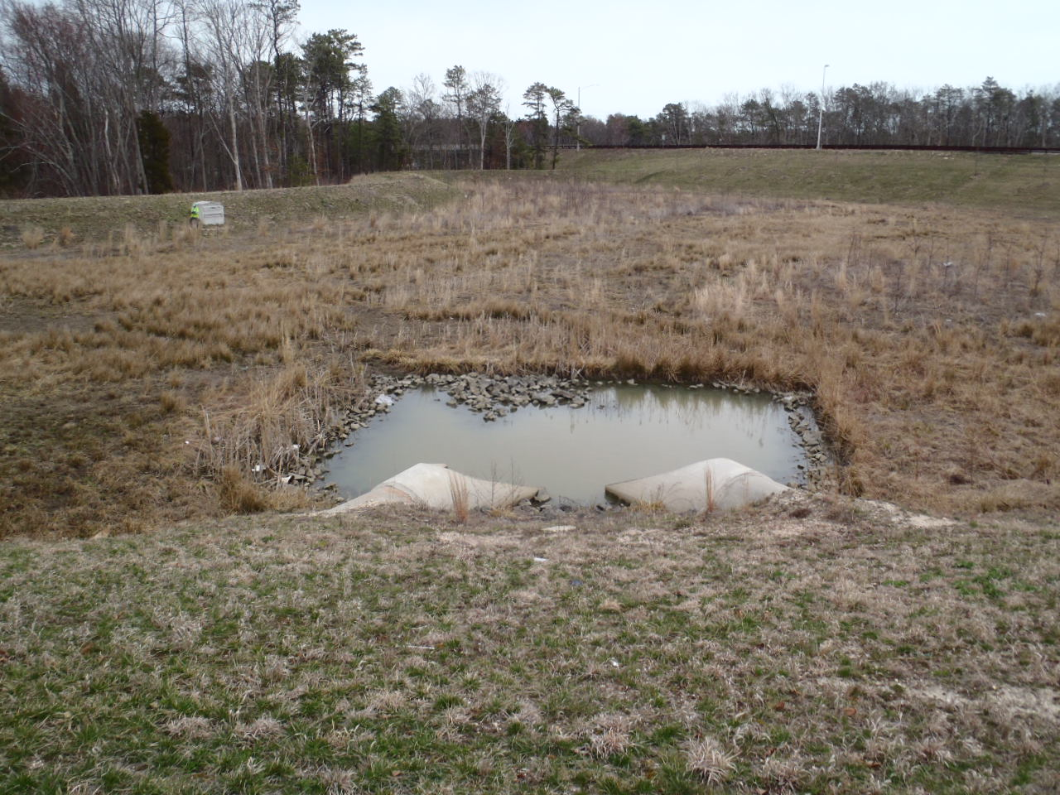
Courtesy of NJDOT

Issue:  Corrective Action:  Preventative Action: |  |  |  | The inlet is not properly drained, assuming it has not rained within 72 hours.  Clear and remove sediment. Check whether the water table is at or above the bottom of the forebay. Also check the permeability of the underlying soil, if necessary.  Routine inspections and removal of sediment from the forebay.
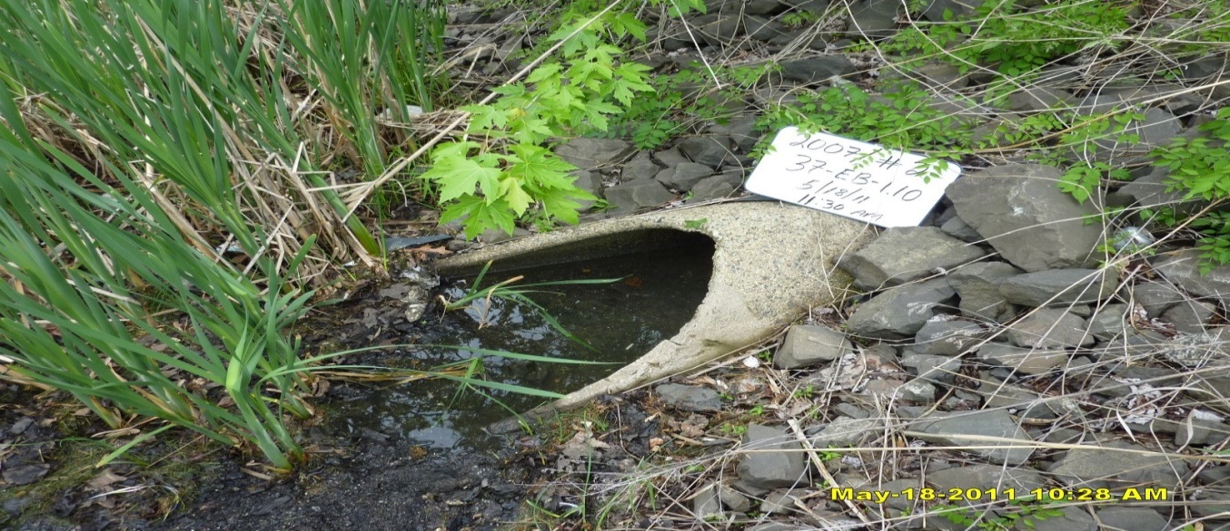
Courtesy of NJDOT
Issue:  Corrective Action:  Preventative Action: |  |  |  | The Inflow pipe is clogged by sediment and vegetation.  Clear and remove sediment and unwanted vegetation.  Routine inspection and removal of sediment and unwanted vegetation.
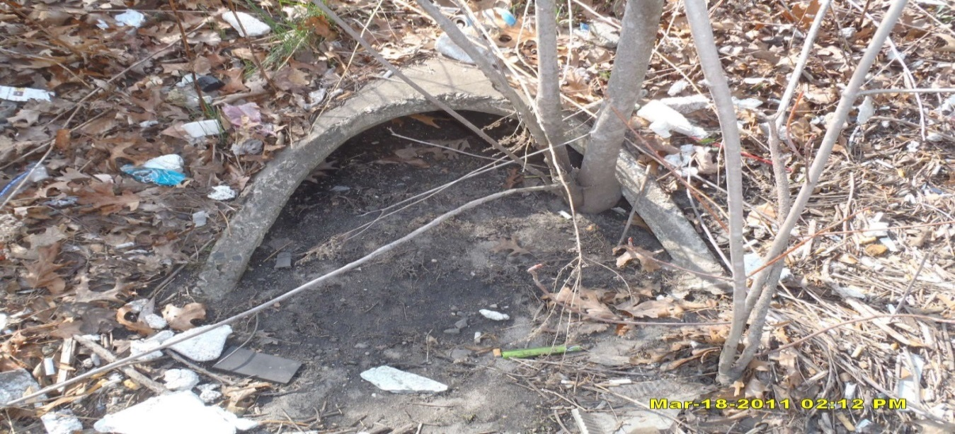
Courtesy of NJDOT

Issue:  Corrective Action:  Preventative Action: |  |  |  | The Inflow pipe is entirely clogged by sediment and trees.  Clear and remove sediment and trees.  Routine inspection & removal of sediment and unwanted vegetation.
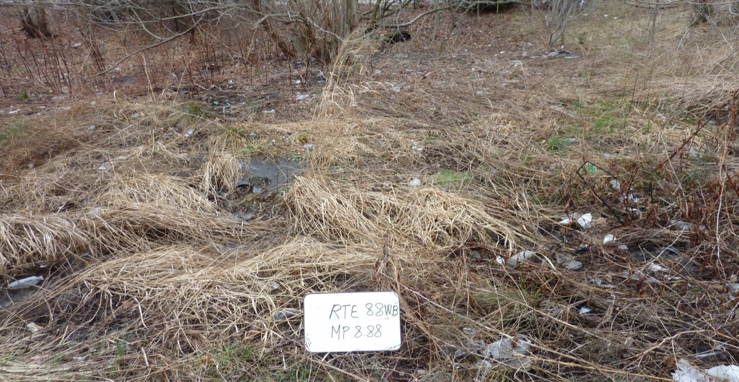
Courtesy of NJDOT

Issue:  Corrective Action:  Preventative Action: |  |  |  | The excessive sediment in inflow pipe (shown above) might be caused by a blockage of flow to the basin due to excessive vegetation and overgrown trees.  Clear and remove trees and vegetation. If necessary, re-grade the bottom slope to ensure the flow properly spreads over the basin bottom.  Routine inspection and removal of sediment and unwanted vegetation.
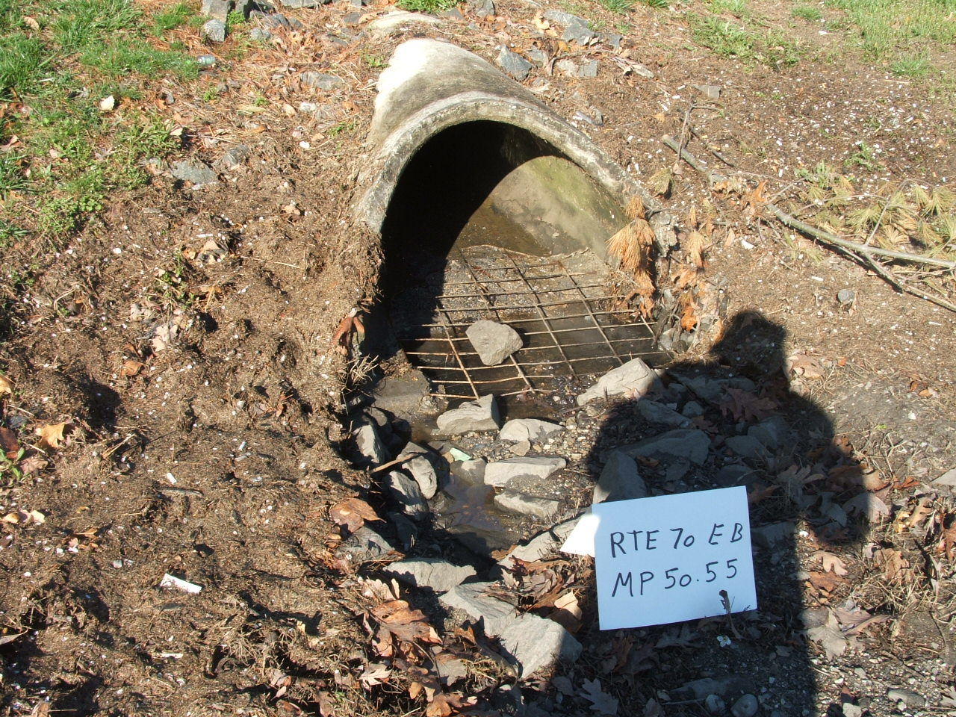
Courtesy of NJDOT
Issue:  Corrective Action:  Preventative Action: | Eroded inflow apron.  Repair apron.  Routine inspection and rehabilitation, if necessary.
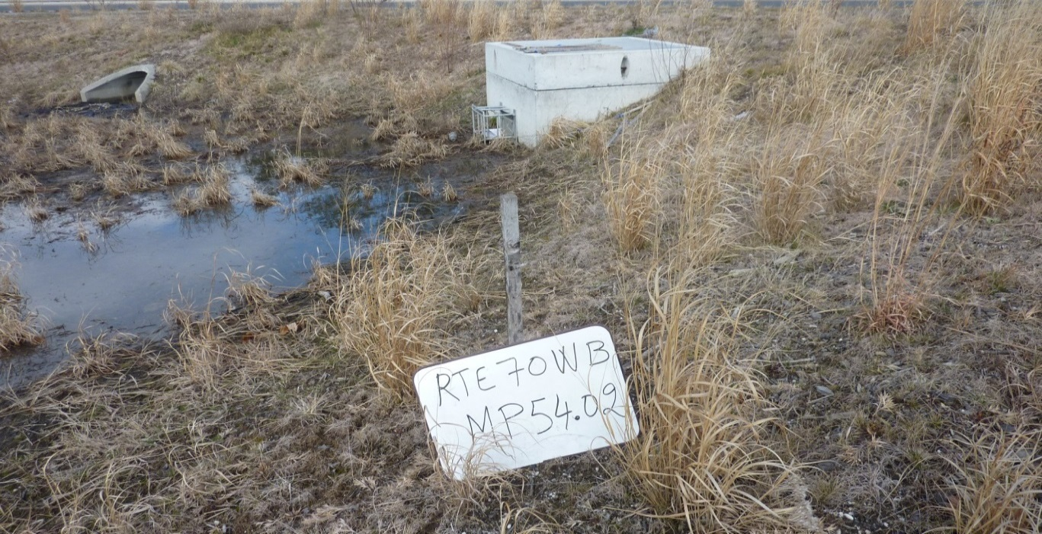
Courtesy of NJDOT

Issue:  Corrective Action:  Preventative Action: |  | The vegetation loss and the blackish soil may indicate frequent inundation.  Check the permeability rate of the soil and the water table elevation. Replace the soil if necessary.  Routine inspection and tilling/aeration, if necessary.
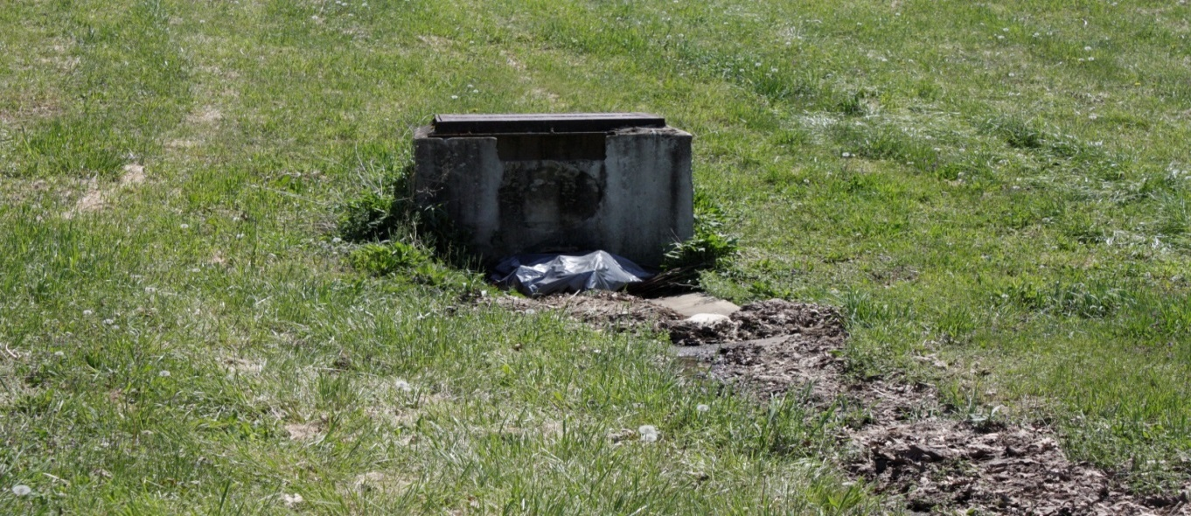
Issue:  Corrective Action:  Preventative Action: |  |  | The low flow channel has excessive accumulation of sediment and debris. The outflow orifice is clogged by a trash bag and debris. Note that there is no trash rack installed.  Check the permeability rate of the soil and the water table elevation. Replace the soil if necessary.  Routine inspection and cleaning.
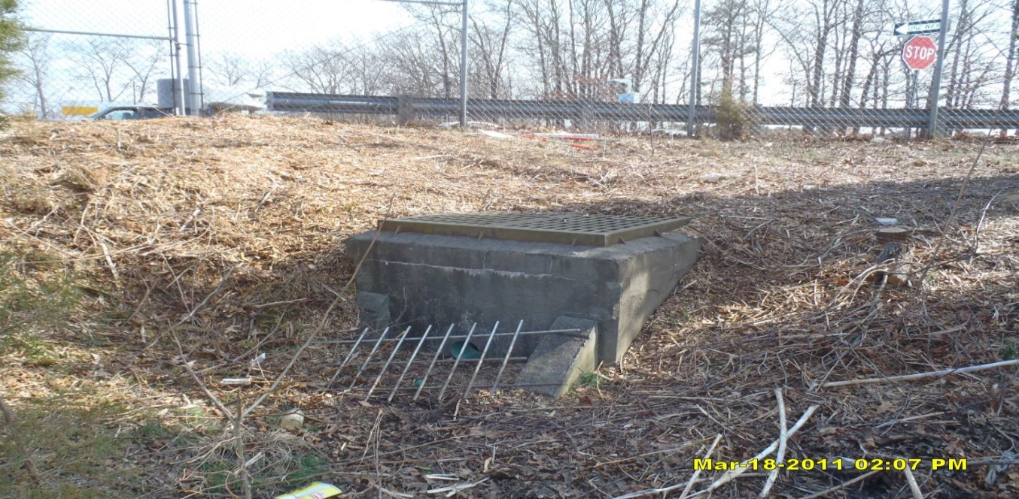
Courtesy of NJDOT

Issue:  Corrective Action:  Preventative Action: |  |  | Trash rack is damaged.  Repair the trash rack.  Routine inspection, especially after large storm events. Tighten any loose bolts and repair structural flaws.
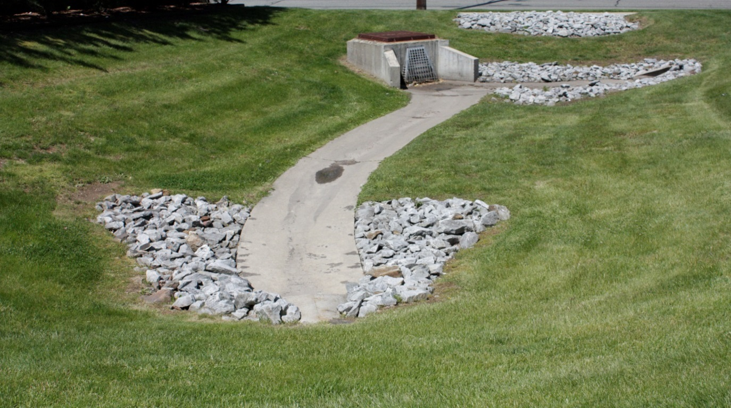
A well maintained detention basin

Reference Documents

Documents to be placed in this field manual should include the following:

- As-built Drawings with Drainage Plans
- Landscaping Plan
- Liner Specifications and Maintenance Manual
- Soil Boring Logs

Attach Reference Documents Here

Inspection Checklist / Maintenance Actions
Subsurface Gravel Wetland

Checklist (circle one): Quarterly / Annual / Monthly / Special Event Inspection

Checklist No. ______________ Inspection Date: _______________

Date of most recent rain event: __________

Rain Condition (circle one):
Drizzle / Shower / Downpour / Other _____________

Ground Condition (circle one):
Dry / Moist / Ponding / Submerged / Snow accumulation

The inspection items and preventative/corrective maintenance actions listed below represent general requirements. The design engineer and/or responsible party shall adjust the items and actions to better meet the conditions of the site, the specific design targets, and the requirements of regulatory authorities.
 | For Inspector |  |  | For Maintenance Crew
Component No. Component Name | Inspection Item and Inspection Item No. |  | Result | Preventative / Corrective Maintenance Actions
A1  Pretreatment  (Forebay) | 1 | Scouring or erosion is present at inlet structure and/or riprap apron | Y__  N__ | Check the flow diversion device before the inlet pipe and whether the bypass flow channel is clogged  Work Order # __________
 | 2 | Clogged pipes or excessive sediment in the forebay | Y__  N__ | Remove sediment or debris
 | 3 | Damaged outlet structure (e.g.,  cracking, subsidence, spalling, erosion, or deterioration) | Y__  N__ | Repair or replace the outlet structure  Work Order # __________
A2  Pretreatment  (MTD,  if installed) | 1 | MTD inspection | Y__  N__ | (If a MTD is used for pretreatment, see manufacturer’s maintenance manual)
A3  Pretreatment  (Structural BMP) | 1 | BMP inspection | Y__  N__ | (See BMP No. ________ Field Manual)
Note:
B1  Surface Wetland | 1 | Standing water is present after the design drain time  The observed drain time is approximately _________ hours. | Y__  N__ | Check whether the outlet is clogged  Check whether the perforated riser is clogged  Clear and remove any clogs  Remove any sediment buildup  Work Order # ______________
 | 2 | Mosquito breeding | Y__  N__ | Check if standing water is present  A physical barrier such as foam or mesh may be installed after careful hydraulic analysis of clogging  Refer to the county’s mosquito control agencies for guidance  Work Order # __________
 | 3 | Excessive dead vegetation on wetland surface | Y__  N__ | Remove dead vegetation according to the Landscaping Plan
 | 4 | Excessive sediment, silt, or trash accumulation on wetland surface | Y__  N__ | Clean pretreatment system  Remove silt, sediment, and trash  Work Order # __________
 | 5 | Erosion or channelization is present on wetland surface | Y__  N__ | Check whether the flow bypass or diversion device is clogged  Check if excessive sediment on the side of the wetland  Work Order # __________
Note:
B2  Subsurface Gravel Cell | 1 | Sediment buildup in gravel bed | Y__  N__ | If sediment buildup is preventing flow through the wetland or reducing storage volume, remove gravel and sediment from the cell(s), replace with clean gravel, and replant vegetation.  Work Order # __________  A permit may be required to discharge when emptying the system. Contact NJDEP Division of Land Use Regulation before discharging.
 | 2 | Dead vegetation or soil in the outlet control structure | Y__  N__ | Check whether the perforated riser is damaged and allows soil or dead vegetation into the pipe  Check whether sediment is deposited above the riser perforations  Work Order # __________
Note:
C  Vegetation | 1 | Invasive plants are present | Y__  N__ | Remove the invasive plants and restore the vegetation in accordance with the landscaping plan  Work Order # __________
 | 2 | Growth of trees or bushes in the wetland | Y__  N__ | Remove trees and bushes  Check whether the wetland soil layer or the transition layer have been damaged by tree roots  Work Order # __________
D  Surface Wetland Embankment and Side Slopes | 1 | Signs of erosion, soil slide or bulges, seeps and wet spots, loss of vegetation, or erosion on the basin slope | Y__  N__ | Check for excessive overland runoff flow through the embankment.  Check for any sink hole development  Direct the overland runoff to the forebay or pretreatment area  Restabilize the bank  Work Order # __________
Note:
E  Outlet | 1 | Trash or debris accumulation more than 20% | Y__  N__ | Clean and remove  Determine source of trash and address to reduce future maintenance costs or basin failure
 | 2 | Trash rack is damaged or rusted greater than 50%  Trash rack is bent, loose, or missing parts | Y__  N__ | Repair or replace trash rack  Work Order #__________
 | 3 | Outlet components (e.g., orifice plates or weir plate) skewed, misaligned, or missing | Y__  N__ | Repair or replace component  Work Order #__________
 | 4 | Discharge pipe apron is eroded or scoured | Y__  N__ | Restabilize the discharge riprap apron  Work Order #__________
 | 5 | Standing water is present in the outlet structure longer than 72 hours | Y__  N__ | Pump out the standing water  Work Order # __________
F  Emergency  Spillway | 1 | Trees or excessive vegetation present | Y__  N__ | Remove trees and roots, and restore berms if necessary  Work Order #________
 | 2 | Damaged structure | Y__  N__ | Repair  Work Order #________
Note:
G  Miscellaneous | 1 | Fence: broken or eroded parts | Y__  N__ | Repair or replace  Work Order #__________
 | 2 | Gate: missing gate or lock | Y__  N__ | Repair or replace  Work Order #__________
 | 3 | Sign/plate: tiled, missing, or faded | Y__  N__ | Repair or replace  Work Order #__________
 | 4 | Excessive or overgrown vegetation blocking access to the basin | Y__  N__ | Clear, trim, or prune the vegetation to allow access for inspection and maintenance  Work Order #________
Note:

Follow Up Items (Component No. / Inspection Item No.):
(e.g., B/1, C/2)

Associated Work Orders: # ______, # ______, # ______, # ______, # _____

________________________ ______________________ ________________
Inspector Name Signature Date

Report issues to the local authority and mosquito commission as required by local ordinances and regulatory authorities.

File this checklist in the Maintenance Log after performing maintenance.

Preventative Maintenance Record

Corresponding Checklist No. ________
Component No._______, Inspection Item No.________

Work Logs
Activities | Components | Date Completed
Sediment/debris removal  Sediment removal should take place when the basin is thoroughly dry. | A1/A2/A3 – Pretreatment
 | B1 – Surface Wetland
 | B2 – Subsurface Gravel Cell
 | D – Surface Wetland Embankment and Side Slopes
 | E – Outlet
Vegetation removal | A1/A2/A3 – Pretreatment
 | B1 – Surface Wetland
 | D – Surface Wetland Embankment and Side Slopes
 | E – Outlet
 | F – Emergency Spillway
(List additional tasks, if applicable)
Vegetation is removed by _____________ (type of equipment) with minimum disruption to the remaining vegetation.

All use of fertilizers, pesticides, mechanical treatments, and other means to ensure optimum vegetation health must not compromise the intended purpose of the stormwater management measure. The fertilizer applied is ____________ (type), and _________ (quantity per usage) is applied _____________ (frequency of use).

Debris, sediment, and trash are handled (onsite / by ____________ (contractor name) to disposal site _________________). (See Part I: Maintenance Plan – Disposal Plan Section)

Crew member:___________________/_________________ Date: _____________
(name/ signature)

Supervisor:_____________________/__________________ Date: _____________

A permit may be required to discharge when emptying the pond. Contact NJDEP Division of Land Use Regulation before discharging.
File this Preventative Maintenance Record in the Maintenance Log after performing maintenance.

Corrective Maintenance Record

- Work Order # ______________________ Date Issued _____________

- Issue to be resolved:
(e.g., orifice plate is loose and bent)

- The issue was from Corresponding Checklist No. ________, Component No. (e.g., E – Outlet), Inspection Item No. (e.g., 2, 3) .

- Required Actions
Actions | Planned Date | Date Completed
New bolts to fix the orifice plate
Repair/replace the trash rack
Restabilize side slope (indicate location)
Repair riprap apron with 100 cubic yards of aggregate
Revegetate
(If there are additional tasks, list them here.)

- Responsible person(s):
_______________________________________________________________

- Special requirements
  - Time of the season or weather condition:_________________________
  - Tools/equipment:____________________________________________
  - Subcontractor (name or specific type):___________________________
Approved by ___________________/_______________ Date _____________
(name/signature)

Verification of completion by ____________/________ Date _____________
(name/signature)

File this Corrective Maintenance Record in the Maintenance Log after performing maintenance

