Standard Constructed Wetland
Basin #___ on the Location Map

Development Name: ___________________________

Township, County: ___________________________

Location of Basin: X: ______; Y: ______ (or N: ______; E :_____)

Location Description: e.g., Northwest corner of the development, near County RT 531

Location Map
N
E

County Route 531

Discharge
Grass Swale #1

Basin #1
Drywell #1

Corporation Road
Building
Parking
Lot

Vegetative Filter strip #1

Drywell #2

Access
Grass Swale #2

Example Map: Use aerial photo, site plan, or other graphics showing the locations of BMPs.

Note:

This Field Manual is intended to be editable and adjustable in accordance with the stormwater management design, the site conditions, and the special needs of the responsible party. The design engineer should supplement information and best management practices to assist the responsible party to perform maintenance.

Blue text indicates information may be deleted and or replaced as necessary.

Table of Contents

Standard Constructed Wetland Overview 4
Basic Design Information 5
Visual Aid for Wet Type Stormwater Basin Inspection 8
Reference Documents 12
Inspection Checklist / Maintenance Actions 14
Preventative Maintenance Record 23
Corrective Maintenance Record 24

Standard Constructed Wetland Overview

Functionality
Standard constructed wetlands are stormwater management systems design to maximize the removal of pollutants from stormwater runoff. Flow is directed through an engineered, open marsh system where pollutants are removed through settling and vegetative uptake/filtration. The total suspended solids (TSS) removal rate is 90%.

Proper care and attention in the long-term maintenance of the stormwater management measure is critically important to the safety and health of the public.

Type of BMP – Wet Basin / Extended Detention of Runoff and Settlement of TSS
A constructed wetland is a type of wet basin, in which water is retained in a permanent pool. This standard constructed wetland is designed for extended detention of runoff and settlement of TSS. It is not design to infiltrate the runoff.

Standard constructed wetlands shall have a water surface elevation approximately at the design water surface elevation year round. Standard constructed wetlands consist of a combination of two or more of the following components: pool zone, marsh zone and semi-wet zone. The different zones of the constructed wetland require different water depths, shapes, and vegetation; therefore, it is normal to see varying water depths throughout the system.

Basic Design Information
This section shall be filled out by the design engineer.

Hydrology Design Targets
- This standard constructed wetland is designed as a (pond wetland / marsh wetland / extended detention wetland), consisting of the following zones and water depths:

Use one of the tables according to the design
Pond Constructed Wetlands Design Specifications
Drainage Area | _____ Acres
Standing Water Depth: High Marsh Zone | _____ Inches
Standing Water Depth: Low Marsh Zone | _____ Inches
Standing Water Depth: Pool Zone | _____ Feet

Marsh Constructed Wetland Design Specifications
Drainage Area | _____ Acres
Standing Water Depth: High Marsh Zone | _____ Inches
Standing Water Depth: Low Marsh Zone | _____ Inches
Standing Water Depth: Pool Zone | _____ Feet

Extended Detention Constructed Wetland Design Specifications
Drainage Area | _____ Acres
Standing Water Depth: High Marsh Zone | _____ Inches
Standing Water Depth: Low Marsh Zone | _____ Inches
Standing Water Depth: Pool Zone | _____ Feet
Standing Water Depth: Semi-Wet Zone | Dry under normal conditions, inundated during 2, 10, 100 years events,  Detention time: _______ hours

2. This basin will be discharged to (municipal stormwater sewer system/ combined sewer system/ stream (stream name).)

Hydraulic Design Targets
- Design parameters
 | Water Quality Design Storm | 2-year  storm | 10-year  storm | 100-year  storm
Rainfall Depth (inches) | 1.25 inch  in 2 hours | ___ inches  in 24 hours | ___ inches  In 24 hours | ___ inches  In 24 hours
Runoff Volume (cubic feet)
Peak Flow Rate
(cfs)
Water Surface Elevation
(feet)
Note: The design engineer shall fill out the table in accordance with the design of the stormwater management measure. If the item is not applicable, enter N/A in the table.

- The emergency spillway is at EL. ___________ feet (if applicable)

Basin Configuration Targets
- Pretreatment is provided by a (forebay with a depth of _________ feet / BMP Type: __________, BMP No.). A perforated riser (is / is not) used.
- Outlet Information:
Outlet Description | Outlet Type | Orifice Size / Weir Length | Invert Elevation
Water Quality Orifice
Outlet #1
Outlet #2
(Other)

- The basin (is / is not) lined. The liner is constructed of (clay / geotextile /
geosynthetic liner / other ___________). (If the basin is lined, the liner material and maintenance information should be attached in the Reference Documents section.)
- The wet pond (does / does not) intercept groundwater.
- A Landscaping Plan should be included that specifies the vegetation required in each zone of the constructed wetland.
- The pond is designed (with / without) a bottom drain pipe to empty the pond.
  - If a drain pipe is installed, the discharge point is __________.
(Notice: A permit to discharge may be required. Contact NJDEP Division of Land Use Regulation before discharging.)
- Safety ledges are installed at ______ EL. and ______ EL. (or ______ feet above the bottom of the pond).

Critical Maintenance Features
- Floatables need to be cleaned and removed from the wetland.
- Remove dead vegetation to prevent mosquito problem.
- Water depth in each different zone must be maintained at design level.
- Sediment level in the Pool Zone needs to be checked and cleaned frequently to ensure sufficient storage space and detention time.
- Native species when revegetating is preferred.
- (Others to be added by the design engineer, if necessary)

Attach the following Disturbance Notices, if applicable to the site:

Wetland Disturbance Notice:
Maintenance of this BMP may disturb a wetland area. Contact NJDEP Division of Land Use Regulation for guidance and any required permit(s) before performing maintenance.

Wildlife Disturbance Notice:
Maintenance of this BMP may disturb or remove vegetation in an area designated to endangered and/or threatened species. Contact NJDEP Division of Fishing and Wildlife for guidance and any required permit(s) before performing maintenance.

Visual Aid for Wet Type Stormwater Basin Inspection
Note: Basins shown here include various types of wet basins, not limited to the category of basin in this field manual.
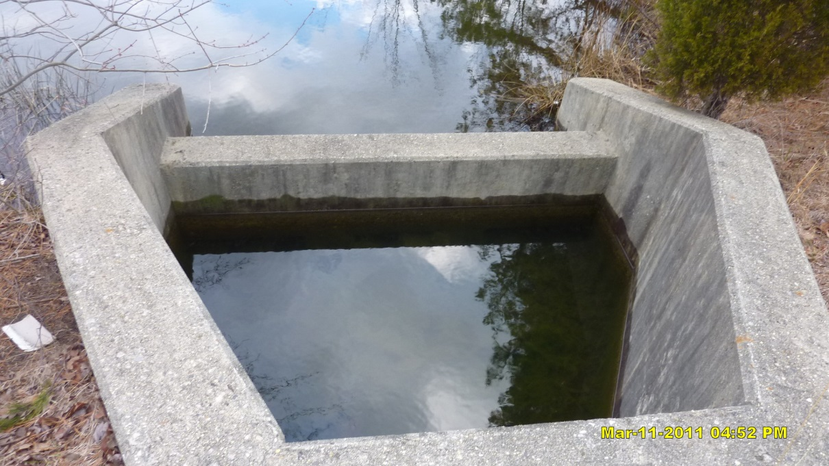
Issues:  Corrective Action:  Preventative Action: |  | The forebay has not drained. Note the sediment accumulation in the forebay.  Clear and remove sediment. Check if the drain hole is clogged.  Routine inspection and maintenance to remove sediment. If sediment accumulates too fast, find the source of sediment and method to reduce the sediment.
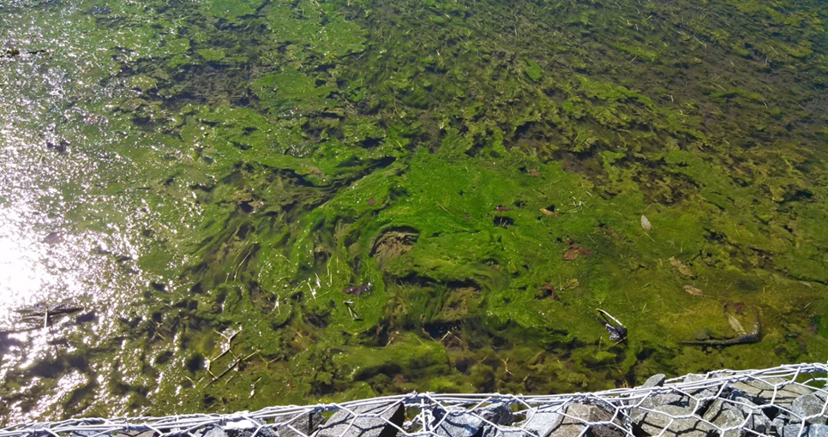
Issues:  Corrective Action:  Preventative Action: |  | Algae blooming.  Remove algae.  Routine inspection and aeration of the pond. Remove algae before blooming. A finding of the nutrient source and method to reduce the nutrient loading may be needed.
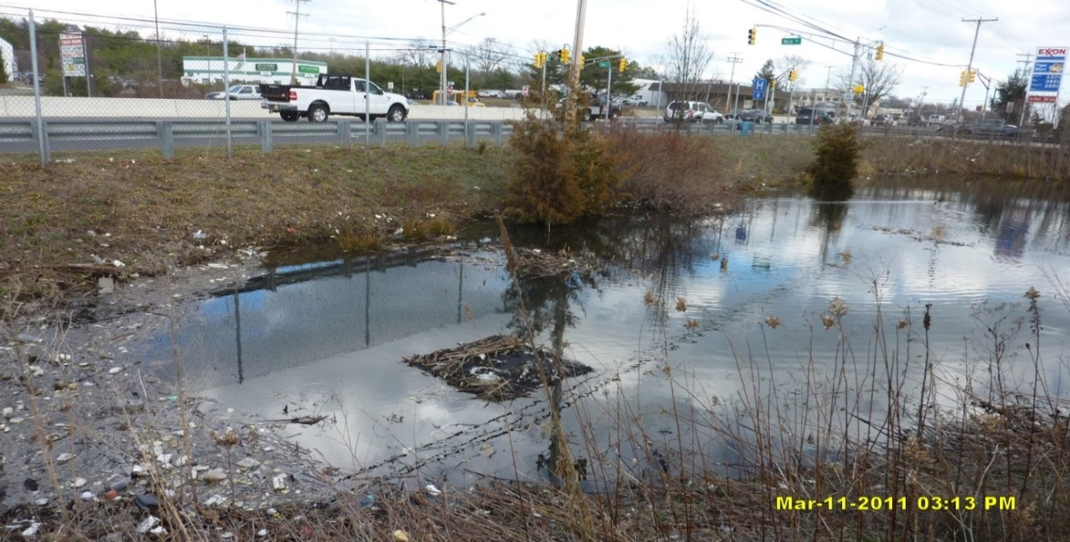
Courtesy of NJDOT

Issues:  Corrective Action:  Preventative Action: |  | The outlet grating is covered by trash. Excessive trash in the pond.  Clear and remove trash.  Routine inspection and removal of trash. A finding of the trash source and method to reduce the trash may be needed.
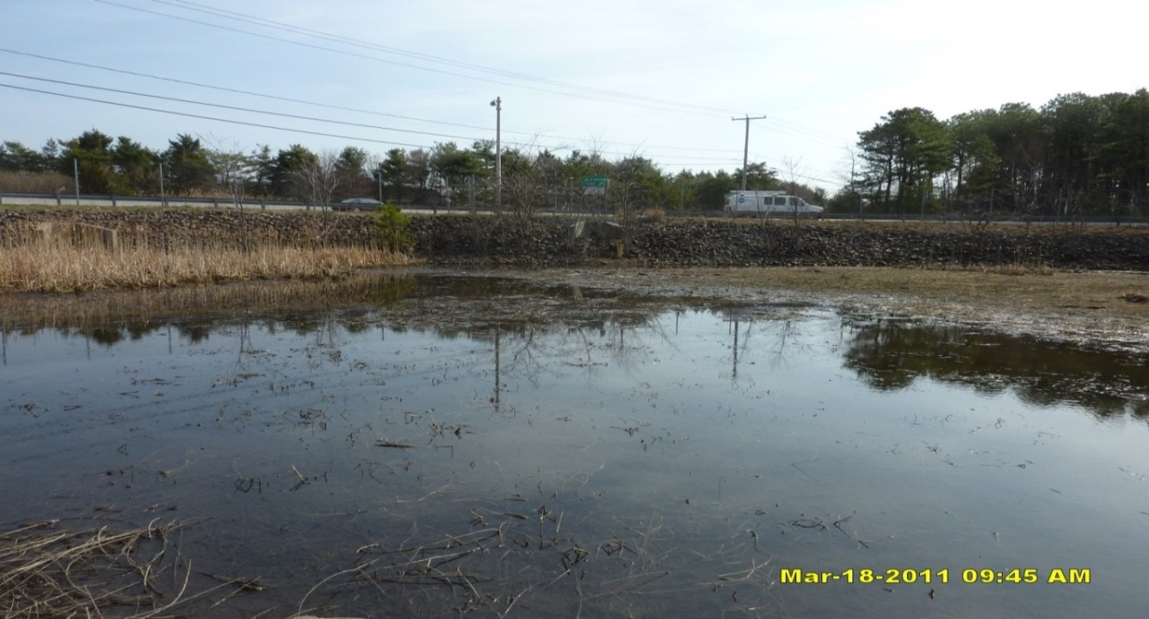
Courtesy of NJDOT

Issues:  Corrective Action:  Preventative Action: |  | The water level in the wet pond is significantly below the design water surface elevation.  Check if the outlet structure or the liner is damaged. Repair any damage.  Routine inspection of the basin and the liner.
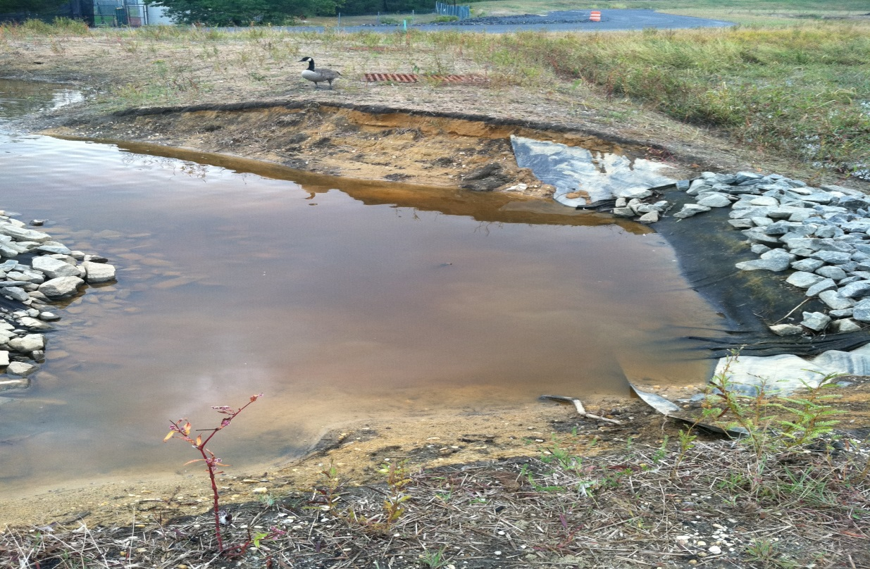
Issues:  Corrective Action:  Preventative Action: |  | Erosion on the embankment.  Repair the embankment. Report to local authority and DEP Dam Safety as required by the local and DEP rules.  Construct a riprap apron on the slope. Routine inspection before erosion becomes severe.
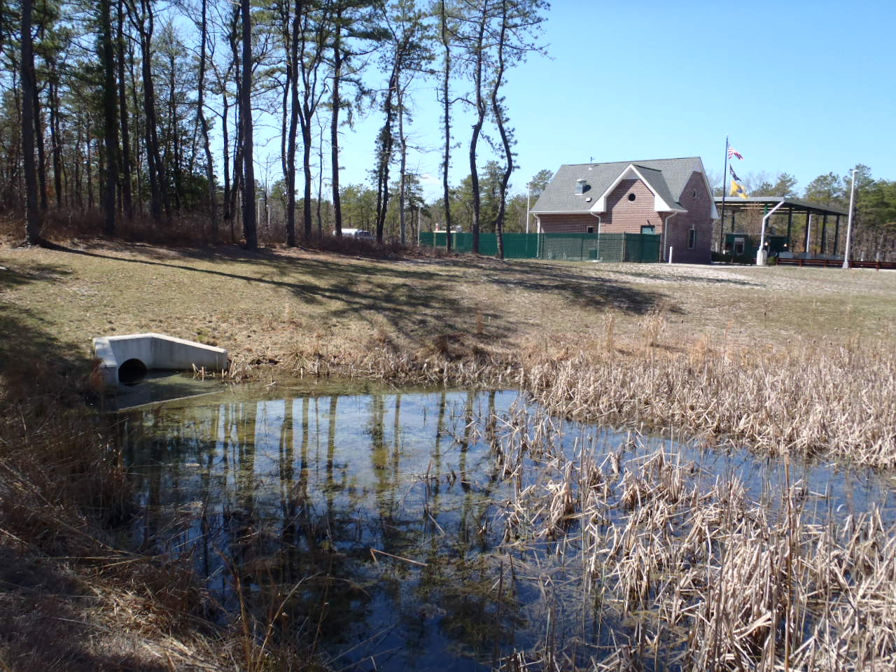
Courtesy of NJDOT

Issues:  Note: | This basin was designed as a detention basin (dry basin), but now looks like a constructed wetland (wet basin). If the maintenance crews do not refer back to the original design information, they may perform the wrong maintenance work.  The maintenance crew must refer to the as-built drawings and design information to avoid confusion and inappropriate maintenance work.
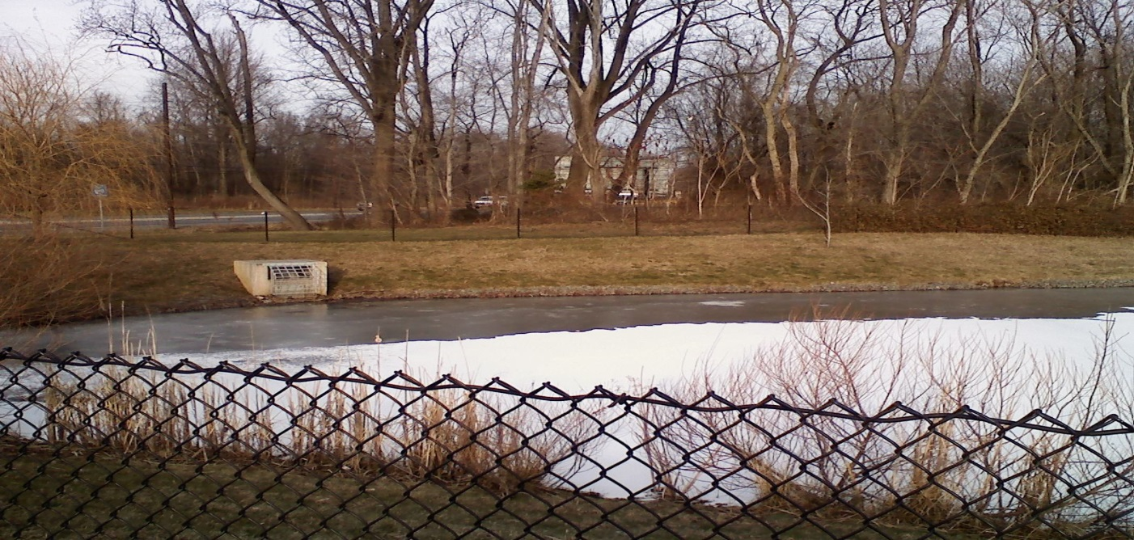
If the original design information is not available, the pond configuration may signal whether it was designed as a wet basin or dry basin. As shown here, the water level is at the invert elevation of the outlet (orifice behind the trash rack). If the water level is at the first outlet from the basin bottom (this can be determined by checking the inside the outlet box), then it is a wet basin and is at correct water surface level. However, if there is another outlet below the water, then it may signal that it is a failed dry basin now filled with water.

Also the pond has a circle of riprap (also known as an energy dissipater) around the edge at the water level. A dry basin will generally not have this configuration; therefore, it suggests a wet pond.

Reference Documents

Documents to be placed in this field manual should include the following:

- As-built Drawings with Drainage Plans
- Soil Boring Logs
- Liner Specifications and Maintenance Manual
- Landscaping Plan

Attach Reference Documents Here

Inspection Checklist / Maintenance Actions
Standard Constructed Wetland

Checklist (circle one): Quarterly / Annual / Monthly / Special Event Inspection

Checklist No. ______________ Inspection Date: _______________

Date of most recent rain event: __________

Rain Condition (circle one):
Drizzle / Shower / Downpour / Other _____________

Ground Condition (circle one):
Dry / Moist / Ponding / Submerged / Snow accumulation

The inspection items and preventative/corrective maintenance actions listed below represent general requirements. The design engineer and/or responsible party shall adjust the items and actions to better meet the conditions of the site, the specific design targets, and the requirements of regulatory authorities.
 | For Inspector |  |  | For Maintenance Crew
Component No. Component Name | Inspection Item and Inspection Item No. |  | Result | Preventative / Corrective Maintenance Actions
A1  Pretreatment  (Forebay) | 1 | Scouring or erosion is present at inlet structure and/or riprap apron | Y__  N__ | Check the flow diversion device before the inlet pipe and whether the bypass flow channel is clogged  Work Order # __________
 | 2 | Clogged pipes or excessive sediment in the forebay | Y__  N__ | Remove sediment or debris
 | 3 | Damaged outlet structure (e.g.,  cracking, subsidence, spalling, erosion, or deterioration) | Y__  N__ | Repair or replace the outlet structure  Work Order # __________
A2  Pretreatment  (MTD,  if installed) | 1 | MTD inspection | Y__  N__ | (If a MTD is used for pretreatment, see manufacturer’s maintenance manual)
A3  Pretreatment  (Structural BMP) | 1 | BMP No. ________ inspection | Y__  N__ | (See BMP No. ________ Field Manual)
Note:
B1  Marsh Zone | 1 | The water depth in the marsh zone is significantly above or below the design water depth  Dry spot(s) appearing in the marsh zone  Growth of trees or bushes in the marsh zone | Y__  N__ | Check for:  * Damages to the liner (if applicable)  * Changes in inflow patterns (less runoff, lower groundwater table)  Repair any structural damages  Remove sediment, reconfigure the marsh zone, remove trees, or repair the liner (if necessary)  Work Order # __________
 | 2 | Vegetation loss in the high marsh zone | Y__  N__ | Check whether the water level is higher than the design level  Check the Landscaping Plan for remedial actions  Work Order # __________
 | 3 | Significant changes of the sinuous path pattern from the original design  Channelization in the wetland | Y__  N__ | Check whether the incoming flow is larger than the design inflow  Check if excessive sediment has accumulated in the marsh zone  Remove sediment and reconfigure the flow path, if necessary  Work Order # __________
Note:
B2  Pond Zone | 1 | The water depth in the marsh zone is significantly above or below the design water depth | Y__  N__ | Check for:  - Changes in inflow patterns (less runoff, lower groundwater table)  - Damages to the outlet structure  - Damages to the liner (if applicable)  Repair any structural damages  Work Order # __________
 | 2 | Islands or shallow marsh emerging out of the pond zone | Y__  N__ | Check whether there is excessive sediment in the pond  Check whether the incoming flow has excessive sediment  Remove excessive sediment  Find the source of excessive sediment and method to reduce the source  Work Order # __________
Note: If emptying the pond is required before sediment removal, it shall be noted that a permit may be required before discharging the pond water. Contact NJDEP Division of Land Use Regulation before discharge.

Other Note:

B2  Pond Zone | 3 | The observed detention time is longer than the design detention time.  The observed detention time is approximately ______ hours. | Y__  N__ | Check whether the outlets are clogged, see section E-Outlet of this checklist
 | 4 | Debris or trash floating on the water | Y__  N__ | Remove debris and trash  If trash and debris are excessive, find the source and the method to reduce the source.
 | 5 | Excessive dead vegetation in the pond | Y__  N__ | Clear and remove vegetation
 | 6 | Mosquitoes breeding | Y__  N__ | Remove dead vegetation  Consult local mosquito commission for guidance  Work Order # __________
 | 7 | Subsidence of safety ledge | Y__  N__ | Drain the pond and repair the safety ledge  Work Order # __________
Note: If emptying the pond is required, a permit may be required before discharging the pond water. Contact NJDEP Division of Land Use Regulation before discharge.

Other Note:

B3  Semi-Wet Zone | 1 | Erosion on the side slopes | Y__  N__ | See D – Pond Embankment and Side Slopes
 | 2 | Overgrown trees and bushes | Y__  N__ | Clear, trim, or prune the trees according to the original Landscaping Plan  Inspect to determine if the tree roots caused any structural damage  Work Order # __________
C  Vegetation | 1 | Invasive plants are present | Y__  N__ | Remove the invasive plants and restore the vegetation in accordance with the landscaping plan  Work Order # __________
 | 2 | Algae blooming | Y__  N__ | Remove algae  Find the nutrient source and the solution to reduce the nutrient loading  Work Order # __________
Note:
D  Pond Embankment and Side Slopes | 1 | Signs of erosion, soil slide or bulges, seeps and wet spots, loss of vegetation, or erosion on the basin slope | Y__  N__ | Check for excessive overland runoff flow through the embankment.  Check for any sink hole development  Direct the overland runoff to the forebay or pretreatment area  Restabilize the bank  Work Order # __________
E  Outlet | 1 | Trash or debris accumulation more than 20% | Y__  N__ | Clean and remove  Determine source of trash and address to reduce future maintenance costs or basin failure
 | 2 | Trash rack is damaged or rusted greater than 50%  Trash rack is bent, loose, or missing parts | Y__  N__ | Repair or replace trash rack  Work Order #__________
 | 3 | Outlet components (e.g., orifice plates or weir plate) skewed, misaligned, or missing | Y__  N__ | Repair or replace component  Work Order #__________
 | 4 | Discharge pipe apron is eroded or scoured | Y__  N__ | Restabilize the discharge riprap apron  Work Order #__________
 | 5 | Standing water is present in the outlet structure longer than 72 hours | Y__  N__ | Pump out the standing water  Work Order # __________
Note:
F  Emergency  Spillway | 1 | Trees or excessive vegetation present | Y__  N__ | Remove trees and roots, and restore berms if necessary  Work Order #________
 | 2 | Damaged structure | Y__  N__ | Repair  Work Order #________
G  Miscellaneous  (if applicable) | 1 | Fence: broken or eroded parts | Y__  N__ | Repair or replace  Work Order #__________
 | 2 | Gate: missing gate or lock | Y__  N__ | Repair or replace  Work Order #__________
 | 3 | Sign/plate: tiled, missing, or faded | Y__  N__ | Repair or replace  Work Order #__________
 | 4 | Excessive or overgrown vegetation blocking access to the basin | Y__  N__ | Clear, trim, or prune the vegetation to allow access for inspection and maintenance  Work Order #________
Note:

Follow Up Items (Component No. / Inspection Item No.):
(e.g., B/1, C/2)

Associated Work Orders: # ______, # ______, # ______, # ______, # _____

________________________ ___________________ ________________
Inspector Name Signature Date

Report issues to the local authority and mosquito commission as required by local ordinances and regulatory authorities.

File this checklist in the Maintenance Log after performing maintenance

Preventative Maintenance Record

Corresponding Checklist No. ________
Component No._______, Inspection Item No.________
Work Logs
Activities | Components | Check if finished
Sediment/debris removal  Sediment removal should take place when the pond zone is thoroughly dry. | A1/A2/A3 – Pretreatment
 | B2 – Pond Zone
 | D – Pond Embankment and Side Slopes
 | E – Outlet
Vegetation removal | A1/A2/A3 – Pretreatment
 | B1 – Marsh Zone
 | B2 – Pond Zone
 | B3 – Semi-Wet Zone
 | D – Pond Embankment and Side Slopes
 | E – Outlet
 | F – Emergency Spillway
(List additional tasks, if applicable)
Vegetation is removed by _____________ (type of equipment) with minimum disruption to the remaining vegetation.

All use of fertilizers, pesticides, mechanical treatments, and other means to ensure optimum vegetation health must not compromise the intended purpose of the stormwater management measure. The fertilizer applied is ____________ (type), and _________ (quantity per usage) is applied _____________ (frequency of use).

Debris, sediment, and trash are handled (onsite / by ____________ (contractor name) to disposal site _________________). (See Part I: Maintenance Plan – Disposal Plan Section)

Crew member:___________________/____________ Date: _____________
(name/ signature)

Supervisor:_____________________/_____________ Date: _____________
A permit may be required to discharge when emptying the pond. Contact NJDEP Division of Land Use Regulation before discharging.
File this Preventative Maintenance Record in the Maintenance Log after performing maintenance.

Corrective Maintenance Record

- Work Order # ______________________ Date Issued _____________

- Issue to be resolved:
(e.g., orifice plate is loose and bent)

- The issue was from Corresponding Checklist No. ________, Component No. (e.g., E – Outlet), Inspection Item No. (e.g., 2, 3) .

- Required Actions
Actions | Planned Date | Date Completed
New bolts to fix the orifice plate
Repair/replace the trash rack
Restabilize side slope (indicate location)
Repair riprap apron with 100 cubic yards of aggregate
Revegetate
(If there are additional tasks, list them here.)

- Responsible person(s):
_____________________________________________________________

- Special requirements
  - Time of the season or weather condition:_________________________
  - Tools/equipment:____________________________________________
  - Subcontractor (name or specific type):___________________________
Approved by ___________________/_______________ Date _____________
(name/signature)

Verification of completion by ____________/________ Date _____________
(name/signature)

File this Corrective Maintenance Record in the Maintenance Log after performing maintenance.

