Wet Pond
Basin #___ on the Location Map

Development Name: ___________________________

Township, County: ___________________________

Location of Basin: X: ______; Y: ______ (or N: ______; E :_____)

Location Description: e.g., Northwest corner of the development, near County RT 531

Location Map
N
E

County Route 531

Grass Swale #1

Discharge

Basin #1
Drywell #1

Corporation Road
Building
Parking
Lot

Vegetative Filter strip #1

Drywell #2

Access
Grass Swale #2

Example Map: Use aerial photo, site plan, or other graphics showing the locations of BMPs.

Note:

This Field Manual is intended to be editable and adjustable in accordance with the stormwater management design, the site conditions, and the special needs of the responsible party. The design engineer should supplement information and best management practices to assist the responsible party to perform maintenance.

Blue text indicates information may be deleted and or replaced as necessary.

Table of Contents

Wet Pond Overview 4
Basic Design Information 5
Visual Aid for Wet Type Stormwater Basin Inspection 7
Reference Documents 11
Inspection Checklist / Maintenance Actions 13
Preventative Maintenance Record 21
Corrective Maintenance Record 22

Wet Pond Overview

Functionality
Wet ponds, also known as retention basins, are used to address the stormwater quantity and quality impacts of land development. This type of stormwater facility has an elevated outlet structure that creates a permanent pool where stormwater runoff is detained and attenuated. Wet ponds can be designed as multi-stage, multi-function systems; extended detention in the permanent pool provides pollutant treatment for runoff from the Water Quality Design Storm through sedimentation and biological processing; detention and attenuation is also provided for larger storm event through the higher elevation outlets. The total suspended solids (TSS) removal rate is 50 – 90%, depending upon the storage volume in the permanent pool and the duration of detention time, if extended detention is provided.

Proper care and attention in the long-term maintenance of the stormwater management measure is critically important to the safety and health of the public.

Type of BMP – Wet Basin / Extended Detention of Runoff and Settlement of TSS
A wet pond is a type of wet basin, in which water is retained in a permanent pool. This wet pond is designed for extended detention of runoff and settlement of TSS. It is not designed to infiltrate runoff.

Wet ponds shall have a water surface elevation approximately at the design water surface elevation year round. If a wet pond has an exposed bottom or a shallow water level, there may be an issue caused by changes to the contributing drainage area, damage to the outlet structure(s), or damage to the bottom liner. An investigation is then required to determine the issue and restore proper function.

Basic Design Information
This section shall be filled out by the design engineer.

Hydrology Design Targets
- The design detention time of this pond is approximately __________ hours.
- This wet pond is design to receive runoff from a drainage area of _______ acres.
- The TSS removal rate of this wet pond is _________ %.
- This basin will be discharged to (municipal stormwater sewer system/combined sewer system/stream (stream name).)

Hydraulic Design Targets
- Design parameters
 | Water Quality Design Storm | 2-year  storm | 10-year  storm | 100-year  storm
Rainfall Depth (inches) | 1.25 inch  in 2 hours | ___ inches  in 24 hours | ___ inches  In 24 hours | ___ inches  In 24 hours
Runoff Volume (cubic feet)
Peak Flow Rate
(cfs)
Water Surface Elevation
(feet)
Note: The design engineer shall fill out the table in accordance with the design of the stormwater management measure. If the item is not applicable, enter N/A in the table.

- The emergency spillway is at EL. ___________ feet (if applicable).

Basin Configuration Targets
- Pretreatment is provided by a (forebay with a depth of _________ feet / BMP Type: __________, BMP No.). A perforated riser (is / is not) used.
- Outlet Information:
Outlet Description | Outlet Type | Orifice Size / Weir Length | Invert Elevation
Water Quality Orifice
Outlet #1
Outlet #2
(Other)

- This wet pond is designed to (have / have no) vegetation along its perimeter. (If vegetated, a Landscaping Plan should be attached to the Reference Documents section of this manual.)
- The basin (is / is not) lined. The liner is constructed of (clay / geotextile /
geosynthetic liner / other ___________). (If the basin is lined, the liner material and maintenance information should be attached in the Reference Documents section.)
- The wet pond (does / does not) intercept groundwater.
- The wet pond (is / is not) aerated by an aerator or fountain (If the wet pond is aerated, an Operation and Maintenance Manual for the aerator or fountain should be included in the Reference Documents section).
- The pond is designed (with / without) a bottom drain pipe to empty the pond.
  - If a drain pipe is installed, the discharge point is __________.
(A permit to discharge may be required. Contact NJDEP Division of Land Use Regulation before discharging.)
- Safety ledges are installed at ______ EL. and ______ EL. (or ______ feet above the bottom of the pond).

Critical Maintenance Features
- Floatables need to be cleaned and removed from the pond.
- Remove dead vegetation to prevent mosquito problem.
- The pond needs to maintain aeration or circulation to prevent mosquito problem.
- Native species when revegetating is preferred.
- (Others to be added by the design engineer, if necessary)

Attach the following Disturbance Notices, if applicable to the site:

Wetland Disturbance Notice:
Maintenance of this BMP may disturb a wetland area. Contact NJDEP Division of Land Use Regulation for guidance and any required permit(s) before performing maintenance.

Wildlife Disturbance Notice:
Maintenance of this BMP may disturb or remove vegetation in an area designated to endangered and/or threatened species. Contact NJDEP Division of Fishing and Wildlife for guidance and any required permit(s) before performing maintenance.

Visual Aid for Wet Type Stormwater Basin Inspection
Note: Basins shown here include various types of wet basins, not limited to the category of basin in this field manual.
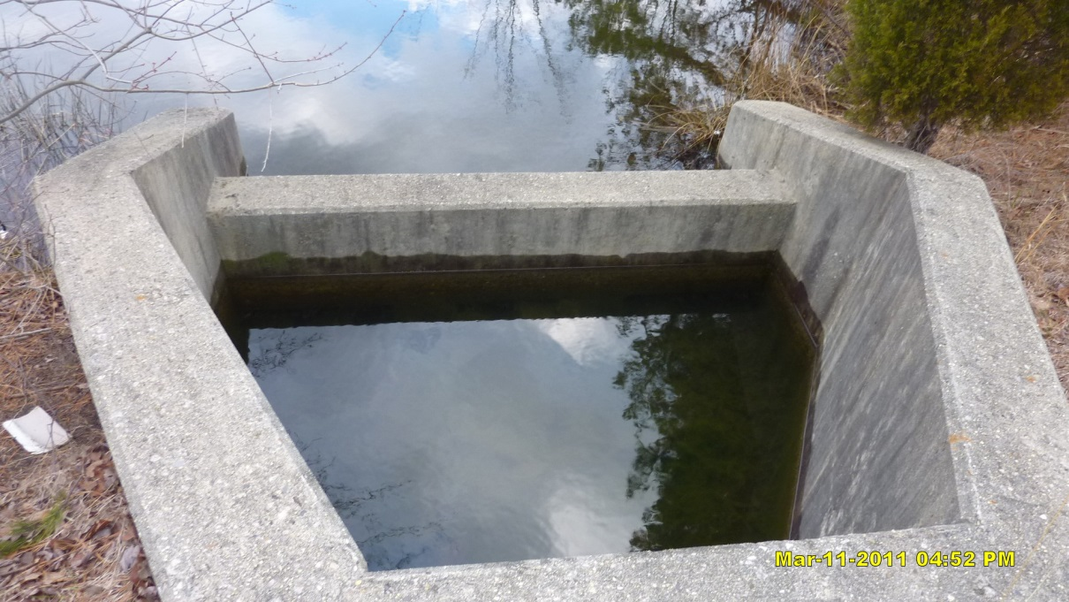
Issues:  Corrective Action:  Preventative Action: |  |  | The forebay has not drained. Note the sediment accumulation in the forebay.  Clear and remove sediment. Check if the drain hole is clogged.  Routine inspection and maintenance to remove sediment. If sediment accumulates too fast, find the source of sediment and method to reduce the sediment.
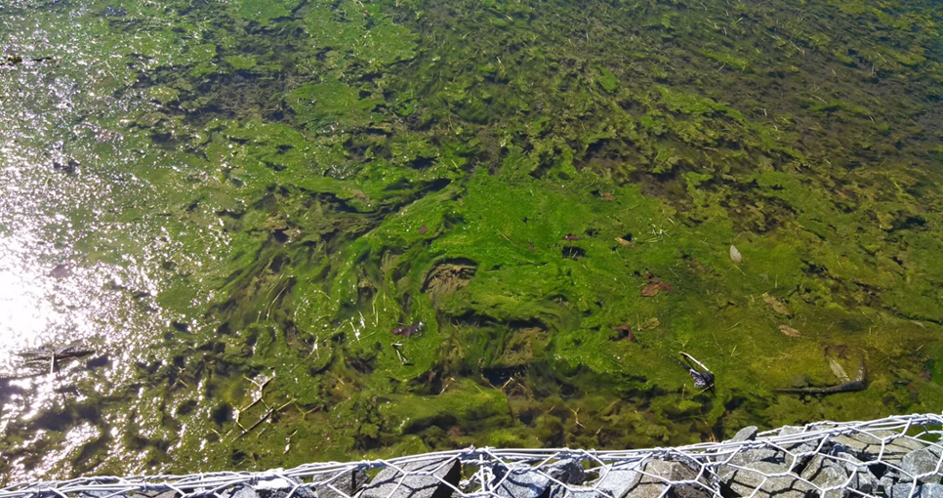
Issues:  Corrective Action:  Preventative Action: |  | Algae blooming.  Remove algae.  Routine inspection and aeration of the pond. Remove algae before blooming. A finding of the nutrient source and method to reduce the nutrient loading may be needed.
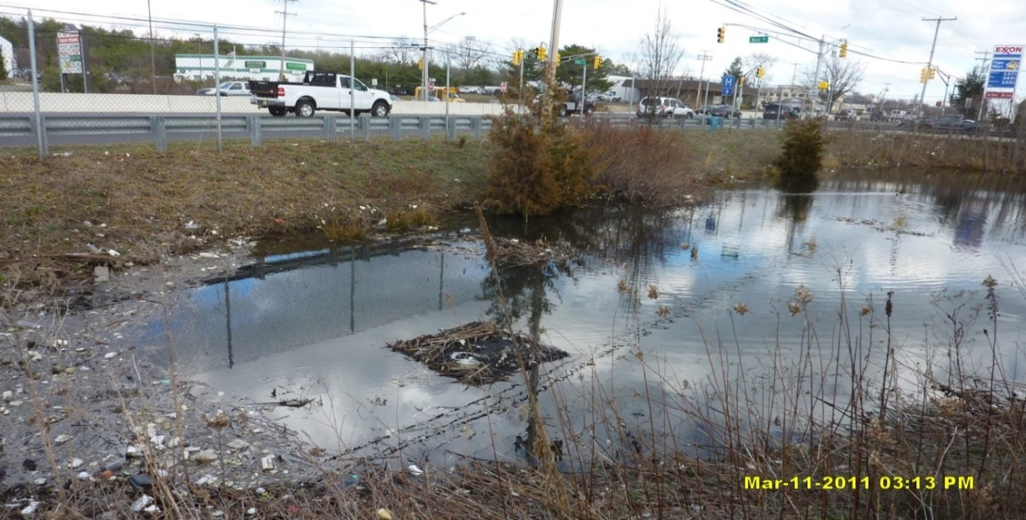
Courtesy of NJDOT

Issues:  Corrective Action:  Preventative Action: |  | The outlet grating is covered by trash. Excessive trash in the pond.  Clear and remove trash.  Routine inspection and removal of trash. A finding of the trash source and method to reduce the trash may be needed.
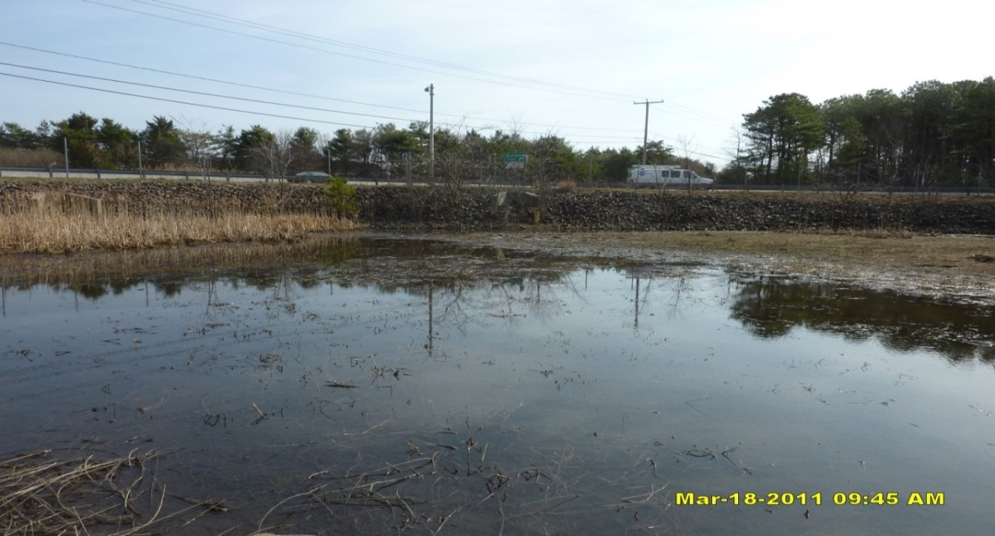
Courtesy of NJDOT

Issues:  Corrective Action:  Preventative Action: |  | The water level in the wet pond is significantly below the design water surface elevation.  Check if the outlet structure or the liner is damaged. Repair any damage.  Routine inspection of the basin and the liner.
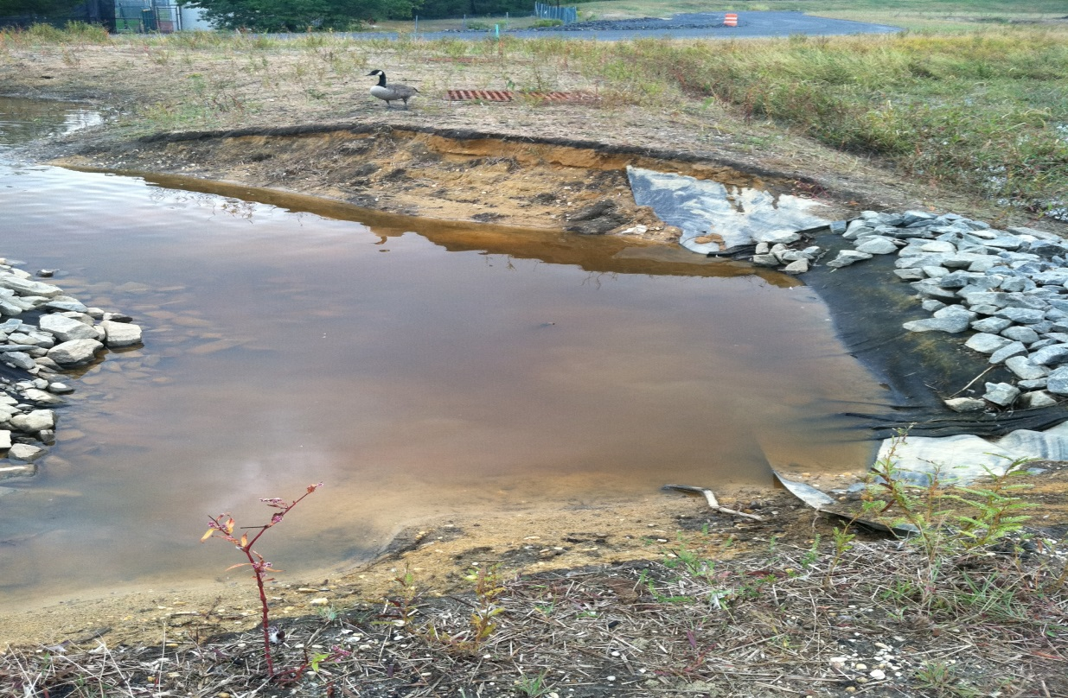
Issues:  Corrective Action:  Preventative Action: |  | Erosion on the embankment.  Repair the embankment. Report to local authority and DEP Dam Safety as required by the local and DEP rules.  Construct a riprap apron on the slope. Routine inspection before erosion becomes severe.
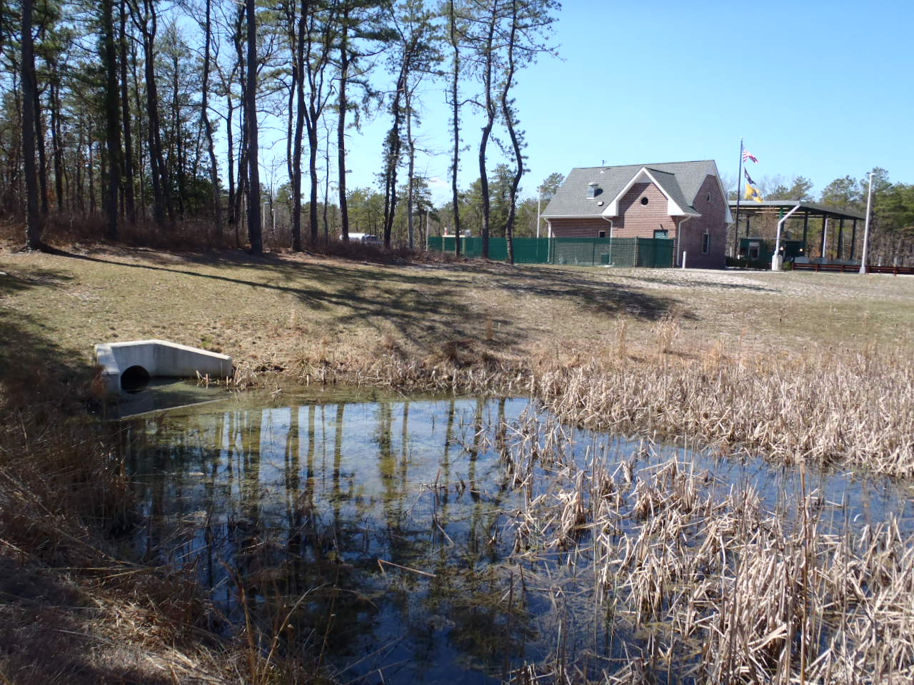
Courtesy of NJDOT

Issues:  Note: | This basin was designed as a detention basin (dry basin), but now looks like a constructed wetland (wet basin). If the maintenance crews do not refer back to the original design information, they may perform the wrong maintenance work.  The maintenance crew must refer to the as-built drawings and design information to avoid confusion and inappropriate maintenance work.
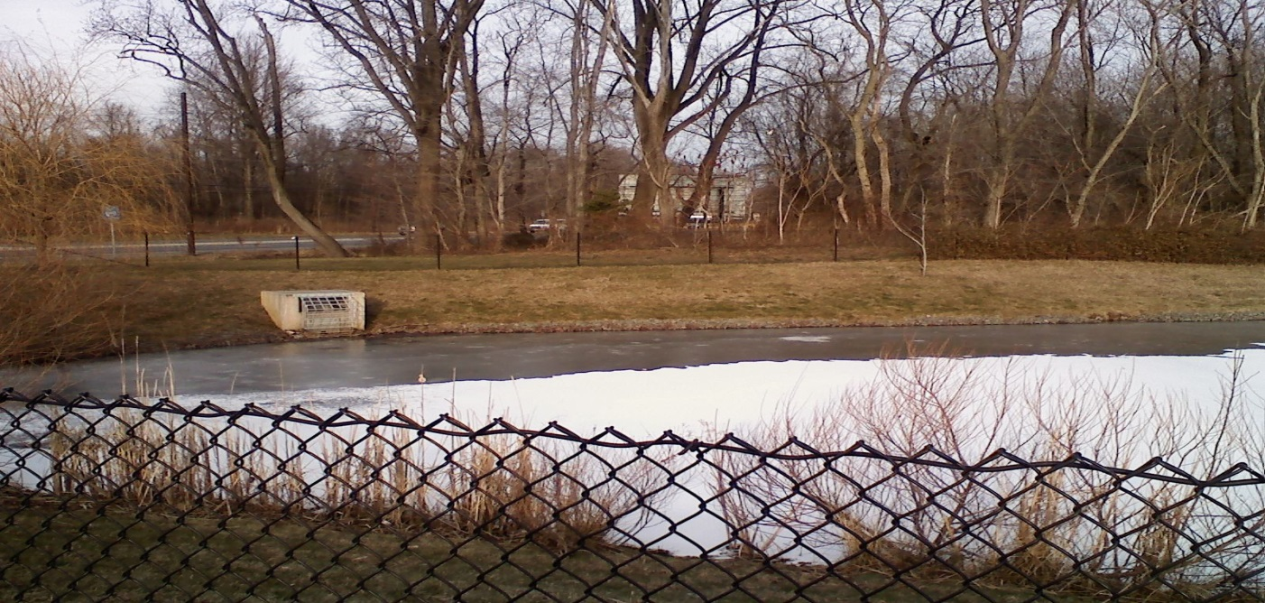
If the original design information is not available, the pond configuration may signal whether it was designed as a wet basin or dry basin. As shown here, the water level is at the invert elevation of the outlet (orifice behind the trash rack). If the water level is at the first outlet from the basin bottom (this can be determined by checking the inside the outlet box), then it is a wet basin and is at correct water surface level. However, if there is another outlet below the water, then it may signal that it is a failed dry basin now filled with water.

Also the pond has a circle of riprap (also known as an energy dissipater) around the edge at the water level. A dry basin will generally not have this configuration; therefore, it suggests a wet pond.

Reference Documents

Documents to be placed in this field manual should include the following:

- As-built Drawings with Drainage Plans
- Soil Boring Logs
- Liner Specifications and Maintenance Manual
- Landscaping Plan
- Aerator or Fountain Operation and Maintenance Manual

Attach Reference Documents Here

Inspection Checklist / Maintenance Actions
Wet Pond

Checklist (circle one): Quarterly / Annual / Monthly / Special Event Inspection

Checklist No. ______________ Inspection Date: _______________

Date of most recent rain event: __________

Rain Condition (circle one):
Drizzle / Shower / Downpour / Other _____________

Ground Condition (circle one):
Dry / Moist / Ponding / Submerged / Snow accumulation

The inspection items and preventative/corrective maintenance actions listed below represent general requirements. The design engineer and/or responsible party shall adjust the items and actions to better meet the conditions of the site, the specific design targets, and the requirements of regulatory authorities.
 | For Inspector |  |  | For Maintenance Crew
Component No. Component Name | Inspection Item and Inspection Item No. |  | Result | Preventative / Corrective Maintenance Actions
A1  Pretreatment  (Forebay) | 1 | Scouring or erosion is present at inlet structure and/or riprap apron | Y__  N__ | Check the flow diversion device before the inlet pipe and whether the bypass flow channel is clogged  Work Order # __________
 | 2 | Clogged pipes or excessive sediment in the forebay | Y__  N__ | Remove sediment or debris
 | 3 | Damaged outlet structure (e.g.,  cracking, subsidence, spalling, erosion, or deterioration) | Y__  N__ | Repair or replace the outlet structure  Work Order # __________
A2  Pretreatment  (MTD,  if installed) | 1 | MTD inspection | Y__  N__ | (If a MTD is used for pretreatment, see manufacturer’s maintenance manual)
A3  Pretreatment  (Structural BMP) | 1 | BMP No. ________ inspection | Y__  N__ | (See BMP No. ________ Field Manual)
Note:
B  Pond Area | 1 | The water level in the pond is below the design water surface elevation | Y__  N__ | Check for:  *Changes in inflow *patterns (less runoff, *lower groundwater table)  *Damages to the outlet structure  *Damages to the liner (if applicable)  Repair any structural damages  Work Order # __________
 | 2 | Islands or shallow marsh emerging out of the pond | Y__  N__ | Check whether there is excessive sediment in the pond  Check whether the incoming flow has excessive sediment  Find the source of excessive sediment and method to reduce the source  Remove excessive sediment  Work Order # __________
 | 3 | The observed detention time is longer than the design detention time.  The observed detention time is approximately ______ hours. | Y__  N__ | Check whether the outlets are clogged, see section E-Outlet of this checklist
Note:
B  Pond Area | 4 | Debris or trash floating on the water | Y__  N__ | Remove debris and trash  If trash and debris are excessive, find the source and the method to reduce the source.
 | 5 | Excessive dead vegetation in the pond | Y__  N__ | Clear and remove vegetation
 | 6 | Mosquito breeding | Y__  N__ | Aerate or circulate the pond  Remove dead vegetation  Consult local mosquito commission for guidance  Work Order # __________
 | 7 | Presence of domestic waterfowl and wildlife | Y__  N__ | Minimize mowing at the perimeter of the pong with a no-mow fringe to keep waterfowl from accessing the pond  Contact NJDEP - Division of Fish and Wildlife for guidance and permits to capture and release
Note:
B  Pond Area | 8 | Erosion on pond side | Y__  N__ | Check whether the surrounding area has uncontrolled drainage into the pond  Install an energy dissipater to slow down the incoming flow (e.g. deep-rooted riparian vegetation or bioengineering method)  Check if the liner is damaged (if a liner is installed)  Work Order # __________
 | 9 | Liner of the basin is visible and is damaged (if applicable) | Y__  N__ | Repair the liner  Work Order # __________
 | 10 | The aerator/fountain is not working | Y__  N__ | Refer to the manufacturer’s Operation and Maintenance Manual.  Work Order # __________
Note: If emptying the pond is required before sediment removal, it shall be noted that a permit may be required before discharging the pond water. Contact NJDEP Division of Land Use Regulation before discharge

Note:
C  Vegetation | 1 | Invasive plants are present | Y__  N__ | Remove the invasive plants and restore the vegetation in accordance with the landscaping plan  Work Order # __________
 | 2 | Algae blooming | Y__  N__ | Remove algae  Aerate the pond  Find the nutrient source and the solution to reduce the nutrient loading  Work Order # __________
D  Pond Embankment and Side Slopes | 1 | Signs of erosion, soil slide or bulges, seeps and wet spots, loss of vegetation, or erosion on the basin slope | Y__  N__ | Check for excessive overland runoff flow through the embankment.  Check for any sink hole development  Direct the overland runoff to the forebay or pretreatment area  Restabilize the bank  Work Order # __________
Note:
E  Outlet | 1 | Trash or debris accumulation more than 20% | Y__  N__ | Clean and remove  Determine source of trash and address to reduce future maintenance costs or basin failure
 | 2 | Trash rack is damaged or rusted greater than 50%  Trash rack is bent, loose, or missing parts | Y__  N__ | Repair or replace trash rack  Work Order #__________
 | 3 | Outlet components (e.g., orifice plates or weir plate) skewed, misaligned, or missing | Y__  N__ | Repair or replace component  Work Order #__________
 | 4 | Discharge pipe apron is eroded or scoured | Y__  N__ | Restabilize the discharge riprap apron  Work Order #__________
 | 5 | Standing water is present in the outlet structure longer than 72 hours | Y__  N__ | Pump out the standing water  Work Order # __________
F  Emergency  Spillway | 1 | Trees or excessive vegetation present | Y__  N__ | Remove trees and roots, and restore berms if necessary  Work Order #________
 | 2 | Damaged structure | Y__  N__ | Repair  Work Order #________
Note:
G  Miscellaneous | 1 | Fence: broken or eroded parts | Y__  N__ | Repair or replace  Work Order #__________
 | 2 | Gate: missing gate or lock | Y__  N__ | Repair or replace  Work Order #__________
 | 3 | Sign/plate: tiled, missing, or faded | Y__  N__ | Repair or replace  Work Order #__________
 | 4 | Excessive or overgrown vegetation blocking access to the basin | Y__  N__ | Clear, trim, or prune the vegetation to allow access for inspection and maintenance  Work Order #________
Note:

Follow Up Items (Component No. / Inspection Item No.):
(e.g., B/1, C/2)

Associated Work Orders: # ______, # ______, # ______, # ______, # _____

________________________ ______________________ ________________
Inspector Name Signature Date

Report issues to the local authority and mosquito commission as required by local ordinances and regulatory authorities.
File this checklist in the Maintenance Log after performing maintenance.

Preventative Maintenance Record

Corresponding Checklist No. ________
Component No._______, Inspection Item No.________

Work Logs
Activities | Components | Date Completed
Sediment/debris removal  Sediment removal should take place when the basin is thoroughly dry. | A1/A2/A3 – Pretreatment
 | B – Pond Area
 | D – Pond Embankment and Side Slopes
 | E – Outlet
Vegetation removal | A1/A2/A3 – Pretreatment
 | B – Pond Area
 | D – Pond Embankment and Side Slopes
 | E – Outlet
 | F – Emergency Spillway
(List additional tasks, if applicable)
Vegetation is removed by _____________ (type of equipment) with minimum disruption to the remaining vegetation.

All use of fertilizers, pesticides, mechanical treatments, and other means to ensure optimum vegetation health must not compromise the intended purpose of the stormwater management measure. The fertilizer applied is ____________ (type), and _________ (quantity per usage) is applied _____________ (frequency of use).

Debris, sediment, and trash are handled (onsite / by ____________ (contractor name) to disposal site _________________). (See Part I: Maintenance Plan – Disposal Plan Section)

Crew member:___________________/__________________ Date: _____________
(name/ signature)

Supervisor:_____________________/__________________ Date: _____________

A permit may be required to discharge when emptying the pond. Contact NJDEP Division of Land Use Regulation before discharging.
File this Preventative Maintenance Record in the Maintenance Log after performing maintenance

Corrective Maintenance Record

- Work Order # ______________________ Date Issued _____________

- Issue to be resolved:
(e.g., orifice plate is loose and bent)

- The issue was from Corresponding Checklist No. ________, Component No. (e.g., E – Outlet), Inspection Item No. (e.g., 2, 3) .

- Required Actions
Actions | Planned Date | Date Completed
New bolts to fix the orifice plate
Repair/replace the trash rack
Restabilize side slope (indicate location)
Repair riprap apron with 100 cubic yards of aggregate
Revegetate
(If there are additional tasks, list them here.)

- Responsible person(s):
______________________________________________________________

- Special requirements
  - Time of the season or weather condition:_________________________
  - Tools/equipment:____________________________________________
  - Subcontractor (name or specific type):___________________________
Approved by ___________________/_______________ Date _____________
(name/signature)

Verification of completion by ____________/________ Date _____________
(name/signature)

File this Corrective Maintenance Record in the Maintenance Log after performing maintenance

