
Compass Basics
Determining your exact orientation (location, based on direction) is important when planning and constructing a Schoolyard Habitat. A compass can also be used in many student activities on your site.

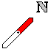
The RED part of the Compass Needle points NORTH.

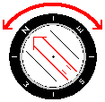
The Compass Housing can turn.
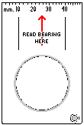
The Base should point in the direction of travel.
Turn the Housing so that the Compass Needle lies over the
Orienting Arrow. (Put RED to BED)
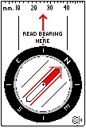
In this case the direction you are facing is North West

