
Clinometer
A clinometer is a simple device used to measure angles. It can be used to measure the slope of a specific terrain, the height of a building or tree, or the declination of a celestial body. In the diagrams below the slope of the Schoolyard Habitat is measured.

Materials needed
2 metersticks per group ,
1 protractor , 1 straw , 1 level,
1 weight (a hex nut is used here),
length of string (marked off in meters),
short length of string to support the weight
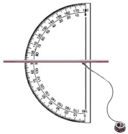
Assemble your clinometer as shown and loosely attach to the end of one of the metersticks.
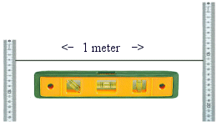
Place metersticks 1 meter apart. String should be level to assure greater accuracy.
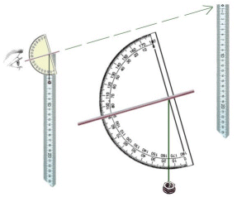
Turn the clinometer so that the top of the other meterstick can be seen through the straw.
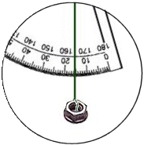
The angle of inclination between the two points is 16 degrees
This information can be used to plot a topographic map of the schoolyard habitat, determine proper planting locations of certain vegetation, or establish the placement of other landscape elements.

