**Bank Account Information Form**

A project sponsor must establish a separate, non-interest-bearing bank account for the purpose of receiving Green Acres advance payments for the project. If the project sponsor has undertaken more than one Green Acres project, it may establish a single bank account to receive all Green Acres disbursements for all of the projects. If the project sponsor will be receiving its Green Acres disbursement only as reimbursements, it may designate an existing account (interest or non-interest bearing) into which the disbursement will be received, provided proper accounting procedures are in place to allow for easy and accurate financial tracking of Green Acres disbursements. **Any account into which Green Acres disbursements are deposited will be subject to audit by the State.**

All Green Acres grant and loan disbursements will be made via ACH payment. Please have the Chief Financial Officer complete this form and the attached *Electronic Payment Authorization for Non-Procurement Vendors* form and return them to your Green Acres project manager.

Date:

# Green Acres Project Sponsor:

Municipality: County:

Or

Nonprofit Organization

Project Name: Project Number:

# Chief Financial Officer

Name: Phone:

Signature:___________________________________________

Email address: **Please check one of the following:**

Vendor Number: ______________________________________ Non-Interest Bearing Account

*(required for advance payments)*

Bank Transit Number: __________________________________ Interest Bearing Account

Account Number: _____________________________________

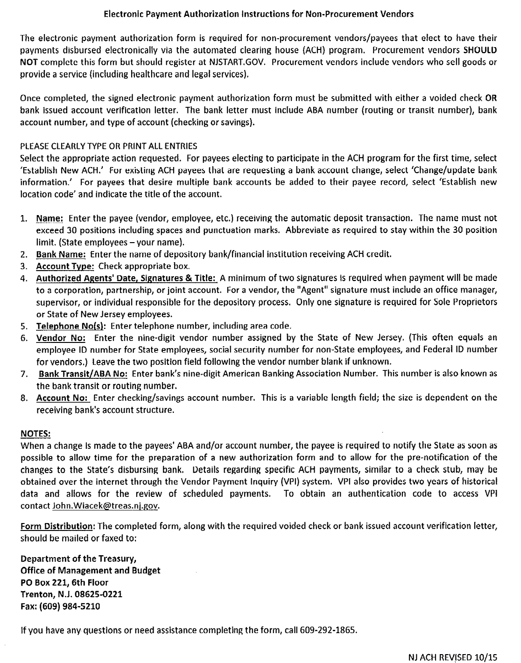

Please return to:

NJDEP Green Acres Mail Code 401-07B

P.O. Box 420

Trenton, NJ 08625-0420

