### Green Acres Program

### *New Jersey Department of Environmental Protection*

### Park Development Application

#### **Local & Nonprofit Assistance Program**

Deadline: **February 5, 2025**

Application Information Sessions:

**October 30, 2024, November 25, 2024, and December 18, 2024**



***Green Acres Mission Statement***

*To achieve, in partnership with others, a system of interconnected open spaces*

*the protection of which will preserve and enhance New Jersey’s natural environment*

*and its historic, scenic, and recreational resources for public use and enjoyment.*

Green Acres Program

Mail Code 401-07B

401 East State Street, 7th Floor

P.O. Box 420

Trenton, NJ 08625-0420

Tel: (609) 984-0500; Fax: (609) 984-0608

##### [**www.NJGreenAcres.org**](http://www.NJGreenAcres.org)

[GreenAcresApplications@dep.nj.gov](mailto:GreenAcresApplications@dep.nj.gov)

##### **Table of Contents**

Application Information 1

Park Development Application Overview 2

Eligibility 7

Eligible Projects 7

Eligible Project Sites 8

Eligible Costs 9

Funding 10

Funding Categories & Percentages 10

Matching Funds 12

Funding Round Caps 12

Public Engagement and Notice Requirements 14

Submitting A Competitive Application 15

Grounds For Application Disqualification 18

What happens after application submission? 19

Approval Process 19

Highlighted Project Administration Requirements 19

Project Period 20

Post-Project Requirements & Responsibilities 20

Forms & Samples 22

Park Development Application Form 23

Application Checklist – Park Development Projects 29

Application Checklist Items – Notes 31

Environmental Impact Assessment Outline 36

Park Development Tree Removal Evaluation Form 37

Synthetic Turf Field Addendum 39

Enabling Resolution Template 41

Anticipated Project Schedule – Park Development 42

Concept Plan Checklist 43

Project Narrative Outline Template 44

Public Hearing Checklist (Local Governments) 47

Public Notice Checklist (Nonprofits) 49

Public Hearing Announcement/Public Notice Templates 50

Nonprofit Eligibility Certification 51

Tools / References 52

Highly and Densely Populated Municipalities & Counties 53

Urban Aid Municipalities List 54

Municipalities That Contain an Overburdened Community Subject to Adverse Cumulative Stressors 55

Funding Request Limits by Applicant Type 59

How to Find Out if A Proposed Project is in an Overburdened Community Subject to Adverse Cumulative Stressors 60

How to Find Out if A Proposed Project is Designated as Historic 64

How to Confirm IRS Tax Exempt Status (Nonprofit applicants) 69

How to Confirm CRIA Compliance Status (Nonprofit applicants) 70

Allowable Costs (Local Governments) - Green Acres Rules Excerpt 71

Allowable Costs (Nonprofits) - Green Acres Rules Excerpt 72

Helpful Links 73

Application Information

Park Development Application Overview

Since 1961, the Green Acres Program has funded the acquisition of open space for recreation and conservation purposes, and the development of outdoor recreational facilities.  Green Acres remains committed to preserving New Jersey’s natural, historic, and recreational resources statewide and is pleased to continue the tradition of partnering with local and county governments and nonprofit organizations to serve New Jersey residents.

The Green Acres application package provides guidance for applicants, including information about the most frequently asked questions and common mistakes.  To assist applicants, a clickable Table of Contents and links throughout the document are provided to assist in locating the information needed to select the best funding option for the community’s needs, determine eligibility, understand the funding parameters, and submit a successful application.

To help Green Acres’ applicants submit competitive applications with a greater chance of success, information has been included on the types of projects that will achieve multiple public goals and support existing planning, open space, and recreation initiatives.  In the *Submitting a Competitive Application* section, details about the following State, Department, and Program priorities are provided:

* Public Engagement and Outreach
* Public Recreation Benefits
* Environmental Justice
* Community Revitalization
* Protection of Natural and Historic Resources
* Climate Mitigation and Resilience
* Consistency with Open Space and Recreation Planning
* Stewardship of Public Funds

As in recent past rounds, applicants are encouraged to review and acknowledge the requirements outlined in the Public Engagement and Notice Requirements section.  Please note that the traditionally required public hearing ***does not*** fulfill the public engagement requirement.  While a pre-application public hearing is still required, applicants must engage in public outreach activities **during the project planning process**, and those activities must be documented in the Green Acres application.  Please contact Green Acres with any questions about these requirements.  **Applications that do not include demonstration of meaningful public engagement during the project planning process will be deemed ineligible**.

Please share feedback and suggestions for future funding rounds by emailing [GreenAcres@dep.nj.gov](mailto:GreenAcres@dep.nj.gov).

**Getting Started:**

We recommend beginning the application process by focusing on the following items. Addressing these items early in the process will help ensure that your application is complete and can be submitted by the application deadline.

1. Public engagement during the project planning process must be the first step. If it has not yet been initiated, this should begin right away. For more information, skip to the Public Engagement and Notice Requirements section.
2. For local governments: Pick a date for the public hearing. Once the date is established, you can work out the timing of the website and newspaper notices of the public hearing and take the steps necessary to get proposed application and resolution on the governing body’s agenda. The date of the public hearing should allow for rescheduling prior to the application deadline in the case of inclement weather. Again, for more information, see the Public Engagement and Notice Requirements section.
3. Reach out to the Green Acres contact for your area and confirm proposed project eligibility and funding category.
4. We highly recommend reading through the entire application package to understand what is required and see the guidance we have provided to help you prepare an application that is likely to succeed.

**Application Support**

**Technical Support**

All interested applicants are encouraged to contact Green Acres *as early as possible* to discuss project eligibility, program priorities, and application procedures.  Staff are available for assistance throughout project planning, application preparation, and project management.

**Upcoming Information Sessions**

Green Acres will be hosting virtual application information sessions, on:

* October 30, 2024 - Application overview and Q&A
* 10:00am to 11:30am for Acquisition projects (including Green Acres and Urban Parks), and
* 1:00pm to 2:30pm for Park Development (Green Acres and Urban Parks), Stewardship, and Jake’s Law projects.
* November 25, 2024 - Application Q&A (no presentation)
* 10:00am to 11:00am for all projects
* December 18, 2024 - Application Q&A (no presentation)
* 10:00am to 11:00am for all projects

Notices will be sent to stakeholders, and links to the virtual application information sessions will be posted on the Green Acres website. The virtual application information sessions will be recorded, and the recordings will also be available on the Green Acres website.

**Green Acres Contact**s

Please reach out to the appropriate project manager regarding application questions.  Email outreach is recommended.  The [Green Acres contact list](https://dep.nj.gov/greenacres/contact-us/) can be found on the website, or general questions may be directed to  [GreenAcresApplications@dep.nj.gov](mailto:GreenAcresApplications@dep.nj.gov), or (609) 984-0500.

**Definitions**

These definitions are used in the application materials.  Please note that all population data is based on the 2020 Census:

**Municipalities**

Highly Populated Municipality **–** A municipality with a population of 35,000 or more

Densely Populated Municipality **–** Amunicipality with a population density of 5,000 or more per square mile

Urban Aid Municipality **–** A municipality eligible to receive state aid pursuant to P.L.1978, c.14 (C.52:27D-178 et seq.)

Standard Municipality **–** A municipality that does not qualify as Highly Populated, Densely Populated, or Urban Aid

**Counties**

Highly Populated County **–** A county with a population density of 1,000 or more per square mile

Densely Populated County **–** A county with a population density of 5,000 or more per square mile

Standard County **–** A county that does not qualify as Highly Populated or Densely Populated

**Environmental Justice Definitions**

Overburdened Community (OBC) **-** New Jersey’s Environmental Justice Law defines an [overburdened community](https://dep.nj.gov/ej/policy/communities) as any census block group, as determined in accordance with the most recent United States Census, in which:

* at least 35 percent of the households qualify as low-income households (at or below twice the poverty threshold as determined by the United States Census Bureau); and/or
* at least 40 percent of the residents identify as minority or as members of a State recognized tribal community; and/or
* at least 40 percent of the households have limited English proficiency (without an adult that speaks English “very well” according to the United States Census Bureau).

Overburdened Community Subject to Adverse Cumulative Stressors (ACS/OBC) **-** Previously referred to as an Adversely Stressed OBC, this is an Overburdened Community with a combined stressor total higher than the 50th percentile for total environmental and public health stressors.

Easily Accessible From an ACS/OBC – Less than ¼ mile away with no barriers to pedestrian access.  Barriers include impediments to people walking to the site, such as highways or impassable waterways.  Pedestrian access distance is measured not “as the crow flies,” but using GIS to follow the roads an ACS/OBC resident would need to walk to get to the site.

Lists of Highly and Densely Populated Municipalities, Highly Populated Counties, Densely Populated Counties, Urban Aid Municipalities, and municipalities that contain at least one Overburdened Community Subject to Adverse Cumulative Stressors can be found in Tools/References. The Green Acres Program encourages applicants to review this information prior to project planning to determine applicant category and to check whether the potential project is located within an ACS/OBC using [EJMAP](https://experience.arcgis.com/experience/548632a2351b41b8a0443cfc3a9f4ef6) (see instructions in Tools/References). It is important to note that the Office of Environmental Justice updates the ACS/OBC data each year, which can result in census blocks being added or removed. Please reach out to your Green Acres contact with any questions.

**2025 Funding Round Programs**

The Green Acres Program will offer four funding programs for 2025, as identified below.  Information about each program is provided in all Green Acres application packages to ensure that applicants are aware of all funding options and the limits on the number of funding requests that can be submitted per applicant.

**Figure 1:  2025 Funding Round Programs**

*Applicants may submit one request per funding program*

|  |  |  |
| --- | --- | --- |
| **Program** | **Description** | **Eligibility Notes** |
| **Traditional Green Acres** | Land Acquisition  (including Planning Incentive, Site-Specific Incentive, Standard, Urban Aid, or Nonprofit)  ***OR*** | All local governments and nonprofits |
| Park Development  ***OR*** | All local governments; Nonprofit projects located in an Urban Aid, Densely Populated, or Highly Populated Municipality or a Densely Populated County or that draw over 75% of their users from those areas |
| Urban Parks Rollover | Projects located within Overburdened Communities Subject to Adverse Cumulative Stressors within Urban Aid Municipalities that were unfunded or underfunded through the Urban Parks Program |
| **Stewardship** | Restoration and Protection of Natural Resources and Historic Landscapes | All local governments and nonprofits |
| **Jake’s Law Playground Funding** | Completely Inclusive Playgrounds – *Final year of enhanced funding pilot program* | County and municipal governments |
| **Urban Parks** | Land Acquisition, Park Development & Historic Preservation | Local government projects located within Overburdened Communities Subject to Adverse Cumulative Stressors within Urban Aid Municipalities |

This application is for park development projects.  Please see the [Green Acres’ Forms and Regulations website](https://dep.nj.gov/greenacres/forms-and-regulations/#green-acres-application-forms) to obtain applications for other programs.  Please note that February 5, 2025, is the deadline for all funding programs, for new applications as well as supplemental funding requests from local governments and nonprofits that have active projects that are progressing in a timely fashion.

For local governments and nonprofits seeking supplemental funding for previously approved Traditional Green Acres or Stewardship projects, please complete and submit the 2025 Supplemental Funding Request Form, available on the [Green Acres website](https://dep.nj.gov/greenacres/forms-and-regulations/) by the February 5, 2025 deadline.  Applicants for supplemental funding should reach out to the appropriate Green Acres contact for assistance in filling out the form.

Funding Request Limits

Applicants may submit one request for each funding program for which they are eligible, and the one request for each program may be a new application *OR* a supplemental funding request.  For example, an applicant can request supplemental funding for a Planning Incentive project OR funding for a Green Acres park development application, but not both.  The *Funding Request Limits by Applicant Type* chart in the Tools / References, which lists the maximum number of funding requests that can be submitted by each applicant type, may be helpful.

Please carefully consider project management capacity when deciding how many applications to submit.  To ensure project success, applicants should not take on more than they can complete within the 2-year project period.

Eligibility

The Green Acres Program *strongly* encourages applicants to contact the program to discuss the proposed project and confirm eligibility prior to preparing an application.  New applications will undergo an eligibility and completeness review upon receipt; only those complete applications deemed eligible will be ranked and compete for funding.

**Eligible Applicants**

Local Governments – County and municipal governments are eligible to apply for funding, with limitations for the Urban Parks program noted above in Figure 1.  School boards, housing and utility authorities, and other similar agencies without primary recreation and conservation responsibilities are not eligible.

Nonprofit Organizations – Nonprofits that meet the requirements set out in the Nonprofit Eligibility Certification form are eligible to apply for traditional Green Acres funding, with limitations for park development projects noted above in Figure 1.  This form must be signed by the nonprofit’s chief executive officer or state director and its attorney, and the form and attachments must be submitted with the application.

**Please note**: Municipalities and nonprofits that have three or more open projects, and counties that have five or more open projects, as well as applicants that are not making sufficient progress resolving open compliance issues, were notified in October 2024 that they are not eligible to submit new applications.  The following exceptions apply for applicants that have too many open projects: (1) They are eligible to submit a new Jake’s Law application; and (2) They may submit supplemental funding requests for open projects if those projects are making significant progress.  No exceptions apply for applicants with stalled compliance issues.

Eligible Projects

Eligible park development projects are those that create, restore, or expand outdoor recreation opportunities. Eligible recreation facilities include, but are not limited to, athletic fields and courts, recreational trails and trail amenities, facilities for picnicking, fishing, boating, biking, hiking, swimming, camping, nature and historic interpretation, and similar activities.

Facilities that support outdoor recreation are also eligible; examples of support facilities include lighting, parking areas, and structures that provide restrooms, concessions, or storage for park equipment. Support facilities or other ancillary project elements (i.e., parking lots, site preparation costs, etc.) should be commensurate with the recreational component of any given project or phase. Projects must result in a usable recreation facility; applications for support facilities and/or ancillary improvements alone will likely not rank high enough to receive a funding award.

Indoor recreation facilities, community centers, school sports facilities, and facilities that support semi-professional or professional athletics are not eligible for Green Acres funding. All projects must be constructed in compliance with the Americans with Disabilities Act, and we encourage applicants to exceed the minimum ADA standards and provide maximum accessibility whenever possible.

***Synthetic Turf***

Green Acres continues to prioritize the installation of natural turf over synthetic turf but understands that some applicants believe synthetic turf may best meet their community’s needs. Green Acres periodically re-evaluates the safety and environmental impact of synthetic turf fields, as more research is done on their benefits and risks.  The DEP’s Division of Science and Research has conducted several reviews of existing research on Green Acres’ behalf.  Based on their findings, Green Acres will continue to fund the construction of synthetic turf fields, but applicants are required to conduct their own due diligence and share it with the public. By reviewing the available information and weighing the potential benefits and risks, applicants can make an informed decision for their communities. If applicants choose to install an artificial turf field, the information gathered through the due diligence process may help limit the risks associated with this type of recreation facility.

Applicants must specifically address in their application each item listed in the Synthetic Turf Field Addendum to the Environmental Impact Assessment and explain the reasons they are choosing synthetic over natural turf. Applicants also must review their due diligence with the public, including the findings and reasons for choosing synthetic turf over natural turf. **Applications that do not demonstrate compliance with these requirements will not be funded**. Please note that synthetic turf fields, like natural turf fields, must be open to the public, including regular unscheduled public access.

***Previously Funded Facilities***

Replacement of facilities that Green Acres funded less than 20 years ago is ineligible, with limited exceptions. Please contact Green Acres early in the project planning stage if there is uncertainty about previous funding, or possible extenuating circumstances warranting re-funding, as waiting until late in the process may result in insufficient time to ensure the proposed facilities are eligible. Applicants applying for funding for previously funded facilities should reach out to their Green Acres contact to obtain the Facility Refunding Waiver Request Form.

Eligible Project Sites

Applicants may apply to develop any property with clear title, except property that:

* is identified by a municipality or otherwise designated for use in meeting municipal fair share low- and moderate-income housing obligations under the Fair Housing Act of 1985 (N.J.S.A. 52:27D-301);
* is designated as a road right-of-way; and/or
* does not have an established legal means of access

Nonprofit park development projects must be located in an Urban Aid, Densely Populated, or Highly Populated Municipality or a Densely Populated County or draw over 75% of users from those areas. Lists of these locations can be found in the Tools/References section.

Applications to construct improvements on multiple parks (“multi-park projects”) are not eligible. Park development applications must include proposed improvements at one project site only.

Site Ownership

Applicants must either own the land to be developed or must obtain an irrevocable lease (pre-approved by Green Acres) for a term of at least 25 years starting from the beginning of the project. If no such lease exists, applicants should submit a letter from the landowner stating that they will provide such an agreement if the project is approved.

If the applicant does not own the land, but the property is listed on a Recreation and Open Space Inventory of a local government that is not the project sponsor, the applicant may instead include in the application a use agreement (pre-approved by Green Acres) authorizing access to the site and permission to construct the proposed improvements, or a letter or governing body resolution from the landowner stating that they will provide such an agreement.

If improvements are proposed within state-owned tidelands, the applicant must hold a grant or license to use the property.

Board of Education Property

In rare circumstances, Green Acres provides funding to develop or rehabilitate recreational facilities located on school property to accommodate communities that have limited parkland and must meet the recreation needs of a significant population (e.g., built-out urban areas). If this situation applies to your community and you would like to request Green Acres funding for such a facility, please immediately reach out to your Green Acres contact to obtain the Request for Green Acres Funding for Facilities on Board of Education Property Form. This document provides information on the potential project and must be signed by the local government and the superintendent of schools. We recommend submitting the form before applying to confirm project eligibility.

Site Limitations & Permitting

Applicants seeking development funds should carefully analyze site suitability early in the open space/outdoor recreation planning process and prior to applying to Green Acres. Early awareness of possible site development limitations is integral to sound planning practices and often minimizes subsequent construction delays and constraints. Site attributes, such as wetlands, dunes, endangered species, mature forested areas, or other significant natural resources, may define, limit or, in some instances, preclude current or future development. Permit identification is required as part of all Green Acres development applications, and applicants are urged to seek assistance from the DEP or other regulatory/permitting agencies to ascertain whether special approvals and permits may be associated with sites proposed for recreational development.

Projects that involve improvements to a historic property shall meet the Secretary of the Interior's Standards for the Treatment of Historic Properties, as determined by the State Historic Preservation Office. Projects involving a historic or cultural landscape shall meet the Secretary of the Interior's Standards for the Treatment of Historic Properties and follow the Secretary of the Interior's Guidelines for the Treatment of Cultural Landscapes (see *Helpful Links*).

Green Acres encourages applicants to reclaim and restore former brownfields sites and transform them into public spaces, such as recreational and natural areas. The Department’s [Office of Brownfield and Community Revitalization](https://dep.nj.gov/srp/brownfields/) has experienced DEP case managers who can assist with remediation and revitalization efforts.  Applicants can apply to develop a contaminated site and, if approved, pursue remediation while obtaining and submitting the other necessary deliverables for the park development project.

Eligible Costs

The following are eligible park development project costs:

* + The cost of constructing the recreational facilities
  + Professional services (i.e., engineering and construction supervision), up to a cap of 13% of eligible and completed construction costs
  + Environmental assessment costs, i.e., the cost of the preliminary assessment report and, if necessary, the site investigation report, provided these reports are prepared in accordance with Green Acres guidelines
  + The cost to demolish *non-historic* structures
  + Other incidental costs related to the development project, including legal and advertising, are eligible up to a cap of 2% of submitted construction costs or $20,000, whichever is less
  + Permit fees
  + Cost of equipment required to make a facility operational

To ensure sufficient funding, all anticipated costs should be included in the initial funding request.

The following costs are not eligible for park development funding:

* + Administrative and operating costs and salaries and wages of any employee of the local government or nonprofit applicant
  + Costs to remediate a contaminated site

For more information, see the Green Acres Rules excerpts for Allowable Costs in Tools / References.

Funding

Applicants are strongly encouraged to contact the appropriate Green Acres project manager prior to application preparation to confirm funding categories and likely awards.

Funding Categories & Percentages

The categories of park development projects are summarized below and in Figure 2. Categories 1-3 apply to local governments; category 4 applies to nonprofits. See Matching Funds section below for information on Green Acres loan funding.

* 1. Park Development Project Located in or Easily Accessible From an Overburdened Community Subject to Adverse Cumulative Stressors – Local government projects located in or easily accessible from (see definitions) Overburdened Communities Subject to Adverse Cumulative Stressors. These projects are eligible for 0% loan funding, if available, and the following grant percentages:

1. Such projects *located in* a Standard municipality are eligible for 25% matching grant funding.
2. Such projects *located in* a Highly or Densely Populated Municipality are eligible for 50% matching grant funding.
3. Such projects *located in* an Urban Aid Municipality are eligible for 100% grant funding.
   1. Urban Aid Development – Local government park development projects *located in* Urban Aid Municipalities, but not within an Overburdened Community Subject to Adverse Cumulative Stressors. Projects in this category are eligible for a 75% matching grant and, subject to available funding, 0% loan funding.

* 1. Standard Park Development – Local government projects not located within an Urban Aid Municipality or located within or easily accessible from an Overburdened Community Subject to Adverse Cumulative Stressors. Green Acres provides funding to local governments for 0% loan funding for these projects. In addition, partial grant funding is available as noted below:
     1. Projects *located in* a Highly or Densely Populated Municipality or *sponsored by* a Highly Populated County (see enclosed list) are eligible for funding in the form of a 25% matching grant.
     2. Projects *sponsored by* a Densely Populated County (see enclosed list) are eligible for funding in the form of a 50% matching grant.
     3. Projects *located in* an Urban Aid Municipality (see enclosed list) are eligible for funding in the form of a 75% matching grant.

* 1. Nonprofit Development – Park development projects sponsored by qualifying nonprofit organizations and *located in* an Urban Aid, Densely Populated, or Highly Populated Municipality or a Densely Populated County. Alternately, a nonprofit park development project may be eligible if the park draws over 75% of its users from those areas. If this exception appears applicable, please contact the appropriate Green Acres project manager to discuss the proposed project *before applying*. All nonprofit park development projects are eligible for a 50% matching grant.

**Please note:** If a project falls into more than one category (e.g., a project located in an Urban Aid Municipality sponsored by a Highly Populated County), the more favorable grant percentage applies.

**Please also note:** If supplemental funding is awarded for a project that has changed categories since the original award (e.g., a project located in or easily accessible from an Overburdened Community Subject to Adverse Cumulative Stressors in a Highly or Densely Populated Municipality), the supplemental funding will be awarded at the new grant percentage; the original funding award will remain at the previous grant percentage.

**Figure 2: Grant Percentages for Green Acres Park Development Projects by Applicant, Project Location**

***(See*** ***Matching Funds*** ***section for discussion of Green Acres loan funding)***

|  |  |  |  |  |
| --- | --- | --- | --- | --- |
| **Grant %** | **Park Development Project Located in or Easily Accessible from an Overburdened Community Subject to Adverse Cumulative Stressors** | **Urban Aid Park Development** | **Standard Park Development** | **Nonprofit Development** |
| **0%** |  |  | *Project sponsored by a standard municipality or standard county and not located in ACS/OBC eligible for low interest loan only* |  |
| **25%** | *Project sponsored by a standard municipality or standard county* |  | *Project located in a Highly or Densely Populated Municipality or sponsored by a Highly Populated County and not located in ACS/OBC* |  |
| **50%** | *Project located in a Highly or Densely Populated Municipality or sponsored by a Highly Populated County* |  | *Project sponsored by a Densely Populated County and not located in ACS/OBC* | *Project sponsored by a qualifying nonprofit, located in an Urban Aid, Densely Populated, or Highly Populated Municipality or a Densely Populated County, or that draws over 75% of its users from those areas* |
| **75%** | *Project sponsored by a Densely Populated County* | *Project located in an Urban Aid Municipality and not located in ACS/OBC* |  |  |
| **100%** | *Project located in an Urban Aid Municipality* |  |  |  |

Matching Funds

Apart from projects that receive 100% grant funding or 100% loan funding, Green Acres funding must be matched. Possible sources of matching funds include:

* + Local government open space, capital, or bond funds
  + County open space program funding, used directly by the county or granted to municipalities/nonprofits
  + Other public funding sources
  + Private or corporate monetary donations
  + Grants from private foundations
  + Green Acres loan funding for local governments, if available. Park development project loans have a term of 20 years and a 0% interest rate. Please note that grants and loans obtained through the Green Acres Program are not subject to local government CAP laws. Upon loan approval, a local government will be required to pass a capital spending ordinance authorizing two semi-annual repayments to the state.

Ineligible sources of match funding include:

* + Other Green Acres funding (i.e., Green Acres State Land Acquisition Program funding or Green Acres Local & Nonprofit Assistance Program funding awarded to a different applicant)
  + Other funding awarded through the Garden State Preservation Trust (i.e., funding from the State Farmland Preservation Program or the NJ Historic Trust)
  + The value of any donated goods and services that have not been obtained in conformance with the Local Public Contracts Law, N.J.S.A. 40A:11-1 et seq.

Links to specific sources of possible matching funds can be found in the *Helpful* *Links*section. Applicants must identify the anticipated source of matching funds at the time of application, and the applicant’s Chief Financial Officer must sign off on the financial figures in the required resolution, including the available match amount.

Funding Round Caps

While projects may be eligible for funding up to a certain percentage of the total project cost, the actual amount awarded to individual projects is determined by weighing total demand against available resources. Since the demand for Green Acres funding consistently exceeds the amounts available, successful applications are normally approved subject to an award cap. Award cap amounts for local government projects are calculated using a base award, adjusted based on the type of applicant. Award cap amounts for nonprofit projects depend heavily on the demand for this smaller pot of funding.

While award levels cannot be predicted prior to knowing the total demand, for planning purposes, here is a chart of the range of funding round caps in the previous three funding rounds for each type of applicant:

**Figure 3: Funding Round Caps – Park Development Projects**

|  |  |  |
| --- | --- | --- |
| **Project Sponsor** | **Award Formula** | **Range of Funding Round Caps**  **2021-2024** |
| Standard Municipality | Base award | $600,000 - $700,000 |
| Highly or Densely Populated Municipality | 1½ x base award | $900,000 - $1,050,000 |
| Urban Aid Municipality | 2 x base award | $1,200,000 - $1,400,000 |
| Standard County | 2 x base award | $1,200,000 - $1,400,000 |
| Highly Populated County | 2½ x base award | $1,500,000 - $1,750,000 |
| Densely Populated County | 3 x base award | $1,800,000 - $2,100,000 |
| Nonprofit | N/A | Awards based on demonstrated need, past performance, and overall demand |

Applicants must design their park development project with a total project cost that does not exceed the likely funding award amount shown above, plus any required matching funds and any additional available funding. Please do not apply for a project that will need funding from a subsequent Green Acres funding round to proceed. Applicants that significantly reduce the scope of their project after funding has been awarded will be asked to withdraw and reapply in a future funding round.

If the anticipated project cost is significantly greater than the range of potential Green Acres funding and the necessary resources to make up the difference are currently unavailable, the applicant should scale the project down correspondingly or break the project into phases. Subsequent project phases may be eligible for future funding rounds; however, applications should only reflect one phase. The uncertainty surrounding future resources precludes Green Acres’ ability to guarantee assistance for subsequent phases.

Public Engagement and Notice Requirements

Meaningful public engagement is critical in order to accurately determine community open space and recreation needs and create better parks. Involving the public in project planning ensures that the investment of public funds reflects the community’s needs and priorities for *where* open space should be acquired and *how* it should be developed.

Community Engagement

All applications in the 2025 funding round, sponsored by local governments and nonprofits, must reflect meaningful community engagement during the project planning stage. As previously noted, **the required public hearing (see below) does not fulfill the application public engagement requirement, and applications that do not demonstrate additional community involvement during the project planning stage will not be funded**.

Instead of limiting engagement to one or two organizations (e.g., the open space committee or a particular sports league), applicants must strive to solicit broad community feedback from varied sources. Whatever means are used to engage the public during project planning, outreach efforts should be well-advertised and offer ample opportunities for participation. The project application should document the public engagement efforts and clearly identify how final project plans incorporate community input.

To be eligible, applicants must implement at least two of the following outreach methods and submit documentation of completion for each:

1. Community survey
   * On-line surveys, advertised on websites, in local news sources, flyers, etc.
   * Paper surveys available at public buildings and events – e.g., library, municipal building, recreation center, senior citizen center, school functions

***Note***: To qualify as meaningful outreach, the survey should include open-ended questions to solicit respondent opinions and be conducted early enough in the process to allow sufficient time for response and to incorporate findings into project planning and design.

1. Community meeting *(in person and/or virtual; on site or elsewhere)*
   * Open house meetings
   * Design workshops
   * Focus groups
2. Invitation for community input
   * Pop-up feedback sessions at parks and/or at public buildings and community events
   * Emails/newsletters to households inviting input
   * Social media posts inviting input

Public Hearing & Notice Requirements – Local Governments and Nonprofits

In addition to the public engagement requirements, all local government applicants must advertise and hold a public hearing before applying. Requirements for the public hearing announcement, the hearing itself, and the hearing minutes were updated in recent funding rounds, and the complete requirements can be found in the attached checklist. Most notably, there is no post-deadline grace period for submitting the required public hearing documents. Minutes of the public hearing (draft is acceptable) must be submitted *by the application deadline* or the application will be incomplete and deemed ineligible.

County applicants are also required to forward the notice of the public hearing to the clerk of the municipality(ies) within which their project is located, preferably at least 15 days prior, but at a minimum 48 hours before the hearing.

All nonprofit applicants must publish a public notice regarding their application and notify the clerk of the municipality(ies) in which the proposed project is located. The complete public notice requirements can be found in the attached checklist, and a template for the notice has been included in the application package.

Submitting A Competitive Application

The Green Acres Program receives overwhelming interest from potential applicants and is not always able to approve all eligible projects. Applications for Green Acres funding are subject to a competitive ranking system (please see enclosed Project Narrative Outline template). The Project Description question in the application form and the Project Narrative Outline provide opportunities to highlight the benefits of the proposed project.

As previously noted, successful applications will reflect a combination of State, Department, and Program priorities, which figure prominently in Green Acres’ ranking. Given the interrelated nature of our environment and communities, these priorities may be addressed by multiple Factors within the Project Narrative Outline. Below is a discussion of these priorities with tips for how to consider each when designing a project and preparing the application.

**1.**  **Public Engagement and Outreach**

Public engagement is not only an application requirement (see previous section), but the quality of engagement efforts is also an element in the project ranking. Applicants can address this priority in their responses to Factors 1 and 4 of the Project Narrative Outline.

**2.** **Public Recreation Benefits**

All funded project sites must have meaningful public access. To be competitive, however, applicants should highlight in Factors 1 and 5 how the proposed project will provide significant public recreation benefits, for example by:

* Serving a large population that can easily access the property by walking or public transportation, particularly within an Overburdened Community Subject to Adverse Stressors
* Including passive and active recreation options
* Planning to provide recreation opportunities that are not readily available in the area, and that will meet the needs of different user groups, age groups, and abilities, particularly within an Overburdened Community Subject to Adverse Stressors
* Enhancing access to waters consistent with the [Municipal Public Access Plan](https://www.nj.gov/dep/cmp/access/mpaplans.htm)
* Providing an improved trail connection between a community and local parkland or a trail system
* Serving other recreation needs – e.g., project site is located across the street from a school or within a transit hub, park accommodates seasonal increase in population, or facilities reflect the cultural needs of the community

**3.** **Environmental Justice**

Central to the Green Acres mission is improvingthe quality of life for all NJ residents, particularly those in communities with environmental justice concerns. New Jersey’s Environmental Justice Law, passed in 2020, provided a targeted approach for this goal, and Green Acres gave priority to projects in Overburdened Communities (OBCs) in the 2021 funding round. Using environmental stressors data, the Department subsequently identified Overburdened Communities Subject to Adverse Cumulative Stressors, those OBCs that are higher than the 50th percentile for total environmental and public health stressors. In turn, Green Acres refined its project ranking and funding policies in 2023 to offer additional points and enhanced grant funding to projects that are located within or are easily accessible from (see definitions) an Overburdened Community Subject to Adverse Cumulative Stressors. To ascertain if a proposed project meets these criteria, please see the instructions in the Tools/References section at the end of this application. Applicants can address this priority in their response to Factor 1.

**4.** **Revitalization**

Green Acres supports expanding outdoor recreation and conservation opportunities through the reclamation and restoration of vacant industrial or commercial properties, including landfills, brownfields, other contaminated sites, and expansive impervious parcels. Transforming these lands into recreational and natural areas revitalizes communities and improves residents’ quality of life. Applicants can address this priority in their response to Factor 4. The application should highlight how the project will help revitalize the property through:

* Demolition of dilapidated buildings
* Removal of expansive impervious surfaces
* Remediation of known contaminated sites
* Clean-up of solid waste

**5.** **Protection of Natural and Historic Resources**

Conservation and environmental protection goals have always been a core part of the Green Acres mission, including protection of critical wildlife habitat, unique natural areas and land types, biodiversity, flood storage areas, and surface and groundwater quality. Green Acres funding has also supported the protection of significant historic resources. Applicants should discuss in Factors 4 and 6 how the project contributes to these efforts in either or both of these ways:

* Direct preservation of natural and historic resources – e.g., through restoration; and
* Protection of these resources from harm – e.g., through projects that provide or preserve buffers to protect them.

**6.** **Climate Mitigation and Resilience**

Reducing and responding to climate change is a top statewide priority, and a particular focus for the DEP. Open space and park development projects can help contribute to climate mitigation and resilience, particularly through efforts to preserve and enhance natural carbon sequestration and flood mitigation. Applicants should highlight in Factor 2 how the proposed project will support climate mitigation and resilience, e.g., through:

* Preservation of forested and flood-prone areas, such as acquiring properties that are located within one of the Flood Hazard Zones within FEMA’s Flood Zones, as identified by [New Jersey’s Flood Indicator Tool](https://njdep.maps.arcgis.com/apps/webappviewer/index.html?id=e26feba3b4844e5d960d3163b23623f2)
* Expansion of upstream flood attenuation potential
* Reduction or minimization of impervious surfaces
* Consistency with the applicant’s Climate Resilience Plan
* Support for *New Jersey’s Global Warming Response Act 80x50 Report* strategies and goals, including but not limited to permanent preservation for sequestration purposes

Please see *Helpful Links* in Reference Documents for more information about the DEP’s climate change efforts, climate-friendly parks, and sustainable building design.

The DEP’s 80x50 Report identifies carbon sequestration as an important climate mitigation and resiliency tool and promotes the maintenance and expansion of the state’s tree canopy.   With this goal in mind, Green Acres strongly discourages tree removal and encourages applicants to include native tree plantings in their park development projects.  Applicants are asked to provide more detailed information regarding any tree removal proposed as part of the project, including a discussion of alternatives to removing the trees. Tree removal information will be requested as part of the Environmental Impact Assessment (see form for additional information). Projects that propose excessive tree removals will not be eligible for funding.

Local government applicants can obtain guidance on effective tree and forest ecosystem management, including technical and financial assistance, from the DEP’s [Urban & Community Forestry Program](https://www.nj.gov/dep/parksandforests/forest/urbanandcommunity/).

**7.** **Consistency with Open Space and Recreation Planning**

Green Acres is dedicated to investing in open space and recreation projects that reflect local priorities and support regional and state planning goals. Applicants should demonstrate planning consistency in Factor 2 through discussion of how the following planning resources influenced the design of the proposed project:

* Consultation with local and county government officials and commissions, including recreation staff and advisory boards, environmental commissions, historic preservation committees, and open space committees
* Consultation with local interest groups, including environmental groups, historic preservation groups, athletic clubs, and other community groups and current or potential park users
* Local and county land use plans, and specifically any open space or recreation elements
* Regional planning efforts, such as regional trail plans, redevelopment plans, and special area master plans (e.g., [Highlands](https://www.nj.gov/njhighlands/master/), [Meadowlands](https://www.njsea.com/master-plan/#:~:text=HACKENSACK%20MEADOWLANDS%20DISTRICT%20MASTER%20PLAN%20UPDATE%202020&text=The%202020%20Master%20Plan%20Update,economic%20growth%20in%20appropriate%20areas.), [Pinelands](https://www.nj.gov/pinelands/cmp))
* State open space and land use planning efforts, such as the [New Jersey State Development and Redevelopment Plan](https://www.nj.gov/state/bac/planning/state-plan/overview/) (State Plan) and the Statewide Comprehensive Outdoor Recreation Plan, [*Outside, Together!*](https://dep.nj.gov/outside-together/) (Please address *Outside, Together!* Principles)
* The [NJMAP/Conservation Blueprint](https://www.njmap2.com/blueprint/), an interactive map-based statewide open space and recreation planning tool
* [*Furthering the Promise*](https://dspace.njstatelib.org/xmlui/bitstream/handle/10929/68451/furthering-the-promise.pdf?sequence=1&isAllowed=y), a guidance document for advancing environmental justice
* NJ’s *Global Warming Response Act 80x50 Report,* the *Climate Change Resilience Strategies*, the *Scientific Report on Climate Change*, and the appropriate [regional action plan](https://www.nj.gov/dep/bcrp/resilientnj/), if available, all available through the Department’s [Climate Change](https://www.nj.gov/dep/climatechange/) website.
* The municipal [DEP-approved Public Access Plan](https://www.nj.gov/dep/cmp/access/mpaplanapproved.htm), if the municipality has prepared one (please note if it has been incorporated into the master plan)
* The NJ Department of Health and NJDEP [Healthy Community Planning](https://www.nj.gov/health/hcpnj/about/overview/) website and resources
* For a project involving a historic property, the [New Jersey Comprehensive Statewide Historic Preservation Plan](https://www.nj.gov/dep/hpo/Index_HomePage_images_links/hpo_plan%202013_2019/hpoplan2014.pdf) and, if applicable, a planning document such as a Historic Structures Report, a Preservation Plan, or a
* Cultural Landscape Report; and the National Park Service’s Professional Qualification Standards in the relevant disciplines, published at 36 CFR Part 61

**8.** **Stewardship of Public Funds**

The Green Acres Program has the responsibility to ensure public funds it administers are invested wisely. Applicants should establish through Factors 1, 2, and 3 that the proposed project is a good investment by:

* Highlighting any aspects of the project that demonstrate cost-efficiency, e.g., matching funds from other funders, donations of value, use of cost-saving technology
* Documenting that the applicant is aware of the increased cost of maintenance and has the financial resources and staff/volunteers to properly maintain the funded facilities
* Demonstrating consideration of the 2-year project period that Green Acres establishes after project approval, through a description of anticipated timeline milestones and deadlines, ensuring that the community will benefit from the proposed project in a timely fashion

Applicants for park development projects should also:

* Review the cost of the project in light of the anticipated life of the facilities
* Confirm that sufficient public outreach and recreational planning was conducted to ensure that the proposed facilities are appropriately designed to meet short-term community needs and will be relevant and used by the community for years to come

Grounds For Application Disqualification

As previously noted, new applications will undergo an eligibility review upon receipt; only those deemed eligible will be ranked and compete for funding. The following circumstances will disqualify an application:

1. Applicant is a municipality or nonprofit that has three or more open projects or is a county that has five or more open projects at the time of application (affected applicants were previously notified)
2. Applicant has failed to adequately address outstanding Green Acres compliance issues (affected applicants were previously notified)
3. Application submission does not include all required items by deadline (see Submissions Checklist)

(Must be submitted on the Green Acres website by 5:00 pm on February 5, 2025)

1. Application has failed to discuss and document meaningful public input during the planning process (see Public Engagement and Notice Requirements section)
2. Public hearing/notice requirements have not been met (please see appropriate checklist)
3. Application is not signed by the person authorized in the enabling resolution (“NOW, THEREFORE, BE IT RESOLVED...” paragraph)
4. Application is not fully signed, including by Chief Financial Officer (bottom of the last page of the application form)
5. Application is to re-fund a facility Green Acres funded less than 20 years ago, unless applicant has discussed the proposal with Green Acres staff and sufficient justification is submitted as per Green Acres rules and requirements
6. Proposed project is located on Board of Education property, unless applicant has discussed the proposal with Green Acres staff and sufficient justification is submitted as per Green Acres rules and requirements
7. Proposed project does not result in a usable recreation facility (e.g., only includes site work)
8. Proposed project involves excessive tree removal or otherwise causes significant environmental harm
9. Applicant is proposing to install or replace a synthetic turf field and has not conducted the required due diligence and/or has not shared the results with the public at the public hearing
10. Applicant has awarded the construction contract for the project without prior Green Acres authorization

What happens after application submission?

Approval Process

After applications are reviewed, Green Acres will first identify projects that are ineligible. Next, Green Acres will rank eligible projects and compile a list of approval recommendations, which then will be reviewed by the Department and transmitted to the Garden State Preservation Trust (GSPT). The GSPT will approve successful applications using funds available from the 2014 voter-approved referendum, which became the Preserve New Jersey Act (P.L. 2016, C 12). Green Acres will send letters notifying applicants if their application was successful or not. Approved projects must then go through legislative appropriation.

The length of the approval process has varied in the past, averaging 3-6 months. Many of the changes to be implemented during this funding round are designed to shorten the review process; this year the anticipated DEP/GSPT review period is 3 to 4 months after the submission deadline. We cannot predict the length of the legislative appropriation process.

**Please note**: To maintain funding eligibility, applicants must not move forward with bidding the project before funding awards are announced. Should an emergent circumstance arise, please contact the appropriate Green Acres project manager to discuss the At-Risk Authorization process.

Highlighted Project Administration Requirements

While Green Acres projects involve several requirements, the most notable are highlighted below.

Preliminary Assessment Report (PAR)

Green Acres requires careful review of all proposed project sites for evidence of past use as landfills; hazardous waste production, storage, or disposal sites; or the adverse effects resulting from such sites in close proximity to the proposed public park, as well as the presence of historic fill and certain residual agricultural chemicals. This review is intended to minimize public liability for site cleanup costs and allows the state, Green Acres’ applicants, and the public to be reasonably assured that lands acquired or developed with public funds can be used for recreation or conservation purposes without risk to public health.

For this reason, approved applicants will be required to obtain a preliminary assessment of the project site. Green Acres will provide guidance documents that require adherence to the criteria established by the DEP’s Technical Requirements for Site Remediation (N.J.A.C. 7:26E-3). A percentage of the costs normally associated with this professional service is reimbursable as part of an approved and completed Green Acres project, as long as the preliminary assessment is done in accordance with Green Acres guidelines.

If the Preliminary Assessment Report recommends additional investigation of any Area of Concern at the project site, the applicant will be required to submit a Site Investigation Report (SIR). If the SIR notes contamination above acceptable levels, the applicant may pursue remediation while obtaining and submitting the other necessary project deliverables. Once all Areas of Concern are resolved to the Department’s satisfaction, Green Acres participation in the project may proceed.

Local Public Contracts Law/Prevailing Wage Regulations

All applicants, *including nonprofits*, are required to administer park development and stewardship projects in accordance with laws governing public construction projects, most notably the [Local Public Contracts Law](https://www.nj.gov/dca/dlgs/rules_reg.shtml), N.J.S.A. 40A:11-1 et seq., and prevailing wage regulations. The LPCL often requires bidding project contracts. Applicants should discuss this with their attorney, Treasurer, and/or Qualified Purchasing Agent to ensure an understanding of the LPCL and prevailing wage requirements.

Conservation/Historic Preservation Restriction

Nonprofits that develop land with Green Acres funding must execute and donate to the State, at no charge, a conservation restriction or historic preservation restriction, as the case may be, pursuant to P.L. 1979, c. 378 (C.13:8B-1 et seq.) on the lands to be developed utilizing the grant. The conservation restriction and historic preservation restriction referred to in the law will be provided by Green Acres. For projects on leased land, the required lease will take the place of the restriction. Green Acres may waive this requirement for land that is currently or shortly will be listed on a local government’s Recreation and Open Space Inventory (see Post-Project Requirements & Responsibilities section below).

Project Period

Once approved, Green Acres establishes a two-year project period, during which time the local government or nonprofit must meet all procedural requirements, complete the development project, and request payment. In addition, significant progress must be made throughout the project period to remain eligible. A proposed project schedule is required as part of each application to assist with project planning and to allow Green Acres to evaluate the proposal. Please talk to the appropriate Green Acres project manager regarding any schedule changes that will affect the ability to meet project deadlines. Barring extenuating circumstances, approved projects that are not making significant progress or cannot be completed by the end of the project period will be cancelled.

Post-Project Requirements & Responsibilities

Prospective applicants are urged to familiarize themselves with the Department’s Green Acres Program rules (N.J.A.C. 7:36, found at the [Green Acres’ Forms and Regulations website](https://dep.nj.gov/greenacres/forms-and-regulations/)).  Acceptance of Green Acres funds obligates the local government or nonprofit to adhere to the Department’s requirements, both during the funding process and after a project is complete.

Protected Parkland – Recreation and Open Space Inventory

The Department is dedicated to creating a net increase in parkland. For that reason, a local government that receives Green Acres funding is not allowed to convey, dispose of, or divert to a use for other than recreation and conservation purposes (1) any lands (including facilities) funded by Green Acres and/or (2) any lands held by the local government for recreation and conservation purposes at the time of receipt of Green Acres funding.  The local government is required to list such lands on the Recreation and Open Space Inventory (ROSI), which is part of an application for Green Acres funding.  If the application is approved, the ROSI will become part of the project agreement between the local government and the State.

Parkland Maintenance and Operation

Prior to accepting our funding, local governments and nonprofits should be aware of the specific requirements of N.J.A.C. 7:36-25 regarding maintenance and operation of Green Acres encumbered parkland. The requirements related to maintenance and operation of Green Acres encumbered parkland are administered and enforced by the Department’s [Office of Transactions and Public Land Administration, Public Land Compliance Section](https://dep.nj.gov/otpla/public-land-compliance/) (“OTPLA”). These requirements include, but are not limited to,

* 1. Upon closing, Green Acres encumbered parkland must be open to the public without discrimination or exclusion based on residency.  N.J.A.C. 7:36-25.10 (for funded parkland) and N.J.A.C. 7:36-25.11 (for unfunded parkland)
  2. Scheduling the use of facilities either funded by Green Acres or located on parkland acquired with Green Acres assistance (funded parkland) is allowable, provided that such programmed uses are not exclusive or discriminatory and that adequate provisions are made for non-scheduled use.  N.J.A.C. 7:36-25.9.  The Department does not regulate the scheduling of facilities on unfunded parkland.  N.J.A.C. 7:36-25.11.
  3. Fees for use of directly funded sites are allowable.  Differential fees for use by non-residents or different categories of users may also be charged but must be discussed with OTPLA to ensure they are equitable.   All revenues derived from use or operation of a directly funded site must be used by the local government for the operation, maintenance, or capital expenses of either that park facility or their funded parkland or recreation system as a whole. A nonprofit must use any revenues derived from the use or operation of a funded site for either that park facility or other permanently preserved recreation and conservation land owned by the nonprofit.  N.J.A.C. 7:36-25.9.  The Department does not regulate the fees for use of unfunded parkland.  N.J.A.C. 7:36-25.11.
  4. Structures being acquired or developed with Green Acres funding, or new construction on funded parkland after a property is acquired by a local government or nonprofit, must be used exclusively in support of public outdoor recreation and conservation purposes and must be approved in advance by OTPLA. This condition will be included in the project agreement if the project is approved.  Many compliance problems result from the use of such structures for ineligible purposes.  To avoid such problems, local governments and nonprofits must discuss proposed future uses of structures with Green Acres and OTPLA, both during and after the funding process, to ensure that such uses are allowable.  N.J.A.C. 7:36-25.7.  The requirements for new construction or use of structures on unfunded parkland are similar to those that apply to funded parkland, but structures on unfunded parkland may be used for public indoor recreation as well as support of outdoor recreation.  N.J.A.C. 7:36-25.8.
  5. Leasing of Green Acres encumbered parkland for agricultural purposes is allowable as an interim parkland management tool but is not allowed as a permanent use of parkland.  Farm leases on funded parkland must be approved by OTPLA and are subject to specific requirements in N.J.A.C. 7:36-25.13.  Clearing of trees for agricultural use is not allowed on Green Acres encumbered parkland.  Public access is required after closing, even if the property is leased.
  6. Compliance inspections of funded parkland are conducted by OTPLA every three years.  If noncompliance is identified and not corrected in a timely fashion, Green Acres, in consultation with OTPLA, may suspend payments on active projects and the local government or nonprofit will not be eligible for future Green Acres funding.  Additional information about post-funding responsibilities can be found at [what-to-expect-when-we-re-inspecting-otpla.pdf (nj.gov)](https://dep.nj.gov/wp-content/uploads/otpla/plc-documents/what-to-expect-when-we-re-inspecting-otpla.pdf).
  7. Parkland must not be sold, leased, exchanged, or donated except to the State, or local government unit, a qualifying tax-exempt nonprofit organization, or the Federal government for recreation and conservation purposes (and then only with the prior written approval of the Commissioner).

Forms & Samples

**For G.A. Use Only**

Date Rec’d: ________________

Application No. _____________

### Local & Nonprofit Assistance Program

Park Development Application Form

Complete and submit application with all required attachments by February 5, 2025, through the Green Acres website. Instructions for submitting your application can be found at [www.NJGreenAcres.org](http://www.NJGreenAcres.org).

______________________________________________________________________________________________

**Project Information**

**Project Title: __________________________________________________________________________________ Project Sponsor: _______________________________________________________________________________**

Applicant Type *(please check appropriate box)*:

|  |  |  |  |
| --- | --- | --- | --- |
|  | Standard Municipality |  | Standard County |
|  | Highly or Densely Populated Municipality |  | Highly Populated County |
|  | Urban Aid Municipality |  | Densely Populated County |
|  | Nonprofit *(project must be located within an UA or HDP municipality or in a DP county, or draw over 75% of its users from those areas)* | | |

**Project Description**

On a separate page, please briefly address each of the following in order. This information will be used to determine project eligibility. *(See* *Submitting a Competitive Application* *section.)*

1. Description of the property, including:
   1. Physical site characteristics and features
   2. Existing land use, including any indoor recreation facilities and/or non-recreation uses
   3. Pre-existing and planned rights-of-way, easements, reversionary interests, or other legal rights and restrictions impacting the property
2. Please indicate if this proposal will create a new public park
3. Project scope - Please provide a bulleted list of proposed improvements, including specific facilities and general site improvements.* For each listed improvement:
   1. Please note whether each proposed improvement is an addition to the park, a rehabilitation of an existing facility, or if the improvement will replace an existing facility
   2. Please explain why it is needed
   3. For athletic fields, please specify natural or synthetic turf

*\*If part of a larger project, please only include proposed improvements that are included in the cost estimate for this phase.*

1. Please indicate if one or more trees will be removed during this project. (If so, the *Park Development Tree Removal Evaluation Form* must be completed.)

**Site Information**

Property Address:

|  |  |
| --- | --- |
| Street Address or Nearest Intersection |  |
| Municipality(ies) |  |
| County |  |

Property Lot(s) and Acreage(s) *(add rows or attach additional pages, if necessary)*:

|  |  |  |  |  |
| --- | --- | --- | --- | --- |
| **Block** | **Lot** | **Owned by Applicant?\*** | **Total Lot Acreage** | **Acreage to be Developed** |
|  |  |  |  |  |
|  |  |  |  |  |
|  |  |  |  |  |
| **Total Acreage to be Developed:** | | | |  |

*\* If not, please indicate if the land is currently leased or if the application includes a letter from the landowner indicating that they are willing to lease the property to the applicant.*

Site Location Categories – Municipal and Adversely Stressed OBC *(please check one in each column)*:

|  |  |  |  |  |
| --- | --- | --- | --- | --- |
|  | Standard Municipality |  |  | Within an ACS/OBC* |
|  | Highly or Densely Populated Municipality |  |  | Easily Accessible from an ACS/OBC** |
|  | Urban Aid Municipality |  |  | Not within an ACS/OBC |

*\*ACS/OBC = Overburdened Community Subject to Adverse Cumulative Stressors*

*See instructions in Tools/References for how to identify if a property is an ACS/OBC. Please attach screen shot.*

*\*\* See definitions. Include map showing route of travel from ACS/OBC (marked-up tax map is fine).*

**Is the property identified as historic on the NJDEP Historic Preservation Office LUCY Online Map Viewer?**

*(See instructions in Tools/References for how to identify if a property is a historic site. Please submit screen shot.)*

Yes _____ No _____

Are there any structures located on the project site? Yes _____ No _____

If yes:

Please identify each structure, its present condition, and its current use

__________________________________________________________________________________________

__________________________________________________________________________________________

Please note the intended use of each structure *(in support of outdoor recreation)* or if it will be demolished

__________________________________________________________________________________________

__________________________________________________________________________________________

**Is the project site a current or former landfill site, known or suspected hazardous waste site, or adjacent to (or**

**affected by) such sites?** Yes _____ No _____

**If yes, please explain:** ___________________________________________________________________________

**For currently undeveloped properties, has the project site been identified by a municipality or otherwise designated for use in meeting municipal fair share low- and moderate-income housing obligations under the Fair Housing Act of 1985(N.J.S.A. 52:27D-301)?**  Yes _____ No _____

**If yes, please describe the alternative to meeting such obligations:** ______________________________________ ______________________________________________________________________________________________

**State Legislative District of Project Site:** __________ **Congressional District of Project Site:** ___________

**Funding Request**

**Total Estimated Cost of Project *(see attached*** ***Allowable Costs*** ***Green Acres rules excerpt)*:**

|  |  |
| --- | --- |
| Construction  *(including contingency of up to 10%)* | $ |
| Engineering & Construction Supervision/Inspection  *(Limited to 13% of eligible and completed construction costs)* x 0.13= | $ |
| Preliminary Assessment Report  *(& Site Investigation Report, if necessary)* | $ |
| Permit Fees | $ |
| Incidental Costs  *(Limited to 2% of eligible and completed construction costs)*  x 0.02= | $ |
| **Total Project Cost – *Rounded to next $1,000*** | **$** |

**Green Acres Funding Request:**

|  |  |
| --- | --- |
| Total Project Cost *(from above)* | $ |
| x Eligible Grant %* | x 0.___ |
| Eligible Green Acres Grant | $ |
| **Grant Request** | **$** |
| **Loan Request** | **$** |

*\* See* *Funding Categories & Percentages* *section; confirm with Green Acres contact*

**Has the applicant received or is aware of previous Green Acres funding for this property/park (acquisition, development, or stewardship)?**   Yes _____ No _____

If yes, please list year, project # (if known), and funding recipient (if not applicant): ______________________________________________________________________________________________

**Has the applicant or partners received any funding awards from other sources for this project, or are any**

**applications pending?** Yes _____ No _____

If yes, please list source, amount, and deadline to use funds: ______________________________________________

______________________________________________________________________________________________

**Public Engagement**

Please describe the process that led to the development of this proposed project and how the public was involved. Public engagement must include outreach during the project planning stage. Please **do not discuss the required public hearing in this section**, as the hearing does not satisfy the application public outreach requirement.

_______________________________________________________________________________________________________

_______________________________________________________________________________________________________

_______________________________________________________________________________________________________

_______________________________________________________________________________________________________

Please discuss how the results of the public engagement process were incorporated into the project design. _______________________________________________________________________________________________________

_______________________________________________________________________________________________________

_______________________________________________________________________________________________________

Please identify the particular documentation of public engagement efforts that has been included in the application (e.g., survey questions and tabulated results, copy of mailing, photos from public meeting).

_______________________________________________________________________________________________________

**Post-Development Information**

Please give a detailed breakdown of anticipated operation and maintenance costs.

________________________________________________________________________________________________________________________________________________________________________________________________________________________________________________________________________________________________________________________________________________________________________________________

Are these costs greater than current site costs? If so, by what amount?

______________________________________________________________________________________________

What will be the source of funds for the operation and maintenance costs?

______________________________________________________________________________________________

**Sponsor Information**

Project Sponsor:

|  |  |
| --- | --- |
| Name of Local Government or Nonprofit |  |
| Street Address |  |
| City, State, Zip |  |
| Webpage Address |  |
| Tax ID Number |  |

Chief Executive Officer:

|  |  |  |  |
| --- | --- | --- | --- |
| Name |  | Telephone |  |
| Title |  | Email |  |

**Current Community Profile:**

*(County applications should provide information based on the anticipated service area of the project.)*

|  |  |  |  |
| --- | --- | --- | --- |
| Population |  | Year |  |
| Area (square miles) |  | Population/Square Mile |  |

**Contact for Application Questions:**

|  |  |
| --- | --- |
| Name |  |
| Title |  |
| Street Address |  |
| City, State, Zip |  |
| Telephone |  |
| Cell Phone |  |
| Email Address |  |

**Contact for Project Management if Project is Funded** *(if different than Application Contact)***:**

|  |  |
| --- | --- |
| Name |  |
| Title |  |
| Street Address |  |
| City, State, Zip |  |
| Telephone |  |
| Cell Phone |  |
| Email Address |  |

**Signatures (2)**

**I,** __________________________ (name of official authorized by the governing body resolution)**, hereby certify that the information provided within this Green Acres Program Application Form is complete and true.**

_______________________ _________________________________________________

Date Signature of official authorized to submit application*

**\* *Must be individual authorized by attached Enabling Resolution or application will be disqualified***

**I,** __________________________ (name of Chief Financial Officer)**, have reviewed the likely funding award for this project** *(see Figure 3:* *Funding Round Caps**)* **and hereby certify that the financial information in the attached Governing Body Enabling Resolution is accurate.**

_______________________ _________________________________________________

Date Signature of Chief Financial Officer

Application Checklist – Park Development Projects

Application materials must be submitted electronically in pdf form through the Green Acres website by **5:00pm on February 5, 2025**. Instructions for submitting your application can be found at [www.NJGreenAcres.org](http://www.NJGreenAcres.org).

***NOTE:*** This checklist should be returned with the completed application. If any of the starred items (*) are not applicable, please indicate ‘N/A’ next to that item. All other required items must be submitted. Specific instructions for each submission follow the checklist.

|  |  |  |  |
| --- | --- | --- | --- |
| **REQUIRED ITEMS – All applicants** | | | |
|  | 1. | Application Form | |
|  | 2. | Environmental Impact Assessment | |
|  | 3. | * Tree Removal Form, if project proposes tree removal | |
|  | 4. | * Synthetic Turf Addendum, if project proposes synthetic turf | |
|  | 5. | Governing Body Resolution | |
|  | 6. | Anticipated Project Schedule | |
|  | 7. | Units & Quantities Cost Estimate | |
|  | 8. | Tax Record for Each Tax Lot to be Developed | |
|  | 9. | *\* For Any Lot Not Owned by Applicant:* Copy of Lease/Use Agreement or Letter from Landowner Confirming They Will Enter into a Lease or Agreement | |
|  | 10. | Official Tax Map with Project Location Highlighted | |
|  | 11. | Aerial of Project Location with Streets Identified | |
|  | 12. | Concept Plan with Checklist | |
|  | 13. | *\** Conceptual Floor Plan, if project proposes development or redevelopment of a structure | |
|  | 14. | Photographs of the Project Site | |
|  | 15. | Project Narrative Outline | |
|  | 16. | List of Permits Anticipated to be Required for the Project | |
|  | 17. | Documentation of Public Engagement During the Project Planning Stage | |
| **ADDITIONAL REQUIRED ITEMS – Local Government Applicants** | | | |
|  | 18. | Public Hearing Checklist | |
|  | 19. | Proof of Publication for Public Hearing Website Notice and Newspaper Advertisement | |
|  | 20. | Public Hearing Minutes | |
|  | 21. | Recreation and Open Space Inventory (ROSI) Form | |
|  | 22. | *\** ***County projects:*** Notification to Municipality(ies) | |
| **ADDITIONAL REQUIRED ITEMS – Nonprofit Applicants** | | | |
|  | 23. | Nonprofit Eligibility Certification with Attachments: | |
|  | 24. | * IRS Website Printout | |
|  | 25. | * NJ Division of Consumer Affairs CRIA Website Printout | |
|  | 26. | * List of Current Board Members | |
|  | 27. | * Minutes from Most Recent Board Meeting | |
|  | 28. | Public Notice Checklist |
|  | 29. | Proof of Publication of Newspaper Notice | |
|  | 30. | Notification to Municipality(ies) | |
| **OPTIONAL ITEMS – All Applicants** | | | |
|  | 31. | * Letters of Support (recommended for ranking) | |
|  | 32. | * Existing Property Survey (if available) | |

Application Checklist Items – Notes

**REQUIRED ITEMS – All applicants**

* + - 1. **Application Form**

***Please make sure that/please note:***

* All questions are answered
* Project sponsor is the local government or nonprofit that is requesting funding
* Applicant type – see Definitions section & municipality/county lists in Tools / References
* Each item in Project Description is addressed in order
* Project Description information matches that provided in cost estimate and concept plan
* All tax lots for the subject property are listed separately with separate acreage figures
* Site location category – see Definitions section and municipality lists in Tools / References
* Overburdened Community Subject to Adverse Cumulative Stressors information – see *How to Figure Out if a Proposed Project is in an Overburdened Community Subject to Adverse Cumulative Stressors* in Tools / References
* Historic properties – see *How to Figure Out if a Proposed Project Site is Historic* in Tools / References
* Funding figures
  + Please review Allowable Costs excerpt from the Green Acres rules
  + Please contact Green Acres to review project cost and request figures
* Project contact is someone who the Green Acres Program can ask questions to about the application
  + If the applicant would like us to send project-related correspondence to another contact person if funding is awarded to the project, please list information for that individual as well
  + If a consultant is listed for both/either contact, please specify if there is a municipal, county, or nonprofit contact who should be copied on correspondence
* Form is signed by individual identified in the “NOW, THEREFORE, BE IT RESOLVED...” paragraph of the applicant’s Enabling Resolution
* Form is signed by the Chief Financial Officer
  + - 1. **Environmental Impact Assessment**

***Please make sure that/please note:***

* The Environmental Impact Assessment is completed with care and accuracy, as it will be closely reviewed to ensure eligibility and consistency with DEP priorities
* The Environmental Impact Analysis of Proposed Action section must address all anticipated and potential impacts of the project in detail
  + - 1. **Tree Removal Form**

***Please make sure that/please note:***

* This form must be completed for any project that proposes removal of one or more trees
* Please complete all portions of the form and fill in all columns of the Tree Characteristics chart
* Form must be signed by the Chairperson of either the Shade Tree Commission or the Environmental Commission or by a NJ Licensed Tree Expert
  + - 1. **Synthetic Turf Addendum**

***Please make sure that/please note:***

* This form must be completed for any project that proposes a synthetic turf field
* Please complete all portions of the form, answering the questions thoroughly
* Only those applicants that demonstrate that thorough due diligence and an alternative analysis were conducted and shared with the public, and that the public had ample opportunity to comment on the project, will receive funding for a synthetic turf field
  + - 1. **Governing Body Resolution**

***Please make sure that/please note:***

* The enclosed form must be used, without changes
* Resolution amounts equal request amounts on the application form – In the event there is a discrepancy, the amounts listed in the resolution will be used.
* If not requesting loan, loan amount is listed as $0
* Individual identified in “NOW, THEREFORE, BE IT RESOLVED...” paragraph is the same person who signs the application form (only one person should be listed)
* The applicant’s match is listed in #2; if the project is 100% grant or 100% loan, the match is $0; otherwise, a match must be listed

It is extremely important that the resolution is accurate, so please reach out to your Green Acres contact with any questions!

* + - 1. **Project Schedule**

***Please make sure that/please note:***

* Estimated dates are provided for when each project step will be addressed/completed
* The schedule demonstrates that each step of the proposed project has been planned so that it can be completed in the time allotted - i.e., the date for submitting for final payment is not past the two-year project period (given a hypothetical start date of July 1, 2025, ending no later than July 1, 2027).
  + - 1. **Units & Quantities Cost Estimate**

***Please make sure that/please note:***

* Estimate is prepared and signed by an authorized, licensed professional
* Remediation costs are not included (e.g., disposal of contaminated soil)
* Tree removal costs and site grading costs are broken out in separate lines
* Contingency is applied only to construction costs (i.e., not to engineering costs as well)
* Contingency is less than or equal to 10%
* Cost estimate information matches project description and concept plan
  + - 1. **Tax Record for Each Tax Lot to be Acquired**

Please submit a full tax record for each lot, including information about structures on site and property use. If you have any trouble obtaining a full tax record, please reach out to your Green Acres contact.

* + - 1. **For Any Lot Not Owned by Applicant: Copy of Lease/Use Agreement**

***Please make sure that/please note:***

* The lease term must be 25 years from the anticipated date of project commencement to ensure term of public use of facilities
* The lease will need to be approved by Green Acres prior to execution
* If there is an existing lease, it may need to be extended or amended to meet Green Acres requirements
* If there is no lease, the applicant must submit a letter from the landowner agreeing to enter into a 25-year irrevocable lease for the property that allows for the proposed improvements and use
* If the property is listed on a municipal or county ROSI, the applicant must submit a letter from the landowner agreeing to enter into a partnership/use agreement that allows for the proposed improvements and use
  + - 1. **Official Tax Map with Project Location Highlighted**

Please submit an official tax map; GIS tax lot outlines do not include notations (e.g., drainage easements, etc.).

* + - 1. **Aerial of Project Location with Streets Identified**

Please make sure that the aerial map is submitted in color (no black and white scans, please).

* + - 1. **Concept Plan with Checklist**

***Please make sure that/please note:***

* All items listed on checklist are included on the map
* All tax lots shown as part of the project on the concept plan are listed in the application and match the submitted tax records and tax maps
* Concept plan information matches that provided in the project description and the cost estimate
* The map is submitted in color (no black and white scans, please)
  + - 1. **Conceptual Floor Plan of Any Structure to be Developed or Redeveloped**

Please make sure that the floor plan indicates the proposed use of any rooms/spaces in the structure to be developed. All structures must be used in support of outdoor recreation and conservation.

* + - 1. **Photographs of the Project Site**

***Please make sure that/please note:***

* The photos are submitted in color (no black and white scans, please)
* If possible, property should not be snow-covered in photos
  + - 1. **Project Narrative Outline**

***Please make sure that/please note:***

* Narrative is presented in outline form, addressing *in order* each applicable Factor contained in the enclosed Project Narrative Outline template
* Any item that does not apply is marked “Not applicable”
* When addressing each item, keep in mind the eight priorities listed under the Submitting a Successful Application section
* If project will be phased, narrative only includes information about the phase included in the request and the match amount listed in the Enabling Resolution
  + - 1. **List of Permits Anticipated to be Required for the Project**

***Please make sure that/please note:***

* The list demonstrates that the applicant has reached out to all applicable permitting agencies to obtain permit information/application materials prior to the submission of the Green Acres application
* For projects in the Highlands, the Meadowlands, or the Pinelands, the list should note that the applicant has consulted with the Highlands Council, Sports and Exhibition Authority (for projects in the Meadowlands), or Pinelands Commission, as applicable, to discuss the proposed project prior to applying
  + - 1. **Documentation of Public Engagement**
* Examples of documentation to be submitted reflecting public engagement efforts:
  + Copy of digital or paper survey and tabulated survey results
  + Copies of flyers, ads, and/or mailings advertising public engagement opportunities/meetings
  + Photos of public open house meeting, feedback sessions, focus groups, idea boards
  + Screen shots of social media posts soliciting public input

Applications that do not include documentation of public engagement efforts will be deemed ineligible.

**ADDITIONAL REQUIRED ITEMS – Local Government Applicants**

* + - 1. **Public Hearing Checklist**

Please make sure that all items on the checklist are complied with and checked off. If not, it is likely that the application will be disqualified. Please reach out to the appropriate Green Acres project manager with any questions about the public hearing requirements.

* + - 1. **Proof of Publication for Public Hearing Website and Newspaper Advertisements**

Please see Public Hearing Checklist for requirements

* + - 1. **Public Hearing Minutes**

Please see Public Hearing Checklist for requirements

* + - 1. **Recreation and Open Space Inventory (ROSI) Form**

***Please make sure that/please note:***

* The ROSI is submitted in the Excel spreadsheet form (see [Recreation and Open Space Inventory (ROSI) Form](https://dep.nj.gov/wp-content/uploads/greenacres/xls/rosi_spreadsheet_ver1.xltm_.zip))
* ROSI is filled in according to instructions provided in the first tab of the spreadsheet form
* Each tax lot is listed on a separate line, unless it is listed as an additional lot in the tax records
* Both the Total Lot Acres and GA Encumbered Acres columns are filled in, with partial lot encumbrances reflected by a smaller acreage figure in the GA Encumbered Acres column
* Listings are confirmed against municipal tax maps and/or GIS shape files
* ROSI has all required signatures
* The ROSI information is up to date and the form is dated within the last 12 months.
* **Please note:** Applicants should refer to previously provided ROSIs found at <https://dep.nj.gov/otpla/rosi/>, but a printout from this webpage is not an acceptable ROSI submission.
  + - 1. ***County Project:* Notification to Municipality(ies)**

Please attach a copy of letter forwarding public hearing notice to municipality(ies).

**ADDITIONAL REQUIRED ITEMS – Nonprofit Applicants**

* + - 1. **Nonprofit Eligibility Certification with Attachments (#24-27 below)**
      2. **IRS Website Printout**

See instructions in Tools/References. Please only submit the IRS website printout; additional documentation (e.g., letters from the IRS regarding status) is not needed.

* + - 1. **NJ Division of Consumer Affairs CRIA Website Printout**

See instructions in Tools/References

* + - 1. **List of Current Board Members**
      2. **Minutes from Most Recent Board Meeting**

Draft minutes are acceptable

* + - 1. **Public Notice Checklist**

Please make sure that all items on the checklist are complied with and checked off. If not, it is likely that the application will be disqualified. Please reach out to the appropriate Green Acres project manager with any questions about the public notice requirements.

* + - 1. **Proof of Publication of Newspaper Notice**

Please see template Notice

* + - 1. **Notification to Municipality(ies)**

Please forward copy of the letter of notice sent to the municipality(ies) in which the project is located

**OPTIONAL ITEMS – All Applicants**

* + - 1. **Letters of Support**

***Please make sure that/please note:***

* Letters reference project scope that matches application
* Letters note why the particular writer/organization supports the project
* Letters are dated within the last twelve months
* Looking for letters from current/future park users, environmental commission, shade tree commission, recreation advisory board, community groups that will benefit from the project, etc.
* County projects – strongly encourage submission of a letter of support from the municipality(ies) in which the project is located
  + - 1. **Existing Property Survey (if available)**

Environmental Impact Assessment Outline

As part of the Green Acres funding proposal, each applicant must collect, evaluate, and present pertinent environmental information necessary to ascertain the suitability of the site for the activities proposed. Please review and consider the applicable Landscape Project maps and reports, developed by DEP Fish and Wildlife, during the preparation of the environmental assessment. Information can be found on the [Landscape Project](http://www.nj.gov/dep/fgw/ensp/landscape/index.htm) website or by emailing [Fish and Wildlife](https://dep.nj.gov/njfw/contact-us/).

**Outline**

**1.** **Description of The Proposed Project**

1. Briefly describe the total development project
2. State objectives of the project
3. Fully describe multi-phase projects

**2.** **Description of The Environment**

Describe existing environmental features:

1. vegetation
2. wildlife, including State and federal threatened and endangered species and critical habitats
3. geology, topography, and soils
4. water resources/hydrology
5. historic/archeological resources
6. transportation/access to site
7. adjacent land uses/description of the surrounding neighborhood

**3. Environmental Impact Analysis of Proposed Action**

Impacts are defined as direct or indirect changes to the existing environment, whether beneficial or adverse, that are anticipated to result from the proposed action or related future actions and uses. Any off-site impacts, such as increased traffic on neighborhood roads or increased noise levels in surrounding areas, should be described. Whenever possible, environmental impacts should be quantified (i.e., number of trees to be removed, cubic yards of cut/fill, etc.).

1. Discuss all affected resources and the significance of each impact
2. Discuss short-term and long-term project impacts
3. Discuss anticipated increase in recreation and overall use of site over time
4. Identify adjacent environmental features that may be affected by the proposal
5. List any permits required for project and brief status (i.e., waterfront development)
6. For development that would impact an undisturbed portion of the project site, the local government must submit a [Natural Heritage Data Request Form](https://nj.gov/dep/parksandforests/natural/heritage/request.html) to the DEP's Office of Natural Lands Management (form available at the website or by writing to Natural Heritage Program, PO Box 404, Trenton, New Jersey 08625-0404). Please attach and discuss the results of the search.
7. Discuss if/how the project may be impacted by sea level rise and any related design considerations.

**4.** **Alternatives to the Proposed Action**

1. Identify alternate sites
2. Discuss alternate levels and types of development
3. Compare environmental impacts of each alternative

**5.** **Mitigating Measures**

Describe the measures that will be undertaken to mitigate adverse impacts

**6.** **Author(s) and Qualifications** (in brief)

Preparation by an environmental professional is recommended but not required

New Jersey Department of Environmental Protection

Green Acres Program

Park Development Tree Removal Evaluation Form

Applicant: ________________________________ Block/Lot: _________________________

Project Name: _____________________________ Location: __________________________

Municipality *(If different than applicant)*: _____________________

Trees can provide a variety of ecological, social, and cultural services, including habitat for wildlife, public recreation, water filtration, decreased ambient air temperatures, and carbon sequestration and storage. To ensure that park development projects support these benefits, applicants shall provide detailed information regarding any tree removal proposed as part of the project, as well as a discussion of alternatives to removing the trees.  Projects that propose excessive tree removals will not be eligible for funding. **If more than 10 trees over 6” DBH* or more than 50% of the tree inventory at the project site are proposed to be removed, please contact Green Acres to discuss the proposed project before submitting an application.**

**Alternatives Review**

* Please discuss whether the proposed removal of any tree listed below could be avoided by relocating proposed facilities on the site:

________________________________________________________________________________________________

_________________________________________________________________________________________________

_________________________________________________________________________________________________

* Please discuss whether the proposed removal of any tree listed below could be avoided through trimming or securing (cabling, bracing):

_________________________________________________________________________________________________

_________________________________________________________________________________________________

_________________________________________________________________________________________________

**Please estimate the current total number of trees in the project site: ______**

**Municipal Tree Ordinance**

All applicants should adhere to any existing ordinance that governs tree removal while administering their park development project, even if the ordinance would otherwise exempt the proposed project.

**Tree Characteristics**

Please complete the requested information for each tree over 6” DBH that is proposed to be removed. (Fallen trees should not be listed.)

|  |  |  |  |  |  |  |  |  |
| --- | --- | --- | --- | --- | --- | --- | --- | --- |
| **Species** | **DBH** | **Condition**  ***(Healthy, Diseased, Damaged, Dead)*** | **Exceptional Specimen?** | **Historically Significant?** | **Significant Ecological Value?** | **Located in Riparian Zone?** | **Located on Steep Slope?** | **Additional Notes** |
|  |  |  |  |  |  |  |  |  |
|  |  |  |  |  |  |  |  |  |
|  |  |  |  |  |  |  |  |  |
|  |  |  |  |  |  |  |  |  |
|  |  |  |  |  |  |  |  |  |
|  |  |  |  |  |  |  |  |  |
|  |  |  |  |  |  |  |  |  |
|  |  |  |  |  |  |  |  |  |
|  |  |  |  |  |  |  |  |  |
|  |  |  |  |  |  |  |  |  |

**\* Definitions:**

DBH = Diameter at Breast Height – Tree diameter measured 4.5 feet from ground level on the downhill side of the tree.

Exceptional Specimen – A tree that is particularly impressive or unusual example of a species due to its size, shape, age, or any other trait that epitomizes the character of the species.

Historically Significant – A tree that is associated with a notable local or regional historic event, person, structure, or landscape.

Significant Ecological Value – A tree that provides greater than average ecological benefits, e.g., by providing food or shelter to threatened or endangered wildlife.

Riparian Zone – Land and vegetation within and directly adjacent to all surface water bodies including, but not limited to lakes, ponds, reservoirs, perennial and intermittent streams, up to and including their point of origin, such as seeps and springs.

Steep Slopes – Areas with slopes greater than 15 percent.

**Certification**

I certify that the information provided is accurate and complete to the best of my knowledge. (*Signature does not imply an endorsement of the proposed project.)*

________________________________ Date: _________________

*Signature*

________________________________ Title (check one):¨ Chairperson, Shade Tree Commission

*Print Name* ¨Chairperson, Environmental Commission

¨ NJ Licensed Tree Expert

Synthetic Turf Field Addendum

Please provide the information below if your proposed project includes a synthetic turf field:

1. **Due Diligence:**Review the issues listed below and, for each, specifically describe how it will be addressed during the development project and in the future.
2. Synthetic turf field drainage systems must be well-designed and properly maintained to avoid increased run-off.  Successful applicants whose projects include a synthetic turf field will be required to design their projects in conformance with the requirements of the NJDEP Stormwater Management rules, even if the project is otherwise exempt.  Please describe how the proposed field will be designed and maintained to minimize run-off:

______________________________________________________________________________________________

______________________________________________________________________________________________

______________________________________________________________________________________________

1. Turf fibers and infill type must be evaluated with regard to potential ecosystem contamination. Certain infill types cling to players and are carried off the field. Containment systems must be explored.  Please describe the research performed regarding turf fibers and infill types; which types were chosen, and why; and the containment systems that will be employed:

______________________________________________________________________________________________

______________________________________________________________________________________________

______________________________________________________________________________________________

1. Synthetic turf fields can increase the ambient temperature of the neighborhood, especially in highly developed areas.  Synthetic turf fields also have been shown to have elevated surface temperatures, which can increase the risk of heat-related injuries, especially in children.  Applicants must design their project to mitigate these concerns, for example by ensuring that shade trees are preserved whenever possible, planting additional shade trees, and/or providing shade structures.  The impact of infill type on surface temperature must be reviewed. Please discuss how these heat impacts will be managed and minimized:

______________________________________________________________________________________________

______________________________________________________________________________________________

______________________________________________________________________________________________

1. The industry standard for synthetic turf field warranties is eight years, though properly maintained fields may last up to fifteen years. Applicants must ensure that field maintenance is conducted using best management practices to maximize the life of the field. End-of-life recycling for the turf carpet and infill is available and should be explored. When budgeting for a synthetic field, applicants must keep in mind the anticipated life of the facility, cost and frequency of replacement, and Green Acres’ policy to not re-fund facilities for at least 20 years. Please discuss how the field(s) will be maintained, as well as disposal plans and how the replacement field will be funded:

______________________________________________________________________________________________

______________________________________________________________________________________________

______________________________________________________________________________________________

1. **Alternatives:**Please provide a compelling justification for why synthetic turf is a necessary or preferable alternative to natural turf for this project:

______________________________________________________________________________________________

______________________________________________________________________________________________

______________________________________________________________________________________________

______________________________________________________________________________________________

1. **Communication:**Please describe how the environmental impacts and potential benefits and risks, including the information presented in this Addendum and the rest of the Environmental Impact Assessment, were shared with the public, particularly during public engagement and at the required public hearing for the project application.

______________________________________________________________________________________________

______________________________________________________________________________________________

______________________________________________________________________________________________

______________________________________________________________________________________________

Additional Information

NJDEP’s Division of Science and Research has prepared several memos regarding synthetic turf, which are available on their [website](https://dep.nj.gov/dsr/environmental-health/).

## Green Acres Application

Enabling Resolution Template

WHEREAS, the New Jersey Department of Environmental Protection, Green Acres Program (“State”), provides grants and/or loans to municipal and county governments and grants to nonprofit organizations for assistance in the acquisition, development, and stewardship of lands for outdoor recreation and conservation purposes; and

WHEREAS, the ___________________(*name of applicant)* desires to further the public interest by obtaining total funding in the amount of $____________________, in the form of a $_______ matching grant and, if available, a $___________ loan, from the State to fund the following project(s): (*project title) _________________________________________________*__________________________________at a cost of $____________________ (*total project cost*);

WHEREAS, the State shall determine if the application is complete and in conformance with the scope and intent of the Green Acres Program, and notify the applicant of the amount of the funding award; and

WHEREAS, the applicant is willing to use the State’s funds in accordance with such rules, regulations, and applicable statutes, and is willing to enter into an agreement with the State for the above-named project;

NOW, THEREFORE, the governing body/board resolves that:

1. _________________________ *(name of authorized official)* or the successor to the office of _______________________ *(title of authorized official)* is hereby authorized to:
   1. make application for such a loan and/or such a grant,
   2. provide additional application information and furnish such documents as may be required, and
   3. act as the authorized correspondent of the above-named applicant;
2. The applicant agrees to provide its matching share to the Green Acres funding request, if a match is required, in the amount of $____________________;
3. In the event the State’s funds are less than the total project cost specified above, the applicant has the balance of funding necessary to complete the project;
4. The applicant agrees to comply with all applicable federal, state, and local laws, rules, and regulations in its performance of the project; and
5. This resolution shall take effect immediately.

# Certification

I, __________________________*(name and title of Secretary or equivalent)* do hereby certify that the foregoing is a true copy of a resolution adopted by _____________________*(name of legal body or board)* at a meeting held on the ______ day of ________________, 20___.

IN WITNESS WHEREOF, I have hereunder set my hand and the official seal of this body this _____ day of ________________, 20___.

_____________________________________

*(name and title of Secretary or equivalent)*

Anticipated Project Schedule – Park Development

The project period will be **two years** from the date of the executed project agreement. In estimating a project schedule, please assume a hypothetical July 1, 2025, agreement date. If approved, this project schedule will be adjusted to the actual agreement date. Regular reporting will be required to ensure continuous progress.

Approximate Date

1. Obtain and submit Preliminary Assessment Report __________________________

*(Resolution of any Areas of Concern should occur concurrent with subsequent steps.)*

2. Complete project design, pending permit approvals __________________________

3. Obtain permit approvals from appropriate agencies __________________________

4. Finalize bid package/submit to GA for pre-bid approval __________________________

5. Advertise for bids __________________________

6. Award construction contract __________________________

7. Begin construction __________________________

8. Complete construction __________________________

9. Submit for final payment __________________________

Comments: ________________________________________________________________________

__________________________________________________________________________________

__________________________________________________________________________________

Concept Plan Checklist

The Concept Plan, which serves as a reference for Green Acres ranking and evaluation, must include the information listed below. The Concept Plan should be prepared by a licensed professional, who should complete this checklist. The plan should be generated using AutoCAD or Geographic Information System (GIS) technology; the layers required by the Green Acres Program are available from the DEP’s GIS GeoWeb.

This checklist should be returned with the completed application. If any items are not applicable, please indicate with “N/A” next to that item. The following are required elements of the concept plan:

|  |  |
| --- | --- |
| 1. ____ | Project name and location |
| 2. ____ | Tax parcel lot lines and road rights-of-way lines |
| 3. ____ | Block and lot numbers and municipality(ies) in which the project is located |
| 4. ____ | North arrow and scale of map |
| 5. ____ | Adjacent streets, labeled; if there are no adjacent streets, the nearest street or landmark must be included as a reference point. |
| 6. ____ | Existing improvements and facilities shown in approximate location on parcel and labeled |
| 7. ____ | Proposed improvements and facilities shown in approximate location on parcel and labeled, with approximate area delineated |
| 8. ____ | Any trees proposed to be removed, with an “X” in the location of the tree |
| 9. ____ | Location of all known existing easements, road rights-of-way, and encroachments |
| 10. ____ | Location of all streams, rivers, waterbodies, and associated buffers |
| 11.____ | Location of tidelands, available from the [Department’s Bureau of GIS](https://www.nj.gov/dep/gis/), as determined from New Jersey Tidelands claims maps, conveyance overlays, and atlas sheets |
| 12.____ | Location of floodplain, as shown on the New Jersey State Flood Hazard Area maps prepared under the Flood Hazard Area Control Act, N.J.S.A. 58:16A50 et seq. and available from [the NJDEP Bureau of Flood Engineering and Climate Resilience Design](https://dep.nj.gov/wlm/drec/flood-engineering/) website or as determined from other State or Federal mapping or from a site delineation |
| 13.____ | Location of coastal wetlands, as shown on maps prepared by the Department under the Wetlands Act of 1970, N.J.S.A. 13:9A1 et seq. and available from the [Department’s Bureau of GIS](https://www.nj.gov/dep/gis/). |
| 14.____ | Location of freshwater wetlands, available from the [Department’s Bureau of GIS](https://www.nj.gov/dep/gis/). |

If possible, the items listed above should be superimposed on the most recent aerial image of the site (aerials available from the [Department’s Bureau of GIS](https://www.nj.gov/dep/gis/)).

Project Narrative Outline Template

# Park Development Projects

This Project Narrative Outline Template requests information that is used to evaluate the relative merits of proposed park development projects. Our project evaluation is designed to reflect the degree to which proposed projects conform to findings, recommendations and priorities of the [New Jersey Statewide Comprehensive Outdoor Recreation Plan](https://www.state.nj.us/gspt/pdf/Reports/DEPComprehensiveOutdoorRecreationPlan.pdf), the New Jersey State Development and Redevelopment Plan, the [New Jersey Comprehensive Statewide Historic Preservation Plan](https://www.nj.gov/dep/hpo/Index_HomePage_images_links/hpo_plan%202013_2019/hpoplan2014.pdf), the Preserve New Jersey Act, and DEP priorities. Green Acres uses the following set of Factors to evaluate each project’s conservation and outdoor recreation features and benefits.

NOTE: EACH APPLICABLE FACTOR SHOULD BE ADDRESSED, IN ORDER, IN OUTLINE FORM.

**Factor #1** **Service Area Facility Needs** Maximum 20 points

This factor addresses the recreation needs of the community to be served and how this project will meet those needs.

A) **Describe the population or community to be served**:

1. Provide population size and population density

2. Note whether the project site is located within an Overburdened Community Subject to Adverse Cumulative Stressors. If the project site is not located within an ACS/OBC but is easily accessible from (see definitions) and will directly benefit residents of a nearby ACS/OBC, describe project site’s relative location and benefits.

B) **Describe how the project will meet the community’s recreation needs**:

1. List other parks within ½ mile, 1 mile, and 2 miles, and note whether any contain similar facilities. Explain if/how the project will address an existing recreation deficit.

2. List proposed recreation facilities and amenities and, for each, please note:

* + - 1. Whether the improvement is an addition to the park, a rehabilitation of an existing facility, or if it will replace an existing facility
      2. Why it is needed

3. Discuss the different user and demographic groups that will benefit from the proposed facilities

4. Discuss the geographic reach of the project - Will the project site primarily serve residents of a neighborhood, a whole municipality, or an entire region?

5. Discuss any unique features of the property or community to be served that make this proposed park development project particularly important or impactful

**Factor #2** **Public Support and Engagement/Planning** Maximum 15 points

This factor evaluates public involvement and support in the planning process beyond the public hearing.

1. **Public Support and Engagement**
   * + 1. Letters of support from the municipal and county park agencies, recreation departments, environmental commissions, open space committees, historic preservation commissions, other community/user groups, and the general public (see Application Checklist Items - Notes section for more information)
       2. Documentation of public engagement efforts and a discussion of the input received and how the results were incorporated into the project design
2. **Planning**

Discuss how the project promotes the specific goals and principles of the planning resources listed in the *Submitting a Competitive Application*section, as applicable

**Factor #3** **Project Quality** Maximum 24 points This factor evaluates project elements and features.

A) **Accessibility**

1. The site location:

* + - 1. Is within a ¼ mile of a residential neighborhood
      2. Is accessible by public transportation (within a ¼ mile of a bus stop or train station)
      3. Is accessible by walking and bicycling
      4. Creates public access where none exists or where existing access is undeveloped or restricted (e.g., a new park, new trail through wooded area, additional park entrance from different part of park)

2. Project exceeds Americans with Disabilities Act requirements for accessibility (explain)

B) **Expanded Water Access**

1. Project creates new needed visual and/or physical public access to bodies of water (please identify type of water body – e.g., pond, stream, river, lake, bay, ocean)

2. Project helps achieve the goals of applicant’s [Public Access Plan approved by NJDEP](https://www.nj.gov/dep/cmp/access/mpaplanapproved.htm) (note if approved plan is incorporated applicant’s Master Plan)

C) **Recreation Benefits**

The proposed project:

1. Provides opportunities for a variety of different forms of recreation

2. Creates a new park or a net increase in the types of recreation offered at an existing park

3. Provides recreational opportunities for users of different ages and abilities

4. Provides recreational facilities in an Overburdened Community Subject to Adverse Cumulative Stressors where they do not already exist

**D) Cost Effectiveness**

This subfactor evaluates the quality of conservation or recreation opportunities provided by a project in comparison to the anticipated cost. Considerations include:

1. Whether project includes donation of labor, equipment, or materials

2. Cost of future operation and maintenance – please highlight cost efficiencies (e.g., solar) or donation of volunteers for maintenance, and please identify source of funds

3. The anticipated life of the proposed facilities relative to the capital investment – please list anticipated lifespan of each proposed facility

4. Whether other public or private funds have been obtained for this project, and what percentage of the total project cost they represent

**Factor #4** **Project Priorities** Maximum 16 points for Local Governments, 14 points for Nonprofits

**Including Climate Mitigation And Resilience**

The following development project elements are encouraged. Please support answer.

a) Ecotourism or heritage tourism potential

b) Trails, bike paths, or greenways

c) Community gardens

d) Design and construction that utilizes clean and renewable energy and maximizes energy efficiency

e) Rehabilitation or redevelopment of an existing recreational facility

f) Reclamation of a former brownfields site

g) A project undertaken by a municipality that has amended its development regulations in accordance with the State Transfer of Development Rights Act (P.L. 2004, c. 2 (N.J.S.A. 40:55D-137 et seq. to establish one or more receiving zones for the transfer of development potential

h) Historic or archaeologic resource enhancement or preservation

i) Projects that support climate mitigation and resilience through:

* + 1. Enhancement of wetlands
    2. Revegetation of riparian areas
    3. Establishment of living shorelines
    4. Incorporating green infrastructure elements
    5. Significant net planting of native tree species (Please indicate net number of new trees and % of cost estimate they represent; for lists of NJ native tree species, please see *Helpful Links*section)
    6. Net removal of impervious surfaces
    7. Expansion of upstream flood attenuation potential (the ability of a region to reduce the intensity and duration of flooding by slowing the flow of water and spreading it out over a larger area)

**Factor #5** **First Time Applicant** 5 points (Local Governments only)

Applies to a project sponsored by a municipality or county that previously has not received Green Acres funding for any project.

**Factor #6** **Facility Design Sensitivity And Site Suitability** Maximum 13 points A) **General recreation** **facilities**

The environmental features of the site will be used to determine the design sensitivity of the project. Projects that will have a significant negative impact on the site's natural or historic resources will not be considered. Project design should minimize adverse impacts on the environmentally sensitive features of the site by:

1. Locating proposed facilities in already cleared areas, to minimize additional clearing of trees and vegetation, assessed by net proposed tree clearing (please note number of trees to be planted, number of trees to be removed, and any efforts to locate facilities so as to minimize tree removal)

2. Locating proposed facilities where topography is suitable, to minimize grading, excavation, fill, and drainage of a site, assessed by cost estimate breakdown of grading costs (please note grading costs)

3. Uses pervious products for surfaced areas, when available (please note additions or removals of impervious coverage as well as plans to use pervious products)

4. Retaining, enhancing, or establishing vegetative buffers, or incorporating other site-sensitive techniques, to minimize impacts on sensitive areas such as shellfish beds, beach/dune systems, forests, wetlands, steep slopes, endangered or threatened species habitat, and aquifer recharge areas

5. Incorporating natural features to adapt for sea level rise (e.g., establishing living shorelines, revegetating riparian areas, enhancing wetlands, protecting flood prone lands, and including green infrastructure)

B) **Structures/Buildings**

For projects involving structures, project is designed and constructed to meet the [U.S. Green Building Council’s](http://www.usgbc.org) (USGBCs) Leadership in Energy and Environmental Design (LEEDTM) Green Building Rating System for New Construction and Major Renovations Version 2.1.

For buildings that are too small to qualify for LEEDTM certification, project should adhere to similar design principles, including some of the following: the installation of equipment that results in water use reduction; the use of clean energy, renewable energy, and energy efficient technologies; the use of construction materials that include recycled content; and the use of materials that reduce exposure to indoor air contaminants.

Public Hearing Checklist (Local Governments)

**Public Notice Requirements**

|  |  |
| --- | --- |
| 1. ____ | Public hearing notice published in a prominent location on applicant’s website and through social media account(s) that link to the application information page on the applicant’s website at least 15 calendar days prior to hearing (e.g., if the hearing is on January 20th, the notice must be posted on the website on or before January 5th).  Date of posting ________________ Date of hearing ________________ |
| 2. ____ | Public hearing notice published in the official newspaper of the municipality in which the proposed project is located, preferably at least 15 days prior, but at a minimum 48 hours before the hearing.  Date of publication ________________ Date of hearing ________________ |
| 3. ____ | For county projects, public hearing notice also published in a newspaper of general interest and circulation, preferably at least 15 days prior, but at a minimum 48 hours before the hearing.  Date of publication ________________ Date of hearing ________________ |
| 4. ____ | For county projects, public hearing notice forwarded to the clerk of the municipality(ies) within which the project is located, preferably at least 15 days prior, but at a minimum 48 hours before the hearing. |
|  |  |
| 5. ____ | Hearing notice published in the newspaper(s) as a display ad (encouraged) or a public notice. |
| 6. ____ | Hearing notice specifically mentioned the Green Acres application. |
| 7. ____ | Website/social media hearing notice included a link to information about the application – the full application package or, at a minimum, the Concept Plan, Environmental Impact Assessment, and Units and Quantities Cost Estimate. Proposed athletic field construction or restoration must be identified as natural turf or artificial turf. |
| 8. ____ | Newspaper hearing notice included the link address for accessing the application information and instructions for how to access a hard copy of the application package. |
| 9. ____ | If public meeting was held remotely, meeting access information included in the public notice. |

**Public Hearing Requirements**

|  |  |
| --- | --- |
| 1. ___ | Hearing held in the evening, 6:00pm or later. (Meeting may start earlier as long as the Green Acres hearing is held at or after 6:00pm and the different times are noted in the public notice.) |
| 2. ___ | Hearing attended by a quorum of the elected governing body of the local government. |
| 3. ___ | Concept plan that conforms to the Concept Plan Checklist was presented at the public hearing. |
| 4. ___ | Applicant presented at the hearing the findings in the Impact Analysis, Mitigation Measures, Alternatives to the Proposed Action sections of the Environmental Impact Assessment. |
| 5. ___ | Each public comment at the hearing addressed. |
| 6. ___ | If the governing body voted on the Enabling Resolution at the same public meeting, the vote on the resolution took place *after* the public hearing was held. |

**Meeting Minutes Requirements**

|  |  |
| --- | --- |
| 1. ___ | Public hearing minutes are being submitted with this application. (Draft minutes can be submitted prior to final approval by the governing body. Transcripts are also acceptable.) |
| 2. ___ | Minutes are in written form (no video or audio submissions). |
| 3. ___ | Complete meeting minutes are being submitted (not just a portion). |
| 4. ___ | Minutes reflect that the project description, Concept Plan, and Environmental Impact Assessment were presented at the hearing. If the proposed project includes one or more synthetic turf fields, the minutes include the presentation of the elements required on Synthetic Turf Field Addendum. |
| 5. ___ | The minutes include all public comments and the response for each. |
|  |  |

Public Notice Checklist (Nonprofits)

|  |  |
| --- | --- |
| 1. ____ | Public notice published in a prominent location on applicant’s website and through social media account(s) that link to the application information page on the applicant’s website at least 15 calendar days before the application is submitted (e.g., if the application will be submitted on the application deadline, February 5th, the notice must be posted on or before January 21st).  Date of posting ________________ Date of hearing ________________ |
| 2. ____ | Public notice published in the official newspaper of the municipality in which the proposed project is located, preferably at least 15 days prior, but at a minimum 48 hours before the application is submitted.  Date of publication ________________ Date of hearing ________________ |
| 3. ____ | Notice published in the newspaper(s) as a display ad (encouraged) or a public notice. |
| 4. ____ | Notice specifically mentioned the Green Acres application. |
| 5. ____ | Website/social media notice included a link to information about the application – the full application package or, at a minimum, the Concept Plan, Environmental Impact Assessment, and Units and Quantities Cost Estimate. Proposed athletic field construction or restoration must be identified as natural turf or artificial turf. |
| 6. ____ | Notice forwarded to the clerk of the municipality(ies) within which the project is located, preferably at least 15 days prior, but at a minimum 48 hours before application submission. |

Public Hearing Announcement/Public Notice Templates

**Park Development Application**

**Local Governments - Public Hearing**

PURPOSE: *Applicant* is seeking funding through the State of NJ Green Acres Program for improvements at *park name* located at *street address and nearest intersection* in *municipality*.

PROJECT SCOPE: *Applicant* proposes to create the following new facilities at *park name*: *name facilities*; and/or to renovate the following facilities: *name facilities*; and/or to remove the following facilities: *name facilities*. A concept plan showing the proposed changes, a preliminary cost estimate, and an environmental impact assessment for the project can be found at: *website address*.

PUBLIC HEARING INFORMATION: The public is encouraged to attend a public hearing to learn more about the proposal and to ask questions or provide comments on the proposed plan on *Day, Date, 202__*, at *Time*. The meeting will be held *In Person/Via (name virtual platform*), *as part of the regularly scheduled Council meeting*. [*If virtual, provide website link/call in number/access code for meeting here.*] Written comments on the proposed application may be directed to *applicant contact’s name, title, email address, and address*.

**Nonprofits - Public Notice**

PURPOSE: *Applicant* is seeking funding through the State of NJ Green Acres Program for improvements at *park name* located at *street address and nearest intersection* in *municipality*.

PROJECT SCOPE: *Applicant* proposes to create the following new facilities at *park name*: *name facilities*; and/or to renovate the following facilities: *name facilities*; and/or to remove the following facilities: *name facilities*. A concept plan showing the proposed changes, a preliminary cost estimate, and an environmental impact assessment for the project can be found at: *website address*.

PUBLIC REVIEW AND COMMENT: A copy of the full application will be on file at the offices of *Applicant*, *office address*, and is available for review and comment. Written comments on the proposed application may be directed to *name, title, email address, and address of person receiving comments*.

New Jersey Department of Environmental Protection

Green Acres Program

Nonprofit Eligibility Certification

We, __________________________ and _________________________, certify that

*Print Name of Chief Executive Officer or State Director*  *Print Name of Applicant’s Attorney*

__________________________________ meets all the Green Acres’ nonprofit eligibility

*Print Name of Nonprofit Organization*

requirements as listed below:

1. The organization is an incorporated not-for-profit that has a constitution and/or bylaws.

2. The organization is currently recognized by the Internal Revenue Service (IRS) as tax-exempt under 501(c)3 of the Internal Revenue Code. (Please attach confirmation of tax-exempt status from the [IRS website](https://apps.irs.gov/app/eos/).)

3. The organization is in compliance with the NJ Charitable Registration and Investigation Act. (Please attach confirmation from the [Division of Consumer Affairs website](https://njconsumeraffairs.state.nj.us/public-charity-search-results/).)

4. The organization qualifies as a Charitable Conservancy for the purposes of [P.L. 1979, c. 378 (C.13:8B-1 et seq.)](https://dspace.njstatelib.org/bitstream/handle/10929/54422/1979vol2.pdf?sequence=2&isAllowed=y) [pages numbered 1489-1492]. (An excerpt from that law that defines a Charitable Conservancy is included below*, but applicants should review the entire law.)

5. The organization has sufficient financial resources to match the grant requested and sufficient staff and funds to administer the project and maintain the project site after closing in conformance with Green Acres requirements.

6. The organization has an active governing Board that holds regular meetings. Please list dates of board meetings held during the previous 12 months:

_________________________________________________________________________________ (Please attach a list of current Board members and a copy of the minutes from the most recent Board meeting.)

________________________________ Date: _________________

*Chief Executive Officer or State Director*

________________________________ Date: _________________

*Applicant’s Attorney*

* "**Charitable conservancy**" means a corporation or trust whose purposes include the acquisition and preservation of land or water areas or of a particular land or water area, or either thereof, in a natural, scenic, or open condition, no part of the net earnings of which inures to the benefit of any private shareholder or individual, and which has received tax exemption under section 501(c) of the 1954 Internal Revenue Code.

10/9/2024

Tools / References

Highly and Densely Populated Municipalities & Counties

*(Updated based on 2020 Census data)*

**Atlantic**

Egg Harbor Twp.

Galloway Twp.

**Bergen**

Bogota Borough

Dumont Borough

Edgewater Borough

Elmwood Park Borough

Englewood City

Fair Lawn Borough

Fairview Borough

Fort Lee Borough

Hasbrouck Heights Borough

Leonia Borough

Little Ferry Borough

Maywood Borough

New Milford Borough

North Arlington Borough

Palisades Park Borough

Ridgefield Park Village

River Edge Borough

Rochelle Park Twp.

Rutherford Borough

Saddle Brook Twp.

Teaneck Twp.

Wallington Borough

Wood-Ridge Borough

**Burlington**

Evesham Twp.

Mount Laurel Twp.

Riverside Twp.

**Camden**

Audubon Borough

Audubon Park Borough

Cherry Hill Twp.

Collingswood Borough

Haddon Twp.

Merchantville Borough

Mount Ephraim Borough

Oaklyn Borough

Woodlynne Borough

**Essex**

Caldwell Borough

Glen Ridge Borough

Maplewood Twp.

South Orange Village Twp.

West Orange Twp.

**Gloucester**

Washington Twp.

**Hudson**

East Newark Borough

Guttenberg Town

**Mercer**

Ewing Twp.

Hamilton Twp.

**Middlesex**

Dunellen Borough

East Brunswick Twp.

Edison Twp.

Highland Park Borough

Jamesburg Borough

Monroe Twp.

North Brunswick

Piscataway Twp.

Sayreville Borough

South Amboy City

South Brunswick Twp.

South River Borough

**Monmouth**

Belmar Borough

Bradley Beach Borough

Freehold Borough

Freehold Twp.

Highlands Borough

Howell Twp.

Keansburg Borough

Keyport Borough

Lake Como Borough

Manalapan Twp.

Marlboro Twp.

Middletown Twp.

Red Bank Borough

Shrewsbury Twp.

**Morris**

Dover Town

Morristown Town

Parsippany-Troy Hills Twp.

Victory Gardens Borough

**Ocean**

Berkeley Twp.

Jackson Twp.

Manchester Twp.

Toms River Twp.

**Passaic**

Haledon Borough

Hawthorne Borough

Prospect Park Borough

Wayne Twp.

**Somerset**

Bound Brook Borough

Bridgewater Twp.

Franklin Twp.

Hillsborough Twp.

North Plainfield Borough

Somerville Borough

South Bound Brook Borough

**Union**

Fanwood Borough

Garwood Borough

Linden City

Roselle Park Borough

Union Twp.

Winfield Twp.

**Densely Populated Counties**

Essex

Hudson

Union

**Highly Populated Counties**

Bergen

Camden

Mercer

Middlesex

Monmouth

Morris

Ocean

Passaic

Somerset

Urban Aid Municipalities List

**FY 2024**

Urban Aid Municipalities are those eligible to receive state aid pursuant to P.L.1978, c.14 (C.52:27D-178 et seq.). To determine if the municipality qualifies, please see list below or visit the [Department of Community Affairs’ webpage](http://www.nj.gov/dca/) .

Municipality County

Asbury Park City* Monmouth

Atlantic City Atlantic

Bayonne City Hudson

Belleville Township Essex

Bergenfield Borough Bergen

Bloomfield Township Essex

Brick Township* Ocean

Bridgeton City* Cumberland

Camden City Camden

Carteret Borough* Middlesex

Cliffside Park Borough Bergen

Clifton City Passaic

East Orange City Essex

Elizabeth City Union

Garfield City Bergen

Glassboro Borough* Gloucester

Gloucester City* Camden

Gloucester Township* Camden

Hackensack City Bergen

Harrison Town Hudson

Hillside Township Union

Hoboken City* Hudson

Irvington Township Essex

Jersey City Hudson

Kearny Town* Hudson

Lakewood Township* Ocean

Lindenwold Borough* Camden

Lodi Borough Bergen

Long Branch City* Monmouth

Millville City* Cumberland

Municipality County

Monroe Township* Gloucester

Montclair Township* Essex

Mount Holly Township* Burlington

Neptune City Borough* Monmouth

Neptune Township* Monmouth

New Brunswick City* Middlesex

Newark City Essex

North Bergen Township Hudson

Nutley Township Essex

Old Bridge Township* Middlesex

Orange City Essex

Passaic City Passaic

Paterson City Passaic

Pemberton Township* Burlington

Penns Grove Borough* Salem

Pennsauken Township* Camden

Perth Amboy City Middlesex

Phillipsburg Town* Warren

Plainfield City Union

Pleasantville City* Atlantic

Rahway City Union

Roselle Borough** Union

Salem City* Salem

Trenton City Mercer

Union City Hudson

Vineland City* Cumberland

Weehawken Township* Hudson

West New York Town Hudson

Willingboro Township* Burlington

Winslow Township* Camden

Woodbridge Township* Middlesex

Woodbury City* Gloucester

*Meet criteria by budget language

Municipalities That Contain an Overburdened Community Subject to Adverse Cumulative Stressors

**NOTE**: Project must be located in or be easily accessible from an Overburdened Community Subject to Adverse Cumulative Stressors to receive preferential funding terms.

**Municipality**  **County Municipality**  **County**

|  |  |
| --- | --- |
| Aberdeen Township | MONMOUTH |
| Absecon City | ATLANTIC |
| Asbury Park City | MONMOUTH |
| Atlantic City | ATLANTIC |
| Bayonne City | HUDSON |
| Beachwood Borough | OCEAN |
| Belleville Township | ESSEX |
| Bellmawr Borough | CAMDEN |
| Belmar Borough | MONMOUTH |
| Bergenfield Borough | BERGEN |
| Berkeley Township | OCEAN |
| Berlin Borough | CAMDEN |
| Beverly City | BURLINGTON |
| Bloomfield Township | ESSEX |
| Bogota Borough | BERGEN |
| Boonton Town | MORRIS |
| Bordentown Township | BURLINGTON |
| Bound Brook Borough | SOMERSET |
| Bradley Beach Borough | MONMOUTH |
| Branchburg Township | SOMERSET |
| Brick Township | OCEAN |
| Bridgeton City | CUMBERLAND |
| Bridgewater Township | SOMERSET |
| Brooklawn Borough | CAMDEN |
| Buena Borough | ATLANTIC |
| Buena Vista Township | ATLANTIC |
| Burlington City | BURLINGTON |
| Burlington Township | BURLINGTON |
| Butler Borough | MORRIS |
| Caldwell Borough | ESSEX |
| Camden City | CAMDEN |
| Cape May City | CAPE MAY |
| Carlstadt Borough | BERGEN |
| Carneys Point Township | SALEM |
| Carteret Borough | MIDDLESEX |
| Cedar Grove Township | ESSEX |
| Cherry Hill Township | CAMDEN |
| Chesterfield Township | BURLINGTON |
| Cinnaminson Township | BURLINGTON |
| Clark Township | UNION |
| Clementon Borough | CAMDEN |
| Cliffside Park Borough | BERGEN |
| Clifton City | PASSAIC |
| Clinton Township | HUNTERDON |
| Closter Borough | BERGEN |
| Collingswood Borough | CAMDEN |
| Corbin City | ATLANTIC |
| Cresskill Borough | BERGEN |
| Deerfield Township | CUMBERLAND |
| Delanco Township | BURLINGTON |
| Delran Township | BURLINGTON |
| Deptford Township | GLOUCESTER |
| Dover Town | MORRIS |
| Dumont Borough | BERGEN |
| Dunellen Borough | MIDDLESEX |
| East Brunswick Township | MIDDLESEX |
| East Newark Borough | HUDSON |
| East Orange City | ESSEX |
| East Rutherford Borough | BERGEN |
| East Windsor Township | MERCER |
| Eatontown Borough | MONMOUTH |
| Edgewater Borough | BERGEN |
| Edgewater Park Township | BURLINGTON |
| Edison Township | MIDDLESEX |
| Egg Harbor City | ATLANTIC |
| Egg Harbor Township | ATLANTIC |
| Elizabeth City | UNION |
| Elmwood Park Borough | BERGEN |
| Emerson Borough | BERGEN |
| Englewood City | BERGEN |
| Englewood Cliffs Borough | BERGEN |
| Estell Manor City | ATLANTIC |
| Ewing Township | MERCER |
| Fair Lawn Borough | BERGEN |
| Fairfield Township | CUMBERLAND |
| Fairfield Township | ESSEX |
| Fairview Borough | BERGEN |
| Fanwood Borough | UNION |
| Fieldsboro Borough | BURLINGTON |
| Flemington Borough | HUNTERDON |
| Florence Township | BURLINGTON |
| Florham Park Borough | MORRIS |
| Fort Lee Borough | BERGEN |
| Franklin Township | SOMERSET |
| Freehold Borough | MONMOUTH |
| Freehold Township | MONMOUTH |
| Galloway Township | ATLANTIC |
| Garfield City | BERGEN |
| Glassboro Borough | GLOUCESTER |
| Glen Ridge Borough | ESSEX |
| Gloucester City | CAMDEN |
| Gloucester Township | CAMDEN |
| Green Brook Township | SOMERSET |
| Greenwich Township | GLOUCESTER |
| Greenwich Township | WARREN |
| Guttenberg Town | HUDSON |
| Hackensack City | BERGEN |
| Hackettstown Town | WARREN |
| Haddon Township | CAMDEN |
| Hainesport Township | BURLINGTON |
| Haledon Borough | PASSAIC |
| Hamburg Borough | SUSSEX |
| Hamilton Township | MERCER |
| Hammonton Town | ATLANTIC |
| Hanover Township | MORRIS |
| Harrison Town | HUDSON |
| Hasbrouck Heights Borough | BERGEN |
| Haworth Borough | BERGEN |
| Hawthorne Borough | PASSAIC |
| Hazlet Township | MONMOUTH |
| Highland Park Borough | MIDDLESEX |
| Hightstown Borough | MERCER |
| Hillsborough Township | SOMERSET |
| Hillside Township | UNION |
| Hi-Nella Borough | CAMDEN |
| Hoboken City | HUDSON |
| Hopewell Township | CUMBERLAND |
| Howell Township | MONMOUTH |
| Irvington Township | ESSEX |
| Jackson Township | OCEAN |
| Jamesburg Borough | MIDDLESEX |
| Jersey City | HUDSON |
| Keansburg Borough | MONMOUTH |
| Kearny Town | HUDSON |
| Kenilworth Borough | UNION |
| Keyport Borough | MONMOUTH |
| Lacey Township | OCEAN |
| Lakehurst Borough | OCEAN |
| Lakewood Township | OCEAN |
| Lawnside Borough | CAMDEN |
| Lawrence Township | MERCER |
| Leonia Borough | BERGEN |
| Lincoln Park Borough | MORRIS |
| Linden City | UNION |
| Lindenwold Borough | CAMDEN |
| Little Falls Township | PASSAIC |
| Little Ferry Borough | BERGEN |
| Livingston Township | ESSEX |
| Lodi Borough | BERGEN |
| Logan Township | GLOUCESTER |
| Long Branch City | MONMOUTH |
| Lopatcong Township | WARREN |
| Lower Township | CAPE MAY |
| Lumberton Township | BURLINGTON |
| Lyndhurst Township | BERGEN |
| Madison Borough | MORRIS |
| Magnolia Borough | CAMDEN |
| Mahwah Township | BERGEN |
| Manalapan Township | MONMOUTH |
| Manchester Township | OCEAN |
| Manville Borough | SOMERSET |
| Maple Shade Township | BURLINGTON |
| Maplewood Township | ESSEX |
| Matawan Borough | MONMOUTH |
| Maywood Borough | BERGEN |
| Merchantville Borough | CAMDEN |
| Metuchen Borough | MIDDLESEX |
| Middle Township | CAPE MAY |
| Middlesex Borough | MIDDLESEX |
| Millburn Township | ESSEX |
| Milltown Borough | MIDDLESEX |
| Millville City | CUMBERLAND |
| Monroe Township | GLOUCESTER |
| Monroe Township | MIDDLESEX |
| Montclair Township | ESSEX |
| Montgomery Township | SOMERSET |
| Montville Township | MORRIS |
| Moonachie Borough | BERGEN |
| Morris Township | MORRIS |
| Morristown Town | MORRIS |
| Mount Ephraim Borough | CAMDEN |
| Mount Holly Township | BURLINGTON |
| Mount Laurel Township | BURLINGTON |
| Neptune City Borough | MONMOUTH |
| Neptune Township | MONMOUTH |
| New Brunswick City | MIDDLESEX |
| New Milford Borough | BERGEN |
| New Providence Borough | UNION |
| Newark City | ESSEX |
| Newton Town | SUSSEX |
| North Arlington Borough | BERGEN |
| North Bergen Township | HUDSON |
| North Brunswick Township | MIDDLESEX |
| North Haledon Borough | PASSAIC |
| North Hanover Township | BURLINGTON |
| North Plainfield Borough | SOMERSET |
| North Wildwood City | CAPE MAY |
| Northvale Borough | BERGEN |
| Norwood Borough | BERGEN |
| Nutley Township | ESSEX |
| Ocean City | CAPE MAY |
| Ocean Township | MONMOUTH |
| Old Bridge Township | MIDDLESEX |
| Oradell Borough | BERGEN |
| Orange City | ESSEX |
| Palisades Park Borough | BERGEN |
| Palmyra Borough | BURLINGTON |
| Paramus Borough | BERGEN |
| Parsippany-Troy Hills Township | MORRIS |
| Passaic City | PASSAIC |
| Paterson City | PASSAIC |
| Paulsboro Borough | GLOUCESTER |
| Penns Grove Borough | SALEM |
| Pennsauken Township | CAMDEN |
| Pennsville Township | SALEM |
| Perth Amboy City | MIDDLESEX |
| Phillipsburg Town | WARREN |
| Piscataway Township | MIDDLESEX |
| Plainfield City | UNION |
| Plainsboro Township | MIDDLESEX |
| Pleasantville City | ATLANTIC |
| Point Pleasant Beach Borough | OCEAN |
| Princeton | MERCER |
| Prospect Park Borough | PASSAIC |
| Rahway City | UNION |
| Randolph Township | MORRIS |
| Raritan Borough | SOMERSET |
| Readington Township | HUNTERDON |
| Red Bank Borough | MONMOUTH |
| Ridgefield Borough | BERGEN |
| Ridgefield Park Village | BERGEN |
| Ridgewood Village | BERGEN |
| River Edge Borough | BERGEN |
| River Vale Township | BERGEN |
| Riverside Township | BURLINGTON |
| Rochelle Park Township | BERGEN |
| Rockaway Borough | MORRIS |
| Rockaway Township | MORRIS |
| Rockleigh Borough | BERGEN |
| Roselle Borough | UNION |
| Roselle Park Borough | UNION |
| Roxbury Township | MORRIS |
| Runnemede Borough | CAMDEN |
| Rutherford Borough | BERGEN |
| Saddle Brook Township | BERGEN |
| Salem City | SALEM |
| Sayreville Borough | MIDDLESEX |
| Scotch Plains Township | UNION |
| Seaside Heights Borough | OCEAN |
| Secaucus Town | HUDSON |
| Somerdale Borough | CAMDEN |
| Somers Point City | ATLANTIC |
| Somerville Borough | SOMERSET |
| South Amboy City | MIDDLESEX |
| South Bound Brook Borough | SOMERSET |
| South Brunswick Township | MIDDLESEX |
| South Hackensack Township | BERGEN |
| South Orange Village Township | ESSEX |
| South Plainfield Borough | MIDDLESEX |
| South River Borough | MIDDLESEX |
| South Toms River Borough | OCEAN |
| Spotswood Borough | MIDDLESEX |
| Springfield Township | UNION |
| Stratford Borough | CAMDEN |
| Summit City | UNION |
| Sussex Borough | SUSSEX |
| Swedesboro Borough | GLOUCESTER |
| Teaneck Township | BERGEN |
| Tenafly Borough | BERGEN |
| Teterboro Borough | BERGEN |
| Tinton Falls Borough | MONMOUTH |
| Toms River Township | OCEAN |
| Totowa Borough | PASSAIC |
| Trenton City | MERCER |
| Union City | HUDSON |
| Union Township | UNION |
| Upper Deerfield Township | CUMBERLAND |
| Upper Saddle River Borough | BERGEN |
| Ventnor City | ATLANTIC |
| Victory Gardens Borough | MORRIS |
| Vineland City | CUMBERLAND |
| Voorhees Township | CAMDEN |
| Wallington Borough | BERGEN |
| Wanaque Borough | PASSAIC |
| Warren Township | SOMERSET |
| Washington Borough | WARREN |
| Washington Township | GLOUCESTER |
| Wayne Township | PASSAIC |
| Weehawken Township | HUDSON |
| West Deptford Township | GLOUCESTER |
| West New York Town | HUDSON |
| West Orange Township | ESSEX |
| West Wildwood Borough | CAPE MAY |
| West Windsor Township | MERCER |
| Westampton Township | BURLINGTON |
| Westfield Town | UNION |
| Westville Borough | GLOUCESTER |
| Westwood Borough | BERGEN |
| Weymouth Township | ATLANTIC |
| Wharton Borough | MORRIS |
| Wildwood City | CAPE MAY |
| Willingboro Township | BURLINGTON |
| Woodbine Borough | CAPE MAY |
| Woodbridge Township | MIDDLESEX |
| Woodbury City | GLOUCESTER |
| Woodland Park Borough | PASSAIC |
| Woodlynne Borough | CAMDEN |
| Wood-Ridge Borough | BERGEN |
| Woolwich Township | GLOUCESTER |
| Wrightstown Borough | BURLINGTON |

Funding Request Limits by Applicant Type

|  |  |  |  |
| --- | --- | --- | --- |
| **Type of Applicant** | **Max. # of Requests** | **Eligible Funding Program** | **Notes** |
| **Nonprofit** | 2 | * Traditional Green Acres * Stewardship |  |
| **Municipality – Non-Urban Aid** | 3 | * Traditional Green Acres * Stewardship * Jake’s Law |  |
| **Municipality – Urban Aid** | 4 | * Traditional Green Acres * Stewardship * Jake’s Law * Urban Parks | * Urban Parks application project must be located within/easily accessible from an Overburdened Community Subject to Adverse Cumulative Stressors. * Municipality may ask to have the Urban Parks application rolled over into the Green Acres round if it is unsuccessful or underfunded, but it must indicate which request is the priority (Urban Parks rollover or Green Acres request), since both cannot be funded. |
| **County** | 4 | * Traditional Green Acres * Stewardship * Jake’s Law * Urban Parks | * Urban Parks application project must be located within/easily accessible from an Overburdened Community Subject to Adverse Cumulative Stressors in an Urban Aid Municipality. * County may ask to have the Urban Parks application rolled over into the Green Acres round if it is unsuccessful or underfunded, but it must indicate which request is the priority (Urban Parks rollover or Green Acres request), since both cannot be funded. |

How to Find Out if A Proposed Project is in an Overburdened Community Subject to Adverse Cumulative Stressors

NJDEP Environmental Justice mapping website: [Environmental Justice Mapping, Assessment and Protection Tool (EJMAP)](https://njdep.maps.arcgis.com/home/item.html?id=548632a2351b41b8a0443cfc3a9f4ef6)

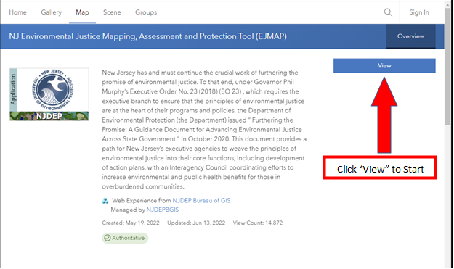

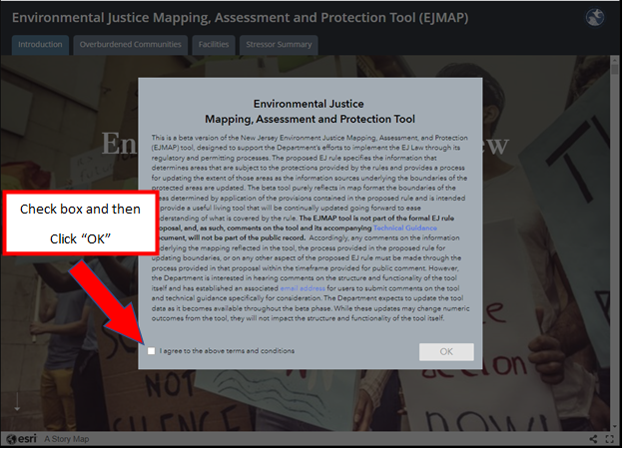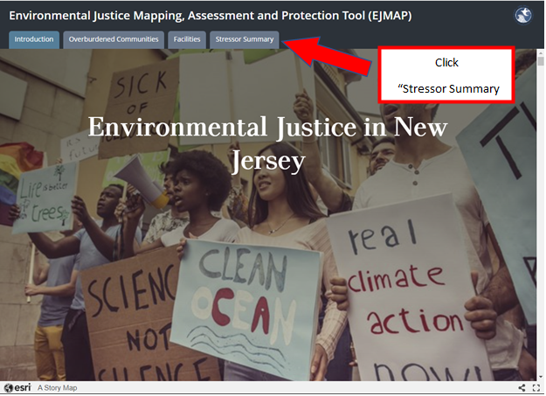

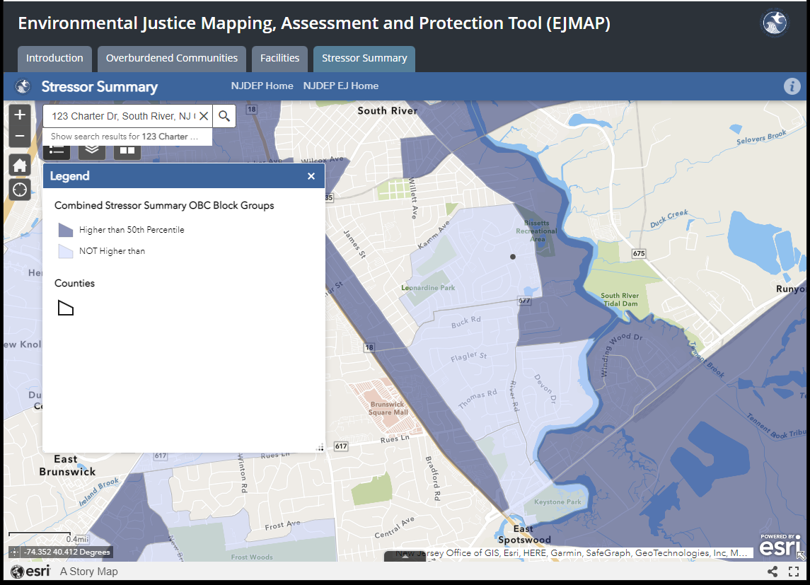

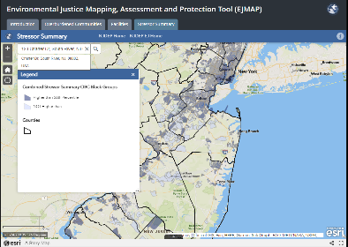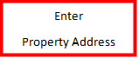

If the property is in dark blue (“Higher than 50th Percentile”), the site is within an Overburdened Community Subject to Adverse Cumulative Stressors. If it is in light blue or has no color, the site is not within an Overburdened Community Subject to Adverse Cumulative Stressors.

*Additional information can be found here:*

[Environmental Justice Mapping, Assessment, and Protection (EJMap): Technical Guidance](https://www.nj.gov/dep/ej/ejmap-tg.pdf)

How to Find Out if A Proposed Project is Designated as Historic

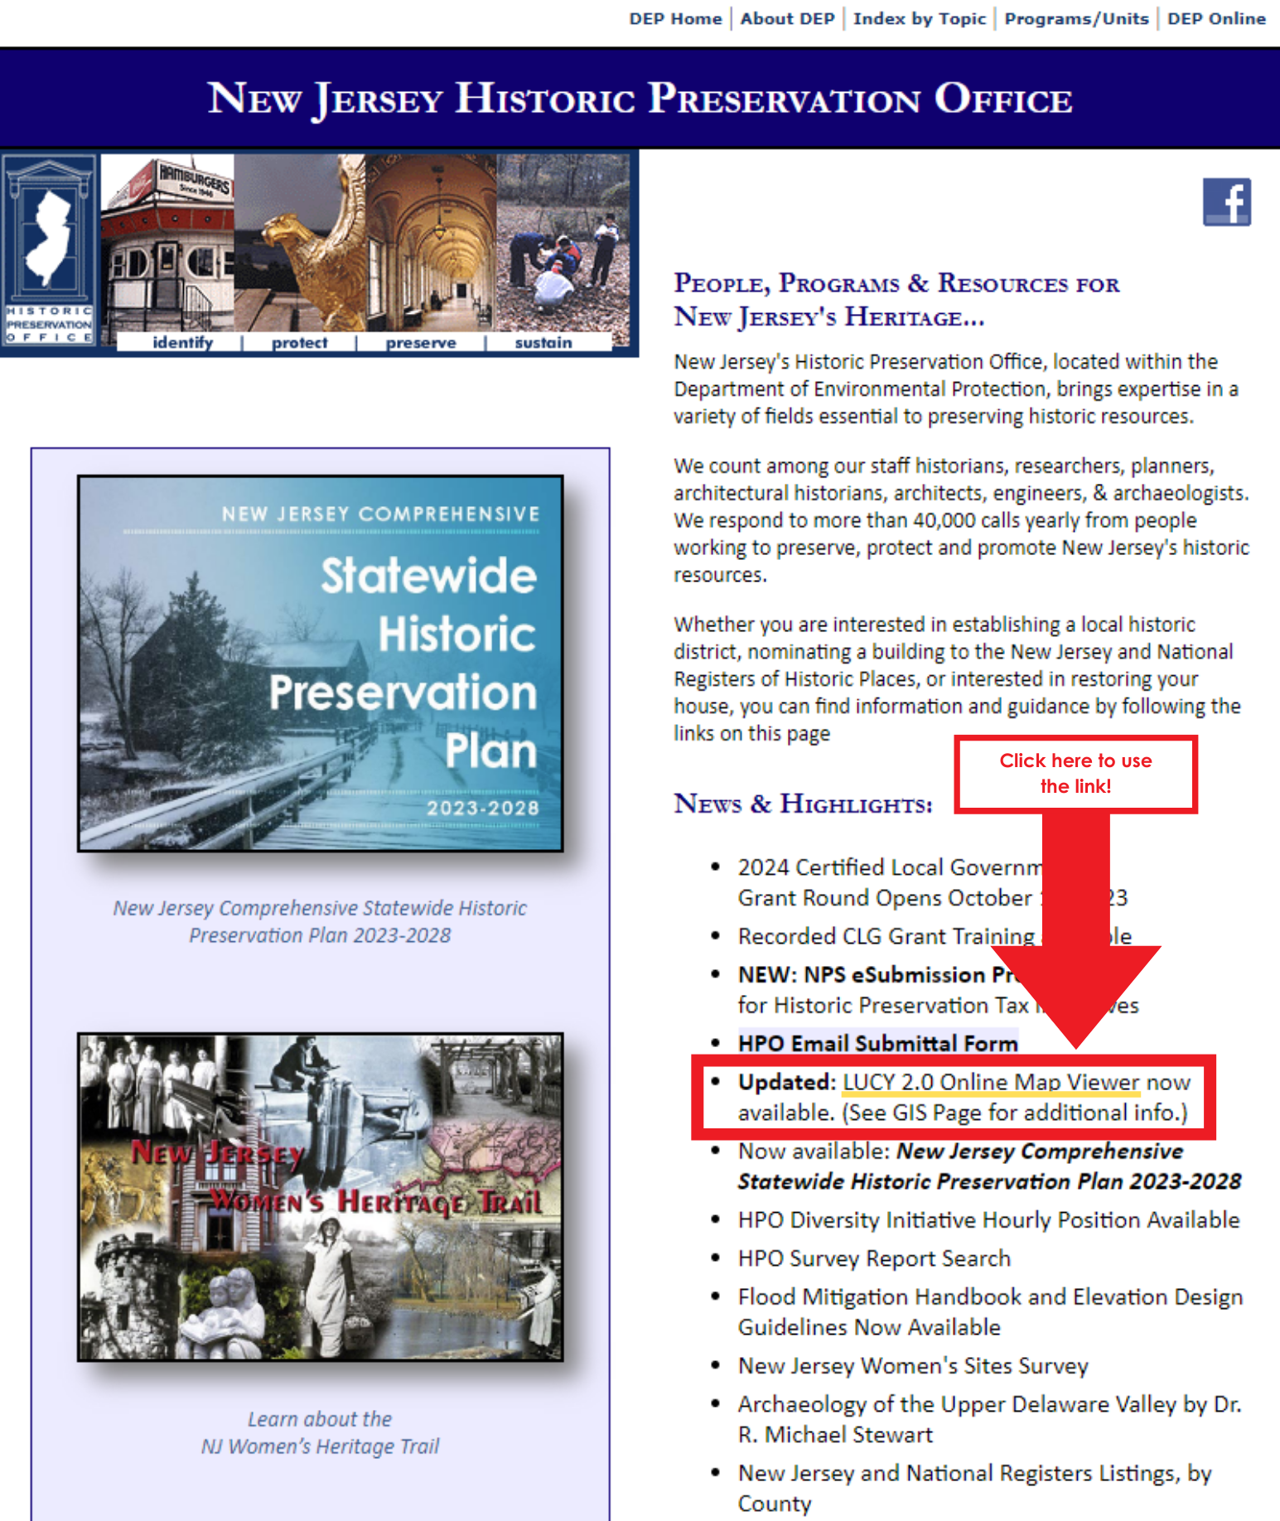Visit the [Historic Preservation Office](https://www.nj.gov/dep/hpo/) website.

[LUCY](https://nj.gov/dep/hpo/1identify/gis.htm) = DEP’s Historic Preservation Office identification of Historic Resources with Geographic Information System (GIS)

* [LUCY Online Map Viewer](https://njdep.maps.arcgis.com/apps/webappviewer/index.html?id=44ce3eb3c53349639040fe205d69bb79)
* [LUCY User Guide](https://nj.gov/dep/hpo/1identify/LUCY_2.0_User_Guide.pdf)

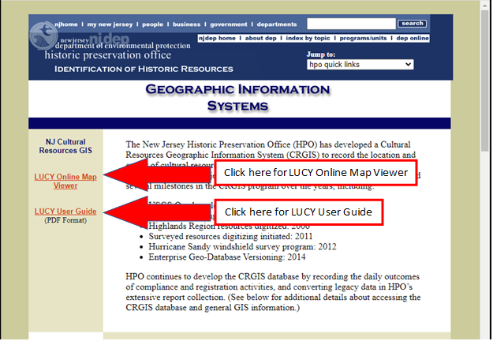

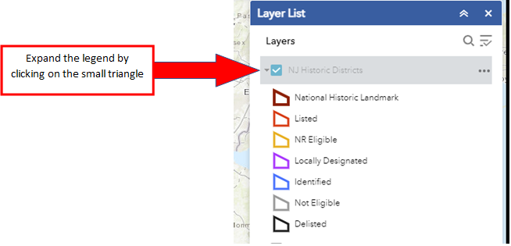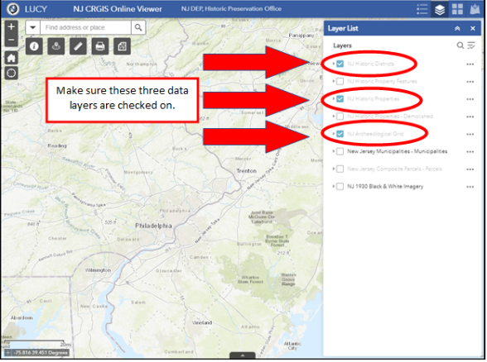

Text Box

Properties within these Categories are Potentially Historic

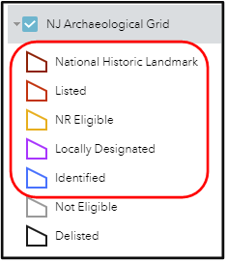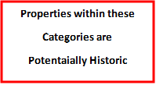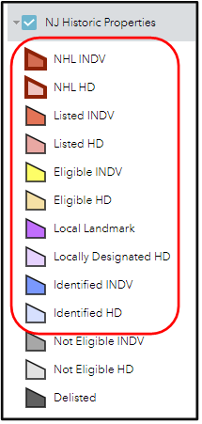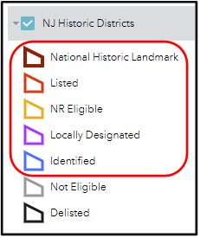

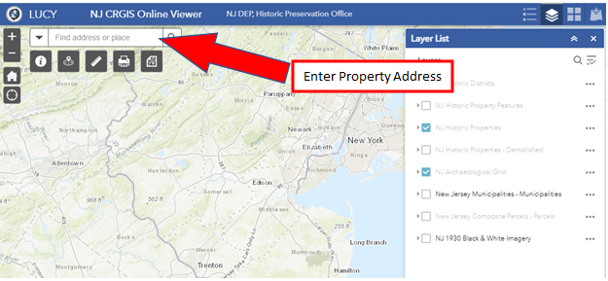

If the project site is highlighted or outlined in one of the colors circled above, check Yes for the application question: **Is the property identified as historic on the NJDEP Historic Preservation Office LUCY Online Map Viewer?** Otherwise, check No.

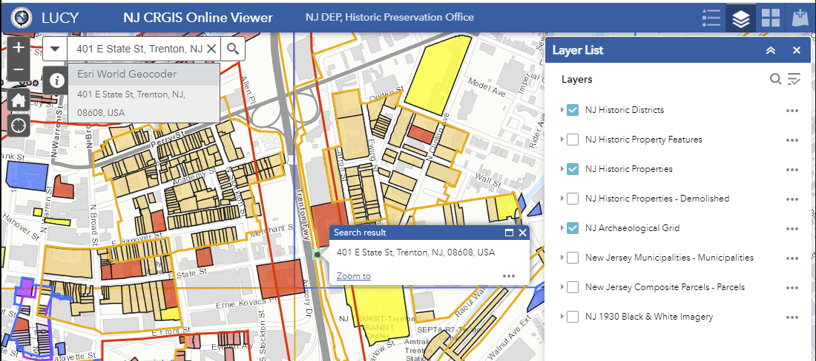

How to Confirm IRS Tax Exempt Status (Nonprofit applicants)

IRS website: [Tax Exempt Organization Search](https://apps.irs.gov/app/eos/)

Can search by EIN or by Organization Name. If the search is unsuccessful, the website has a link to Search Tips.

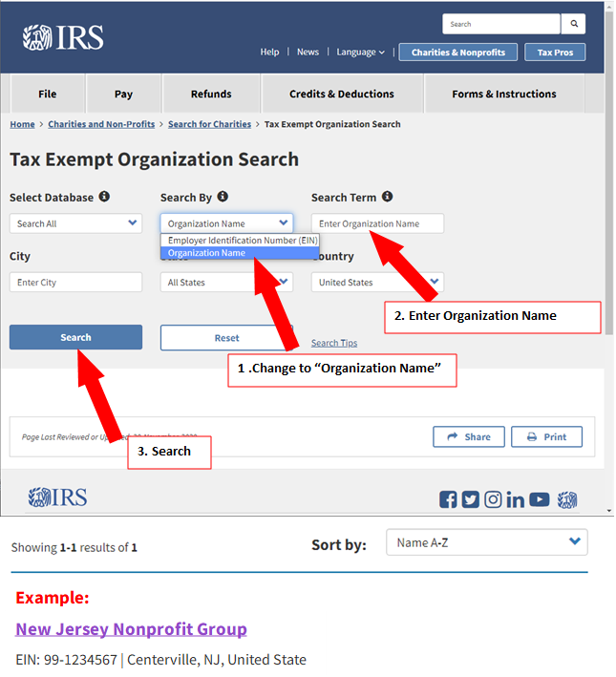

ShapeText Box

After Clicking the Name, the *Publication 78 Data* box should appear and must state: "On Publication 78 Data List: Yes"

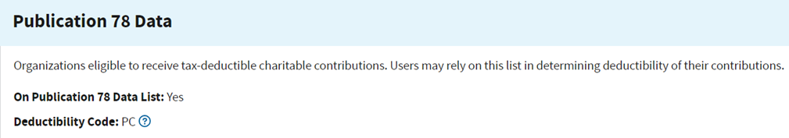

How to Confirm CRIA Compliance Status (Nonprofit applicants)

The State of New Jersey’s Division of Consumer Affairs website: [Search of a Charity](https://njconsumeraffairs.state.nj.us/public-charity-search-results/)

Note: If the search is unsuccessful, it could be because terms have been abbreviated (e.g., CTY instead of COUNTY, NJ instead of NEW JERSEY).

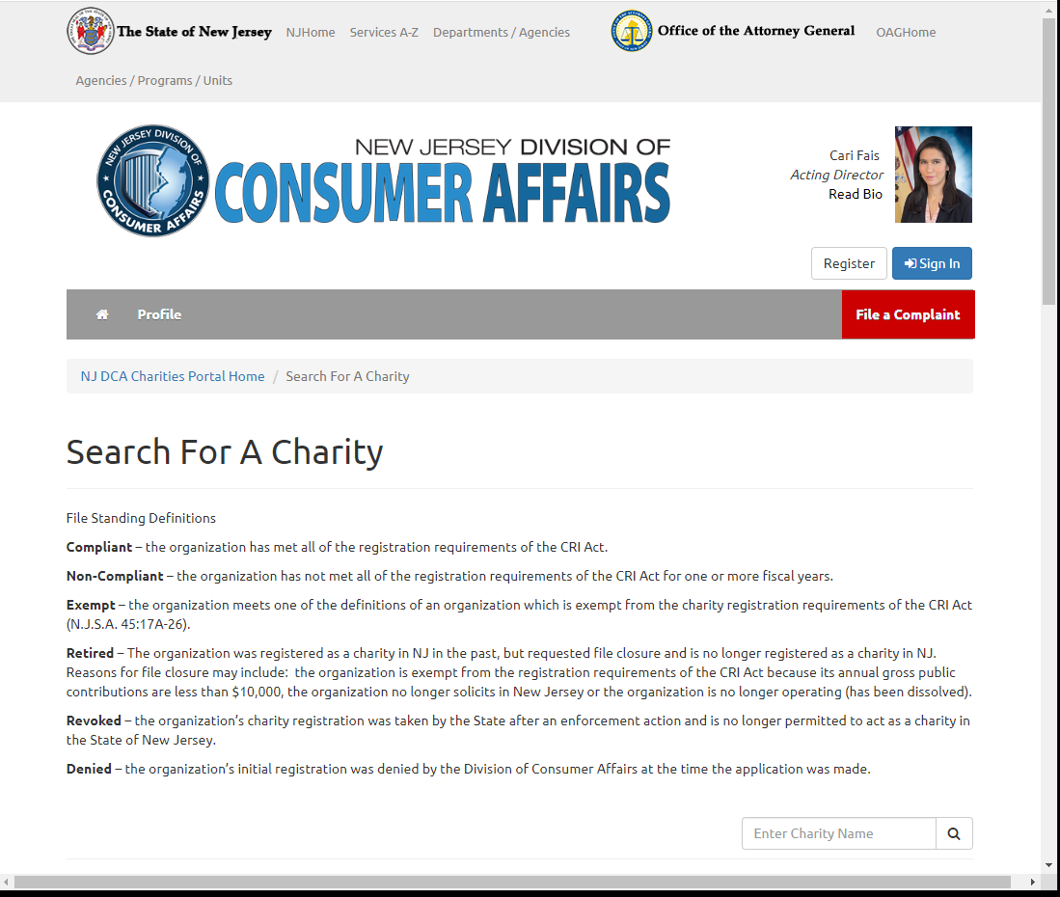Text Box

If the Division of Consumer Affairs website identifies the applicant as “Noncompliant” and the nonprofit believes it is an error, the nonprofit can request a written Letter of Compliance from Consumer Affairs. The request can be submitted on a signed, dated letter on the nonprofit’s letterhead emailed to Yvonne Jenkins at [JenkinsY@dca.njoag.gov](mailto:JenkinsY@dca.njoag.gov) . The request letter should list the following information:

* Name of the Organization
* Charity Registration Number
* That the Letter of Compliance is needed for the Green Acres grant application
* Green Acres grant application deadline
* “Requesting a Letter of Compliance”

Allowable Costs (Local Governments) - Green Acres Rules Excerpt

**N.J.A.C. 7:36-10.6 Allowable project costs**

(a) For development projects, the following costs are allowable, provided the local government unit incurs such costs in conformance with all applicable laws, including the Local Public Contracts Law, N.J.S.A. 40A:11-1 et seq.:

1. Construction costs;

2. Engineering costs associated with facility design and preparation of plans and specifications, supervision, and inspection, not to exceed 13 percent of the construction costs submitted by the local government unit and approved for Green Acres funding;

3. Incidental costs, individually itemized, associated with the implementation of the development project, including the cost of advertising, archaeological, architectural, conservation, financial, geological, historic research, hydrological, legal, or other professional advice, estimates, reports, services, or studies and the cost of preliminary planning and engineering necessary for the preparation of the application, provided such costs are not also included in the costs listed at (a)1 or 2 above. Incidental costs are limited to a maximum of two percent of the construction costs submitted by the local government unit and approved for Green Acres funding, or $20,000, whichever is less;

4. Permit fees associated with the development project;

5. Costs of equipment required to make the facility operational; and

6. Costs of the preliminary assessment, when completed in accordance with N.J.A.C. 7:26E, as required under N.J.A.C. 7:36-13.4, and further testing as determined by the Department, based on findings and recommendations of the preliminary assessment.

(b) The following types of costs are not allowable:

1. Administrative and operating costs and salaries and/or wages of any employee of the local government unit incurred as part of the development project;

2. Costs associated with an application for Green Acres funding that the Garden State Preservation Trust does not approve under N.J.A.C. 7:36-13.3;

3. Remediation work done to address any areas of concern, as defined under the Technical Requirements for Site Remediation, N.J.A.C. 7:25E, that are identified in the preliminary assessment required under N.J.A.C. 7:36-13.4 or by other means; and

4. Costs in excess of the sum of the approved Green Acres funding plus the local government unit's matching share, if required, unless Green Acres has approved a request for supplemental funding under N.J.A.C. 7:36-14.3.

Allowable Costs (Nonprofits) - Green Acres Rules Excerpt

**N.J.A.C. 7:36-21.6 Allowable project costs**

(a) For development projects, the following types of costs are allowable, provided the nonprofit incurs such costs in conformance with all applicable laws, as well as the Local Public Contracts Law, N.J.S.A. 40A:11-1 et seq.:

1. Construction costs;

2. Engineering costs associated with facility design and preparation of plans and specifications, supervision, and inspection, not to exceed 13 percent of the construction costs submitted by the nonprofit and approved for Green Acres funding;

3. Incidental costs, individually itemized, associated with the implementation of the development project, including the cost of advertising, archaeological, architectural, conservation, financial, geological, historic research, hydrological, legal, or other professional advice, estimates, reports, services, or studies and the cost of preliminary planning and engineering necessary for the preparation of the application, provided such costs are not also included in the costs listed at (a)1 or 2 above. Incidental costs are limited to a maximum of two percent of the construction costs submitted by the nonprofit and approved for Green Acres funding, or $20,000, whichever is less;

4. Permit fees associated with the development project;

5. Costs of equipment required to make the facility operational; and

6. Costs of the preliminary assessment, when completed in accordance with N.J.A.C. 7:26E, as required under N.J.A.C. 7:36-23.4, and further testing as determined by the Department, based on findings and recommendations of the preliminary assessment.

(b) The following types of costs are not allowable:

1. Administrative and operating costs and salaries and/or wages of any employee of the nonprofit incurred as part of the development project;

2. Costs associated with an application for Green Acres funding that the Garden State Preservation Trust does not approve under N.J.A.C. 7:36-23.3;

3. Remediation work done to address any areas of concern, as defined under the Technical Requirements for Site Remediation, N.J.A.C. 7:25E, that are identified in the preliminary assessment required under N.J.A.C. 7:36-23.4 or by other means; and

4. Costs in excess of the sum of the approved Green Acres funding plus the nonprofit's matching share, unless Green Acres has approved a request for supplemental funding under N.J.A.C. 7:36-24.3.

Helpful Links

*Click on name of link to access. If unsuccessful, hold down the Ctrl button while clicking.*

**Potential Funding Sources**

* County open space funds

[Atlantic County](https://www.atlantic-county.org/planning/land-acquisition.asp)

[Bergen County](https://co.bergen.nj.us/division-of-land-management/open-space-trust-fund)

[Burlington County](http://www.co.burlington.nj.us/234/Municipal-Park-Development-Program)

[Camden County](https://www.camdencounty.com/service/environmental-affairs/open-space-farmland-preservation/)

[Cape May County](https://capemaycountynj.gov/596/Open-Space-Farmland-Preservation)

[Cumberland County](https://www.co.cumberland.nj.us/farmland-and-open-space)

[Essex County](https://essexcountyparks.org/)

[Gloucester County](https://www.gloucestercountynj.gov/405/Open-Space-Preservation-Program)

[Hudson County](https://www.hcnj.us/planning/hcosrhp-trust-fund/)

[Hunterdon County](https://www.co.hunterdon.nj.us/442/Grant-Opportunities)

[Mercer County](https://www.mercercounty.org/departments/planning/open-space)

[Middlesex County](https://www.middlesexcountynj.gov/government/departments/department-of-infrastructure-management/office-of-parks-and-recreation/conservation-and-open-space-stewardship)

[Monmouth County](https://www.monmouthcountyparks.com/page.aspx?Id=2593)

[Morris County](https://www.morriscountynj.gov/Departments/Open-Space-Preservation)

[Ocean County](https://www.planning.co.ocean.nj.us/frmepnaturallandtrust)

[Passaic County](https://www.passaiccountynj.org/government/boards-committees-and-commissions-f-z/open-space-farmland-and-historic-preservation-advisory-committee)

[Salem County](https://www.salemcountynj.gov/departments/open-space-advisory-council/)

[Somerset County](https://www.co.somerset.nj.us/government/public-works/planning/agriculture-development-board/open-space-and-preservation-programs)

[Sussex County](https://www.sussex.nj.us/cn/webpage.cfm?tpid=15781)

[Union County](https://ucnj.org/office-of-open-space-recreation-historic-preservation-trust-fund/#:~:text=Office%20of%20Open%20Space%2C%20Recreation%20%26%20Historic%20Preservation%20Trust%20Fund,A-Victoria%20Durbin%20Drake&text=The%20mission%20of%20the%20Open,and%20to%20preserve%20historic%20sites)

[Warren County](https://www.warrencountynj.gov/government/land-preservation-department/municipal-charitable-conservancy-grants)

* General Open Space/Recreation/Community Development Grant Programs
  + [DCA Local Recreation Improvement Grant Program](https://www.nj.gov/dca/dlgs/programs/lriggrants.shtml#:~:text=The%20Local%20Recreation%20Improvement%20Grant%20(LRIG)%20exists%20to%3A,in%20achieving%20unmet%20recreational%20obligations)
  + [American Water’s Building Better Communities Grant Program](https://www.amwater.com/corp/Customers-and-Communities/American-Water-Charitable-Foundation/index) (administered by National Recreation and Park Association)
  + [DCA Community Development Block Grants](https://www.nj.gov/dca/dhcr/offices/comact.shtml)
  + [USDA Community Facilities Grant](https://www.rd.usda.gov/programs-services/community-facilities/community-facilities-direct-loan-grant-program)
  + [DCA Neighborhood Revitalization Tax Credit](https://nj.gov/dca/dhcr/offices/nrtc.shtml) (nonprofits working in certain municipalities)
  + [William Penn Foundation](https://williampennfoundation.org/what-we-fund) (Greater Philadelphia region)
  + [Open Space Institute](https://www.openspaceinstitute.org/states/new-jersey)
  + [DEP Office of Natural Resource Restoration](https://www.nj.gov/dep/nrr/index.html)
  + [City Parks Alliance Equitable Parks Funding Hub](https://cityparksalliance.org/funding-hub/)
  + [USNPS Outdoor Recreation Legacy Partnership Grants Program](http://www.nps.gov/subjects/lwcf/outdoor-recreation-legacy-partnership-grants-program.htm)

* Grant Programs for Specific Types of Improvements
  + [ANJEC Open Space Stewardship Grants](https://anjec.org/open-space-stewardship-grants/)
  + [New Jersey Urban and Community Forestry Grants](https://www.nj.gov/dep/parksandforests/forest/urbanandcommunity/grants.html)
  + [319 Nonpoint Source Pollution Grants](https://dep.nj.gov/wlm/watershed/319-grants/)
  + [NJ Historic Trust Funding Programs](https://www.nj.gov/dca/njht/programs/overview/) (cannot be used to match GA funding)
  + [US Tennis Association Grants](https://www.usta.com/en/home/coach-organize/tennis-support/grants-assistance.html)
  + [Boat U.S. Grants](https://www.boatus.org/grants/faq/)
  + [Boating Infrastructure Grant Program](https://www.fws.gov/program/boating-infrastructure) (US Fish & Wildlife Service)
  + [NBIG – National Boat Infrastructure Grant](https://www.fws.gov/library/collections/boating-infrastructure-grant-big-awards) (US Fish & Wildlife Service)

* Accessibility Grants
  + [Recreation Opportunities for Individuals with Disabilities Grants (DCA)](https://www.nj.gov/dca/dhcr/rec/Grants.shtml)
  + [Inclusive Healthy Communities Grant Program (IHC)](https://inclusivehealthycommunities.org/)

**Other Resources**

* Green Acres & OTPLA Links
  + [Green Acres](https://dep.nj.gov/greenacres/)
  + [Green Acres Regulations](https://dep.nj.gov/wp-content/uploads/greenacres/pdf/njac7_36.pdf)
  + [Application Forms](https://dep.nj.gov/greenacres/forms-and-regulations/#green-acres-application-forms)
  + [Contacts List](https://dep.nj.gov/greenacres/contact-us/)
  + [Office of Transactions and Public Land Administration, Public Land Compliance Section](https://dep.nj.gov/otpla/public-land-compliance/)
  + [Recreation and Open Space Inventory (ROSI) Form](https://dep.nj.gov/wp-content/uploads/greenacres/xls/rosi_spreadsheet_ver1.xltm_.zip)

* Public Engagement in Park Planning Resources
  + [Community Engagement Resource Guide (NRPA)](https://www.nrpa.org/contentassets/19b3cbe05a634d5e8d3b712dbc8aa9d0/community-engagement-guide-nrpa.pdf)
  + [Designing Parks Using Community-Based Planning](https://www.parksforcalifornia.org/planning_guide) (California State Parks)
  + [Planning for Parks, Recreation, and Open Space in Your Community](https://rco.wa.gov/wp-content/uploads/2019/10/PlanningforParksOpenSpace.pdf) (Washington State)
  + Examples of Park Planning Community Engagement Efforts:
    - [Carver County, MN](https://conservancy.umn.edu/bitstream/handle/11299/185012/RCP_24c-PA_5253-report.pdf?sequence=2&isAllowed=y)
    - [Portland, OR](https://www.oregonmetro.gov/sites/default/files/2019/10/08/Connect-with-Nature-Report.pdf)

* Open Space and Recreation Facilities Mapping and Planning Resources
  + [SCORP](https://dep.nj.gov/outside-together/) (Outside, Together!)
  + [NJMAP / Conservation Blueprint](http://www.njmap2.com/)
  + [NJ-GeoWeb](https://www.nj.gov/dep/gis/geowebsplash.htm)
  + [NJ Community Asset Map](https://www.nj.gov/dca/news/news/2019/approved/20190412.html)
  + [DEP-approved Public Access Plans](https://www.nj.gov/dep/cmp/access/mpaplans.htm)
  + [Healthy Communities NJ](https://www.nj.gov/health/hcpnj/)

* Climate Mitigation and Resilience Resources
  + [DEP Climate Change Information](https://www.nj.gov/dep/climatechange/)
  + [NJ Global Warming Response Act 80x50 Report](https://dep.nj.gov/wp-content/uploads/climatechange/nj-gwra-80x50-report-2020.pdf)
  + [New Jersey’s Flood Indicator Tool](https://njdep.maps.arcgis.com/apps/webappviewer/index.html?id=e26feba3b4844e5d960d3163b23623f2)
  + [Climate Friendly Parks](https://www.nps.gov/subjects/climatechange/cfpprogram.htm)
  + [US Green Building Council](https://new.usgbc.org/)

* Environmental Justice Resources
  + [Office of Environmental Justice](https://dep.nj.gov/ej/)
  + [*Furthering the Promise*](https://dspace.njstatelib.org/xmlui/bitstream/handle/10929/68451/furthering-the-promise.pdf?sequence=1&isAllowed=y)
  + [EJMAP](https://experience.arcgis.com/experience/548632a2351b41b8a0443cfc3a9f4ef6)

* Historic Preservation Resources
  + [NJ State Historic Preservation Office](https://www.nj.gov/dep/hpo/)
  + [New Jersey Comprehensive Statewide Historic Preservation Plan](https://www.nj.gov/dep/hpo/Index_HomePage_images_links/hpo_plan%202013_2019/hpoplan2014.pdf)
  + [LUCY Online Map Viewer](https://njdep.maps.arcgis.com/apps/webappviewer/index.html?id=44ce3eb3c53349639040fe205d69bb79)
  + [LUCY User Guide](https://nj.gov/dep/hpo/1identify/LUCY_2.0_User_Guide.pdf)
  + [New Jersey and National Registers of Historic Places](https://www.nj.gov/dep/hpo/1identify/nrsr_lists.htm)
  + [Secretary of the Interior's Standards for the Treatment of Historic Properties](https://www.nps.gov/orgs/1739/secretary-standards-treatment-historic-properties.htm#:~:text=Standards%20for%20Rehabilitation-,The%20Secretary%20of%20the%20Interior's%20Standards%20for%20the%20Treatment%20of,Grants%E2%80%93in%E2%80%93Aid%20programs)
  + [Secretary of the Interior's Guidelines for the Treatment of Cultural Landscapes](https://www.nps.gov/crps/tps/landscape-guidelines/index.htm)

* Accessibility Resources
  + [Americans with Disabilities Act](https://www.dol.gov/general/topic/disability/ada#:~:text=The%20Americans%20with%20Disabilities%20Act,local%20government'%20programs%20and%20services)
  + [NJ Division of Disability Services](https://nj.gov/humanservices/dds/home/)
  + [New Jersey Barrier Free Subcode](https://www.nj.gov/dca/divisions/dhcr/rec/pdf/barrierfree_effective.pdf) (Recreation: Sections 5:23-7.16 to 5.23-7.32)
  + [DCA Rules for Completely Inclusive Playgrounds](https://www.nj.gov/dca/divisions/codes/codreg/pdf_regs/njac_5_23_11.pdf)
  + [Disability Snapshots](https://climatesnapshots.rutgers.edu/disability)
  + [Rutgers State Policy Lab – Increased Access to Nature and Outdoor Recreation for People with Disabilities](https://policylab.rutgers.edu/projects/environment-projects/)
* Tree Resources
  + [New Jersey Urban & Community Forestry Program](https://www.nj.gov/dep/parksandforests/forest/urbanandcommunity/)
  + [NJ State Approved Foresters](https://www.nj.gov/dep/parksandforests/forest/docs/ACF.pdf)
  + [NJ Shade Tree Federation Information](https://njstf.org/publications.php)
  + [Sample list of NJ Native Trees](https://npsnj.org/native-plants/plant-lists/)

* Trail Resources
  + [NJ Trails Program](https://dep.nj.gov/greenacres/trails-program-home/)
  + [Trail Maintenance Costs per Mile](https://www.railstotrails.org/resource-library/resources/yearly-routine-rail-trail-maintenance-costs-per-mile/)
* State of NJ Information on Synthetic Turf:
  + [NJDEP Division of Science & Research Findings](https://dep.nj.gov/dsr/environmental-health/)
  + [NJDOH Artificial Turf Investigation](https://www.nj.gov/health/ceohs/environmental-occupational/hazardous-waste-sites/regional/artificial_turf.shtml)

* Resources for Contaminated Sites
  + [DEP Office of Brownfields Reuse](https://www.nj.gov/dep/srp/brownfields/contacts.htm)
  + [Hazardous Discharge Site Remediation Fund](https://www.nj.gov/dep/srp/finance/hdsrf/) (grants for site investigation and remediation)

* Public Contracts Information
  + [NJ Local Agency Procurement Laws](https://www.nj.gov/dca/dlgs/programs/NJ_LAPL.shtml)
  + [Local Public Contracts Law Contracting Thresholds](https://www.nj.gov/dca/divisions/dlgs/programs/lpcl_docs/Contracting%20Threshold%20Tables.pdf)
  + [Prevailing Wage Rates on Construction-Related Public Works Projects](https://www.nj.gov/labor/wageandhour/prevailing-rates/public-works/index.shtml)

* Nonprofit Compliance Links
  + [IRS Tax Exempt Organization Search](https://apps.irs.gov/app/eos/)
  + [NJ DCA Charities Search](https://njconsumeraffairs.state.nj.us/public-charity-search-results/)