### Green Acres Program

### *New Jersey Department of Environmental Protection*

### Acquisition Application

#### **Local & Nonprofit Assistance Program**

Deadline: February 5, 2025

Application Information Sessions:

**October 30, 2024, November 25, 2024, and December 18, 2024**



***Green Acres Mission Statement***

*To achieve, in partnership with others, a system of interconnected open spaces*

*the protection of which will preserve and enhance New Jersey’s natural environment*

*and its historic, scenic, and recreational resources*

*for public use and enjoyment.*

Green Acres Program

Mail Code 401-07B

401 East State Street, 7th Floor

P.O. Box 420

Trenton, NJ 08625-0420

Tel: (609) 984-0500; Fax: (609) 984-0608

##### [**www.NJGreenAcres.org**](http://www.NJGreenAcres.org)

[GreenAcresApplications@dep.nj.gov](mailto:GreenAcresApplications@dep.nj.gov)

##### **Table of Contents**

Application Information 1

Acquisition Application Overview 2

Application Support 3

Technical Support 3

Upcoming Information Sessions 3

Green Acres Contacts 3

Definitions 4

2025 Funding Round Programs 5

Eligibility 7

Eligible Applicants 7

Eligible Projects 7

Eligible Project Sites 7

Eligible Costs 8

Funding 9

Funding Categories & Percentages 9

Matching Funds 11

Funding Round Caps 11

Public Engagement and Notice Requirements 13

Submitting A Competitive Application 14

Grounds For Application Disqualification 17

What happens after application submission? 18

Approval Process 18

Highlighted Project Administration Requirements 18

Project Period 19

Post-Project Requirements & Responsibilities 19

Forms & Samples 21

Land Acquisition Application Form 22

Application Checklist Items – Notes 29

Enabling Resolution Template 33

Anticipated Project Schedule – Land Acquisition 34

Project Reference Map Checklist 35

Project Narrative Outline Template 37

Public Hearing Checklist (Local Governments) 41

Public Notice Checklist (Nonprofits) 43

Public Hearing Announcement / Nonprofit Public Notice Templates 44

Nonprofit Eligibility Certification 45

Tools / References 46

Highly and Densely Populated Municipalities & Counties 47

Urban Aid Municipalities List 48

Municipalities That Contain an Overburdened Community Subject to Adverse Cumulative Stressors 49

Funding Request Limits by Applicant Type 53

How to Find Out if A Proposed Project is in an Overburdened Community Subject to Adverse Cumulative Stressors 54

How to Find Out if A Proposed Project is Designated as Historic 58

How to Confirm IRS Tax Exempt Status (Nonprofit applicants) 63

How to Confirm CRIA Compliance Status (Nonprofit applicants) 64

Allowable Costs (Local Governments) - Green Acres Rules Excerpt 65

Allowable Costs (Nonprofits) - Green Acres Rules Excerpt 67

Helpful Links 69

Application Information

Acquisition Application Overview

Since 1961, the Green Acres Program has funded the acquisition of open space for recreation and conservation purposes, and the development of outdoor recreational facilities. Green Acres remains committed to preserving New Jersey’s natural, historic, and recreational resources statewide and is pleased to continue the tradition of partnering with local and county governments and nonprofit organizations to serve New Jersey residents.

The Green Acres application package provides guidance for applicants, including information about the most frequently asked questions and common mistakes. To assist applicants, a clickable Table of Contents and links throughout the document are provided to assist in locating the information needed to select the best funding option for the community’s needs, determine eligibility, understand the funding parameters, and submit a successful application.

To help Green Acres’ applicants submit competitive applications with a greater chance of success, information has been included on the types of projects that will achieve multiple public goals and support existing planning, open space, and recreation initiatives. In the *Submitting a Competitive Application* section, details about the following State, Department, and Program priorities are provided:

* Public Engagement and Outreach
* Public Recreation Benefits
* Environmental Justice
* Community Revitalization
* Protection of Natural and Historic Resources
* Climate Mitigation and Resilience
* Consistency with Open Space and Recreation Planning
* Stewardship of Public Funds

As in recent past rounds, applicants are encouraged to review and acknowledge the requirements outlined in the Public Engagement and Notice Requirements section. Please note that the traditionally required public hearing ***does not*** fulfill the public engagement requirement. While a pre-application public hearing is still required, applicants must engage in meaningful public outreach activities during the project planning process, and those activities must be documented in the Green Acres application. Please contact Green Acres with any questions about these requirements. **Applications that do not include demonstration of meaningful public engagement during the project planning process will be deemed ineligible**.

Please share feedback and suggestions for upcoming funding rounds by emailing [GreenAcres@dep.nj.gov](mailto:GreenAcres@dep.nj.gov).

**Getting Started:**

We recommend beginning the application process by focusing on the following items. Addressing these items early in the process will help ensure that your application is complete and can be submitted by the application deadline.

1. Public engagement during the project planning process must be the first step. If it has not yet been initiated, this should begin right away. For more information, skip to the Public Engagement and Notice Requirements section.
2. For local governments: Pick a date for the public hearing. Once the date is established, you can work out the timing of the website and newspaper notices of the public hearing and take the steps necessary to get proposed application and resolution on the governing body’s agenda. The date of the public hearing should allow for rescheduling prior to the application deadline in the case of inclement weather. Again, for more information, see the Public Engagement and Notice Requirements section.
3. Reach out to the Green Acres contact for your area and confirm proposed project eligibility and funding category.
4. We highly recommend reading through the entire application package to understand what is required and see the guidance we have provided to help you prepare an application that is likely to succeed.

Application Support

Technical Support

All interested applicants are encouraged to contact Green Acres *as early as possible* to discuss project eligibility, program priorities, and application procedures. Staff are available for assistance throughout project planning, application preparation, and project management.

Upcoming Information Sessions

Green Acres will be hosting virtual application information sessions, on:

* October 30, 2024 - Application overview and Q&A
  + 10:00am to 11:30am for Acquisition projects (including Green Acres and Urban Parks), and
  + 1:00pm to 2:30pm for Park Development (Green Acres and Urban Parks), Stewardship, and Jake’s Law projects.
* November 25, 2024 - Application Q&A (no presentation)
  + 10:00am to 11:00am for all projects
* December 18, 2024 - Application Q&A (no presentation)
  + 10:00am to 11:00am for all projects

Notices will be sent to stakeholders, and links to the virtual application information sessions will be posted on the Green Acres website. The virtual application information sessions will be recorded, and the recordings will also be available on the Green Acres website.

Green Acres Contacts

Please reach out to the appropriate project manager regarding application questions. Email outreach is recommended. The [Green Acres contact list](https://dep.nj.gov/greenacres/contact-us/) can be found on the website, or general questions may be directed to [GreenAcresApplications@dep.nj.gov](mailto:GreenAcresApplications@dep.nj.gov), or (609) 984-0500.

Definitions

These definitions are used in the application materials. Please note that all population data is based on the 2020 Census:

**Municipalities**

Highly Populated Municipality **–** A municipality with a population of 35,000 or more

Densely Populated Municipality **–** Amunicipality with a population density of 5,000 or more per square mile

Urban Aid Municipality **–** A municipality eligible to receive state aid pursuant to P.L.1978, c.14 (C.52:27D-178 et seq.)

Standard Municipality **–** A municipality that does not qualify as Highly Populated, Densely Populated, or Urban Aid

**Counties**

Highly Populated County **–** A county with a population density of 1,000 or more per square mile

Densely Populated County **–** A county with a population density of 5,000 or more per square mile

Standard County **–** A county that does not qualify as Highly Populated or Densely Populated

**Environmental Justice Definitions**

Overburdened Community (OBC) **-** New Jersey’s Environmental Justice Law defines an [overburdened community](https://dep.nj.gov/ej/policy/communities) as any census block group, as determined in accordance with the most recent United States Census, in which:

* at least 35 percent of the households qualify as low-income households (at or below twice the poverty threshold as determined by the United States Census Bureau); and/or
* at least 40 percent of the residents identify as minority or as members of a State recognized tribal community; and/or
* at least 40 percent of the households have limited English proficiency (without an adult that speaks English “very well” according to the United States Census Bureau).

Overburdened Community Subject to Adverse Cumulative Stressors (ACS/OBC) **-** Previously referred to as an Adversely Stressed OBC, this is an Overburdened Community with a combined stressor total higher than the 50th percentile for total environmental and public health stressors.

Easily Accessible From an ACS/OBC – Less than ¼ mile away with no barriers to pedestrian access. Barriers include impediments to people walking to the site, such as highways or impassable waterways. Pedestrian access distance is measured not “as the crow flies,” but using GIS to follow the roads an ACS/OBC resident would need to walk to get to the site.

Lists of Highly and Densely Populated Municipalities, Highly Populated Counties, Densely Populated Counties, Urban Aid Municipalities, and municipalities that contain at least one Overburdened Community Subject to Adverse Cumulative Stressors can be found in Tools / References. The Green Acres Program encourages applicants to review this information prior to project planning to determine applicant category and to check whether the potential project is located within an ACS/OBC using [EJMAP](https://experience.arcgis.com/experience/548632a2351b41b8a0443cfc3a9f4ef6) (see instructions in Tools / References). It is important to note that the Office of Environmental Justice updates the ACS/OBC data each year, which can result in census blocks being added or removed. Please reach out to your Green Acres contact with any questions.

2025 Funding Round Programs

The Green Acres Program will offer four funding programs for 2025, as identified below. Information about each program is provided in all Green Acres application packages to ensure that applicants are aware of all funding options and the limits on the number of funding requests that can be submitted per applicant.

**Figure 1: 2025 Funding Round Programs**

*Applicants may submit one request per funding program*

|  |  |  |
| --- | --- | --- |
| **Program** | **Description** | **Eligibility Notes** |
| **Traditional Green Acres** | Land Acquisition  (including Planning Incentive, Site-Specific Incentive, Standard, Urban Aid, or Nonprofit)  ***OR*** | All local governments and nonprofits |
| Park Development  ***OR*** | All local governments; Nonprofit projects located in an Urban Aid, Densely Populated, or Highly Populated Municipality or a Densely Populated County or that draw over 75% of their users from those areas |
| Urban Parks Rollover | Projects located within Overburdened Communities Subject to Adverse Cumulative Stressors within Urban Aid Municipalities that were unfunded or underfunded through the Urban Parks Program |
| **Stewardship** | Restoration and Protection of Natural Resources and Historic Landscapes | All local governments and nonprofits |
| **Jake’s Law Playground Funding** | Completely Inclusive Playgrounds – *Final year of enhanced funding pilot program* | County and municipal governments |
| **Urban Parks** | Land Acquisition, Park Development & Historic Preservation | Local government projects located within Overburdened Communities Subject to Adverse Cumulative Stressors within Urban Aid Municipalities |

This application is for acquisition projects. Please see the [Green Acres’ Forms and Regulations website](https://dep.nj.gov/greenacres/forms-and-regulations/#green-acres-application-forms) to obtain applications for other programs. Please note that February 5, 2025, is the deadline for all funding programs, for new applications as well as supplemental funding requests from local governments and nonprofits that have active projects that are progressing in a timely fashion.

For local governments and nonprofits seeking supplemental funding for previously approved Traditional Green Acres or Stewardship projects, please complete and submit the 2025 Supplemental Funding Request Form, available on the [Green Acres website](https://dep.nj.gov/greenacres/forms-and-regulations/) by the February 5, 2025 deadline. Applicants for supplemental funding should reach out to the appropriate Green Acres contact for assistance in filling out the form.

Funding Request Limits

Applicants may submit one request for each funding program for which they are eligible, and the one request for each program may be a new application *OR* a supplemental funding request. For example, an applicant can request supplemental funding for a Planning Incentive project OR funding for a Green Acres park development application, but not both. The *Funding Request Limits by Applicant Type* chart in the Tools / References, which lists the maximum number of funding requests that can be submitted by each applicant type, may be helpful.

Please carefully consider project management capacity when deciding how many applications to submit. To ensure project success, applicants should not take on more than they can complete within the 2-year project period.

Eligibility

The Green Acres Program *strongly* encourages applicants to contact the program to discuss the proposed project and confirm eligibility prior to preparing an application. New applications will undergo an eligibility and completeness review upon receipt; only those complete applications deemed eligible will be ranked and compete for funding.

Eligible Applicants

Local Governments – County and municipal governments are eligible to apply for funding, with limitations for the Urban Parks program noted above in Figure 1. School boards, housing and utility authorities, and other similar agencies without primary recreation and conservation responsibilities are not eligible.

Nonprofit Organizations – Nonprofits that meet the requirements set out in the Nonprofit Eligibility Certification form are eligible to apply for traditional Green Acres funding, with limitations for park development projects noted above in Figure 1. This form must be signed by the nonprofit’s chief executive officer or state director and its attorney, and the form and attachments must be submitted with the application.

**Please note**: Municipalities and nonprofits that have three or more open projects, and counties that have five or more open projects, as well as applicants that are not making sufficient progress resolving open compliance issues, were notified in October 2024 that they are not eligible to submit new applications. The following exceptions apply for applicants that have too many open projects: (1) They are eligible to submit a new Jake’s Law application; and (2) They may submit supplemental funding requests for open projects if those projects are making significant progress. No exceptions apply for applicants with stalled compliance issues.

Eligible Projects

Eligible land acquisition projects are those that result in the acquisition of land for outdoor recreation and/or conservation purposes, including, but not limited to, the purchase of forests, natural areas, linear parkland for trails, historic sites, conservation areas, water bodies, and open space for active or passive recreation purposes. Any existing structures on an acquisition site must either be used in direct support of outdoor recreation, or demolished to create open space, provided that the DEP’s Historic Preservation Office determines they do not have historic significance. For more information, please see our [Structures policy](https://dep.nj.gov/wp-content/uploads/greenacres/pdf/local-and-nonprofit-guide-structures-2024-july.pdf).

Applicants may purchase land in fee simple or may acquire a perpetual conservation easement or historic preservation easement on the property, as long as meaningful public access is provided to the project site. For more information, please see our [Easement policy](https://dep.nj.gov/wp-content/uploads/greenacres/pdf/local-and-nonprofit-guide-easements-meaningful-public-access_july-2024.pdf). Meaningful public access, as determined by Green Acres based on specific parcel circumstances, must be provided from the time of closing to every project funded under this program.

Eligible Project Sites

Applicants may apply to acquire any property with clear title, except property that:

* + - is identified by a municipality or otherwise designated for future use in meeting municipal fair share low- and moderate-income housing obligations under the Fair Housing Act of 1985 (N.J.S.A. 52:27D-301)
    - is designated as a road right-of-way
    - is listed on a Recreation and Open Space Inventory
    - is permanently preserved, as determined by the Department
    - is claimed as state-owned tidelands
    - contains a non-historic structure that the applicant does not anticipate using in support of outdoor recreation

Green Acres encourages municipalities and counties to reclaim and restore former brownfields sites and transform them into public spaces, such as recreation and natural areas. The Department’s [Office of Brownfield and Community Revitalization](https://dep.nj.gov/srp/brownfields/) has experienced DEP case managers who can assist with remediation and revitalization efforts. Applicants can apply to acquire a contaminated site and, if approved, pursue remediation while obtaining and submitting the other necessary deliverables for the acquisition project.

Local governments proposing to acquire property for future park development should carefully analyze site suitability early in the planning process and prior to applying. Site attributes, such as wetlands, dunes, endangered species, mature forested areas, or other significant natural resources, may define, limit or, in some instances, preclude current or future development.

Eligible Costs

The following are eligible land acquisition project costs:

* The cost of acquiring the land (subject to the Green Acres’ certified market value/average appraised value, which will be established through the appraisal process if the project receives a funding award)
* Technical report expenses, including appraisal(s), environmental assessment (preliminary assessment report and, if necessary, site investigation), title, and survey, provided these reports are prepared in accordance with Green Acres guidelines
* The cost to demolish *non-historic* structures on a site being acquired, up to a cap of 10% of the eligible land cost or $100,000, whichever is less (cap is waived for projects in Urban Aid Municipalities)
* Tenant relocation costs, if applicable
* Costs of well testing done in compliance with the Private Well Testing Act (P.L. 2001, c. 40; N.J.S.A. 58:12A-26 et seq.), if applicable
* Incidental costs, individually itemized, associated with the implementation of the acquisition project, including legal, engineering, financial, geological, hydrological, inspection, and other professional services, up to a cap of 2% of the eligible land cost or $20,000, whichever is less
* The value of a condemnation commissioners’ award or jury award in excess of the certified market value/average appraised value of a property

To ensure sufficient funding, all anticipated costs should be included in the initial funding request.

The following costs are not eligible for Green Acres funding:

* Administrative and operating costs and salaries and wages of any employee of the local government or nonprofit applicant
* Costs to remediate soil, groundwater, and surface water contamination
* Property taxes
* The value of a condemnation settlement (consent judgment) in excess of the certified market value/average appraised value of a property

For more information, see the Green Acres Rules excerpts for Allowable Costs in Tools / References.

Funding

It is *strongly* encouraged for applicants to contact the appropriate Green Acres project manager prior to application preparation to confirm funding categories and likely awards.

Funding Categories & Percentages

The categories of Green Acres land acquisition projects are summarized below and in Figure 2. Categories 1-5 apply to local governments; category 6 applies to nonprofits. Grant ratios vary depending on (1) project sponsor (applicant) and (2) project location. See Matching Funding section below for information on Green Acres loan funding.

* 1. Planning Incentive Acquisition – Projects undertaken by municipalities and counties that have an open space tax (or a Green Acres-approved alternative) and an adopted Open Space and Recreation Plan approved by Green Acres. Funding is available in the form of a 50% matching grant, and applicants may submit one application for all the properties that are located in the project areas or that meet the criteria listed in their plan. Properties located in Urban Aid municipalities are eligible for 75% matching grant funding. If interested, please reach out to the appropriate Green Acres contact for a streamlined Planning Incentive application and additional information
  2. Site Specific Incentive Acquisition - Projects undertaken by municipalities and counties that have an open space tax (or a Green Acres-approved alternative) but do not yet have an Open Space and Recreation Plan approved by Green Acres. Projects in this category are eligible for a 50% matching grant, but applicants must submit a separate application for each parcel they would like to purchase. Subject to available funding, Site-Specific Incentive Acquisition projects are also eligible for Green Acres loan funding. Applications for Site-Specific Incentive Acquisition projects must include a completed Site-Specific Incentive Certification form.
  3. Standard Acquisition - Projects undertaken by municipalities and counties that do not yet have an open space tax. Projects in this category are eligible for a 25% matching grant. Subject to available funding, Standard Acquisition projects are also eligible for Green Acres loan funding.
  4. Urban Aid Acquisition – Local government acquisition projects *located in* Urban Aid Municipalities. Projects in this category are eligible for a 75% matching grant and, subject to available funding, a 0% interest Green Acres loan.
  5. Acquisition Project Located in an Overburdened Community Subject to Adverse Cumulative Stressors – Local government projects *located in* or easily accessible from (see definitions) Overburdened Communities Subject to Adverse Cumulative Stressors are eligible for higher grant percentages. Such projects *located in* a Standard or Highly or Densely Populated Municipality are eligible for 50% matching grant funding, and those *located in* an Urban Aid Municipality are eligible for 100% grant funding. If available, these projects are also eligible for Green Acres loan funding (interest rate based on type of applicant).
  6. Nonprofit Acquisition – All acquisitions undertaken by a qualifying nonprofit organization are eligible for 50% matching grant funding.

**Please note**: If supplemental funding is awarded for a project that has changed funding percentages since the original award (e.g., a project located in or easily accessible from an Overburdened Community Subject to Adverse Cumulative Stressors in a Highly or Densely Populated municipality), the supplemental funding will be awarded at the new grant percentage (e.g., 50%), and the original funding award will remain at the previous grant percentage (e.g., 25%).

**Figure 2: Grant Percentages for Green Acres Land Acquisition Projects by Applicant, Project Location**

***(See*** ***Matching Funds*** ***section for discussion of Green Acres loan funding)***

|  |  |  |  |  |  |  |
| --- | --- | --- | --- | --- | --- | --- |
| **Grant %** | **Planning Incentive** | **Site-Specific Incentive** | **Standard Acquisition** | **Urban Aid Acquisition** | **Acquisition Project Located in or Easily Accessible from an Overburdened Community Subject to Adverse Cumulative Stressors** | **Nonprofit Acquisitions** |
| **25%** |  |  | *Single property project not located in an Urban Aid Municipality (applicant does not have an open space tax)* |  | *All other projects (not listed below)* |  |
| **50%** | *Local government with open space tax and plan* | *Local government with open space tax* |  |  | *Project located in a Highly or Densely Populated Municipality* | *All Nonprofit Projects* |
| **75%** | *Urban Aid Municipality with open space tax and plan* |  |  | *Project located in an Urban Aid Municipality* |  |  |
| **100%** |  |  |  |  | *Project located in an Urban Aid Municipality* |  |

Matching Funds

Apart from projects that receive 100% grant funding, Green Acres funding must be matched. Possible sources of matching funds include:

* + Local government open space, capital, or bond funds
  + County open space program funding, used directly by the county or granted to municipalities/nonprofits
  + Other public funding sources
  + Private or corporate monetary donations
  + Grants from private foundations
  + Green Acres loan funding for local governments, if available. Acquisition loans have a term of 30 years and a 0% interest rate. Please note that grants and loans obtained through the Green Acres Program are not subject to local government CAP laws. Upon loan approval, a local government will be required to pass a capital spending ordinance authorizing two semi-annual repayments to the state.

Ineligible sources of match funding include:

* + Other Green Acres funding (i.e., Green Acres State Land Acquisition Program funding or Green Acres Local & Nonprofit Assistance Program funding awarded to a different applicant)
  + Other funding awarded through the Garden State Preservation Trust (i.e., funding from the State Farmland Preservation Program or the NJ Historic Trust)
  + The value of any donated goods and services that have not been obtained in conformance with the Local Public Contracts Law, N.J.S.A. 40A:11-1 et seq.
  + The value of another entity’s contribution to the acquisition if they will receive a proportionate property interest.

Links to specific sources of possible matching funds can be found in the *Helpful* *Links*section. Applicants must identify the anticipated source of matching funds at the time of application, and the applicant’s Chief Financial Officer must sign off on the financial figures in the required resolution, including the available match amount.

Funding Round Caps

While projects may be eligible for funding up to a certain percentage of the total project cost, the actual amount awarded to individual projects is determined by weighing total demand against available resources. Since the demand for Green Acres funding consistently exceeds the amounts available, successful applications are normally approved subject to an award cap. Award cap amounts for local government projects are calculated using a base award, adjusted based on the type of applicant. Award cap amounts for nonprofit projects depend heavily on the demand for this smaller pot of funding.

While award levels cannot be predicted prior to knowing the total demand, for planning purposes, here is a chart of the range of funding round caps in the previous three funding rounds for each type of applicant:

**Figure 3: Funding Round Caps – Acquisition Projects**

|  |  |  |
| --- | --- | --- |
| **Project Sponsor** | **Award Formula** | **Range of Funding Round Caps 2021-2024** |
| Standard Municipality | Base award | $500,000 - $700,000 |
| Highly or Densely Populated Municipality | 1½ x base award | $750,000 - $1,050,000 |
| Urban Aid Municipality | 2 x base award | $1,000,000 - $1,400,000 |
| Standard County | 2 x base award | $1,000,000 - $1,400,000 |
| Highly Populated County | 2½ x base award | $1,250,000 - $1,750,000 |
| Densely Populated County | 3 x base award | $1,500,000 - $2,100,000 |
| Nonprofit |  | Awards based on demonstrated need, past performance, and overall demand |

Public Engagement and Notice Requirements

Meaningful public engagement is critical in order to accurately determine community open space and recreation needs and create better parks. Involving the public in project planning ensures that the investment of public funds reflects the community’s needs and priorities for *where* open space should be acquired and *how* it should be developed.

Community Engagement

All applications to the 2025 funding round, local government and nonprofit, must reflect meaningful community engagement during the project planning stage. As previously noted, **the required public hearing (see below) does not fulfill the application public engagement requirement, and applications that do not demonstrate additional community involvement during the project planning stage will not be funded**.

Instead of limiting engagement to one or two organizations (e.g., the open space committee or a particular sports league), applicants must strive to solicit broad community feedback from varied sources. Whatever means are used to engage the public during project planning, outreach efforts should be well-advertised and offer ample opportunities for participation. The project application should document the public engagement efforts and clearly identify how final project plans incorporate community input.

To be eligible, applicants must implement at least two of the following outreach methods and submit documentation of completion for each:

1. Community survey
   * On-line surveys, advertised on websites, in local news sources, flyers, etc.
   * Paper surveys available at public buildings and events – e.g., library, municipal building, recreation center, senior citizen center, school functions

***Note***: To qualify as meaningful outreach, the survey should include open-ended questions to solicit respondent opinions and be conducted early enough in the process to allow sufficient time to incorporate findings into project planning and design.

1. Community meeting *(in person and/or virtual; on site or elsewhere)*
   * Open house meetings
   * Design charrettes
   * Focus groups
2. Invitation for community input
   * Pop-up feedback sessions at park and/or at public buildings and community events
   * Mailers to households inviting input
   * Social media posts inviting input

Public Hearing & Notice Requirements – Local Governments and Nonprofits

In addition to the public engagement requirements, all local government applicants must advertise and hold a public hearing before applying. Requirements for the public hearing announcement, the hearing itself, and the hearing minutes were updated in recent funding rounds, and the complete requirements can be found in the attached checklist. Most notably, there is no post-deadline grace period for submitting the required public hearing documents. Minutes of the public hearing (draft is acceptable) must be submitted *by the application deadline* or the application will be incomplete and deemed ineligible.

County applicants are also required to forward the notice of the public hearing to the clerk of the municipality(ies) within which their project is located, preferably at least 15 days prior, but at a minimum 48 hours before the hearing.

All nonprofit applicants must publish a public notice regarding their application and notify the clerk of the municipality(ies) in which the proposed project is located. The complete public notice requirements can be found in the attached checklist, and a template for the notice has been included in the application package.

Submitting A Competitive Application

The Green Acres Program receives overwhelming interest from potential applicants and is not always able to approve all eligible projects. Applications for Green Acres funding are subject to a competitive ranking system (please see enclosed Project Narrative Outline template). The Project Description question in the application form and the Project Narrative Outline provide opportunities to highlight the benefits of the proposed project.

As previously noted, successful applications will reflect a combination of State, Department, and Program priorities, which figure prominently in Green Acres’ ranking. Given the interrelated nature of our environment and communities, these priorities may be addressed by multiple Factors within the Project Narrative Outline. Below is a discussion of these priorities with tips for how to consider each when designing a project and preparing the application.

1. **Public Engagement and Outreach**

Public engagement is not only an application requirement (see previous section), but the quality of engagement efforts is also an element in the project ranking. Applicants can address this priority in their responses to Factors 1 and 4 of the Project Narrative Outline.

1. **Public Recreation Benefits**

All funded project sites must have meaningful public access. To be competitive, however, applicants should highlight in Factors 1 and 5 how the proposed project will provide significant public recreation benefits, for example by:

* Serving a large population that can easily access the property by walking or public transportation, particularly within an Overburdened Community Subject to Adverse Stressors
* Including passive and active recreation options
* Planning to provide recreation opportunities that are not readily available in the area, and that will meet the needs of different user groups, age groups, and abilities, particularly within an Overburdened Community Subject to Adverse Stressors
* Enhancing access to waters consistent with the [Municipal Public Access Plan](https://www.nj.gov/dep/cmp/access/mpaplans.htm)
* Providing an improved trail connection between a community and local parkland or a trail system
* Serving other recreation needs – e.g., project site is located across the street from a school or within a transit hub, park accommodates seasonal increase in population, or facilities reflect the cultural needs of the community

1. **Environmental Justice**

Central to the Green Acres mission is improvingthe quality of life for all NJ residents, particularly those in communities with environmental justice concerns. New Jersey’s Environmental Justice Law, passed in 2020, provided a targeted approach for this goal, and Green Acres gave priority to projects in Overburdened Communities (OBCs) in the 2021 funding round. Using environmental stressors data, the Department subsequently identified Overburdened Communities Subject to Adverse Cumulative Stressors, those OBCs that are higher than the 50th percentile for total environmental and public health stressors. In turn, Green Acres refined its project ranking and funding policies in 2023 to offer additional points and enhanced grant funding to projects that are located within or are easily accessible from (see definitions) an Overburdened Community Subject to Adverse Cumulative Stressors. To ascertain if a proposed project meets these criteria, please see the instructions in the Tools / References at the end of this application. Applicants can address this priority in their response to Factor 1.

1. **Revitalization**

Green Acres supports expanding outdoor recreation and conservation opportunities through the reclamation and restoration of vacant industrial or commercial properties, including landfills, brownfields, other contaminated sites, and expansive impervious parcels. Transforming these lands into recreational and natural areas revitalizes communities and improves residents’ quality of life. Applicants can address this priority in their response to Factors 2 and 6. The application should highlight how the project will help revitalize the property through:

* Demolition of dilapidated buildings
* Removal of expansive impervious surfaces
* Remediation of known contaminated sites
* Clean-up of solid waste

1. **Protection of Natural and Historic Resources**

Conservation and environmental protection goals have always been a core part of the Green Acres mission, including protection of critical wildlife habitat, unique natural areas and land types, biodiversity, flood storage areas, and surface and groundwater quality. Green Acres funding has also supported the protection of significant historic resources. Applicants should discuss in Factors 2 and 3 how the project contributes to these efforts in either or both of these ways:

* Direct preservation of natural and historic resources – e.g., through acquisition and restoration; and
* Protection of these resources from harm – e.g., through projects that provide or preserve buffers to protect them.

1. **Climate Mitigation and Resilience**

Reducing and responding to climate change is a top statewide priority, and a particular focus for the DEP. Open space and park development projects can help contribute to climate mitigation and resilience, particularly through efforts to preserve and enhance natural carbon sequestration and flood mitigation. Applicants should highlight in Factor 2 how the proposed project will support climate mitigation and resilience, e.g., through:

* Preservation of forested and flood-prone areas, such as acquiring properties that are located within one of the Flood Hazard Zones within FEMA’s Flood Zones, as identified by [New Jersey’s Flood Indicator Tool](https://njdep.maps.arcgis.com/apps/webappviewer/index.html?id=e26feba3b4844e5d960d3163b23623f2)
* Expansion of upstream flood attenuation potential (the ability of a region to reduce the intensity and duration of flooding by slowing the flow of water and spreading it out over a larger area)
* Reduction or minimization of impervious surfaces
* Consistency with the applicant’s Climate Resilience Plan
* Support for *New Jersey’s Global Warming Response Act 80x50 Report* strategies and goals, including but not limited to permanent preservation for sequestration purposes

Please see *Helpful Links* in Reference Documents for more information about the DEP’s climate change efforts, climate-friendly parks, and sustainable building design.

1. **Consistency with Open Space and Recreation Planning**

Green Acres is dedicated to investing in open space and recreation projects that reflect local priorities and support regional and state planning goals. Applicants should demonstrate planning consistency in Factor 4 through discussion of how the following planning resources influenced the design of the proposed acquisition project:

* Consultation with local and county government officials and commissions, including recreation staff and advisory boards, environmental commissions, historic preservation committees, and open space committees
* Consultation with local interest groups, including environmental groups, historic preservation groups, athletic clubs, and other community groups and current or potential park users
* Local and county land use plans, and specifically any open space or recreation elements
* Regional planning efforts, such as regional trail plans, redevelopment plans, and special area master plans (e.g., [Highlands](https://www.nj.gov/njhighlands/master/), [Meadowlands](https://www.njsea.com/master-plan/#:~:text=HACKENSACK%20MEADOWLANDS%20DISTRICT%20MASTER%20PLAN%20UPDATE%202020&text=The%202020%20Master%20Plan%20Update,economic%20growth%20in%20appropriate%20areas.), [Pinelands](https://www.nj.gov/pinelands/cmp))
* State open space and land use planning efforts, such as the [New Jersey State Development and Redevelopment Plan](https://www.nj.gov/state/bac/planning/state-plan/overview/) (State Plan) and the Statewide Comprehensive Outdoor Recreation Plan, [*Outside, Together!*](https://dep.nj.gov/outside-together/) (Please address *Outside, Together!* Principles)
* The [NJMAP/Conservation Blueprint](https://www.njmap2.com/blueprint/), an interactive map-based statewide open space and recreation planning tool
* [*Furthering the Promise*](https://dspace.njstatelib.org/xmlui/bitstream/handle/10929/68451/furthering-the-promise.pdf?sequence=1&isAllowed=y), a guidance document for advancing environmental justice
* NJ’s *Global Warming Response Act 80x50 Report,* the *Climate Change Resilience Strategies*, the *Scientific Report on Climate Change*, and the appropriate [regional action plan](https://www.nj.gov/dep/bcrp/resilientnj/), if available, all available through the Department’s [Climate Change](https://www.nj.gov/dep/climatechange/) website.
* The municipal [DEP-approved Public Access Plan](https://www.nj.gov/dep/cmp/access/mpaplanapproved.htm), if the municipality has prepared one (please note if it has been incorporated into the master plan)
* The NJ Department of Health and NJDEP [Healthy Community Planning](https://www.nj.gov/health/hcpnj/about/overview/) website and resources
* For a project involving a historic property, the [New Jersey Comprehensive Statewide Historic Preservation Plan](https://www.nj.gov/dep/hpo/Index_HomePage_images_links/hpo_plan%202013_2019/hpoplan2014.pdf) and, if applicable, a planning document such as a Historic Structures Report, a Preservation Plan, or a

Cultural Landscape Report; and the National Park Service’s Professional Qualification Standards in the relevant disciplines, published at 36 CFR Part 61

1. **Stewardship of Public Funds**

The Green Acres Program has the responsibility to ensure public funds it administers are invested wisely. Applicants for all projects should establish through Factors 1, 4, and 5 that the proposed project is a good investment by:

* Highlighting any aspects of the project that demonstrate cost-efficiency, e.g., matching funds from other funders, donations of value, use of cost-saving technology
* Documenting that the applicant is aware of the increased cost of maintenance and has the financial resources and staff/volunteers to properly maintain the funded facilities
* Demonstrating consideration of the 2-year project period that Green Acres establishes after project approval, through a description of anticipated timeline milestones and deadlines, ensuring that the community will benefit from the proposed project in a timely fashion

Applicants for park development projects should also:

* Review the cost of the project in light of the anticipated life of the facilities
* Confirm that sufficient public outreach and recreational planning was conducted to ensure that the proposed facilities are appropriately designed to meet short-term community needs and will be relevant and used by the community for years to come

Grounds For Application Disqualification

As previously noted, new applications will undergo an eligibility review upon receipt; only those deemed eligible will be ranked and compete for funding. The following circumstances will disqualify an application:

1. Applicant is a municipality or nonprofit that has three or more open projects or is a county that has five or more open projects at the time of application (affected applicants were previously notified)
2. Applicant has failed to adequately address outstanding Green Acres compliance issues (affected applicants were previously notified)
3. Application submission does not include all required items by deadline (see Submissions Checklist)

(Must be submitted on the Green Acres website by 5:00 pm on February 5, 2025)

1. Application has failed to discuss and document meaningful public input during the planning process (see Public Engagement and Notice Requirements section)
2. Public hearing/notice requirements have not been met (please see appropriate checklist)
3. Application is not signed by the person authorized in the enabling resolution (“NOW, THEREFORE, BE IT RESOLVED...” paragraph)
4. Application is not fully signed, including by Chief Financial Officer (bottom of the last page of the application form)
5. Applicant closes on the property before Green Acres funding for the project is approved, unless an At-Risk letter was issued, and/or before submitting pre-appraisal documents and receiving Green Acres written confirmation of eligibility.

What happens after application submission?

Approval Process

After applications are reviewed, Green Acres will first identify projects that are ineligible. Next, Green Acres will rank eligible projects and compile a list of approval recommendations, which then will be reviewed by the Department and transmitted to the Garden State Preservation Trust (GSPT). The GSPT will approve successful applications using funds available from the 2014 voter-approved referendum, which became the Preserve New Jersey Act (P.L. 2016, C 12). Green Acres will send letters notifying applicants if their application was successful or not. Approved projects must then go through legislative appropriation.

The length of the approval process has varied in the past, averaging 3-6 months. Many of the changes to be implemented during this funding round are designed to shorten the review process; this year the anticipated DEP/GSPT review period is 3 to 4 months after the submission deadline. We cannot predict the length of the legislative appropriation process.

**Please note**: To maintain funding eligibility, applicants must not move forward before funding awards are announced. Should an emergent circumstance arise, please contact the appropriate Green Acres project manager to discuss the At-Risk Authorization process.

Highlighted Project Administration Requirements

While Green Acres projects involve several requirements, the most notable are highlighted below.

Preliminary Assessment Report (PAR)

Green Acres requires careful review of all proposed project sites for evidence of past use as landfills; hazardous waste production, storage, or disposal sites; or the adverse effects resulting from such sites in close proximity to the proposed public park, as well as the presence of historic fill and certain residual agricultural chemicals. This review is intended to minimize public liability for site cleanup costs and allows the state, Green Acres’ applicants, and the public to be reasonably assured that lands acquired or developed with public funds can be used for recreation or conservation purposes without risk to public health.

For this reason, approved applicants will be required to obtain a preliminary assessment of the project site. Green Acres will provide guidance documents that require adherence to the criteria established by the DEP’s Technical Requirements for Site Remediation (N.J.A.C. 7:26E-3). A percentage of the costs normally associated with this professional service is reimbursable as part of an approved and completed Green Acres project, as long as the preliminary assessment is done in accordance with Green Acres guidelines.

If the Preliminary Assessment Report recommends additional investigation of any Area of Concern at the project site, the applicant will be required to submit a Site Investigation Report (SIR). If the SIR notes contamination above acceptable levels, the applicant may pursue remediation while obtaining and submitting the other necessary project deliverables. Once all Areas of Concern are resolved to the Department’s satisfaction, Green Acres participation in the project may proceed.

Conservation/Historic Preservation Restriction

Nonprofits that acquire land with Green Acres funding must execute and donate to the State, at no charge, a conservation restriction or historic preservation restriction, as the case may be, pursuant to P.L. 1979, c. 378 (C.13:8B-1 et seq.) on the lands to be acquired utilizing the grant. The conservation restriction and historic preservation restriction referred to in the law will be provided by Green Acres. Green Acres may waive this requirement for land that is currently or shortly will be listed on a local government’s Recreation and Open Space Inventory (see Post-Project Requirements & Responsibilities section below).

Project Period

Once approved, Green Acres establishes a two-year project period, during which time the local government or nonprofit must meet all procedural requirements, complete the acquisition project, and request payment. In addition, significant progress must be made throughout the project period to remain eligible. A proposed project schedule is required as part of each application to assist with project planning and to allow Green Acres to evaluate the proposal. Please talk to the appropriate Green Acres project manager regarding any schedule changes that will affect the ability to meet project deadlines. Barring extenuating circumstances, approved projects that are not making significant progress or cannot be completed by the end of the project period will be cancelled.

Post-Project Requirements & Responsibilities

Prospective applicants are urged to familiarize themselves with the Department’s Green Acres Program rules (N.J.A.C. 7:36, found at the [Green Acres’ Forms and Regulations website](https://dep.nj.gov/greenacres/forms-and-regulations/)). Acceptance of Green Acres funds obligates the local government or nonprofit to adhere to the Department’s requirements, both during the funding process and after a project is complete.

Protected Parkland – Recreation and Open Space Inventory

The Department is dedicated to creating a net increase in parkland. For that reason, a local government that receives Green Acres funding is not allowed to convey, dispose of, or divert to a use for other than recreation and conservation purposes (1) any lands (including facilities) funded by Green Acres and/or (2) any lands held by the local government for recreation and conservation purposes at the time of receipt of Green Acres funding.  The local government is required to list such lands on the Recreation and Open Space Inventory (ROSI), which is part of an application for Green Acres funding.  If the application is approved, the ROSI will become part of the project agreement between the local government and the State.

Parkland Maintenance and Operation

Prior to accepting our funding, local governments and nonprofits should be aware of the specific requirements of N.J.A.C. 7:36-25 regarding maintenance and operation of Green Acres encumbered parkland. The requirements related to maintenance and operation of Green Acres encumbered parkland are administered and enforced by the Department’s [Office of Transactions and Public Land Administration, Public Land Compliance Section](https://dep.nj.gov/otpla/public-land-compliance/) (“OTPLA”). These requirements include, but are not limited to,

* 1. Upon closing, Green Acres encumbered parkland must be open to the public without discrimination or exclusion based on residency.  N.J.A.C. 7:36-25.10 (for funded parkland) and N.J.A.C. 7:36-25.11 (for unfunded parkland)
  2. Scheduling the use of facilities either funded by Green Acres or located on parkland acquired with Green Acres assistance (funded parkland) is allowable, provided that such programmed uses are not exclusive or discriminatory and that adequate provisions are made for non-scheduled use.  N.J.A.C. 7:36-25.9.  The Department does not regulate the scheduling of facilities on unfunded parkland.  N.J.A.C. 7:36-25.11.
  3. Fees for use of directly funded sites are allowable.  Differential fees for use by non-residents or different categories of users may also be charged but must be discussed with OTPLA to ensure they are equitable.   All revenues derived from use or operation of a directly funded site must be used by the local government for the operation, maintenance, or capital expenses of either that park facility or their funded parkland or recreation system as a whole. A nonprofit must use any revenues derived from the use or operation of a funded site for either that park facility or other permanently preserved recreation and conservation land owned by the nonprofit.  N.J.A.C. 7:36-25.9.  The Department does not regulate the fees for use of unfunded parkland.  N.J.A.C. 7:36-25.11.
  4. Structures being acquired or developed with Green Acres funding, or new construction on funded parkland after a property is acquired by a local government or nonprofit, must be used exclusively in support of public outdoor recreation and conservation purposes and must be approved in advance by OTPLA. This condition will be included in the project agreement if the project is approved.  Many compliance problems result from the use of such structures for ineligible purposes.  To avoid such problems, local governments and nonprofits must discuss proposed future uses of structures with Green Acres and OTPLA, both during and after the funding process, to ensure that such uses are allowable.  N.J.A.C. 7:36-25.7.  The requirements for new construction or use of structures on unfunded parkland are similar to those that apply to funded parkland, but structures on unfunded parkland may be used for public indoor recreation as well as support of outdoor recreation.  N.J.A.C. 7:36-25.8.
  5. Leasing of Green Acres encumbered parkland for agricultural purposes is allowable as an interim parkland management tool but is not allowed as a permanent use of parkland.  Farm leases on funded parkland must be approved by OTPLA and are subject to specific requirements in N.J.A.C. 7:36-25.13.  Clearing of trees for agricultural use is not allowed on Green Acres encumbered parkland.  Public access is required after closing, even if the property is leased.
  6. Compliance inspections of funded parkland are conducted by OTPLA every three years.  If noncompliance is identified and not corrected in a timely fashion, Green Acres, in consultation with OTPLA, may suspend payments on active projects and the local government or nonprofit will not be eligible for future Green Acres funding.  Additional information about post-funding responsibilities can be found at [what-to-expect-when-we-re-inspecting-otpla.pdf (nj.gov)](https://dep.nj.gov/wp-content/uploads/otpla/plc-documents/what-to-expect-when-we-re-inspecting-otpla.pdf).
  7. Parkland must not be sold, leased, exchanged, or donated except to the State, or local government unit, a qualifying tax-exempt nonprofit organization, or the Federal government for recreation and conservation purposes (and then only with the prior written approval of the Commissioner).

Forms & Samples

**For G.A. Use Only**

Date Rec’d: ________________

Application No. _____________

### Local & Nonprofit Assistance Program

Land Acquisition Application Form

Complete and submit application with all required attachments by February 5, 2025, through the Green Acres website. Instructions for submitting your application can be found at [www.NJGreenAcres.org](http://www.NJGreenAcres.org).

______________________________________________________________________________________________

**Project Information**

**Project Title: __________________________________________________________________________________ Project Sponsor: _______________________________________________________________________________**

Applicant Type *(please check appropriate box)*:

|  |  |  |  |
| --- | --- | --- | --- |
|  | Standard Municipality |  | Standard County |
|  | Highly or Densely Populated Municipality |  | Highly Populated County |
|  | Urban Aid Municipality |  | Densely Populated County |
|  | Nonprofit | | |

Type of Application *(please check one)*: Standard _____ *or* Site-Specific Incentive _____

*(See* *Funding Categories & Percentages* *section.)*

**Type of Acquisition *(please check one for each line)***: Fee simple ______ *or* Easement _______

Entire taking ______ *or* Partial taking _______

**Project description**

On a separate page, please briefly address each of the following in order. This information will be used to determine project eligibility. *(See* *Submitting a Competitive Application* *section.)*

1. Description of the property, including:
   1. Physical site characteristics and features
   2. Existing land use
   3. Pre-existing and planned rights-of-way, easements, reversionary interests, or other legal rights and restrictions impacting the property
2. Status of acquisition, particularly discussions with the landowner and any existing due diligence reports
3. Explanation of why property needs to be acquired
4. Whether acquisition will be an addition to an existing park or whether it will create a new park
5. Discussion of future use, including:
   1. immediate and long-term plans to accommodate public use/access to project site
   2. short-term and long-term management entity
   3. short-term and long-term use of the property for outdoor recreation and/or conservation purposes. If the property will be developed for these uses, discuss the anticipated timeframe for the start and completion of development, and when it will be open for expanded public use.

**Site Information**

Property Address:

|  |  |
| --- | --- |
| Street Address or Nearest Intersection |  |
| Municipality(ies) |  |
| County |  |

Property Lot(s) and Acreage(s) *(add rows or attach additional pages, if necessary)*:

|  |  |  |  |
| --- | --- | --- | --- |
| **Block** | **Lot** | **Total Lot Acreage** | **Acreage to be Acquired** |
|  |  |  |  |
|  |  |  |  |
|  |  |  |  |
| **Total Acreage to be Acquired:** | | |  |

Site Location Categories – Municipal and Adversely Stressed OBC *(please check one in each column)*:

|  |  |  |  |  |
| --- | --- | --- | --- | --- |
|  | Standard Municipality |  |  | Within an ACS/OBC* |
|  | Highly or Densely Populated Municipality |  |  | Easily Accessible from an ACS/OBC** |
|  | Urban Aid Municipality |  |  | Not within an ACS/OBC |

*\*ACS/OBC = Overburdened Community Subject to Adverse Cumulative Stressors*

*See instructions in* *Tools / References* *for how to identify if a property is an ACS/OBC. Please attach screen shot.*

*\*\* See definitions. Include map showing route of travel from ACS/OBC (marked-up tax map is fine).*

**Is the property identified as historic on the NJDEP Historic Preservation Office LUCY Online Map Viewer?**

*(See instructions in* *Tools / References* *for how to identify if a property is a historic site. Please submit screen shot.)*

Yes _____ No _____

Are there any structures located on the project site? Yes _____ No _____

If yes:

Please identify each structure, its present condition, and its current use

__________________________________________________________________________________________

__________________________________________________________________________________________

Please note the intended use of each structure *(in support of outdoor recreation)* or if it will be demolished

__________________________________________________________________________________________

__________________________________________________________________________________________

**Is the project site a current or former landfill site, known or suspected hazardous waste site, or adjacent to (or**

**affected by) such sites?** Yes _____ No _____

**If yes, please explain:** ___________________________________________________________________________

**Has the project site been identified by a municipality or otherwise designated for use in meeting municipal fair share low- and moderate-income housing obligations under the Fair Housing Act of 1985 (N.J.S.A. 52:27D-**

**301)?** Yes _____ No _____

**If yes, please describe the alternative to meeting such obligations:** ______________________________________ ______________________________________________________________________________________________

**Is this property the subject of an active application for farmland preservation at the state or local level? If yes, please name the preservation program and describe status of application:**

**_____________________________________________________________________________________________**

**_____________________________________________________________________________________________**

**Is there any pending litigation involving the property?**  Yes _____ No _____

**If yes, please describe below:**

**_____________________________________________________________________________________________**

**_____________________________________________________________________________________________**

**State Legislative District of Project Site:** __________ **Congressional District of Project Site:** ___________

**Funding Request**

**Total Estimated Cost of Project *(see attached*** ***Allowable Costs*** ***excerpt from Green Acres rules)*:**

|  |  |
| --- | --- |
| Land Cost | $ |
| Appraisals | $ |
| Preliminary Assessment Report  (& Site Investigation Report, if necessary) | $ |
| Title Commitment & Policy | $ |
| Survey | $ |
| Demolition* | $ |
| Incidental Costs* | $ |
| **Total Project Cost – *Rounded to next $1,000*** | **$** |

*\* Demolition and incidental costs limited to established caps (see* *Eligible Costs* *section)*

**Green Acres Funding Request:**

|  |  |
| --- | --- |
| Total Project Cost *(from above)* | $ |
| x Eligible Grant %* | x 0.___ = |
| Eligible Green Acres Grant | $ |
| **Grant Request** | **$** |
| **Loan Request** | **$** |

*\* See* *Funding Categories & Percentages* *section; confirm with Green Acres contact*

**Has the applicant or partners received any funding awards from other sources for this property, or are any**

**applications pending?** Yes _____ No _____

If yes, please list source, amount, and deadline to use funds: ______________________________________________

______________________________________________________________________________________________

______________________________________________________________________________________________

**Public Engagement**

Please describe the process that led to the development of this acquisition effort and how the public was involved. Public engagement must include outreach during the project planning stage. Please **do not discuss the required public hearing in this section**, as the hearing does not satisfy the application public outreach requirement.

_______________________________________________________________________________________________________

_______________________________________________________________________________________________________

_______________________________________________________________________________________________________

_______________________________________________________________________________________________________

Please discuss how the results of the public engagement process were incorporated into the project design. _______________________________________________________________________________________________________

_______________________________________________________________________________________________________

_______________________________________________________________________________________________________

Please identify the particular documentation of public engagement efforts that has been included in the application.

_______________________________________________________________________________________________________

**Post-Acquisition Information**

Please give a detailed breakdown of anticipated operation and maintenance costs.

________________________________________________________________________________________________________________________________________________________________________________________________________________________________________________________________________________________________________________________________________________________________________________________

What will be the source of funds for the operation and maintenance costs?

______________________________________________________________________________________________

**Sponsor Information**

Project Sponsor:

|  |  |
| --- | --- |
| Name of Local Government or Nonprofit |  |
| Street Address |  |
| City, State, Zip |  |
| Webpage Address |  |
| Tax ID Number |  |

Chief Executive Officer:

|  |  |  |  |
| --- | --- | --- | --- |
| Name |  | Telephone |  |
| Title |  | Email |  |

**Current Community Profile:**

*(County applications should provide information based on the anticipated service area of the project.)*

|  |  |  |  |
| --- | --- | --- | --- |
| Population |  | Year |  |
| Area (square miles) |  | Population/Square Mile |  |

**Contact for Application Questions:**

|  |  |
| --- | --- |
| Name |  |
| Title |  |
| Street Address |  |
| City, State, Zip |  |
| Telephone |  |
| Cell Phone |  |
| Email Address |  |

**Contact for Project Management if Project is Funded** *(if different than Application Contact)***:**

|  |  |
| --- | --- |
| Name |  |
| Title |  |
| Street Address |  |
| City, State, Zip |  |
| Telephone |  |
| Cell Phone |  |
| Email Address |  |

**Signatures (2)**

**I,** __________________________ (name of official authorized by the governing body resolution)**, hereby certify that the information provided within this Green Acres Program Application Form is complete and true.**

_______________________ _________________________________________________

Date Signature of official authorized to submit application*

**\* *Must be individual authorized by attached*** ***Enabling Resolution*** ***or application will be ineligible***

**I,** __________________________ (name of Chief Financial Officer)**, have reviewed the likely funding award for this project** *(see* *Figure 3: Funding Round Caps**)* **and hereby certify that the financial information in the attached Governing Body Enabling Resolution is accurate.**

_______________________ _________________________________________________

Date Signature of Chief Financial Officer

## Application Checklist – Land Acquisition Projects

Application materials must be submitted electronically in pdf form through the Green Acres website by **5:00pm on February 5, 2025**. Instructions for submitting your application can be found at [www.NJGreenAcres.org](http://www.NJGreenAcres.org).

***NOTE:*** This checklist should be returned with the completed application. If the starred item (*) is not applicable, please indicate ‘N/A’ next to that item. All other required items must be submitted. Specific instructions for each submission follow the checklist.

|  |  |  |
| --- | --- | --- |
| **REQUIRED ITEMS – All applicants** | | |
|  | 1. | Application Form |
|  | 2. | Governing Body Resolution |
|  | 3. | Anticipated Project Schedule |
|  | 4. | Tax Record for Each Tax Lot to be Acquired |
|  | 5. | Official Tax Map with Project Location Highlighted |
|  | 6. | Aerial of Project Location with Streets Identified |
|  | 7. | Project Reference Map with Checklist |
|  | 8. | Photographs of the Project Site |
|  | 9. | Project Narrative Outline |
|  | 10. | Documentation of Public Engagement Activities During the Project Planning Stage |
| **ADDITIONAL REQUIRED ITEMS – Local Government Applicants** | | |
|  | 11. | Public Hearing Checklist |
|  | 12. | Proof of Publication for Public Hearing Website Notice and Newspaper Advertisement |
|  | 13. | Public Hearing Minutes |
|  | 14. | Recreation and Open Space Inventory (ROSI) Form |
|  | 15. | * ***County project:*** Notification to municipality(ies) |
|  | 16. | * ***Site Specific Incentive projects:*** [Site Specific Incentive Certification](https://dep.nj.gov/greenacres/forms-and-regulations/#green-acres-local-and-nonprofit-guidance-documents) |
| **ADDITIONAL REQUIRED ITEMS – Nonprofit Applicants** | | |
|  | 17. | Nonprofit Eligibility Certification with Attachments: |
|  | 18. | * IRS Website Printout |
|  | 19. | * NJ Division of Consumer Affairs CRIA Website Printout |
|  | 20. | * List of Current Board Members |
|  | 21. | * Minutes from Most Recent Board Meeting |
|  | 22. | Public Notice Checklist |
|  | 23. | Proof of Publication of Newspaper Notice |
|  | 24. | Notification to municipality(ies) |
| **OPTIONAL ITEMS – All Applicants** | | |
|  | 25. | * Letters of Support (recommended for ranking) |
|  | 26. | * Existing Property Survey (if available) |

Application Checklist Items – Notes

**REQUIRED ITEMS – All applicants**

* + - 1. **Application Form**

***Please make sure that/please note:***

* All questions are answered
* Project sponsor is the local government or nonprofit that is requesting funding
* Applicant type – see Definitions section or municipality/county lists in Tools / References
* Each item in Project Description is addressed
* All tax lots for the subject property are listed separately with separate acreage figures
* Site location category – see Definitions section and municipality lists in Tools / References
* Overburdened Community Subject to Adverse Cumulative Stressors information – see *How to Figure Out if a Proposed Project is in an Overburdened Community Subject to Adverse Cumulative Stressors* in Tools / References
* Historic properties – see *How to Figure Out if a Proposed Project Site is Historic* in Tools / References
* Funding figures
  + Please review Allowable Costs excerpt from the Green Acres rules
  + Please contact Green Acres to review project cost and request figures
* Project contact is someone the Green Acres Program can contact with questions about the ***application***.
  + If the applicant would like Green Acres to send ***project-related*** correspondence to a different contact person if funding is awarded, please list information for that individual as well
  + If a consultant is listed as the contact, please specify if there is a municipal, county, or nonprofit contact who should be copied on correspondence
* Form is signed by individual identified in the “NOW, THEREFORE, BE IT RESOLVED...” paragraph of the applicant’s Enabling Resolution
* Form is signed by the Chief Financial Officer
  + - 1. **Governing Body Resolution**

***Please make sure that/please note:***

* The enclosed form must be used, without changes
* Resolution amounts equal request amounts – In the event there is a discrepancy, the amounts listed in the resolution will be used
* If not requesting loan, loan amount should be listed as $0
* Individual identified in “NOW, THEREFORE, BE IT RESOLVED...” paragraph is the person who signs the application form (only one person should be listed)
* The applicant’s match is listed in #2. If the project is 100% grant or 100% loan, the match is $0; otherwise, a match amount must be listed

It is extremely important that the resolution is accurate, so please reach out to your Green Acres contact with any questions!

* + - 1. **Project Schedule**

***Please make sure that/please note:***

* Dates are provided for anticipated completion of each project step, with the understanding that dates may change based on the ultimate project approval date.
* This schedule demonstrates a plan for each step of the proposed project, so that if approved, it can be completed in the two years allotted - i.e., the date for submitting for final payment is not past the two-year project period (given a hypothetical start date of July 1, 2025, ending no later than July 1, 2027).
  + - 1. **Tax Record for Each Tax Lot to be Acquired**

Please submit a full tax record for each lot, including information about structures on site and property use. If you have any trouble obtaining a full tax record, please reach out to your Green Acres contact.

* + - 1. **Official Tax Map with Project Location Highlighted**

Please submit an official tax map; GIS tax lot outlines do not include notations (e.g., drainage easements, etc.).

* + - 1. **Aerial of Project Location with Streets Identified**

Please make sure that the aerial map is submitted in color (no black and white scans, please).

* + - 1. **Project Reference Map with Checklist**

***Please make sure that/please note:***

* All items listed on checklist are included on the map
* The map is submitted in color (no black and white scans, please)
  + - 1. **Photographs of the Project Site**

***Please make sure that/please note:***

* The photos are submitted in color (no black and white scans, please)
* If possible, property should not be snow-covered in photos

1. **Project Narrative Outline**

***Please make sure that/please note:***

* Narrative is presented in outline form, addressing *in order* each applicable Factor contained in the enclosed Project Narrative Outline template
* Any item that does not apply is marked “Not applicable”
* When addressing each item, keep in mind the eight priorities listed under the Submitting a Successful Application section
* If project will be phased, narrative only includes information about the phase included in the total project cost shown in the application

1. **Documentation of Public Engagement**

* Examples of documentation to be submitted for public engagement efforts:
  + Copy of digital or paper survey and tabulated survey results
  + Copies of flyers, ads, and/or mailings advertising public engagement opportunities/meetings
  + Photos of public open house meeting, feedback sessions, focus groups, idea boards
  + Screen shots of social media posts soliciting public input

Applications that do not include documentation of public engagement efforts will be deemed ineligible.

**ADDITIONAL REQUIRED ITEMS – Local Government Applicants**

1. **Public Hearing Checklist**

Please make sure that all items on the checklist are complied with and checked off. If not, it is likely that the application will be disqualified. Please reach out to the appropriate Green Acres project manager with any questions about the public hearing requirements.

1. **Proof of Publication for Public Hearing Website and Newspaper Advertisements**

Please see Public Hearing Checklist for requirements

1. **Public Hearing Minutes**

Please see Public Hearing Checklist for requirements

1. **Recreation and Open Space Inventory (ROSI) Form**

***Please make sure that/please note:***

* The ROSI is submitted in the Excel spreadsheet form (see [Recreation and Open Space Inventory (ROSI) Form](https://dep.nj.gov/wp-content/uploads/greenacres/xls/rosi_spreadsheet_ver1.xltm_.zip))
* ROSI is filled in according to instructions provided in the first tab of the spreadsheet form
* Each tax lot is listed on a separate line, unless it is listed as an additional lot in the tax records
* Both the Total Lot Acres and GA Encumbered Acres columns are filled in, with partial lot encumbrances reflected by a smaller acreage figure in the GA Encumbered Acres column
* Listings are confirmed against municipal tax maps and/or GIS shape files
* ROSI has all required signatures
* The ROSI information is up to date and the form is dated within the last 12 months.
* **Please note:** Applicants should refer to previously provided ROSIs found at <https://dep.nj.gov/otpla/rosi/>, but a printout from this webpage is not an acceptable ROSI submission.

1. ***County Project:* Notification to Municipality(ies)**

Please attach a copy of letter forwarding public hearing notice to municipality(ies).

1. ***Site Specific Incentive projects:* Site Specific Incentive Certification**

For Site Specific Incentive projects, please complete the [Site Specific Incentive Certification](https://dep.nj.gov/greenacres/forms-and-regulations/#green-acres-local-and-nonprofit-guidance-documents)

**ADDITIONAL REQUIRED ITEMS – Nonprofit Applicants**

1. **Nonprofit Eligibility Certification** **with Attachments (#18-21 below)**
2. **IRS Website Printout**

See instructions in Tools / References. Please only submit the IRS website printout; additional documentation (e.g., letters from the IRS regarding status) is not needed.

1. **NJ Division of Consumer Affairs CRIA Website Printout**

See instructions in Tools / References

1. **List of Current Board Members**
2. **Minutes from Most Recent Board Meeting**

Draft minutes are acceptable

1. **Public Notice Checklist**

Please make sure that all items on the checklist are complied with and checked off. If not, it is likely that the application will be disqualified. Please reach out to the appropriate Green Acres project manager with any questions about the public notice requirements.

1. **Proof of Publication of Newspaper Notice**

Please see template Notice

1. **Notification to Municipality(ies)**

Please forward copy of the letter of notice sent to the municipality(ies) in which the project is located

**OPTIONAL ITEMS – All Applicants**

1. **Letters of Support**

***Please make sure that/please note:***

* Letters reference project scope that matches application
* Letters note why the particular writer/organization supports the project
* Letters are dated within the last twelve months
* Looking for letters from current/future park users, environmental commission, shade tree commission, recreation advisory board, community groups that will benefit from the project, etc.
* County projects – strongly encourage submission of a letter of support from the municipality(ies) in which the project is located

1. **Existing Property Survey (if available)**

## Green Acres Application

Enabling Resolution Template

WHEREAS, the New Jersey Department of Environmental Protection, Green Acres Program (“State”), provides grants and/or loans to municipal and county governments and grants to nonprofit organizations for assistance in the acquisition, development, and stewardship of lands for outdoor recreation and conservation purposes; and

WHEREAS, the ___________________(*name of applicant)* desires to further the public interest by obtaining total funding in the amount of $____________________, in the form of a $_______ matching grant and, if available, a $___________ loan, from the State to fund the following project(s): (*project title)_________________________________________________*__________________________________at a cost of $____________________ (*total project cost*);

WHEREAS, the State shall determine if the application is complete and in conformance with the scope and intent of the Green Acres Program, and notify the applicant of the amount of the funding award; and

WHEREAS, the applicant is willing to use the State’s funds in accordance with such rules, regulations, and applicable statutes, and is willing to enter into an agreement with the State for the above-named project;

NOW, THEREFORE, the governing body/board resolves that:

1. _________________________ *(name of authorized official)* or the successor to the office of _______________________ *(title of authorized official)* is hereby authorized to:
   1. make application for such a loan and/or such a grant,
   2. provide additional application information and furnish such documents as may be required, and
   3. act as the authorized correspondent of the above-named applicant;
2. The applicant agrees to provide its matching share to the Green Acres funding request, if a match is required, in the amount of $____________________;
3. In the event the State’s funds are less than the total project cost specified above, the applicant has the balance of funding necessary to complete the project;
4. The applicant agrees to comply with all applicable federal, state, and local laws, rules, and regulations in its performance of the project; and
5. This resolution shall take effect immediately.

# Certification

I, __________________________*(name and title of Secretary or equivalent)* do hereby certify that the foregoing is a true copy of a resolution adopted by _____________________*(name of legal body or board)* at a meeting held on the ______ day of ________________, 20___.

IN WITNESS WHEREOF, I have hereunder set my hand and the official seal of this body this _____ day of ________________, 20___.

_____________________________________

*(name and title of Secretary or equivalent)*

Anticipated Project Schedule – Land Acquisition

The project period will be **two years** from the date of the executed project agreement. In estimating a project schedule, please assume a hypothetical July 1, 2025, agreement date. If approved, this project schedule will be adjusted to the actual agreement date. Regular reporting will be required to ensure continuous progress.

Approximate Date

1. Obtain and submit Preliminary Assessment Report __________________________

*(Resolution of any Areas of Concern should occur concurrent with subsequent acquisition steps.)*

1. Obtain appraisal instructions from Green Acres __________________________
2. Hire appraisers __________________________

*(This may include an on-site meeting, unless waived by Green Acres.)*

1. Submit appraisals to Green Acres for review __________________________

*(Allow 60 days for certification of market value.)*

1. Sign purchase contract with owner __________________________

6. Obtain and submit survey __________________________

7. Obtain and submit title insurance commitment __________________________

8. Close on property __________________________

9. Submit for final payment __________________________

Comments: ________________________________________________________________________

__________________________________________________________________________________

__________________________________________________________________________________

Project Reference Map Checklist

The Project Reference Map is the basis for Green Acres evaluation and is used by the appraiser(s) in the determination of the property’s market value. Digital submission of the map is standard; if a paper map is submitted, please note that the minimum size should be 11” x 17".

The project reference map should be generated digitally using AutoCAD or Geographic Information System (GIS) technology. Applicants using GIS technology may acquire the geo-reference required by the Green Acres Program from the DEP’s GIS GeoWeb. All data and documents pertinent to the site (i.e., existing surveys, local government master plan, etc.) should be available during the mapping process.

This checklist should be returned with the completed application. If any items are not applicable, please indicate with “N/A” next to that item. The following are required elements of the project reference map:

|  |  |
| --- | --- |
| 1. ____ | Project name and location |
| 2. ____ | Block and lot numbers and municipality(ies) in which the acquisition is located |
| 3. ____ | Current owner(s) of record (also indicate adjacent lots under the same ownership) |
| 4. ____ | Area given in acreage or square feet |
| 5. ____ | Dimensions of each lot marked on each perimeter boundary |
| 6. ____ | Improvements shown in approximate location on parcel |
| 7. ____ | Acquisition area - if only a portion of the parcel is proposed for acquisition, the boundaries and size of both the proposed portion and the remaining area should be noted |
| 8. ____ | Indication of whether purchase will be fee or easement |
|  |  |
| 9. ____ | North arrow |
| 10. ____ | Scale of map, which should be proportional to the size of the site to allow an appraiser to prepare an accurate appraisal |
| 11. ____ | If located in the Highlands, indication of whether site is in the Planning Area or Preservation Area |
| 12. ____ | Location and area of all known existing easements (e.g., drainage, utility, conservation) and restrictions (from tax map, vesting deed, subdivision approval, etc.), road rights-of-way, encroachments (from landowner report or aerial with tax map overlay), dune and beach areas, with the source of such information shown |
| 13. ____ | Location and area of all streams, rivers, waterbodies, and associated buffers. Any waterbody classified as Category One pursuant to N.J.A.C. 7:9B, and the associated special water resource protection area established pursuant to N.J.A.C. 7:8, must be shown and labeled**. (Instructions for Finding Stream Classifications and Category One Waters Using NJ Geo-Web**, available from the [DEP Bureau of GIS](https://www.nj.gov/dep/gis/).) |
|  |  |
| 14. ____ | Location and area of tideland-claimed areas, available from the [Bureau of GIS](https://www.nj.gov/dep/gis/), as determined from New Jersey Tidelands claims maps, conveyance overlays, and atlas sheets |
| 15. ____ | Location and area of floodplain, as shown on the New Jersey State Flood Hazard Area maps prepared under the Flood Hazard Area Control Act, N.J.S.A. 58:16A50 et seq. and available from [the NJDEP Bureau of Flood Engineering and Climate Resilience Design](https://dep.nj.gov/wlm/drec/flood-engineering/) website or as determined from other State or Federal mapping or from a site delineation |
| 16. ____ | Location and area of coastal wetlands, as shown on maps prepared by the Department under the Wetlands Act of 1970, N.J.S.A. 13:9A1 et seq. and the [Bureau of GIS](https://www.nj.gov/dep/gis/). |
| 17. ____ | Location and area of freshwater wetlands, as determined from:  NJDEP-issued Letter of Interpretation (LOI) or [NJ-GeoWeb](https://dep.nj.gov/gis/nj-geoweb/) |
| 18. ____ | For easement projects: Depictions of the proposed easement terms, if applicable - i.e., delineation of any limits to the public access area; the boundary of a non-severable exception around existing improvements on site. *These delineations should be carefully established, as any changes to the areas later in the acquisition process may necessitate an appraisal update and significant delays.* |

**If possible, the items listed above should be superimposed on the most recent aerial image of the site (aerials available from the** [**Department’s Bureau of GIS**](https://www.nj.gov/dep/gis/)**).**

Project Narrative Outline Template

# Acquisition Projects

This Project Narrative Outline Template requests information that is used to evaluate the relative merits of proposed acquisition projects. Our project evaluation is designed to reflect the degree to which proposed projects conform to findings, recommendations and priorities of the [New Jersey Statewide Comprehensive Outdoor Recreation Plan](https://www.state.nj.us/gspt/pdf/Reports/DEPComprehensiveOutdoorRecreationPlan.pdf), the New Jersey State Development and Redevelopment Plan, the [New Jersey Comprehensive Statewide Historic Preservation Plan](https://www.nj.gov/dep/hpo/Index_HomePage_images_links/hpo_plan%202013_2019/hpoplan2014.pdf), the Preserve New Jersey Act, and DEP priorities. Green Acres uses the following set of Factors to evaluate each project’s conservation and outdoor recreation features and benefits.

NOTE: EACH APPLICABLE FACTOR SHOULD BE ADDRESSED, IN ORDER, IN OUTLINE FORM.

**Factor #1** **Open Space Needs**  Maximum 30 points

This factor addresses the open space needs of the community to be served and how this project will meet those needs.

* + - 1. **Describe the community to be served**:
    1. Provide population size and population density
    2. Note whether a project site is located within an Overburdened Community Subject to Adverse Cumulative Stressors. If the project site is not located within an ACS/OBC but is easily accessible from (see definitions) and will directly benefit residents of a nearby ACS/OBC, describe project site’s relative location and benefits.
       1. **Describe how the project will meet the community’s recreation and conservation needs**:
    3. Describe other open space within ¼ mile, ½ mile, 1 mile, and 2 miles, and explain if/how the project will address an existing open space or recreation deficit or gap in a trail network
    4. Discuss the geographic reach of the project - Will the project site primarily serve residents of a neighborhood, a whole municipality, or an entire region?
    5. Discuss any unique features of the property or community to be served that make this proposed acquisition particularly important or impactful

**Factor #2** **Environmental Protection & Climate Mitigation and Resilience** Maximum 30 points

This factor is used to determine to what extent a proposed acquisition meets key conservation and environmental protection goals, such as addressing climate change.

1. **Lands that are of sufficient size and located so as to:**

Protect critical wildlife habitat, as determined by the DEP’s GIS/GeoWeb layer for the Landscape Project

1. Enhance or preserve a critical site identified in the State Plan, New Jersey Meadowlands Master Plan, the Pinelands Comprehensive Management Plan, and Highlands Regional Master Plan, as applicable, and/or another unique natural area or land type (for example, steep slopes, dunes, beach, wetlands, forest lands)
2. Provide additions to or link between existing public recreation and/or open space areas
3. Support regional open space and/or conservation initiatives, such as shore protection or the preservation of landscape ecology, biodiversity, wildlife corridors and/or greenways
4. Protect documented endangered and/or threatened species habitat
5. **Greenways and water resource protection projects,** including forests, shorelines, and stream corridors that are of sufficient size and located so as to:

Establish an integral link in an existing or planned local, regional, or statewide conservation initiative, or a component of a Wild and Scenic Rivers system under the National Wild and Scenic Rivers Act, 16 U.S.C. § 1271-1287 and/or the New Jersey Wild and Scenic Rivers Act, N.J.S.A. 13:8-45 et seq.

Facilitate water resource protection efforts by preserving property that is located partially or wholly in a watershed upstream of a surface water drinking intake as determined by the DEP’s

GIS/GeoWeb layer, “water source area” or within a well head protection area as determined by the DEP’s GIS/GeoWeb layer, “well head protection areas (community)” and/or “well head protection areas (non-community)”

Provide significant natural flood protection (refer to Flood Hazard Area information on Project Reference Map)

Site is a physical or visual buffer between a significant natural resource/feature and development, or provide visual or physical access to the water

Protect headwaters, tributaries, or corridors of any waterbodies classified as "Category One Waters," pursuant to N.J.A.C. 7:9B, and associated special water resource protection areas established pursuant to N.J.A.C. 7:8, as well as other streams or rivers (refer to Project Reference Map)

1. **Projects that support climate mitigation and resilience through:**
   * + 1. Preservation of significant forested areas (specify number of wooded acres to be preserved)
       2. Preservation of flood-prone areas (specify number of Flood Hazard Area acres)
       3. Removal of impervious surfaces (specify size of impervious surface area to be removed)

**Factor #3** **Historic Resource Preservation** Maximum 15 points

This factor is used to determine to what extent a proposed historic project meets key historic resource preservation goals.

1. The degree to which the project site has local, statewide, or national significance, or if it is also listed on the National Register of Historic Places
2. The degree to which the parcel to be acquired provides an extension to or linkage between existing historic property(ies) and other public recreation/conservation areas
3. The degree to which the project is a significant and/or contributing component of a historic district designated as such under N.J.S.A. 13:IB-15.128 et seq. (see [LUCY Online Map Viewer](https://njdep.maps.arcgis.com/apps/webappviewer/index.html?id=44ce3eb3c53349639040fe205d69bb79))
4. If the project is part of an ongoing historic preservation or rehabilitation project or historic study or investigation, or contributes toward statewide efforts to prepare for the Semiquincentennial (2026)
5. The project is guided by New Jersey’s [2023-2028 Comprehensive Statewide Historic Preservation Plan](https://www.nj.gov/dep/hpo/4sustain/media_PDF/DRAFT_2023-2028_NJHPP_2022-09-19.pdf)

**Factor #4** **Public Support and Engagement/Planning** Maximum 15 points

This factor evaluates public involvement and support in the planning process beyond the public hearing.

1. **Public Support and Engagement**
   * + 1. Letters of support from the municipal and county park agencies, recreation departments, environmental commissions, open space committees, historic preservation commissions, other community/user groups, and the general public (see Application Checklist Items - Notes section for more information)
       2. Documentation of public engagement efforts and a discussion of the input received and how the results were incorporated into the project design
2. **Planning**

Discuss how the project promotes the specific goals and principles of the planning resources listed in the *Submitting a Competitive Application*section, as applicable.

**Factor #5** **Project Quality**  Maximum 28 points

This factor evaluates project elements and features.

1. **Accessibility**
2. Indicate the site location as applicable:
   * + 1. Is within a ¼ mile of a residential neighborhood
       2. Is accessible by public transportation (within a ¼ mile of a bus stop or train station)
       3. Is accessible by walking and bicycling
       4. Acquisition will create new park or add an additional park entrance from different part of park
3. **Recreation Potential**

The site:

1. Is suitable for major outdoor recreation facility development (several active recreation facilities/fields)
2. Is suitable for the use and/or development of appropriate water dependent recreation activities or facilities
3. Is suitable for the creation of a new recreational trail or a connector trail within an existing trail system
4. Represents part of a planned or existing waterfront (re)development initiative
5. Provides environmental and/or historic interpretive opportunities
6. Improves management or expansion of recreation facilities
7. Creates a potential recreation area in an Overburdened Community Subject to Adverse Cumulative Stressors where one does not already exist
8. **Expanded Water Access**
9. Project creates new needed visual and/or physical public access to bodies of water (please identify type of water body – e.g., pond, stream, river, lake, bay, ocean)
10. Project helps achieve the goals of applicant’s Public Access Plan approved by DEP (note if approved plan is incorporated into applicant’s Master Plan)
11. **Cost Effectiveness**

This subfactor evaluates the quality of conservation or recreation opportunities provided by a project in comparison to the anticipated cost. Considerations include:

1. Whether the land is available at lower cost due to bargain sale, easement, donation of land value, or partnerships
2. Cost of future operation and maintenance – please discuss source of funds for maintenance, and highlight cost efficiencies or donation of volunteers for maintenance
3. Whether the project site has preliminary or final development approvals from local planning board
4. Whether other public or private funds have been obtained for this project, and what percentage of the total project cost they represent

**Factor #6** **Project Priorities** Maximum 14 points for Local Governments, 12 points for Nonprofits

The following acquisition and development project elements are encouraged. Please support answer.

1. Ecotourism or heritage tourism potential
2. Trails, bike paths, or greenways (specify whether on-site only or connects to larger trail, etc.)
3. Community gardens (specify planned or existing)
4. Likelihood or threat of private development for other than recreation and conservation purposes. Examples include whether the property is on the market or is the subject of local planning board action, or if any development permits or approvals have been sought for the property
5. Reclamation of a former brownfields site
6. A project undertaken by a municipality that has amended its development regulations in accordance with the State Transfer of Development Rights Act (P.L. 2004, c. 2 (N.J.S.A. 40:55D-137 et seq.) to establish one or more receiving zones for the transfer of development potential

**Factor #7** **First Time Applicant** 5 points (Local Governments only)

Applies to a project sponsored by a municipality or county that previously has not received Green Acres funding for any project.

Public Hearing Checklist (Local Governments)

**Public Notice Requirements**

|  |  |
| --- | --- |
| 1. ____ | Public hearing notice published in a prominent location on applicant’s website and through social media account(s) that link to the application information page on the applicant’s website at least 15 calendar days prior to hearing (e.g., if the hearing is on January 20th, the notice must be posted on the website on or before January 5th).  Date of posting ________________ Date of hearing ________________ |
| 2. ____ | Public hearing notice published in the official newspaper of the municipality in which the proposed project is located, preferably at least 15 days prior, but at a minimum 48 hours before the hearing.  Date of publication ________________ Date of hearing ________________ |
| 3. ____ | For county projects, public hearing notice also published in a newspaper of general interest and circulation, preferably at least 15 days prior, but at a minimum 48 hours before the hearing.  Date of publication ________________ Date of hearing ________________ |
| 5. ____ | For county projects, public hearing notice forwarded to the clerk of the municipality(ies) within which the project is located, preferably at least 15 days prior, but at a minimum 48 hours before the hearing. |
|  |  |
| 6. ____ | Hearing notice published in the newspaper(s) as a display ad (encouraged) or a public notice. |
| 7. ____ | Hearing notice specifically mentioned the Green Acres application. |
| 8. ____ | Website/social media hearing notice included a link to information about the application – the full application package or, at a minimum, the Project Reference Map and funding request. |
| 9. ____ | Newspaper hearing notice included the link address for accessing the application information and instructions for how to access a hard copy of the application package. |
| 10. ____ | If public meeting was held remotely, meeting access information included in the public notice. |

**Public Hearing Requirements**

|  |  |
| --- | --- |
| 1. ___ | Hearing held in the evening, 6:00pm or later. (Meeting may start earlier as long as the Green Acres hearing is held at or after 6:00pm and the different times are noted in the public notice.) |
| 2. ___ | Hearing attended by a quorum of the elected governing body of the local government. |
| 3. ___ | Explanation of why applicant is pursuing this particular acquisition provided. |
| 4. ___ | Each public comment at the hearing addressed. |
| 5. ___ | If the governing body voted on the Enabling Resolution at the same public meeting, the vote on the resolution took place *after* the public hearing was held. |

**Meeting Minutes Requirements**

|  |  |
| --- | --- |
| 1. ___ | Public hearing minutes are being submitted with this application. (Draft minutes can be submitted prior to final approval by the governing body. Transcripts are also acceptable.) |
| 2. ___ | Minutes are in written form (no video or audio submissions). |
| 3. ___ | Complete meeting minutes are being submitted (not just a portion). |
| 4. ___ | The minutes include all public comments and the response for each. |

Public Notice Checklist (Nonprofits)

|  |  |
| --- | --- |
| 1. ____ | Public notice published in a prominent location on applicant’s website and through social media account(s) that link to the application information page on the applicant’s website at least 15 calendar days before the application is submitted (e.g., if the application will be submitted on the application deadline, February 5th, the notice must be posted on or before January 21st).  Date of posting ________________ Date of hearing ________________ |
| 2. ____ | Public notice published in the official newspaper of the municipality in which the proposed project is located, preferably at least 15 days prior, but at a minimum 48 hours before the application is submitted.  Date of publication ________________ Date of hearing ________________ |
| 3. ____ | Notice published in the newspaper(s) as a display ad (encouraged) or a public notice. |
| 4. ____ | Notice specifically mentioned the Green Acres application. |
| 5. ____ | Website/social media notice included a link to information about the application – the full application package or, at a minimum, the Project Reference Map and funding request. |
| 6. ____ | Notice forwarded to the clerk of the municipality(ies) within which the project is located, preferably at least 15 days prior, but at a minimum 48 hours before application submission. |

Public Hearing Announcement / Nonprofit Public Notice Templates

**Acquisition Application**

**Local Governments - Public Hearing**

*Applicant* is seeking funding through the State of NJ Green Acres Program to acquire property on *street name* in *municipality* for recreation and conservation purposes. The public is encouraged to attend a public hearing to learn more about the proposal and to ask questions or provide comments on the proposed plan on *Day, Date, 202__*, at *Time*. The meeting will be held *In Person/Via (name virtual platform*), *as part of the regularly scheduled Council meeting*. [*If virtual, provide website link/call in number/access code for meeting here.*] Written comments on the proposed application may be directed to *applicant contact’s name, title, email address, and address*.

**Nonprofits - Public Notice**

Notice is hereby given that *Applicant*, a 501(c)3 nonprofit, is applying for funding from the State of NJ Green Acres Program to acquire property on *street name* in *municipality* for recreation and conservation purposes. A copy of the application will be on file at the offices of *Applicant*, *office address*, and is available for review and comment. Written comments on the proposed application may be directed to *name, title, email address, and address of person receiving comments*.

New Jersey Department of Environmental Protection

Green Acres Program

Nonprofit Eligibility Certification

We, __________________________ and _________________________, certify that

*Print Name of Chief Executive Officer or State Director*  *Print Name of Applicant’s Attorney*

__________________________________ meets all the Green Acres’ nonprofit eligibility

*Print Name of Nonprofit Organization*

requirements as listed below:

1. The organization is an incorporated not-for-profit that has a constitution and/or bylaws.

2. The organization is currently recognized by the Internal Revenue Service (IRS) as tax-exempt under 501(c)3 of the Internal Revenue Code. (Please attach confirmation of tax-exempt status from the IRS website.)

3. The organization is in compliance with the NJ Charitable Registration and Investigation Act. (Please attach confirmation from the Division of Consumer Affairs website).

4. The organization qualifies as a Charitable Conservancy for the purposes of [P.L. 1979, c. 378 (C.13:8B-1 et seq.)](https://dspace.njstatelib.org/bitstream/handle/10929/54422/1979vol2.pdf?sequence=2&isAllowed=y) [pages numbered 1489-1492]. (An excerpt from that law that defines a Charitable Conservancy is included below*, but applicants should review the entire law.)

5. The organization has sufficient financial resources to match the grant requested and sufficient staff and funds to administer the project and maintain the project site after closing in conformance with Green Acres requirements.

6. The organization has an active governing Board that holds regular meetings. Please list dates of board meetings held during the previous 12 months:

_________________________________________________________________________________ (Please attach a list of current Board members and a copy of the minutes from the most recent Board meeting.)

________________________________ Date: _________________

*Chief Executive Officer or State Director*

________________________________ Date: _________________

*Applicant’s Attorney*

* "**Charitable conservancy**" means a corporation or trust whose purposes include the acquisition and preservation of land or water areas or of a particular land or water area, or either thereof, in a natural, scenic, or open condition, no part of the net earnings of which inures to the benefit of any private shareholder or individual, and which has received tax exemption under section 501(c) of the 1954 Internal Revenue Code

10/9/2024

Tools / References

Highly and Densely Populated Municipalities & Counties

*(Updated based on 2020 Census data)*

**Atlantic**

Egg Harbor Twp.

Galloway Twp.

**Bergen**

Bogota Borough

Dumont Borough

Edgewater Borough

Elmwood Park Borough

Englewood City

Fair Lawn Borough

Fairview Borough

Fort Lee Borough

Hasbrouck Heights Borough

Leonia Borough

Little Ferry Borough

Maywood Borough

New Milford Borough

North Arlington Borough

Palisades Park Borough

Ridgefield Park Village

River Edge Borough

Rochelle Park Twp.

Rutherford Borough

Saddle Brook Twp.

Teaneck Twp.

Wallington Borough

Wood-Ridge Borough

**Burlington**

Evesham Twp.

Mount Laurel Twp.

Riverside Twp.

**Camden**

Audubon Borough

Audubon Park Borough

Cherry Hill Twp.

Collingswood Borough

Haddon Twp.

Merchantville Borough

Mount Ephraim Borough

Oaklyn Borough

Woodlynne Borough

**Essex**

Caldwell Borough

Glen Ridge Borough

Maplewood Twp.

South Orange Village Twp.

West Orange Twp.

**Gloucester**

Washington Twp.

**Hudson**

East Newark Borough

Guttenberg Town

**Mercer**

Ewing Twp.

Hamilton Twp.

**Middlesex**

Dunellen Borough

East Brunswick Twp.

Edison Twp.

Highland Park Borough

Jamesburg Borough

Monroe Twp.

North Brunswick

Piscataway Twp.

Sayreville Borough

South Amboy City

South Brunswick Twp.

South River Borough

**Monmouth**

Belmar Borough

Bradley Beach Borough

Freehold Borough

Freehold Twp.

Highlands Borough

Howell Twp.

Keansburg Borough

Keyport Borough

Lake Como Borough

Manalapan Twp.

Marlboro Twp.

Middletown Twp.

Red Bank Borough

Shrewsbury Twp.

**Morris**

Dover Town

Morristown Town

Parsippany-Troy Hills Twp.

Victory Gardens Borough

**Ocean**

Berkeley Twp.

Jackson Twp.

Manchester Twp.

Toms River Twp.

**Passaic**

Haledon Borough

Hawthorne Borough

Prospect Park Borough

Wayne Twp.

**Somerset**

Bound Brook Borough

Bridgewater Twp.

Franklin Twp.

Hillsborough Twp.

North Plainfield Borough

Somerville Borough

South Bound Brook Borough

**Union**

Fanwood Borough

Garwood Borough

Linden City

Roselle Park Borough

Union Twp.

Winfield Twp.

**Densely Populated Counties**

Essex

Hudson

Union

**Highly Populated Counties**

Bergen

Camden

Mercer

Middlesex

Monmouth

Morris

Ocean

Passaic

Somerset

Urban Aid Municipalities List

**FY 2025**

Urban Aid Municipalities are those eligible to receive state aid pursuant to P.L.1978, c.14 (C.52:27D-178 et seq.). To determine if the municipality qualifies, please see list below or visit the [Department of Community Affairs’ webpage](http://www.nj.gov/dca/).

Municipality County

Asbury Park City* Monmouth

Atlantic City Atlantic

Bayonne City Hudson

Belleville Township Essex

Bergenfield Borough Bergen

Bloomfield Township Essex

Brick Township* Ocean

Bridgeton City* Cumberland

Camden City Camden

Carteret Borough* Middlesex

Cliffside Park Borough Bergen

Clifton City Passaic

East Orange City Essex

Elizabeth City Union

Garfield City Bergen

Glassboro Borough* Gloucester

Gloucester City* Camden

Gloucester Township* Camden

Hackensack City Bergen

Harrison Town Hudson

Hillside Township Union

Hoboken City* Hudson

Irvington Township Essex

Jersey City Hudson

Kearny Town* Hudson

Lakewood Township* Ocean

Lindenwold Borough* Camden

Lodi Borough Bergen

Long Branch City* Monmouth

Millville City* Cumberland

Municipality County

Monroe Township* Gloucester

Montclair Township* Essex

Mount Holly Township* Burlington

Neptune City Borough* Monmouth

Neptune Township* Monmouth

New Brunswick City* Middlesex

Newark City Essex

North Bergen Township Hudson

Nutley Township Essex

Old Bridge Township* Middlesex

Orange City Essex

Passaic City Passaic

Paterson City Passaic

Pemberton Township* Burlington

Penns Grove Borough* Salem

Pennsauken Township* Camden

Perth Amboy City Middlesex

Phillipsburg Town* Warren

Plainfield City Union

Pleasantville City* Atlantic

Rahway City Union

Roselle Borough** Union

Salem City* Salem

Trenton City Mercer

Union City Hudson

Vineland City* Cumberland

Weehawken Township* Hudson

West New York Town Hudson

Willingboro Township* Burlington

Winslow Township* Camden

Woodbridge Township* Middlesex

Woodbury City* Gloucester

*Meet criteria by budget language

Municipalities That Contain an Overburdened Community Subject to Adverse Cumulative Stressors

**NOTE**: Project must be located in or be easily accessible from an Overburdened Community Subject to Adverse Cumulative Stressors to receive preferential funding terms.

**Municipality**  **County Municipality**  **County**

|  |  |
| --- | --- |
| Aberdeen Township | MONMOUTH |
| Absecon City | ATLANTIC |
| Asbury Park City | MONMOUTH |
| Atlantic City | ATLANTIC |
| Bayonne City | HUDSON |
| Beachwood Borough | OCEAN |
| Belleville Township | ESSEX |
| Bellmawr Borough | CAMDEN |
| Belmar Borough | MONMOUTH |
| Bergenfield Borough | BERGEN |
| Berkeley Township | OCEAN |
| Berlin Borough | CAMDEN |
| Beverly City | BURLINGTON |
| Bloomfield Township | ESSEX |
| Bogota Borough | BERGEN |
| Boonton Town | MORRIS |
| Bordentown Township | BURLINGTON |
| Bound Brook Borough | SOMERSET |
| Bradley Beach Borough | MONMOUTH |
| Branchburg Township | SOMERSET |
| Brick Township | OCEAN |
| Bridgeton City | CUMBERLAND |
| Bridgewater Township | SOMERSET |
| Brooklawn Borough | CAMDEN |
| Buena Borough | ATLANTIC |
| Buena Vista Township | ATLANTIC |
| Burlington City | BURLINGTON |
| Burlington Township | BURLINGTON |
| Butler Borough | MORRIS |
| Caldwell Borough | ESSEX |
| Camden City | CAMDEN |
| Cape May City | CAPE MAY |
| Carlstadt Borough | BERGEN |
| Carneys Point Township | SALEM |
| Carteret Borough | MIDDLESEX |
| Cedar Grove Township | ESSEX |
| Cherry Hill Township | CAMDEN |
| Chesterfield Township | BURLINGTON |
| Cinnaminson Township | BURLINGTON |
| Clark Township | UNION |
| Clementon Borough | CAMDEN |
| Cliffside Park Borough | BERGEN |
| Clifton City | PASSAIC |
| Clinton Township | HUNTERDON |
| Closter Borough | BERGEN |
| Collingswood Borough | CAMDEN |
| Corbin City | ATLANTIC |
| Cresskill Borough | BERGEN |
| Deerfield Township | CUMBERLAND |
| Delanco Township | BURLINGTON |
| Delran Township | BURLINGTON |
| Deptford Township | GLOUCESTER |
| Dover Town | MORRIS |
| Dumont Borough | BERGEN |
| Dunellen Borough | MIDDLESEX |
| East Brunswick Township | MIDDLESEX |
| East Newark Borough | HUDSON |
| East Orange City | ESSEX |
| East Rutherford Borough | BERGEN |
| East Windsor Township | MERCER |
| Eatontown Borough | MONMOUTH |
| Edgewater Borough | BERGEN |
| Edgewater Park Township | BURLINGTON |
| Edison Township | MIDDLESEX |
| Egg Harbor City | ATLANTIC |
| Egg Harbor Township | ATLANTIC |
| Elizabeth City | UNION |
| Elmwood Park Borough | BERGEN |
| Emerson Borough | BERGEN |
| Englewood City | BERGEN |
| Englewood Cliffs Borough | BERGEN |
| Estell Manor City | ATLANTIC |
| Ewing Township | MERCER |
| Fair Lawn Borough | BERGEN |
| Fairfield Township | CUMBERLAND |
| Fairfield Township | ESSEX |
| Fairview Borough | BERGEN |
| Fanwood Borough | UNION |
| Fieldsboro Borough | BURLINGTON |
| Flemington Borough | HUNTERDON |
| Florence Township | BURLINGTON |
| Florham Park Borough | MORRIS |
| Fort Lee Borough | BERGEN |
| Franklin Township | SOMERSET |
| Freehold Borough | MONMOUTH |
| Freehold Township | MONMOUTH |
| Galloway Township | ATLANTIC |
| Garfield City | BERGEN |
| Glassboro Borough | GLOUCESTER |
| Glen Ridge Borough | ESSEX |
| Gloucester City | CAMDEN |
| Gloucester Township | CAMDEN |
| Green Brook Township | SOMERSET |
| Greenwich Township | GLOUCESTER |
| Greenwich Township | WARREN |
| Guttenberg Town | HUDSON |
| Hackensack City | BERGEN |
| Hackettstown Town | WARREN |
| Haddon Township | CAMDEN |
| Hainesport Township | BURLINGTON |
| Haledon Borough | PASSAIC |
| Hamburg Borough | SUSSEX |
| Hamilton Township | MERCER |
| Hammonton Town | ATLANTIC |
| Hanover Township | MORRIS |
| Harrison Town | HUDSON |
| Hasbrouck Heights Borough | BERGEN |
| Haworth Borough | BERGEN |
| Hawthorne Borough | PASSAIC |
| Hazlet Township | MONMOUTH |
| Highland Park Borough | MIDDLESEX |
| Hightstown Borough | MERCER |
| Hillsborough Township | SOMERSET |
| Hillside Township | UNION |
| Hi-Nella Borough | CAMDEN |
| Hoboken City | HUDSON |
| Hopewell Township | CUMBERLAND |
| Howell Township | MONMOUTH |
| Irvington Township | ESSEX |
| Jackson Township | OCEAN |
| Jamesburg Borough | MIDDLESEX |
| Jersey City | HUDSON |
| Keansburg Borough | MONMOUTH |
| Kearny Town | HUDSON |
| Kenilworth Borough | UNION |
| Keyport Borough | MONMOUTH |
| Lacey Township | OCEAN |
| Lakehurst Borough | OCEAN |
| Lakewood Township | OCEAN |
| Lawnside Borough | CAMDEN |
| Lawrence Township | MERCER |
| Leonia Borough | BERGEN |
| Lincoln Park Borough | MORRIS |
| Linden City | UNION |
| Lindenwold Borough | CAMDEN |
| Little Falls Township | PASSAIC |
| Little Ferry Borough | BERGEN |
| Livingston Township | ESSEX |
| Lodi Borough | BERGEN |
| Logan Township | GLOUCESTER |
| Long Branch City | MONMOUTH |
| Lopatcong Township | WARREN |
| Lower Township | CAPE MAY |
| Lumberton Township | BURLINGTON |
| Lyndhurst Township | BERGEN |
| Madison Borough | MORRIS |
| Magnolia Borough | CAMDEN |
| Mahwah Township | BERGEN |
| Manalapan Township | MONMOUTH |
| Manchester Township | OCEAN |
| Manville Borough | SOMERSET |
| Maple Shade Township | BURLINGTON |
| Maplewood Township | ESSEX |
| Matawan Borough | MONMOUTH |
| Maywood Borough | BERGEN |
| Merchantville Borough | CAMDEN |
| Metuchen Borough | MIDDLESEX |
| Middle Township | CAPE MAY |
| Middlesex Borough | MIDDLESEX |
| Millburn Township | ESSEX |
| Milltown Borough | MIDDLESEX |
| Millville City | CUMBERLAND |
| Monroe Township | GLOUCESTER |
| Monroe Township | MIDDLESEX |
| Montclair Township | ESSEX |
| Montgomery Township | SOMERSET |
| Montville Township | MORRIS |
| Moonachie Borough | BERGEN |
| Morris Township | MORRIS |
| Morristown Town | MORRIS |
| Mount Ephraim Borough | CAMDEN |
| Mount Holly Township | BURLINGTON |
| Mount Laurel Township | BURLINGTON |
| Neptune City Borough | MONMOUTH |
| Neptune Township | MONMOUTH |
| New Brunswick City | MIDDLESEX |
| New Milford Borough | BERGEN |
| New Providence Borough | UNION |
| Newark City | ESSEX |
| Newton Town | SUSSEX |
| North Arlington Borough | BERGEN |
| North Bergen Township | HUDSON |
| North Brunswick Township | MIDDLESEX |
| North Haledon Borough | PASSAIC |
| North Hanover Township | BURLINGTON |
| North Plainfield Borough | SOMERSET |
| North Wildwood City | CAPE MAY |
| Northvale Borough | BERGEN |
| Norwood Borough | BERGEN |
| Nutley Township | ESSEX |
| Ocean City | CAPE MAY |
| Ocean Township | MONMOUTH |
| Old Bridge Township | MIDDLESEX |
| Oradell Borough | BERGEN |
| Orange City | ESSEX |
| Palisades Park Borough | BERGEN |
| Palmyra Borough | BURLINGTON |
| Paramus Borough | BERGEN |
| Parsippany-Troy Hills Township | MORRIS |
| Passaic City | PASSAIC |
| Paterson City | PASSAIC |
| Paulsboro Borough | GLOUCESTER |
| Penns Grove Borough | SALEM |
| Pennsauken Township | CAMDEN |
| Pennsville Township | SALEM |
| Perth Amboy City | MIDDLESEX |
| Phillipsburg Town | WARREN |
| Piscataway Township | MIDDLESEX |
| Plainfield City | UNION |
| Plainsboro Township | MIDDLESEX |
| Pleasantville City | ATLANTIC |
| Point Pleasant Beach Borough | OCEAN |
| Princeton | MERCER |
| Prospect Park Borough | PASSAIC |
| Rahway City | UNION |
| Randolph Township | MORRIS |
| Raritan Borough | SOMERSET |
| Readington Township | HUNTERDON |
| Red Bank Borough | MONMOUTH |
| Ridgefield Borough | BERGEN |
| Ridgefield Park Village | BERGEN |
| Ridgewood Village | BERGEN |
| River Edge Borough | BERGEN |
| River Vale Township | BERGEN |
| Riverside Township | BURLINGTON |
| Rochelle Park Township | BERGEN |
| Rockaway Borough | MORRIS |
| Rockaway Township | MORRIS |
| Rockleigh Borough | BERGEN |
| Roselle Borough | UNION |
| Roselle Park Borough | UNION |
| Roxbury Township | MORRIS |
| Runnemede Borough | CAMDEN |
| Rutherford Borough | BERGEN |
| Saddle Brook Township | BERGEN |
| Salem City | SALEM |
| Sayreville Borough | MIDDLESEX |
| Scotch Plains Township | UNION |
| Seaside Heights Borough | OCEAN |
| Secaucus Town | HUDSON |
| Somerdale Borough | CAMDEN |
| Somers Point City | ATLANTIC |
| Somerville Borough | SOMERSET |
| South Amboy City | MIDDLESEX |
| South Bound Brook Borough | SOMERSET |
| South Brunswick Township | MIDDLESEX |
| South Hackensack Township | BERGEN |
| South Orange Village Township | ESSEX |
| South Plainfield Borough | MIDDLESEX |
| South River Borough | MIDDLESEX |
| South Toms River Borough | OCEAN |
| Spotswood Borough | MIDDLESEX |
| Springfield Township | UNION |
| Stratford Borough | CAMDEN |
| Summit City | UNION |
| Sussex Borough | SUSSEX |
| Swedesboro Borough | GLOUCESTER |
| Teaneck Township | BERGEN |
| Tenafly Borough | BERGEN |
| Teterboro Borough | BERGEN |
| Tinton Falls Borough | MONMOUTH |
| Toms River Township | OCEAN |
| Totowa Borough | PASSAIC |
| Trenton City | MERCER |
| Union City | HUDSON |
| Union Township | UNION |
| Upper Deerfield Township | CUMBERLAND |
| Upper Saddle River Borough | BERGEN |
| Ventnor City | ATLANTIC |
| Victory Gardens Borough | MORRIS |
| Vineland City | CUMBERLAND |
| Voorhees Township | CAMDEN |
| Wallington Borough | BERGEN |
| Wanaque Borough | PASSAIC |
| Warren Township | SOMERSET |
| Washington Borough | WARREN |
| Washington Township | GLOUCESTER |
| Wayne Township | PASSAIC |
| Weehawken Township | HUDSON |
| West Deptford Township | GLOUCESTER |
| West New York Town | HUDSON |
| West Orange Township | ESSEX |
| West Wildwood Borough | CAPE MAY |
| West Windsor Township | MERCER |
| Westampton Township | BURLINGTON |
| Westfield Town | UNION |
| Westville Borough | GLOUCESTER |
| Westwood Borough | BERGEN |
| Weymouth Township | ATLANTIC |
| Wharton Borough | MORRIS |
| Wildwood City | CAPE MAY |
| Willingboro Township | BURLINGTON |
| Woodbine Borough | CAPE MAY |
| Woodbridge Township | MIDDLESEX |
| Woodbury City | GLOUCESTER |
| Woodland Park Borough | PASSAIC |
| Woodlynne Borough | CAMDEN |
| Wood-Ridge Borough | BERGEN |
| Woolwich Township | GLOUCESTER |
| Wrightstown Borough | BURLINGTON |

Funding Request Limits by Applicant Type

|  |  |  |  |
| --- | --- | --- | --- |
| **Type of Applicant** | **Max. # of Requests** | **Eligible Funding Program** | **Notes** |
| **Nonprofit** | 2 | * Traditional Green Acres * Stewardship |  |
| **Municipality – Non-Urban Aid** | 3 | * Traditional Green Acres * Stewardship * Jake’s Law |  |
| **Municipality – Urban Aid** | 4 | * Traditional Green Acres * Stewardship * Jake’s Law * Urban Parks | * Urban Parks application project must be located within/easily accessible from an Overburdened Community Subject to Adverse Cumulative Stressors. * Municipality may ask to have the Urban Parks application rolled over into the Green Acres round if it is unsuccessful or underfunded, but it must indicate which request is the priority (Urban Parks rollover or Green Acres request), since both cannot be funded. |
| **County** | 4 | * Traditional Green Acres * Stewardship * Jake’s Law * Urban Parks | * Urban Parks application project must be located within/easily accessible from an Overburdened Community Subject to Adverse Cumulative Stressors in an Urban Aid Municipality. * County may ask to have the Urban Parks application rolled over into the Green Acres round if it is unsuccessful or underfunded, but it must indicate which request is the priority (Urban Parks rollover or Green Acres request), since both cannot be funded. |

How to Find Out if A Proposed Project is in an Overburdened Community Subject to Adverse Cumulative Stressors

NJDEP Environmental Justice mapping website: [Environmental Justice Mapping, Assessment and Protection Tool (EJMAP)](https://njdep.maps.arcgis.com/home/item.html?id=548632a2351b41b8a0443cfc3a9f4ef6)

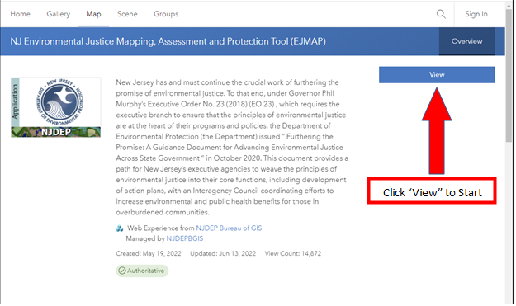

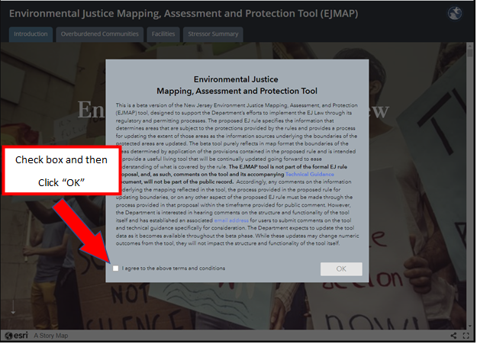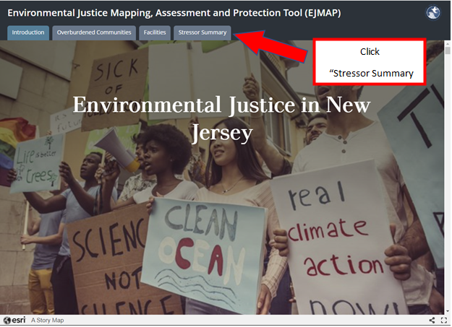

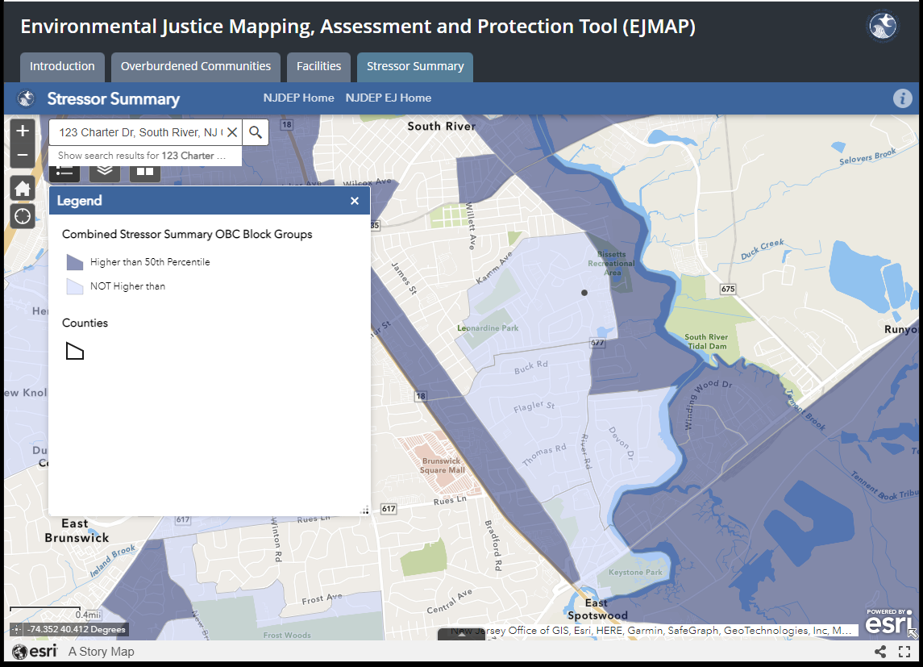

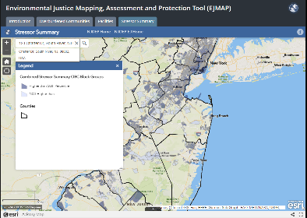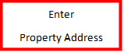

If the property is in dark blue (“Higher than 50th Percentile”), the site is within an Overburdened Community Subject to Adverse Cumulative Stressors. If it is in light blue or has no color, the site is not within an Overburdened Community Subject to Adverse Cumulative Stressors.

*Additional information can be found here:*

[Environmental Justice Mapping, Assessment, and Protection (EJMap): Technical Guidance](https://www.nj.gov/dep/ej/ejmap-tg.pdf)

How to Find Out if A Proposed Project is Designated as Historic

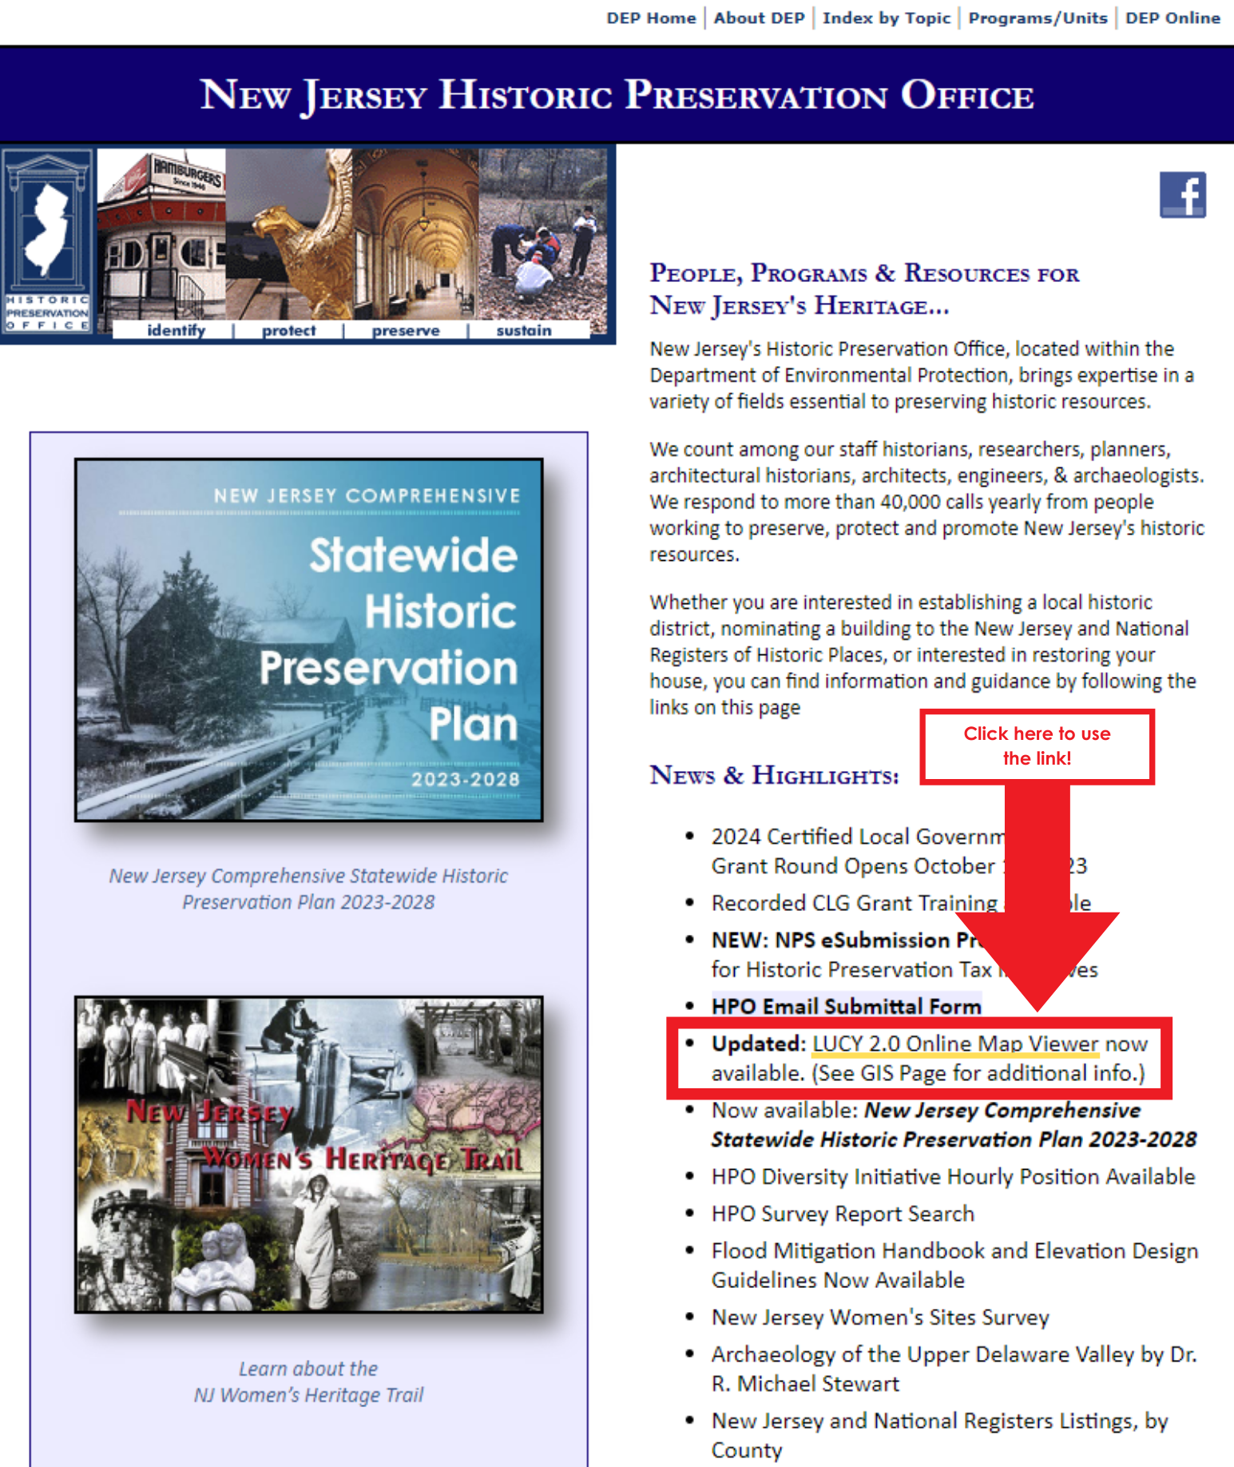Visit the [Historic Preservation Office](https://www.nj.gov/dep/hpo/) website.

[LUCY](https://nj.gov/dep/hpo/1identify/gis.htm) = DEP’s Historic Preservation Office identification of Historic Resources with Geographic Information System (GIS)

* [LUCY Online Map Viewer](https://njdep.maps.arcgis.com/apps/webappviewer/index.html?id=44ce3eb3c53349639040fe205d69bb79)
* 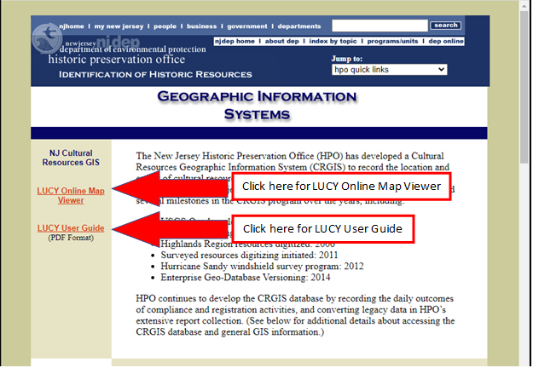[LUCY User Guide](https://nj.gov/dep/hpo/1identify/LUCY_2.0_User_Guide.pdf)

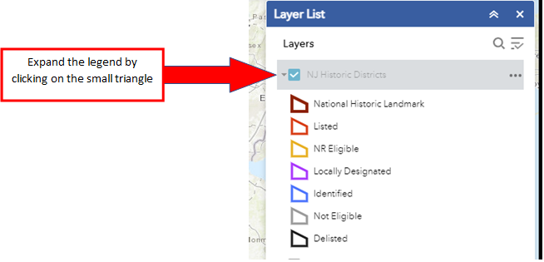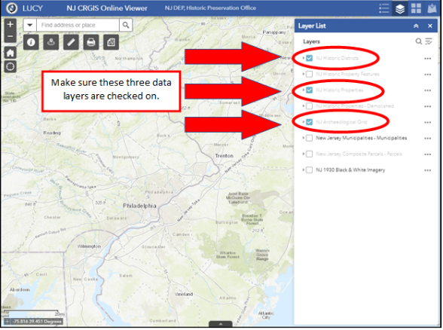

Text Box

Properties within these Categories are Potentially Historic

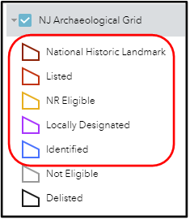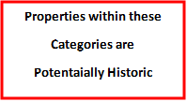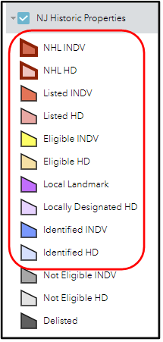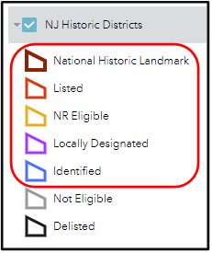

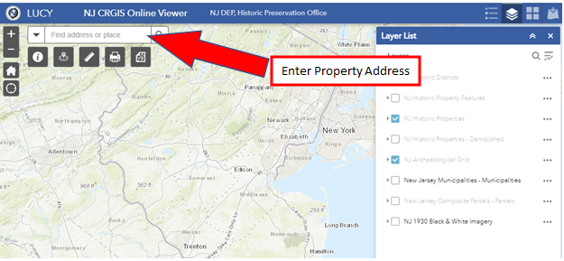

If the project site is highlighted or outlined in one of the colors circled above, check Yes for the application question: **Is the property identified as historic on the NJDEP Historic Preservation Office LUCY Online Map Viewer?** Otherwise, check No.

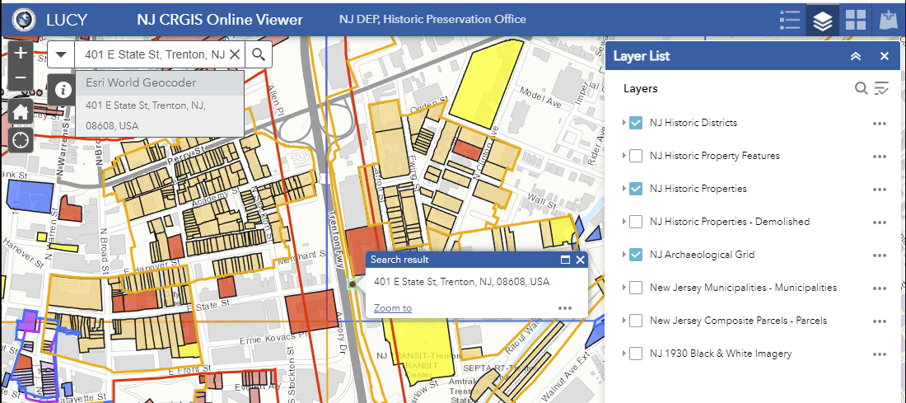

How to Confirm IRS Tax Exempt Status (Nonprofit applicants)

IRS website: [Tax Exempt Organization Search](https://apps.irs.gov/app/eos/)

Can search by EIN or by Organization Name. If the search is unsuccessful, the website has a link to Search

Tips.

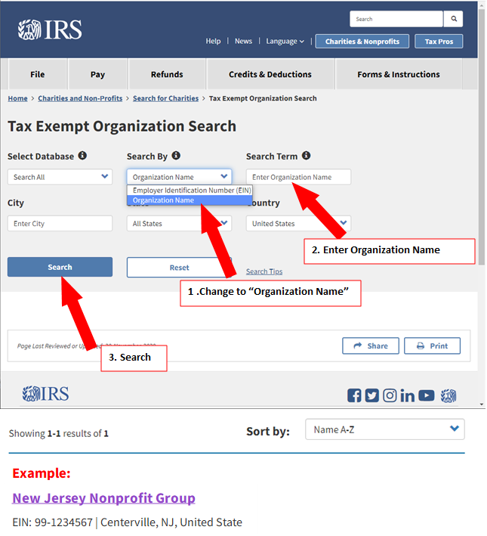

ShapeText Box

After Clicking the Name, the *Publication 78 Data* box should appear and must state: "On Publication 78 Data List: Yes"

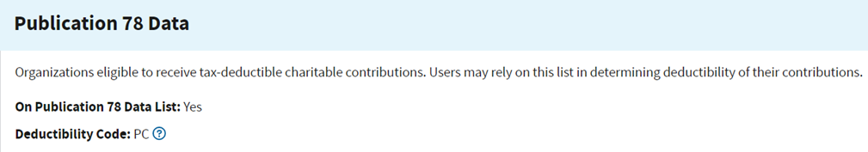

How to Confirm CRIA Compliance Status (Nonprofit applicants)

The State of New Jersey’s Division of Consumer Affairs website: [Search of a Charity](https://njconsumeraffairs.state.nj.us/public-charity-search-results/)

Note: If the search is unsuccessful, it could be because terms have been abbreviated (e.g., CTY instead of COUNTY, NJ instead of NEW JERSEY).

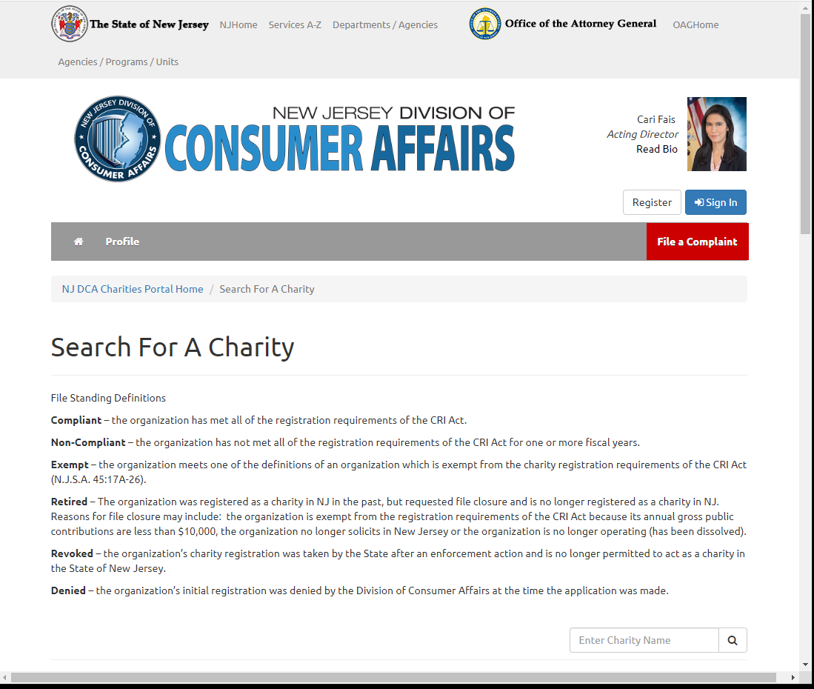Text Box

If the Division of Consumer Affairs website identifies the applicant as “Noncompliant” and the nonprofit believes it is an error, the nonprofit can request a written Letter of Compliance from Consumer Affairs. The request can be submitted on a signed, dated letter on the nonprofit’s letterhead emailed to Yvonne Jenkins at [JenkinsY@dca.njoag.gov](mailto:JenkinsY@dca.njoag.gov). The request letter should list the following information:

* Name of the Organization
* Charity Registration Number
* That the Letter of Compliance is needed for the Green Acres grant application
* Green Acres grant application deadline
* “Requesting a Letter of Compliance”

Allowable Costs (Local Governments) - Green Acres Rules Excerpt

**N.J.A.C. 7:36-4.10 Allowable project costs**

(a) For an acquisition project, the following costs are allowable, provided the local government unit incurs such costs in conformance with all applicable laws, including the Local Public Contracts Law, N.J.S.A. 40A:11-1 et seq.:

1. Costs that a local government unit incurs to acquire title or permanent interest in the project site, up to the greater of either:

i. The eligible land cost; or

ii. The purchase price, up to the hypothetical land value;

2. Relocation payments made by a local government unit in accordance with the Relocation Assistance Act, N.J.S.A. 20:4-1 et seq. or the Relocation Assistance Law at 1967, N.J.S.A. 52:31B-1 et seq. The local government unit shall provide to Green Acres a Workable Relocation Assistance Plan (WRAP) approved by the New Jersey Department of Community Affairs;

3. Costs that the local government unit incurs for any appraisal obtained in accordance with N.J.A.C. 7:36-8.3;

4. Land survey costs that the local government unit incurs for the field determination of acreage to be subject to Green Acres restrictions, done in compliance with the Local and Nonprofit Land Survey Overview, incorporated herein by reference as chapter Appendix 2. The Overview is available from Green Acres at PO Box 412, Trenton, New Jersey 08625 or on the Green Acres web page at www.nj.gov/dep/greenacres. Technical assistance regarding the preparation of the land survey is available from Green Acres.

5. Costs of the preliminary assessment, when completed in accordance with N.J.A.C. 7:26E, as required under N.J.A.C. 7:36-8.2, and further testing as determined by the Department, based on findings and recommendations of the preliminary assessment;

6. Subject to N.J.A.C. 7:36-4.4, costs of demolition and removal of any structure:

i. For a project located in an Urban Aid municipality, all allowable costs associated with demolition and removal of structures are eligible, subject to available funding;

ii. For a project not located in an Urban Aid municipality, allowable costs associated with demolition and removal of structures are limited to a maximum of 10 percent of the eligible land cost or $100,000, whichever is less; and

iii. The local government unit's attorney must submit a certification that each contract related to the demolition and removal was let in conformance with the Local Public Contracts Law, N.J.S.A. 40A:11-1 et seq. This certification is required for each executed contract for professional services or construction, and must be on a form provided by Green Acres;

7. Costs of well testing done in compliance with the Private Well Testing Act, P.L. 2001, c.40; N.J.S.A. 58:12A-26 et seq., and implementing rules at N.J.A.C. 7:9E; and

8. Incidental costs, individually itemized, associated with the implementation of the acquisition project, including the cost of advertising, archaeological, architectural, conservation, engineering, feasibility studies, financial, geological, historic research, hydrological, inspection, legal, planning, or other professional advice, estimates, reports, services, or studies; and title insurance obtained in accordance with N.J.A.C. 7:36-9.4(c)1iv and 2iv. Incidental costs are limited to a maximum of two percent of the eligible land cost or $20,000, whichever is less.

(b) The following types of costs are not allowable:

1. Administrative and operating costs and salary and/or wages of any employee of the local government unit incurred as part of the acquisition project;

2. Real property taxes;

3. Costs associated with an application for Green Acres funding that the Garden State Preservation Trust does not approve under N.J.A.C. 7:36-8.1;

4. Remediation work done to address any areas of concern, as defined under the Technical Requirements for Site Remediation, N.J.A.C. 7:25E, that are identified in the preliminary assessment required under N.J.A.C. 7:36-8.2 or by other means; and

5. Costs in excess of the sum of the approved Green Acres funding plus the local government unit's matching share, if required, unless Green Acres has approved a request for supplemental funding under N.J.A.C. 7:36-9.3.

(c) Costs of a condemnation award in excess of the eligible land cost of the project site may be funded by a supplemental Green Acres loan or matching grant under N.J.A.C. 7:36-9.3.

Allowable Costs (Nonprofits) - Green Acres Rules Excerpt

**N.J.A.C. 7:36-15.9 Allowable project costs**

(a) For an acquisition project, the following costs are allowable, provided the nonprofit incurs such costs in conformance with all applicable laws, as well as the Local Public Contracts Law, N.J.S.A. 40A:11-1 et seq.:

1. Costs that the nonprofit incurs to acquire title or permanent interest in the project site, up to the greater of either:

i. The eligible land cost; or

ii. The purchase price, up to the hypothetical land value;

2. Costs that the nonprofit incurs for any appraisal obtained in accordance with N.J.A.C. 7:36-19.3;

3. Land survey costs that the nonprofit incurs for the field determination of acreage to be subject to Green Acres restrictions, done in compliance with the Local and Nonprofit Land Survey Overview, set forth herein as chapter Appendix 2. The Overview is available from Green Acres at PO Box 412, Trenton, New Jersey 08625 or on the Green Acres web page at www.nj.gov/dep/greenacres. Technical assistance regarding the preparation of the land survey is available from Green Acres;

4. Costs of the preliminary assessment, when completed in accordance with N.J.A.C. 7:26E, as required under N.J.A.C. 7:36-19.2, and further testing as determined by the Department, based on findings and recommendations of the preliminary assessment;

5. Subject to N.J.A.C. 7:36-15.5, costs of demolition and removal of structures;

i. For a project located in an Urban Aid municipality, all allowable costs associated with demolition and removal of structures are eligible, subject to available funding;

ii. For a project not located in an Urban Aid municipality, allowable costs associated with demolition and removal of structures are limited to a maximum of 10 percent of the eligible land cost or $100,000, whichever is less; and

iii. The nonprofit's attorney must submit a certification that each contract related to the demolition and removal was let in conformance with the Local Public Contracts Law, N.J.S.A. 40A:11-1 et seq. This certification is required for each executed contract for professional services or construction, and must be on a form provided by Green Acres;

6. Costs of well testing done in compliance with the Private Well Testing Act, P.L. 2001, c.40; N.J.S.A. 58:12A-26 et seq., and implementing rules at N.J.A.C. 7:9E; and

7. Incidental costs, individually itemized, associated with the implementation of the acquisition project, including the cost of advertising, archaeological, architectural, conservation, engineering, feasibility studies, financial, geological, historic research, hydrological, inspection, legal, planning, or other professional advice, estimates, reports, services, or studies; and title insurance obtained in accordance with N.J.A.C. 7:36-20.4.3(c)1iv and 2iv. Incidental costs are limited to a maximum of two percent of the eligible land cost or $20,000, whichever is less.

(b) The following types of costs are not allowable:

1. Administrative and operating costs and salaries and/or wages of any employee of the nonprofit incurred as part of the acquisition project;

2. Real property taxes;

3. Costs associated with an application for Green Acres funding that the Garden State Preservation Trust does not approve under N.J.A.C. 7:36-19.1.

4. Remediation work done to address any areas of concern, as defined under the Technical Requirements for Site Remediation, N.J.A.C. 7:25E, that are identified in the preliminary assessment required under N.J.A.C. 7:36-19.2 or by other means; and

5. Costs in excess of the sum of Green Acres funding plus the nonprofit's matching share, unless Green Acres has approved a request for supplemental funding under N.J.A.C. 7:36-20.3.

Helpful Links

*Click on name of link to access. If unsuccessful, hold down the Ctrl button while clicking.*

**Potential Funding Sources**

* County open space funds

[Atlantic County](https://www.atlantic-county.org/planning/land-acquisition.asp)

[Bergen County](https://co.bergen.nj.us/division-of-land-management/open-space-trust-fund)

[Burlington County](http://www.co.burlington.nj.us/234/Municipal-Park-Development-Program)

[Camden County](https://www.camdencounty.com/service/environmental-affairs/open-space-farmland-preservation/)

[Cape May County](https://capemaycountynj.gov/596/Open-Space-Farmland-Preservation)

[Cumberland County](https://www.co.cumberland.nj.us/farmland-and-open-space)

[Essex County](https://essexcountyparks.org/)

[Gloucester County](https://www.gloucestercountynj.gov/405/Open-Space-Preservation-Program)

[Hudson County](https://www.hcnj.us/planning/hcosrhp-trust-fund/)

[Hunterdon County](https://www.co.hunterdon.nj.us/442/Grant-Opportunities)

[Mercer County](https://www.mercercounty.org/departments/planning/open-space)

[Middlesex County](https://www.middlesexcountynj.gov/government/departments/department-of-infrastructure-management/office-of-parks-and-recreation/conservation-and-open-space-stewardship)

[Monmouth County](https://www.monmouthcountyparks.com/page.aspx?Id=2593)

[Morris County](https://www.morriscountynj.gov/Departments/Open-Space-Preservation)

[Ocean County](https://www.planning.co.ocean.nj.us/frmepnaturallandtrust)

[Passaic County](https://www.passaiccountynj.org/government/boards-committees-and-commissions-f-z/open-space-farmland-and-historic-preservation-advisory-committee)

[Salem County](https://www.salemcountynj.gov/departments/open-space-advisory-council/)

[Somerset County](https://www.co.somerset.nj.us/government/public-works/planning/agriculture-development-board/open-space-and-preservation-programs)

[Sussex County](https://www.sussex.nj.us/cn/webpage.cfm?tpid=15781)

[Union County](https://ucnj.org/office-of-open-space-recreation-historic-preservation-trust-fund/#:~:text=Office%20of%20Open%20Space%2C%20Recreation%20%26%20Historic%20Preservation%20Trust%20Fund,A-Victoria%20Durbin%20Drake&text=The%20mission%20of%20the%20Open,and%20to%20preserve%20historic%20sites)

[Warren County](https://www.warrencountynj.gov/government/land-preservation-department/municipal-charitable-conservancy-grants)

* General Open Space/Recreation/Community Development Grant Programs
  + [ANJEC Open Space Stewardship Grants](https://anjec.org/open-space-stewardship-grants/)
  + [DCA Local Recreation Improvement Grant Program](https://www.nj.gov/dca/dlgs/programs/lriggrants.shtml#:~:text=The%20Local%20Recreation%20Improvement%20Grant%20(LRIG)%20exists%20to%3A,in%20achieving%20unmet%20recreational%20obligations)
  + [American Water’s Building Better Communities Grant Program](https://www.amwater.com/corp/Customers-and-Communities/American-Water-Charitable-Foundation/index) (administered by National Recreation and Park Association)
  + [DCA Community Development Block Grants](https://www.nj.gov/dca/dhcr/offices/comact.shtml)
  + [USDA Community Facilities Grant](https://www.rd.usda.gov/programs-services/community-facilities/community-facilities-direct-loan-grant-program)
  + [DCA Neighborhood Revitalization Tax Credit](https://nj.gov/dca/dhcr/offices/nrtc.shtml) (nonprofits working in certain municipalities)
  + [William Penn Foundation](https://williampennfoundation.org/what-we-fund) (Greater Philadelphia region)
  + [Open Space Institute](https://www.openspaceinstitute.org/states/new-jersey)
  + [DEP Office of Natural Resource Restoration](https://www.nj.gov/dep/nrr/index.html)
  + [City Parks Alliance Equitable Parks Funding Hub](https://cityparksalliance.org/funding-hub/)
  + [USNPS Outdoor Recreation Legacy Partnership Grants Program](http://www.nps.gov/subjects/lwcf/outdoor-recreation-legacy-partnership-grants-program.htm)
* Grant Programs for Specific Types of Improvements
  + [New Jersey Urban and Community Forestry Grants](https://www.nj.gov/dep/parksandforests/forest/urbanandcommunity/grants.html)
  + [319 Nonpoint Source Pollution Grants](https://dep.nj.gov/wlm/watershed/319-grants/)
  + [NJ Historic Trust Funding Programs](https://www.nj.gov/dca/njht/programs/overview/) (cannot be used to match GA funding)
  + [US Tennis Association Grants](https://www.usta.com/en/home/coach-organize/tennis-support/grants-assistance.html)
  + [Boat U.S. Grants](https://www.boatus.org/grants/faq/)
  + [Boating Infrastructure Grant Program](https://www.fws.gov/program/boating-infrastructure) (US Fish & Wildlife Service)
  + [NBIG – National Boat Infrastructure Grant](https://www.fws.gov/library/collections/boating-infrastructure-grant-big-awards) (US Fish & Wildlife Service)
* Accessibility Grants
  + [Recreation Opportunities for Individuals with Disabilities Grants (DCA)](https://www.nj.gov/dca/dhcr/rec/Grants.shtml)
  + [Inclusive Healthy Communities Grant Program (IHC)](https://inclusivehealthycommunities.org/)

**Other Resources**

* Green Acres & OTPLA Links
  + [Green Acres](https://dep.nj.gov/greenacres/)
  + [Green Acres Regulations](https://dep.nj.gov/wp-content/uploads/greenacres/pdf/njac7_36.pdf)
  + [Application Forms](https://dep.nj.gov/greenacres/forms-and-regulations/#green-acres-application-forms)
  + [Contacts List](https://dep.nj.gov/greenacres/contact-us/)

* + [Office of Transactions and Public Land Administration, Public Land Compliance Section](https://dep.nj.gov/otpla/public-land-compliance/)
  + [Recreation and Open Space Inventory (ROSI) Form](https://dep.nj.gov/wp-content/uploads/greenacres/xls/rosi_spreadsheet_ver1.xltm_.zip)
* Public Engagement in Park Planning Resources
  + [Community Engagement Resource Guide (NRPA)](https://www.nrpa.org/contentassets/19b3cbe05a634d5e8d3b712dbc8aa9d0/community-engagement-guide-nrpa.pdf)
  + [Designing Parks Using Community-Based Planning](https://www.parksforcalifornia.org/planning_guide) (California State Parks)
* [Planning for Parks, Recreation, and Open Space in Your Community](https://rco.wa.gov/wp-content/uploads/2019/10/PlanningforParksOpenSpace.pdf) (Washington State)
  + Examples of Park Planning Community Engagement Efforts:
    - [Carver County, MN](https://conservancy.umn.edu/bitstream/handle/11299/185012/RCP_24c-PA_5253-report.pdf?sequence=2&isAllowed=y)
    - [Portland, OR](https://www.oregonmetro.gov/sites/default/files/2019/10/08/Connect-with-Nature-Report.pdf)
* Open Space and Recreation Facilities Mapping and Planning Resources
  + [SCORP](https://dep.nj.gov/outside-together/) (Outside, Together!)
  + [NJMAP / Conservation Blueprint](http://www.njmap2.com/)
  + [NJ-GeoWeb](https://www.nj.gov/dep/gis/geowebsplash.htm)
  + [NJ Community Asset Map](https://www.nj.gov/dca/news/news/2019/approved/20190412.html)
  + [DEP-approved Public Access Plans](https://www.nj.gov/dep/cmp/access/mpaplans.htm)
  + [Healthy Communities NJ](https://www.nj.gov/health/hcpnj/)
* Climate Mitigation and Resilience Resources
  + [DEP Climate Change Information](https://www.nj.gov/dep/climatechange/)
  + [NJ Global Warming Response Act 80x50 Report](https://dep.nj.gov/wp-content/uploads/climatechange/nj-gwra-80x50-report-2020.pdf)
  + [New Jersey’s Flood Indicator Tool](https://njdep.maps.arcgis.com/apps/webappviewer/index.html?id=e26feba3b4844e5d960d3163b23623f2)
  + [Climate Friendly Parks](https://www.nps.gov/subjects/climatechange/cfpprogram.htm)
  + [US Green Building Council](https://new.usgbc.org/)
* Environmental Justice Resources
  + [Office of Environmental Justice](https://dep.nj.gov/ej/)
  + [*Furthering the Promise*](https://dspace.njstatelib.org/xmlui/bitstream/handle/10929/68451/furthering-the-promise.pdf?sequence=1&isAllowed=y)
  + [EJMAP](https://experience.arcgis.com/experience/548632a2351b41b8a0443cfc3a9f4ef6)
* Historic Preservation Resources
  + [NJ State Historic Preservation Office](https://www.nj.gov/dep/hpo/)
  + [New Jersey Comprehensive Statewide Historic Preservation Plan](https://www.nj.gov/dep/hpo/Index_HomePage_images_links/hpo_plan%202013_2019/hpoplan2014.pdf)
  + [LUCY Online Map Viewer](https://njdep.maps.arcgis.com/apps/webappviewer/index.html?id=44ce3eb3c53349639040fe205d69bb79)
  + [LUCY User Guide](https://nj.gov/dep/hpo/1identify/LUCY_2.0_User_Guide.pdf)
  + [New Jersey and National Registers of Historic Places](https://www.nj.gov/dep/hpo/1identify/nrsr_lists.htm)
  + [Secretary of the Interior's Standards for the Treatment of Historic Properties](https://www.nps.gov/orgs/1739/secretary-standards-treatment-historic-properties.htm#:~:text=Standards%20for%20Rehabilitation-,The%20Secretary%20of%20the%20Interior's%20Standards%20for%20the%20Treatment%20of,Grants%E2%80%93in%E2%80%93Aid%20programs)
  + [Secretary of the Interior's Guidelines for the Treatment of Cultural Landscapes](https://www.nps.gov/crps/tps/landscape-guidelines/index.htm)
* Accessibility Resources
  + [Americans with Disabilities Act](https://www.dol.gov/general/topic/disability/ada#:~:text=The%20Americans%20with%20Disabilities%20Act,local%20government'%20programs%20and%20services)
  + [NJ Division of Disability Services](https://nj.gov/humanservices/dds/home/)
  + [New Jersey Barrier Free Subcode](https://www.nj.gov/dca/divisions/dhcr/rec/pdf/barrierfree_effective.pdf) (Recreation: Sections 5:23-7.16 to 5.23-7.32)
  + [DCA Rules for Completely Inclusive Playgrounds](https://www.nj.gov/dca/divisions/codes/codreg/pdf_regs/njac_5_23_11.pdf)
  + [Disability Snapshots](https://climatesnapshots.rutgers.edu/disability)
  + [Rutgers State Policy Lab – Increased Access to Nature and Outdoor Recreation for People with Disabilities](https://policylab.rutgers.edu/projects/environment-projects/)
* Tree Resources
  + [New Jersey Urban & Community Forestry Program](https://www.nj.gov/dep/parksandforests/forest/urbanandcommunity/)
  + [NJ State Approved Foresters](https://www.nj.gov/dep/parksandforests/forest/docs/ACF.pdf)
  + [NJ Shade Tree Federation Information](https://njstf.org/publications.php)
  + [Sample list of NJ Native Trees](https://npsnj.org/native-plants/plant-lists/)

* Trail Resources
  + [NJ Trails Program](https://dep.nj.gov/greenacres/trails-program-home/)
  + [Routine Trail Maintenance Costs per Mile](https://www.railstotrails.org/resource-library/resources/yearly-routine-rail-trail-maintenance-costs-per-mile/)
* DEP Division of Science & Research Findings on Synthetic Turf:
  + [Environmental Health and Assessment](https://dep.nj.gov/dsr/environmental-health/)
* Resources for Contaminated Sites
  + [DEP Office of Brownfields Reuse](https://www.nj.gov/dep/srp/brownfields/contacts.htm)
  + [Hazardous Discharge Site Remediation Fund](https://www.nj.gov/dep/srp/finance/hdsrf/) (grants for site investigation and remediation)
* Public Contracts Information
  + [NJ Local Agency Procurement Laws](https://www.nj.gov/dca/dlgs/programs/NJ_LAPL.shtml)
  + [Local Public Contracts Law Contracting Thresholds](https://www.nj.gov/dca/divisions/dlgs/programs/lpcl_docs/Contracting%20Threshold%20Tables.pdf)
  + [Prevailing Wage Rates on Construction-Related Public Works Projects](https://www.nj.gov/labor/wageandhour/prevailing-rates/public-works/index.shtml)
* Nonprofit Compliance Links
  + [IRS Tax Exempt Organization Search](https://apps.irs.gov/app/eos/)
  + [NJ DCA Charities Search](https://njconsumeraffairs.state.nj.us/public-charity-search-results/)