Add your SMP drawing here: add legend/notes for key features requiring maintenance

**NJ Stormwater Toolkit  
Stormwater Maintenance Card**

Municipality of “Greenville”  
Template by NJDEP

Prepared by “J. Doe, Public Works Manager”



**Facility: Example - Wet Pond Facility No. 4**

**Location**Example - Small park behind Municipal Building;

34 Main Street

**Description/Purpose**Example - Bioswale/rain garden surrounding infiltration pond

**SHORT TERM or WEEKLY or MONTHLY MEASURES** (*choose one*)

**DRAINAGE:**

**Example guidance**: list in this section the short-term maintenance measures related to facility drainage that should be performed frequently to maintain the functionality and effectiveness of the stormwater management BMP

* Examples are listed below

***Measure 1***: Weekly – confirm drainageways, pipe outlets to pond are clear

* Action: Confirm working condition of original drainage pathways
* Action: Look for evidence of undesirable erosion and repair

***Measure 2***: Log/summarize results from BMP inspection on back of card

**VEGETATION:**

**Example guidance**: list in this section the short-term maintenance measures related to BMP vegetation that should be performed frequently to maintain the functionality and effectiveness of the stormwater management facility

* An example is listed below

***Measure 1***: Confirm health of grasses/ground cover, shrubs, trees near BMP

* Examine the vegetation that was installed as part of the BMP for signs of stress, disease, predation, and replace as needed
* Identify the causes of lack of vegetative success as possible to determine if replacement with a different vegetation is needed

**SITE:**

**Example guidance**: list in this section the short-term maintenance measures related to BMP site environment

***Measure 1***: Review whether use of the site is causing any damage or creating any safety issues

* Log & repair damage to BMP features; immediately report safety issues

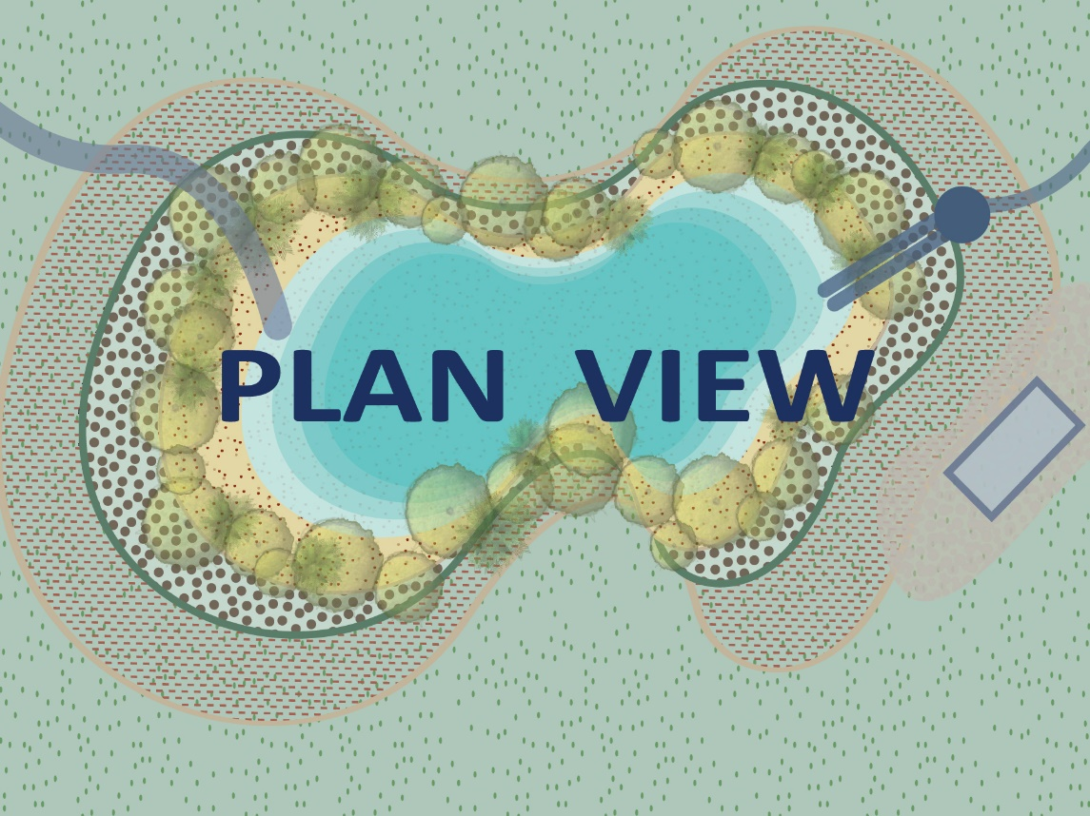

**MEDIUM TERM or QUARTERLY MEASURES** (*choose one*)

**DRAINAGE:**

**Example guidance**: list in this section the intermediate-term maintenance measures related to facility drainage that should be performed every few months to maintain the functionality and effectiveness of the BMP

***Measure 1***: Example-check all piping and inlet/outlet devices for signs of settling or clogging

* Unclog or repair pipe or outlet/inlet as needed; log actions

**VEGETATION:**

**Example guidance**: list in this section the intermediate-term maintenance measures related to facility vegetation that should be performed every few months to maintain the functionality and effectiveness of the BMP

***Measure 1***: Review whether any vegetation needs to be replaced

* Insert detailed guidance text here for specific actions to be performed

**SITE:**

**Example guidance**: list in this section the intermediate-term maintenance measures related to the facility environment that should be performed every few months to maintain the functionality & effectiveness of the BMP

***Measure 1***: Review integrated function of site vegetation and drainage components to assure full functionality, including infiltration

* Compare site design drawings to current site environment

**LONG TERM or YEARLY MEASURES** (*choose one*)

* On an annual basis, refer to **O&M Manual** for more details.

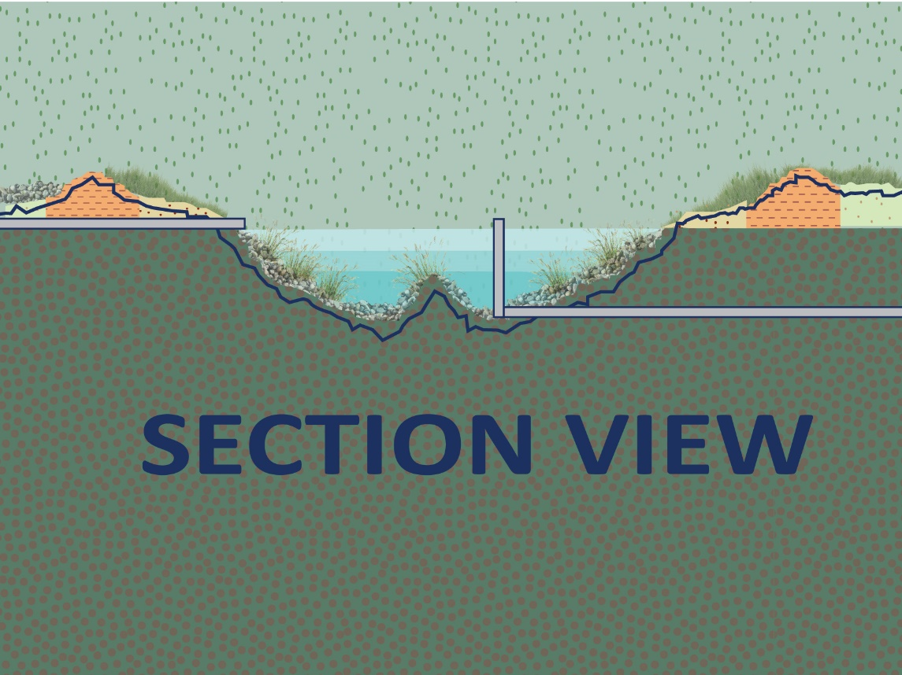

**DESIGN CONSIDERATIONS**

* 1. List here specific design detail information needed by field crew to facilitate proper inspection
* 2. Example – Outlet riser pipe in pond has debris screen that needs to be cleared of leaves and debris
* 3. List here specific design detail information needed by field crew
* 4. List here specific design detail information needed by field crew

**INSPECTIONS REQUIRED BY MAINTENANCE PLAN OR PERMIT**

* Permit Inspection requirement No. 1  
  [Optional – record results of inspection with date]
* Plan Inspection requirement No. 2  
  [Optional – record results; keep photo recordation of BMP condition at public works department for annual report to NJDEP]

**RECORD KEEPING**

Please keep separate records of maintenance actions taken or optionally summarize below.

* [Optional – Log inspection or maintenance action taken; include date]

**REPORTING**

* Identify who critical safety issues should be reported to, with contact information. For example: Facility conditions that might create near-term danger to the public should be reported to:_____________________________
* Does inspection result or maintenance action need to be reported for permit modification? If yes, record relevant notes/reminder.
* Does inspection result or maintenance action need to be reported so maintenance card can be modified? If yes, record relevant notes.

**MAINTENANCE NOTES**

[Optional – Write in any maintenance notes, or reminders for follow-up action]

**Contact information if there are maintenance questions**

Website: [www.text.com](http://www.text.com) Contact: Supervisor - John Smith  
Phone: (555) 555-5555 Email: [email2@text.gov](mailto:email2@text.gov)

**[Optional – If notes are added to the maintenance card, file it with:]**

Manager - Jane Doe  
Phone: (000) 000-0000 Email: [email1@text.gov](mailto:email1@text.gov)

Add your SMP drawing here: add legend/notes for key features requiring maintenance

**Version Date: May 2020 Back of Form**