RADIUS 3.1
WHAT’S NEW



TABLE OF CONTENTS

1. Error Message When Upgrading RADIUS Database 3
2. Error Messages When Importing Files into RADIUS 4
3. Copying Data Into Locked Documents 4
4. Reason for Application Screen 4
5. Changes to Details Screens 4
6. Printed Version of Facility Profile (General) Screen 6
7. Printed Version of Emission Statement Screen 6

Error Message When Upgrading RADIUS Database

RADIUS 3.1 corrects the issue (see screenshots, below) that some users had when upgrading to a newer version of RADIUS.
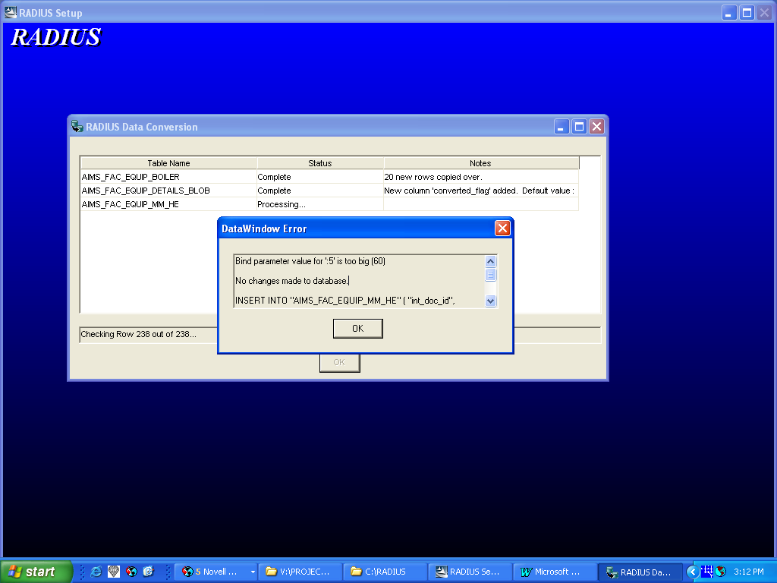
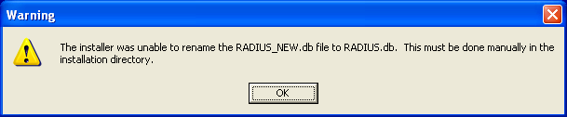

Error Messages When Importing Files into RADIUS

RADIUS 3.1 corrects the issue (see screenshots, below) that some users had when importing a permit file into RADIUS.
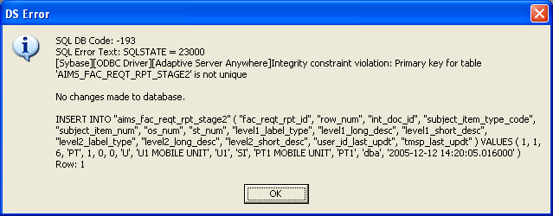
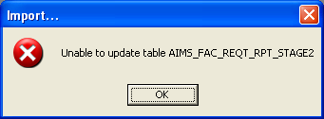

This problem occurred when users printed, or used the Print Preview feature on, the Compliance Plan. The exported version of this file contained an extra data table that caused the error messages. The corrected version fixes this problem. NOTE: Files with this problem will not import into RADIUS 3.1 without assistance from the RADIUS Help Line. For further instructions, please contact the RADIUS Help Line by calling (609) 633-7259.

Copying Data Into Locked Documents

RADIUS 3.1 no longer allows users to copy data into locked documents.

Reason for Application Screen

The Reason for Application screen can store up to 4000 characters, but previous versions of RADIUS only printed the first 2000 characters. This issue has been corrected in RADIUS 3.1.

Changes to Details Screens

The following changes were made to the details screens in RADIUS 3.1:

- Other Equipment (Equipment Inventory Details Screen) - The drop-down menu for the "Units" field was not functioning. This has been fixed in RADIUS 3.1.

- Adsorber (Control Device Details Screen) - The size of the "Maximum Adsorbant Capacity (lbs Adsorbate/lbs Adsorbant)" and "Minimum Adsorbant Capacity (lbs Adsorbate/lbs Adsorbant)" fields have been changed to allow values up to 999.99 (from 9.99).

- Scrubber (Venturi) (Control Device Details Screen) - Users attempting to open the venturi scrubber details screen in Control Device Inventory were receiving the following error message:

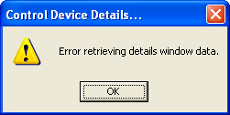
Users can now enter data into this screen.

- Incinerator (Waste Being Incinerated Window - Operating Scenario Details Screen) - The field titled "Is the Site Authorized by the NJDEP to Accept Waste?" is now enabled all the time. It was previously enabled only when the answer to the previous question was "no".

- Incinerator (Waste Being Incinerated Window - Operating Scenario Details Screen) - The size of "Burning Rate of Commercial Field" has been changed to allow values up to 99,999,999.99 (from 999,999.99).

Printed Version of Facility Profile (General) Screen

The printed version of the Facility Profile (General) screen now displays the NAICS code (see below).

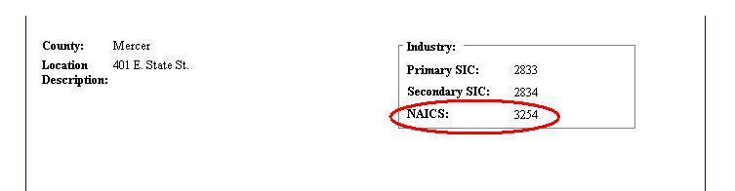

Printed Version of Emission Statement Screen

RADIUS 3.1 corrects a discrepancy that occurred when printing the Emission Statement screen. The "Tons/Yr" column now contains explanatory text, and the "Tons/Season" column has been added. These changes now make the printed version of the screen consistent with the data entry screen (see below).

