RADIUS 3.01
WHAT’S NEW



TABLE OF CONTENTS

1. Converting All Formula 1 Details Screens to PowerBuilder Format 3
2. Changes to Facility Profile (Permitting) Screen 5
3. Compliance Plan Printing 6
4. Ability to Copy Screens Across Applications 9
5. Cascade Delete Functionality 10
6. Multiple Row Deletes in Inventory Screens 10
7. New “Reason for Application” Screen 11
8. Simplified PCP Permit Application Form Categories and Form Types 11
9. Enhancements to RADIUS Printing and Viewing Capabilities 12
10. Auto-Fill PTE Screens Based on Compliance Plan Limitation Requirements 15

Converting All Formula 1 Details Screens to PowerBuilder Format

Formula 1 and PowerBuilder refer to the programs used to create the details screens used in RADIUS. Up until RADIUS 2.9, most details screens were in Formula 1 format. Details screens for Boilers, Manufacturing and Materials Handling, and Storage Vessels were in PowerBuilder format (see examples of Formula 1 and PowerBuilder details screens at the end of this section). The biggest difference between the two formats is that PowerBuilder provides the capability for drop-down menus and validation logic (numeric values must be within a certain range, text cannot be entered where numeric data is expected, etc.) whereas Formula 1 does not.

In order to improve data quality, the format of all new details screens have been changed to PowerBuilder format. Existing data in Formula 1 format will not be automatically converted to PowerBuilder, though we hope to have a conversion function in a future RADIUS build. The following provides additional information regarding this change in format:

- Design Efficiencies screens in the Control Device details screens have been eliminated.

- The degreaser details screens have been completely overhauled to comply with the recently changed Sub 16 requirements. To be consistent with Sub 16, degreasers are now called “cleaning machines” in RADIUS. Formula 1 degreaser details screens should no longer be used because they do not contain the information needed to determine compliance with Sub 16. Only PowerBuilder cleaning machine details screens should be accepted. You may also notice the equipment type drop-down in the Equipment Inventory screen contains a selection for conveyorized degreasers. This was intentional to allow RADIUS users to view historical data. It should not to be used in new applications or permits as details screens do not exist for this equipment type.

- This change has been designed to minimize the proliferation of Formula 1 details screens through implementation of the following rules:

- Formula 1 data WILL be preserved and displayed when performing the following operations:
- Importing/exporting files between NJEMS and RADIUS.
- Using the File\Save As command in RADIUS on a file containing Formula 1 details screens.
- Copying Formula 1 details screens within a file or to another file, as long as the target details screen contains data that is also in Formula 1 format.

- Formula 1 data WILL NOT be preserved when performing the following operaitons:
- Copying Formula 1 details screen data into a PowerBuilder details screen, and vice versa. You will get an error message telling you that the formats are not compatible with each other.
- Copying Equipment or Control Device subject items within the same document, or from one document to another (see #5, below). The underlying data in the details screen will not be copied over if it is in Formula 1 format. You will either have to manually enter the data, or go to a different details screen containing data in PowerBuilder format and copy it from there.

- Existing Formula 1 details screen with no data in them will automatically be converted to PowerBuilder format the next time it is opened. It will never open in Formula 1 format again, regardless of when that file was created.

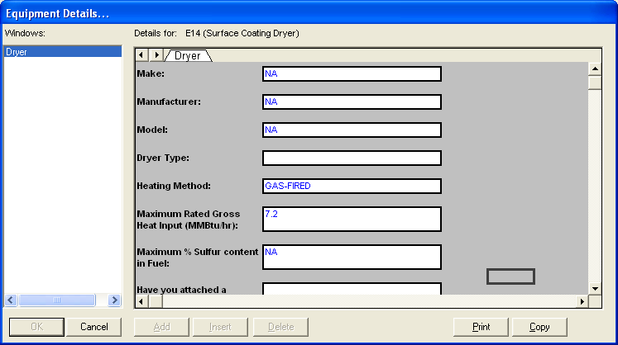Example of a Formula 1 Details Screen (allowed to click anywhere on the screen, no drop-down menus)

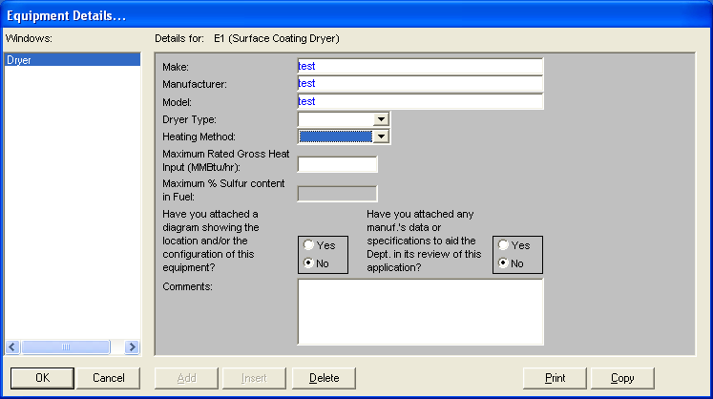
Example of the same screen in PowerBuilder format. Notice drop-down menus for Dryer Type and Heating Method. % Sulfur field enabled only for certain Dryer Types, but not for others.

Changes to Facility Profile (Permitting) Screen

Questions 7-11 were added to this screen. See screenshot (below):
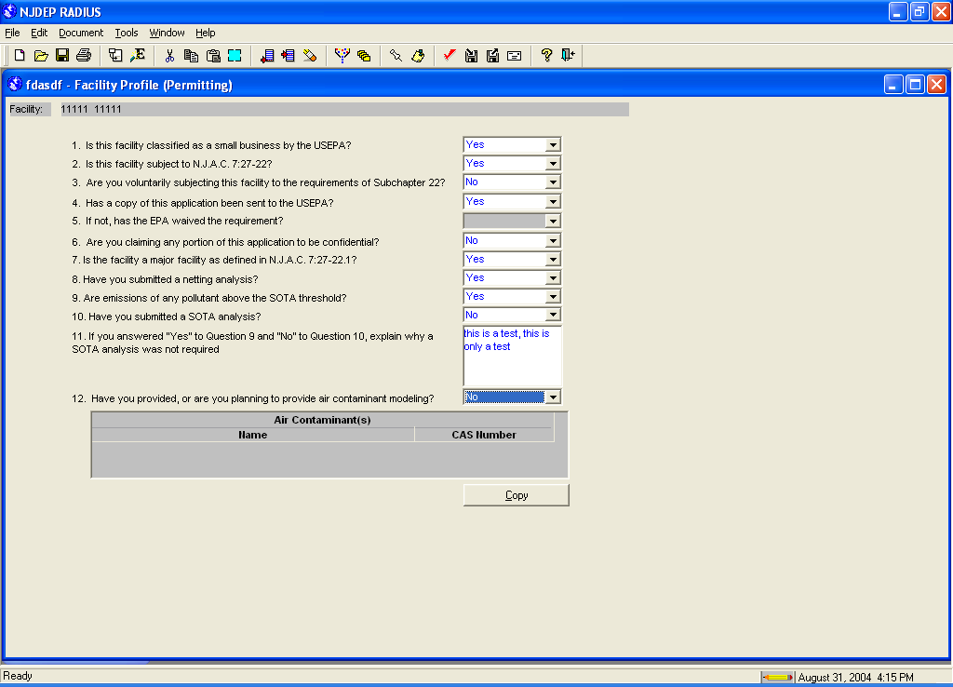

Compliance Plan Printing

Compliance Plan printing has been significantly changed to more logically order subject items within the Compliance Plan and to minimize the number of printed pages. Page numbering and subject item locations will be quite different than previous versions of RADIUS. This affects all permit documents, regardless of when it was created.

The following changes have been made:

- The subject item header will print on the top of the first page of each subject item. Subsequent pages will not have a header.

- The PT, CD, E, OS, and ST subject items no longer print in a separate section of the permit. Instead, they will print in the same section as the batch process or emission unit they are associated with. Subject item order will be as follows:
- FC (Facility)
- FG (Non-Source Fugitive Emissions)
- IS (Insignificant Sources)
- GR (Subject Item Group)
- BP\PT (Batch Process\Emission Point)
- BP\CD (Batch Process\Control Device)
- BP\E (Batch Process\Equipment)
- BP\OS (Batch Process\Operating Scenario)
- BP\OS\ST (Batch Process\Operating Scenario\Step)
- U\PT (Emission Unit\Emission Point)
- U\CD (Emission Unit\Control Device)
- U\E (Emission Unit\Equipment)
- U\OS (Emission Unit\Operating Scenario)

- Equipment, Control Devices, and Emission Points must be associated with an Emission unit or a Batch Process if you want the Compliance Plan for these subject items to be printed.

- Printing of identical subject items within the same Emission Unit/Batch Process will no longer cause separate pages to be printed for each subject item when the “Copy All” button is used to create a “same as” link. Instead, all identical subject items will print in the same header (see 1st screenshot on next page). Separate pages will continue print if the identical subject items are in different Emission Units/Batch Processes (see 2nd screenshot on next page).

- Equipment, Control Devices, and Emission Points assigned to multiple Emission Units/Batch Processes will have their Compliance Plans printed under each Emission Unit/Batch Process (see 3rd screenshot). It is very similar to the example shown in the 2nd screenshot, the difference being no “same as” link in the Compliance Plan. This causes the number of pages in the Compliance Plan to increase when compared to previous versions of NJEMS/RADIUS. For this reason, placing Equipment, Control Devices, and Emission Points in multiple Emission Units/Batch Process is not encouraged.

Sample Compliance Plan showing multiple identical subject items within the same emission unit.
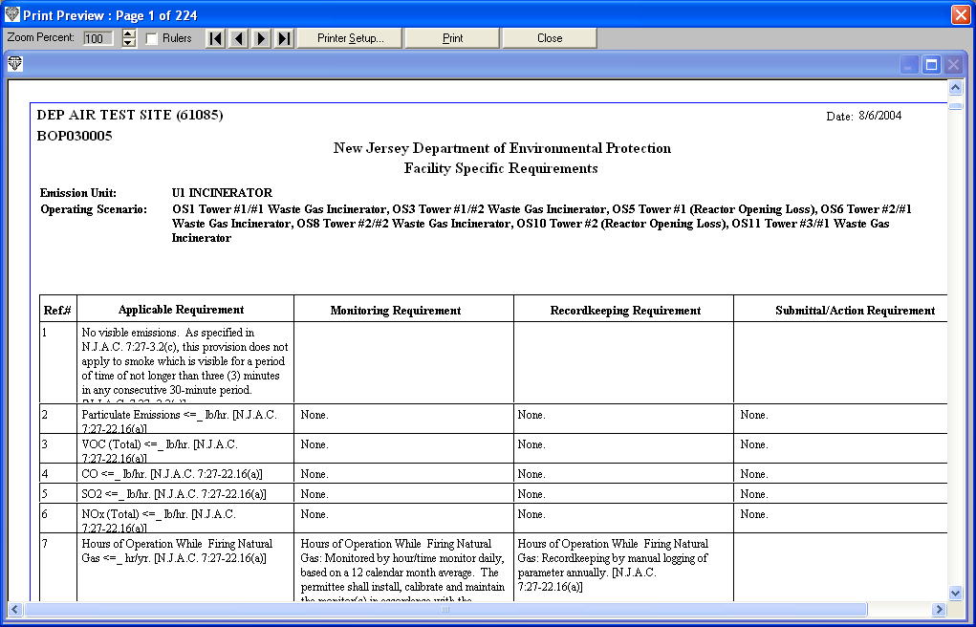
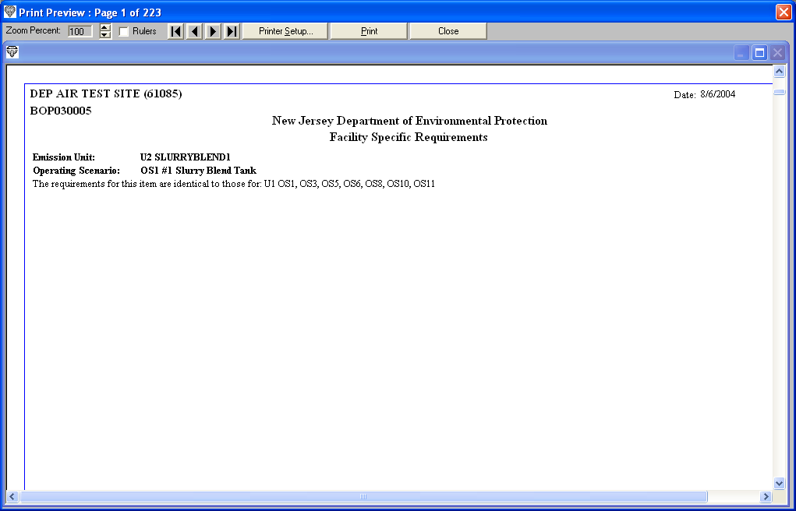
Sample Compliance Plan showing multiple identical subject items in different emission units.
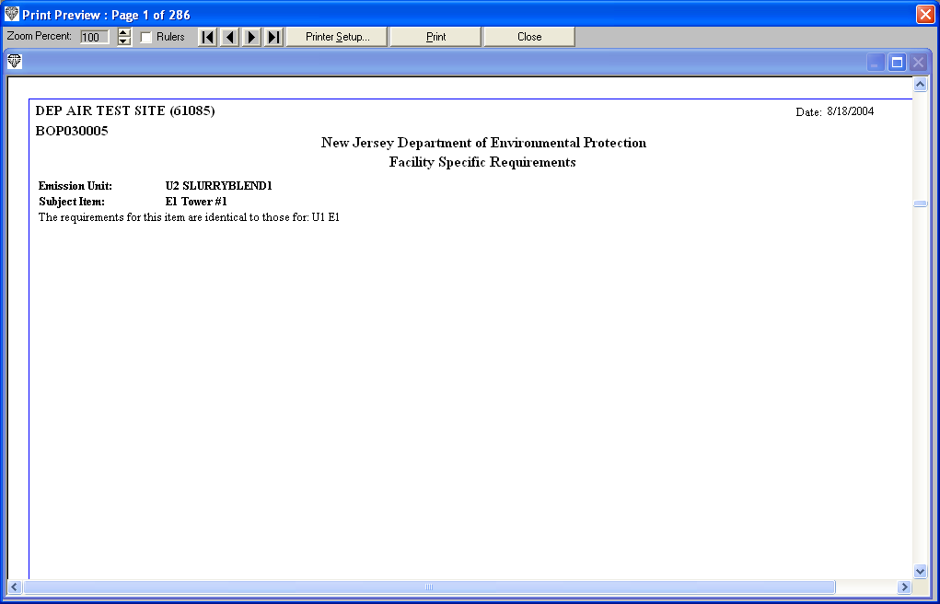
Sample Compliance Plan showing a single piece of equipment in multiple emission units.

Example of “Same As” Link
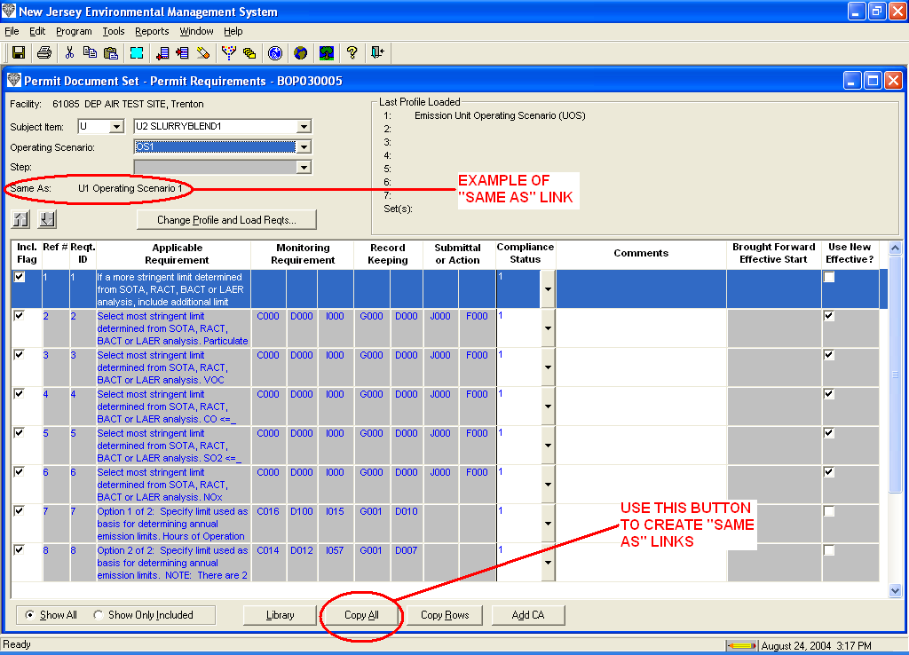

Ability to Copy Screens Across Applications

New copy features have been added to RADIUS. You can now copy information from most screens between permit applications or permit document sets. You will see a “Copy” button at the bottom of each screen that has this new functionality. Clicking on that button will give you a window similar to the following:
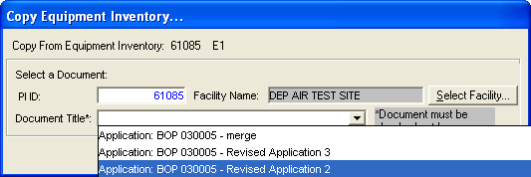
Simply select the PI # and Document you want to copy the information to. Remember that the document you are copying to must be checked out to yourself.

The following screens have this new Copy button:

Facility Profile (General)
Facility Profile (Permitting)
Non-Source Fugitive Emissions*
Insignificant Source Emissions*
Equipment Inventory (copies the underlying equipment details screens as well)*
Control Device Inventory (copies the underlying equipment details screens as well)*
Emission Point Inventory*
Compliance Plan/Permit Requirements**

* Only single row selections are allowed in these screens.
** Multiple row selections are allowed in this screen.

The following rules have been implemented when using this feature:

- The Copy Current Row button no longer exists. This button was used to copy inventory rows within the same document. Instead, use the right-click mouse button to access the “Duplicate Row” command. It works the same as the previous Copy Current Row button (see screenshot on following page).

- Data copied from the Facility Profile (General) and Facility Profile (Permitting) screens will overwrite any existing data contained in those screens in the application you are copying to (the target document).

- Data copied from the other screens will append itself to the data contained in the target document. Overwriting will not occur. If there is a numbering conflict (same NJID exists in the target document), RADIUS will automatically renumber the NJID to the next highest available number.

Duplicate Row function
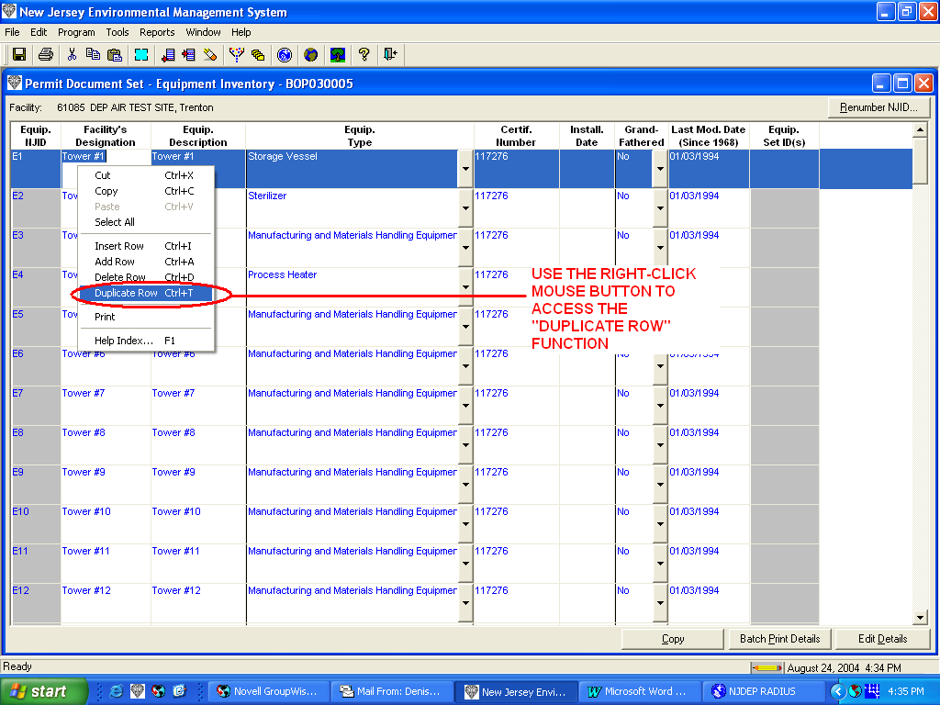

Cascade Delete Functionality

RADIUS users attempting to delete emission units from their documents had to delete each underlying operating scenario first. This was changed to allow the underlying operating scenarios to be deleted automatically when a user deletes the emission unit.

Multiple Row Deletes in Inventory Screens

RADIUS now allows users to select multiple rows in inventory screens for deletion. Shift-click and control-click methods (similar to the functionality in Windows) can be used to highlight the multiple rows.

New “Reason for Application” Screen

The old “Permit Modification Cover Page” has been renamed “Reason for Application”. This screen is now available for use in all permit application types, including initial BOP applications and construction of new source PCP applications. All applications submitted through the new version of RADIUS should have a completed Reason for Application screen.

The size of the Reason for Application field has been increased from 2000 to 4000 characters so that more information can be stored in it.

Simplified PCP Permit Application Form Categories and Form Types

The Form Categories and Form Types for Preconstruction Permits have been greatly simplified. In addition, RADIUS has been revised to allow users to view and edit all permit application screens for all PCP Form Types. See screenshots below:

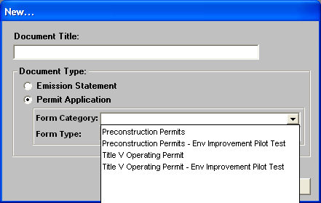
Example of Simplified Form Categories

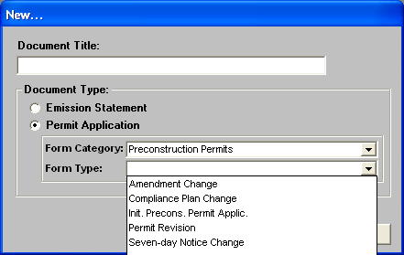
Example of Simplified Form Types

Enhancements to RADIUS Printing and Viewing Capabilities

Several enhancements related to printing and viewing have been added to RADIUS. See screenshots below:
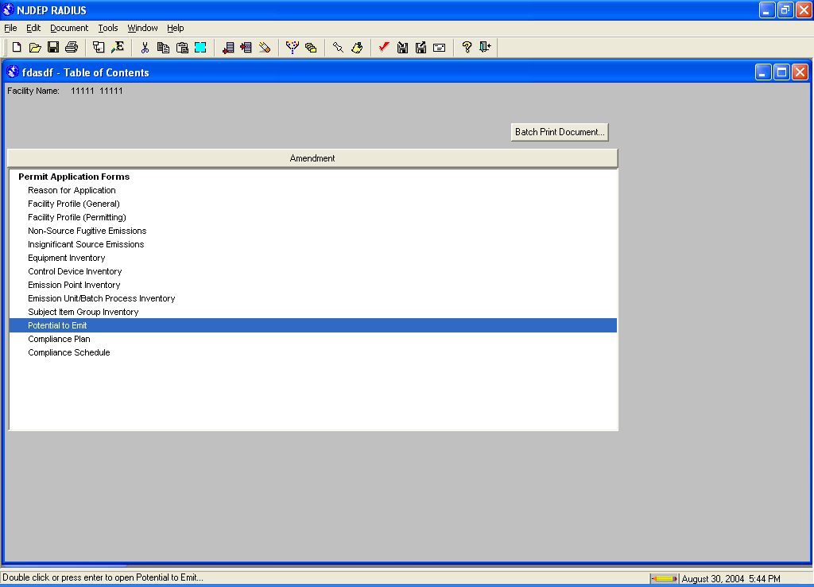
New Batch Print Document button
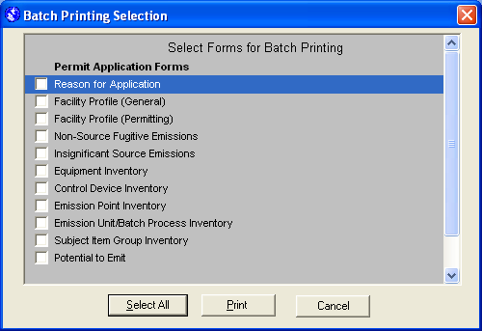
Clicking on that button allows you to batch print any combination of RADIUS screens

Print Preview capability added under the “File” menu
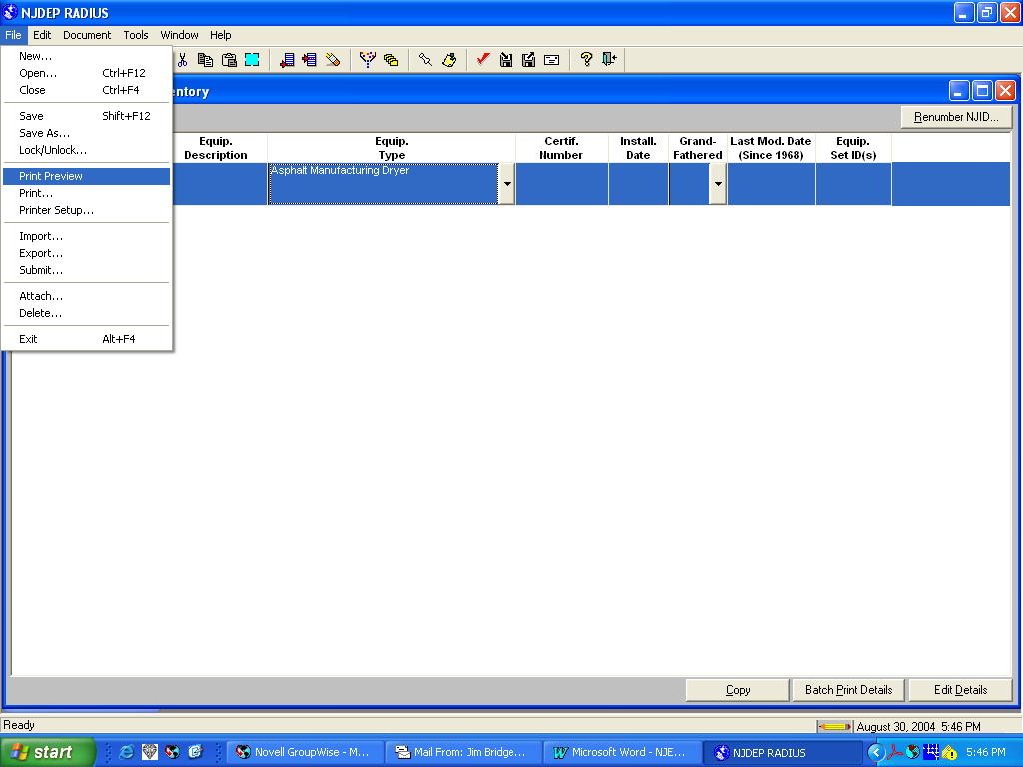
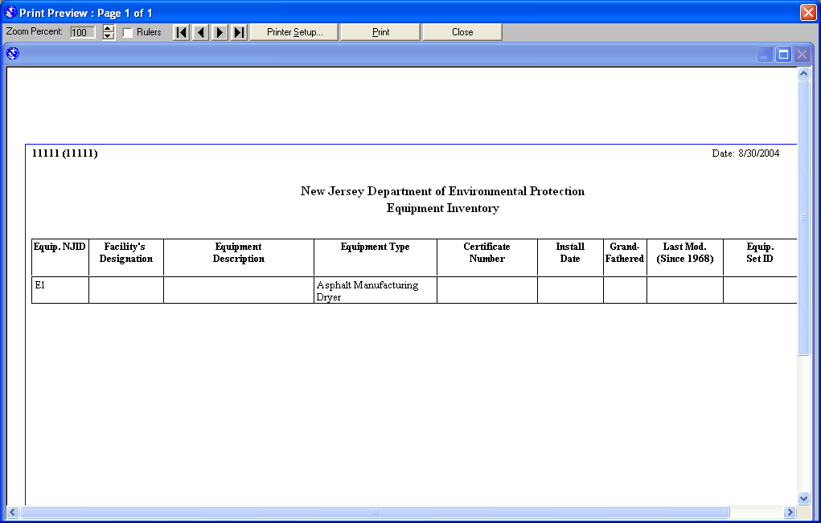
Sample Print Preview screen

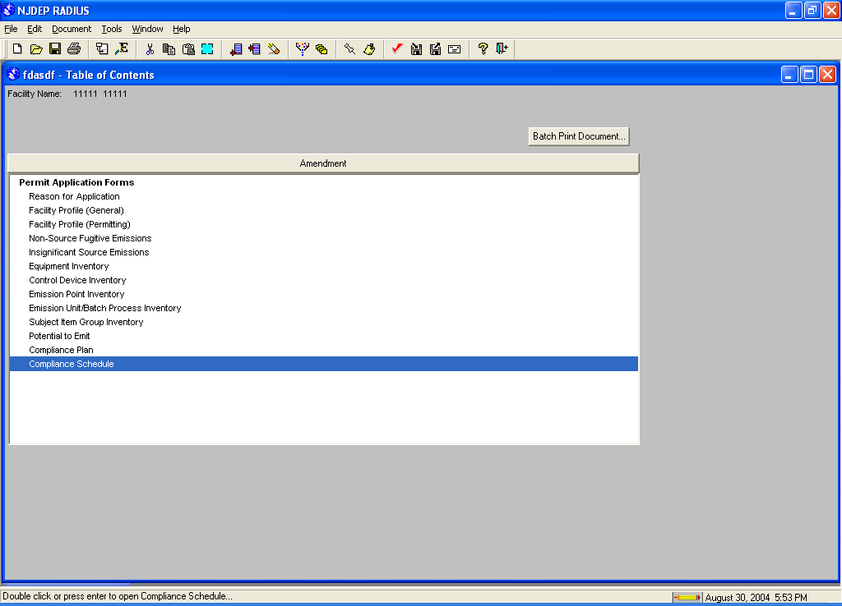
New Compliance Schedule screen allows RADIUS users to view Compliance Schedules for the first time in RADIUS (intended Operating Permit applications/permits only)

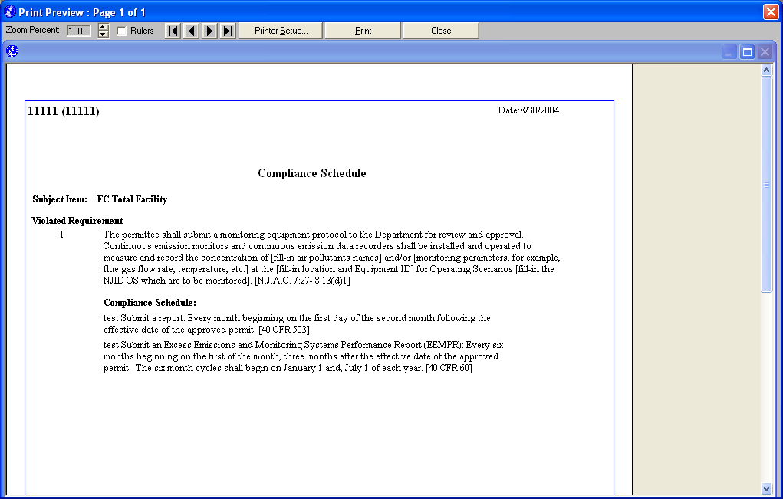
Sample View of a Compliance Schedule

Auto-Fill PTE Screens Based on Compliance Plan Limitation Requirements

This feature allows RADIUS users to populate the Potential to Emit (PTE) screen with emissions data from the compliance plan. Clicking on the new “Load PTE from Reqts” button on the bottom of each PTE screen will automatically transfer data into the PTE screen. Data will be transferred into the Emissions After Controls column and the Totals column will be recalculated.

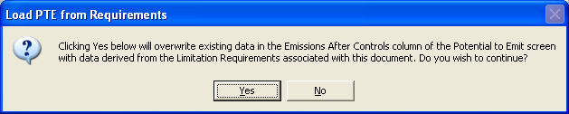
Clicking on that button will provide you with the following warning message:

For this feature to work properly, RADIUS uses the following rules:
- The emission limit in the compliance plan must be a limitation requirement (see screenshot, below). Text requirements will not transfer.
- For preconstruction permits, only those emission limits with a N.J.A.C. 7:27-8 citation will be transferred.
- For operating permits, only those emission limits with a N.J.A.C. 7:27-22 citation will be transferred.
- If a subject item contains multiple emission limits with the same units for the same pollutant, the item with the highest value will be transferred.
- If a subject item contains multiple emission limits with different units for the same pollutant, each item will be transferred.
- Data in the PTE screen will only be overwritten if the compliance plan contains a limitation requirement for the specified pollutant, units, and rule citation.
- Users can always edit the data in the PTE screen, even after the “Load PTE from Reqts” feature is used.

Example of Limitation Requirement
