NEW JERSEY STATE DEPARTMENT OF ENVIRONMENTAL PROTECTION

NEW JERSEY ADMINISTRATIVE CODE

TITLE 7

CHAPTER 27

SUBCHAPTER 9

**Sulfur in Fuels**

TABLE OF CONTENTS

**Section** **Page**

# REGULATORY HISTORY 2

# 7:27-9.1 Definitions 3

7:27-9.2 Sulfur Content Standards 4

7:27-9.3 Exemptions 8

7:27-9.4 Waiver of Air Quality Modeling 8

7:27-9.5 Reserved 10

*Please note: The Department has made every effort to ensure that this text is identical to the official, legally effective version of this rule, set forth in the New Jersey Register. However, should there be any discrepancies between this text and the official version of the rule, the official version will prevail.*

REGULATORY HISTORY

|  |  |
| --- | --- |
| Filed: | January 12, 1968 |
| Effective: | May 1, 1968 |
|  |  |
| Amendments Promulgated: | March 12, 1976 (8 N.J.R.181(a)) |
|  |  |
| Amendments Promulgated: | March 31, 1976 (8 N.J.R. 222(a)) |
|  |  |
| Amendments Promulgated: | August 10, 1978 |
| Amendments Effective: | October 12, 1978 (10 N.J.R.234(a) and 10 N.J.R. 383(c)) |
|  |  |
| Amendments Filed: | October 10, 1978 |
| Changing Effective Date to: | December 31, 1978 (10 N.J.R. 479(c)) |
|  |  |
| Amendments Filed and Effective: | January 10, 1979 |
| Changing Effective Date to: | July 12, 1979 (11 NJR 63(c)) |
|  |  |
| Amendments Effective: | December 6, 1982 |
| Amendments Operative: | February 4, 1983 (13 N.J.R. 870(a) and 13 N.J.R.14 N.J.R.1452(a)) |
|  |  |
| Administrative Corrections: | April 15, 1991 (23 N.J.R.1166(b)) |
| See: | May 6, 1991 (23 N.J.R.1432(d))  ) |
|  |  |
| Amendments Effective: | May 4, 1998 |
| Amendments Operative: | June 12, 1998 (29 N.J.R.3521(a) and 30 N.J.R.1563(b)) |
|  |  |
| Emergency Amendments Effective: | February 16, 2000 |
| Emergency Amendments Expired: | April 16, 2000 (32 N.J.R.836(a)) |
|  |  |
| Amendments Effective: | September 20, 2010 |
| Amendments Operative: | October 25, 2010 (42 N.J.R. 2244) |
|  |  |

# 7:27-9.1 Definitions

The following words and terms, when used in this subchapter, shall have the following meanings unless the context clearly indicates otherwise.

**“Aerodynamic downwash”** means the rapid descent of a plume to ground level with little dilution and dispersion as a result of alteration of background air flow characteristics caused by the presence of buildings or other obstacles in the vicinity of the emission point.

**“Air quality simulation model”** means a mathematical procedure for predicting the ambient air concentration of pollutants resulting from the dispersive properties of the atmosphere.

**“Ambient air quality standard”** means a limit on the concentration of a contaminant in the general outdoor atmosphere, which cannot be exceeded without causing or tending to cause injury to human health, welfare, animal or plant life, or property, or unreasonably interfering with the enjoyment of life and property, excluding all aspects of employer-employee relationship as to health and safety hazards.

**“Carbon dioxide (CO2)”** means a colorless, odorless gas at standard conditions, having a molecular composition of one carbon atom and two oxygen atoms.

**“Fuel”** means gaseous, liquid, or liquefiable petroleum product (excluding coal) which is produced, manufactured, used or sold for the purpose of creating useful heat.

**“Fuel oil”** means a liquid or liquefiable petroleum product burned for lighting or for the generation of heat or power and derived directly or indirectly from crude oil.

**“Mathematical combination”** means the summation of the emissions from two or more stacks or chimneys and the regulation of those emissions as if they came from the same sources venting through a single stack.

**“Motor vehicle”** means any vehicle propelled otherwise than by muscular power, excepting such vehicles as run only upon rails or tracks.

**“Municipal solid waste (MSW)”** means residential, commercial, and institutional non-hazardous solid waste.

**“Solid fuel”** means solid material or any substance derived from solid material used or to be used for the purpose of creating useful heat and includes, but is not limited to, coal, gasified coal, liquified coal, solid solvent-refined coal, municipal solid waste, refuse-derived fuel, and wood.

**“SSU viscosity”** means the number of seconds it takes 60 cubic centimeters of an oil to flow through the standard orifice of a Saybolt Universal viscometer at 100 degrees Fahrenheit.

**“Stack or chimney”** means a flue, conduit or opening designed, constructed, and/or utilized for the purpose of emitting air contaminants into the outdoor air.

**“Sulfur dioxide (SO2)”** means a colorless gas at standard conditions, having a molecular composition of one sulfur atom and two oxygen atoms.

**“Viscosity”** means the measure of a fluid's resistance to flow.

**“Zone 1”** means Atlantic, Cape May, Cumberland, and Ocean Counties.

**“Zone 2”** means Hunterdon, Sussex, and Warren Counties.

**“Zone 3”** means Burlington, Camden, Gloucester, and Mercer Counties except those municipalities included in Zone 6.

**“Zone 4”** means Bergen, Essex, Hudson, Middlesex, Monmouth, Morris, Passaic, Somerset, and Union Counties.

**“Zone 5”** means Salem County.

**“Zone 6”** means in Burlington County, the municipalities of Bass River Township, Shamong Township, Southampton Township, Tabernacle Township, Washington Township, Woodland Township, and in Camden County, Waterford Township.

**7:27-9.2 Sulfur content standards**

(a) No person shall store, offer for sale, sell, deliver or exchange in trade, for use in New Jersey, fuel that contains sulfur in excess of the applicable parts per million by weight set forth in Tables 1A and 1B of this section, except as provided in (c), (d) and (e) below. Fuel stored in New Jersey that met the applicable maximum sulfur content standard of Tables 1A or 1B of this section at the time the fuel was stored in New Jersey may be stored, offered for sale, sold, delivered or exchanged in trade, for use in New Jersey, after the effective date of the applicable standard in Table 1B.

(b) No person shall use fuel that contains sulfur in excess of the applicable parts per million by weight set forth in Tables 1A and 1B of this section, except as provided in (c), (d) and (e) below. Fuel stored in New Jersey that met the applicable maximum sulfur content standard of Tables 1A or 1B of this section at the time it was stored in New Jersey may be used in New Jersey after the operative date of the applicable standard in 1B.

|  |  |  |  |  |  |
| --- | --- | --- | --- | --- | --- |
| **TABLE 1A** | | | | | |
| **MAXIMUM ALLOWABLE SULFUR IN FUEL EFFECTIVE THROUGH JUNE 30, 2014** | | | | | |
| **Typical Grades of Fuel Oil** | **Classification by SSU Viscosity at 100°F** | **Parts per Million by Weight (ppm)** | | | |
|  |  | **Zone 1** | **Zones 2 & 5** | **Zone 3** | **Zones 4 & 6** |
| No. 2 & lighter | Less than or equal to 45, including gases | 3,000 | 3,000 | 2,000 | 2,000 |
| No. 4 | Greater than 45 but less than 145 | 20,000 | 7,000 | 3,000 | 3,000 |
| No. 5, No. 6 & heavier | Equal to or greater than 145 | 20,000 | 10,000 | 5,000 | 3,000 |

|  |  |  |  |  |  |
| --- | --- | --- | --- | --- | --- |
| **TABLE 1B** | | | | | |
| **MAXIMUM ALLOWABLE SULFUR IN FUEL EFFECTIVE JULY 1, 2014**  **AND JULY 1, 2016** | | | | | |
| **Typical Grades of Fuel Oil** | **Classification by SSU Viscosity at 100°F** | **Parts per Million by Weight (ppm)** | | | |
|  |  | **Zone 1** | **Zones 2 & 5** | **Zone 3** | **Zones 4 & 6** |
| No. 2 & lighter  (effective July 1, 2014 through  June 30, 2016) | Less than or equal to 45, including gases | 500 | 500 | 500 | 500 |
| No. 2 & lighter  (effective July 1, 2016) | Less than or equal to 45, including gases | 15.0 | 15.0 | 15.0 | 15.0 |
| No. 4  (effective July 1, 2014) | Greater than 45 but less than 145 | 2,500 | 2,500 | 2,500 | 2,500 |
| No. 5, No. 6 & heavier  (effective July 1, 2014) | Equal to or greater than 145 | 5,000 | 5,000 | 5,000 | 3,000 |

(c) The provisions of (a) and (b) above shall not apply to fuels whose combustion carries sulfur dioxide emissions from any stack or chimney into the outdoor atmosphere that are demonstrated to the Department as not exceeding, at any time, those quantities of sulfur dioxide expressed in pounds per 1,000,000 British Thermal Units (BTU) gross heat input, set forth in Tables 2A and 2B of this section.

|  |  |  |  |  |  |
| --- | --- | --- | --- | --- | --- |
| **TABLE 2A** | | | | | |
| **MAXIMUM ALLOWABLE SULFUR DIOXIDE EMISSIONS EFFECTIVE THROUGH JUNE 30, 2014** | | | | | |
| **Typical Grades of Fuel Oil** | **Classification by SSU Viscosity at 100°F** | **SO2 Emissions (lbs per million BTU)** | | | |
|  |  | **Zone 1** | **Zones 2 & 5** | **Zone 3** | **Zones 4 & 6** |
| No. 2 & lighter | Less than or equal to 45, including gases | 0.32 | 0.32 | 0.21 | 0.21 |
| No. 4 | Greater than 45 but less than 145 | 2.10 | 0.74 | 0.32 | 0.32 |
| No. 5, No. 6 & heavier | Equal to or greater than 145 | 2.10 | 1.05 | 0.53 | 0.32 |

|  |  |  |  |  |  |
| --- | --- | --- | --- | --- | --- |
| **TABLE 2B** | | | | | |
| **MAXIMUM ALLOWABLE SULFUR DIOXIDE EMISSIONS EFFECTIVE JULY 1, 2014 AND JULY 1, 2016** | | | | | |
| **Typical Grades of Fuel Oil** | **Classification by SSU Viscosity at 100°F** | **SO2 Emissions (lbs per million BTU)** | | | |
|  |  | **Zone 1** | **Zones 2 & 5** | **Zone 3** | **Zones 4 & 6** |
| No. 2 & lighter  (effective July 1, 2014 through  June 30, 2016) | Less than or equal to 45, including gases | 0.0530 | 0.0530 | 0.0530 | 0.0530 |
| No. 2 & lighter  (effective July 1, 2016) | Less than or equal to 45, including gases | 0.00160 | 0.00160 | 0.00160 | 0.00160 |
| No. 4  (effective July 1, 2014) | Greater than 45 but less than 145 | 0.260 | 0.260 | 0.260 | 0.260 |
| No. 5, No. 6 & heavier  (effective July 1, 2014) | Equal to or greater than 145 | 0.530 | 0.530 | 0.530 | 0.320 |

(d) The provisions of (a) and (b) above shall not apply to fuels included in an alternative emission control plan based on a mathematical combination approved by the Department. Application for such approval shall be made to the Department in writing and must include:

1. Certification that all source operations to be included in the mathematical combination are under the control of, or operated by, one person;

2. Certification that the total sulfur dioxide emissions from the mathematical combination during each 24-hour period will not exceed the quantity of sulfur dioxide expressed in pounds per million BTU gross heat input set forth in Tables 2A and 2B of this section;

3. Certification that the total sulfur dioxide emissions from the mathematical combination during each 24-hour period will not exceed the maximum total weight of sulfur dioxide that all the sources in the mathematical combination were allowed to emit at the time of applying;

4. Identification of each fuel burning unit and stack to be included in the mathematical combination;

5. Identification of the grades of fuel to be burned in each unit, the maximum sulfur content of each fuel to be burned in each unit, the maximum gross heat input rate for each unit, the higher heating value of each fuel, and the annual fuel use and operating hours per year for each unit;

6. An application for a permit for any fuel burning unit that must be altered or for any fuel burning unit in which fuel is to be burned having a sulfur content in excess of the applicable limits specified in Tables 1A and 1B of this section. The permit may be a preconstruction permit and certificate under N.J.A.C. 7:27-8, an operating permit under N.J.A.C. 7:27-22 or a facility-wide permit as defined at N.J.A.C. 7:1K-1.5;

7. A demonstration by air quality simulation modelling acceptable to the Department, including aerodynamic downwash modelling, unless waived in accordance with the provisions of N.J.A.C. 7:27-9.4, that increases in air contaminants resulting from use of the alternative emission control plan will not cause any ambient air quality standard to be exceeded, or cause any allowable prevention of significant deterioration ambient air increment as established by the United States Environmental Protection Agency to be exceeded; and in areas where an ambient air quality standard is already exceeded, will not cause an increase in ambient air concentrations greater than the threshold increases set forth in Table 1 of N.J.A.C. 7:27-18.4;

8. Sufficient information to evaluate aerodynamic downwash effects including a site plan, heights of all structures within 1,000 feet (305 meters) of the stacks in the mathematical combination, and the topography of the area within 1,000 feet (305 meters) of the stacks in the mathematical combination; and

9. A guarantee that fuel analyses will be submitted at intervals specified by the Department.

(e) The provisions of (a), (b), (c), and (d) above shall not apply whenever a person responsible for the sulfur dioxide emissions from a facility into the outdoor air resulting from the combustion of facility by-products alone, or from the combustion of facility by-products combined with fuels conforming with this section, can demonstrate to the Department that the facility's emissions are predictable and will in no case exceed 310 ppm by volume adjusted to 12 percent carbon dioxide by volume. In such cases, the Department may establish conditions as it deems appropriate including, but not limited to, requiring sampling and analysis of emissions of sulfur dioxide, periodic fuel analysis and the periodic submission of data.

(f) If the identified grade of fuel oil does not agree with the classification by viscosity set forth in Tables 1A and 1B and Tables 2A and 2B, then he allowable parts per million sulfur by weight shall be determined by the viscosity classification.

# 7:27-9.3 Exemptions

# 

(a) The provisions of this subchapter shall not apply to fuel used by ocean-going vessels or in motor vehicles.

(b) The Department will set such standards for the sulfur contents of fuel as may be necessary to prevent violation of air quality standards where it is determined that an aerodynamic downwash problem exists as the result of emissions from a source or sources of air pollution.

# 7:27-9.4 Waiver of air quality modeling

# 

(a) The Department may waive the air quality simulation modelling requirements of N.J.A.C. 7:27-9.2(d) if the applicant demonstrates that:

1. The effective heights, as determined in accordance with the provisions of (b) below, of the stacks to be included in the mathematical combination are equal, or that the emissions from the fuel having the greatest sulfur content will be discharged to the atmosphere from the stack having the greatest effective height;

2. The total maximum SO2 emission rate for all source gases to be included in the mathematical combination is no greater than 800 pounds per hour (363 Kg/hr);

3. No stack in the mathematical combination is separated from any other stack by a distance measured from the stack center lines, greater than three times the least effective stack height of any stack included in the mathematical combination; and

4. No stack in the mathematical combination is separated from any other stack by a distance greater than the allowable separation as determined from Figure 1 of this section.

(b) Procedure for using Figure 1.

1. Determine the effective stack heights in accordance with the provisions of (c) below.

2. Locate the least effective stack height on the left side of Figure 1 of this section.

3. Find the intersection of the least effective stack height and maximum total SO2 emission rate. Interpolation is permitted.

4. Draw a vertical line from this point to the bottom of the chart to find the maximum allowable separation of the stacks.

FIGURE 1

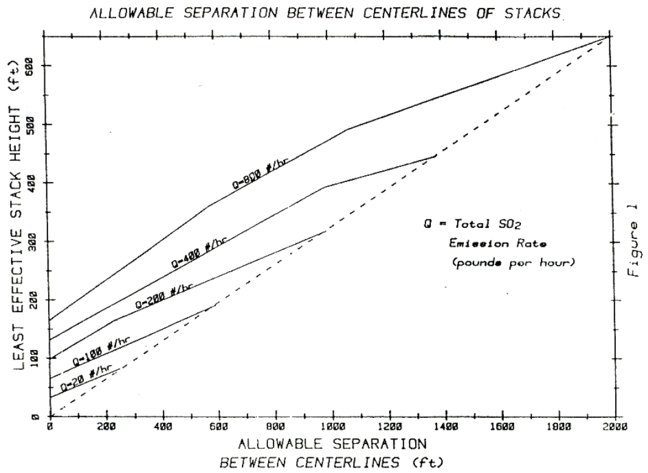

(c) The effective stack height of a given stack for the purposes of this subchapter is the lesser of the following values:

1. 650 feet; or

2. The sum of the physical stack height and the plume rise. Plume rise is calculated from the formula:

   

Where:

h is the plume rise in feet;

u is 12 if the physical stack height is less than 65 feet; u is 5 for physical stack heights of 65 feet or greater;

V is the actual exit velocity of the stack gas in feet per second;  
d is the inside diameter of the stack exit in feet; and

T is the temperature of the stack gas at the stack exit, in degrees Fahrenheit.

**7:27-9.5 (Reserved)**