# Flood Plans and Flood Profiles

1. Flood Plan Locator

<https://njdep.maps.arcgis.com/home/item.html?id=9ef439b13cd54693840967a237e6b520>

1. NJ Flood Profiles

<https://njdep.maps.arcgis.com/home/item.html?id=67578724c67b4c57a5b566dfa886df48>

*** These instructions are based upon using Google Chrome since it is the most widely used browser. Other browsers can be used but the behavior will be slightly different. ***

Click or open the above “Flood Plan Locator” URL in your browser; the following screen opens and shows two main ways to Open and View the data.

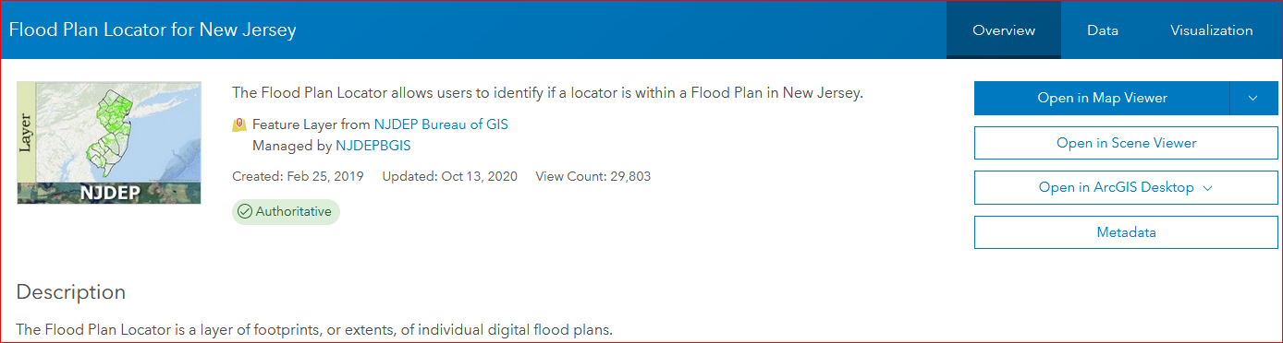

Two Ways to View Data after opening URL in Browser by either Using ArcMap on PC or Using Map Viewer with Internet Browser:

# Using ArcMap on PC

*** If user wants the ArcMap session to be in the NJ State Plan projection, do the following step before Opening the Flood Plan Locator in ArcMap:

* Open ArcMap with a layer that is in the NJ State Plan projection first.***

1. Click on “Open in ArcGIS Desktop” and then “Open in ArcMap”
2. The layer will open in the tray of browser (bottom left corner)

* Click on it and it will open the Flood Plan Locator layer in ArcMap
* (Flood plans will not be visible in map yet until user zooms to area of interest. This can be done after opening the Flood Profiles layer in the next step.)

1. Open a new tab in your browser. Copy and paste the following Flood Profiles layer URL in the new tab:

<https://njdep.maps.arcgis.com/home/item.html?id=67578724c67b4c57a5b566dfa886df48>

* Click on “Open in ArcGIS Desktop” and then “Open in ArcMap”
* The layer will open in the tray of browser (bottom left corner)
* Click on it and it will open the Flood Profiles layer in the same ArcMap session as the Flood Plan Locator.

1. Navigate to area of interest by panning and zooming
2. Download Flood Plan Map Image by using Identify:

* Using Identify, click on a Flood Plan polygon
* In the Identify window, next to “Flood Plan Image”, Click on the URL or Lightning bolt
* It will open in the tray of browser (bottom left corner); click on Filename;
* The Flood Plan image file will open in the user’s default image viewer
* Follow these same steps to download Flood Profile image using Identify.
* With Flood Profiles, there is a choice of a TIF or JPG file in the Identify window.

-Click on JPG URL to view Profile image Thumbnail in browser

-Click on TIF URL to download Profile image

1. Download Map Image by using attribute table:

* After finding or selecting map image on attribute table, copy the URL from attribute table and paste into browser
* It will open in the tray of browser (bottom left corner); click on Filename;
* The Flood Plan or Profile image file will open in the user’s default image viewer

# Using Map Viewer with Internet Browser

1. Open the following Flood Plan Locator URL in your browser:

<https://njdep.maps.arcgis.com/home/item.html?id=9ef439b13cd54693840967a237e6b520>

* Click on “Open in Map Viewer” (Select “Add to New Map” if down arrow is used)
* The Flood Plan Locator opens in the Contents of web map as following screenshot shows.

(Flood plans will not be visible in map yet until user zooms to area of interest. This can be done after opening the Flood Profiles layer in the next step.)

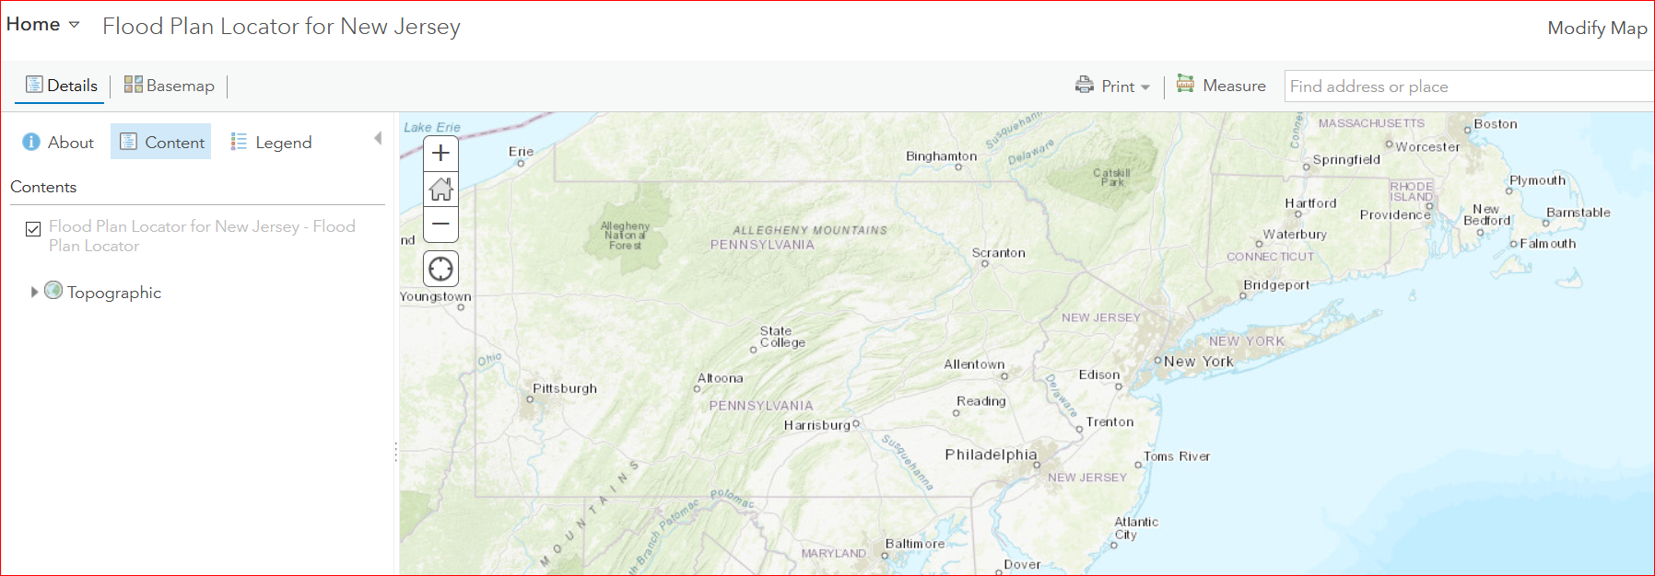

1. To add the Flood Profiles to this web map;

* Click on “Modify Map” in upper right corner
* This will add the Add data functionality to upper left corner

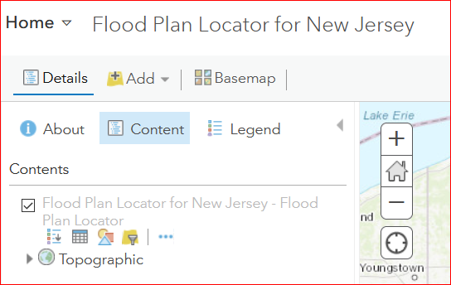

* Click the dropdown next to  and select “Search for layers”
* In the Search box, type “flood profiles”
* This will return the 1 layer as in the following screenshot:

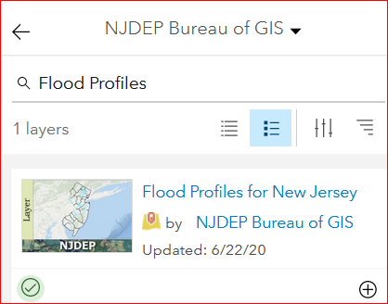

* Click on the add icon,  , and then the back arrow next to “NJDEP Bureau of GIS”



* This will now add the Flood Profiles and the web map will look like this:

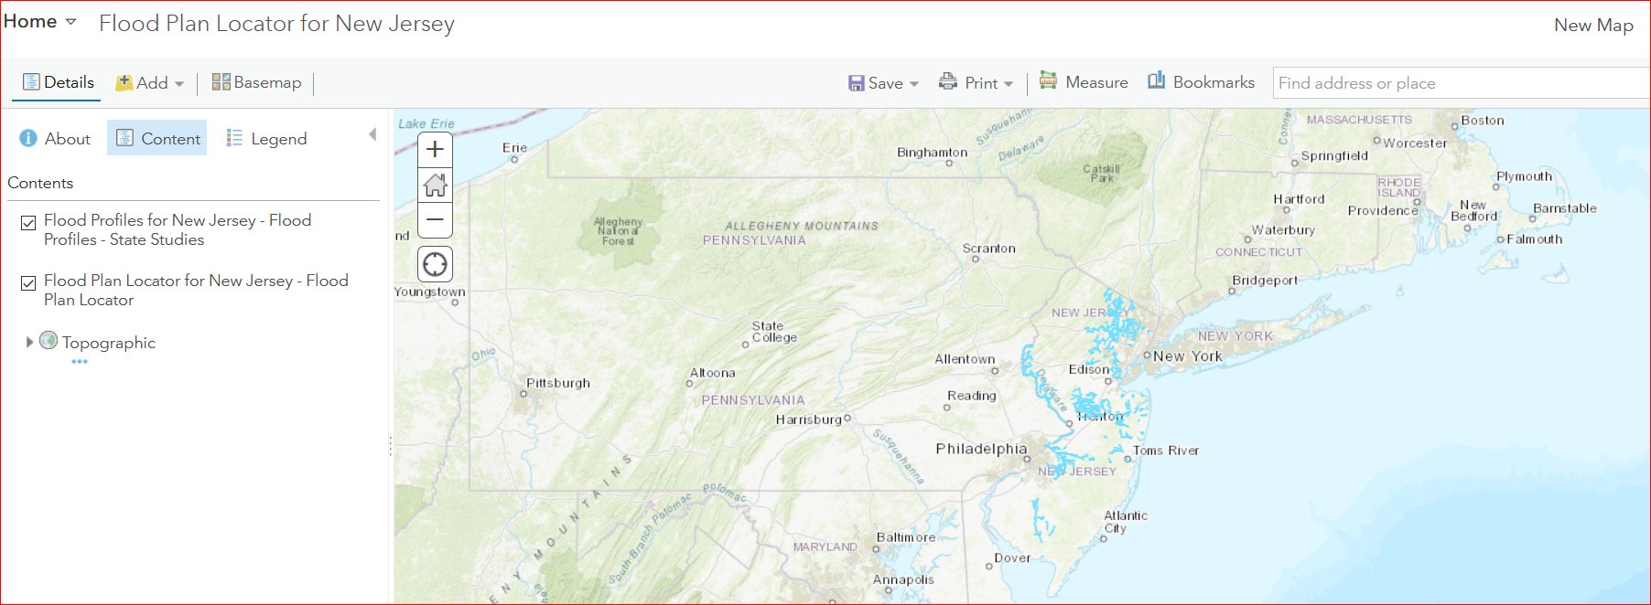

1. Navigate to your area of interest by either:

* Using Pan and Zoom
* Or use the “Find address or place” box



(Flood Plans will not appear on map until zoomed in.)

**TIP:** To see Flood Plan map numbers as labels on map; click on 3-dots under layer in the Contents (You may need to hover mouse over layer name):

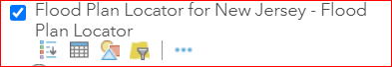

* Select “Create Labels” and Click OK

1. Download Flood Plan image by clicking on green Flood Plan polygon

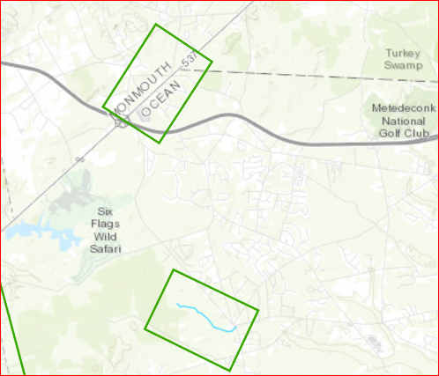

* After clicking on Flood Plan, a Pop-up window will appear as:

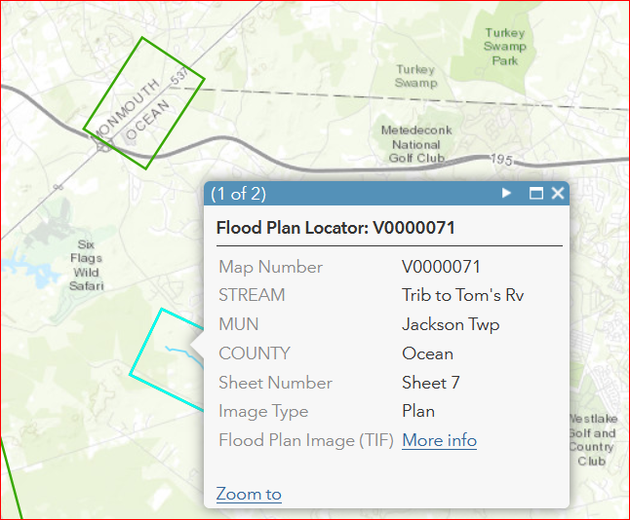

* Click on “More info” link to download Flood Plan.
* It will open in the tray of browser (bottom left corner); click on Filename;
* The Flood Plan image file will open in the user’s default image viewer
* Follow the same steps to download Flood Profile image.
* With Flood Profiles, there is a choice of a TIF or JPG file in the pop-up window.

-Click on JPG (More info) to view Profile image Thumbnail in browser

-Click on TIF (More info) to download Profile image